Group Members:
Student Number | Student Name
M01072497 | Tejasvin Jedddedu
M01067514 | Rahul Ramburrun
M01018159 | Rohan Seelochun

CST2572 COURSEWORK GROUP REPORT

Contents
Code Implementation and Description 2
Admin.html 2
Screenshots 2
Explanation 9
Case study 9
References 11
Author Contributions 11

Code Implementation and Description

Admin.html

Screenshots
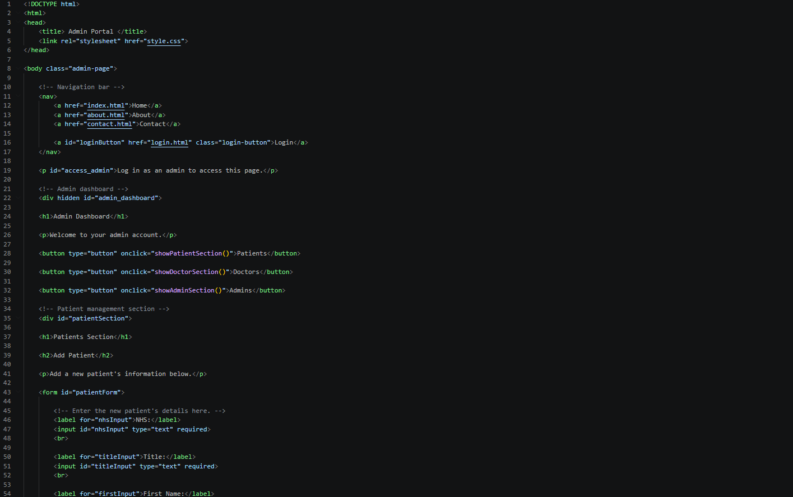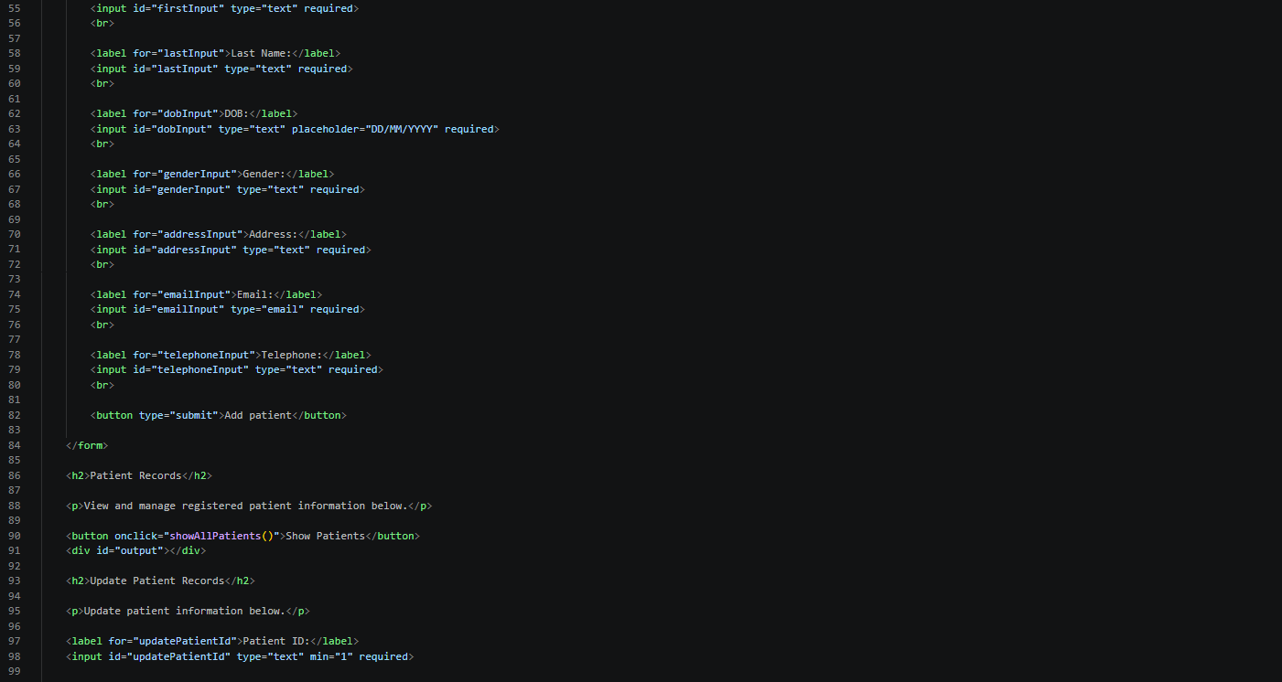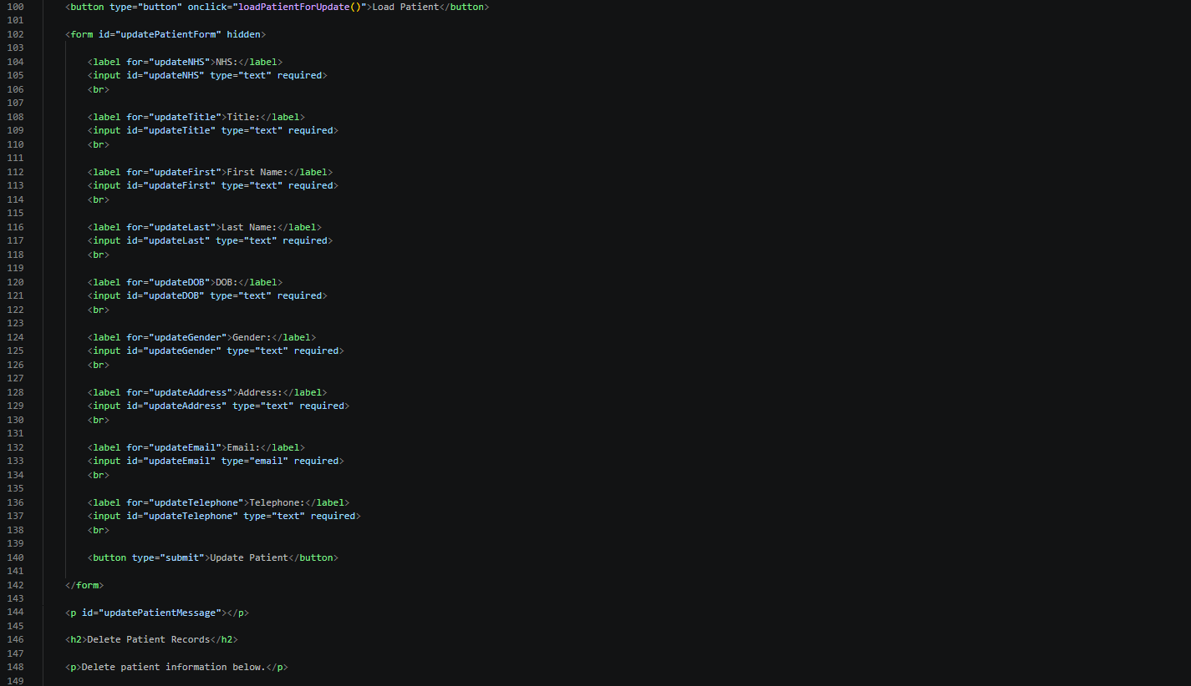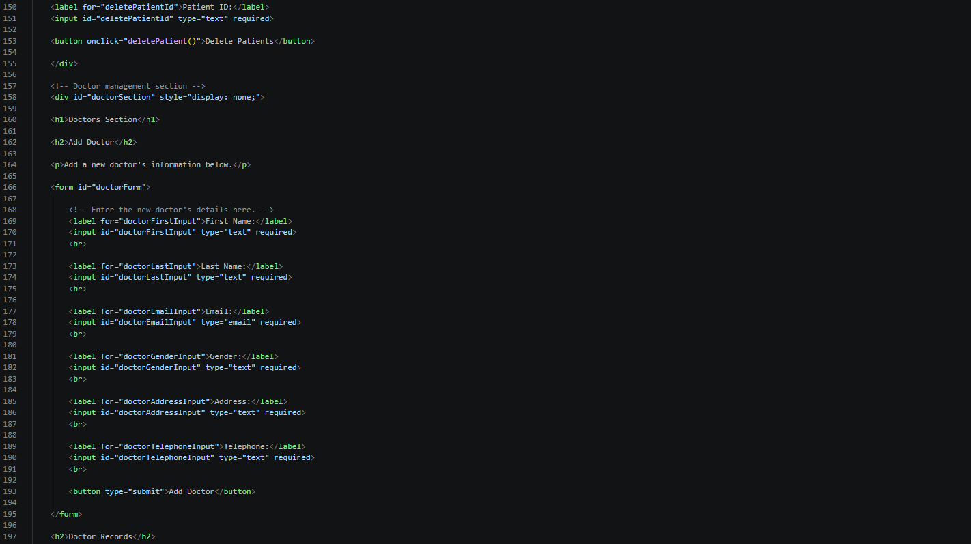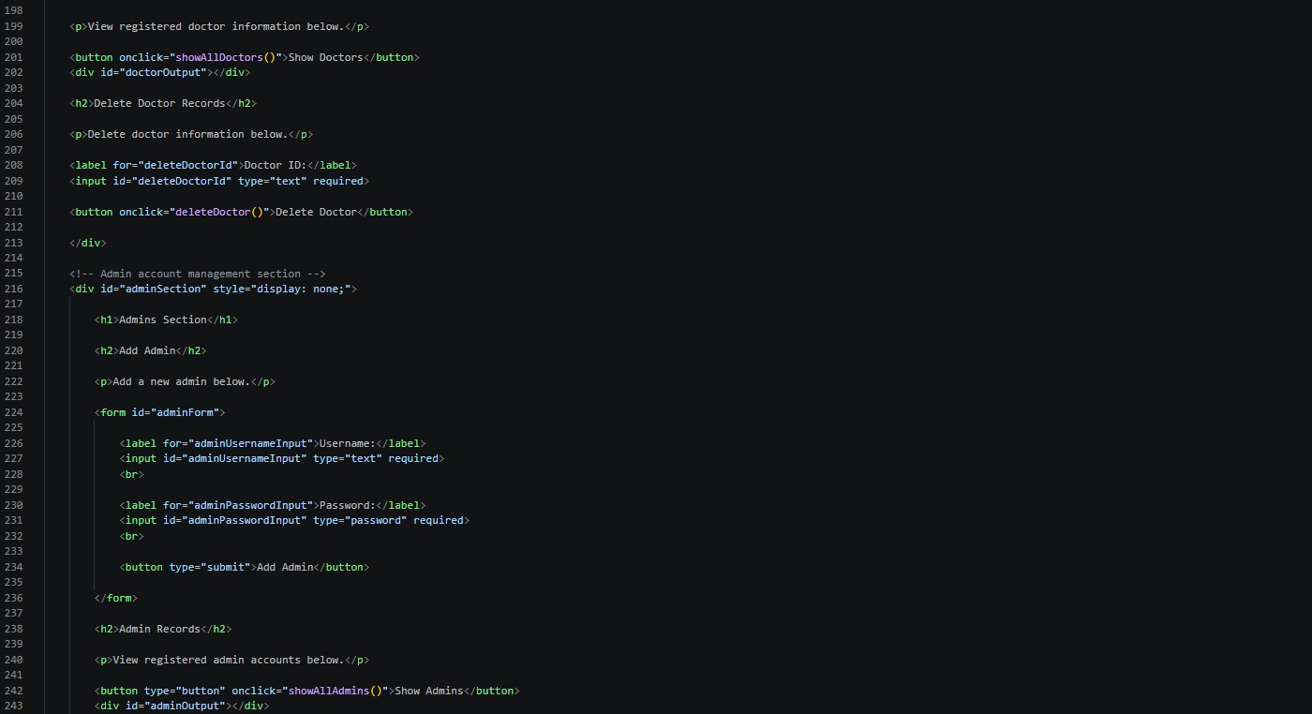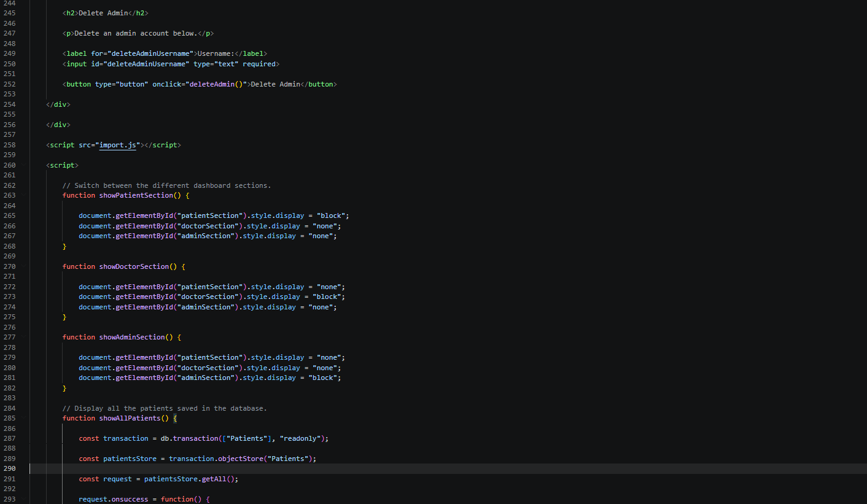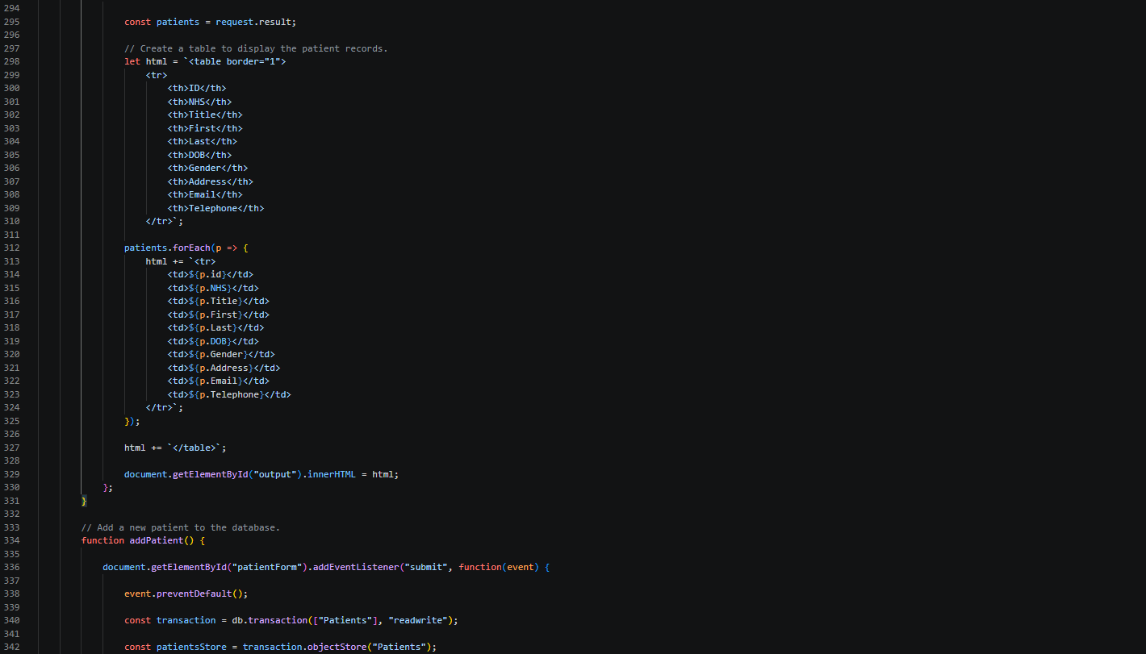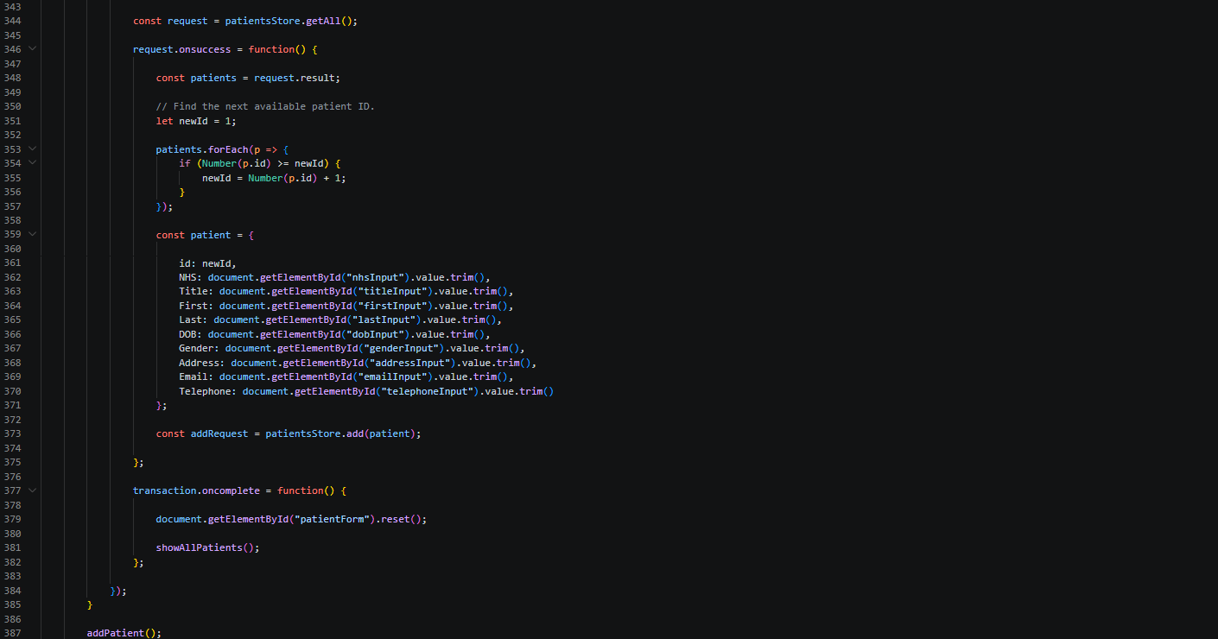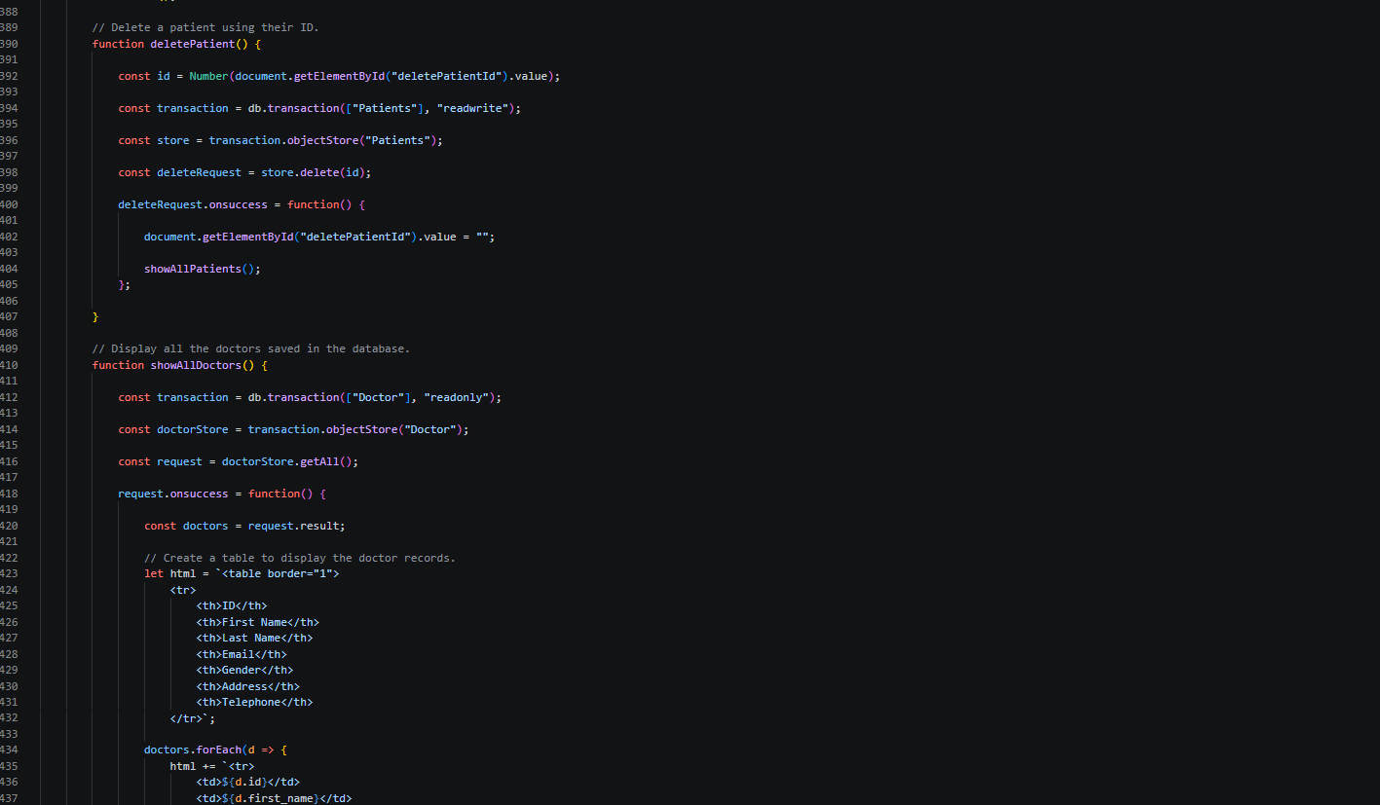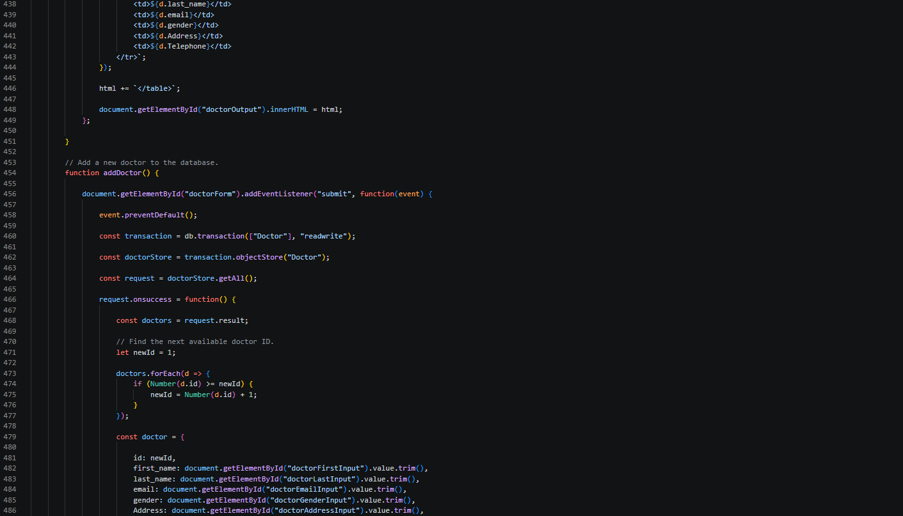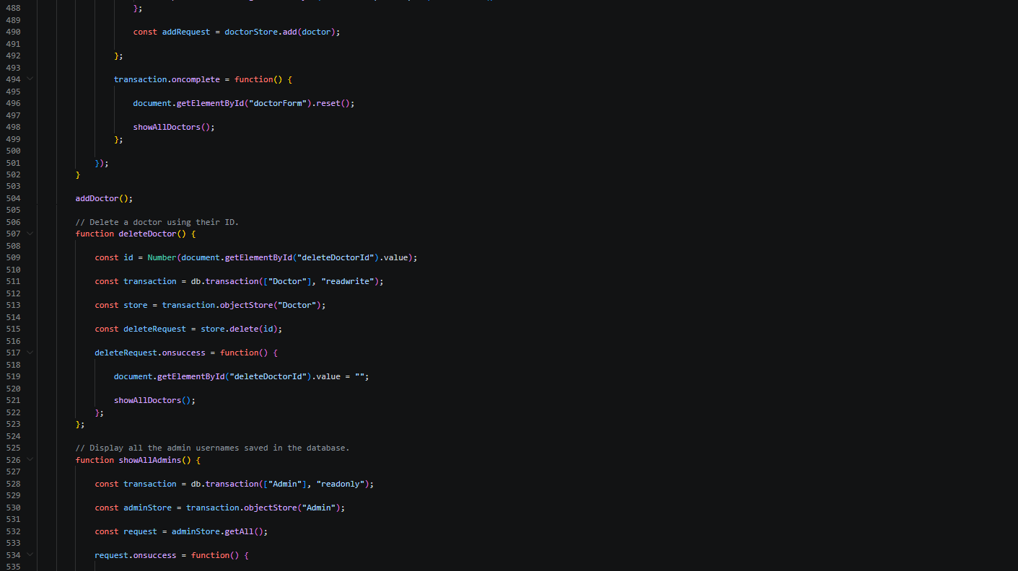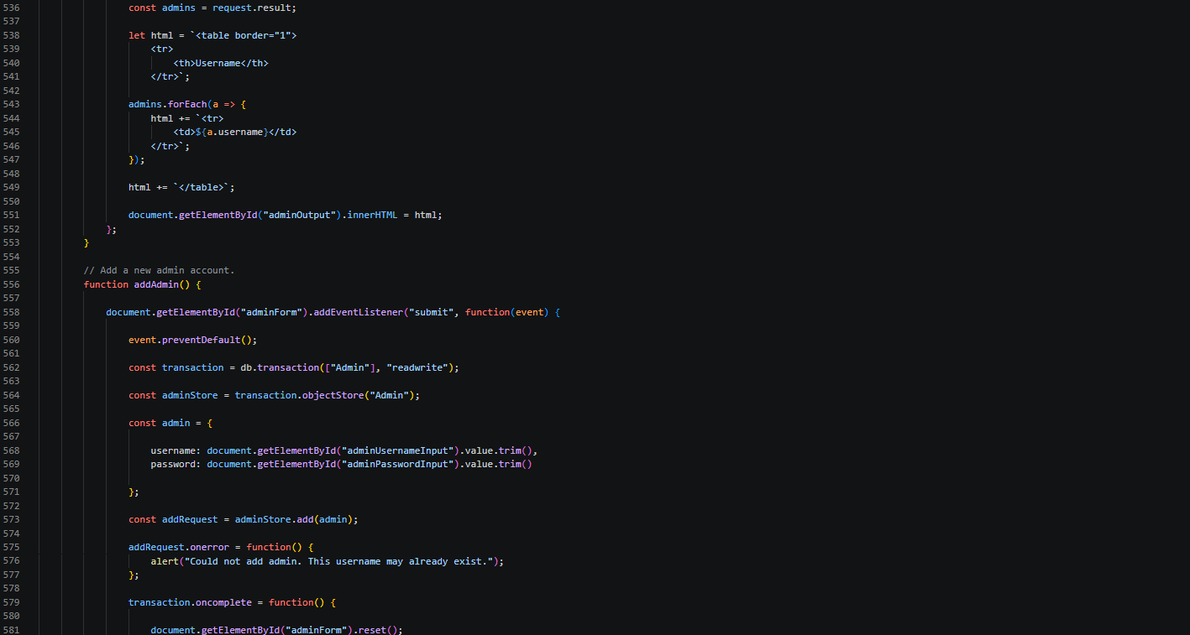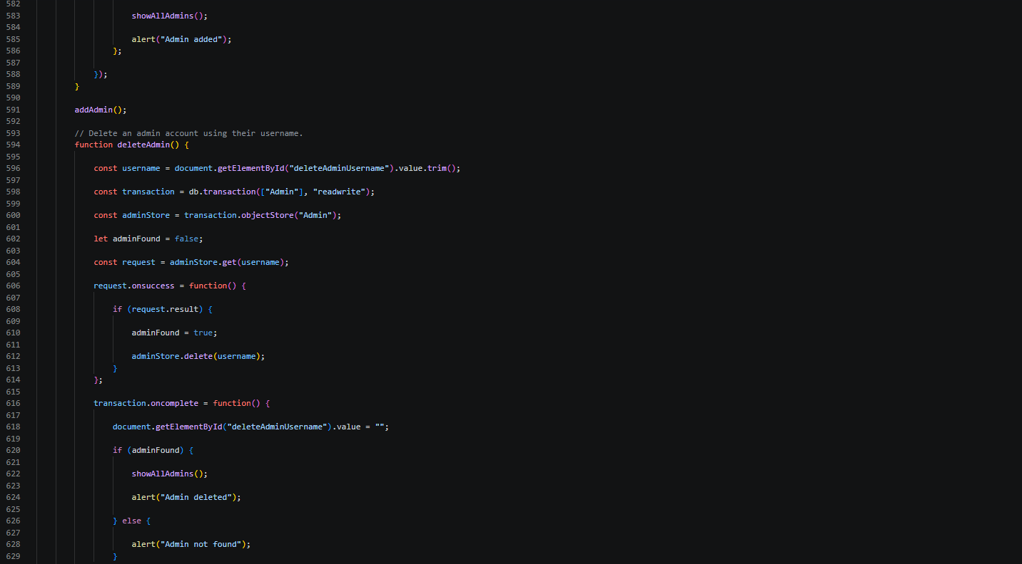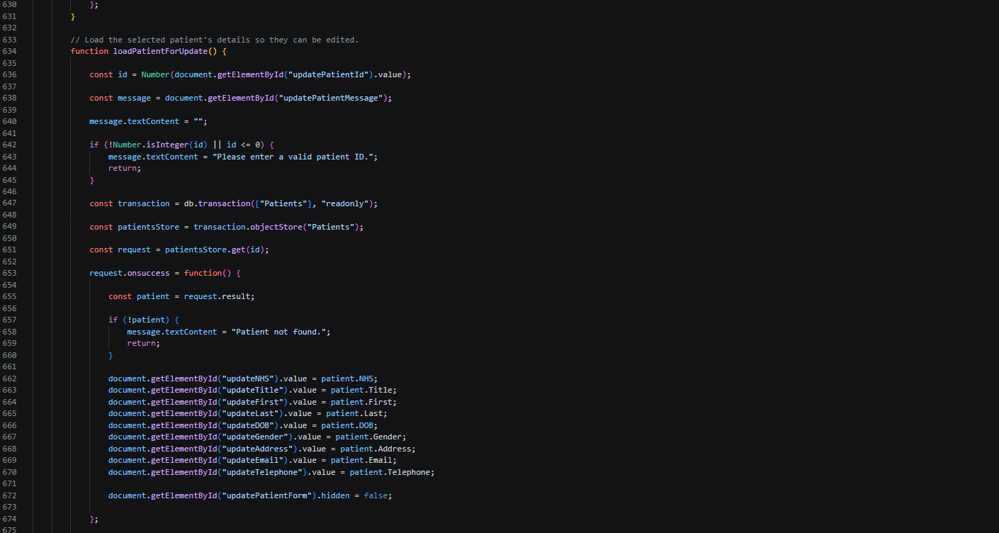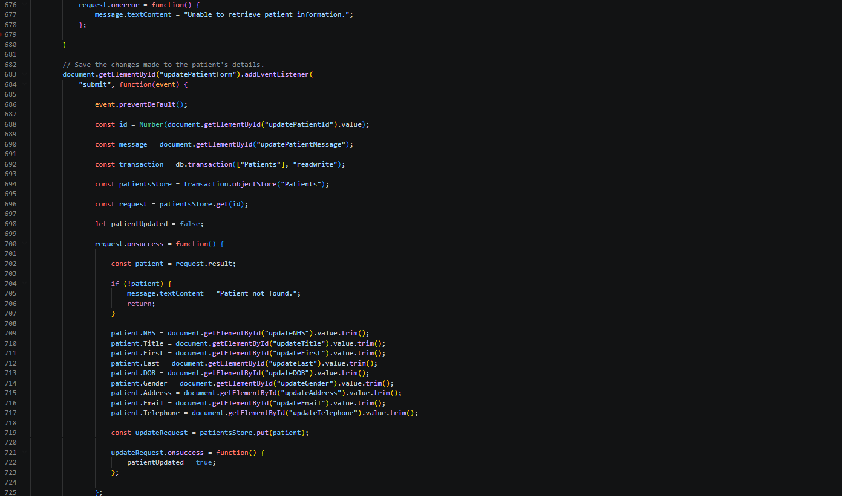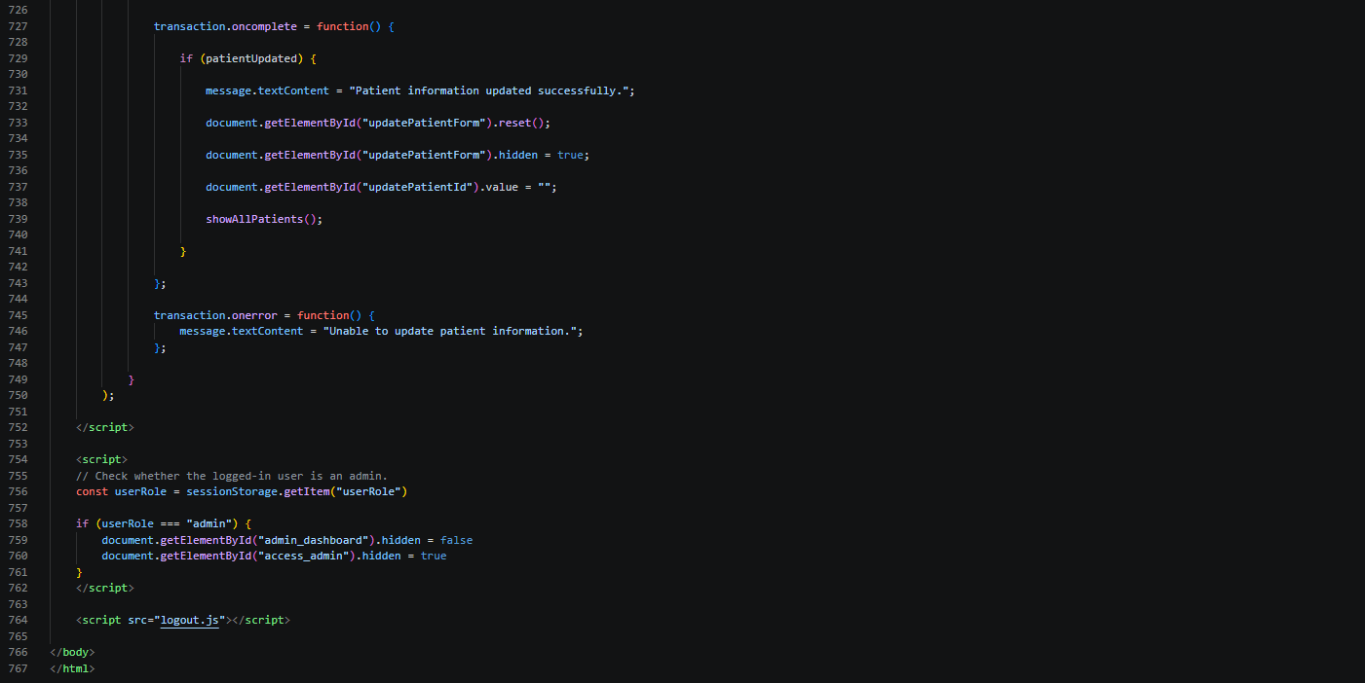

Explanation
The admin portal allows administrators to manage user accounts. It is divided into three sections: Doctors, Patients and Admin. Visibility of these sections are controlled using CSS display property. IndexedDB transactions interact with the relevant object stores to retrieve, insert, modify and remove records. The getAll(), add(), put() and delete() methods are used to perform database operations. The portals allow for displaying user details, adding of users, updating users details and deletion of users. The code uses sessionStorage to check the logged-in user's role and display the admin dashboard only when the role is set to admin.

Case study
According to the Cybersecurity and Infrastructure Sdetails, adding(CISA, 2021), the fiusers’tep is to investigate how the website was compromised and find the extent of the attack. Suspicious events are analysed to understand what is happening. Apache access logs are verified to review every HTTP request made by server. Apache error logs are verified to review every diagnostic information. Unusual errors may be found. Available WordPress activity records are reviewed for suspicious admin logins, account changes, themes or plugins. Databases are checked for any modifications. Website files are checked if they were modified without any authorisation. Malware alerts are checked for any suspicious files. Any system connected to the virtual machine needs to be checked. Relevant logs and digital evidence are preserved for investigation of possible entry points
Remedy is important as it stops the attack from causing more damage and allows the website to be safely restored. The NHS carries massive public trust, and an attack could damage the organisation’s reputation. Containment is of the highest priority. The infected VM is isolated to stop spreading the attacks to other systems. Firewall is updated to block any suspicious connections and attackers from accessing other systems. Unauthorised access is blocked. Admin passwords are changed in case admin account was compromised. In case of suspicion, admin privilege is revoked. Any suspicious connection to databases, are blocked and database credentials are changed to prevent access to sensitive information. Only authorised users and applications should access it. Every evidence such as Apache logs, suspicious files are preserved to help investigate the cyberattack.
Clean-up and restore is important to remove all evidence of an attack and prevent attacker from remaining in system. All systems need to be fixed, not just where attack was discovered, no make sure no compromised parts are left. Infected VM is wiped clean and reinstalled using a trusted source and the compromised WordPress files need to be replaced with clean ones. Repairing could leave out hidden files, so it is better to restart. The latest patches are installed and all the passwords that may be compromised need to be changed to ensure optimum security. The ruleset for the firewall needs to be tightened to prevent any more unauthorised entry and systems need to be tested thoroughly before bringing it back online. There need to be a continuous monitoring for any abnormal behaviours
After an attack mitigation is crucial reducing the likelihood and impact of future cyberattacks. Regular security updates must be done to ensure the system is at maximum security and eliminating known vulnerabilities. Multi-Factor authentication must be used in password systems to ensure only authorised suers get access to the system. Use Web Application Firewall to filter potential malicious request. Database servers must be ensured to be isolated to limit the impact if one system is compromised. Sensitive information in the database must be encrypted un cause unauthorised users get access to it.
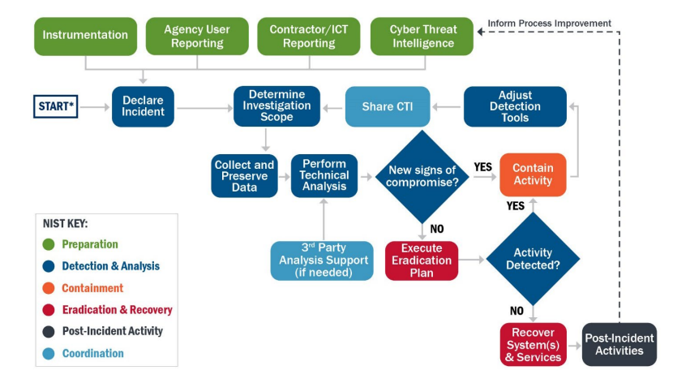
Figure 1: Cybersecurity Incident Response Process (Source: CISA 2021, p. 6))

References
- CISA (2021). Cybersecurity incident & vulnerability response playbooks operational procedures for planning and conducting cybersecurity incident and vulnerability response activities in FCEB Information Systems. [online] Available at: https://www.cisa.gov/sites/default/files/2024-08/Federal_Government_Cybersecurity_Incident_and_Vulnerability_Response_Playbooks_508C.pdf [Accessed 6 Nov. 2026].

Author Contributions
Rohan Seelochun was responsible for the ...
Tejasvin Jedddedu was responsible for the...
Rahul Ramburrun was responsible for the ...

