INTERNET OF THINGS (MDCO321)
MINI PROJECT REPORT
ON
“AI-Based Non-Communicable Disease Prediction and Smart Medicine Reminder System using IoT”
Internet of Things (IoT) – Group ID:
Submitted By
Wakchaure Shruti | 0124UCSF1059
Shinde Chanchal | 0124UCSF1060
Nere Tejas | 0124UCSM1067
Gidhad Arti | 0124UCSF1069
(T.Y. BTech Computer Engineering, Division A)

SAVITRIBAI PHULE PUNE UNIVERSITY
In the academic year 2026-27
Department of Computer Engineering
Sanjivani Rural Education Society’s
Sanjivani College of Engineering
Kopargaon - 423603.

(An Autonomous Institute)
DEPARTMENT OF COMPUTER ENGINEERING
CERTIFICATE
This is to certify that the Project Entitled
“AI-Based Non-Communicable Disease Prediction and Smart Medicine Reminder System using IoT”
Submitted By
Wakchaure Shruti | 0124UCSF1059
Shinde Chanchal | 0124UCSF1060
Nere Tejas | 0124UCSM1067
Gidhad Arti | 0124UCSF1069
(T.Y. BTech Computer Engineering, Division A)
Is A Bonafide Work Carried Out By Students Under The Supervision Of Prof. N. Y. Siddiqui And It Is Submitted Towards The Partial Fulfillment Of The Requirement Of Internet Of Things (IoT) – Project Based Learning Of T.Y. Bachelor Of Technology (Computer Engineering) During The Academic Year 2026-27.

PROF. N. Y. SIDDIQUI
[PROJECT GUIDE]
DR. M. A. JAWALE | DR. R. A. KAPGATE
HOD DIRECTOR

DECLARATION
We declare that this project report represents our own ideas expressed in our own words, and that wherever the work of others has been used, the original sources have been properly cited and referenced. We further declare that we have followed all principles of academic honesty and integrity and have acknowledged the contributions of others.

Sr. No. | PRN | Names | Student Sign
1 | 0124UCSF1059 | Wakchaure Shruti
2 | 0124UCSF1060 | Shinde Chanchal
3 | 0124UCSM1067 | Nere Tejas
4 | 0124UCSF1069 | Gidhad Arti

Place : Kopargaon Date : /10/2026

ACKNOWLEDGEMENT
We would like to express our sincere gratitude to our project guide, Prof. N. Y. Siddiqui, for valuable guidance, constructive feedback and encouragement throughout the development of this project.
We are thankful to the Head of the Department of Computer Engineering, Sanjivani College of Engineering, Kopargaon, for providing the facilities and supportive academic environment needed for this project.
We also thank all the teachers and non-teaching staff of the department for their help, suggestions and cooperation.
Finally, we express our heartfelt thanks to our parents, family and friends for their support, patience and motivation.

Wakchaure Shruti | 0124UCSF1059
Shinde Chanchal | 0124UCSF1060
Nere Tejas | 0124UCSM1067
Gidhad Arti | 0124UCSF1069

Table of Contents
Sr. No. | Content | Page No.
01 | Abstract / Problem Description | 06
02 | Objective | 07
03 | Hardware, Dataset & Tools | 07
04 | Methodology | 09
05 | Model Performance Comparison | 12
06 | Implementation Code | 13
07 | Results | 14
08 | Discussion | 16
09 | Conclusion and Future Work | 16
10 | References | 17

1. Abstract / Problem Description
Non-communicable diseases (NCDs), including diabetes, hypertension, heart disease and kidney disease, often require regular medication, periodic review of medical reports and continued monitoring. In routine care, patients may forget or delay a scheduled dose, caregivers may not know whether medicine was collected, and clinicians may have limited visibility into medication adherence and recovery between visits. Medical reports may also be difficult to interpret manually, especially when values must be extracted from scanned or photographed documents.
The proposed “AI-Based Non-Communicable Disease Prediction and Smart Medicine Reminder System using IoT” combines an IoT medicine dispenser with optical character recognition (OCR), AI/ML-based disease-risk prediction, a database and a role-based web dashboard. The hardware layer is planned around an ESP32 controller, a real-time clock (RTC), servo motors, an IR sensor or push button for pickup confirmation, a 16×2 LCD, LEDs and a passive buzzer. An eight-slot rotating medicine carousel stores the scheduled medicines. A carousel servo positions the required slot, while two gate servos control dispensing for slots 1–4 and slots 5–8.
On the software side, OCR using Tesseract is intended to extract relevant medical parameters from uploaded reports. The extracted values can be checked, stored and passed to machine-learning models that estimate risk for selected conditions: diabetes, heart disease, hypertension, kidney disease and stroke. The dashboard provides role-based views for patients, doctors, nurses or family members, and Community Health Officers (CHOs). Missed-dose notifications, adherence history, report history and risk summaries are intended to support communication between patients and care providers.
The project follows a dual-layer approach: (1) IoT/hardware for scheduled dispensing, reminders and pickup detection, and (2) software/cloud services for report digitisation, AI prediction, database management, notifications and dashboard visualisation. The current presentation describes the proposed architecture and prototype specifications; measured model performance and clinical validation results are not provided in the supplied material. Therefore, predictions should be treated as decision-support estimates rather than medical diagnoses.

1.1 Problem Identified
Patients managing chronic conditions can miss or delay medication doses when reminders and dispensing are handled manually.

1.2 Key Challenges in the Existing Process
Family members, nurses and doctors may lack a shared, timely record of scheduled doses, missed doses and pickup confirmation.

1.3 Research / Design Question
Can an integrated IoT, OCR and AI-enabled system improve medicine-reminder management, adherence monitoring and preliminary disease-risk assessment?
Medical reports often contain printed or scanned values that must be manually read and entered before analysis.
Patients may find it difficult to understand multiple health indicators or how they relate to potential disease risk.
Community-level healthcare workers need a way to view relevant patient trends, subject to appropriate access controls and privacy.
Can an integrated IoT, OCR and AI-enabled system improve medicine-reminder management, adherence monitoring and preliminary disease-risk assessment?
Key design features include scheduled dispensing, pickup confirmation, report digitisation, disease-risk estimation and role-based monitoring.

1.4 Scope
- Pickup detection at the medicine outlet using an IR sensor or a push button.
- OCR-assisted extraction of medical report values using Tesseract.
- AI/ML risk estimation for a defined set of non-communicable diseases.
- Role-based monitoring for patients, doctors, nurses/family members and CHOs.
- A combined record of prescriptions, report data, medicine adherence, alerts and recovery-related information.
- The project scope covers a prototype medicine dispenser, reminder and pickup-detection logic, medical-report digitisation, an AI prediction module, database-backed history and a role-based dashboard. The presentation does not specify a final dataset, trained model architecture, measured accuracy, notification provider or clinical validation protocol; these must be selected and documented during implementation.

2. Objective
To develop an IoT, AI and OCR-enabled healthcare monitoring system that automates medicine reminders and dispensing, confirms medication pickup, analyses medical reports, predicts potential disease risk and provides role-based health monitoring.
- To design a medicine-dispenser prototype controlled by an ESP32 and a real-time clock.
- To schedule medicine dispensing according to a stored prescription or reminder timetable.
- To use a rotating eight-slot carousel and dual-gate mechanism to select and dispense a medicine slot.
- To detect medicine pickup at the outlet using an IR sensor or push button and record the event.
- To provide reminders and status feedback through a buzzer, LEDs and a 16×2 LCD.
- To apply OCR using Tesseract to extract candidate medical values from uploaded reports.
- To store patient details, prescriptions, extracted report values, predictions and adherence events in a database.
- To develop AI/ML modules to estimate risk for diabetes, heart disease, hypertension, kidney disease and stroke using suitable validated data.
- To provide separate dashboard views for patients, doctors, nurses/family members and CHOs.
- To generate missed-dose notifications and make adherence history available to authorised users.
- To evaluate the system's hardware behaviour, OCR extraction quality, model performance and usability using documented tests.

3. Hardware, Dataset & Tools
The system is divided into hardware and software components. The following inventory is taken from the project presentation. Exact model numbers for some modules, database technology, deployment environment and notification provider are not specified in the presentation and should be finalised during implementation.

3.1 Hardware Components
- ESP32 controller: coordinates scheduled dispensing, servo control, pickup sensing, local indicators and Wi-Fi communication.
- RTC module: maintains the time reference used to trigger configured medicine reminders and dispensing events.
- Servo motors: rotate the eight-slot medicine carousel and operate the two dispensing gates for slots 1–3 and 4–6.
- IR sensor or push button: provides pickup confirmation at the medicine outlet so the event can be recorded.
- 16×2 LCD, LEDs and passive buzzer: show dose status and provide visual and audible reminders.
- Prototype enclosure: contains the medicine carousel, control electronics and dispensing outlet; dimensions are listed in the methodology chapter.

3.2 Software and AI Components
- Database: stores patient profiles, prescriptions, medicine schedules, uploaded reports, verified OCR values, predictions and adherence events.
- OCR service: uses Tesseract to extract text from uploaded medical reports and presents candidate values for user verification.
- AI/ML module: estimates risk for diabetes, heart disease, hypertension, kidney disease and stroke using disease-specific data and selected features.
- Web dashboard: presents authorised views of reminders, adherence history, report records and preliminary risk estimates.
- Notification service: sends a reminder or missed-dose alert to an authorised family member or nurse when pickup remains unconfirmed.
- Development tools: Arduino IDE or an equivalent embedded development environment, a Python environment for OCR/AI processing, and a database/backend stack selected during implementation.

3.3 Functional Requirements
- Safety: the prototype must not replace clinician instructions, change a prescribed dose or present a risk estimate as a medical diagnosis.
- Maintain patient and prescription records and associate each scheduled dose with the intended medicine slot.
- Use the RTC to check scheduled medicine times and prevent duplicate handling of the same dose event.
- Rotate the carousel to the selected slot and operate the correct gate servo for slots 1–4 or 5–8.
- Provide local reminders and status feedback through the 16×2 LCD, LEDs and passive buzzer.
- Detect or confirm pickup using the IR sensor or push button and record the event with a timestamp.
- Allow authorised users to upload medical reports and run Tesseract OCR on the uploaded file.
- Display extracted report values for review and correction before they are used as model inputs.
- Generate preliminary risk estimates for the selected non-communicable diseases using suitable disease-specific models.
- Provide role-based access to history and notify authorised caregivers about missed or unconfirmed doses.

3.4 Non-Functional Requirements
- Reliability: verify scheduled actions, servo operation, pickup detection and recovery after a power interruption.
- Security: use authentication and role-based access to protect patient and prescription information.
- Privacy: store and share only the health information needed for the project’s functions.
- Usability: use clear reminder messages and distinguish a routine dose reminder from an unconfirmed or missed dose.
- Maintainability: keep schedule logic, servo control, OCR processing, prediction and dashboard modules separate.
- Connectivity: define how local reminders behave when Wi-Fi is unavailable and how events are synchronised after reconnection.
- Data quality: validate units, missing values and out-of-range report values before passing them to a prediction model.
- Traceability: retain timestamps and status records so dispensing, OCR review and prediction events can be checked.

# | Category | Component / Tool | Purpose / Description
1 | Controller | ESP32 development board | Coordinates RTC scheduling, servo control, pickup sensing, indicators and Wi-Fi communication.
2 | Dispensing mechanism | Carousel servo motor | Rotates the eight-slot medicine carousel to the selected slot.
3 | Gate mechanism | Two gate servo motors | Controls dispensing gates for slots 1–4 and slots 5–8.
4 | Pickup sensor | IR sensor / push button | Detects or confirms medicine pickup at the outlet.
5 | Display | 16×2 LCD | Displays medicine reminders and status messages.
6 | Indicators | LEDs and passive buzzer | Provides visual and audible alerts.
7 | OCR | Tesseract OCR | Extracts candidate medical values from uploaded reports.
8 | AI/ML | Python and machine-learning libraries | Estimates disease risk from suitable validated data.
9 | Backend/dashboard | Database and web dashboard | Stores patient, prescription, report, prediction and adherence records.
10 | Notifications | SMS / notification service | Notifies authorised family members or nurses about missed doses.
11 | Development tools | Arduino IDE / Python environment | Supports embedded firmware, OCR and AI module development.

4. Methodology
The proposed architecture contains a device layer, a communication/backend layer and an application/intelligence layer. The device layer manages time-based dispensing and pickup detection. The backend receives events, stores them and runs report processing and prediction services. The dashboard presents the information to each authorised role.

4.1 Step 1 – Requirement Analysis
The project begins by identifying the main needs of chronic-disease management: timely medication, reliable dispensing, pickup confirmation, understandable medical-report information and shared monitoring. These needs are mapped to the hardware and software components described in the presentation.
- Medication schedules are stored with the relevant patient and medicine details. The RTC provides a stable time reference to the ESP32. At each scheduled time, the firmware checks whether the event is due and whether it has already been handled, reducing the risk of duplicate dispensing. The exact schedule format, time-zone handling and missed-dose timeout should be specified in the final implementation.
- The upper medicine housing contains an eight-slot rotating carousel. The carousel servo positions the selected slot at the dispensing opening. Two servo-operated gates control the two groups of slots: Gate Servo 1 is associated with slots 1–4, and Gate Servo 2 with slots 5–8. The controller should confirm the target slot and execute the required gate sequence before marking the event as dispensed. The dimensions shown in the presentation are: base enclosure 14 × 12 × 4 inches, upper medicine housing 8 × 8 × 13 inches, dispensing opening 5 × 8 inches, and overall height approximately 17 inches.
- An IR sensor is positioned near the dispensing outlet at a stated distance of approximately five inches, or a push button can be used as an alternative confirmation input. When a dose is dispensed, the controller waits for a pickup event. If pickup is detected, the event is timestamped and sent to the backend. If no pickup is detected within the configured interval, the system can mark the dose as unconfirmed and trigger a reminder or notification to the configured caregiver.
A user uploads a medical report through the dashboard. The OCR service uses Tesseract to extract text from the report image or scanned document. The extracted text is then processed to identify candidate labels, units and numeric values. Since OCR can confuse characters, decimal points or units, the interface should show extracted values for review before they are used by the prediction model. The supplied presentation identifies OCR and Tesseract but does not provide a complete field-extraction schema or measured OCR accuracy.
The presentation proposes an AI/ML model to estimate risk for diabetes, heart disease, hypertension, kidney disease and stroke. The model should receive only the features relevant to the disease-specific dataset and should validate missing, out-of-range or incompatible inputs. Because the presentation does not name a dataset, feature list, model algorithm, train/test split or evaluation results, these details must be documented after implementation. Predictions should be labelled as preliminary risk estimates and not as a diagnosis.

4.2 Step 2 – Medicine Schedule
Each medicine schedule should include the intended time, patient, medicine slot and event status. The exact schedule format and missed-dose timeout should be defined during implementation.
The ESP32 checks the time against the stored schedule and marks a dose event as handled only after its dispensing attempt is recorded, reducing duplicate triggers.
Component | Interface | ESP32 pin / address
ESP32 | Wi-Fi / GPIO | Main controller; pin mapping to be confirmed from the implemented circuit.
Carousel servo | PWM output | Positions the selected medicine slot.
Gate servos 1 and 2 | PWM outputs | Operate gates for slots 1–4 and slots 5–8.
IR sensor / push button | Digital input | Detects or confirms medicine pickup.
16×2 LCD | I²C or parallel | Shows reminders and system status.
Configure patient profile, medicine schedule and authorised caregiver access.
- Read current time from the dashbaord and wait for the next scheduled dose.
- Rotate the carousel to the intended slot and operate the corresponding gate servo.
- Display the reminder and activate the buzzer/LED indicators.
- Wait for pickup confirmation from the IR sensor or push button.

4.3 Step 3 – Carousel Positioning and Dispensing
- Rotate the carousel until the selected medicine slot aligns with the dispensing opening.
- Use Gate Servo 1 for slots 1–4 or Gate Servo 2 for slots 5–8, according to the selected slot.
- Operate the relevant gate to release the selected slot, then return the gate to its safe closed position.
- Record the selected slot, scheduled time and dispensing status so the event can be reviewed in the dashboard.

4.4 Step 4 – Pickup Detection and Reminder Logic
After dispensing, read the IR sensor or wait for the patient to press the confirmation button.
If pickup is detected within the configured interval, record the pickup status and timestamp in the event history.
If pickup is not detected, mark the event as unconfirmed and issue the configured reminder or caregiver notification. Pickup detection does not prove that medicine was swallowed.

4.5 Step 5 – Medical Report Upload and OCR
- Accept a medical report image or scanned document through the authorised dashboard.
- Prepare the uploaded image as needed, for example by correcting rotation or improving contrast for text extraction.
- Run Tesseract OCR to extract text from the report.
- Identify candidate field labels, numeric values and units, and flag missing or uncertain values.
- Display candidate values for human verification and store only reviewed values as confirmed inputs for the risk model.

4.6 Step 6 – AI-Based Disease-Risk Prediction
Select a suitable labelled dataset and define the target for each disease being modelled.
- Choose disease-relevant input features and handle missing values, units and out-of-range values consistently.
- Train and tune a candidate classification model using a documented training and validation process.
- Evaluate the model on held-out data and record appropriate metrics such as precision, recall, F1-score and a confusion matrix.
- Present the output as a preliminary risk estimate with its limitations; it must not be treated as a diagnosis or a replacement for a clinician.

4.7 Step 7 – Database and Role-Based Dashboard
- Store patient profiles, prescriptions, schedules, dispensing events, pickup status, uploaded reports, reviewed OCR values and prediction history in the database.
- Apply authentication and role-based permissions so each user can access only the functions and records allowed for that role.
- Patient view: display medicine reminders, pickup status, report history and available risk estimates.
- Doctor view: provide access to authorised patient prescriptions, reports, adherence records and prediction history.
- Nurse/family view: support permitted adherence monitoring; CHO view: show only the community-level summaries allowed by the system. Missed-dose notifications go to configured authorised contacts.

5. Model Performance Comparison
The supplied presentation describes the project components and intended behaviour but does not include measured results, a dataset description or completed implementation code. This chapter therefore provides a testing and evaluation plan rather than unverified performance figures.
- Hardware bring-up: verify ESP32 operation, RTC timekeeping, carousel and gate servo movement, pickup input, LCD, LEDs and buzzer independently.
- Dispensing logic: test all eight carousel slots, both gate groups, scheduled activation and duplicate-event prevention.
Pickup-event logging: test confirmed pickup, no pickup, repeated sensor transitions and communication loss.
Aspect | Manual / conventional process | Proposed IoT healthcare system
Medicine schedule | Patient relies on memory or separate reminders | RTC-based scheduled reminder and dispensing
Pickup confirmation | May not be recorded centrally | IR sensor or push-button confirmation
Medical report entry | Values read and entered manually | Tesseract OCR proposes values for review
Risk assessment | Manual interpretation or separate tool | AI/ML risk estimation after validation
Monitoring | Records may be fragmented | Role-based dashboard and adherence history
Alerts | May depend on patient remembering | Buzzer/LED and missed-dose notifications
Evidence status | Depends on existing process | Performance to be measured during testing

5.1 Implementation Phases
- Backend and database: implement authentication, role permissions, prescription schedules and timestamped event storage.
- OCR integration: test report upload, text extraction, field parsing, missing-value handling and manual correction.
- Prediction pipeline: select suitable disease-specific datasets and features, train candidate models and record evaluation results.
- Dashboard and notifications: verify role-specific screens, event history, missed-dose alerts and error messages.
- System integration: run end-to-end scenarios and document failures, fixes and actual test outcomes.

5.2 Hardware Test Cases
For each test, record the scheduled slot, expected action, observed action, pickup status and any failure. Test all eight slots, both gate groups, reminder outputs, repeated schedule checks and power or Wi-Fi interruption. Report the actual results after the tests are run.
Metric | Definition | Why it is used
Dispensing success rate | Correct scheduled dispensing events / total test events | Measures hardware reliability
Pickup detection rate | Correct pickup detections / observed pickups | Measures outlet sensing
OCR extraction quality | Compare extracted values against manually verified values | Measures report digitisation
Precision | TP / (TP + FP) | Measures correctness of positive risk predictions
Recall | TP / (TP + FN) | Measures detection of positive cases

5.3 OCR Evaluation
- Evaluate OCR using medical reports that can be used lawfully for testing. Record expected fields, correctly extracted fields, incorrect values, missed fields and fields requiring manual correction. Test clear reports as well as rotated, low-contrast or scanned examples.
- No numerical OCR accuracy is reported because the supplied presentation does not include a test set or measured results.

5.4 AI Model Evaluation
For each disease-specific model, document the dataset source, target definition, input features, missing-data treatment, data split and selected algorithm. Evaluate on held-out data using suitable metrics such as precision, recall, F1-score, confusion matrix and ROC-AUC where appropriate. Avoid data leakage and document limitations; no performance figures should be added until testing is complete.

5.5 Evaluation Record
- Dispensing success rate: number of correct scheduled dispensing events divided by the total number of test events.
- Pickup detection rate and OCR extraction quality: compare sensor confirmations with observed pickups, and extracted report fields with manually verified values.
- AI model evaluation: report precision, recall, F1-score and other justified metrics on held-out disease-specific data; leave values blank until measured.

6. Implementation Code
The ESP32 firmware is intended to coordinate to the dashboard, carousel servo, gate servos, pickup input and local indicators. A complete implementation should separate schedule checking, carousel movement, gate control, pickup monitoring and event transmission into distinct functions. It should prevent duplicate dispensing events and record whether pickup was detected.

6.1 Embedded Firmware Module
// Illustrative ESP32 medicine-dispenser control flow
// Final GPIO assignments and library setup depend on the assembled circuit.
void checkDoseSchedule(DateTime now) {
if (!doseIsDue(now) || doseAlreadyHandled()) return;
int slot = getScheduledMedicineSlot();
rotateCarouselTo(slot); // 8-slot carousel
openGateForSlot(slot); // slots 1-4 or slots 5-8
showDoseReminderOnLCD();
activateBuzzerAndLED();
bool pickedUp = waitForPickup(IR_SENSOR_OR_BUTTON);
saveDispensingEvent(now, slot, pickedUp);
if (!pickedUp) {
triggerMissedDoseNotification();
}
}

6.2 OCR Processing Module
# Illustrative Tesseract OCR workflow for an uploaded medical report
# Extracted values must be checked before being used for risk prediction.
from PIL import Image
import pytesseract
def extract_report_text(image_path):
image = Image.open(image_path).convert("RGB")
text = pytesseract.image_to_string(image)
return text
report_text = extract_report_text("uploaded_report.png")
print(report_text)
# Next: parse candidate labels, numeric values and units;
# show them to an authorised user for verification.
The OCR module accepts an uploaded medical report, prepares the image for text extraction and runs Tesseract. Image preparation may include rotation correction, grayscale conversion and contrast enhancement. A parser can identify candidate field names, values and units. Extracted values should be shown for human review because OCR may confuse characters, decimal points or units.

6.3 AI/ML Prediction Module
# Illustrative disease-risk model workflow (not trained project results)
# Choose a suitable, documented dataset separately for each target disease.
# 1. Load a validated, labelled disease-specific dataset.
# 2. Select relevant features and handle missing values.
# 3. Split data into train, validation and test sets without leakage.
# 4. Train and tune a suitable classification model.
# 5. Evaluate on held-out data and record actual metrics.
# 6. Save the model and its feature/preprocessing configuration.
# 7. Return a preliminary risk estimate, not a medical diagnosis.

7. Results

- Scheduled dispensing and reminders: the prototype is intended to trigger medicine dispensing at configured times using the Live Time and ESP32.
- Pickup status: the IR sensor or push button is intended to record whether medicine collection is detected at the outlet.
- OCR-assisted report processing: Tesseract is intended to extract text from uploaded medical reports so candidate values can be reviewed.
- Disease-risk estimation: the proposed AI/ML module is intended to estimate risk for diabetes, heart disease, hypertension, kidney disease and stroke.
- Role-based monitoring: the dashboard is intended to show adherence, report and prediction history to authorised users.
- Missed-dose notifications: if pickup remains unconfirmed, the system can notify a configured family member or nurse.
- Evaluation status: measured hardware reliability, OCR quality and AI model performance were not included in the supplied presentation and must be recorded after testing.

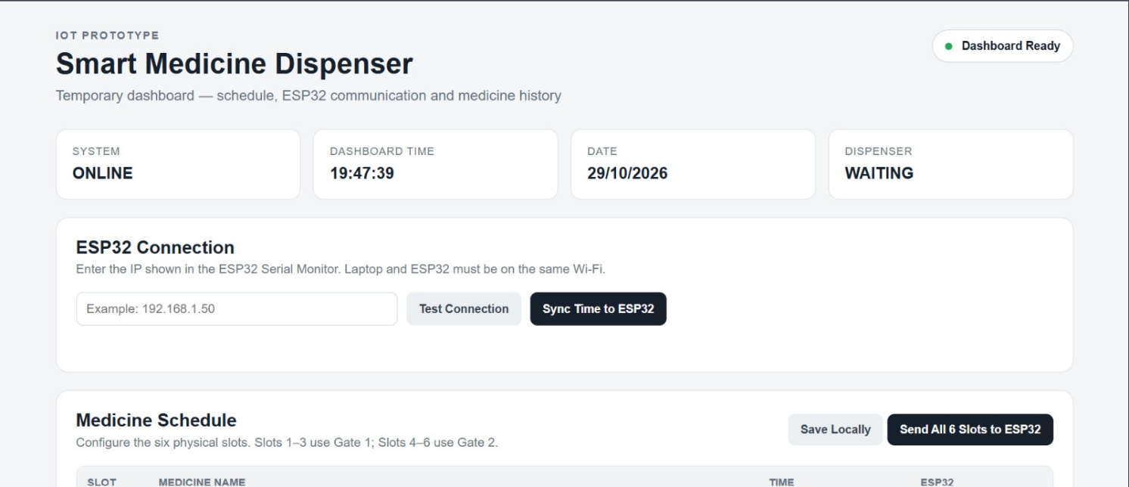
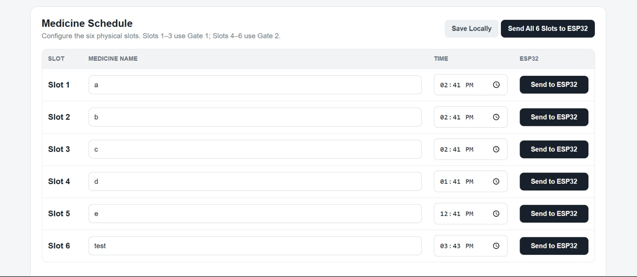

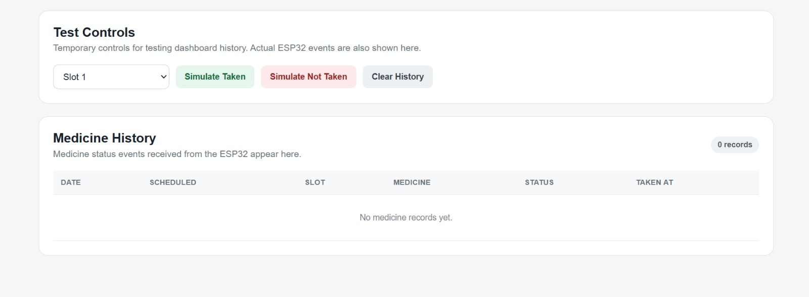

Table 5. Examples of system events and recommended responses
Detected pattern | Reason shown to the user | Recommendation
Detected event | Reason / status | Recommended action
Scheduled time reached | Medicine dose is due | Dispense selected slot and show reminder
No pickup detected within the configured interval | Dose may have been missed or delayed | Trigger reminder and notify authorised caregiver
Low-quality medical report image | OCR output may be unreliable | Request a clearer report and manual verification
Risk model flags elevated risk | Preliminary risk estimate only | Refer patient to a qualified healthcare professional

Table 6. Evaluation record (to be completed after testing)
Metric | Measurement / target | Status
Dispensing success rate | To be measured | Testing required
Pickup detection rate | To be measured | Testing required
OCR extraction quality | To be measured | Testing required
Precision / Recall / F1-score | To be measured | Validated dataset required
Response time | To be measured | Testing required
The values in Table 6 should be recorded after the dispenser, OCR module and disease-risk models have been implemented and tested. No performance figures are claimed here because the supplied presentation does not include measured results.

8. Discussion
Home healthcare: scheduled medicine reminders and dispensing for people managing chronic conditions.
Hospitals and clinics: support for reviewing authorised prescriptions, medical reports and adherence history.
Family and nursing care: remote monitoring of missed or unconfirmed doses for assigned patients.
Community healthcare: CHO access to permitted summaries of patient adherence and disease-risk trends.
Preventive healthcare: OCR-assisted organisation of medical report values and preliminary risk estimation.
- Population health management: centralised summaries for identifying follow-up needs, subject to privacy and governance rules.
- Integrated approach: combines medicine dispensing, reminders, OCR, AI prediction and monitoring in one platform.
- Automated schedule support: reduces reliance on remembering each medicine time manually.
- Pickup confirmation: adds an event indicating whether medicine collection was detected.
- Digital records: makes schedules, reports, adherence events and predictions searchable.
- Role-based access: supports different views for patients, doctors, nurses/family members and CHOs.
- Potential for early follow-up: risk summaries may help users identify when professional review is appropriate.

8.1 Applications
- Wi-Fi dependency: remote synchronisation and online notifications require connectivity, although local reminder behaviour should be designed to work safely offline.
- OCR dependency: extraction accuracy may vary with report quality, layout, scan angle and image resolution.
- AI model dependency: prediction quality depends on representative data, correct labels, appropriate features and external validation.
- Power requirement: the controller, display and servos require a suitable supply and a safe recovery strategy after power failure.

9. Conclusion and Future Work
The project proposes an integrated IoT, OCR and AI-based healthcare monitoring platform for people managing non-communicable diseases. The hardware concept uses an ESP32, RTC, an eight-slot rotating medicine carousel, two gate servos, pickup detection, an LCD, LEDs and a buzzer to support scheduled medicine dispensing and reminders. The software concept adds Tesseract-based medical-report text extraction, disease-risk estimation, a database, notifications and role-based dashboards for patients, doctors, nurses/family members and CHOs.

9.1 Future Work
- The combined design aims to improve visibility into medication adherence and make medical-report information easier to organise. However, the supplied presentation does not provide measured hardware reliability, OCR accuracy, trained-model performance or clinical validation. The project should therefore be considered a proposed prototype and decision-support concept until these components have been implemented and evaluated. Safe operation, data privacy, transparent reporting and clinician oversight are essential for any real healthcare use.
- Complete and validate the physical dispenser, including slot calibration, gate control and jam detection.
- Add robust handling of empty slots, missed doses, power interruption, duplicate schedules and offline operation.
- Create a labelled OCR test set and improve field extraction for the report formats expected in practice.
- Select suitable disease-specific datasets and evaluate models using documented splits and clinically relevant metrics.
- Add confidence indicators, input validation and human review for uncertain OCR values and predictions.
- Integrate a reliable notification service and measure delivery, retry and failure behaviour.
- Conduct usability testing with representative users and assess dashboard accessibility.

References
[1] Espressif Systems, “ESP32 Series Datasheet,” Espressif Systems, Technical Documentation, Version 5.3, 2026. [Online]. Available: https://documentation.espressif.com/esp32_datasheet_en.html. [Accessed: Oct. 30, 2026].
[2] Arduino, “Arduino IDE 2 Documentation: Getting Started, Installation, Board Configuration and Sketch Development,” Arduino Documentation. [Online]. Available: https://docs.arduino.cc/software/ide/. [Accessed: Oct. 30, 2026].
[3] Tesseract OCR, “Tesseract User Manual,” Tesseract OCR Documentation, Version 5.x. [Online]. Available: https://tesseract-ocr.github.io/tessdoc/. [Accessed: Oct. 30, 2026].
[4] World Health Organization (WHO), “Noncommunicable Diseases,” WHO Fact Sheet, Sept. 25, 2025. [Online]. Available: https://www.who.int/news-room/fact-sheets/detail/noncommunicable-diseases. [Accessed: Oct. 30, 2026].
[5] World Health Organization (WHO), “Medication Without Harm: Global Patient Safety Challenge,” WHO, launched Mar. 29, 2017. [Online]. Available: https://www.who.int/initiatives/medication-without-harm. [Accessed: Oct. 30, 2026].
[6] F. Pedregosa, G. Varoquaux, A. Gramfort, V. Michel, B. Thirion, O. Grisel, M. Blondel, P. Prettenhofer, R. Weiss, V. Dubourg, J. Vanderplas, A. Passos, D. Cournapeau, M. Brucher, M. Perrot, and É. Duchesnay, “Scikit-learn: Machine Learning in Python,” Journal of Machine Learning Research, vol. 12, no. 85, pp. 2825–2830, 2011. [Online]. Available: https://jmlr.org/papers/v12/pedregosa11a.html.
[7] TensorFlow, “TensorFlow Documentation: API Reference, Machine Learning Framework and Developer Guides,” Google. [Online]. Available: https://www.tensorflow.org/api_docs. [Accessed: Oct. 30, 2026].
[8] Sanjivani College of Engineering, “AI-Based Non-Communicable Disease Prediction and Smart Medicine Reminder System using IoT,” Project Presentation, 2026. [Internal academic project reference].

