 | Sanjivani Rural Education Society’s  SANJIVANI COLLEGE OF ENGINEERING  (An Autonomous Institution)  Kopargaon – 423 603, Maharashtra. | ACAD-F-15 K
Academic Year: 2026-27 | CIA ACTIVITY REPORT | Revision : 00
Department : | Computer Engineering | Date of Preparation :  10/10/2026
Course Code & Name: | PCCO302 : Computer Network | Year/Sem : TY/ 5th

Activity Title: Dynamic Error Detection and Correction for Reliable Data Transmission
Data sent through a communication network does not always arrive exactly as it was sent. Noise, electromagnetic interference and other disturbances in the channel can change one or more transmitted bits, so the receiver needs a mechanism to find out whether the data is corrupted and, where possible, to correct it. Well-known error-control techniques such as parity, checksum, Cyclic Redundancy Check (CRC) and Hamming code differ in their detection strength, correction ability and overhead, so no single technique is equally suitable for every requirement.
This report presents the study and proposed design of an academic prototype, an adaptive error-control framework, which selects a suitable technique from the error-handling requirement, encodes the data, passes it through a simulated noisy channel, and detects or corrects the error at the receiver. The prototype has not yet been implemented; all results discussed are expected behaviour, not measured data.

Submitted by:
Group Id- [TO BE PROVIDED]
Roll No. | PRN No | Name of the Student | Signature
56 | 0124UCSM1056 | Kandalkar Atharva Prabhakar
62 | 0124UCSM1062 | Dabhade Aditya Ramesh
64 | 0124UCSM1064 | Sambare Rohit Nanasaheb
67 | 0124UCSM1067 | Nere Tejas Vikas

Dr. P. N. Kalavadekar
Course Incharge

INDEX
Sr. No. | Topic | Pg. No.
1 | Abstract | 3
2 | Problem Definition | 4
3 | Introduction | 7
4 | System Architecture and Design | 11
5 | Methodology / Algorithms | 18
6 | Proposed Implementation Details | 25
7 | Proposed Experimental Setup and Expected Results | 28
8 | Advantages, Limitations and Applications | 31
9 | Conclusion | 33
10 | Future Scope | 34
11 | References | 35
12 | Annexures | 36

List of Figures: Figure 1 Types of transmission errors: (a) single-bit error and (b) burst error; Figure 2 Proposed adaptive error-control system architecture; Figure 3 Proposed module-level block diagram; Figure 4 Prototype decision logic flowchart; Figure 5 Proposed frame formats of the four techniques; Figure 6 Proposed data flow for Scenario A (Hamming code); Figure 7 Hamming (7,4) bit positions and parity coverage; Figure 8 Hamming code worked example: detection and correction of a single-bit error; Figure 9 Proposed methodology flowchart.
List of Tables: Table 1 Limitations of a fixed single error-control technique; Table 2 Comparison of Parity, Checksum, CRC and Hamming code; Table 3 Proposed system modules; Table 4 Proposed inputs of the prototype; Table 5 Prototype decision rules; Table 6 Proposed software and tools; Table 7 Parity worked example; Table 8 Checksum worked example; Table 9 CRC division steps; Table 10 Number of Hamming parity bits required; Table 11 Hamming parity-bit calculation (even parity); Table 12 Syndrome values and error positions; Table 13 Proposed software functions; Table 14 Redundancy added by each technique (design values); Table 15 Planned test cases and expected results; Table 16 Observation sheet (to be completed after implementation); Table 17 Advantages and associated conditions; Table 18 Potential relevance of error control and adaptive selection.

Project status: Every chapter of this report that discusses working, implementation or results describes a proposed design and expected behaviour. No program has been written or run, and no experimental data has been collected at the time of writing. Examples are worked out by hand from the definitions of the techniques.

CHAPTER 1
ABSTRACT
Data communication networks carry information as sequences of bits over physical channels such as copper cables, optical fibres and wireless links. These channels are never perfect. Thermal noise, impulse noise, crosstalk, electromagnetic interference and signal fading can change one or more bits of a transmitted frame, so that the data received differs from the data sent. For example, the byte 10110110 may arrive as 10100110, with a single bit changed. To obtain reliable data transmission, the receiver must be able to find out whether the received data is corrupted and, where the technique permits, to correct the error.
Computer networks use several error-control techniques for this purpose. Parity provides basic error detection, checksum verifies the integrity of a block of data, Cyclic Redundancy Check (CRC) provides strong error detection and is well suited to detecting burst errors, and Hamming code can detect and correct a single-bit error. These techniques differ in the redundancy they add, the errors they can detect and whether they can correct errors, so no single technique is equally suitable for every error type or reliability requirement.
This report presents the study and the proposed design of an academic prototype named the adaptive error-control framework. The system accepts the data and an error-handling requirement, analyses the requirement in an Adaptive Decision Module, and selects Parity, Checksum, CRC or Hamming code according to predefined demonstration rules. The sender generates the corresponding error-control information, the encoded data is passed through a simulated communication channel that can introduce a single-bit or burst error, and the receiver performs the matching detection or correction procedure. The system then reports the selected technique, the encoded and received data, the error status, the error position where applicable and the corrected data where the technique supports correction. The proposed innovation is this adaptive decision framework; it is not a new error-correction algorithm, and the decision rules are demonstration rules, not an industry standard.
The report describes the problem, the background, the proposed architecture, the methodology and algorithms with worked examples, the proposed C++ console implementation, a planned test set and the expected behaviour. The prototype has not yet been implemented, and no experimental measurements have been obtained; every statement about operation in this report describes intended or expected behaviour, not an achieved result. The expected advantages include support for several techniques in one framework, a clear view of the difference between detection and correction, and a modular design that is easy to extend. The main limitations are the predefined decision rules, the single-bit correction limit of the standard Hamming code, and the fact that the system is a simulation and not a production protocol.
Keywords: Error Detection, Error Correction, Parity, Checksum, Cyclic Redundancy Check, Hamming Code, Adaptive Error Control, Reliable Data Transmission, Computer Networks, Proposed Prototype.

CHAPTER 2
PROBLEM DEFINITION

2.1 Problem Statement
Modern communication systems transmit many kinds of data: text, sensor readings, control messages, files and streaming media. Every transmission passes through a channel that is affected by noise, electromagnetic interference, signal disturbances and other imperfections. As a result, bits may be altered on the way. Consider the following example:
Original data : 10110110
Received data : 10100110 (the 4th bit has changed from 1 to 0)

The receiver cannot know from the data alone that something has gone wrong. It needs extra, redundant information that was added by the sender, and a rule for checking it. Several techniques exist for this purpose, but they are not interchangeable. A simple parity bit is cheap but weak, a checksum verifies a block of data, a CRC detects many more error patterns including burst errors but cannot correct them, and Hamming code can correct a single-bit error at the cost of more redundant bits. A single error-control technique is therefore not equally suitable for every type of error or every application requirement, and using one fixed technique for every transmission scenario may be inefficient or inappropriate.
The problem addressed by this project is to design a prototype that analyses the error-handling requirement of a transmission and dynamically selects a suitable error detection or correction technique, and that demonstrates the complete process of encoding, transmission through a noisy channel, detection and, where supported, correction. The work is presented as an academic prototype that shows how different error-control mechanisms can be chosen according to the requirement. It is not claimed to replace the error-control mechanisms of any existing communication protocol.

2.2 Existing Approach to Error Control
In practice, error control is built into the protocols and the hardware of a communication system, and the mechanism is normally chosen when the protocol is designed. For example, an Ethernet frame carries a 32-bit CRC field, the Frame Check Sequence, that the receiver uses to detect corrupted frames [8]; the IPv4, TCP and UDP headers use the Internet checksum, which is a 16-bit one’s complement sum [7]; simple serial links can use a single parity bit; and memory systems with error-correcting code use Hamming-based codes that correct single-bit errors. Wireless and satellite links commonly combine detection codes with more powerful forward error correction codes [3][10]. Where only detection is available, a corrupted frame is normally recovered by retransmission.
These mechanisms are mature, optimised for their protocol and widely tested. The limitations discussed below do not make them unsuitable. They only explain why, for learning and demonstration, it is useful to have one framework in which the requirement is an input and the choice of technique becomes visible.

2.3 Limitations of the Conventional Approach
The points that motivate the proposed framework are summarised in Table 1. The last column shows how the proposed prototype relates to each point, without implying that it is better than the protocol-specific mechanisms used in real systems.
Table 1: Limitations of a fixed single error-control technique
Limitation | Description | Relevance to the proposed framework
Selection fixed in advance | The mechanism is usually predefined by the protocol or application, so it is not obvious how a different requirement would change the choice. | The requirement is an input, and the decision module shows which technique it selects.
Detection without correction | Parity, checksum and CRC only detect errors. Recovery needs retransmission or a separate correction code. | The framework shows clearly which techniques can only detect and which can also correct.
Limits of each detection method | Parity misses any even number of bit flips. A checksum can miss errors that cancel out. A short CRC cannot guarantee detection of every long burst. | Planned test cases include these limiting cases so that the limits can be observed.
Limited correction capability | Standard Hamming code corrects only a single-bit error and may mis-correct multiple-bit errors. | The prototype reports the single-bit limit and includes a two-bit error test.
Strength versus overhead | Stronger protection needs more redundant bits, which increases the frame size. | The redundancy added by each technique is tabulated for comparison (Chapter 7).
Techniques studied separately | Textbooks usually treat each technique in a separate section, which makes direct comparison harder. | All four techniques are demonstrated in one framework with the same input and output format.

2.4 Objectives
- To study the causes and types of transmission errors, namely single-bit and burst errors.
- To study Parity, Checksum, CRC and Hamming code and to compare their detection and correction capability.
- To understand why a single error-control technique is not suitable for every requirement.
- To define simple prototype decision rules that map an error-handling requirement to a technique.
- To design an adaptive error-control framework consisting of an input module, decision module, encoder, channel simulator, receiver and output module.
- To plan a simulated noisy channel that can introduce a single-bit or a burst error.
- To design the receiver procedures that detect errors and, with Hamming code, locate and correct a single-bit error.
- To plan test cases and expected observations for the future evaluation of the prototype.
- To identify the advantages, limitations, real-world relevance and future scope of the framework.

2.5 Scope
The scope of this report is the study and proposed design of a console-based simulation of adaptive error control. Within this scope the report covers: the causes and types of transmission errors; the four error-control techniques named above; a proposed system architecture and set of modules; prototype decision rules; the algorithms and worked examples for each technique; a proposed C++ implementation plan; a plan for testing the prototype in future; and the advantages, limitations and relevance of the approach.
The following are outside the scope of the present work: implementation of the prototype and collection of any experimental data; integration with a real network or protocol stack; hardware or IoT implementation; retransmission protocols such as ARQ; more powerful correction codes such as BCH, Reed-Solomon or LDPC; automatic selection based on measured channel quality or machine learning; and performance benchmarking. Some of these are noted as future work in Chapter 10. The decision rules named in this report are demonstration rules and have not been validated against any industrial practice.

CHAPTER 3
INTRODUCTION

3.1 Reliable Data Transmission
A data communication system moves information from a sender to a receiver through a transmission medium. The information is represented as bits, grouped into frames or packets, and converted into signals suitable for the medium. Reliable data transmission means that the data delivered to the receiving application is identical to the data sent, or that the receiver at least knows when it is not. Error control is a major part of this task and is a function of the data link layer in the layered network model; transport and application protocols may add their own checks [1][2].

3.2 Transmission Errors and their Causes
A real channel changes the signal during transmission, so that the receiver may interpret a 1 as a 0 or the reverse. The common causes are:
- Thermal noise: random motion of electrons in conductors and electronic components.
- Impulse noise: short bursts of high energy, for example from switching of electrical equipment or lightning. Because it lasts for a number of bit periods, it is a common cause of burst errors [1].
- Electromagnetic interference: unwanted signals from motors, power lines and other radio emitters.
- Crosstalk: coupling between neighbouring wires or channels.
- Attenuation and distortion: weakening and shaping of the signal along the medium, which makes bits harder to distinguish.
- Fading and multipath (wireless links): variation of the received signal strength because of reflections and movement.
The theoretical basis for reliable communication over a noisy channel was established by Shannon [6], who showed that it is possible, with suitable coding, to communicate reliably over a noisy channel at rates up to the channel capacity. Error-control codes, which add structured redundancy to the data, are the practical tools for this purpose.

3.3 Types of Errors
Two types of error are important for this project (Figure 1).
- Single-bit error: only one bit of the data unit changes. In the example 10110110 → 10100110 only the 4th bit is different.
- Burst error: two or more bits of the data unit change within a short span. The burst length is measured from the first corrupted bit to the last corrupted bit. In the example 101100111001 → 101011000001, bits 4 to 9 are different, so the burst length is 6. Burst errors are common when the disturbance lasts longer than one bit period.
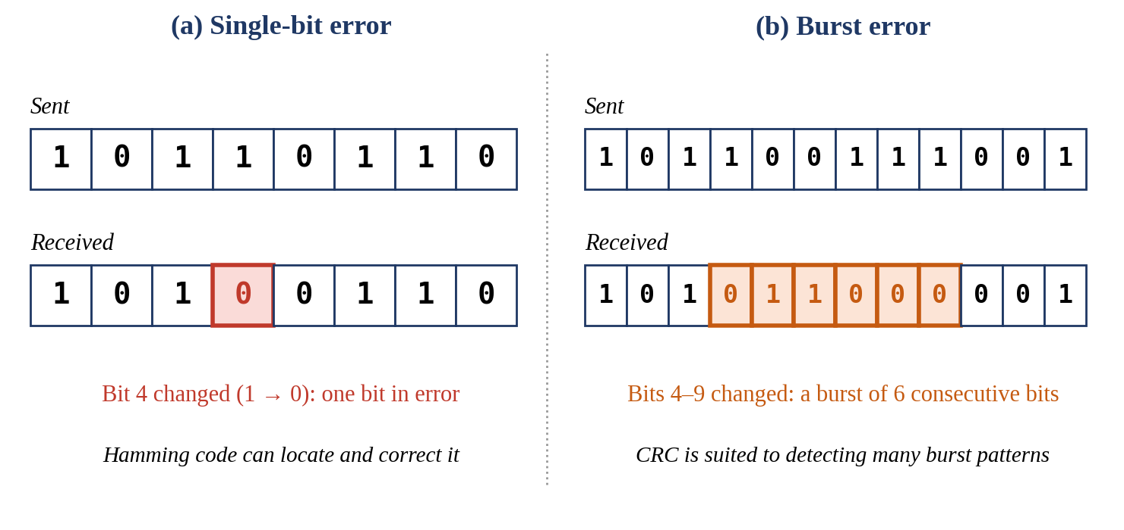
Figure 1: Types of transmission errors: (a) single-bit error and (b) burst error

3.4 Error Detection and Error Correction
All error-control techniques work by adding redundant bits to the data. A data unit of k bits is converted into a codeword of n = k + r bits, where r is the number of redundant bits. Only some of the possible n-bit patterns are valid codewords. If the received pattern is not a valid codeword, an error is detected. If the code is designed so that the received pattern is close to exactly one valid codeword, the receiver can also correct the error by choosing that codeword. The minimum Hamming distance d between valid codewords measures this ability: a code can detect up to d − 1 bit errors and correct up to ⌊(d − 1)/2⌋ bit errors [1][10]. A single even-parity bit gives d = 2, so it detects but cannot correct; the Hamming (7,4) code gives d = 3, so it can correct one bit error.
Two approaches are used when an error is found. In forward error correction, the receiver corrects the error itself using the redundancy. In error detection with retransmission, the receiver only detects the error and asks the sender to send the data again. The prototype proposed in this report demonstrates detection and correction at the receiver; it does not implement retransmission.

3.5 Overview of the Techniques

3.5.1 Parity
A parity bit is appended so that the total number of 1s in the data unit is even (even parity) or odd (odd parity). The receiver counts the 1s. Any odd number of bit errors makes the count wrong and is detected, but an even number of errors is not detected and the position of the error cannot be found. Parity gives basic error detection at the lowest overhead.

3.5.2 Checksum
The data is divided into blocks of equal size, the blocks are added using one’s complement arithmetic, and the complement of the sum is sent as the checksum. The receiver adds all blocks including the checksum, and the result should consist of all 1s if there is no error. The Internet checksum [7] is based on this idea. A checksum provides block-level integrity verification; it detects most errors but some combinations of errors can cancel out.

3.5.3 Cyclic Redundancy Check (CRC)
The data is treated as a polynomial over the field of two elements and is divided, using modulo-2 arithmetic, by an agreed generator polynomial. The remainder is appended to the data. The receiver repeats the division and expects a zero remainder. With a suitably chosen generator, a CRC with an r-bit remainder detects all burst errors of length up to r bits and a very large fraction of longer bursts [1][2][9]. A CRC provides strong error detection but cannot correct errors by itself.

3.5.4 Hamming Code
Hamming code [5] places several parity bits at positions that are powers of two (1, 2, 4, …) and data bits in the remaining positions. Each parity bit covers a different set of positions. At the receiver the same checks give a number called the syndrome, which is zero when no error is found and otherwise equals the position of a single erroneous bit. Hamming code therefore provides single-bit error detection and correction. The standard code does not reliably handle multiple-bit errors.
Table 2: Comparison of Parity, Checksum, CRC and Hamming code
Parameter | Parity | Checksum | CRC | Hamming code
Main purpose | Basic error detection | Block-level integrity check | Strong error detection | Single-bit detection and correction
Corrects errors? | No | No | No | Yes, single-bit only
Redundant bits | 1 bit per data unit | One checksum word (for example 8 or 16 bits) | r bits (4 in the example, 16 or 32 in practice) | r bits, where 2^r ≥ m + r + 1
Single-bit error | Detected | Detected | Detected | Detected and corrected
Two-bit errors | Not detected (even number of flips) | Usually detected; not guaranteed | Detected by a suitably chosen generator | Not reliable; may be wrongly corrected
Burst errors | Odd number of flips detected, even number missed | Many detected; some patterns can cancel | Bursts up to r bits always detected; most longer ones detected | Not designed for burst errors
Error location | Not available | Not available | Not available | Given by the syndrome (single-bit)
Computation | Very low | Low (addition) | Moderate (modulo-2 division) | Moderate (several parity checks)

3.6 Real-World Relevance
The project is not only a coding exercise. Errors caused by noise occur in many real communication settings, and designers must decide how data will be protected. Illustrative contexts include:
- Wireless communication: fading and interference can corrupt received bits.
- Industrial sensor networks: electrical noise near motors and switching equipment can disturb sensor data.
- IoT communication: small, low-power devices exchange short packets over imperfect links, and the redundancy that can be afforded is limited.
- Satellite communication: long links are exposed to noise and signal disturbances.
- Embedded communication systems and networked monitoring systems: controllers and monitoring nodes exchange data over buses and links that are affected by interference.
- Critical digital communication: where corrupted data can have serious consequences, the reliability requirement is higher.
In each of these contexts the actual error-control mechanism is determined by the protocol and the application constraints. The project demonstrates, in a simplified form, how an error-control layer can make communication more reliable by choosing a mechanism that is appropriate to the error-handling requirement. It does not claim that any of these industries uses the proposed algorithm.

3.7 Need and Motivation
The need for the proposed work arises from the fact that the error-control techniques are normally studied one at a time, while their suitability depends on the requirement. A learner who wants to see why CRC is preferred for burst-error detection, or why a Hamming code is needed when correction is required, has to compare several separate programs. A single framework that takes the requirement as input, selects a technique, and shows encoding, corruption, detection and correction in the same output format makes these differences visible. For students, such a simulation is also a practical way to learn bit-level operations, modulo-2 arithmetic and parity-based reasoning using only basic C++ constructs.

CHAPTER 4
SYSTEM ARCHITECTURE AND DESIGN
This chapter describes the proposed architecture of the adaptive error-control prototype. The intended processing path is:
User / Application Input → Requirement Analysis → Adaptive Decision Module → Selected Technique → Encoding → Simulated Channel (possible error) → Receiver → Detection / Correction → Final Result

4.1 Proposed System Architecture
The architecture has a sender side, a simulated channel and a receiver side (Figure 2). The user or application supplies the data and the requirement. The requirement is analysed and the Adaptive Decision Module selects one of four techniques. The selected encoder generates the error-control information, and the encoded data is sent through the simulated channel, which may corrupt it. The receiver decodes the data with the matching procedure and reports the error status or the corrected data. The same functions are divided into seven modules, listed in Table 3 and shown in Figure 3, so that a technique can later be added or replaced without redesigning the rest of the system.
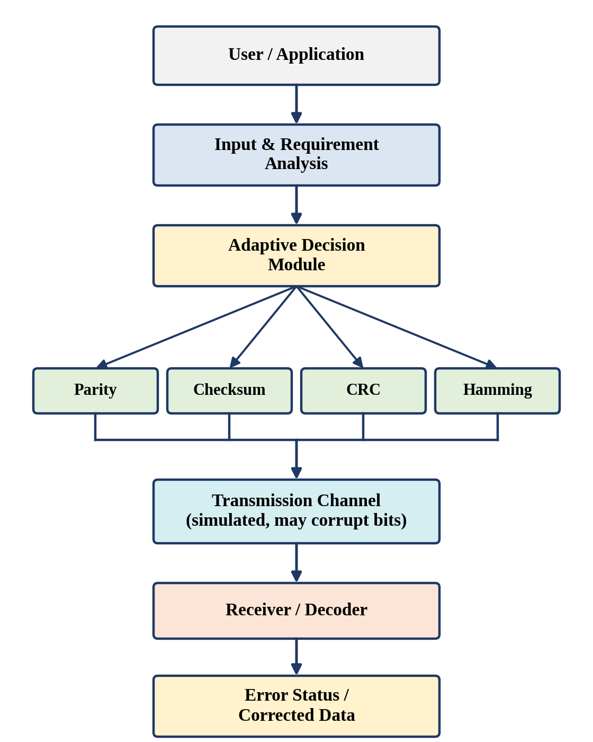
Figure 2: Proposed adaptive error-control system architecture (conceptual design; no prototype has been built)
Table 3: Proposed system modules
No. | Module | Function | Proposed realisation
1 | Input Module | Accepts the data and the transmission / error-handling requirement. | Console input of a binary string and a requirement code.
2 | Adaptive Decision Module | Determines the appropriate error-control technique for the requirement. | Conditional (if / else) rules in a selection function.
3 | Encoder | Generates parity, checksum, CRC or Hamming information. | One encoding function per technique.
4 | Channel Simulator | Simulates transmission and optional bit corruption. | Function that flips chosen bit positions.
5 | Receiver / Decoder | Checks the received data using the selected technique. | One checking function per technique.
6 | Error Analyzer | Determines whether an error exists and whether it can be corrected. | Result structure: error flag, position, correctable flag.
7 | Output Module | Displays the technique, error status, error position and corrected data. | Formatted console output.

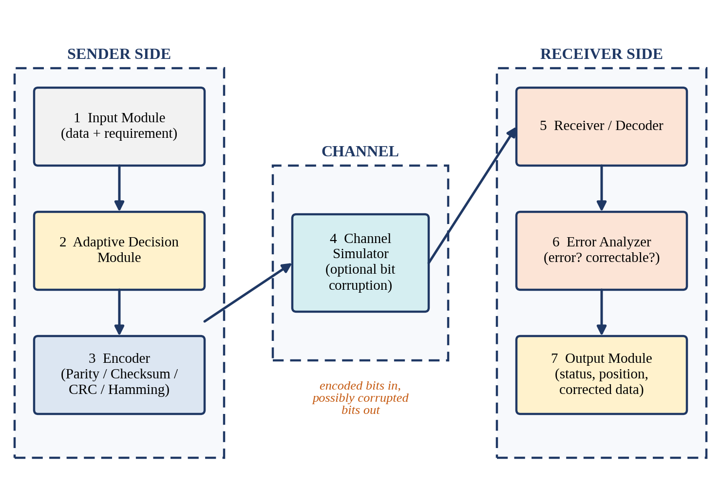
Figure 3: Proposed module-level block diagram

4.2 Input Module
The input module collects the information required for one transmission (Table 4). Input is validated before use: the data must be a non-empty string of 0s and 1s, the requirement code must be one of the defined values, and error positions must lie inside the encoded data.
Table 4: Proposed inputs of the prototype
Input | Description | Example
Data bits | Binary message to be transmitted. | 1011
Requirement code | 1 – basic error detection; 2 – data integrity verification; 3 – strong / burst-error detection; 4 – single-bit error correction. | 4 (single-bit correction)
Error option | 0 – no error; 1 – single-bit error at a given position; 2 – burst error with a start position and length. | 1, position 5
Fixed technique parameters | Even parity; 8-bit one’s complement checksum; CRC generator 10011 (x^4 + x + 1); Hamming code with even parity. | Defined in the program

4.3 Adaptive Decision Module
The decision module is the part of the design that is specific to this project. It maps the requirement to a technique using the rules in Table 5 and Figure 4. The rules are checked in the order of priority shown: correction is considered first, then strong detection, then block integrity, and finally basic detection. These are prototype decision rules written for demonstration. They are not a universal rule for real networks, where the choice also depends on latency, bandwidth, hardware, the protocol in use and the characteristics of the channel.
Table 5: Prototype decision rules
Priority | Requirement | Selected technique | Purpose | Capability
1 | Single-bit error correction | Hamming code | Detection and correction | Detects and corrects one bit
2 | Strong / burst-error detection | CRC | Robust detection | Detects only
3 | Data integrity verification | Checksum | Block-level checking | Detects only
4 | Basic error detection | Parity | Simple detection | Detects only

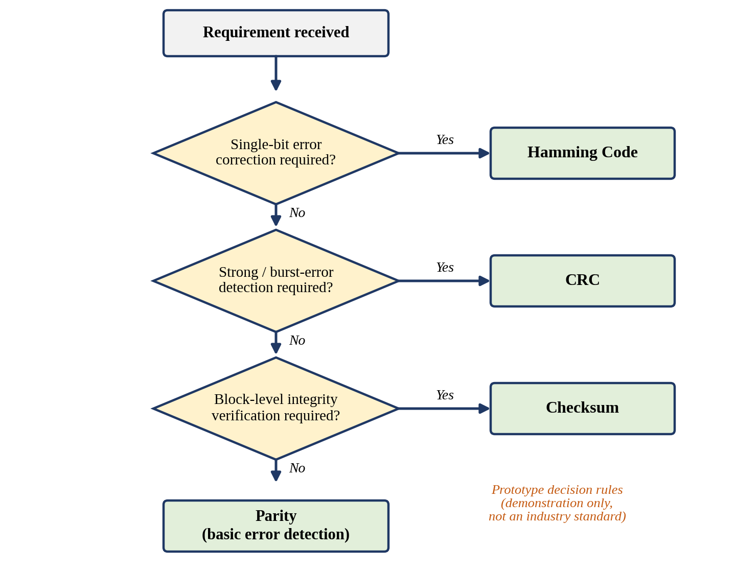
Figure 4: Prototype decision logic flowchart
Because the rules are kept in a single selection function, they can be edited without changing the encoders and decoders, which is the basis of the extensibility claimed in Chapter 8.

4.4 Encoder
The encoder generates the error-control information for the selected technique. The structure of the encoded data for each technique is shown in Figure 5. Parity appends one bit to the data. Checksum appends one checksum word after the data blocks. CRC appends the r-bit remainder of the modulo-2 division. Hamming code interleaves parity bits with the data bits at positions 1, 2, 4, …
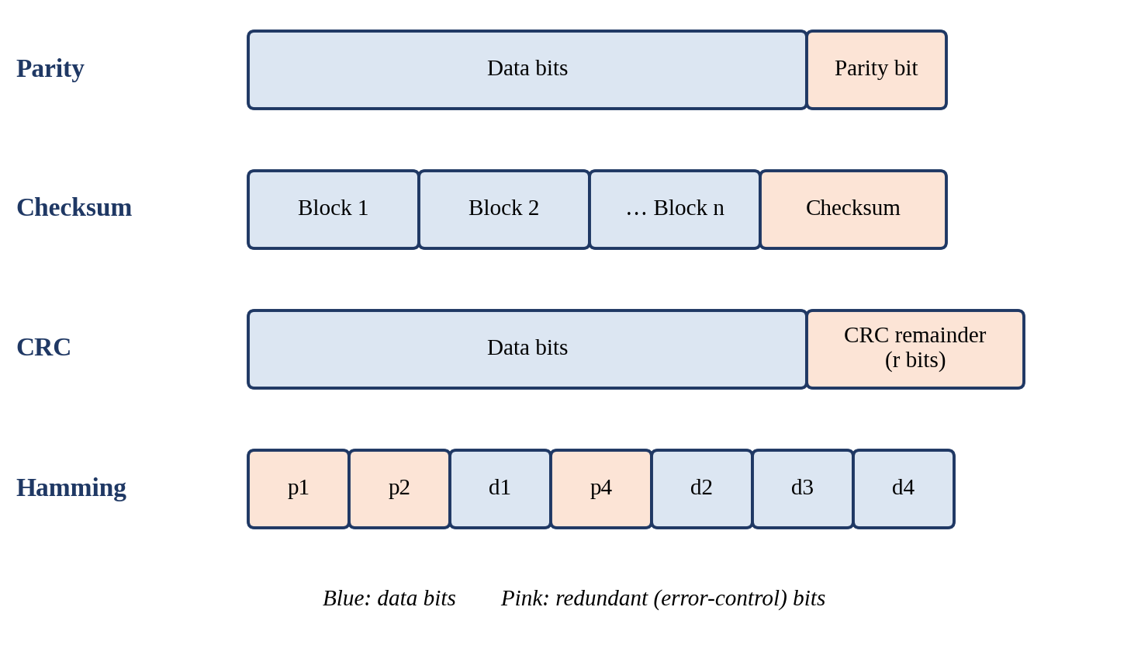
Figure 5: Proposed frame formats of the four techniques

4.5 Communication Channel Simulator
The simulator receives the encoded bits and returns the bits that reach the receiver. It does not model a physical channel. Instead it applies the error option chosen by the user: no change, a flip of the bit at a given position (single-bit error), or a flip of a run of consecutive bits (burst error). Because the error is specified by the user, every test can be repeated exactly, which is useful for demonstration and for comparing techniques on the same error. Random errors based on a bit error rate are listed as future work.

4.6 Receiver / Decoder and Error Analyzer
The receiver applies the checking procedure of the selected technique: it counts the 1s for parity, recomputes and compares the checksum, divides by the generator for CRC, and computes the syndrome for Hamming code. The error analyzer turns this outcome into a result: whether an error exists, whether it can be located, and whether it can be corrected. Only Hamming code can locate and correct the error; for Parity, Checksum and CRC the result is limited to “error detected” or “no error”.

4.7 Output Module
The output module displays, for each run: the input data, the requirement, the selected technique, the encoded data, the received data, the error status, the error position (if applicable) and the corrected data (if supported). Fields that do not apply to a technique are shown as “N/A”, which keeps the difference between detection and correction visible.

4.8 Data Flow
The form of the data at each stage is shown in Figure 6 for Scenario A (Hamming code). The input data 1011 becomes the 7-bit codeword 0110011, the channel flips bit 5, the receiver obtains 0110111, computes the syndrome 101 (equal to 5), flips bit 5 and recovers 0110011, from which the data 1011 is extracted. The figure illustrates the proposed operation and is not a recording from a working system.
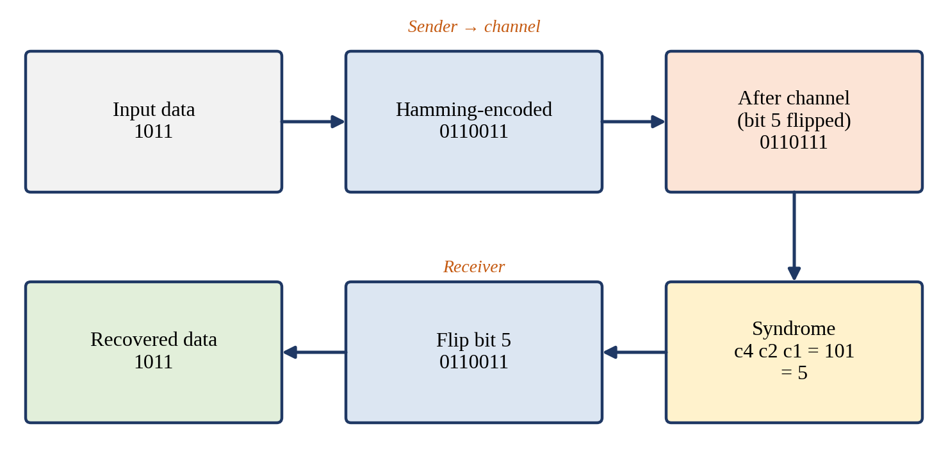
Figure 6: Proposed data flow for Scenario A (Hamming code)

4.9 Technology Stack
The implementation is kept deliberately simple. The proposed language is C++, using arrays or strings, loops, conditional statements, bit manipulation where required (for example the XOR operation) and simple mathematical calculation. No external framework or library beyond the standard library is planned. The prototype is planned as a console-based simulation. The tools are listed in Table 6; all are proposed and none has yet been used for this project.
Table 6: Proposed software and tools
Item | Purpose | Status
C++ compiler (for example g++) | Compiling and running the program | Proposed
Code editor or IDE (for example VS Code, Code::Blocks) | Writing and debugging the code | Proposed
Console / terminal | Entering input and viewing the output | Proposed
Spreadsheet | Tabulating observations after testing | Optional
Git / GitHub | Version control and code upload (Annexure 1) | Optional

CHAPTER 5
METHODOLOGY / ALGORITHMS

5.1 Proposed Methodology
The proposed working of the system proceeds through the following steps:
- Enter the data. The user enters the binary data to be transmitted.
- Specify the requirement. The user or application specifies the error-handling requirement.
- Analyse the requirement. The system validates the input and analyses the requirement.
- Select the technique. The adaptive decision module selects Parity, Checksum, CRC or Hamming code using the prototype rules.
- Generate error-control information. The sender computes the parity bit, checksum, CRC remainder or Hamming parity bits.
- Transmit. The encoded data is sent through the simulated channel.
- Introduce a simulated error. The channel simulator may flip one or more bits according to the chosen error option.
- Receive. The receiver obtains the (possibly corrupted) data.
- Check. The receiver performs the detection or correction procedure of the selected technique.
- Report. The system reports no error, or error detected, and where supported the error position and the corrected data.

5.2 Proposed Algorithm for Adaptive Selection
The proposed pseudocode of the main routine and of the decision rules is given below. It describes the intended logic and has not yet been coded, run or tested.
Algorithm 1: Proposed adaptive selection and transmission
Algorithm ADAPTIVE_TRANSMIT(data, requirement, errorOption)
validate(data, requirement, errorOption)
if requirement == SINGLE_BIT_CORRECTION : technique <- HAMMING
else if requirement == BURST_DETECTION : technique <- CRC
else if requirement == INTEGRITY_CHECK : technique <- CHECKSUM
else : technique <- PARITY
sent <- ENCODE(technique, data)
received <- CHANNEL(sent, errorOption) // may flip bits
result <- CHECK(technique, received)
if technique == HAMMING and result.error:
corrected <- flip bit result.position of received
DISPLAY(technique, sent, received, result, corrected)

5.3 Parity
Algorithm. Count the 1s in the data. For even parity, append 1 if the count is odd and 0 if it is even, so that the codeword always contains an even number of 1s. At the receiver, count the 1s in the codeword: an odd count means an error is detected; an even count means no error is detected.
Worked example. For the data 1011, which contains three 1s, the even-parity bit is 1 and the transmitted codeword is 10111 (Table 7).
Table 7: Parity worked example (even parity)
Case | Received bits | Number of 1s | Receiver decision
No error | 10111 | 4 (even) | Accepted: no error detected
Bit 2 flipped | 11111 | 5 (odd) | Error detected; position unknown
Bits 1 and 4 flipped | 00101 | 2 (even) | Not detected: even number of errors

The third row shows the limitation of parity: it cannot detect an even number of bit errors, and it never gives the position of an error.

5.4 Checksum
Algorithm. Divide the data into 8-bit blocks. Add the blocks using one’s complement arithmetic, that is, whenever the sum exceeds 8 bits the carry is added back to the least significant bit. The checksum is the complement of the final sum. The receiver adds all blocks including the checksum; if the result is 11111111 (the complement is zero), no error is detected.
Worked example. For the four 8-bit blocks of Table 8, the sum is 00101001 and the checksum is 11010110. The receiver’s sum of the five words is 11111111, so the data is accepted. If bit 6 of block 2 is flipped (01101110 becomes 01101010), the receiver’s sum becomes 11111011, which is not all 1s, and the error is detected.
Table 8: Checksum worked example (8-bit blocks)
Block | Value | Decimal | Running sum (with carry added back) | Running sum (binary)
Block 1 | 10110011 | 179 | 179 | 10110011
Block 2 | 01101110 | 110 | 289 → 34 (carry added back) | 00100010
Block 3 | 11001010 | 202 | 236 | 11101100
Block 4 | 00111100 | 60 | 296 → 41 (carry added back) | 00101001

Checksum of the final sum 00101001 = 11010110 (one’s complement).

5.5 Cyclic Redundancy Check (CRC)
Algorithm. Choose a generator of r + 1 bits. Append r zeros to the data, divide the result by the generator using modulo-2 (XOR) division, and append the r-bit remainder to the original data. The receiver divides the received bits by the same generator: a zero remainder means no error is detected, and a non-zero remainder means an error is detected.
Worked example. Let the data be 1101011011 and the generator be 10011 (x^4 + x + 1, so r = 4). The dividend is 11010110110000. The division steps are given in Table 9 and give the remainder 1110. The transmitted codeword is therefore 11010110111110. At the receiver, division of this codeword gives the remainder 0000.
Table 9: CRC division steps (data 1101011011, generator 10011)
Step | Starting bit | Window before XOR | Generator | Window after XOR
1 | 1 | 11010 | 10011 | 01001
2 | 2 | 10011 | 10011 | 00000
3 | 7 | 10110 | 10011 | 00101
4 | 9 | 10100 | 10011 | 00111

Remainder after all steps = 1110. Windows that start with 0 need no XOR and are skipped.
Burst-error detection. If a burst flips bits 4 to 7 of the codeword, the received bits are 11001000111110 and the receiver’s remainder is 0011, which is non-zero, so the error is detected. In general, a CRC with an r-bit remainder detects every burst of length up to r; a burst of length r + 1 escapes detection with probability 2^−(r−1), and longer bursts with probability 2^−r, assuming all error patterns are equally likely [1][2]. The 4-bit generator is used here only for hand calculation; practical CRCs such as CRC-16 and CRC-32 are longer and therefore detect a larger fraction of long bursts. A CRC cannot, by itself, correct an error.

5.6 Hamming Code
Hamming code is one component of the proposed system. It is selected by the decision module only when single-bit correction is required.

5.6.1 Number of parity bits
For m data bits, the number of parity bits r is the smallest integer that satisfies 2^r ≥ m + r + 1. The inequality counts the possible syndromes: r parity checks can describe 2^r different outcomes, which must cover “no error” and an error in any of the m + r bits. For m = 4, r = 2 gives 4 ≥ 7, which fails, and r = 3 gives 8 ≥ 8, which holds, so r = 3 and the codeword has 7 bits. Table 10 gives some other values.
Table 10: Number of Hamming parity bits required
Data bits m | Parity bits r | Check 2^r ≥ m + r + 1 | Total bits n | Code
4 | 3 | 8 ≥ 8 | 7 | (7,4)
8 | 4 | 16 ≥ 13 | 12 | (12,8)
11 | 4 | 16 ≥ 16 | 15 | (15,11)
16 | 5 | 32 ≥ 22 | 21 | (21,16)
64 | 7 | 128 ≥ 72 | 71 | (71,64)

5.6.2 Positions and parity coverage
The bit positions are numbered from 1. Parity bits occupy the positions that are powers of two (1, 2, 4), and the data bits occupy the remaining positions (3, 5, 6, 7). Parity bit p1 checks the positions whose binary number has the 1s bit set (1, 3, 5, 7), p2 checks those with the 2s bit set (2, 3, 6, 7), and p4 checks those with the 4s bit set (4, 5, 6, 7). Each parity bit is chosen so that the number of 1s in the positions it checks is even (Figure 7).
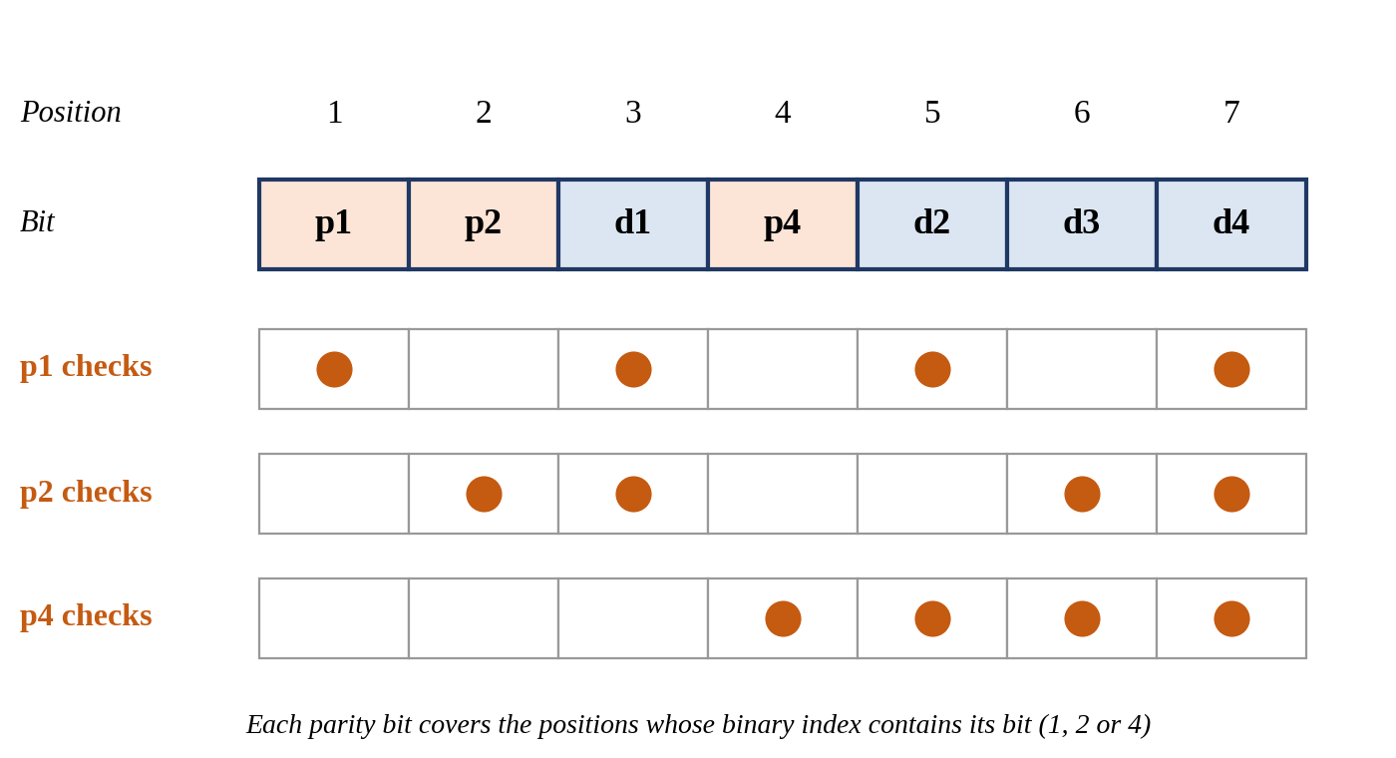
Figure 7: Hamming (7,4) bit positions and parity coverage

5.6.3 Encoding example
Let the data be 1011. The data bits are placed as d1 = 1 (position 3), d2 = 0 (position 5), d3 = 1 (position 6) and d4 = 1 (position 7). The parity bits are calculated as in Table 11, which gives the codeword 0110011 (positions 1 to 7).
Table 11: Hamming parity-bit calculation (even parity)
Parity bit | Positions checked | Data values at those positions | Calculation | Value
p1 | 1, 3, 5, 7 | 1, 0, 1 (positions 3, 5, 7) | 1 XOR 0 XOR 1 = 0 | 0
p2 | 2, 3, 6, 7 | 1, 1, 1 (positions 3, 6, 7) | 1 XOR 1 XOR 1 = 1 | 1
p4 | 4, 5, 6, 7 | 0, 1, 1 (positions 5, 6, 7) | 0 XOR 1 XOR 1 = 0 | 0

5.6.4 Detection and correction at the receiver
The receiver repeats the three parity checks over the received bits and forms the syndrome c4 c2 c1, where each check result is 0 if the number of 1s is even and 1 if it is odd. The syndrome, read as a binary number, is the position of the erroneous bit; a syndrome of 000 means that no error is detected (Table 12).
Table 12: Syndrome values and error positions
Syndrome (c4 c2 c1) | Binary value | Error position | Bit affected
000 | 0 | No error | –
001 | 1 | 1 | p1
010 | 2 | 2 | p2
011 | 3 | 3 | d1
100 | 4 | 4 | p4
101 | 5 | 5 | d2
110 | 6 | 6 | d3
111 | 7 | 7 | d4

Example. Suppose the channel flips bit 5, so that the received bits are 0110111. The checks give c1 (positions 1, 3, 5, 7) = 0 XOR 1 XOR 1 XOR 1 = 1, c2 (positions 2, 3, 6, 7) = 1 XOR 1 XOR 1 XOR 1 = 0, and c4 (positions 4, 5, 6, 7) = 0 XOR 1 XOR 1 XOR 1 = 1. The syndrome is 101₂ = 5₁₀, so the error is at position 5. The receiver flips bit 5 and obtains 0110011, and the data bits at positions 3, 5, 6 and 7 give the original data 1011 (Figure 8). If the error is in a parity bit, for example bit 4, the syndrome is 100₂ = 4 and the same procedure corrects it.
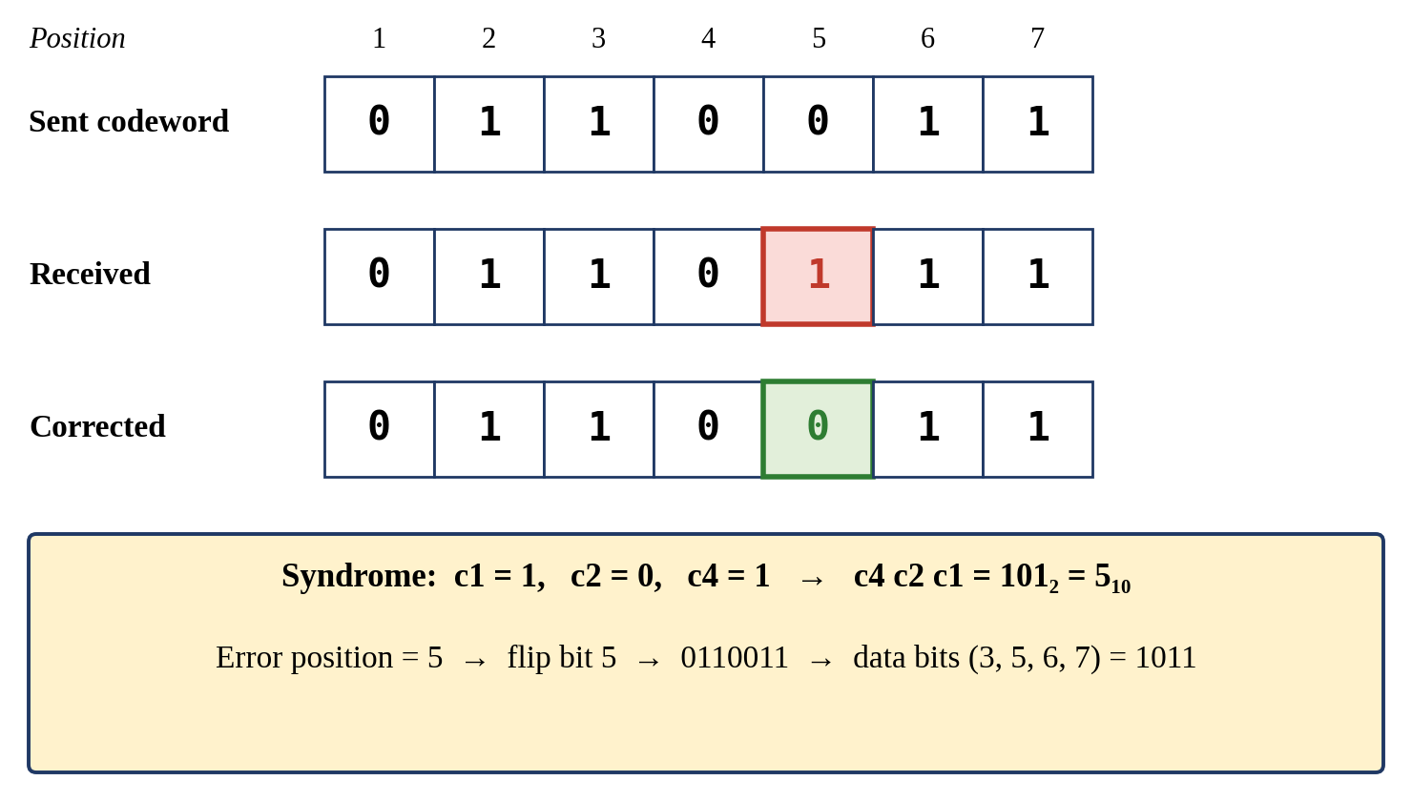
Figure 8: Hamming code worked example: detection and correction of a single-bit error

5.6.5 Limitation
The standard Hamming code assumes that at most one bit is in error. If two bits are in error, the syndrome is still non-zero but it points to a position that is generally wrong, and the receiver will “correct” the wrong bit. For example, if bits 3 and 5 of 0110011 are flipped, the received bits are 0100111, the syndrome is 110₂ = 6, and flipping bit 6 gives 0100101, which is not the original codeword. This is why the decision module selects Hamming code only when the requirement is single-bit correction, and why burst errors are better handled by detection with CRC.

5.7 Flowchart Description
The proposed flowchart (Figure 9) starts with the entry of the data and the requirement. After validation and requirement analysis, the adaptive decision module selects the technique and the encoder adds the error-control bits. The encoded data goes to the channel simulator, where a decision block checks whether a simulated error is requested; if yes, the selected bits are flipped. The receiver then applies the matching check. A second decision block asks whether an error is found: if not, “no error” is reported; if yes, Hamming code locates and corrects the bit, while the other techniques report that an error was detected. Finally the result is displayed.
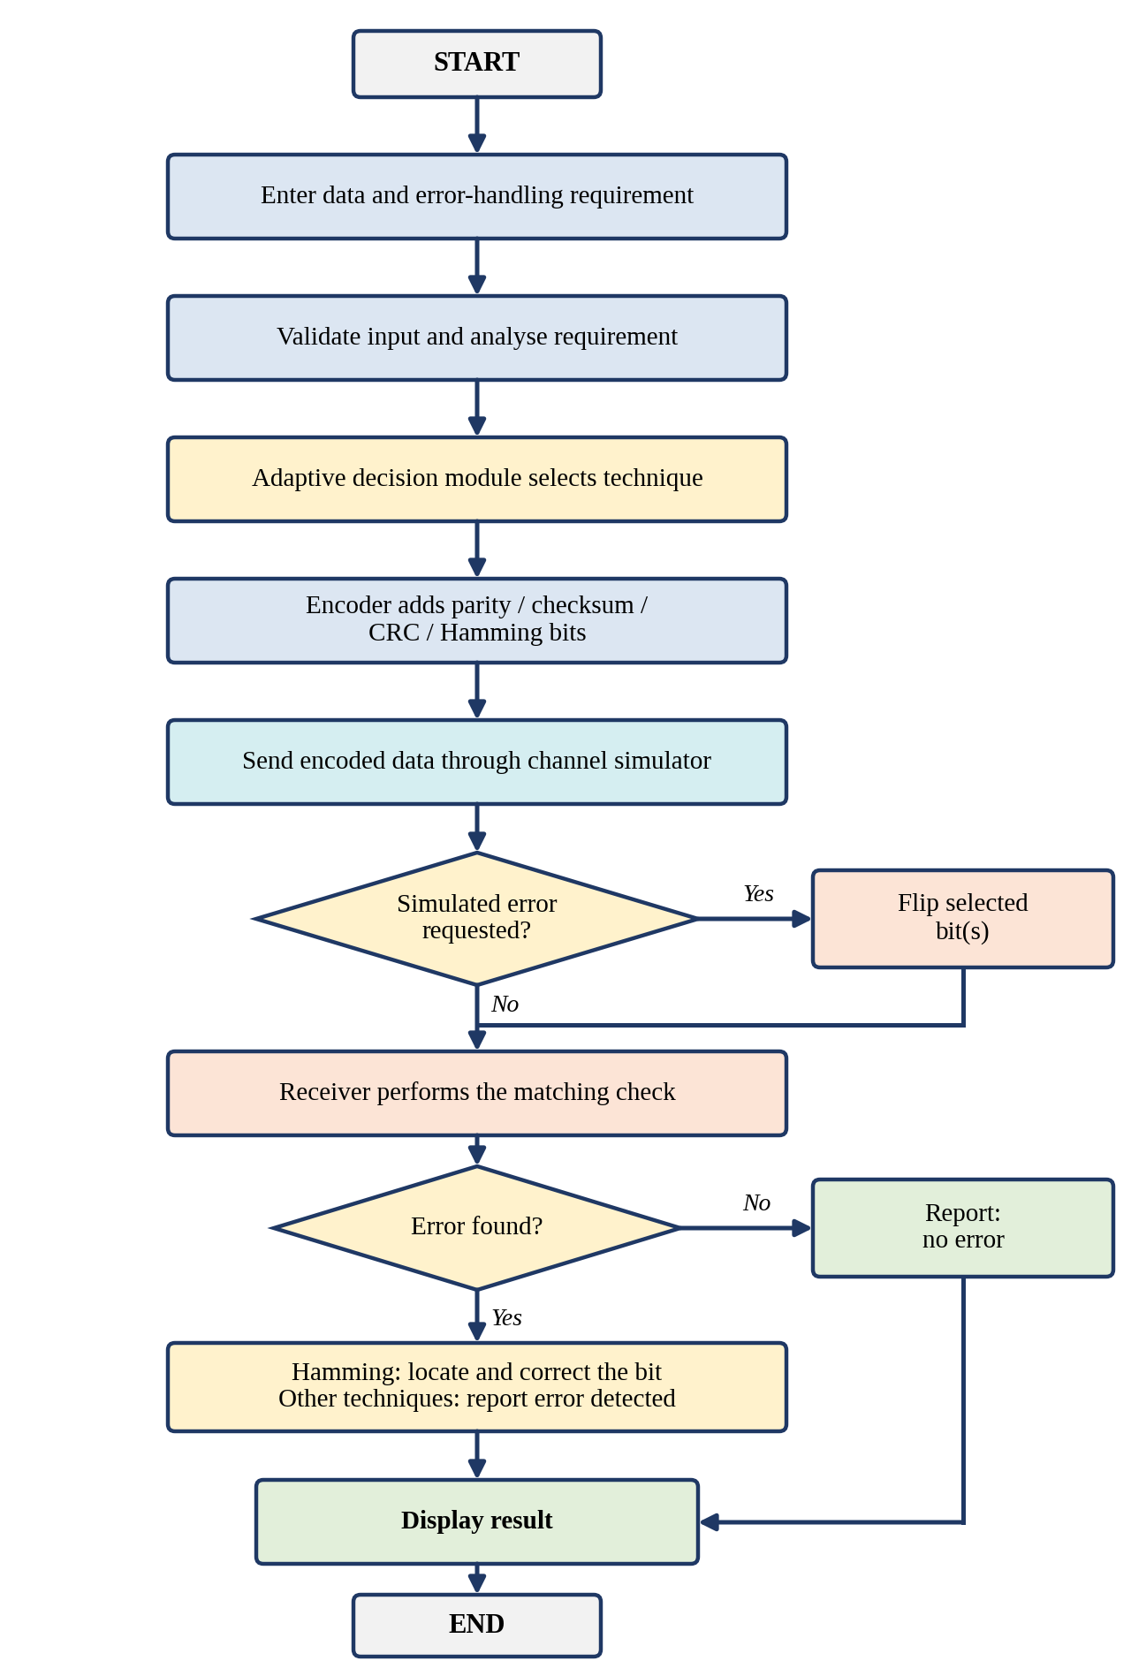
Figure 9: Proposed methodology flowchart

CHAPTER 6
PROPOSED IMPLEMENTATION DETAILS
Note: This chapter describes how the prototype is intended to be built and to operate. The program has not yet been written or run. The console outputs shown are illustrative examples worked out by hand from the algorithms of Chapter 5 and are not captured from a running program.

6.1 Proposed Implementation Environment
The prototype is proposed to be written in C++ as a single console program that can be compiled with any standard C++ compiler. Only the standard input/output and string facilities are needed. The program is divided into small functions so that each module of Chapter 4 corresponds to one or more functions.

6.2 Proposed Program Organisation
The functions of the proposed program are listed in Table 13.
Table 13: Proposed software functions
Function | Module | Intended role
main() | Input / Output | Reads inputs, calls the other functions in sequence and repeats on request.
readInput() | Input Module | Reads the data, requirement code and error option; validates them.
selectTechnique(req) | Adaptive Decision Module | Applies the decision rules and returns PARITY, CHECKSUM, CRC or HAMMING.
encodeParity(), encodeChecksum(), encodeCRC(), encodeHamming() | Encoder | Generate the codeword for the selected technique.
injectError(bits, option) | Channel Simulator | Flips the selected bit or bits and returns the received bits.
checkParity(), verifyChecksum(), verifyCRC(), decodeHamming() | Receiver / Decoder | Perform the check; decodeHamming() also returns the syndrome.
analyze(result) | Error Analyzer | Sets the error flag, error position and correctable flag.
displayResult() | Output Module | Prints the formatted result with N/A for fields that do not apply.

6.3 Data Representation
Binary data is held as a string or an array of characters/integers (0 and 1), which allows loops over individual bits and easy printing. The number of Hamming parity bits is found with a loop that increases r until 2^r ≥ m + r + 1 holds. Bit positions are counted from 1 to match the Hamming numbering. The parity, checksum and CRC calculations use the XOR operation and, for the checksum, simple integer addition with the carry added back.

6.4 Proposed Technique-wise Logic
- Parity: count the 1s and append the even-parity bit; the check counts the 1s of the received word.
- Checksum: split the data into 8-bit blocks (padding the last block with zeros), add with carry wrap-around, complement the result and append it; the receiver adds all blocks and tests for all 1s.
- CRC: append r zeros, perform XOR division by the generator 10011, and append the remainder; the receiver divides the whole codeword and tests for a zero remainder.
- Hamming code: place the data bits at the non-power-of-two positions, calculate each parity bit as the XOR of the positions it covers, and at the receiver compute the syndrome and flip the indicated position.

6.5 Expected Console Output
The prototype is intended to display the following items: input data, requirement, selected technique, encoded data, received data, error status, error position (if applicable) and corrected data (if supported). The illustrative outputs for the four scenarios of the project are shown below.
Scenario A: single-bit error and correction required (Hamming code)
Input Data : 1011
Requirement : Single-bit correction
Selected Technique : Hamming Code
Encoded Data : 0110011
Received Data : 0110111
Error Detected : YES
Error Position : 5
Corrected Data : 0110011

Scenario B: burst-error detection (CRC)
Input Data : 1101011011
Requirement : Strong / burst-error detection
Selected Technique : CRC (generator 10011)
Encoded Data : 11010110111110
Received Data : 11001000111110 (bits 4-7 flipped)
Error Detected : YES
Error Position : N/A
Corrected Data : N/A

Scenario C: basic error detection (Parity)
Input Data : 1011
Requirement : Basic error detection
Selected Technique : Parity (even)
Encoded Data : 10111
Received Data : 11111 (bit 2 flipped)
Error Detected : YES
Error Position : N/A
Corrected Data : N/A

Scenario D: data integrity verification (Checksum)
Input Data : 10110011 01101110 11001010 00111100
Requirement : Data integrity verification
Selected Technique : Checksum (8-bit blocks)
Encoded Data : ... 00111100 | 11010110
Received Data : block 2 received as 01101010
Receiver Sum : 11111011 (not all 1s)
Error Detected : YES
Error Position : N/A
Corrected Data : N/A

6.6 Design Precautions
- The input data will be checked to contain only 0 and 1 and to be non-empty; invalid input will be rejected with a message.
- Error positions and burst lengths will be checked against the length of the encoded data.
- The same parity convention (even parity) will be used throughout the program.
- The generator polynomial and the block size will be defined once, as constants.
- Fields that a technique cannot provide, such as the error position for parity, checksum and CRC, will be shown as N/A and not as a guessed value.
- The output will state that the decision rules are demonstration rules, so that the prototype is not mistaken for a production protocol.

CHAPTER 7
PROPOSED EXPERIMENTAL SETUP AND EXPECTED RESULTS
Important: This chapter describes how the prototype will eventually be tested. No test has been carried out. Every “expected” entry below is a prediction obtained by hand calculation from the definitions of the techniques; it is not a measured result. No performance percentages, accuracy figures or benchmarks are quoted.

7.1 Proposed Experimental Setup
The prototype is intended to be tested on an ordinary computer by compiling the C++ program and running it from a console. For each test the data, the requirement code and the error option are entered, and the displayed output is compared with the expected result. The error is always specified by the tester, so each test can be repeated exactly. A fixed set of test data is used: the data 1011 for Parity and Hamming code, the four 8-bit blocks of Table 8 for Checksum, and the data 1101011011 and 101100111001 for CRC.

7.2 Parameters to be Evaluated
- Correct technique selection: whether each requirement leads to the technique defined in Table 5.
- Error detection outcome: whether the error status matches the injected error.
- Error location: whether the reported position matches the injected position (Hamming code only).
- Correction success: whether the corrected data equals the original codeword.
- Behaviour at the limits: whether the limiting cases (even-number parity errors, two-bit Hamming errors) behave as predicted.
- Redundancy added: the number of redundant bits added by each technique, which can be counted directly (Table 14).
The redundancy added is a design property and not a performance measurement. The values in Table 14 follow from the definitions and from the parameters chosen in this report (one parity bit, one 8-bit checksum word, a 4-bit CRC remainder, and r Hamming parity bits from Table 10).
Table 14: Redundancy added by each technique (design values)
Data bits m | Parity | Checksum (8-bit word) | CRC (4-bit) | Hamming (r)
4 | 1 | 8 | 4 | 3
8 | 1 | 8 | 4 | 4
16 | 1 | 8 | 4 | 5
64 | 1 | 8 | 4 | 7

7.3 Planned Test Cases
Table 15 lists the planned test cases. The status of every test is “Planned”; the column of expected results is a prediction. Test cases 4, 7 and 11 deliberately examine limiting behaviour.
Table 15: Planned test cases and expected results
No. | Technique (requirement) | Data | Injected error | Expected result | Status
1 | Hamming (single-bit correction) | 1011 → 0110011 | None | No error; received data equals sent data | Planned
2 | Hamming | 1011 | Bit 5 flipped (0110111) | Error YES; position 5; corrected 0110011 | Planned
3 | Hamming | 1011 | Bit 4 flipped (0111011), a parity position | Error YES; position 4; corrected 0110011 | Planned
4 | Hamming | 1011 | Bits 3 and 5 flipped (0100111) | Syndrome 110₂ = 6, a wrong position; wrong correction (limitation) | Planned
5 | Parity (basic detection) | 1011 → 10111 | None | No error | Planned
6 | Parity | 1011 | Bit 2 flipped (11111) | Error detected; position not available | Planned
7 | Parity | 1011 | Bits 1 and 4 flipped (00101) | Not detected (even number of flips; limitation) | Planned
8 | Checksum (integrity) | Blocks of Table 8 | Block 2 altered: 01101110 → 01101010 | Error detected; receiver sum 11111011 is not all 1s | Planned
9 | CRC (burst detection) | 1101011011 → 11010110111110 | None | Remainder 0000; no error | Planned
10 | CRC | 1101011011 | Burst of 4 bits, positions 4–7 (11001000111110) | Remainder 0011; error detected | Planned
11 | CRC | 101100111001 → 1011001110010100 | Burst of 6 bits, positions 4–9 (1010110000010100) | Remainder 0010; error detected here, although a 4-bit CRC cannot guarantee this for every burst | Planned
12 | Any | Invalid data, for example 10a1 | – | Input rejected with an error message | Planned

7.4 Expected Observations
The following are expected observations, not measured results.
- Technique selection. Each of the four requirement codes is expected to select the technique given in Table 5.
- Hamming code corrects single-bit errors. For a single flipped bit in any of the 7 positions, the syndrome is expected to equal the position, and the corrected codeword is expected to match the transmitted one (test cases 2 and 3).
- Hamming code does not handle two-bit errors. A non-zero syndrome pointing to a wrong position is expected, producing a wrong correction (test case 4).
- Parity detects odd numbers of errors only. A single-bit error is expected to be detected and a two-bit error to pass undetected (test cases 6 and 7).
- Checksum detects the altered block. The receiver’s sum is expected to differ from all 1s (test case 8).
- CRC detects the burst. A non-zero remainder is expected for the bursts of test cases 10 and 11, and a zero remainder for the error-free codeword (test case 9).
- Detection-only techniques give no position and no correction. For Parity, Checksum and CRC the output is expected to show N/A for the error position and the corrected data.

7.5 Limitations of the Planned Evaluation
The channel simulator applies errors specified by the tester, so it does not model the statistics of a real channel such as random noise at a given bit error rate. The test data is short so that results can be checked by hand. Consequently, the planned tests can verify that the techniques and the decision rules work as designed, but they cannot predict how the techniques would perform on a real network. Measurements of detection accuracy and overhead over many random errors are listed as future work.

7.6 Reporting of Results
After implementation, observations will be recorded in a table such as Table 16. The table is intentionally left blank because no test has been performed.
Table 16: Observation sheet (to be completed after implementation)
Test | Technique | Sent bits | Received bits | Error status | Position | Remarks
1 | [To be recorded] | [To be recorded] | [To be recorded] | [To be recorded] | [To be recorded] | [To be recorded]
2 | [To be recorded] | [To be recorded] | [To be recorded] | [To be recorded] | [To be recorded] | [To be recorded]
3 | [To be recorded] | [To be recorded] | [To be recorded] | [To be recorded] | [To be recorded] | [To be recorded]

CHAPTER 8
ADVANTAGES, LIMITATIONS AND APPLICATIONS

8.1 Advantages
- Dynamic technique selection. The technique follows the requirement, not a fixed choice.
- Several techniques in one framework. Parity, Checksum, CRC and Hamming code use the same input and output format, which makes comparison easy.
- Detection and correction are both shown. The output makes the difference between detecting an error and correcting it visible.
- Demonstrates realistic transmission scenarios. Single-bit and burst errors can be injected and followed from encoding to the final result.
- Modular architecture. Each module has a defined function and can be changed independently.
- Easy to extend. A new technique needs one encoder, one checker and one new decision rule.
- Educational value. The prototype helps in understanding the principles of reliable communication using basic C++ constructs.

8.2 Limitations
- Predefined decision rules. The prototype uses fixed demonstration rules, not rules derived from measured channel behaviour.
- Single-bit correction limit. The standard Hamming code corrects only a single-bit error and does not reliably correct arbitrary multiple-bit errors.
- Detection-only techniques. Parity, checksum and CRC cannot correct errors, and parity cannot locate them.
- Simulation only. The system is a simulation and does not represent a production-grade communication protocol.
- Protocol-specific practice. Real communication systems use protocol-specific mechanisms and implementation constraints.
- Other selection factors. In practice the choice of technique can depend on latency, bandwidth, hardware, protocol, channel characteristics and application requirements, which the prototype does not model.
- Not yet implemented. The prototype has not been built and no measured results exist.
Table 17: Advantages and associated conditions
Advantage | Condition or limitation
Technique chosen from the requirement | Depends on the quality of the rules; the present rules are only for demonstration.
Several techniques in one framework | Each technique keeps its own limits (for example parity misses an even number of flips).
Shows correction as well as detection | Correction is available only for Hamming code and only for a single-bit error.
Easy to extend | A new technique must be understood and tested before a rule is added.
Repeatable tests with a simulated channel | The simulated errors do not reproduce the statistics of a real channel.

8.3 Applications
Table 18 lists the contexts in which the reliability problem addressed by the project is relevant. The entries are potential relevance, not deployments. The proposed prototype has not been used in any of these settings, and the error control of real systems is defined by their own protocols.
Table 18: Potential relevance of error control and adaptive selection
Application | Why error control matters | Remarks
Wireless communication | Fading and interference corrupt bits. | Real links use protocol-specific detection and correction; the project shows the underlying ideas.
Industrial sensor networks | Electrical noise can corrupt sensor readings. | Detection is needed to avoid acting on corrupted data.
IoT communication | Small packets over imperfect links; limited resources. | Overhead of each technique matters (Table 14).
Satellite communication | Long links are exposed to noise. | Stronger correction codes are used in practice; Hamming code is a foundation concept.
Embedded communication systems | Buses and links between controllers are affected by interference. | Simple techniques suit limited processing power.
Networked monitoring systems | Corrupted measurements can mislead operators. | Choice depends on the reliability requirement.
Critical digital communication | Corrupted data can have serious consequences. | Several protective layers are normally used.
Education and demonstration | Concepts of error control are abstract. | The framework is a simulation for learning.

CHAPTER 9
CONCLUSION
This report studied reliable data transmission and presented the proposed design of an adaptive error-control framework. It examined how noise, interference and other channel imperfections can change transmitted bits, described single-bit and burst errors, and compared four techniques: Parity for basic error detection, Checksum for block-level integrity verification, CRC for strong error detection including many burst-error patterns, and Hamming code for single-bit error correction. It was shown that these techniques differ in redundancy, detection strength and correction ability, so that no single technique is equally suitable for every requirement.
The proposed system accepts the data and the requirement, selects a technique through the adaptive decision module, encodes the data, passes it through a simulated channel that may introduce an error, and detects or corrects the error at the receiver. Hamming code provides single-bit error correction, while CRC, checksum and parity provide different forms of error detection. The worked examples in this report, such as the Hamming encoding of 1011 as 0110011 and the correction of an error at position 5 using the syndrome 101, show the mechanism of each technique. The contribution of the proposed work is the unified and adaptive framework for demonstrating reliable data transmission; it is not a new error-correction algorithm and it is not a replacement for the error-control mechanisms of real protocols.
It must be stated clearly that the present work is a proposed design and study. The program has not been written, no data has been transmitted through the simulator, and no experimental measurements have been taken. Implementation in C++ and experimental validation are future steps, to be carried out according to the test plan in Chapter 7. The framework can later be extended towards real-time, channel-aware selection of error-control techniques.

CHAPTER 10
FUTURE SCOPE
The following directions are proposed for continuing the work after the prototype has been implemented and tested.
- Prototype implementation and testing. Write the C++ program, run the planned test cases and record the observations in Table 16.
- Automatic error-pattern classification. Classify an observed error as single-bit or burst from the received data.
- Channel-quality monitoring. Monitor the channel and use the result as an input to the decision module.
- Selection based on measured bit error rate (BER). Replace the fixed rules by rules that use a measured BER.
- Performance-based technique selection. Choose a technique on the basis of measured overhead and detection performance.
- More error-control techniques. Add, for example, two-dimensional parity, extended Hamming code (SECDED), or BCH and Reed-Solomon codes.
- Visualisation dashboard. Show the bits, the parity checks and the syndrome graphically.
- Automatic comparison. Compare detection accuracy and overhead of the techniques over many random errors.
- Real-time network and hardware integration. Connect the framework to a real link or to IoT hardware.
- Machine-learning-assisted selection (advanced extension). This is a possible long-term extension only. It is not part of the present design and has not been implemented.

CHAPTER 11
REFERENCES
1. Forouzan, B. A. (2012). Data Communications and Networking (5th ed.). McGraw-Hill Education.
2. Tanenbaum, A. S., & Wetherall, D. J. (2011). Computer Networks (5th ed.). Pearson.
3. Kurose, J. F., & Ross, K. W. (2021). Computer Networking: A Top-Down Approach (8th ed.). Pearson.
4. Stallings, W. (2013). Data and Computer Communications (10th ed.). Pearson.
5. Hamming, R. W. (1950). Error detecting and error correcting codes. The Bell System Technical Journal, 29(2), 147-160.
6. Shannon, C. E. (1948). A mathematical theory of communication. The Bell System Technical Journal, 27(3), 379-423.
7. Braden, R., Borman, D., & Partridge, C. (1988). Computing the Internet Checksum. RFC 1071, Internet Engineering Task Force.
8. IEEE Std 802.3-2022. IEEE Standard for Ethernet.
9. Peterson, W. W., & Brown, D. T. (1961). Cyclic codes for error detection. Proceedings of the IRE, 49(1), 228-235.
10. Lin, S., & Costello, D. J. (2004). Error Control Coding (2nd ed.). Pearson Prentice Hall.
11. Koopman, P., & Chakravarty, T. (2004). Cyclic redundancy code (CRC) polynomial selection for embedded networks. Proceedings of the International Conference on Dependable Systems and Networks (DSN).
12. C++ Reference. Available at: https://en.cppreference.com/

CHAPTER 12
ANNEXURES
Annexure 1 (GitHub upload screenshot): Not applicable at present, because no code has been developed or uploaded. [TO BE ADDED if a repository is created after implementation]
Annexure 2 (Presentation geo-tagged photo): [TO BE PROVIDED]
Annexure 3 (Proposed function prototypes, not yet implemented): The outline below shows the intended declarations of the main functions of Chapter 6. It is a design outline and has not been compiled or run.
// Decision module
enum Technique { PARITY, CHECKSUM, CRC, HAMMING };
Technique selectTechnique(int requirementCode);

// Encoders (bits are held as strings of 0 and 1)
string encodeParity(const string& data);
string encodeChecksum(const string& data); // 8-bit blocks
string encodeCRC(const string& data, const string& generator);
string encodeHamming(const string& data);

// Channel simulator
string injectError(const string& bits, int option, int start, int length);

// Receiver / decoder and analyzer
struct Result { bool error; int position; bool corrected; string data; };
Result checkParity(const string& received);
Result verifyChecksum(const string& received);
Result verifyCRC(const string& received, const string& generator);
Result decodeHamming(const string& received); // returns syndrome position

// Output
void displayResult(Technique t, const string& sent, const string& recv, const Result& r);


Demonstration Screenshots

