Lean MASLD: Moving Beyond BMI

First A. Author¹, Second B. Author², and Third C. Author³[Font: Times New Roman, Size:11]
¹Member, Institute/Organization name[Font: Times New Roman, Size:11]
²Member, Institute/Organization name[Font: Times New Roman, Size:11]
³Member, Institute/Organization name[Font: Times New Roman, Size:11]

Abstract
Metabolic dysfunction–associated steatotic liver disease (MASLD), the newly adopted terminology for the condition formerly known as non-alcoholic fatty liver disease (NAFLD), has emerged as a predominant chronic liver disorder worldwide. and has traditionally been associated with obesity. A subset of individuals, described as having lean MASLD, develop hepatic steatosis despite a normal body mass index (BMI). Epidemiological and clinical studies reveal that approximately 15% of MASLD cases occur in lean individuals. Prevalence varies across populations, reflecting genetic, ethnic, and lifestyle factors. Diagnosis remains difficult because BMI alone fails to reflect visceral adiposity. Advanced imaging modalities such as MRI-PDFF and non-invasive metabolic indices improve diagnostic accuracy. Recognition of lean MASLD as a distinct metabolic phenotype underscores the need to move beyond BMI for risk assessment. Personalised approaches involving genetic screening, visceral fat evaluation, and targeted metabolic interventions are crucial to prevent disease progression and improve patient outcomes. This study indicates the epidemiology, diagnostic challenges, and mechanistic pathways underlying lean MASLD, and summarises current pharmacological and non-pharmacological management approaches aimed at mitigating hepatic and cardiometabolic complications in this increasingly recognised, yet often overlooked, clinical entity.
Keywords: Lean MASLD, BMI, Hepatic steatosis, Insulin resistance, Visceral adiposity, Metabolic liver disease.

Introduction
The burden of metabolic dysfunction–associated steatotic liver disease (MASLD) has risen globally in parallel with the epidemics of obesity, insulin resistance, and metabolic syndrome. Traditionally regarded as a hepatic manifestation of obesity, MASLD was assumed to occur primarily in individuals with excess body weight and caloric overload. However, growing epidemiological and clinical evidence has challenged this paradigm by identifying a distinct phenotype—lean MASLD—in which hepatic steatosis develops despite a body mass index (BMI) within the normal range. This entity underscores that liver fat accumulation is not merely a consequence of overt obesity but can result from complex metabolic, genetic, and environmental interactions. Lean individuals with MASLD often exhibit metabolic abnormalities disproportionate to their BMI, such as increased visceral adiposity, subtle insulin resistance, dyslipidaemia, and altered adipokine profiles. These metabolic disturbances lead to excessive hepatic lipid deposition, inflammation, and fibrogenesis, mirroring the disease trajectory seen in obese counterparts. Importantly, lean MASLD is not a benign or indolent condition. Longitudinal studies demonstrate comparable, and in some populations even greater, risks of advanced fibrosis, cirrhosis, cardiovascular disease and hepatocellular carcinoma relative to obese MASLD. This recognition has important implications for screening, diagnosis, and management, particularly in regions such as South and East Asia, where visceral adiposity and genetic predisposition amplify risk at lower BMI thresholds. The emerging concept of lean MASLD demands a shift from BMI-centred definitions of metabolic health toward more comprehensive assessments that incorporate body fat distribution, muscle mass, and metabolic flexibility. Understanding its unique pathophysiological mechanisms encompassing polygenic susceptibility, ectopic fat deposition, sarcopenia, and gut–liver axis dysfunction is important for developing desired therapeutic strategies.

Epidemiology
Lean MASLD accounts for approximately 15% of global MASLD cases. Its prevalence differs markedly between populations due to variations in BMI cut‑offs, diet, genetics, and environmental exposures. Asian populations exhibit higher rates owing to increased visceral adiposity at lower BMI thresholds, whereas African populations show lower susceptibility.

Table 1 Comparison of MASH in Obese vs Lean Patients
Feature | Obese MASH | Lean MASH
BMI | Overweight or obese | Normal BMI (<25; ethnicity specific)
Body Fat Pattern | Increased SC and visceral fat | Normal weight but increased visceral fat
Metabolic Syndrome | Common  (Type-2 DM, hypertension, dyslipidaemia) | Less frequent, mild insulin resistance
Genetic Contribution | Lifestyle/obesity dominant | Stronger genetic role (PNPLA3, TM6SF2)
Dietary Risk | High‑calorie, refined carbohydrates | High‑sugar/fructose intake despite normal BMI
Disease Progression | Fibrosis, cirrhosis, HCC risk | Similar risk, not necessarily milder
Management | Weight loss, exercise, met- abolic control | Lifestyle optimisation, insulin sensitivity focus
Prevalence | 7.9 to 54.0% in Asian populations | 15.2 to 27.4% in Asian populations

Diagnostic Challenges
Lean MASLD often remains asymptomatic and is frequently detected incidentally during imaging. Traditional biomarkers like ALT and AST can be within normal ranges, limiting their diagnostic utility. Imaging modalities such as ultrasonography, CT, and MRI assist in identifying hepatic steatosis, with MRI‑PDFF providing superior accuracy. Waist circumference and visceral adiposity indices outperform BMI in risk prediction.

Pathophysiology
Lean MASLD results from the interplay of polygenic risk, altered fat distribution, insulin resistance, and systemic inflammation. Variants such as PNPLA3, TM6SF2, and GCKR contribute to impaired lipid export and excessive hepatic triglyceride accumu- lation. The TOFI (thin‑outside, fat‑inside) phenotype, characterised by high visceral and hepatic fat with low subcutaneous fat, is typical. Sarcopenia exacerbates insulin resistance and lipid overflow into the liver. Gut dysbiosis, oxidative stress, and adi- pokine imbalance further drive hepatic inflammation and fibrogenesis

Mechanistic Pathways: Given are some of the known mechanistic pathways of lean MASLD.
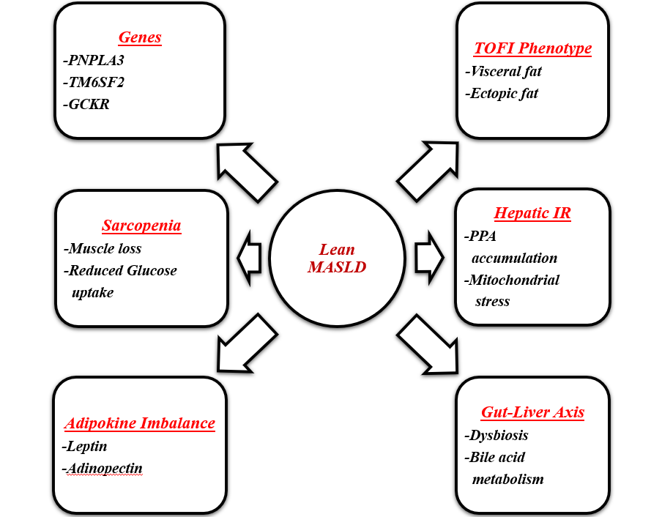
Figure 1 Mechanistic Pathways for Lean MASLD

4.1. Polygenic Susceptibility Lowers the Steatosis Threshold
Genetic predisposition plays a central role in determining individual vulnerability to hepatic steatosis, even in the absence of obesity. Among the most extensively characterised variants, Patatin-like phospholipase domain-containing protein 3 (PNPLA3, rs738409) remains the strongest genetic determinant of MASLD. The I148M substitution impairs triglyceride hydrolysis within hepatocytes, leading to lipid droplet accumulation and heightened susceptibility to inflammation and fibrosis. Similarly, mutations in Transmembrane 6 Superfamily Member 2 (TM6SF2, rs58542926) reduce very-low-density lipoprotein (VLDL) secretion, causing intracellular lipid retention and increasing the risk of steatohepatitis and advanced fibrosis.
The Glucokinase Regulatory Protein (GCKR, rs1260326) polymorphism modulates hepatic glucose handling by promoting glycolytic flux and de novo lipogenesis (DNL), while variants in the Fat Mass and Obesity-associated (FTO) gene contribute to altered energy homeostasis and lipid metabolism through complex effects on adipogenesis and appetite regulation. Collectively, these variants disrupt hepatic lipid balance by enhancing lipogenesis, impairing lipid export, or altering adipose tissue signalling. Importantly, the impact of these genetic alterations is amplified in lean individuals, where environmental and metabolic insults—such as modest caloric excess, fructose intake, or sedentary behaviour can trigger pronounced hepatic lipid accumulation.
The absence of overt obesity often masks the underlying genetic risk, leading to delayed diagnosis and disease progression. Recent studies demonstrate that polygenic risk scores (PRSs) integrating multiple allelic variants outperform single polymorphism models in predicting hepatic steatosis, fibrosis, and hepatocellular carcinoma risk. This polygenic architecture explains why certain lean individuals exhibit disease severity comparable to, or even exceeding, that observed in obese MASLD patients. Understanding these inherited susceptibilities offers a foundation for precision medicine approaches—enabling risk stratification, early intervention, and potentially genotype-guided therapeutic strategies for lean MASLD.

4.2. TOFI Phenotype: Limited Subcutaneous Expandability
The “thin-outside, fat-inside” (TOFI) phenotype represents a paradox in metabolic health, describing individuals who appear lean based on body mass index yet harbour disproportionate amounts of visceral and ectopic fat. In such individuals, limited expandability of subcutaneous adipose tissue (SAT) leads to metabolic overflow, whereby excess dietary or circulating lipids are redirected to non-adipose depots such as the liver, skeletal muscle, pancreas, and mesentery. This maladaptive redistribution of fat drives insulin resistance, chronic inflammation, and hepatic steatosis despite a normal body weight. Subcutaneous adipose tissue normally acts as a metabolic “buffer,” storing triglycerides safely during energy surplus. However, when its capacity for adipocyte differentiation and lipid storage becomes saturated or impaired—through genetic, hormonal, or environmental factors—lipids accumulate in visceral and ectopic compartments. Visceral adipose tissue (VAT), unlike subcutaneous fat, is metabolically active and pro-inflammatory; it releases higher concentrations of free fatty acids (FFAs), interleukin-6, and tumour necrosis factor-α into the portal circulation, directly influencing hepatic insulin sensitivity and promoting de novo lipogenesis. This process establishes a vicious cycle of lipotoxicity, oxidative stress, and hepatic inflammation characteristic of MASLD. Magnetic resonance imaging (MRI) and proton density fat fraction (PDFF) studies have consistently shown that TOFI individuals can have VAT volumes comparable to, or even exceeding, those of overweight individuals.
Such disproportionate fat deposition is strongly linked to cardiometabolic risk, including hypertension, dyslipidaemia, impaired glucose tolerance, and atherosclerosis. Asian populations are particularly predisposed to the TOFI pattern due to ethnic differences in adipocyte morphology, reduced SAT capacity, and a tendency for visceral fat accumulation at lower BMI thresholds. This explains the high prevalence of metabolic diseases in apparently lean Asian individuals. Recognition of the TOFI phenotype has redefined the concept of metabolic obesity. It underscores the limitation of BMI as a sole diagnostic measure and highlights the need for incorporating waist circumference, waist-to-hip ratio, and advanced imaging techniques in clinical risk assessment. By identifying TOFI individuals early, clinicians can initiate lifestyle and metabolic interventions before irreversible hepatic or cardiovascular complications develop.

4.3. Sarcopenia Amplifies Insulin Resistance and Lipid Flux
Skeletal muscle serves as a primary site for glucose uptake and fatty-acid oxidation; thus, a reduction in muscle quantity or quality compromises systemic energy utilisation. In lean MASLD, sarcopenia and visceral adiposity often coexist, forming a deleterious “dual-compartment” phenotype. Excess visceral fat delivers free fatty acids (FFAs) directly to the liver through the portal vein, while limited muscle mass decreases the body’s ability to metabolize these substrates. The result is heightened hepatic insulin resistance, increased production of very-low-density lipoproteins (VLDL), and accumulation of toxic lipid intermediates such as diacylglycerols and ceramides, which impair insulin signalling pathways. Also, the sarcopenic individuals frequently exhibit mitochondrial dysfunction, reduced myokine secretion (e.g., irisin, myonectin), and chronic low-grade inflammation, all of which exacerbate metabolic dysregulation. Emerging evidence indicates that sarcopenia independently predicts the severity of steatosis and fibrosis in MASLD, irrespective of BMI. This finding reinforces the notion that muscle health is a vital determinant of metabolic resilience. Interventions that enhance muscle mass, such as resistance training, adequate protein intake, and optimization of vitamin D and anabolic hormone levels; may therefore represent essential components of comprehensive management strategies for lean MASLD.

4.4. Hepatic Insulin Resistance 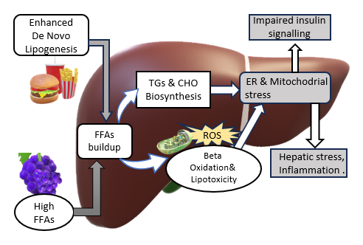
Figure 2 Mechanism of hepatic toxicity and impaired insulin signalling
An increase in hepatic insulin resistance leads to generation of excessive free fatty acids (FFAs) as well as lipid droplets causing lipotoxicity. These accumulated FFAs causes stress on mitochondria and endoplasmic reticulum (ER), leading to formation of reactive oxygen species (ROS). The ROS can damage the contents of cell including the lipids, proteins and DNA. This oxidative damage impairs insulin signaling leading to more enhanced lipotoxicity and mitochondrial stress, disrupting the cellular functions creating a vicious cycle.

4.5. Adipokine Imbalance and Iron-Driven Oxidative Stress
Adipose tissue acts as an active endocrine organ that regulates systemic metabolism through the secretion of adipokines and cytokines. In lean MASLD, despite the absence of obesity, dysfunctional adipose tissue contributes profoundly to hepatic and metabolic injury. A hallmark of this dysfunction is an imbalance between anti-inflammatory and pro-inflammatory adipokines, resulting in a persistent state of low- grade inflammation that promotes insulin resistance and hepatic steatosis. Adiponectin, one of the most important insulin-sensitizing and anti-inflammatory adipokines, is significantly reduced in lean MASLD. Low adiponectin levels impair hepatic fatty acid oxidation, decrease glucose utilisation, and enhance de novo lipogenesis. Additionally, adiponectin deficiency weakens its protective effects on hepatocytes by reducing AMP-activated protein kinase (AMPK) activation and peroxisome proliferator-activated receptor-alpha (PPAR-α) signalling—pathways essential for maintaining lipid and mitochondrial homeostasis. Conversely, leptin levels are often elevated, despite normal body weight. Although leptin physiologically suppresses appetite and regulates lipid metabolism, chronic hyperleptinaemia induces leptin resistance and exerts pro-fibrotic and pro-inflammatory effects. Leptin stimulates hepatic stellate cells via the Janus kinase/signal transducer and activator of transcription (JAK/STAT) pathway, promoting collagen deposition and fibrogenesis. Simultaneously, increased secretion of tumour necrosis factor-alpha (TNF-α) and interleukin-6 (IL-6) from visceral adipocytes and infiltrating macrophages enhances insulin resistance through serine phosphorylation of insulin receptor substrate (IRS) proteins. This type of cytokines also activate the nuclear factor-kappa B (NF-κB) and c-Jun N-terminal kinase (JNK) pathways, which further amplify inflammatory signalling in the liver. Together, these molecular events create a self-perpetuating metabolic–inflammatory cycle in which impaired adipokine signalling, chronic cytokine activation, and hepatic insulin resistance reinforce one another.

4.6. Gut–Liver Axis: Dysbiosis, Permeability, and Bile-Acid Signaling
Lean MASLD exhibits distinct microbiome signatures from obese MASLD. Emerging evidence indicates that alterations in gut microbial composition, or dysbiosis, contribute to disease progression by compromising intestinal barrier integrity, leading to translocation of microbial components such as lipopolysaccharides (LPS) into the portal circulation. This endotoxemia activates hepatic Toll-like receptor (TLR) pathways, triggering proinflammatory and fibrogenic cascades within the liver. Concurrently, dysregulated metabolism of bile acid alters the composition of the bile acid pools, weakening the Farnesoid X Receptor (FXR)–Fibroblast Growth Factor 19 (FGF19) signaling axis that normally supports insulin sensitivity and lipid homeostasis. The depletion of beneficial short-chain fatty acids (SCFAs), which typically exert anti- inflammatory and metabolic regulatory effects, further amplifies hepatic inflammation and insulin resistance. Integrative multi-omics studies and recent reviews have strengthened these associations, revealing that the interplay between gut microbial metabolites, bile acid signaling, and hepatic immune responses forms a critical mechanistic bridge in lean MASLD pathogenesis—although the direction and extent of causality remain under active investigation.

4.7. Systemic Cardiometabolic Integration
Central adiposity, particularly the buildup of visceral fat around abdominal organs—is closely associated with hypertension, elevated triglycerides, reduced HDL cholesterol, and a heightened risk of cardiovascular disease. Research increasingly shows that waist-based indicators, such as waist circumference or waist-to-height ratio, are more reliable predictors of cardiometabolic risk than BMI alone. In nonalcoholic fatty liver disease (NAFLD) cohorts, people classified as “lean” by BMI yet presenting with enlarged waistlines experience greater cardiovascular and all-cause mortality than those who are overweight but have normal waist measurements. This highlights that the distribution of fat, especially visceral fat, rather than total body weight, is the key determinant of metabolic dysfunction and clinical outcomes in these individuals.

5. Treatment and Management

5.1. Non-Pharmacological
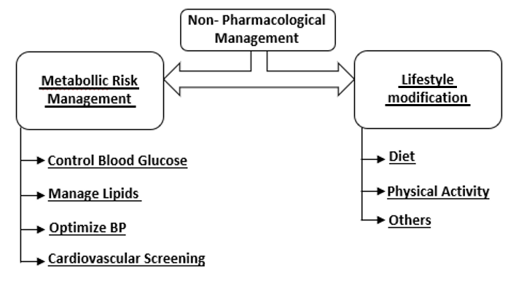

A] Lifestyle Modifications
Diet:- The Mediterranean diet is considered the best dietary pattern for MASLD patients. It is known for its abundance of, whole grains, vegetables, legumes, fruits, nuts, olive oil, & fish, all of which provide antioxidants, omega-3 fatty acids & monounsaturated fats. These components reduce oxidative stress and inflammation in the hepatocytes. Restriction of fructose and refined carbohydrates is crucial. Beverages like soda, packaged fruit juices, and sweets promote de novo lipogenesis (fat production in the liver), leading to worsening steatosis. Adequate protein intake (preferably from plant and lean animal sources) helps maintain muscle mass, which improves insulin sensitivity and prevents sarcopenia often seen in lean MASLD.
Physical Activity:- Aerobic exercise (150–300 minutes per week) such as brisk walking, cycling, or swimming improves insulin sensitivity, reduces hepatic fat, and enhances cardiovascular health. Resistance/strength training is equally important, as it aids in increasing the muscle mass, which improves the utilization of glucose and metabolic balance. In lean MASLD patients with visceral adiposity (belly fat despite normal BMI), even a 5% reduction in body weight has been shown to significantly decrease liver fat and inflammation.
Others:- Alcohol should be strictly avoided, even in moderate amounts, as it can accelerate steatosis and fibrosis progression in MASLD patients. Improving sleep hygiene is important, since poor sleep and sleep apnea are associated with metabolic dysfunction and worsening liver disease. Stress reduction techniques (yoga, mindful- ness, meditation) indirectly benefit liver health by lowering cortisol and improving metabolic regulation.

B] Metabolic Risk Management
Blood glucose control is essential, even in non-diabetic patients, since insulin resistance is a key driver of lean MASLD. Lipid management (controlling cholesterol and triglycerides) helps reduce cardiovascular risk, which accounts for a significant portion of deaths in MASLD.
Blood pressure optimization prevents cardiovascular and kidney complications that can compound liver disease. Cardiovascular screening and prevention (ECG, echo- cardiography, carotid Doppler in high-risk patients) should be integrated into routine care, since cardiovascular events are far more common than progression to cirrhosis in lean MASLD

5.2. Pharmacological

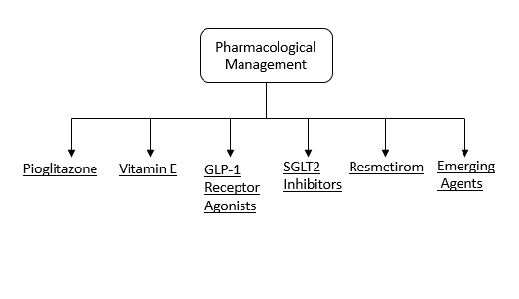
A] Pioglitazone: Pioglitazone is a PPAR-γ agonist that has shown consistent benefits in improving steatosis, hepatic inflammation, and hepatocellular ballooning, which are prominent aspects of MASH. It is particularly effective in type-2 diabetic patients, which are common contributors even in lean MASLD. However, its use requires careful patient selection because it can cause weight gain and fluid retention.

B] Vitamin E: A dose of 800 IU/day of Vit. E is recommended for non-diabetic patients with biopsy-proven NASH. Its antioxidant properties reduce oxidative stress and hepatic inflammation, leading to improvements in steatosis and necroinflammatory activity. Despite these benefits, it is not routinely recommended in diabetic or cirrhotic patients due to safety concerns and limited evidence in those populations.

C] Agonists of GLP-1 receptor: Liraglutide and semaglutide were developed originally for type 2 diabetes along with obesity but have demonstrated strong efficacy in MASLD. They reduce hepatic fat accumulation, improve NASH resolution, and provide additional cardiovascular protection. These agents also promote weight loss and reduce visceral adiposity, making them particularly valuable in lean MASLD patients who often have hidden metabolic dysfunction despite normal BMI.

D] SGLT2 inhibitors: SGLT2 inhibitors including empagliflozin and dapagliflozin, widely used in type 2 diabetes, have also been shown to lower hepatic fat content and improve insulin resistance. They confer significant cardiovascular and renal benefits, which are especially important given that cardiovascular disease which accounts for a significant portion of deaths in MASLD patients. Their role in lean MASLD is promising, especially in those with coexisting diabetes.

E] Resmetirom: It is a thyroid hormone receptor-β agonist, which represents a major advancement in MASLD treatment as it was recently FDA-approved (2024) for NASH with fibrosis. It works by enhancing hepatic lipid metabolism, leading to significant reductions in liver fat and slowing fibrosis progression. Resmetirom marks the first disease-modifying therapy specifically approved for NASH and is expected to reshape the pharmacological management of the disease.

F] Emerging agents: FGF21 analogues (pegozafermin, efruxifermin), lanifibranor, and obeticholic acid are the emerging agents which are currently in clinical trials. These novel drugs target multiple metabolic and fibrotic pathways, with early results showing reductions in steatosis, improvement in lipid metabolism, and potential anti-fibrotic effects. While not yet available in clinical practice, they represent the future of personalized pharmacotherapy in MASLD.

Clinical Implications and Future Directions
Lean MASLD challenges conventional diagnostic frameworks centred on BMI. Its recognition as a distinct metabolic disorder necessitates a multidimensional assessment incorporating genetics, visceral adiposity, and metabolic function. Future directions include developing targeted therapeutics, integrating genetic and microbiome profiling, and enhancing early screening tools. Personalised medicine approaches are essential to mitigate liver‑related and cardiovascular morbidity.

References
1. Younossi ZM, Koenig AB, Abdelatif D, Fazel Y, Henry L, Wymer M. Global epidemiology of nonalcoholic fatty liver disease—Meta-analytic assessment of prevalence, incidence, and outcomes. Hepatology. 2016 Jul;64(1):73-84.
2. Eslam M, Newsome PN, Sarin SK, Anstee QM, Targher G, Romero-Gomez M, et al. A new definition for metabolic dysfunction-associated fatty liver disease: An international expert consensus statement. J Hepatol. 2020 Jul;73(1):202-9.
3. Ye Q, Zou B, Yeo YH, Li J, Huang DQ, Wu Y, et al. Global prevalence, incidence, and outcomes of non-obese or lean non-alcoholic fatty liver disease: a systematic review and meta-analysis. Lancet Gastroenterol Hepatol. 2020 Aug;5(8):739-52.
4. Wong VW, Wong GL, Yeung DK, Lau TK, Chan CK, Chim AM, et al. Incidence of non-alcoholic fatty liver disease in Hong Kong: a population study with paired proton-magnetic resonance spectroscopy. J Hepatol. 2015 Jan;62(1):182-9.
5. Romeo S, Kozlitina J, Xing C, Pertsemlidis A, Cox D, Pennacchio LA, et al. Genetic variation in PNPLA3 confers susceptibility to nonalcoholic fatty liver disease. Nat Genet. 2008 Dec;40(12):1461-5.
6. Liu YL, Patman GL, Leathart JB, Piguet AC, Burt AD, Dufour JF, et al. Carriage of the PNPLA3 rs738409 C>G polymorphism confers an increased risk of non-alcoholic fatty liver disease associated hepatocellular carcinoma. J Hepatol. 2014 Jul;61(1):75-81.
7. Kozlitina J, Smagris E, Stender S, Nordestgaard BG, Zhou HH, Tybjærg-Hansen A, et al. Exome-wide association study identifies a TM6SF2 variant that confers susceptibility to nonalcoholic fatty liver disease. Nat Genet. 2014 Apr;46(4):352-6.
8. Speliotes EK, Yerges-Armstrong LM, Wu J, Hernaez R, Kim LJ, Palmer CD, et al. Genome-wide association analysis identifies variants associated with nonalcoholic fatty liver disease that have distinct effects on metabolic traits. PLoS Genet. 2011 Mar;7(3):e1001324.
9. Stefan N, Häring HU, Cusi K. Non-alcoholic fatty liver disease: causes, diagnosis, cardiometabolic consequences, and treatment strategies. Lancet Diabetes Endocrinol. 2019 Apr;7(4):313-24.
10. Fabbrini E, Sullivan S, Klein S. Obesity and nonalcoholic fatty liver disease: biochemical, metabolic, and clinical implications. Hepatology. 2010 Feb;51(2):679-89.
11. Duseja A, Singh SP, Saraswat VA, Acharya SK, Chawla YK, Chowdhury S, et al. Non-alcoholic fatty liver disease and metabolic syndrome-position statement of Indian National Association for Study of the Liver, Endocrine Society of India, Indian College of Cardiology and Indian Society of Gastroenterology. J Clin Exp Hepatol. 2015 Mar;5(1):51-68.
12. Duseja A, Chalasani N. Epidemiology and risk factors of nonalcoholic fatty liver disease (NAFLD). Hepatol Int. 2013 Nov;7(Suppl 2):755-64.
13. Das K, Das K, Mukherjee PS, Ghosh A, Ghosh S, Mridha AR, et al. Nonobese population in a developing country has a high prevalence of nonalcoholic fatty liver and significant liver disease. Hepatology. 2010 May;51(5):1593-602.
14. Kumar R, Rastogi A, Sharma MK, Bhatia V, Garg H, Bihari C, et al. Clinicopathological characteristics and metabolic profiles of non-alcoholic fatty liver disease in Indian patients with normal body mass index: Do they differ from obese or overweight non-alcoholic fatty liver disease? Indian J Endocrinol Metab. 2013 Sep;17(5):865-70.
15. Chalasani N, Younossi Z, Lavine JE, Charlton M, Cusi K, Rinella M, et al. The diagnosis and management of nonalcoholic fatty liver disease: Practice guidance from the American Association for the Study of Liver Diseases. Hepatology. 2018 Jan;67(1):328-57.
16. Loomba R, Sanyal AJ. The global NAFLD epidemic. Nat Rev Gastroenterol Hepatol. 2013 Nov;10(11):686-90.
17. Armstrong MJ, Gaunt P, Aithal GP, Barton D, Hull D, Parker R, et al. Liraglutide safety and efficacy in patients with non-alcoholic steatohepatitis (LEAN): a multicentre, double-blind, randomised, placebo-controlled phase 2 study. Lancet. 2016 Feb;387(10019):679-90.
18. Cusi K, Orsak B, Bril F, Lomonaco R, Hecht J, Ortiz-Lopez C, et al. Long-Term Pioglitazone Treatment for Patients With Nonalcoholic Steatohepatitis and Prediabetes or Type 2 Diabetes Mellitus: A Randomized Trial. Ann Intern Med. 2016 Sep;165(5):305-15.
19. Sanyal AJ, Chalasani N, Kowdley KV, McCullough A, Diehl AM, Bass NM, et al. Pioglitazone, vitamin E, or placebo for nonalcoholic steatohepatitis. N Engl J Med. 2010 May;362(18):1675-85.
20. Newsome PN, Buchholtz K, Cusi K, Linder M, Okanoue T, Ratziu V, et al. A Placebo-Controlled Trial of Subcutaneous Semaglutide in Nonalcoholic Steatohepatitis. N Engl J Med. 2021 Mar;384(12):1113-24.
21. Harrison SA, Bashir MR, Guy CD, Zhou R, Moylan CA, Frias JP, et al. Resmetirom (MGL-3196) for the treatment of non-alcoholic steatohepatitis: a multicentre, randomised, double-blind, placebo-controlled, phase 2 trial. Lancet. 2019 Dec;394(10213):2012-24.
22. Younossi ZM, Loomba R, Rinella ME, Bugianesi E, Marchesini G, Neuschwander-Tetri BA, et al. Current and future therapeutic regimens for nonalcoholic fatty liver disease and nonalcoholic steatohepatitis. Hepatology. 2018 Jul;68(1):361-71.
23. Boursier J, Mueller O, Barret M, Machado M, Fizanne L, Araujo-Perez F, et al. The severity of nonalcoholic fatty liver disease is associated with gut dysbiosis and shift in the metabolic function of the gut microbiota. Hepatology. 2016 Mar;63(3):764-75.
24. Le TA, Chen J, Changchien C, Peterson MR, Kono Y, Patton H, et al. Effect of colesevelam on liver fat quantified by magnetic resonance in nonalcoholic steatohepatitis: a randomized controlled trial. Hepatology. 2012 Sep;56(3):922-32.
25. Siddiqui MS, Harrison SA, Abdelmalek MF, Anstee QM, Bedossa P, Castera L, et al. Case definitions for inclusion and analysis of endpoints in clinical trials for nonalcoholic steatohepatitis through the lens of regulatory science. Hepatology. 2018 May;67(5):2001-12.
26. Loomba R, Friedman SL, Shulman GI. Mechanisms and disease consequences of nonalcoholic fatty liver disease. Cell. 2021 May;184(10):2537-64.
27. Friedman SL, Neuschwander-Tetri BA, Rinella M, Sanyal AJ. Mechanisms of NAFLD development and therapeutic strategies. Nat Med. 2018 Jul;24(7):908-22.
28. Tilg H, Adolph TE, Moschen AR. Multiple Parallel Hits Hypothesis in Nonalcoholic Fatty Liver Disease: Revisited After a Decade. Hepatology. 2021 Feb;73(2):833-42.

