
VECTOR INDIA
(Advanced Embedded System Training Institute)
[Bangaluru, Chennai, Hyderabad]

A PROJECT SYNOPSIS
ON
SMART INDUSTRIAL RISK DETECTION AND
EMERGENCY ALERT SYSTEM
An Embedded Industrial Safety Monitoring System Based on the LPC2129 ARM7 Microcontroller
_____________________________________________________________

SUBMITTED BY (GROUP NO : 13)
- Mahesh (V25BE7M3)
- Aswin (V25BE7A4)
- Vanitha (V25BE7V2)
- Mayuri (V25BE7M4)
- Tejas (V25BE7T1)

VECTOR INDIA INSTITUTE
(33/49,12th Main Rd,4th T Block East, KV Layout, Jayanagar, Bengaluru, Karnataka 560011)
[July 2026]

INDEX

1. Introduction 3
1.1 Background and Need for the Project 3
1.2 Problem Statement 3
1.3 Objectives of the Project 3
1.4 Scope of the Project 4
2. Components Used 5
2.1 Hardware Components 5
2.2 Software Tools 6
2.3 Communication Interfaces Used 6
3. Block Diagram Explanation 7
3.1 System Block Diagram 8
3.2 Stage-wise Working Principle 9
3.3 Working Flow Diagram 10
4. Code Review 11
4.1 Program Structure Overview 11
4.2 Key Code Modules 11
4.3 Code Analysis and Review Remarks 27
5. Advantages and Disadvantages 28
5.1 Advantages 28
5.2 Disadvantages / Limitations 28
6. Future Scope 29
7. Bibliography 30

CHAPTER 1 | INTRODUCTION

1.1 Need for the Project
Modern manufacturing industries operate numerous machines continuously under demanding conditions such as high temperatures, heavy electrical loads, mechanical vibrations, and exposure to combustible gases or chemical vapours. Although these machines are designed for safe operation, minor faults such as overheating, gas leakage, excessive vibration, or abnormal current draw can gradually develop into serious problems if left undetected. These faults may lead to equipment failure, production downtime, fire hazards, gas explosions, financial losses, and risks to human safety.
In large industrial environments, it is difficult for operators to continuously monitor every machine and all critical parameters manually. Human monitoring is time-consuming, prone to errors, and may fail to detect abnormal conditions at an early stage. As a result, small issues can remain unnoticed until they become critical.
Therefore, there is a need for an automatic, real-time industrial monitoring system that continuously monitors important parameters such as temperature, gas leakage, vibration, and electrical current. By detecting abnormal conditions early and providing immediate alerts, the system helps improve industrial safety, reduce maintenance costs, minimize machine downtime, and ensure reliable and efficient operation with minimal human intervention.

1.2 Problem Statement
Industries currently rely largely on manual inspection and isolated analogue instruments to track machine health. This approach is slow, inconsistent, and reactive rather than preventive — faults are frequently discovered only after damage has already occurred. There is a clear requirement for an embedded, low-cost, real-time monitoring solution capable of observing multiple safety-critical parameters simultaneously, making an immediate decision when a parameter crosses its safe limit, and triggering the appropriate protective action (visual, audible, wireless, and electro-mechanical) without waiting for a human response.

1.3 Objectives of the Project
- To design and develop an intelligent industrial safety monitoring system built around the LPC2129 ARM7 microcontroller.
- To detect industrial hazards — high temperature, gas leakage, fire, abnormal vibration, current overload, and high humidity — in real time.
- To continuously monitor environmental and machine parameters using a network of dedicated sensors.
- To automatically generate visual, audible, and wireless emergency alerts whenever an unsafe condition is detected.
- To automatically disconnect the affected machine from supply using relay-based protection when a hazard is confirmed.
- To implement industrial communication protocols such as CAN, UART, I2C and SPI for multi-node monitoring and data logging.
- To log every fault event with an accurate time-stamp using an RTC module and retain the history in EEPROM even after a power failure.
- To demonstrate AI-inspired embedded decision-making, where the controller autonomously classifies a situation as safe, warning, or emergency and selects the correct response.

1.4 Scope of the Project
The system is designed for deployment in factories, chemical plants, boiler rooms, manufacturing units and other environments where continuous safety supervision is essential. It is intended as an embedded major-project implementation demonstrating practical, industry-oriented monitoring rather than a full industrial-grade product; nevertheless, the architecture — sensor acquisition, threshold-based decision logic, multi-channel alerting, inter-node communication and non-volatile event logging — mirrors the core building blocks used in real industrial safety controllers. The synopsis stage covers system design, component selection, working methodology, and the embedded logic that will subsequently be implemented and tested on hardware.

CHAPTER 2 | COMPONENTS USED

2.1 Hardware Components
The project uses a combination of sensing, processing, communication and output devices, organised into three functional groups as shown below.

Fig. 2.1 – Component Category Overview
Sl. No. | Component | Function in the Project
1 | LPC2129 ARM7 Development Board | Core processing unit; reads all sensors, executes decision logic, drives every output and communication module.
2 | DHT11 Temperature & Humidity Sensor | A single digital sensor that provides both machine/ambient temperature and humidity readings over a 1-wire interface, used for overheat detection and humidity monitoring.
3 | MQ2 Gas Sensor | Detects combustible/toxic gas concentration for leakage and explosion-risk monitoring.
4 | Flame Sensor Module | Detects the infrared signature of a flame for fast, interrupt-driven fire detection.
5 | Vibration Sensor | Detects abnormal mechanical vibration caused by bearing wear or mechanical imbalance.
6 | ACS712 Current Sensor | Measures load current to detect an overload/short-circuit condition on the machine.
7 | 16×2 LCD Display | Displays system status and the specific alert / warning message locally.
8 | HC-05 Bluetooth Module | Wirelessly transmits emergency alert notifications to a nearby mobile device.
9 | CAN Transceiver (MCP2551) | Broadcasts emergency information to other industrial monitoring nodes over the CAN bus.
10 | RTC Module (DS1307) | Time-stamps every fault/emergency event for accurate historical logging.
11 | EEPROM (24C256) / SD Card Module | Provides non-volatile storage for fault history, retained even after power loss.
12 | Relay Module | Electrically disconnects the monitored machine when an emergency is confirmed.
13 | Red / Green / Yellow LEDs | Provide immediate visual indication of normal, warning and emergency states.
14 | Buzzer | Provides an audible alarm during warning and emergency conditions.
15 | Regulated 5V DC Power Supply | Powers the microcontroller board and all connected peripherals.
16 | Breadboard and Jumper Wires | Used for prototype-stage interconnection of all modules.

2.2 Software Tools
- Keil µVision — IDE used for writing, compiling and debugging the Embedded C firmware for the LPC2129.
- Flash Magic — Utility used to program (flash) the compiled hex file onto the LPC2129 through its serial bootloader.
- Embedded C — Programming language used to implement sensor acquisition, decision logic and peripheral control.
- CAN Utility Tools — Used to monitor and verify CAN bus messages exchanged between industrial nodes during testing.

2.3 Communication Interfaces Used
Interface | Purpose in this Project
GPIO | Direct digital control of LEDs, buzzer, relay, flame-sensor interrupt input, and 1-wire timing for the DHT11 sensor.
ADC | Converts analog outputs of the MQ2, vibration and ACS712 sensors into digital readings.
UART | Serial communication with the HC-05 Bluetooth module for wireless alerting.
I2C | Communication with the RTC (DS1307) and EEPROM (24C256) for logging.
SPI | High-speed interface used for SD-card-based data logging.
CAN | Real-time broadcast of emergency messages between multiple industrial monitoring nodes.
Interrupts | Immediate, non-polled response to the flame sensor for fast fire detection.

CHAPTER 3 | WORKING AND BLOCK DIAGRAM EXPLANATION

3.1 System Block Diagram
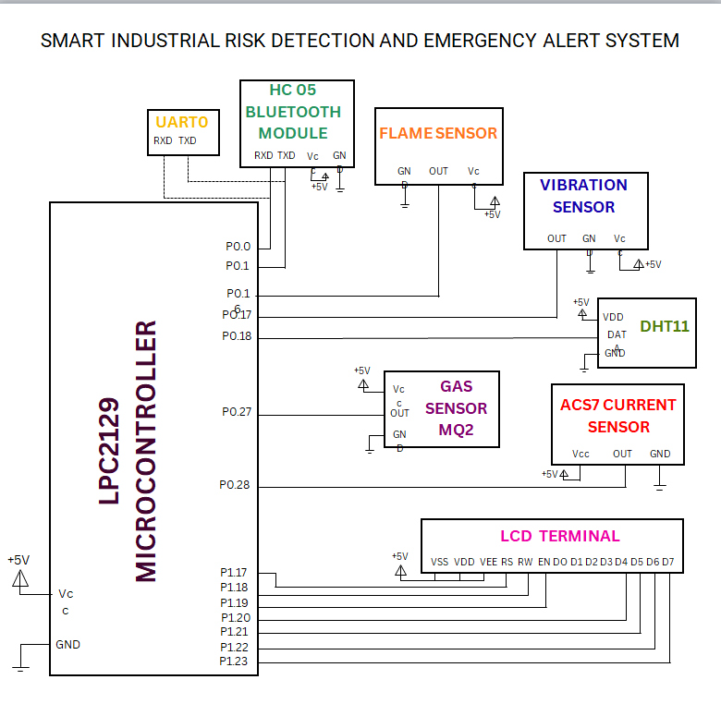
Fig. 3.1 – AI Industrial Risk Detection and Emergency Alert System: Block Diagram
Component | LPC2129 Port | Description
HC-05 Bluetooth Module | P0.0 (RXD), P0.1 (TXD) | Provides wireless communication using UART. Sends emergency alerts to a smartphone or monitoring device.
Flame Sensor | P0.16 | Detects the presence of fire or flame and sends a digital signal to the microcontroller.
Vibration Sensor | P0.17 | Detects abnormal vibrations in industrial machinery and reports them to the controller.
DHT11 Temperature & Humidity Sensor | P0.18 | Measures ambient temperature and humidity and sends digital data to the microcontroller.
MQ-2 Gas Sensor | P0.27 | Detects combustible gases and smoke. Sends an alert signal when gas concentration exceeds the threshold.
ACS712 Current Sensor | P0.28 | Monitors the current drawn by electrical equipment to detect overload or abnormal current conditions.
16×2 LCD Display | P1.17 – P1.23 | Displays system status, sensor readings, and warning messages such as fire, gas leakage, overload, or high vibration.
Power Supply (+5 V) | VCC & GND | Provides regulated power to the LPC2129, sensors, LCD, and Bluetooth module.

3.2 Stage-wise Working Principle
The complete operation of the system can be described as thirteen functional stages, summarised in Table 3.1.
Stage | Name | Description
1 | System Initialization | GPIO, LCD, ADC, UART, I2C, SPI and CAN are initialised; relay stays ON; LCD shows “INDUSTRIAL SAFETY SYSTEM”.
2 | Sensor Monitoring | Temperature and humidity are read digitally from the DHT11; gas, vibration and current sensors are sampled continuously through the ADC.
3 | Normal Condition | If all readings are within safe limits, the Green LED is ON, buzzer is OFF, relay stays ON; LCD shows “SYSTEM NORMAL”.
4 | High Temperature Detection | Red LED ON, buzzer activates, relay disconnects the machine; LCD shows “HIGH TEMP ALERT” and a Bluetooth warning is sent.
5 | Gas Leakage Detection | Red LED blinks, buzzer sounds continuously, relay disconnects load; LCD shows “GAS LEAKAGE DETECTED” with an emergency Bluetooth alert.
6 | Fire Detection (Interrupt-driven) | External interrupt fires instantly; alarm and rapid LED blink activate; relay turns OFF; a CAN emergency broadcast is sent to all nodes.
7 | Machine Vibration Detection | Yellow warning LED and buzzer activate; LCD shows “MACHINE VIBRATION ALERT” to flag developing mechanical faults.
8 | Current Overload Detection | Relay disconnects the load and the alarm activates; LCD shows “OVER CURRENT ALERT” to protect equipment.
9 | Humidity Monitoring | Yellow LED activates and LCD shows “HIGH HUMIDITY DETECTED”, useful for storage and chemical-industry areas.
10 | CAN Bus Communication | Dedicated nodes (temperature, gas, fire, etc.) exchange emergency information over the CAN bus for plant-wide awareness.
11 | RTC Logging (I2C) | Every alert is time-stamped by the DS1307 RTC, e.g. “10:45 AM — GAS ALERT DETECTED”.
12 | Data Logging (SPI) | Sensor readings and emergency events are logged to an SD card for later analysis and report generation.
13 | Smart Decision-Making | The controller continuously compares live readings with threshold limits and classifies the state as Safe, Warning or Emergency before choosing a response.

3.3 Working Flow Diagram
The stage-wise logic described above can be represented as a continuous decision loop, shown in Fig. 3.2. The controller cycles through sensor acquisition, threshold comparison, condition classification and automatic protective action, while simultaneously logging every event over CAN, RTC and EEPROM/SD-card storage.
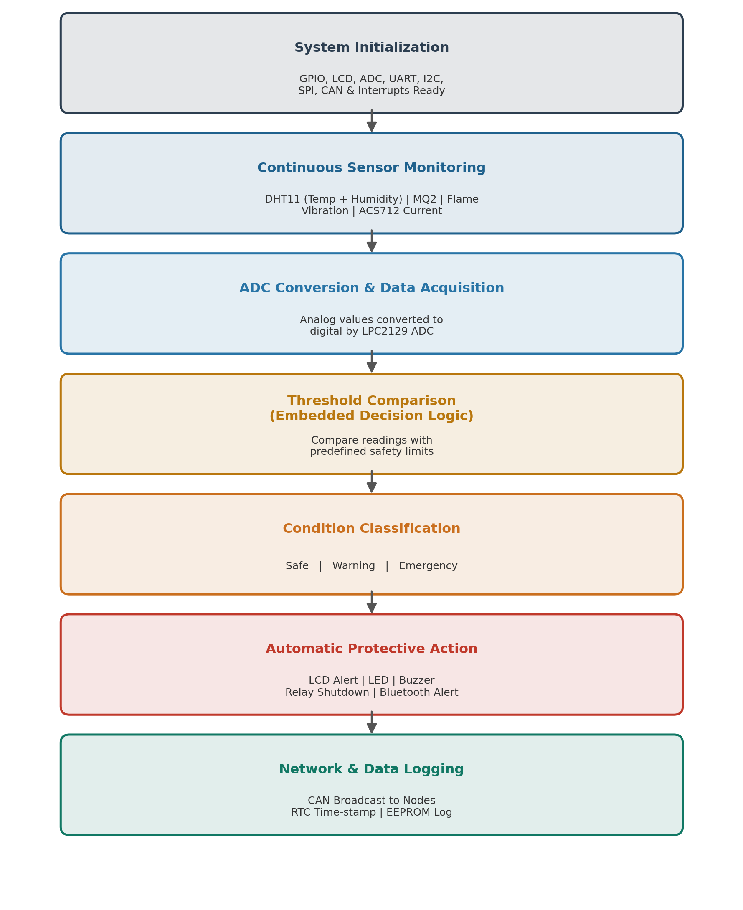
Fig. 3.2 – Working Flow of the Embedded Decision Logic

CHAPTER 4 | CODE REVIEW

4.1 Program Structure Overview
The firmware is developed in Embedded C using Keil µVision and follows a modular structure so that each subsystem — initialisation, sensor acquisition, decision logic, alerting, and communication — is implemented as an independent, testable function. This keeps the main loop compact and makes the code easy to extend when additional sensors or nodes are added. The representative code segments below illustrate the structure and logic that the synopsis design is built around; they will form the basis of the final implementation and are refined further during coding and hardware testing.

4.2 Key Code Modules
(a) Main Program
#include <LPC21xx.H>
#include "header.h"

int fire_detected=0;

//void rtc_time(char *time)
//{
// unsigned char h,m,s;
// h=i2c_read(0xD1,0x2);
// m=i2c_read(0xD1,0x1);
// s=i2c_read(0xD1,0x0);
// if(h>>6&1)
// {
// if(h>>5&1)
// sprintf(time,"%x:%x:%x %s",h,m,s,"PM");
// else
// sprintf(time,"%x:%x:%x %s",h,m,s,"AM");
// }
// else
// sprintf(time,"%x:%x:%x",h,m,s);
//}

int main ()
{
u8 humidity=0, humdec=0;
u8 temperature=0, tempdec=0;
u32 gas_value = 0;
volatile int d;
int adc;
float voltage;
int current;
char time[15];
config_eint0();
adc_init();

uart0_init(9600);
//i2c_init();

uart0_tx_string("\r\n PROJECT DONE BY: group 13");

uart0_tx_string("\r\nDHT11 initialized......\r\n");
//temp & humid....
dht11_start();
humidity = DHT11_ReadByte();
humdec = DHT11_ReadByte();
uart0_tx_string("Humidity: ");
uart0_tx_integer(humidity);
uart0_tx('.');
uart0_tx_integer(humdec);
uart0_tx_string("%\r\n");

temperature = DHT11_ReadByte();
tempdec = DHT11_ReadByte();
uart0_tx_string("Temperature: ");
uart0_tx_integer(temperature);
uart0_tx('.');
uart0_tx_integer(tempdec);
uart0_tx_string("\r\n");

delay_ms(2000);

//.................................

// GAS sensor...............

uart0_tx_string("Gas Sensor (ADC CH0) Test Initialized...\r\n");
gas_value = adc_read(0); // Read analog values from Channel 0

uart0_tx_string("Gas Raw ADC Value: ");
uart0_tx_integer(gas_value);
uart0_tx_string("\r\n");
delay_ms(2000);

//..................................

//vibration sensor..............

// Set up P0.17 as normal GPIO Input
PINSEL0 &= ~(3 << 2); // Set P0.17 bits to 00 (GPIO)
IODIR0 &= ~(1 << 17); // Direction: Input

uart0_tx_string("Vibration Sensor Test Initialized...\r\n");
if (IOPIN0 & (1 << 17)) {
uart0_tx_string("Vibration Status: SHAKING\r\n");
}
else {
uart0_tx_string("Vibration Status: OK \r\n");
}
delay_ms(2000);
//.......................................................

//Current sensor

PINSEL1|=1<<22;
adc=adc_read(1);
voltage=adc*3.3/1023;
//uart0_tx_string("\r\nvoltage:");
delay_ms(100);
//uart0_tx_float(voltage);
delay_ms(100);
current=(voltage/200);
uart0_tx_string("\r\ncurrent:");
uart0_tx_float(current);
delay_ms(100);
//.......................................................

//Fire sensor
IODIR0|=1<<16;

while(1){

//rtc_time(time);

//Temp & Humidity sensor

if(temperature>50){
uart0_tx_string("HIGH TEMPERATURE WARNING!!!!\r\n");
uart0_tx_string("\r\n");
uart0_tx_string(time);
}
if(humidity>70){
uart0_tx_string("HIGH HUMIDITY WARNING!!!!\r\n");
uart0_tx_string("\r\n");
// uart0_tx_string(time) ;
}

//Gas sensor
gas_value = adc_read(0); // Read analog values from Channel 0
if(gas_value>400)
{
uart0_tx_string("HAZARDOUS GAS WARNING!!!\r\n");
uart0_tx_string("\r\n");
// uart0_tx_string(time);
// uart0_tx_string("\r\n");
}

// Vibration sensor
if (IOPIN0 & (1 << 17)) {
uart0_tx_string("Vibration Status: SHAKING / WARN\r\n");
uart0_tx_string("\r\n");
// uart0_tx_string(time);
uart0_tx_string("\r\n");

}

//Current sensor
adc=adc_read(1); // Read analog values from Channel 1
voltage=adc*3.3/1023;
delay_ms(1000);
current=(voltage/200);
if(current>3.5||current<(-10))
{
uart0_tx_string("\r\n Over Current! Alert.");
uart0_tx_string("\r\n");
// uart0_tx_string(time);
// uart0_tx_string("\r\n");

}

//Fire Sensor
if(fire_detected)
{
uart0_tx_string("\r\n Fire Alert! Run for safety");
uart0_tx_string("\r\n");
fire_detected=0;
// uart0_tx_string(time);
// uart0_tx_string("\r\n");

}

}
}

(b) Sensor Driver
sensor driver.c
//sensor_driver.c
//#include<lpc21xx.h>

#include"header.h"

//dht11 Driver.....

unsigned char DHT11_ReadByte(void)
{
unsigned char result = 0;
int i;
for (i = 0; i < 8; i++)
{
while (!(IOPIN0 & (1 << DHT11_PIN)));

delay_us(40);
if (IOPIN0 & (1 << DHT11_PIN))
{
result |= (1 << (7 - i));
while (IOPIN0 & (1 << DHT11_PIN));
}
}return result;
}

unsigned char Read_DHT11(unsigned char *humidity, unsigned char *temperature)
{unsigned char data[5];
PINSEL0 &= ~(3 << 4); // Configure P0.18
IODIR0 |= (1 << DHT11_PIN);
IOCLR0 = (1 << DHT11_PIN);
delay_ms(20);
IOSET0 = (1 << DHT11_PIN);
delay_us(30);
IODIR0 &= ~(1 << DHT11_PIN);
if (!(IOPIN0 & (1 << DHT11_PIN))) {
while (!(IOPIN0 & (1 << DHT11_PIN)));
while (IOPIN0 & (1 << DHT11_PIN));
data[0] = DHT11_ReadByte();
data[1] = DHT11_ReadByte();
data[2] = DHT11_ReadByte();
data[3] = DHT11_ReadByte();
data[4] = DHT11_ReadByte();

if (data[4] == (data[0] + data[1] + data[2] + data[3]))
{ *humidity = data[0]; *temperature = data[2];
return 1;
}}return 0;
}

(c) ADC driver
adc driver.c

#include <LPC21xx.H>
#include "header.h"

void adc_init()
{
PINSEL1 |= 0x15400000; // P0.27=Ain0 P0.28=Ain1, P0.29=Ain2, P0.30=Ain3
ADCR = 0x00200400; // Select CH1,CH2,CH3, 10-bit, CLKDIV=4
}

// Read ADC channel 0-7
unsigned int adc_read(int ch)
{
ADCR|=1<<ch;
ADCR|=1<<24;
while((ADDR>>31&1)==0);
ADCR^=1<<24;
ADCR^=1<<ch;
return ((ADDR>>6)&0x3ff);
}

(d) External interrupt
external interrupt.c

#include <LPC21xx.H>
#include "header.h"
extern int fire_detected;
//extern int gas_detected;
//extern int vibration_detected;

void eint0_handler(void)__irq
{
EXTINT=1;
fire_detected=1;
VICVectAddr=0;
}
void config_eint0(void)
{
PINSEL1 |= 0X1;
EXTMODE=1;
EXTPOLAR=1;
VICIntSelect=0;
VICVectCntl0=14|(1<<5);
VICVectAddr0=(u32)eint0_handler;
VICIntEnable=(1<<14);
}

////EINT1 handler
//void eint1_handler(void)__irq
//{
//EXTINT=2;
//gas_detected=1;
//VICVectAddr=0;
//}
//void config_eint1(void)
//{
//PINSEL0 |= 0X20000000;
//EXTMODE=0;
//EXTPOLAR=0;
//VICIntSelect=0;
//VICVectCntl1=15|(1<<5);
//VICVectAddr1=(u32)eint1_handler;
//VICIntEnable=(1<<15);
//}
//
////EINT2 handler
//void eint2_handler(void)__irq
//{
//EXTINT=4;
//vibration_detected=1;
//VICVectAddr=0;
//}
//void config_eint2(void)
//{
//PINSEL0 |= 0X80000000;
//EXTMODE=0;
//EXTPOLAR=0;
//VICIntSelect=0;
//VICVectCntl3=16|(1<<5);
//VICVectAddr3=(u32)eint2_handler;
//VICIntEnable=(1<<16);
//}
//
////EINT3 handler
//void eint3_handler(void)__irq
//{
//EXTINT=8;
//fire_detected=0;
//gas_detected=0;
//vibration_detected=0;
//VICVectAddr=0;
//}
//void config_eint3(void)
//{
//PINSEL1 |= 0X300;
//EXTMODE=0;
//EXTPOLAR=0;
//VICIntSelect=0;
//VICVectCntl1=17|(1<<5);
//VICVectAddr1=(u32)eint3_handler;
//VICIntEnable=(1<<17);
//}
(e) I2C driver
/i2c_driver.c/
#include <LPC21xx.H>
#include "header.h"
void i2c_init(void)
{
PINSEL0|=0x50;//P0.2->SCL,P0.3->SDA
I2SCLH=I2SCLL=75;//100Kbps freq
/select master mode/
I2CONCLR=(1<<2);//AA=0
I2CONSET=(1<<6);//I2EN=1
}

/i2c byte write frame/
#define SI ((I2CONSET>>3)&1)

void i2c_send(u8 sa,u8 mr,u8 data)
{
/step1:generate start condi/
I2CONSET=(1<<5);//STA=1
I2CONCLR=(1<<3);//Clear SI*
while(SI==0);//waiting for start condi
//to get generated
I2CONCLR=(1<<5);//STA=0*

/step2:send sa+w & check ack/
I2DAT=sa;//send sa+w
I2CONCLR=1<<3;//SI=0
while(SI==0);
if(I2STAT==0x20)
{
uart0_tx_string("err:send sa+w\r\n");
goto exit;
}

/step3:send mr_addr & check ack/
I2DAT=mr;//send mr_addr
I2CONCLR=(1<<3);//SI=0
while(SI==0);
if(I2STAT==0x30)
{
uart0_tx_string("err:send mr_addr\r\n");
goto exit;
}

/step4:send data & check ack/
I2DAT=data;//send data
I2CONCLR=(1<<3);//SI=0
while(SI==0);
if(I2STAT==0x30){
uart0_tx_string("err:send data\r\n");
goto exit;
}

/step5:generate stop condi/
exit:
I2CONSET=(1<<4);//STO=1
I2CONCLR=(1<<3);//Clear SI*
}

/i2c byte read frame/
u8 i2c_read(u8 sa, u8 mr)
{
u8 res=0;
/step1:generate start condi/
I2CONSET=(1<<5);
I2CONCLR=(1<<3);
while(SI==0);
I2CONCLR=(1<<5);

/step2:send sa+w & check ack/
I2DAT=sa^1;//send sa+w
I2CONCLR=(1<<3);//SI=0
while(SI==0);
if(I2STAT==0x20){
uart0_tx_string("err:read sa+w\r\n");
goto exit;
}

/step3:send mr_addr & check ack/
I2DAT=mr;//send mr_addr
I2CONCLR=(1<<3);//SI=0
while(SI==0);
if(I2STAT==0x30){
uart0_tx_string("err:read mr_addr\r\n");
goto exit;
}

/step4:generate restart condi/
I2CONSET=(1<<5);
I2CONCLR=(1<<3);
while(SI==0);
I2CONCLR=(1<<5);

/step5:send sa+r & check ack/
I2DAT=sa;//send SA+R
I2CONCLR=(1<<3);//SI=0
while(SI==0);
if(I2STAT==0x48){
uart0_tx_string("err:read sa+r\r\n");
goto exit;
}

/step6:read data from slave & send noack/
I2CONCLR=(1<<3);//SI=0
while(SI==0);//waiting for data receive
res=I2DAT;

/step7:generate stop condi/
exit:
I2CONSET=(1<<4);//STO=1
I2CONCLR=(1<<3);//SI=0

/step8:return data/
return res;
}
(f) UART driver
uart driver.c
#include <LPC21xx.H>
#include "header.h"
#define THRE (U0LSR>>5&1)
#define RDR (U0LSR>>0&1)
void uart0_init(unsigned int baud)
{
int pclk,result=0;
if(VPBDIV==0x00)
pclk=15000000;
else if(VPBDIV==0x01)
pclk=60000000;
else if(VPBDIV==0x02)
pclk=30000000;
result=pclk/(16*baud);
PINSEL0 |=0x5;
U0LCR=0x83;
U0DLL=result&0xFF;
U0DLM=result>>8&0xFF;
U0LCR=0x03;
}

void uart0_tx(unsigned char data)
{
U0THR=data;
while(THRE==0);
}

unsigned char uart0_rx()
{
while(RDR==0);
return U0RBR;
}

void uart0_tx_string(char *p)
{
while(*p!=0)
{
uart0_tx(*p);
p++;
}
}
void uart0_rx_string(unsigned char *p,int len)
{
int i;
for(i=0;i<len;i++)
{
p[i]=uart0_rx();
if(p[i]=='\r')
break;
}
p[i]='\0';
}

void uart0_tx_integer(int n)
{
char a[10];
int i;
if(n<0)
{
uart0_tx('-');
n=-n;
}
if(n==0)
{
uart0_tx('0');
return;
}
for(i=0;n;n/=10,i++)
a[i]=n%10+48;
for(i-=1;i>=0;i--)
uart0_tx(a[i]);
}

void uart0_tx_float(float f)
{
int n;
if(f<0)
{
uart0_tx('-');
f=-f;
}
if(f==0)
{
uart0_tx_string("0.0");
return;
}
n=f;
uart0_tx_integer(n);
uart0_tx('.');
n=(f-n)*1000000;
uart0_tx_integer(n);
}

(g) LCD driver
#include <LPC21xx.H>
#include"header.h"
void lcd_data(unsigned char data)
{ //higher nibble
unsigned int t;
IOCLR1=0xFE0000;
t=(data&0xF0)<<16;
IOSET1=t;
IOSET1=1<<17;
IOCLR1=1<<18;
IOSET1=1<<19;
delay_ms(2);
IOCLR1=1<<19;

//lower nibble
IOCLR1=0xFE0000;
t=(data&0x0F)<<20;
IOSET1=t;
IOSET1=1<<17;
IOCLR1=1<<18;
IOSET1=1<<19;
delay_ms(2);
IOCLR1=1<<19;
}
void lcd_cmd(unsigned char cmd)
{
//higher nibble
unsigned int t;
IOCLR1=0xFE0000;
t=(cmd&0xF0)<<16;
IOSET1=t;
IOCLR1=1<<17;
IOCLR1=1<<18;
IOSET1=1<<19;
delay_ms(2);
IOCLR1=1<<19;

//lower nibble
IOCLR1=0xFE0000;
t=(cmd&0x0F)<<20;
IOSET1=t;
IOCLR1=1<<17;
IOCLR1=1<<18;
IOSET1=1<<19;
delay_ms(2);
IOCLR1=1<<19;
}
void lcd_init()
{
IODIR1=0xFE0000;
// PINSEL2 = 0x0;
lcd_cmd(0x02);
lcd_cmd(0x28);
lcd_cmd(0x0e);
lcd_cmd(0x01);
}
void lcd_string(char *p)
{
while(*p!=0)
{
lcd_data(*p);
p++;
}
}

void lcd_integer(int n)
{
char a[10];
int i;
if(n<0)
{
lcd_data('-');
n=-n;
}
if(n==0)
{
lcd_data('0');
return;
}
for(i=0;n;n/=10,i++)
a[i]=n%10+48;
for(i-=1;i>=0;i--)
lcd_data(a[i]);
}

void lcd_float(float f)
{
int n;
if(f<0)
{
lcd_data('-');
f=-f;
}
if(f==0)
{
lcd_string("0.0");
return;
}
n=f;
lcd_integer(n);
lcd_data('.');
n=(f-n)*1000000;
lcd_integer(n);
}

(h) Header.h
header.h
typedef unsigned int u32;
typedef unsigned char u8;
typedef signed int s32;
typedef signed char s8;

#include<lpc21xx.h>
#include<stdio.h>
//delay
extern void delay_ms(unsigned int ms);
extern void delay_s(unsigned int s);

//LCD
extern void lcd_data(unsigned char data);
extern void lcd_cmd(unsigned char cmd);
extern void lcd_init(void);
extern void lcd_string (char *p);
extern void lcd_integer(int n);
extern void lcd_float(float f);

//UART
extern void uart0_rx_string(unsigned char *,int len);
extern void uart0_tx_string(char *);
extern unsigned char uart0_rx(void);
extern void uart0_tx(unsigned char data);
extern void uart0_init(unsigned int baud);
extern void uart0_tx_integer(int n);
extern void uart0_tx_float(float f);
extern void uart0_hex(s32 num);
extern void uart0_binary(int num);

//#define THRE (U0LSR>>5&1)
//#define RDR (U0LSR>>0&1) `

//EINT's & UART intr's
extern void config_eint0(void);
extern void config_eint1(void);
extern void config_eint2(void);
extern void config_uart0_intr(void);

//MCP3204 & ADC(built in)
extern u32 mcp3204_adc_read(u8 ch_num);
extern u8 spi0(u8 data);
extern void spi0_init(void);
extern unsigned int adc_read(int ch);
extern void adc_init(void);

//I2C
extern void i2c_init(void);
extern void i2c_send(u8 sa,u8 mr,u8 data);
extern u8 i2c_read(u8 sa, u8 mr);
extern void rtc_time(char *time);

//CAN1
typedef struct CAN1_MSG{
u32 id;
u32 byteA;
u32 byteB;
u8 rtr;
u8 dlc;
}CAN1;
extern void can1_init(void);
extern void can1_tx(CAN1 v);
extern void can1_rx(CAN1 *ptr);
extern void config_vic_for_can1(void);

extern void gpio_init(void);

#define DHT11_PIN 18 //P0.18 for the DHT11 Data Line
extern void delay_us(unsigned int us);
extern unsigned char DHT11_ReadByte(void);
extern unsigned char Read_DHT11(unsigned char *humidity, unsigned char *temperature) ;
extern void dht11_start(void)

- delay driver
#include <LPC21xx.H>
// #include"header.h"
void delay_ms(unsigned int ms)
{
T0PR=15000-1;
T0PC=0;
T0TC=0;
//T0TCR=2;
T0TCR=1;
while(T0TC<ms);
T0TCR=0;
}
void delay_s( unsigned int s)
{
T0PR=15000000-1;
T0PC=0;
T0TC=0;
//T0TCR=2;
T0TCR=1;
while(T0TC<s);
T0TCR=0;
}

void delay_us( unsigned int us)
{
T0PR=15-1;
T0PC=0;
T0TC=0;
//T0TCR=2;
T0TCR=1;
while(T0TC<us);
T0TCR=0;
}

4.3 Code Analysis and Review Remarks
Review Aspect | Observation
Modularity | Each subsystem (init, sensing, decision, alerting, ISR) is isolated in its own function, which simplifies unit testing and future upgrades.
Readability | Named constants (TEMP_LIMIT, GAS_LIMIT, etc.) replace magic numbers, making the threshold logic self-documenting.
Response Time | Fire detection uses a hardware interrupt rather than polling, ensuring the fastest possible reaction to the highest-risk hazard.
Fault Priority | Evaluate Conditions() checks emergency-level hazards (gas, over-current) before warning-level ones (vibration, humidity), which is appropriate for a safety system.
Data Persistence | Logging to both RTC-time-stamped EEPROM and SD card ensures fault history survives a power interruption.
Scope for Improvement | Threshold values are currently static constants; a future version could store them in EEPROM so they can be re-calibrated without reflashing the firmware.
Scope for Improvement | A watchdog timer is recommended to be added so the controller can recover automatically from an unexpected firmware hang.

CHAPTER 5 | ADVANTAGES AND DISADVANTAGES

5.1 Advantages
- Provides continuous, real-time monitoring of six critical industrial parameters without human intervention.
- Automatic emergency alert generation significantly reduces response time compared to manual inspection.
- Interrupt-based fire detection guarantees an immediate reaction to the most time-critical hazard.
- Relay-based automatic shutdown protects machinery before a fault escalates into serious damage.
- CAN-based communication allows multiple monitoring nodes across a factory to share emergency information instantly.
- RTC and EEPROM-based logging preserves a complete, time-stamped fault history even after power loss, supporting root-cause analysis.
- Bluetooth connectivity allows maintenance personnel to receive alerts directly on a mobile device.
- Modular embedded design combines multiple protocols (GPIO, ADC, UART, I2C, SPI, CAN) in a single industry-oriented platform, giving strong practical learning value.
- Relatively low hardware cost compared to commercial industrial SCADA/monitoring packages.

5.2 Disadvantages / Limitations
- Does not use genuine machine-learning or predictive analytics — decision-making is rule-based (AI-inspired), not true AI.
- Fixed threshold values require manual recalibration for different machines or environments.
- Sensor accuracy (especially MQ2 gas sensor and low-cost vibration sensors) can drift over time and needs periodic calibration.
- Bluetooth (HC-05) has a limited range, making it unsuitable for alerting personnel located far from the monitored machine.
- The prototype is built and tested at a small scale; deployment across a full factory would require additional ruggedisation, EMI shielding and industrial-grade enclosures.
- Single-point sensor failure is not automatically distinguished from a genuine hazard unless additional fault-detection logic is added.

CHAPTER 6 | FUTURE SCOPE
While the current synopsis demonstrates a complete embedded safety-monitoring architecture, several enhancements can extend the system toward a production-ready industrial solution:
- IoT Cloud Integration: Streaming sensor data and alerts to a cloud dashboard for remote, plant-wide monitoring and analytics.
- Mobile Application Control: A dedicated Android/iOS application to receive alerts, view live sensor status and acknowledge emergencies, replacing the limited-range Bluetooth link with Wi-Fi/GSM connectivity.
- AI-Based Predictive Maintenance: Applying genuine machine-learning models on historical sensor logs to predict failures before they occur, rather than only reacting after a threshold is crossed.
- Wireless Industrial Node Communication: Extending the current wired CAN network with wireless mesh communication (e.g. Zigbee/LoRa) for large or hard-to-wire facilities.
- Multi-Machine Monitoring: Scaling the architecture to simultaneously monitor tens or hundreds of machines through a distributed network of nodes.
- Camera-Based Monitoring: Adding vision-based inspection (e.g., smoke/flame image recognition) to complement the existing sensor suite.
- Cloud Report Generation: Automatically compiling logged fault history into periodic maintenance and safety-compliance reports.
- Smart Industrial Dashboard: A centralised web dashboard visualising the real-time status, alerts and history of every monitoring node in the plant.

CHAPTER 7 | BIBLIOGRAPHY
The following references and resources were consulted for the design methodology, component selection and embedded programming concepts used in this synopsis report.
- NXP Semiconductors, “LPC2129/2148 ARM7TDMI-S Microcontroller User Manual,” NXP Semiconductors datasheet documentation.
- Texas Instruments, “LM35 Precision Centigrade Temperature Sensors,” LM35 datasheet.
- Hanwei Electronics, “MQ-2 Semiconductor Sensor for Combustible Gas,” MQ-2 gas sensor datasheet.
- Allegro Microsystems, “ACS712 Fully Integrated, Hall-Effect-Based Linear Current Sensor,” ACS712 datasheet.
- Maxim Integrated / Analog Devices, “DS1307 64 x 8 Serial Real-Time Clock,” DS1307 datasheet.
- Microchip Technology, “24AA256/24LC256/24FC256 256K I2C Serial EEPROM,” 24C256 datasheet.
- Microchip Technology, “MCP2551 High-Speed CAN Transceiver,” MCP2551 datasheet.
- Bosch, “CAN Specification Version 2.0,” Robert Bosch GmbH, controller area network protocol specification.
- Keil – An ARM Company, “µVision IDE and ARM Development Tools Reference Guide.”
- Flash Magic, “In-System Programming Utility for NXP Microcontrollers – User Guide.”
- Muhammad Ali Mazidi et al., “ARM Assembly and C Programming for Embedded System Design,” Pearson Education.
- Steve Furber, “ARM System-on-Chip Architecture,” 2nd Edition, Addison-Wesley.
- Relevant IEEE papers and technical articles on embedded industrial safety monitoring and CAN-based industrial automation systems, referred to for background study and literature support.

