

**DR.D.Y.PATIL EDUCATION FEDERATION**

**Dr.D.Y.Patil Institute of Management & Entrepreneur Development**

**Department Of MCA**

**A Project Report**

**On**

***Restaurant Management System***

**Submitted to**

**Savitribai Phule Pune University, Pune**

**F.Y. Master Of Computer Application**

**Academic Year 2021-2022**

**Submitted by**

**1. Shital Hiralal Nandare (21219)**

**2.Tejas Chandrakant Pawar (21234)**

**Under The Guidance of**

**Prof. Prasad Shaha**

**INTRODUCTION**

This is a Project work undertaken in context of partial fulfillment of MCA. We have tried our best to make the complicated process of Online Restaurant Management System as simple as possible using Structured & Modular technique & Menu oriented interface. We have tried to design the software in such a way that user may not have any difficulty in using this package & further expansion is possible without much effort. Even though we cannot claim that this work to be entirely exhaustive, the main purpose of my exercise is perform each Employee’s activity in computerized way rather than manually which is time consuming.

We have confident that this software package can be readily used by non-programming personal avoiding human handled chance of error. This project is used by two types of users

i. Online Users.

ii. Administrator (management of the Hotel)

Online users can see the required articles or news & also they book Rooms, Hall, Food.

Administrator can maintain daily updates in the Restaurant records. Administrator is must be an authorized user. He can further change the password.

The main aim of the entire activity is to automate the process of day to day activities of Restaurant like Room activities, Admission of a New Customer, Assign a room according to customer’s demand, checkout of a computer and releasing the room and finally compute the bill etc.

The limited time and resources have restricted us to incorporate, in this project, only a main activities that are performed in a Restaurant Management System, but almost care has been taken to make the system efficient and user friendly.

**SCOPE OF PROJECT**

This project can be used in the Restaurant after adding some more useful modules in the project for which hotel are providing services.

Utmost care and back-up procedures must be established to ensure 100% successful implementation of the computerized hotel system. In case of system failure, the organization should be in a position to process the transaction with another organization or if the worst comes to the worst, it should be in a position to complete it manually.

**OBJECTIVE**

During the past several decades personnel function has been transformed from a relatively obscure record keeping staff to central and top level management function. There are many factors that have influenced this transformation like technological advances, professionalism, and general recognition of human beings as most important resources

* A computer based management system is designed to handle all the primary information required to calculate monthly statements. Separate database is maintained to handle all the details required for the correct statement calculation and generation.
* This project intends to introduce more user friendliness in the various activities such as record updation, maintenance, and searching.
* The searching of record has been made quite simple as all the details of the customer can be obtained by simply keying in the identification of that customer.
* Similarly, record maintenance and updating can also be accomplished by using the identification of the customer with all the details being automatically generated. These details are also being promptly automatically updated in the master file thus keeping the record absolutely up-to-date.
* The entire information has maintained in the database or Files and whoever wants to retrieve can’t retrieve, only authorization user can retrieve the necessary information which can be easily be accessible from the file.
* The main objective of the entire activity is to automate the process of day to day.

This project have some more features:

• System Connectivity

• No data duplication

• No Paper Work Required

• Time Efficient

• Cost Efficient

• Automatic data validation

• User friendly environment

• Data security and reliability

• Fast data insertion & retrieval

• Easy performance check

**SYSTEM REQUIREMENT**

* **HARDWARE REQUIREMENTS**
* Processor : Intel core i3 or above
* RAM : 4GB
* Hard Disk : 250GB
* **SOFTWARE REQUIREMENTS**
* Operating System : Windows 10 or above
* Chrome Browser
* Database : MYSQL
* Front End : HTML, CSS, JavaScript
* Back End : PHP
* Visual Studio Code
* XAMPP Server

**FUNCTIONAL REQUIREMENTS**

**ADMIN :**

1. Admin can login into the system using username & password

2. Admin update room status

3. Admin can see Booking details

4. Admin can see room details

5. Mannage food orders

6. View feedback

7. Logout

**CUSTOMER :**

1. Register

2. Login

3. Change password

4. Book Room

5. Book Hall

6. Order Food

7. Payment

8. Feedback

9. Logout

**BUSINESS USE CASE DIAGRAM**

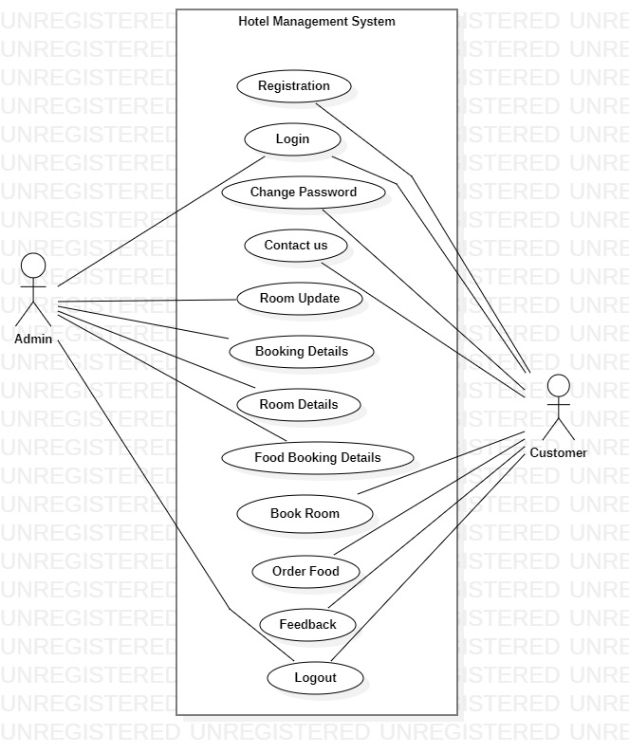

**RESPONSIBILITIES**

* Developing a project plan
* Communicate with project partner
* Establish a project schedule
* Documenting the process
* Identify risks

**Thank You**