**Assignment – Hive**

1. Download vehicle sales data -> <https://github.com/shashank-mishra219/Hive-Class/blob/main/sales_order_data.csv>

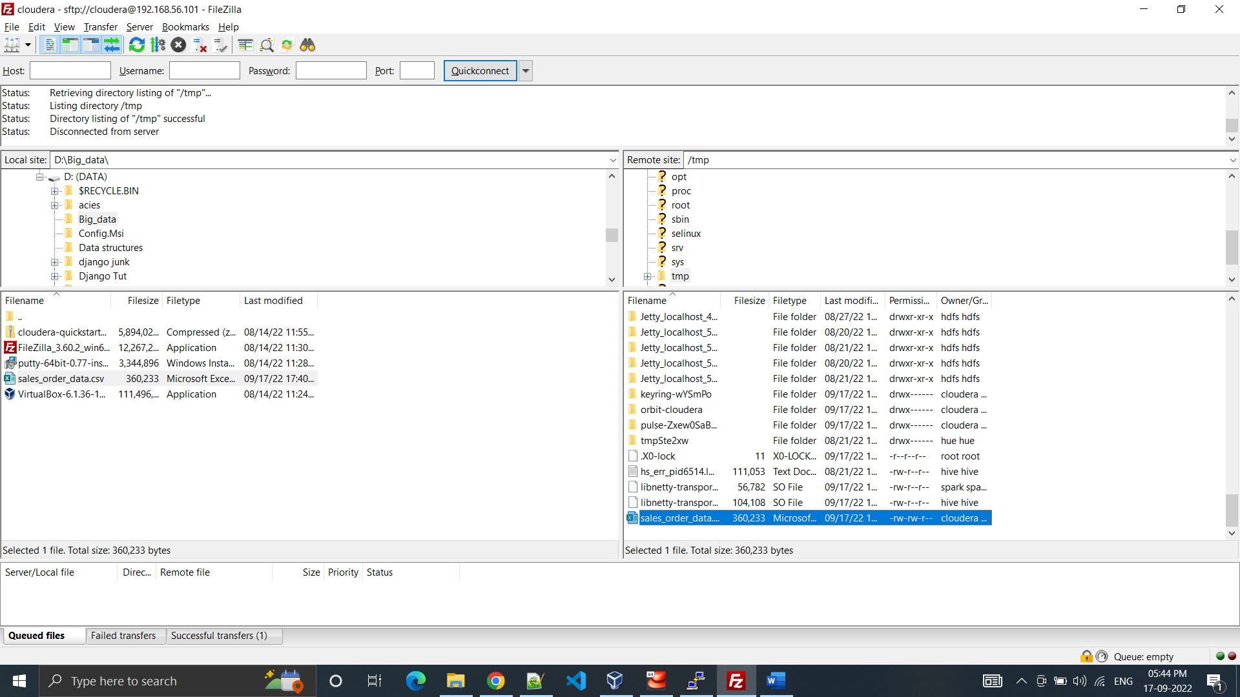

2. Store raw data into hdfs location

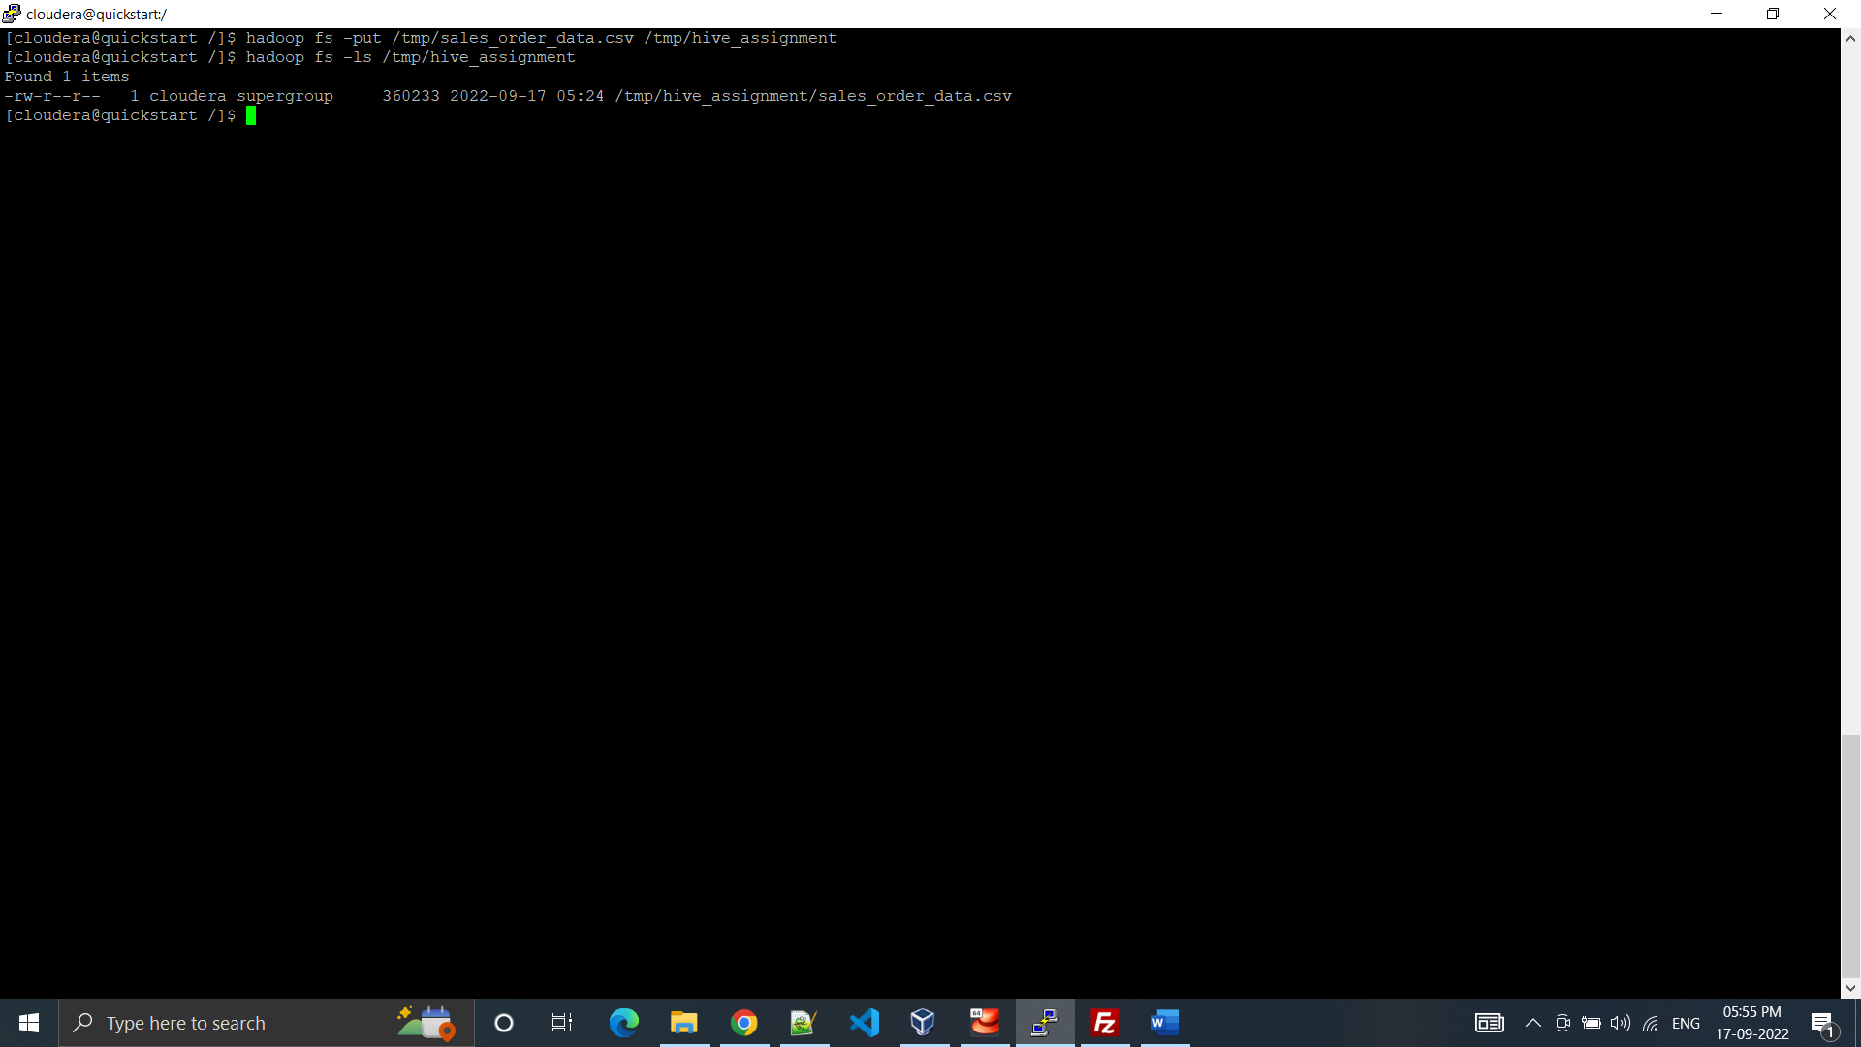

3. Create a internal hive table "sales_order_csv" which will store csv data sales_order_csv .. make sure to skip header row while creating table

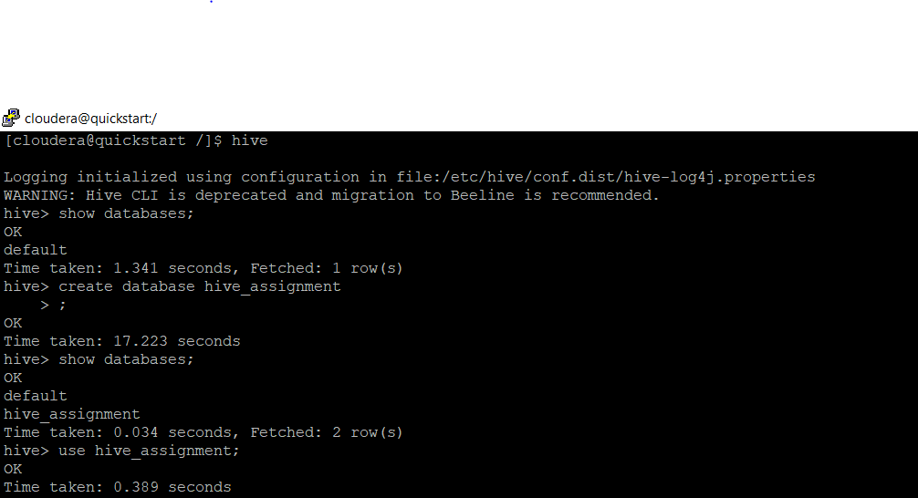

4. Load data from hdfs path into "sales_order_csv"

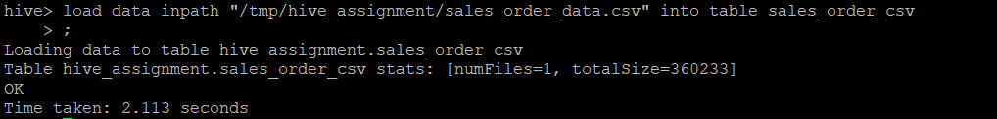

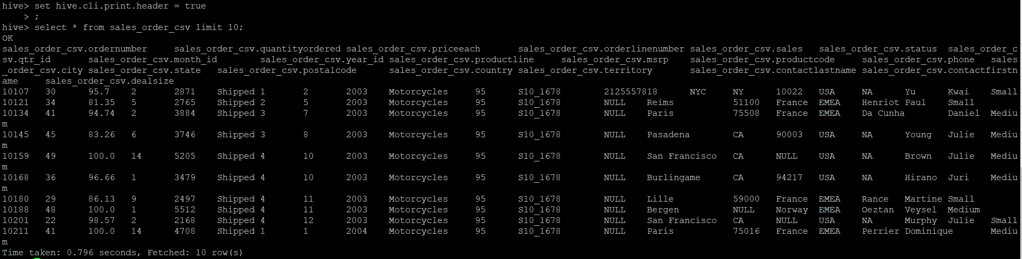

5. Create an internal hive table which will store data in ORC format "sales_order_orc".

6. Load data from "sales_order_csv" into "sales_order_orc"

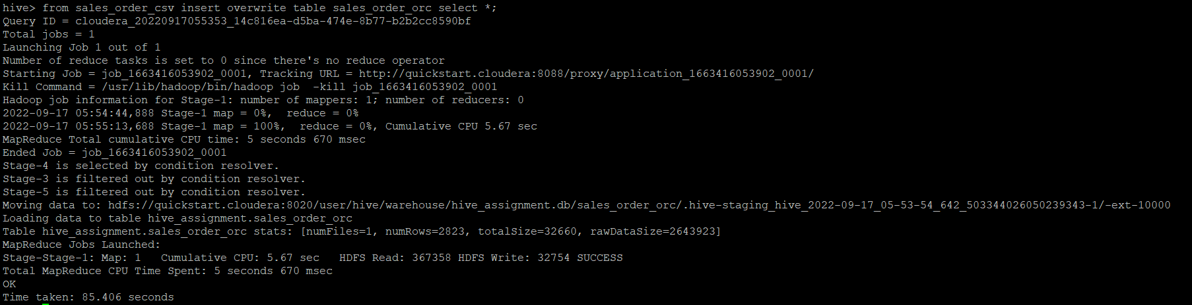

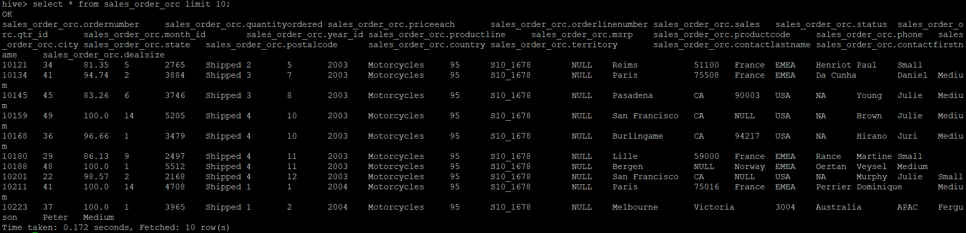

Perform below mentioned queries on "sales_order_orc" table :

1. Calculate total sales per year

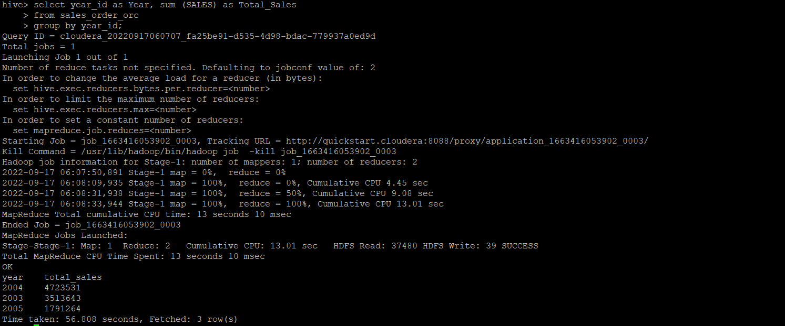

b. Find a product for which maximum orders were placed

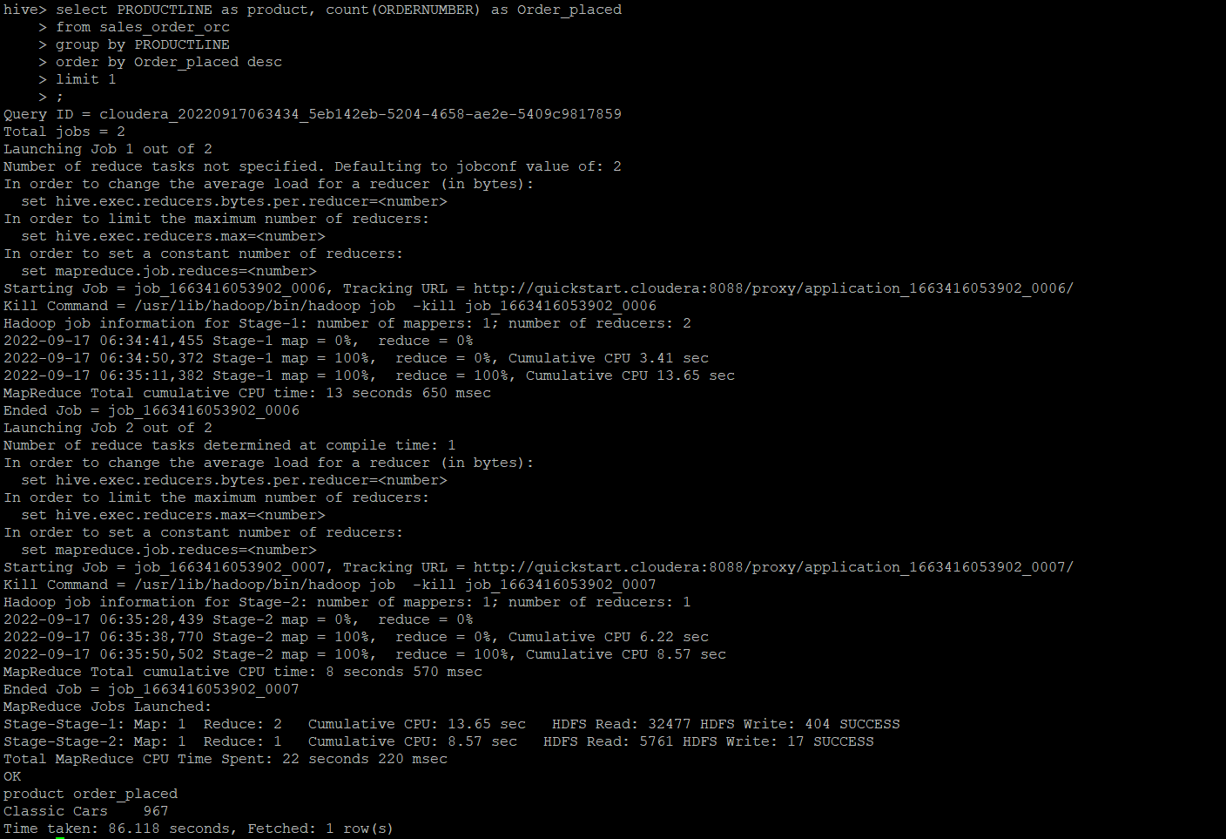

c. Calculate the total sales for each quarter

d. In which quarter sales was minimum

e. In which country sales was maximum and in which country sales was minimum

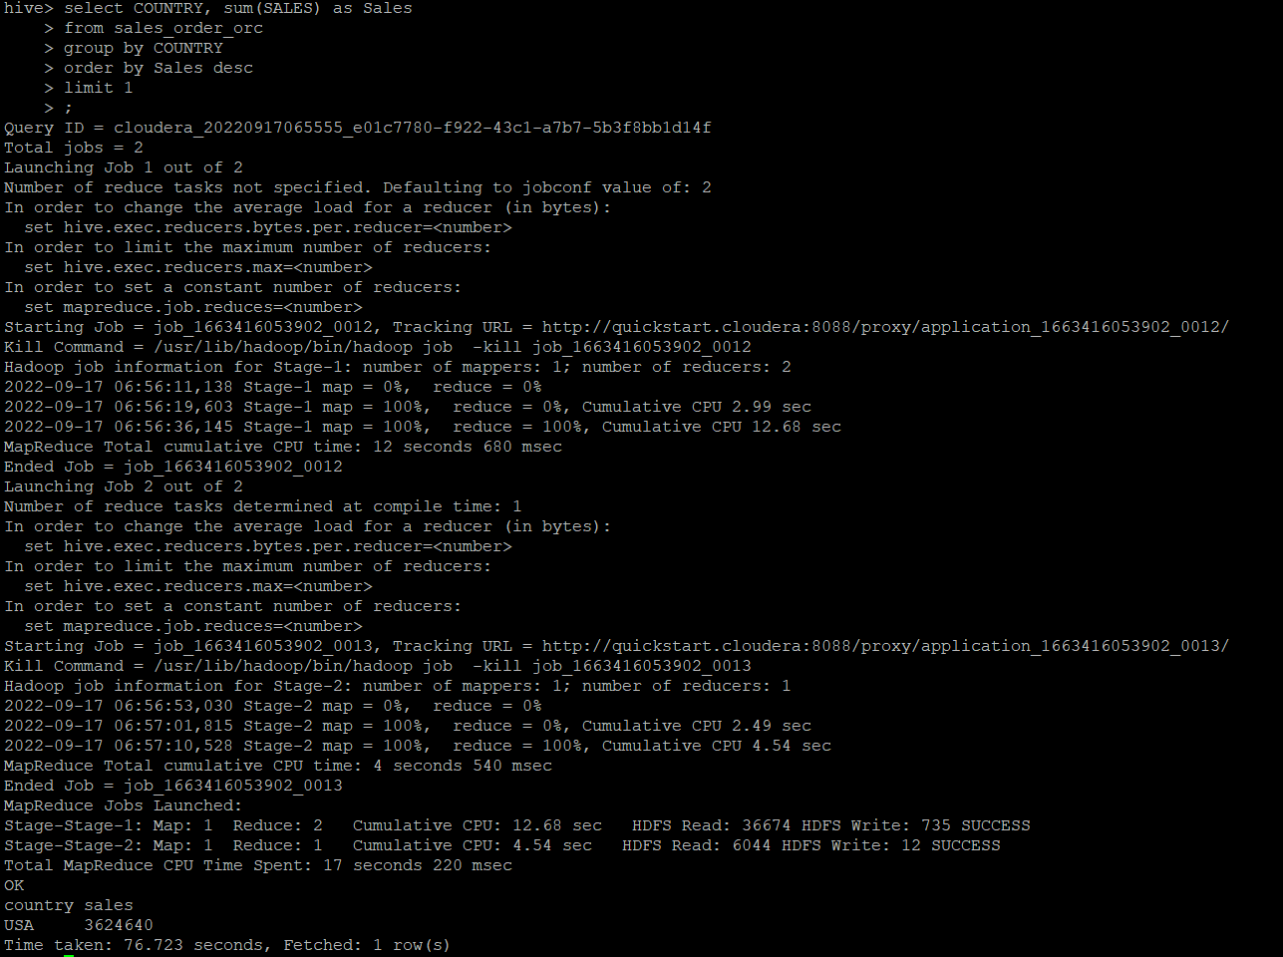

f. Calculate quarterly sales for each city

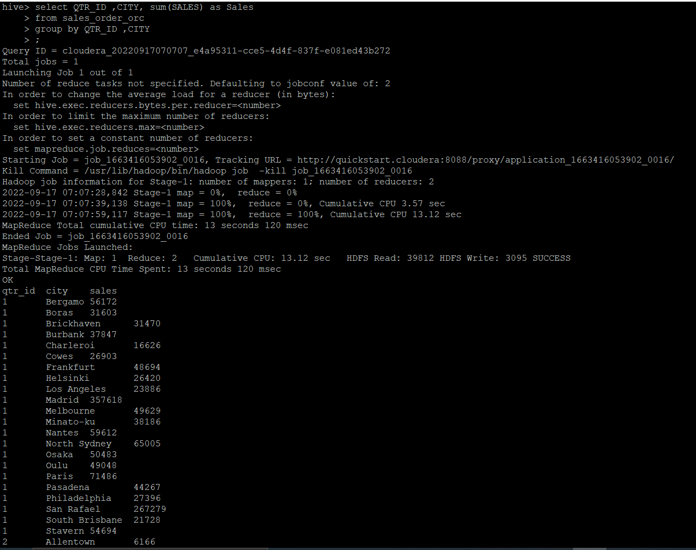

h. Find a month for each year in which maximum number of quantities were sold.



