1. Create a schema based on the given dataset

(

sl_no int,

agent string,

date string,

login_time string,

logout_time string,

duration string

)

row format delimited

fields terminated by ','

stored as textfile

tblproperties("skip.header.line.count"="1")

;

2. Dump the data inside the hdfs in the given schema location.

load data local inpath '/tmp/AgentLogingReport.csv' into table agentloging_staging;

create table agentlogin as select sl_no, agent, from_unixtime(unix_timestamp(date ,'dd-MMM-yy'), 'dd-MM-yyyy') date,

from_unixtime(unix_timestamp(login_time ,'HH:mm:ss'), 'HH:mm:ss') login_time,

from_unixtime(unix_timestamp(logout_time ,'HH:mm:ss'), 'HH:mm:ss') logout_time,

from_unixtime(unix_timestamp(duration ,'HH:mm:ss'), 'HH:mm:ss') duration

from agentloging_staging;

create table agentperformance_staging

(

sl_no int,

date string,

agent_name string,

total_chats int,

avg_response_time string,

avg_resolution_time string,

avg_rating float,

total_feedback int

)

row format delimited

fields terminated by ','

stored as textfile

tblproperties("skip.header.line.count"="1")

;

load data local inpath '/tmp/AgentPerformance.csv' into table agentperformance_staging;

create table agentperformance as select sl_no, from_unixtime(unix_timestamp(date ,'mm/dd/yyyy'), 'dd-mm-yyyy') date, agent_name, total_chats,

from_unixtime(unix_timestamp(avg_response_time ,'HH:mm:ss'), 'HH:mm:ss') avg_response_time,

from_unixtime(unix_timestamp(avg_resolution_time ,'HH:mm:ss'), 'HH:mm:ss') avg_resolution_time,

avg_rating , total_feedback

from agentperformance_staging

;

--List of all agents' names.

select distinct agent_name from agentperformance;

--Find out agent average rating.

select agent_name, round(avg(avg_rating),2) average_rating from agentperformance group by agent_name;

--Total working days for each agents

select agent, count(*) working_days from agentlogin group by agent;

--Total query that each agent have taken

select agent_name, sum(total_chats) total_chats from agentperformance group by agent_name;

--Total Feedback that each agent have received

select agent_name, sum(total_feedback) total_feedback from agentperformance group by agent_name;

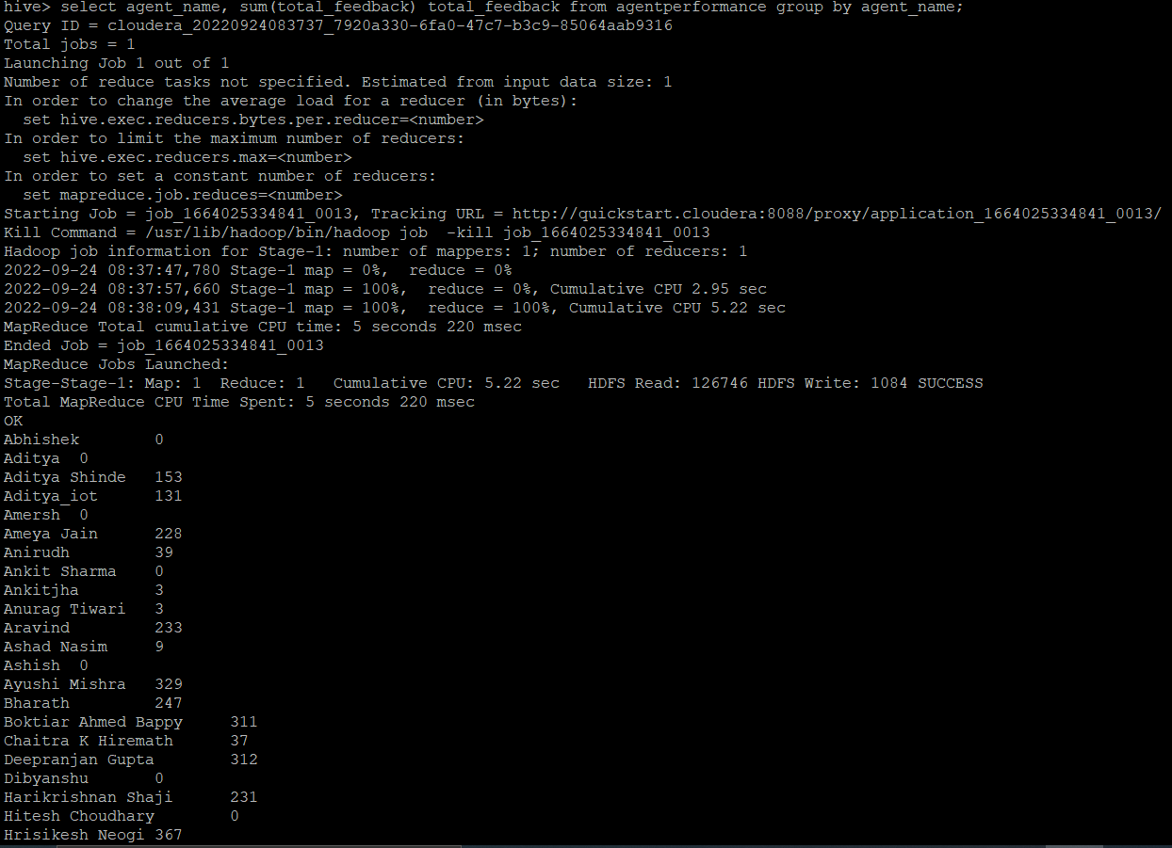

--Agent name who have average rating between 3.5 to 4

select agent_name, avg_rating from agentperformance where avg_rating >= 3.5 and avg_rating <=4;

--Agent name who have rating less than 3.5

select agent_name, round(avg(avg_rating),2) average_rating from agentperformance group by agent_name having round(avg(avg_rating),2) < 3.5;

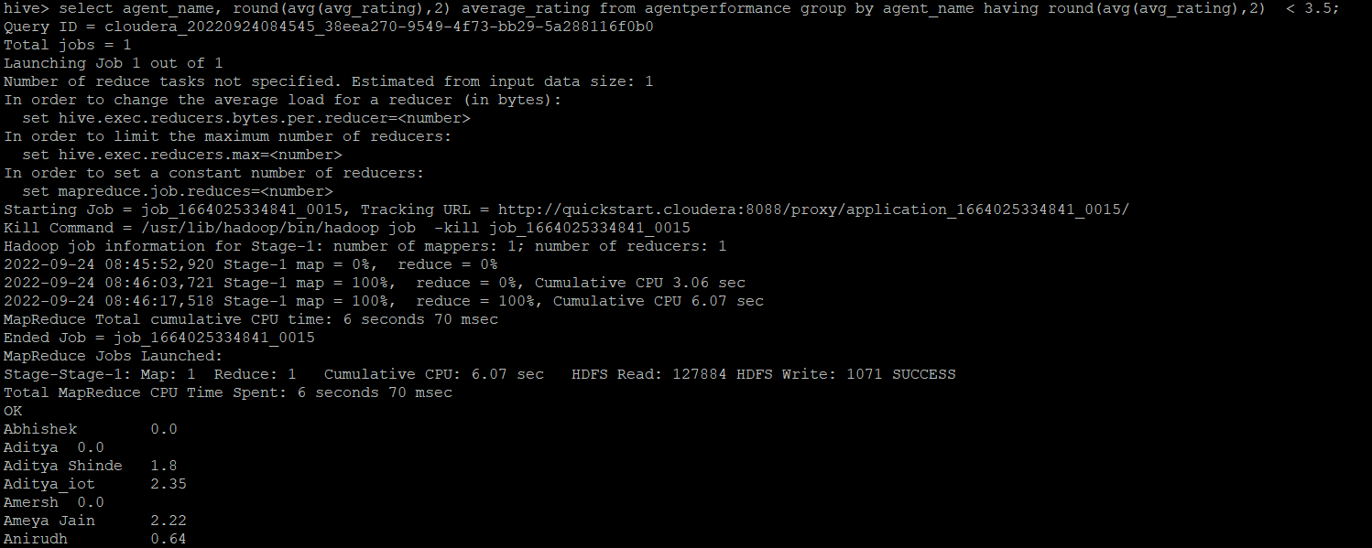

--Agent name who have rating more than 4.5

select agent_name, round(avg(avg_rating),2) average_rating from agentperformance group by agent_name having round(avg(avg_rating),2) > 4.5;

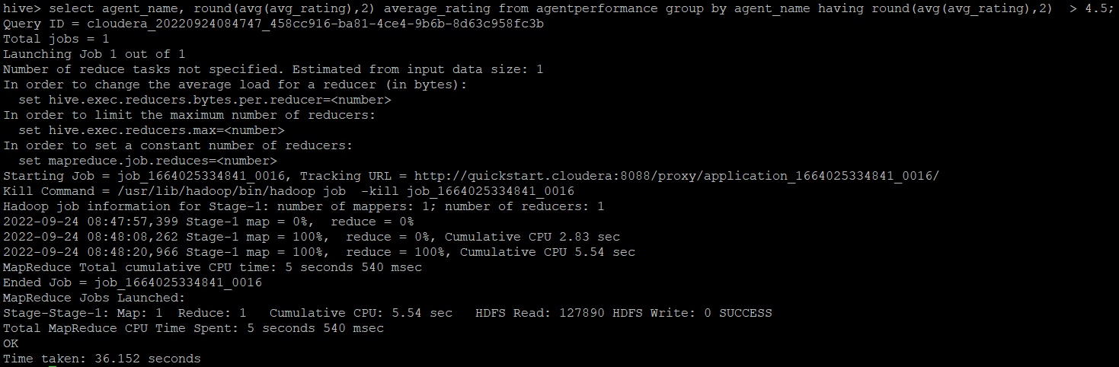

--How many feedback agents have received more than 4.5 average

select agent_name, round(avg(total_feedback),2) avg_total_feedback from agentperformance group by agent_name having avg(total_feedback) > 4.5;

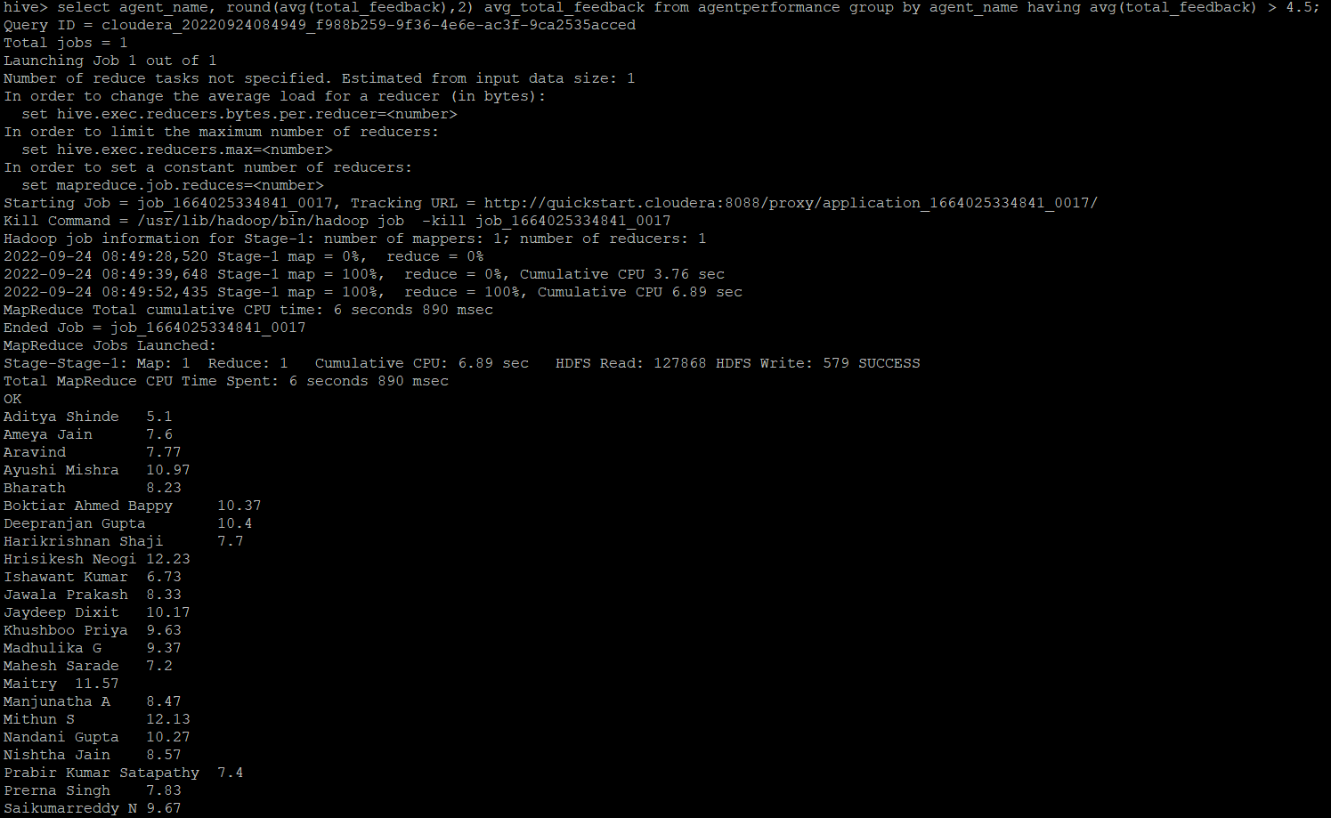

--average weekly response time for each agent

select weekofyear(to_date(date)) Week,agent_name,from_unixtime(cast(avg(unix_timestamp(avg_response_time,'HH:mm:ss'))as bigint),'HH:mm:ss') avg_response_time from agentperformance group by weekofyear(to_date(date)),agent_name;

--average weekly resolution time for each agents

select weekofyear(to_date(date)) Week,agent_name,from_unixtime(cast(avg(unix_timestamp(avg_resolution_time))as bigint),'HH:mm:ss') avg_resolution_time from agentperformance group by weekofyear(to_date(date)),agent_name;

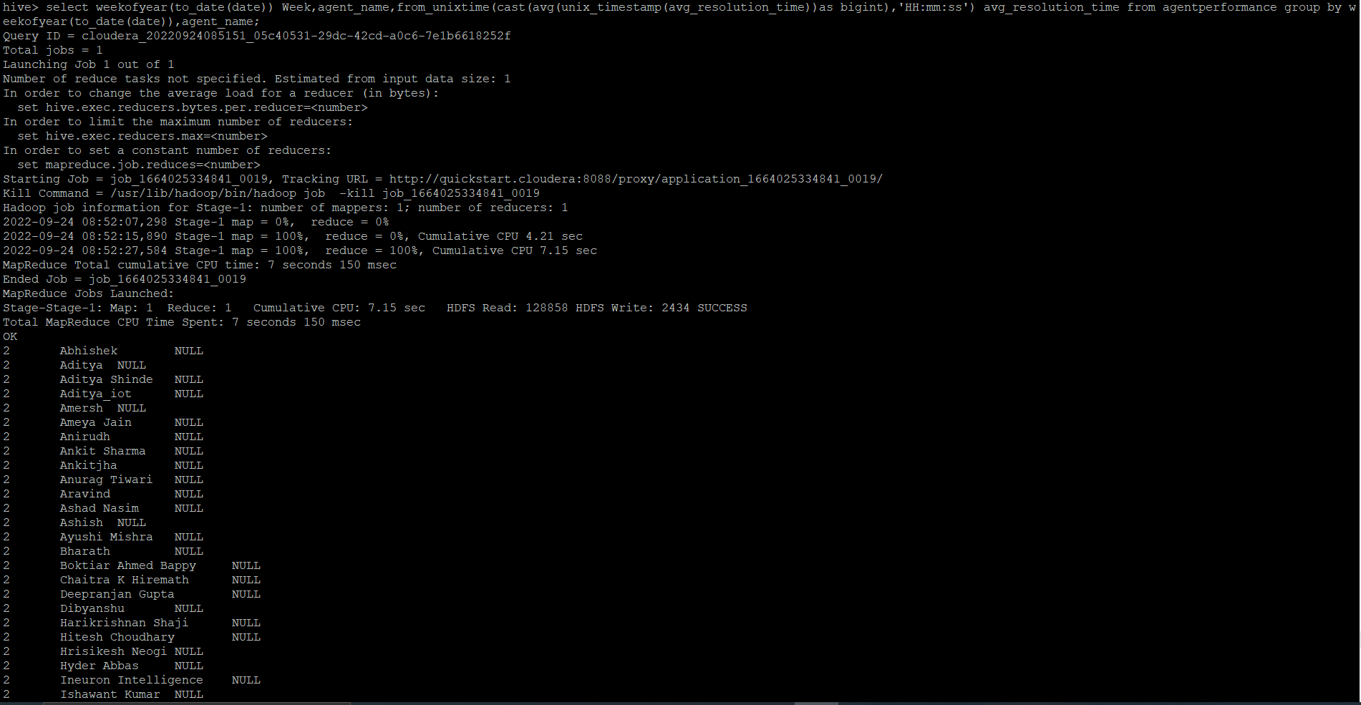

--Find the number of chat on which they have received a feedback

select total_feedback,count(total_chats) no_of_chats from agentperformance where total_feedback !=0 group by total_feedback;

--Perform partitioning on top of the agent column and then on top of that perform bucketing for each partitioning.

set hive.exec.dynamic.partition.mode = nonstrict;

set hive.enforce.bucketing = true;

create table agentperformance_part

(

sl_no int,

date string,

total_chats int,

avg_response_time string,

avg_resolution_time string,

avg_rating float,

total_feedback int

)

partitioned by (agent_name string)

clustered by (date)

sorted by (date)

into 5 buckets

;

insert overwrite table agentperformance_part

partition(agent_name)

select sl_no, date, total_chats, avg_response_time, avg_resolution_time, avg_rating, total_feedback, agent_name

from agentperformance;



