1. Write a program that calculates and prints the value according to the given formula:

Q = Square root of [(2 C D)/H]

Following are the fixed values of C and H:

C is 50. H is 30.

D is the variable whose values should be input to your program in a comma-separated sequence.

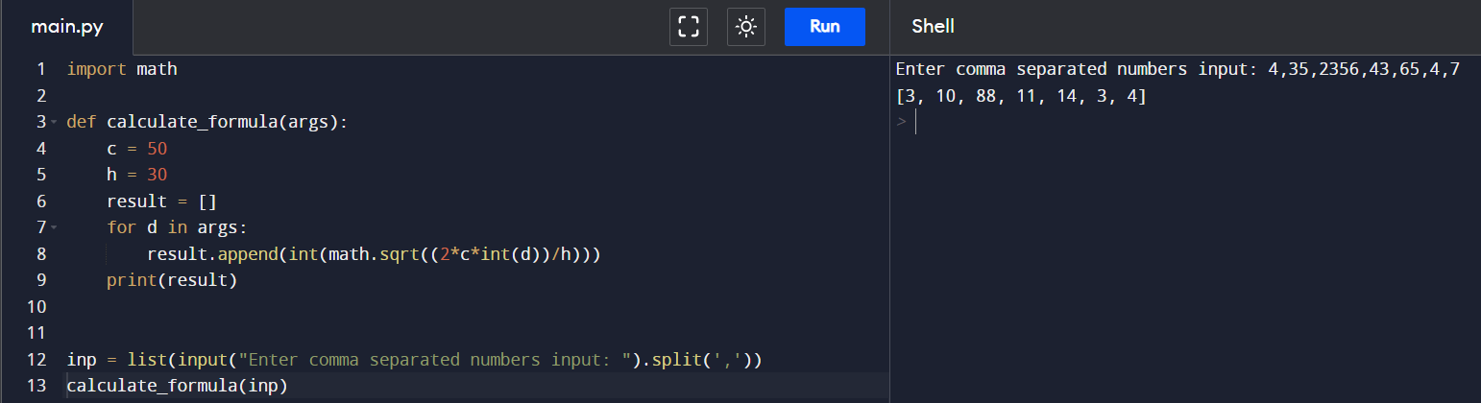

2. Write a program which takes 2 digits, X,Y as input and generates a 2-dimensional array. The element value in the i-th row and j-th column of the array should be i\*j.

3. Write a program that accepts a comma separated sequence of words as input and prints the words in a comma-separated sequence after sorting them alphabetically.

4. Write a program that accepts a sequence of whitespace separated words as input and prints the words after removing all duplicate words and sorting them alphanumerically.

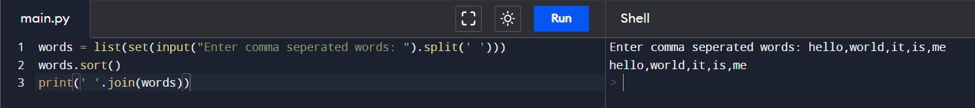

5. Write a program that accepts a sentence and calculate the number of letters and digits.

6. A website requires the users to input username and password to register. Write a program to check the validity of password input by users.