1. Define a class with a generator which can iterate the numbers, which are divisible by 7, between a given range 0 and n.

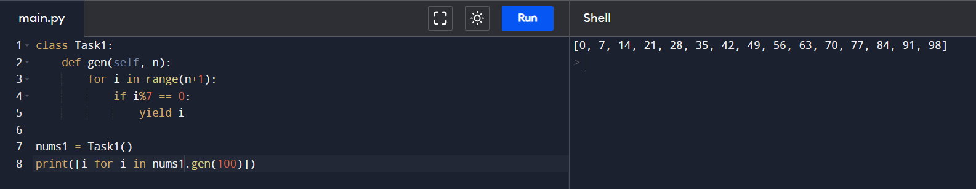

1. Write a program to compute the frequency of the words from the input. The output should output after sorting the key alphanumerically.

1. Define a class Person and its two child classes: Male and Female. All classes have a method "getGender" which can print "Male" for Male class and "Female" for Female class.

1. Please write a program to generate all sentences where subject is in ["I", "You"] and verb is in ['Play', "Love"] and the object is in ["Hockey","Football"].

1. Please write a program to compress and decompress the string "hello world!hello world!hello world!hello world!"

1. Please write a binary search function which searches an item in a sorted list. The function should return the index of element to be searched in the list.

