1. Please write a program using generator to print the numbers which can be divisible by 5 and 7 between 0 and n in comma separated form while n is input by console.

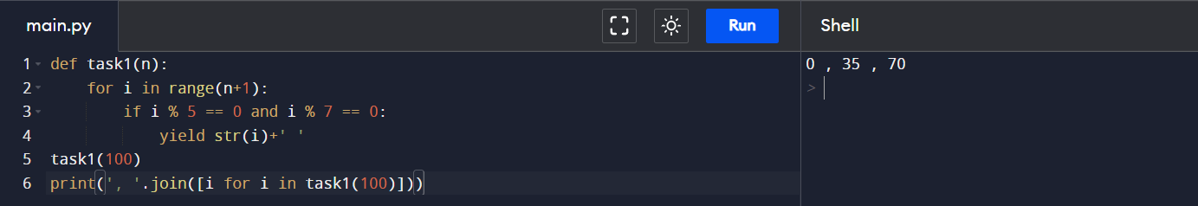

1. Please write a program using generator to print the even numbers between 0 and n in comma separated form while n is input by console.

1. Please write a program using list comprehension to print the Fibonacci Sequence in comma separated form with a given n input by console.

1. Assuming that we have some email addresses in the "username@companyname.com" format, please write program to print the user name of a given email address. Both user names and company names are composed of letters only.

1. Define a class named Shape and its subclass Square. The Square class has an init function which takes a length as argument. Both classes have a area function which can print the area of the shape where Shape's area is 0 by default.

