1. Write a Python program to convert kilometers to miles?

Code:-

km = 4

miles = km/1.609

print("value is ",miles)

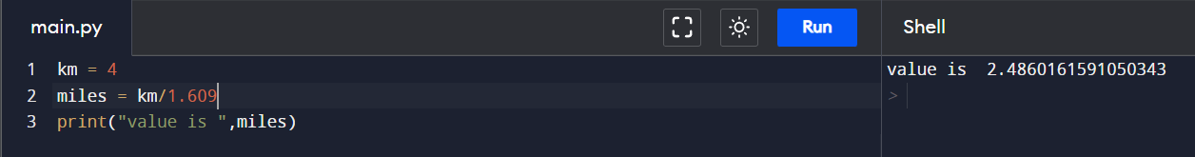

2.Write a Python program to convert Celsius to Fahrenheit?

Code:-

c = 25

f = (9\*c/5)+32

print(f,"deg F")

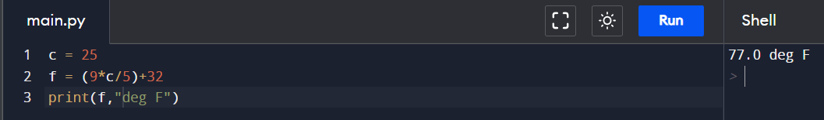

1. Write a Python program to display calendar?

Code:-

import calendar

year = 2021

month = 11

print(calendar.month(year, month))

1. Write a Python program to solve quadratic equation?

Code:-

import math

a = int(input(("Enter the coeff a: ")))

b = int(input(("Enter the coeff b: ")))

c = int(input(("Enter the constant c: ")))

d = (b\*\*2) - (4\*a\*c)

root1 = ((-1\*b)+(math.sqrt(d))) / (2\*a)

root2 = ((-1\*b)-(math.sqrt(d))) / (2\*a)

print(root1, root2)

1. Write a Python program to swap two variables without temp variable?

Code:-

var1 = 6

var2 = 4

var2 = var1 + var2

var1 = var2 - var1

var2 = var2 - var1

print(var1, var2)

