1. Write a Python Program to Check if a Number is Positive, Negative or Zero?

Code:-

print("Enter num")

num = int(input())

if(num > 0):

print(num, "is Positive")

elif(num < 0):

print(num, "is Negative")

else:

print(num, "is Zero")

1. Write a Python Program to Check if a Number is Odd or Even?

Code:-

num = int(input("Enter a number: "))

if(num % 2 == 0):

print(num, "is a Even Nummber")

else:

print(num, "is an Odd Number")

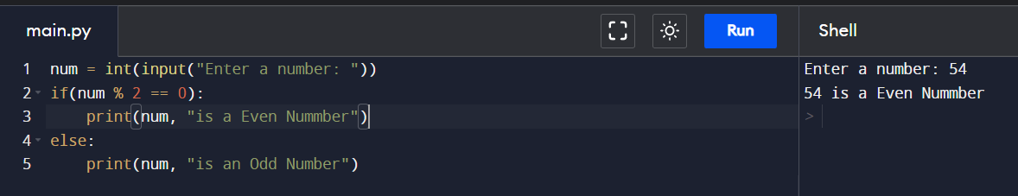

1. Write a Python Program to Check Leap Year?

Code:-

year = 2022

if(((year % 4 == 0) and (year % 100 != 0)) or (year % 400 == 0)):

print("Leap Year")

else:

print("Not a Leap Year")

1. Write a Python Program to Check Prime Number?

Code:=

num = int(input("Enter a number: "))

isPrime = True

if num <= 1:

print(num, "is neither prime nor composite")

else:

d = 2

while(d\*d <= num):

if(num%d==0):

isPrime = False

break

d = d + 1

if(num > 1):

if(isPrime):

print(num, "is prime number")

else:

print(num, "is not prime number")

1. Write a Python Program to Print all Prime Numbers in an Interval of 1-10000?

Code:-

for i in range(1, 100001):

print(i, end = ' ')