1. Write a Python Program to Find the Factorial of a Number?

Code:-

num = int(input("Enter a number: "))

fact = 1

for i in range(num, 0, -1):

fact = fact*i

print(fact)

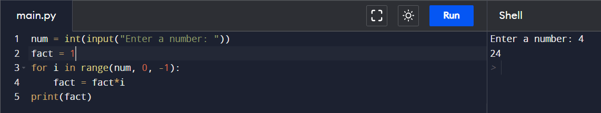

1. Write a Python Program to Display the multiplication Table?

Code:-

num = int(input("Enter a number: "))

for i in range(1, 11):

print(f"{num} x {i} = {num*1}")

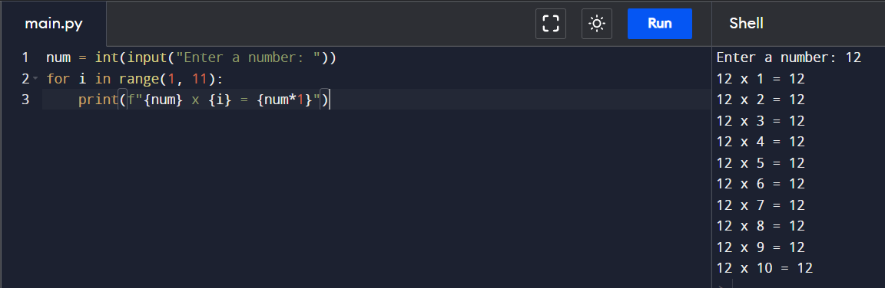

1. Write a Python Program to Print the Fibonacci sequence?

Code:-

fibo_length = int(input("Enter a length: "))

a = 0

b = 1

print(a, end = ' ')

print(b, end = ' ')

while(fibo_length-2 > 0):

nt = a + b

print(nt, end = ' ')

a = b

b = nt

fibo_length -= 1

1. Write a Python Program to Check Armstrong Number?

Code:-

import math

def fibo_check(num):

l = len(str(num)) ## l = number of digits of number

sum1 = 0

temp_num = num

while(num > 0):

d = num % 10

sum1 += int(math.pow(d, l))

num = num // 10

if(sum1 == int(temp_num)):

return 1

else:

return 0

num = int(input("Enter a number: "))

if(fibo_check(num)):

print("{} is an armstrong number".format(num))

else:

print("{} is not an armstrong number".format(num))

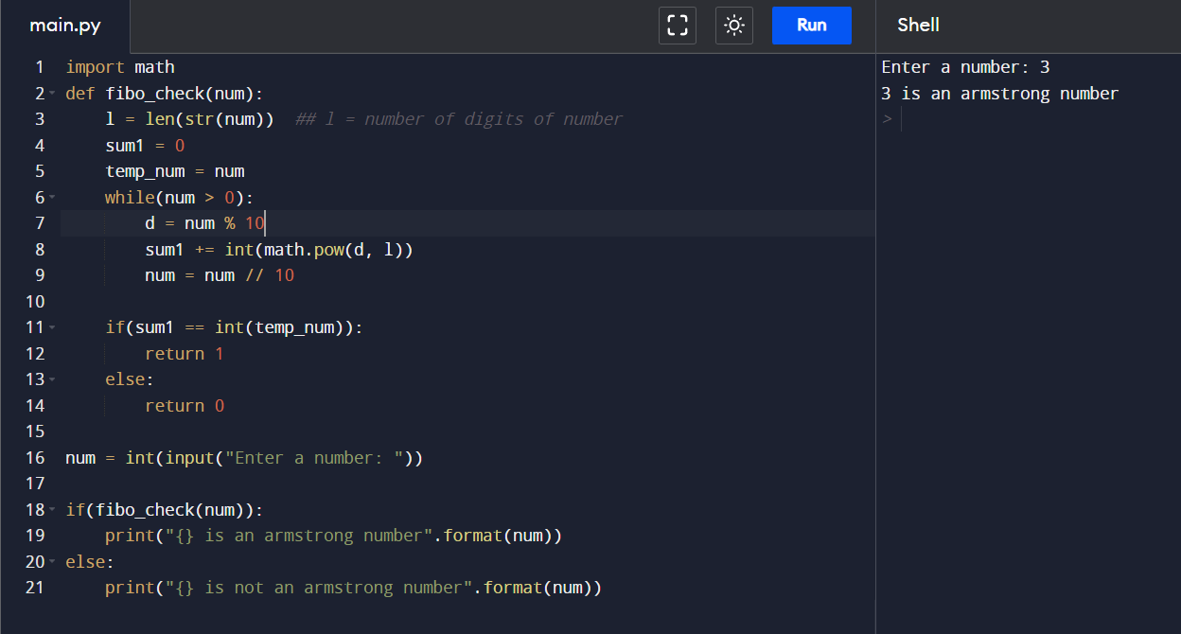

1. Write a Python Program to Find the Sum of Natural Numbers?

num = int(input("Enter a positive number: "))

total_sum = 0

for i in range(1, num+1):

total_sum += i

print("Sum of {} natural number is {}".format(num, total_sum))

