1. Write a Python Program to Find LCM?

Code:-

a=int(input("Enter a:"))

b=int(input("Enter b:"))

high = a if a > b else b

while True:

if (high%a==0) and (high%b==0):

break

else:

high += 1

print("LCM is",high)

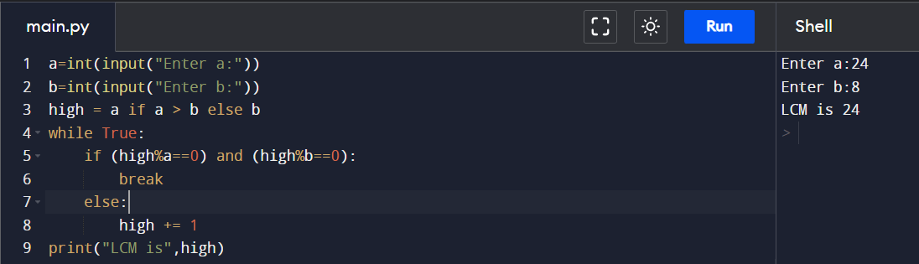

1. Write a Python Program to Find HCF?

Code:-

a=int(input("Enter a:"))

b=int(input("Enter b:"))

low = a if a < b else b

for i in range(1, low+1):

if (a%i==0) and (b%i==0):

hcf = i

print("HCF:-",hcf)

1. Write a Python Program to Convert Decimal to Binary, Octal and Hexadecimal?

Code:-

dec = 344

print("The decimal value of", dec, "is:")

print(bin(dec), "in binary.")

print(oct(dec), "in octal.")

print(hex(dec), "in hexadecimal.")

1. Write a Python Program To Find ASCII value of a character?

Code:-

char = input("Enter a character: ")

print(f"ASCII value of {char} is {ord(char)}")

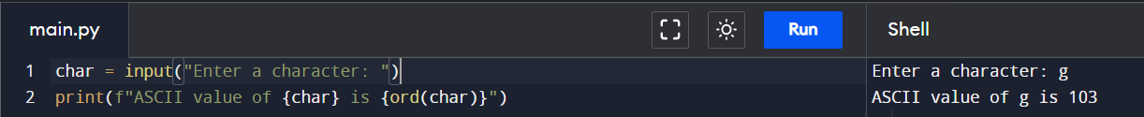

1. Write a Python Program to Make a Simple Calculator with 4 basic mathematical operations?

Code:-

num1 = int(input("Enter first number: "))

num2 = int(input("Enter second number: "))

print("\nFor addition: +")

print("For subtraction: -")

print("For multiplicaton: \*")

print("For division: /")

ch = input("\nEnter the choice: ")

if ch == '+':

output = num1 + num2

elif ch == '-':

output = num1 - num2

elif ch == '\*':

output = num1 \* num2

elif ch == '/':

output = num1 / num2

print("\nResult: ", output)

