1. Write a Python Program to Display Fibonacci Sequence Using Recursion?

Code:-

def fibonacci(n):

if(n <= 1):

return n

else:

return(fibonacci(n-1) + fibonacci(n-2))

n = int(input("Enter number of terms:"))

print("Fibonacci sequence:")

for i in range(n):

print(fibonacci(i))

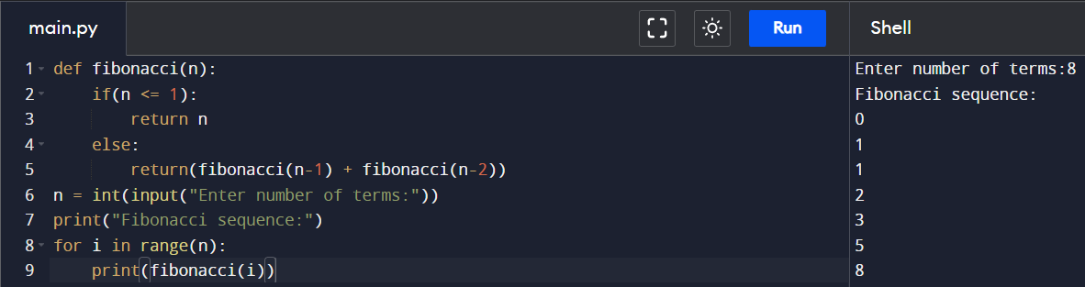

1. Write a Python Program to Find Factorial of Number Using Recursion?

Code:-

def fact(n):

if n == 0:

return 1

else:

return n\*fact(n-1)

print(fact(4))

1. Write a Python Program to calculate your Body Mass Index?

Code:-

weight = int(input("Enter weight:"))

height = int(input("Enter height:"))

bmi = weight/(height\*height)

print("BMI:-",round(bmi,4))

1. Write a Python Program to calculate the natural logarithm of any number?

Code:-

import math

num = int(input("Enter the number: "))

print(math.log(num))

1. Write a Python Program for cube sum of first n natural numbers?

Code:-

num = int(input("Enter the number: "))

print(sum(range(num+1))\*\*3)

