1. Write a Python Program to find sum of array?

Code:-

l = [1,2,3,-412, 123, 369, 111]

total = 0

for i in l:

total += i

print("Sum of array: ", total)

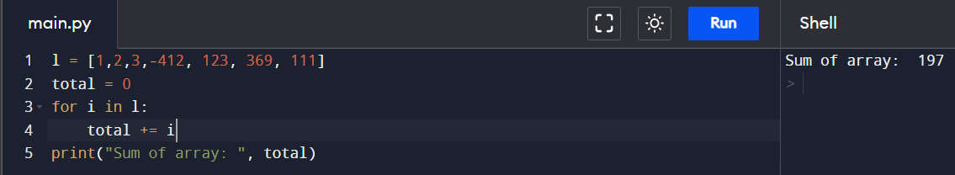

1. Write a Python Program to find largest element in an array?

Code:-

l = [1,2,3,-412, 123, 369, 111]

print(max(l))

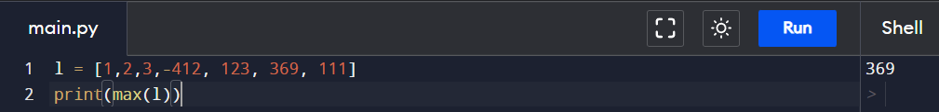

1. Write a Python Program for array rotation?

Code:-

l = [1,2,3,-412, 123, 369, 111]

print("Rotated array:")

print(l[::-1])

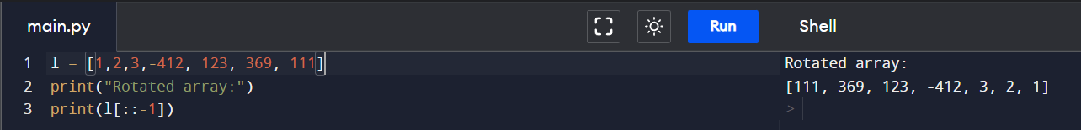

1. Write a Python Program to Split the array and add the first part to the end?

Code:-

l = [1,2,3,-412, 123, 369, 111]

splitIndex = int(input("Enter split index:"))

ans = []

for i in range(len(l)):

index = (i+len(l)+splitIndex)%len(l)

ans.append(l[index])

print(ans)

1. Write a Python Program to check if given array is Monotonic?

Code:-

def isMonotonic(A):

return (all(A[i] <= A[i + 1] for i in range(len(A) - 1)) or

all(A[i] >= A[i + 1] for i in range(len(A) - 1)))

A = [6, 5, 4, 4]

print(isMonotonic(A))

