1. Write a Python Program to Add Two Matrices?

Code:-

X = [[12,7,3],

[4 ,5,6],

[7 ,8,9]]

Y = [[5,8,1],

[6,7,3],

[4,5,9]]

result = [[0,0,0],

[0,0,0],

[0,0,0]]

# iterate through rows

for i in range(len(X)):

# iterate through columns

for j in range(len(X[0])):

result[i][j] = X[i][j] + Y[i][j]

for r in result:

print(r)

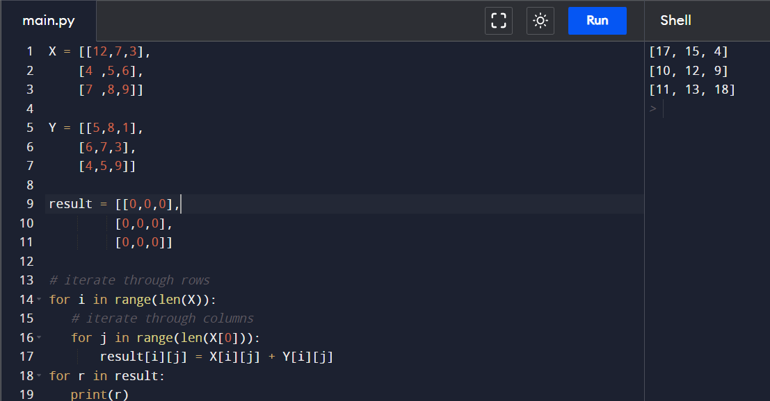

2. Write a Python Program to Multiply Two Matrices?

Code:-

# Take 3x3 matrix

A = [[12, 7, 3],

[4, 5, 6],

[7, 8, 9]]

B = [[5, 8, 1, 2],

[6, 7, 3, 0],

[4, 5, 9, 1]]

result = [[0, 0, 0, 0],

[0, 0, 0, 0],

[0, 0, 0, 0]]

for i in range(len(A)):

for j in range(len(B[0])):

for k in range(len(B)):

result[i][j] += A[i][k] * B[k][j]

for r in result:

print(r)

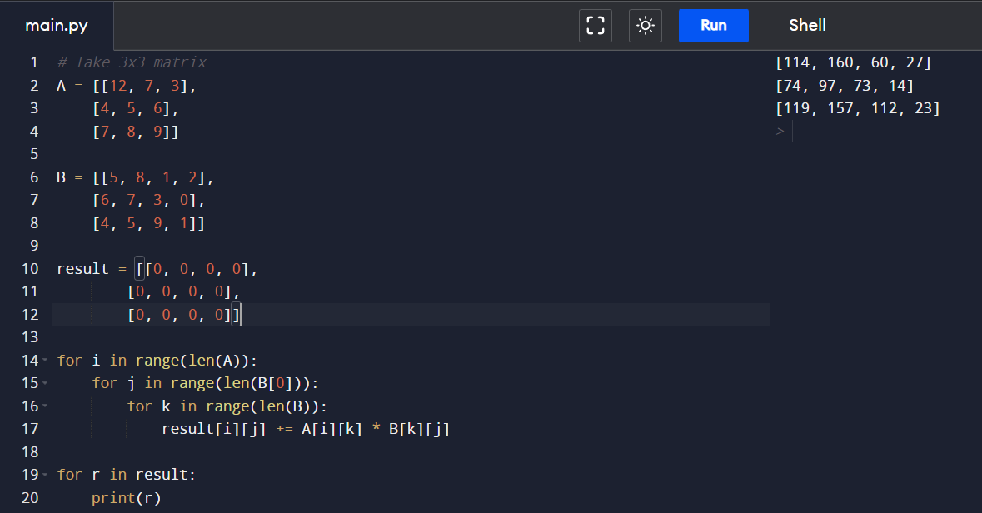

1. Write a Python Program to Transpose a Matrix?

Code:-

# Program to transpose a matrix using a nested loop

X = [[12,7],

[4 ,5],

[3 ,8]]

result = [[0,0,0],

[0,0,0]]

# iterating through rows

for i in range(len(X)):

# iterating through columns

for j in range(len(X[0])):

result[j][i] = X[i][j]

for r in result:

1. Write a Python Program to Sort Words in Alphabetic Order?

Code:-

sentance = input("Enter the words: ")

words = [word.lower() for word in sentance.split()]

words.sort()

print("Sorted order of words:")

for word in words:

print(word)

1. Write a Python Program to Remove Punctuation From a String?

Code:-

punctuations = '''!()-[]{};:'"\,<>./?@#$%^&*_~'''

string = input("Enter the string: ")

outputString = ""

for char in string:

if char not in punctuations:

outputString += char

print(outputString)

