

Comprehensive Functional and Business Document
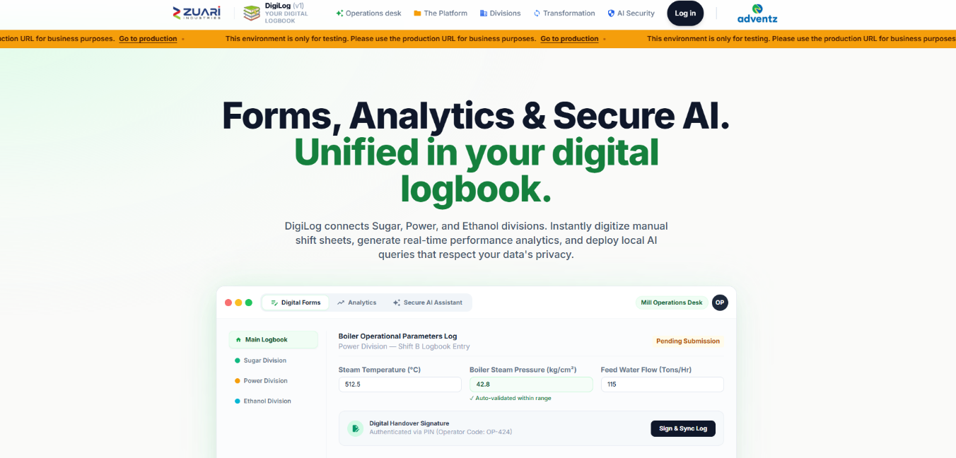
Every screen, button, form field, click action, and business rule — written so anyone can understand the application.

Item | Detail
Audience | Business heads, plant leadership, functional owners, and anyone who needs to understand the complete application
Organization | Zuari Industries (GSMA plant operations — Gobind Sugar Mill)
System | DigiLog — digital logbook, equipment history, and plant analytics
Last verified against source | 8 October 2026
URL | https://digilog.zuarione.com/
Classification | Internal — business use
Companion technical note | docs/PROJECT.md and docs/DigiLog_Technical_Documentation.md (engineer audience)
Source | docs/BUSINESS_FUNCTIONAL_DOCUMENT.md (full text, not a summary)
Generated | 2026-10-08

Table of Contents
This Word file is generated from the full markdown source. Heading styles are applied so you can also use Word’s Navigation pane (View → Navigation Pane).
1. Executive Summary
2. Business Problem DigiLog Addresses
3. Who Uses It — Roles and Access
3.1 User Roles
3.2 Homepage Cards
3.3 App and Form Mapping
4. Screen-by-Screen Navigation Map
4.1 Marketing Landing Page (Public — Unauthenticated)
4.2 Employee Login Modal
4.3 Admin Login Page
4.4 Homepage (Authenticated Employee Dashboard)
4.5 Navigation Bar (Navbar — All Authenticated Pages)
4.6 Profile Modal
4.7 Forms Hub Landing
4.8 Forms Hub Category Page
4.9 App Detail Page
4.10 BI Control Tower Hub
5. Daily Operational Workflow
Step-by-Step User Journey
6. Functional Catalogue
6.0 Standard UI Elements on Every Form
6.1 Operations Forms
6.1.1 Mill Logbook
6.1.2 Lab Logbook
6.1.3 Power Logbook
6.1.4 Distillery Operations (/forms/distillery_ops)
6.1.5 EHS — Environment, Health and Safety
6.1.6 Production Forms
6.1.7 Brix Sampling
6.2 Equipment Maintenance and History
6.2.1 Production House Equipment History
6.2.2 Power Plant Equipment History
6.2.3 Sugar House Equipment History
6.3 Power BI Dashboards (BI Control Tower)
Dashboard: Management Overview
Dashboard: Cane Operations
Dashboard: Cane Quality (Brix Sampling)
Dashboard: Centre Maturity
Dashboard: Milling Operations
Dashboard: Power Plant Operations
Dashboard: Distillery Operations
Dashboard: Purchy Analysis
6.4 Data Ingestion Centre
7. Approval and Governance
7.1 Approval Dashboard (/maintenance/approvals)
7.2 Forms Approval Statuses
7.3 Email-based Approval
7.4 Audit
8. Notification System
8.1 Real-time Delivery
8.2 Notification Badge
8.3 Notification Dropdown
8.4 Toast Styles by Notification Type
8.5 Audio
9. Administration — Complete Config Reference
9.1 Employees
9.2 Employee Categories
9.3 Season Mapping
9.4 BI Dashboards
9.5 Audit & Activity
9.6 Maintenance History Approval
9.7 Forms Approval
10. Security in Business Language
11. Technology Stack
11.1 Frontend (What the User Touches)
11.2 Backend (Business Rules)
11.3 Architecture Diagram
11.4 Marketing Claims NOT in the Product
12. Operating Picture
13. Decisions Still Open for Leadership
14. Glossary
15. Document History
This document describes everything DigiLog does — every screen, every button, every form field, every click action, and every business rule. It is written so that a person who has never opened the application can understand exactly what happens at every point.

1. Executive Summary
DigiLog is the plant's operating system for shift records, laboratory and process logbooks, environment and safety reporting, equipment life history, and management analytics.
It replaces paper registers for sugar (cane, mill, boiling house, laboratory), power, distillery (ethanol), and EHS. Operators enter data once. Department heads can be required to approve selected entries before they stand as official. Leadership sees the same numbers in a BI Control Tower: cane, milling, sugar, power, and distillery on one management scorecard, plus specialist dashboards for cane quality, grower performance, and power-house operations.
Access is not open to everyone. An administrator provisions each person, assigns the apps they may open, and can restrict them to specific forms. Sign-in is by company password, Microsoft (Outlook), or Google. Every signed-in session and important create / update / delete action can be audited.
Business outcome: one controlled record of what happened on the shift, what was maintained on the asset, and how the season is performing — visible to the people who are allowed to see it, and reviewable by the head of department when approval is switched on.

2. Business Problem DigiLog Addresses
# | Before (Paper / Scattered Sheets) | With DigiLog (Centralized & Digital)
1 | Shift sheets live in binders and personal spreadsheets. Data is siloed and hard to search. | Entries are captured in named digital logbooks tied securely to the date, shift, and specific user.
2 | The same reading can be written down twice, or impossible numbers (like a pH of 20) can be recorded by mistake. | Validation checks reject bad entries (e.g., pH must be 0–14 on G shift for ETP) and prevent duplicate rows before they are stored.
3 | Consolidation for the daily meeting is manual. Someone has to spend hours copying data from paper into Excel. | Dashboards automatically calculate indicators (cane, mill, sugar, power, distillery) for WTD, MTD, and STD, and can instantly compare seasons.
4 | Equipment history is kept on physical paper cards or isolated files that can be lost or are hard to access during a night shift. | Assets have a centralized digital card. It holds specifications, OEM schedules, and a permanent maintenance history with attached photos.
5 | "Who changed this number?" is hard to answer when using shared spreadsheets or paper. | Audit logs, session tracking, and approval history permanently record the action, the person, and the before/after values.
6 | Grower and cane data arrives in scattered Excel files via email. | A dedicated Data Ingestion Centre securely loads and tracks Purchy, Management, and Milling files for authorized users.
7 | Accident records are scattered across departments with no central registry. | EHS forms capture Near Miss/Accident Reports with severity, treatment, photos, and document uploads in one place.
8 | Water consumption and effluent data is tracked manually across bore wells and treatment plants. | Three dedicated EHS water forms (Ground Water Abstraction, ETP Working, CPU Water Recycle) with auto-calculated totals.

3. Who Uses It — Roles and Access

3.1 User Roles
Role | What they do | How the system treats them
Operator / chemist / shift staff (role: employee) | Fill logbooks, record stoppages, sample Brix, log EHS events, update equipment history | Sees only the homepage cards, apps, and forms an admin has mapped to them. Can be set to Forms Hub view-only (read, not submit). When view-only is ON, a yellow banner appears at the top of every form: "You have view-only access to Forms Hub." The submit button is hidden.
Head of Department (HOD) | Reviews queued form entries and maintenance-history changes; accepts, sends back for modification, or rejects | Named as the HOD on an approval setting. Receives in-app notifications and scheduled email digests. Does not need the admin role. Gets an "Approvals" icon in the navbar.
Administrator | Creates employees, departments, app mappings, season dates, BI constants, and approval rules; reads the audit log | Separate admin sign-in at /admin/login. Cross-portal login (employee using the admin door, or the reverse) is blocked. Gets a "Config" icon in the navbar.
Leadership / management | Reads the management scorecard and the dashboards they are mapped to | Same employee account, with the BI Control Tower card and the specific dashboards assigned.
Data owner (cane / purchy / milling) | Uploads Excel or CSV into the Data Ingestion Centre | Upload rights are granted per section (Purchy, Management Dashboard, Milling), not to every user. Gets a "Data Upload" icon in the navbar.

3.2 Homepage Cards
Homepage cards an employee can be given (assigned in Admin → Employees):
Card Key | Card Name | What clicking it opens
forms_hub | Forms Hub | Navigates to /forms-hub — the two-category landing page (Operations forms / Equipment maintenance and history)
bi_control_tower | BI Control Tower | Navigates to /bi — the analytics dashboard hub

- An employee with both cards sees a two-column layout with large illustrated cards.
- An employee with one card sees a single centered card.
- An employee with neither card sees: "No homepage destinations assigned. Contact your admin to assign Forms Hub and/or BI Control Tower cards."

3.3 App and Form Mapping
Within each homepage card, the admin further controls what the employee sees:
- App Mapping: Checkboxes for each app (Mill Logbook, Lab Logbook, Power Logbook, EHS, Production, Brix Sampling, Distillery, equipment history apps). An employee only sees the app cards they are mapped to.
- Form-Level Restriction: Within each app, the admin can optionally restrict to specific forms. If left empty, the employee sees all forms in that app. If filled, they see only the listed forms.
- Dashboard Mapping: For BI Control Tower, individual dashboards (Management, Cane Performance, Milling Operations, etc.) can be assigned.

4. Screen-by-Screen Navigation Map
This section documents every screen and what the user sees at each point. It is designed so that a person who has never opened the application can understand exactly what happens at every click.

4.1 Employee Login
When it appears: The person clicks Sign In on the public DigiLog page.
A full-screen sign-in window opens. They can close it with the X, by clicking outside it, or by pressing Escape.
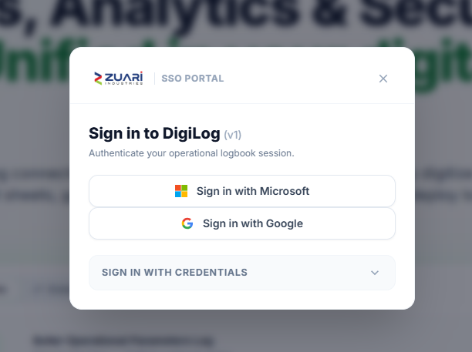
What they can use to sign in
Option | What happens
Microsoft | Company Outlook / Microsoft account. After a successful sign-in they land on their homepage. If the site is not on a secure connection, they are told Microsoft sign-in cannot be used.
Google | Google account popup. After success they land on their homepage.
Email and password | Hidden until they expand Sign in with credentials.

If they arrived from an approval email, they are taken to that review page after sign-in instead of the homepage.

4.2 Admin Login
A separate, darker sign-in page for administrators only.
They enter email and password and click Sign In. There is no Microsoft or Google option here.
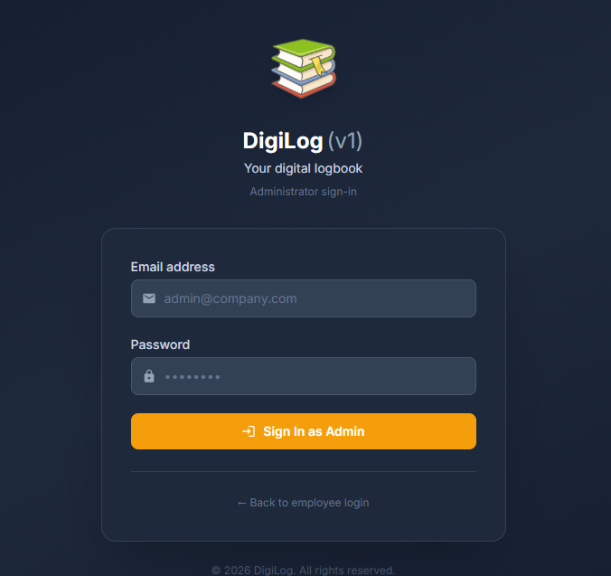
After success they go to employee administration. If a normal employee tries this door, they are told they are not an admin.

4.3 Homepage (after employee sign-in)
Anyone signed in as an employee sees a personal homepage. If they are not signed in, they are sent back to the public DigiLog page.
What they see
- A greeting using their first name, for example “Hello, Vivek”.
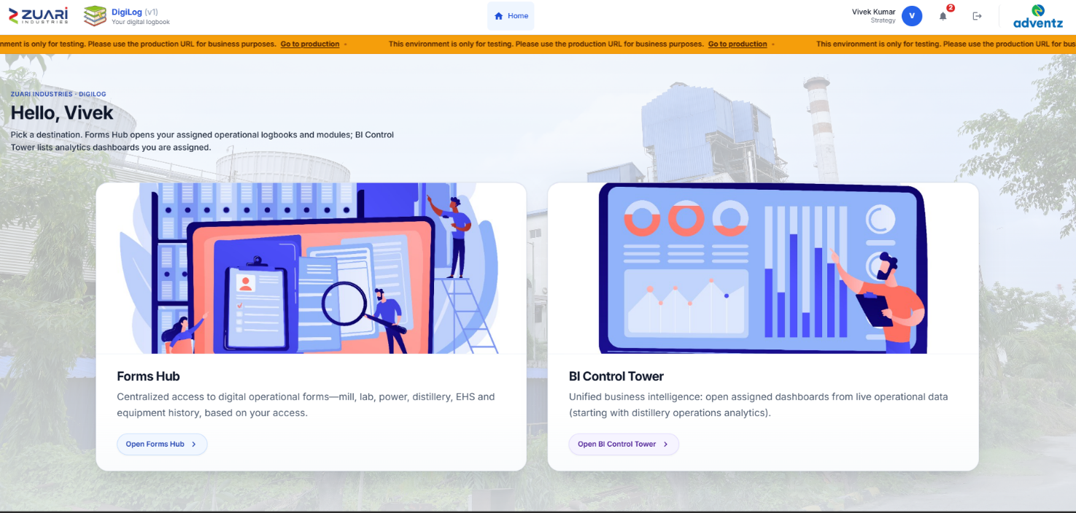
- A short note that they can open Forms Hub (logbooks) and/or BI Control Tower (dashboards), depending on what admin has given them.
Destination cards (only those assigned to that person)
Card | Purpose | Button
Forms Hub | Daily operational forms and equipment history they are allowed to use | Open Forms Hub
BI Control Tower | Analytics dashboards they are allowed to see | Open BI Control Tower
If both cards are assigned, they sit side by side on a computer and one above the other on a phone. If only one is assigned, that card is shown centred. If neither is assigned, they see: “No homepage destinations assigned. Contact your admin…”

4.4 Navigation bar (every signed-in page)
A bar stays at the top while they move around DigiLog.
Always available
Item | What it does
Zuari Industries logo | Opens the company website in a new tab
DigiLog name | Returns to the public DigiLog page
Home | Returns to their homepage
Their photo (or first initial) | Opens the profile window
Bell | Opens notifications (see Section 8)
Logout | Signs them out and returns them to sign-in. Microsoft users are also signed out of Microsoft.
Only if they have the right
Item | Who sees it | What it does
Approvals | Named Head of Department | Opens the approval queue
Data Upload | People allowed to upload files | Opens the Data Ingestion Centre
Config | Administrators | Opens administration
Adventz logo | Larger screens | Opens the Adventz website
Their name and department (or role, if no department) show on larger screens.
On a phone: Home, Approvals, Data Upload, and Config hide behind a menu button. The menu slides in from the right, lists those items plus their name, and closes with X, a tap outside, Escape, or when they go to another page. The current page is highlighted so they can see where they are.

4.5 Profile window
Opens when they click their photo or initial. On a phone it rises from the bottom; on a computer it sits in the centre.
What they can see and change
- Large photo (or initial if none)
- Full name, email, and department — or “No department on file”
- Upload photo — PNG or JPEG only, reasonably small files. They can drag to centre the face and zoom before saving.
- Remove photo — only if a photo already exists. They are asked to confirm.
- Help text: only the profile photo can be changed here.
After they pick a photo: they centre and zoom, then Save photo or Cancel. If the cropped picture is still too large, they are asked to try a simpler or smaller original. On success: “Profile photo updated.”

4.6 Forms Hub landing
Shown to employees who have been given the Forms Hub card.
They choose one of two areas:
Card | For | Button
Operations forms | Daily mill, lab, power, distillery, and EHS logbooks | View Operations
Equipment maintenance and history | Equipment tree, specifications, OEM schedules, maintenance records | View Equipment
The two cards sit side by side on a computer and stack on a phone.

4.7 Forms Hub category (Operations or Equipment)
After they pick a category, they see the applications they are allowed to use in that category. Each application card shows its name, a short description, and how many forms it contains.
If they have nothing assigned in that category: “No applications assigned. Contact your admin to get access.”
How apps are grouped
- Equipment: Power Plant, Sugar House, and Production House equipment history. Older Mill House and old Power Plant cards are retired and not shown.
- Operations: everything else (Mill, Lab, Power, EHS, Distillery, Production, Brix Sampling, and similar).
- BI Control Tower is never listed here; it has its own home.

4.8 Application detail
After they click an application, they see its name and description, then a list of forms (or dashboards, if this were BI).
If that application has only one form, they are taken straight to that form and skip this list.

4.9 BI Control Tower hub
Shown to employees who have been given the BI Control Tower card.
They see how many dashboards they have, and can switch between a card layout and a compact list. That choice is remembered the next time they open it.
Assigned dashboards typically include Management, Cane Performance, Milling Operations, Power House, Distillery, Purchy Analysis, Brix Sampling, and Centre Maturity. Clicking a card opens that dashboard.
If none are assigned: they are told an administrator can assign the BI Control Tower or individual dashboards under Employee management.

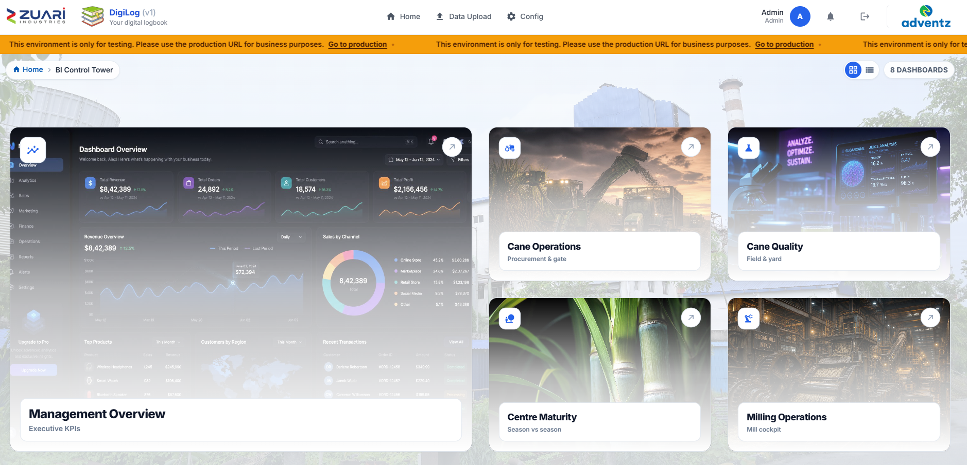

5. Daily Operational Workflow
The lifecycle of plant data follows a strict workflow:
Process flow diagram:
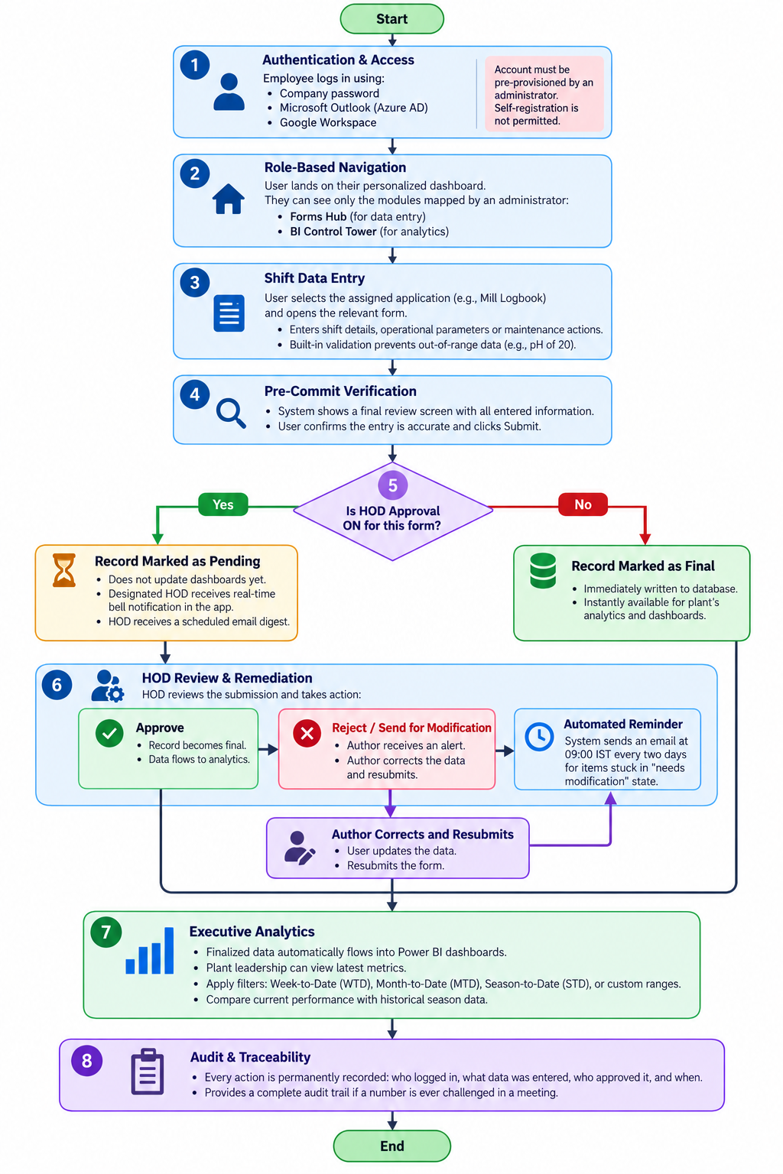

Step-by-Step User Journey
- Authentication & Access: The employee authenticates via company password, Microsoft Outlook (Azure AD redirect), or Google Workspace (popup). The account must have been pre-provisioned by an administrator; self-registration is not permitted. After authentication, a JWT token (default life 7 days) is stored in localStorage. A session tracking record is created.
- Role-Based Navigation: Upon login, the user lands on /dashboard showing only the Forms Hub and/or BI Control Tower cards they are assigned.
- Shift Data Entry: The user navigates: Dashboard → Forms Hub → Category (Operations / Equipment) → App → Form. They select their shift (A/B/C/G) and date, then input their readings.
- Pre-Commit Verification (Form Review Modal): Before data is written, clicking "Submit" or "Review & Submit" triggers validation. If validation passes, a Form Review Modal opens — a full-screen summary showing all entered values organized by section. The modal includes:
  - A summary bar with Date, Shift, and any other key metadata
  - All entered values displayed in a two-column grid organized by section
  - A Confirmation Policy Notice (amber box): "By pressing Confirm & Commit, you certify that these measurements are accurate representations of today's plant production. This entry will be permanently appended to the operations register database."
  - A "Confirm & Commit" button (blue) and a "Back to Edit" button
  - Pressing Escape closes the modal and returns to the form
- The Governance Fork:
  - If HOD Approval is ON: Record status is set to Pending. The HOD gets a real-time bell notification (Socket.IO push) and a scheduled email digest. The author sees a toast: "Sent for approval".
  - If HOD Approval is OFF: Record status is instantly Approved and feeds into analytics. The author sees a success toast.
- HOD Review & Remediation: The HOD opens /maintenance/approvals, reviews the submission, and can:
  - Approve — record becomes final, data feeds into BI dashboards
  - Send for Modification — enters a comment, author gets notified to fix and resubmit
  - Reject — permanently rejected
  - Automated reminder at 09:00 IST every two days for items stuck in "needs modification"
- Executive Analytics: Finalized data flows into dashboards. Leadership views metrics with WTD/MTD/STD filters and compares seasons.
- Audit & Traceability: Every action is permanently recorded in Audit & Activity.

6. Functional Catalogue
This is the core of the application and the most important section of this document. The catalogue has four parts: the shift and daily forms people fill, the equipment cards that hold maintenance history, the Power BI dashboards used in review, and the Data Ingestion Centre for file uploads.

6.0 Standard UI Elements on Every Form
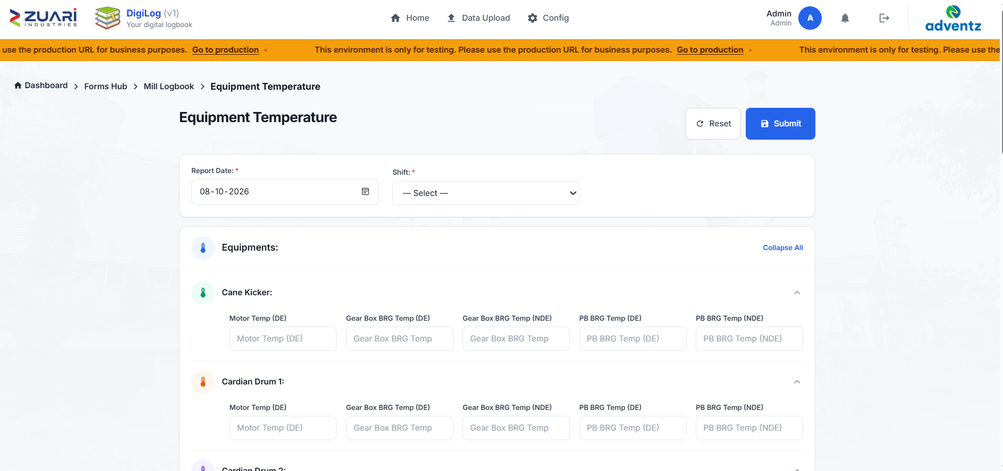
Every operational form in DigiLog shares these common UI elements and button actions:
# | UI Element / Button | Type | Action on Click / Interaction
1 | Form Page Header | Display | Shows the form's name (e.g., "Equipment Temperature"), description, and the app it belongs to. Pulls from the database — admin can rename forms. Falls back to a hardcoded default if the database entry is missing.
2 | View-Only Banner | Banner (yellow) | Only shown if the user has "View Only" access to Forms Hub. Text: "You have view-only access to Forms Hub." When active, the submit button is hidden with CSS class .forms-hub-write-action.
3 | Date Picker | Input (date) | User selects the operating date. Uses AutoNowInput component which auto-fills with the current date on first render if the field is empty. Calendar widget opens on click.
4 | Shift Picker | Dropdown or Radio | Selecting shift: A, B, C, or G (general, EHS only). Some forms use a dropdown (<select>), others use radio buttons.
5 | Numeric Input Fields | Number input | Each field has a label and placeholder. Uses LegacyNumField component for consistent styling. Accepts decimal values (step="any").
6 | Collapsible Section Headers | Toggle | On forms with many equipment rows (e.g., Equipment Temperature, Power Details), clicking a section header toggles expand/collapse. A "Collapse All / Expand All" toggle button at the top collapses or expands every section at once.
7 | Reset Button | Button (secondary) | Resets all form fields to their initial empty state. Confirmation is immediate — no "are you sure?" dialog.
8 | Submit / Review & Submit Button | Button (primary) | Validates all required fields. If valid, opens the Form Review Modal. If invalid, shows a toast error identifying the missing field.
9 | Form Review Modal | Modal (full-screen) | See Step 4 above for complete description.
10 | Back to Forms Hub link | Link | Some forms show a "← Back" button that navigates to the previous page using navigate(-1).

6.1 Operations Forms
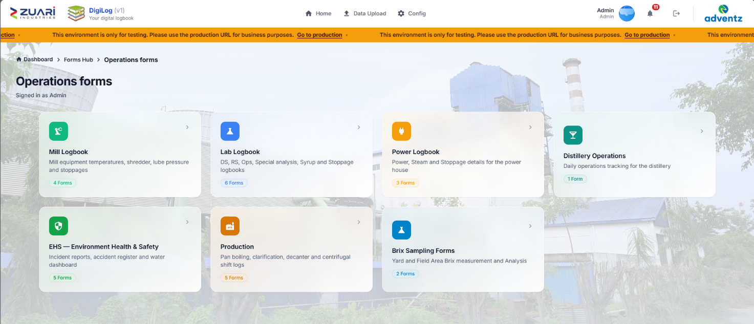
These are the shift and daily logbooks on Forms Hub. An entry is reviewed on screen before it is saved, and it can be held for HOD approval when that form is switched on.

6.1.1 Mill Logbook
App name: Mill Logbook
Purpose: Crushing-floor readings. The Milling Operations dashboard reads this family.
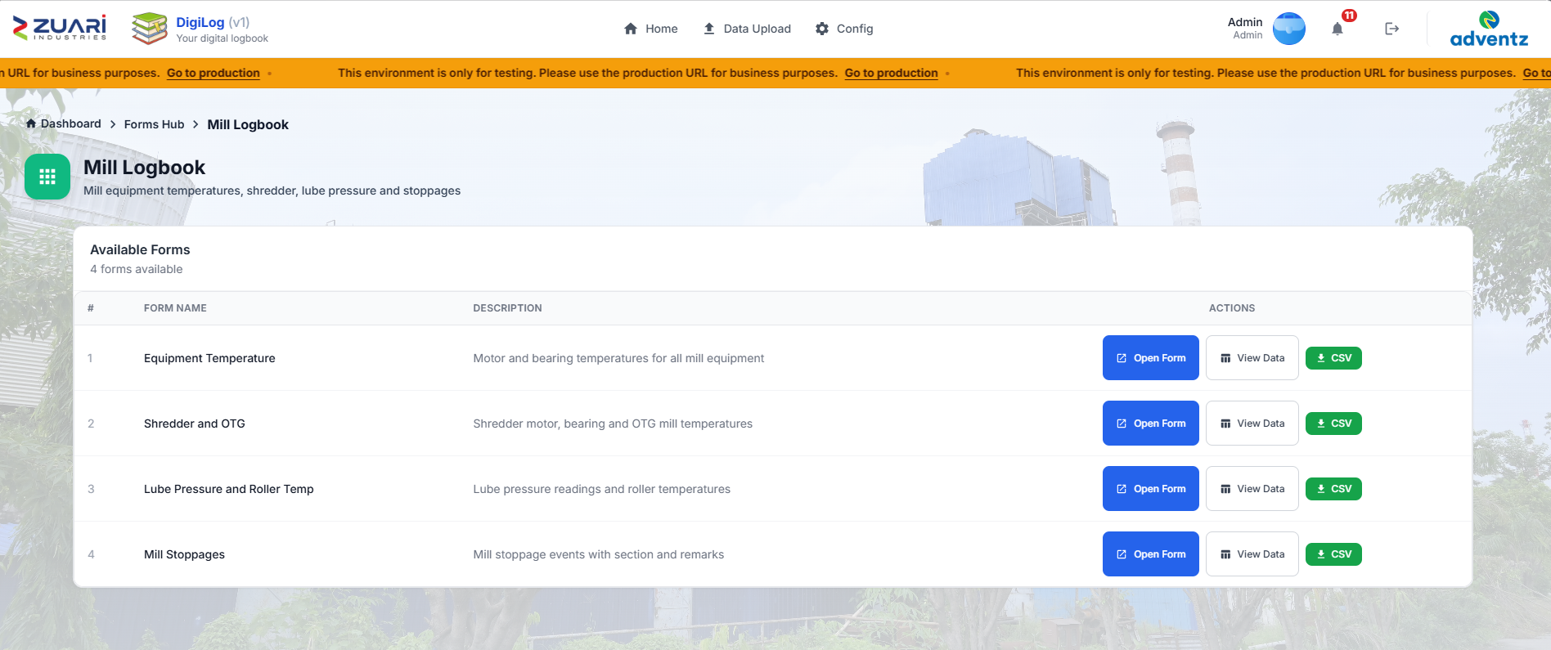
Contains 4 forms:

Form 1: Equipment Temperature (/forms/mill_logbook1)
Purpose: Record motor and bearing temperatures for all 13 pieces of milling equipment per shift.
Header fields:
- Date (required) — date picker
- Shift (required) — dropdown: A, B, C
Equipment list (13 items, each a collapsible section):
# | Equipment Key | Equipment Label
1 | CaneKeig | Cane Kicker
2 | CardDrum1 | Cardian Drum 1
3 | CardDrum2 | Cardian Drum 2
4 | FeedDrum | Feeder Drum
5 | CaneCar | Cane Carrier
6 | ShredCar | Shred. Carrier
7 | BeltConvy | Belt Convy
8 | IRC1 | IRC 1
9 | IRC2 | IRC 2
10 | IRC3 | IRC 3
11 | IRC4 | IRC 4
12 | Mill0 | Mill 0
13 | Mill4 | Mill 4

For each equipment item, 5 temperature fields:
# | Field Suffix | Field Label
1 | MtrTemp | Motor Temp (DE)
2 | GearTempDE | Gear Box BRG Temp (DE)
3 | GearTempNDE | Gear Box BRG Temp (NDE)
4 | BearTempDE | PB BRG Temp (DE)
5 | BearTempNDE | PB BRG Temp (NDE)

Total data points per submission: 13 equipment × 5 temperatures = 65 temperature readings + date + shift = 67 fields total.
UI features:
- Each equipment section is color-coded with a rotating palette (green, orange, purple, amber, blue, indigo, pink, teal, cyan, rose, slate)
- "Collapse All / Expand All" toggle at the card level
- Responsive grid: 2 columns on sm, 3 on lg, 5 on xl
Validation: Date and Shift are required. All temperature fields are optional (allows partial entry).
API endpoint: POST /api/forms/mill_logbook1

Form 2: Shredder and OTG (/forms/mill_logbook2)
Purpose: Record shredder RHS/LHS motor and bearing temperatures plus OTG mill temperatures.
Fields: Date, Shift (A/B/C), then sections for Shredder and OTG temperatures.
API endpoint: POST /api/forms/mill_logbook2

Form 3: Lube Pressure and Roller Temp (/forms/mill_logbook3)
Purpose: Record lube-pump pressure readings for ACC, MCC, Shredder, and all mills. Also roller temperatures per mill.
API endpoint: POST /api/forms/mill_logbook3

Form 4: Mill Stoppages (/forms/mill_stoppages)
Purpose: Record each milling stoppage event.
Fields:
# | Field | Type | Required | Details
1 | Report Date | Date picker | Yes
2 | From | Datetime-local (minute precision) | Yes | Start time of stoppage
3 | To | Datetime-local (minute precision) | Yes | End time of stoppage
4 | Section | Dropdown | Yes | Options: CANE, CANE HANDLING EQUIPMENTS, PREPERATORY DEVICES, MILLS, 70TPH BOILER, 150TPH BOILER, PROCESS DS, PROCESS RS, BOILING HOUSE, REDUCED JUICE FLOW, OTHERS (12 options)
5 | Machinery | Dropdown | Yes | 87 options including: N/A, No Cane, Weather, Cane Unloader 1–6, Truck Trippler, Main Cane Carrier, Kicker, Carding Drum 1–2, Feeder Drum, In-line Shredder, Rake Carrier, IRC 1–4, Zero Mill, 1st–4th Mill, Mill Turbine 1–2, Transmission Gearing 0–4, Under Feed Roller, Mill Automation System, various juice pumps, rotary screens, flow meters, boiler components, and Others
6 | Remark | Text area | No | Free text for additional notes

Validation: Date, Start Time, and End Time are all required.
API endpoint: POST /api/forms/mill_stoppages

6.1.2 Lab Logbook
App name: Lab Logbook
Purpose: Sugar quality and the daily manufacturing picture. DS, RS, and Operations feed the management scorecard.
Contains 6 forms:

Form 1: DS Logbook (/forms/ds_logbook)
Purpose: Direct Sulphitation quality analysis per shift.
Header fields:
- Report Date (required)
- Shift (required) — A, B, C
- Mode of Operation (required) — B Heavy, C Heavy
- Sampling Time — time picker (auto-fills current time)
Data sections — 16 Pol/Brix pairs:
# | Key | Section Label | Fields
1 | PJ | Primary Juice | Pol, Brix
2 | MJ | Mixed Juice | Pol, Brix
3 | LMJ | Last Mill Juice | Pol, Brix
4 | CJ | Clear Juice | Pol, Brix
5 | FJ | Filterate Juice | Pol, Brix
6 | USul_Syrp | Unsulphured Syrup | Pol, Brix
7 | Sul_Syrp | Sulphured Syrup | Pol, Brix
8 | A_Mc | A M/C | Pol, Brix
9 | B_Mc | B M/C | Pol, Brix
10 | A1_Mc | A1 M/C | Pol, Brix
11 | C_Mc | C M/C | Pol, Brix
12 | A1_Mol | A1 Molasses | Pol, Brix
13 | AH_Mol | A-Hy Molasses | Pol, Brix
14 | AL_Mol | A-Light Molasses | Pol, Brix
15 | BH_Mol | B-Hy Molasses | Pol, Brix
16 | CL_Mol | C-Light Molasses | Pol, Brix
17 | FMol | Final Molasses | Pol, Brix

Additional sections:
- Bagasse: Pol, Moisture
- Filter Cake: Pol (added at shift end)
- Decanter Mud Pol: Pol
- Drain Pol: Mill House Drain Pol, Boiling House Drain Pol
Total fields: 4 header + 34 Pol/Brix + 6 additional = 44 fields.
API endpoint: POST /api/forms/ds_logbook

Form 2: RS Logbook (/forms/rs_logbook)
Purpose: Remelt Sulphitation quality analysis per shift.
Header fields: Report Date, Shift (A/B/C), Mode of Operation (B Heavy/C Heavy), Sampling Time.
Data sections — 18 groups with Pol/Brix/IU measurements:
# | Section | Fields
1 | Clear Juice | Pol, Brix
2 | Filterate Juice | Pol, Brix
3 | Untreated Syrup | Pol, Brix
4 | Raw M/C | Pol, Brix
5 | R1 M/C | Pol, Brix, IU
6 | R2 M/C | Pol, Brix, IU
7 | B M/C | Pol, Brix
8 | C M/C | Pol, Brix
9 | A-Hy Molasses | Pol, Brix
10 | A-Light Molasses | Pol, Brix
11 | R1-Heavy Molasses | Pol, Brix, IU
12 | R2-Heavy Molasses | Pol, Brix, IU
13 | B-Hy Molasses | Pol, Brix
14 | C-Light Molasses | Pol, Brix
15 | Final Molasses | Pol, Brix
16 | Raw Melt | Pol, Brix, IU
17 | Clear Melt | Pol, Brix, IU
18 | Fine Liqour Melt | Pol, Brix, IU
19 | Filter Cake | Pol
20 | IER Information | Inlet IU, Inlet PH, Outlet IU, Outlet PH

Total fields: 4 header + 55 data fields = 59 fields.
API endpoint: POST /api/forms/rs_logbook

Form 3: Operations Logbook (/forms/ops_logbook)
Purpose: Comprehensive shift-wise operational readings covering input, output, sugar production by grade, and temperature/moisture details.
Header fields: Report Date, Shift (A/B/C), Sampling Time.
Data sections:
Section | Fields
Input | Yard Balance (Qtls), Crushing (Qtls), Imbibition Water (Qtls), Imbibition Temperature (°C)
Output | Mixed Juice DS, Mixed Juice RS, Molasses Output DS, Molasses Output RS, Filter Cake DS, Filter Cake RS
Sugar Production: DS-L31 | Quantity (Qtls), Mesh, Bagging Temperature
Sugar Production: DS-M31 | Quantity (Qtls), Mesh, Bagging Temperature
Sugar Production: DS-S31 | Quantity (Qtls), Mesh, Bagging Temperature
Sugar Production: RS-L31 | Quantity, Mesh, Bagging Temperature
Sugar Production: RS-M31 | Quantity, Mesh, Bagging Temperature
Sugar Production: RS-S31 | Quantity, Mesh, Bagging Temperature
Sugar Production: Pharma 20/80 | Quantity, Bagging Temperature
Sugar Production: Pharma 30/80 | Quantity, Bagging Temperature
Sugar Production: Pharma SS | Quantity, Bagging Temperature
Temperature & Moisture (DS) | FBD Inlet Temp, FBD Inlet Moisture, FBD Outlet Temp, FBD Outlet Moisture, Hopper Temp, Hopper Moisture
Temperature & Moisture (RS) | FBD Inlet Temp, FBD Inlet Moisture, FBD Outlet Temp, FBD Outlet Moisture, Hopper Temp, Hopper Moisture
Temperature & Moisture (Pharma) | RSD Inlet Temp, RSD Inlet Moisture, RSD Outlet Temp, RSD Outlet Moisture

Total fields: 3 header + 55 data fields = 58 fields.
API endpoint: POST /api/forms/ops_logbook

Form 4: Special Analysis Logbook (/forms/sa_logbook)
Purpose: Detailed quality analysis of produced sugar — retention, moisture, and colour across all 9 sugar product grades plus additional colour analysis.
Header fields: Report Date, Shift (A/B/C), Sampling Time.
Data sections (each section has 3 fields for DS grades L-31/M-31/S-31, 3 for RS grades, 3 for Pharma grades):
Analysis Type | DS (L-31, M-31, S-31) | RS (L-31, M-31, S-31) | Pharma (20/80, 30/80, SS)
Retention | 3 fields | 3 fields | 3 fields
Moisture | 3 fields | 3 fields | 3 fields
Colour | 3 fields | 3 fields | 3 fields

Additional Colour Analysis: Clear Juice DS, Raw Melt RS, Clear Melt RS, Fine Liquor RS (4 fields).
Total fields: 3 header + 27 + 4 = 34 fields.
API endpoint: POST /api/forms/sa_logbook

Form 5: Syrup Logbook (/forms/syrp_logbook)
Purpose: Track syrup production, diversion, and quality.
Fields:
Section | Fields
Header | Report Date, Shift (A/B/C)
Syrup Production | Syrup Production (DS), Syrup Production (RS)
Diversion | Diversion From (dropdown: No Diversion, DS, RS), Diversion Qty (Qtls)
Molasses to Distil | From DS, From RS
Quality | Avg Syrup TRS, Avg B-Heavy TRS

Total: 10 fields.
API endpoint: POST /api/forms/syrp_logbook

Form 6: Stoppage Logbook (/forms/stoppage_logbook)
Purpose: Lab and process stoppages.
Fields:
# | Field | Type | Required | Details
1 | Report Date | Date | Yes
2 | From | Datetime-local | Yes
3 | To | Datetime-local | Yes
4 | Reason | Dropdown | No | Uses lab stoppage reason options list
5 | Remark | Textarea (3 rows) | No | Free-text

API endpoint: POST /api/forms/stoppage_logbook

6.1.3 Power Logbook
App name: Power Logbook
Contains 3 forms:

Form 1: Power Details (/forms/ph_power)
Purpose: Comprehensive daily power generation, consumption, and distribution record.
Header: Date (required). No shift picker — this is a daily summary.
Mandatory remark: The form has a remark field (max 500 characters) that is required before submission. Validation error: "General remarks is required."
Data categories (each is a collapsible section with colour-coded icon):
# | Category | Icon Colour | Fields
1 | Crushing | Green | Cane Crushed (Qtls), Bagasse Produced (Qtls)
2 | Operating Hours | Orange | 30.85MW STG, 3MW STG (O), 3MW STG (N), 4MW STG
3 | Power Generation | Purple | 30.85MW STG, 3MW STG (O), 3MW STG (N), 4MW STG
4 | Power Gen by DG Set | Amber | 625KVA DG Set 1, 625KVA DG Set 2, 625KVA DG Set 3, 380KVA DG Set 4
5 | Power Import | Blue | Grid, 3MW Old, 3MW New, 4MW
6 | Power Export to Grid | Indigo | 30.85MW STG, 3MW STG (O), 3MW STG (N), 4MW STG
7 | Power to Sugar | Pink | 30.85MW STG, 3MW STG (O), 3MW STG (N), 4MW STG
8 | Power to Sugar (Breakup) | Teal | Mill House, DS House, Raw & Refinery, 70TPH, ETP, Colony, Sugar CPU, Others — 8 fields
9 | Power to Cogen (Aux Consumption) | Cyan | 30.85MW STG, 3MW STG (O), 3MW STG (N), 4MW STG
10 | Power to Distillery from 30MW | Rose | 30.85MW STG — 1 field
11 | General Remarks | — | Textarea (required, max 500 chars)

Total fields: 1 date + 2 + 4 + 4 + 4 + 4 + 4 + 4 + 8 + 4 + 1 + 1 remark = 41 fields.
API endpoint: POST /api/forms/ph_power

Form 2: Steam Details (/forms/ph_steam)
Purpose: Daily steam generation, consumption, and fuel consumption across all three boilers.
Header: Date (required).
150 TPH Boiler section (4 stages + fuel):
Stage | Fields
Stage 1 | Steam Generation
Stage 2 | Steam Consumption (30MW), Steam to Sugar through 110/3 ATA PRDS, Steam to 3MW TG Old through 110/45 ATA PRDS, Steam to 3MW TG New through 110/45 ATA PRDS, Steam to Mill Turbine through 110/45 ATA PRDS, Steam to Distillery Process through 110/45 ATA PRDS, Steam to 4MW TG through 110/45 ATA PRDS, DSH Water to 110/3 ATA Steam, DSH Water to 110/45 ATA Steam
Stage 3 | Extraction Steam from 30MW TG, Bleed 2 to HP H1 Steam, Bleed 1 to HP H2 Steam
Stage 4 | Total Steam to Sugar Process, Steam to Deareator (150 TPH)
Fuel | Firewood (MT), Baggase (MT)

70 TPH Boiler section (3 stages + fuel):
Stage | Fields
Stage 1 | Steam Generation
Stage 2 | Steam Consumption 3MW TG Old, 3MW TG New, Steam to Distillery Process from 70 TPH, Steam to 4MW Turbine from 70 TPH, DSH Water to 2 ATA Steam
Stage 3 | Total Steam to Sugar
Fuel | Firewood (MT), Baggase (MT)

35 TPH Boiler section (4 stages + fuel):
Stage | Fields
Stage 1 | Steam Generation
Stage 2 | Steam Consumption 4MW Turbine, Steam through 45/5.5 ATA Process PRDS, Steam through 45/5.5 ATA Deareator & Ejector PRDS, DSH Water to 5.5 ATA Steam
Stage 3 | Extraction steam from 4MW TG
Stage 4 | Total Steam to distillery process, Steam to Ejector, Steam to 35T Boiler Deareator from TG, Steam to Sugar from Distillery
Fuel | Firewood (MT), Baggase (MT), Slop Consumption (MT)

Total fields: 1 date + 17 + 9 + 12 = 39 fields.
API endpoint: POST /api/forms/ph_steam

Form 3: Stoppage Details (/forms/ph_stoppage)
Purpose: Record power-house stoppage events with detailed classification and photographic evidence.
Fields:
# | Field | Type | Required | Details
1 | Report Date | Date | Yes
2 | From | Datetime-local (minute step) | Yes
3 | To | Datetime-local (minute step) | Yes | Must be later than From
4 | Section | Dropdown | Yes | 10 options: 150 TPH Boiler, 30.85 MW Turbine, 35 TPH Boiler, 35 TPH Boiler & 4MW Turbine, 4MW Turbine, 70TPH Boiler, 3MW Turbine (Old), 3MW Turbine (New), Grid, Others
5 | Section Specify | Textarea | If Section = Others | Max 200 characters
6 | Sub-Section | Dropdown | Yes | 20 options: MILL GENERAL CLEANING, BOILER FEED WATER STATION, FURNACE, BOILER FANS, BAGASSE FEEDING SYSTEM, FUEL HANDLING SYSTEM, ASH HANDLING SYSTEM, SHOOT BLOWER SYSTEM, TURBINE & GENERATOR, OIL PUMP, CONDENSATE SYSTEM, COOLING WATER SYSTEM, 110 VDC SYSTEM, DCS & UPS, 132 KV SWITCHYARD, 132 KV TRANSMISSION LINE, Service Air, Converter Transformer, Switch yard, OTHERS
7 | Sub-Section Specify | Textarea | If Sub-Section = OTHERS | Max 200 characters
8 | Machinery | Dropdown | Yes | Over 350 options covering every piece of equipment in the power house — from Feed Water Pumps to ESP Transformers, Belt Conveyors, RSBs, Wall Blowers, UPS sets, DCS systems, etc.
9 | Machinery Specify | Textarea | If Machinery = Others | Max 200 characters
10 | Category | Dropdown | Yes | Electrical, Instrumentation, Mechanical, Other
11 | Category Specify | Textarea | If Category = Other | Max 200 characters
12 | General Remarks | Textarea | Yes | Minimum 20 characters, maximum 150 characters. Character counter shown below the field.
13 | Stoppage Photos | Photo upload | No | Up to 2 photographs. Each photo can be previewed before upload.

Validation rules:
- Date, From, and To are required
- To must be later than From
- All four dropdowns are required
- When "Others" is selected, the specify field becomes required (max 200 chars)
- Remarks must be 20–150 characters
- Maximum 2 photos
API endpoint: POST /api/forms/ph_stoppage

6.1.4 Distillery Operations (/forms/distillery_ops)
Purpose: Daily ethanol production tracking with live auto-calculated fields.
Header: Operation Date (required).
Operation Mode: Radio buttons — Syrup, B Heavy, C Heavy, None. Changes which input fields are most relevant.
Input fields (10 user-entered fields):
# | Field | Unit
1 | Syrup/Molasses Used | Qtls
2 | Wash Distilled | —
3 | TRS | %
4 | UFS | %
5 | Alcohol % | %
6 | Actual Ethanol Production | BL
7 | AL/BL Ratio | %
8 | Total BH Molasses in Storage (Distillery) | Qtls
9 | Total CH Molasses in Storage (Distillery) | Qtls
10 | Ethanol in Storage | BL

Auto-calculated fields (14 read-only fields, updated live as the user types):
# | Field | Calculation
1 | FS | Computed from inputs
2 | FS% | Percentage
3 | FS Quantity | Derived
4 | Theoretical Yield | Uses a date-specific Theoretical Yield constant set by admin in BI Dashboard settings. If no date-specific constant exists, falls back to the default.
5 | Alcohol Production in Fermentation | Derived
6 | Fermentation Efficiency (FE) | Derived
7 | Actual Production (AL) | Derived
8 | Distillation Efficiency (DE) | Derived
9 | Overall Efficiency (OE) | Derived
10 | Recovery BL | Derived
11 | Recovery AL | Derived
12 | TRS Quantity | Derived
13 | UFS Quantity | Derived
14 | Total Molasses in Store (Qtls) | Derived

Display note: "Derived from entries above; stored with the record. Division by zero shows blank."
API endpoint: POST /api/forms/distillery_ops

6.1.5 EHS — Environment, Health and Safety
App name: EHS
Contains 5 forms (plus 1 unwired):

Form 1: Accident Report / Near Miss Report (/forms/ehs_near_miss)
Purpose: Log workplace accidents, near misses, and unsafe conditions with photographic and documentary evidence.
Section 1: Report Date & Time
- Date (required) — auto-fills today
- Time — auto-fills current time
Section 2: Incident Type (required) — Radio buttons:
- Unsafe Act
- Unsafe Condition
- Near Miss
- Non-Reportable Act
- Reportable Act
Section 3: Person(s) Involved
- Name (required) — text input
- Contact No. — text input
- Department / Section — text input
- Person Type — dropdown: Employee, Contractor, Labour, Other
- If "Other" selected: Specify Other — text input
Section 4: Incident Details
- Location — text input
- Severity (required) — dropdown: Fatal, Serious Harm, Minor Harm, No Harm / Near Miss
- Description / Cause of Incident — textarea (4 rows)
Section 5: Treatment
- Treatment Given — dropdown: Nil, First Aid, Doctor, Hospital
- What Treatment was Given? — textarea (2 rows)
- By Whom — text input
Section 6: Follow-up
- Significant Hazard Identified? — dropdown: Yes, No
Section 7: Document Upload
- Up to 3 documents (JPG, JPEG, PDF, or Word). Max 6 MB each.
- First document slot has hint: "Include the signed HOD document here if applicable."
- Uses FormFileUploadRow component with file preview.
Section 8: Incident Photos
- Up to 3 photos (PNG or JPG).
- Uses FormPhotoUploadRow component with image preview.
Validation: Date, Incident Type, Person Name, and Severity are all required.
API endpoint: POST /api/forms/ehs_near_miss

Form 2: Ground Water Abstraction (/forms/ehs_water_gwa)
Purpose: Daily bore-well extraction and water usage report.
Sections:
Section | Fields
Date | Date (required)
Ground Water Pumped (KLD) | Pump 1 Meter Reading (Truck Yard), Pump 1 Extracted (KL), Pump 2 Meter Reading (36 Block), Pump 2 Extracted (KL), Pump 3 Meter Reading (Admin), Pump 3 Extracted (KL), Total Extracted from Bore Wells (KL)
Water Uses — Domestic | Colony (KL), Fire & Labour (KL)
Water Uses — Industrial | Distillery (KL), Power Plant (KL), Refinery (KL), DS (KL), Mill (KL), Total Industrial (KL) — auto-calculated (sum of all 5 industrial fields, read-only)
Cane Crushing (TCD) | On Date, To Date
Water per Tonne Cane (L/T) | Sugar + Dist (L/T), Industrial (L/T), Total Sugar Ext (L/T)
Remarks | Textarea

Total: 22 fields (1 auto-calculated).
API endpoint: POST /api/forms/ehs_water_gwa

Form 3: ETP Working (/forms/ehs_water_etp)
Purpose: Effluent Treatment Plant daily quantity and quality report.
Sections:
Section | Fields
Header | Date (required), Cane Crush On Date (TCD), Cane Crush To Date (TCD)
ETP Inlet | Meter Reading, Extracted (KL)
ETP Outlet | Meter Reading, Extracted (KL)
Effluent | Total Effluent 200 L/TCD (On Date), On Date (KLD)
Quality Parameters | pH (G Shift), TSS <30 ppm, COD <250 ppm, BOD <30 ppm, TDS <2100 mg/L, Oil & Grease <10 mg/L
Remarks | Textarea

Total: 16 fields.
API endpoint: POST /api/forms/ehs_water_etp

Form 4: CPU Water Recycle (/forms/ehs_water_cpu)
Purpose: Condensate Polishing Unit inlet/outlet daily report with quality parameters.
Sections:
Section | Fields
Header | Date (required), Cane Crush On Date, Cane Crush To Date
CPU Inlet | On Date (KL), To Date (KL)
CPU Outlet | On Date (KL), To Date (KL)
Effluent 200 L/TCD | On Date, To Date
Inlet pH | A Shift, B Shift, C Shift
Outlet Quality Parameters | pH (5.5–8.5), TSS <30 ppm, COD <250 ppm, BOD <30 ppm, TDS <2100 mg/L, Oil & Grease <10, Transmittance >85
Remarks | Textarea

Total: 21 fields.
API endpoint: POST /api/forms/ehs_water_cpu

Form 5: Daily Safety Toolbox Talk (/forms/ehs_toolbox_talk)
Purpose: Record daily toolbox talk sessions with attendance verification and session photographs.
Section 1: Session Details
- Date (required)
- Shift (required) — A, B, C
- Time From (required) — auto-fills current time. Must be earlier than Time To.
- Time To (required) — auto-fills current time. Validation: To must be later than From (24-hour format). Error message appears in red below the fields.
Section 2: Report Information
- Report Prepared By — read-only, auto-filled with the logged-in user's name
- Topic Discussed (required) — textarea (3 rows). Character validation: minimum 20 characters, maximum 150 characters (spaces not counted). Live character counter displayed: "[count]/150" in red when below minimum, gray otherwise.
- No. of Attendees (required) — number input, must be a whole number ≥ 1
Section 3: Photos
- Attendance Sheet Photo (required) — hint: "Scanned roster sheet verifying headcount."
- Session Photo 1 (required) — hint: "Primary slide capture or presenter photo."
- Session Photo 2 (optional) — hint: "Additional session context or audience view."
Validation rules (enforced in order):
- Date required
- Shift required
- Time From required
- Time To required
- To must be after From
- Report Prepared By required (always auto-filled)
- Topic 20–150 characters (spaces not counted)
- Attendees ≥ 1
- Attendance sheet photo required
- Session photo 1 required
API endpoint: POST /api/forms/ehs_toolbox_talk

Form 6: Accident Data Register (UNWIRED)
Note: An EhsAccident.jsx component exists in the code but is not wired to the navigation menu. The only accident-related form accessible to users is the Near Miss form above.

6.1.6 Production Forms
App name: Production
Contains 5 forms:

Form 1: Shift Chemist Job Log Book (/forms/prod_shift_chemist)
Purpose: Track shift handover accountability — what was done, what needs to be done next.
Header: Date (required), Season (default: 2025-26).
Shift tabs (3 toggle buttons — only one visible at a time):
- Shift 8–4 (Morning)
- Shift 4–12 (Evening)
- Shift 12–8 (Night)
For each shift:
- Jobs Done — textarea (5 rows), placeholder: "Log jobs accomplished this shift..."
- Jobs To Be Done — textarea (5 rows), placeholder: "Log pending tasks for next shift..."
- Sign-off panel: A verification checkbox: "Confirm Sign-off & Verify Shift Logs". When checked, shows "Verified by: Admin". When unchecked, shows "Awaiting signature".
General: Instructions / Remarks — textarea.
API endpoint: POST /api/forms/prod_shift_chemist

Form 2: A-Centrifugal Machine Stoppage Log Book (/forms/prod_centrifugal)
Purpose: Per-machine stoppage data for the 4 centrifugal machines.
Header: Date (required), Active Shift (dropdown: Shift 8–4, Shift 4–12, Shift 12–8).
Machine table (4 rows × 9 columns):
Machine | Basket Cleaning | Screen Condition | From | To | Duration | Reasons for Stoppage | Separator Changing | Remarks
No.1 (1 Ton) | Checkbox | Text | Time | Time | Hrs | Text | Checkbox | Text
No.2 (1750 Kg/Chg) | Checkbox | Text | Time | Time | Hrs | Text | Checkbox | Text
No.3 (1750 Kg/Chg) NHEC | Checkbox | Text | Time | Time | Hrs | Text | Checkbox | Text
No.4 (1750 Kg/Chg) WB | Checkbox | Text | Time | Time | Hrs | Text | Checkbox | Text

Process & Thermodynamic Parameters:
- S.H.W. Temp (°C)
- S.H.W. Pressure (Kg/cm²)
- Air Pressure (Kg/cm²)
Digital Sign-off & Verifications (3 panels):
Each has a checkbox and shows "Verified" / "Awaiting signature":
- Operator Verification
- Shift Chemist Verification
- Section Head Verification
API endpoint: POST /api/forms/prod_centrifugal

Form 3: Pan Log Book (/forms/prod_pan_logbook)
Purpose: Boiling operation data by massecuite grade.
Header: Boiling Operation Date (required), Season (default: 2025-26).
Grade tabs (5 toggle buttons):
- A-Massecuite
- A1-Massecuite
- B-Massecuite
- C-Massecuite
- C1-Massecuite
For each grade (12 fields):
- Strike No., Pan No., Starting Time, Dropping Time, Boiling Time (Hrs), Down Time (Mins), Massecuite Qty, Dropping Cry No.
- Laboratory Analysis: Key Sample Purity (%), Massecuite Brix (%), Massecuite Purity (%)
- Remarks
Submit button: "Submit All Grades" — submits all 5 grades at once as a batch via POST /api/forms/prod_pan_logbook/batch.

Form 4: Decanter Log Book (/forms/prod_decanter)
Purpose: Hourly readings for first-stage and second-stage decanters.
Header: Operation Date (required), Season, Crop Day.
Shift selector: 3 toggle buttons — Shift 8–4, Shift 4–12, Shift 12–8. Each shows 8 hourly time slots.
24 time slots (8 AM through 8 AM next day):
For each time slot, 16 numeric fields:
- Decanter 1st Stage (8 columns): Mud (m³/h), Centrate (m³/h), Floc (PPM), Water (m³/h), Load (A), Torque (%), Vib (mm/s), Diff Spd (rpm)
- Decanter 2nd Stage (8 columns): Same 8 parameters
Auto-calculated totals row: Shows sum/average for each column in the active shift block (green highlighted row).
Validation: At least one hourly row must be filled.
API endpoint: POST /api/forms/prod_decanter/batch

Form 5: Clarification Log Book (/forms/prod_clarification)
Purpose: Hourly juice clarification readings with comprehensive process parameters.
Header: Operation Date (required), Season, Crop Day.
Instructions section: Three textareas — HOD, Dy HOD, Sectional Head.
Shift selector: Same as Decanter (3 shifts × 8 hours).
For each of 24 time slots, 18 fields:
Column | Fields
Juice Flow (T/Hr) | Numeric
MOL Dose (L/Min) | Numeric
MOL Set Be | Numeric
MOL Std Wt | Numeric
MOL Meas Be | Numeric
MOL Meas Wt | Numeric
Vessel Std (min) | Numeric
Vessel Meas (min) | Numeric
pH Pre | Numeric
pH Shock | Numeric
pH Sulph. | Numeric
Sulphur Temp (°C) | Numeric
Boiler Temp (°C) | Numeric
Boiler Press | Numeric
Op Sign | Text
Chem Sign | Text
Remarks | Text

Total: 24 time slots × 17 fields + header = enormous grid. Minimum table width: 1300px (horizontal scrolling on smaller screens).
Validation: At least one hourly row must be filled.
API endpoint: POST /api/forms/prod_clarification/batch

6.1.7 Brix Sampling
App name: Brix Sampling
Purpose: Cane quality measurement in the field and the yard. Feeds the Cane Quality dashboard.
Contains 2 forms:

Form 1: Yard Brix Sampling (/forms/brix_yard_sampling)
Purpose: Yard-area Brix measurement form.
All fields (13 total, 11 required):
# | Field | Type | Required | Options
1 | Sampling Date | Date | Yes | Auto-fills today
2 | Name | Text | Yes
3 | Delivery Point | Radio | Yes | Gate Cane, Center Cane
4 | Village/Center Code | Number | Yes
5 | Grower Code | Number | No | Only shown when Delivery Point = Gate
6 | Truck Number | Text | No | Only shown when Delivery Point = Center
7 | Vehicle Type | Radio | Yes | Cart, Trolley, Truck
8 | Variety of Cane | Radio | Yes | CO0238, COUK94184, CO0118, COPK5151, COS8272, Others
9 | Crop Type | Radio | Yes | Plant, Ratoon
10 | Middle Brix % | Number (step 0.1) | Yes
11 | Diseased Cane | Radio | Yes | Yes, No
12 | Stale Cane | Radio | Yes | Yes, No
13 | Consignment Conditions | Radio | Yes | Roots, Dry Leaves, Muddy, Clean

Yellow info banner at top: "When you submit this form, it will not automatically collect your details like name and email address unless you provide it yourself."
API endpoint: POST /api/forms/brix_yard_sampling

Form 2: Field Brix Sampling (/forms/brix_field_sampling)
Purpose: Field-area cane Brix measurement form.
All fields (15 total, all required):
# | Field | Type | Options
1 | Sampling Date | Date | Auto-fills today
2 | Name | Text
3 | Test Type | Radio | New, Repeat
4 | Grower Name | Text
5 | Village Name | Text
6 | Variety of Cane | Radio | CO0238, COUK94184, CO0118, COPK5151, COS8272, Others
7 | Land Type | Radio | Upland, Midland, Lowland
8 | Soil Type | Radio | Loamy, Sandy, Clay, Silt, Others
9 | Crop Type | Radio | Plant, Ratoon
10 | Field Condition | Radio | Weed Free, Weedy, Waterlogged, Others
11 | Crop Condition | Radio | Normal, Lodged, Dry, Diseased
12 | Sampling Point | Radio | Border, Center
13 | Bottom Brix % | Number (step 0.1)
14 | Middle Brix % | Number (step 0.1)
15 | Top Brix % | Number (step 0.1)

API endpoint: POST /api/forms/brix_field_sampling

6.2 Equipment Maintenance and History
The system replaces paper history cards with three digital asset registers. Each equipment card provides a complete view of a physical asset's lifecycle.
Equipment history flow:
Process flow (diagram rendered as numbered steps in Word):
- 1. Step 01 — Asset Setup — Specs & OEM Schedule
- 2. Step 02 — Breakdown/Maint. — Operator logs — issue & work
- 3. Step 03 — Evidence — Attach photos — & documents
- 4. Step 04 — HOD Review — Approve or — request changes
- 5. Step 05 — Digital Record — Permanent — audit trail
- 6. "Step 01 — Asset Setup — Specs & OEM Schedule"
- 7. "Step 02 — Breakdown/Maint. — Operator logs — issue & work"
- 8. "Step 03 — Evidence — Attach photos — & documents"
- 9. "Step 04 — HOD Review — Approve or — request changes"
- 10. "Step 05 — Digital Record — Permanent — audit trail"
Standard UI elements on all equipment cards:
# | Element | Action
1 | Hierarchy Tree (Left Panel) | Collapsible tree structure. Click a node to expand/collapse. Click a leaf to load its card.
2 | Search / Filter | Type-ahead search box filters the tree by equipment name.
3 | Star Icon (Bookmark) | Click to add/remove the current asset from the user's "Starred" list for quick access. Filled star = bookmarked.
4 | Move Asset Button | Opens a dialog to select a new parent node. Moves the asset and writes a permanent "Move History" log.
5 | Specification Tab | Read-only nameplate data: design capacities, installation details, manufacturer. Organized by discipline (Mechanical, Civil, Electrical, Instrument).
6 | OEM Schedule Tab | Manufacturer's recommended maintenance intervals in a structured table.
7 | Maintenance History Tab | Chronological timeline of all past work: breakdown records, parts replaced, actions taken. Each entry can have attached documents and photos.
8 | Add History Record Button | Opens a form: breakdown reason, action taken, parts used, date.
9 | Upload Evidence Button | Attach photos of damaged parts or PDF service reports.
10 | Submit History Record | Saves to MySQL. If HOD approval is ON, routes to queue.
11 | Export to PDF | Generates a PDF containing spec + OEM schedule + full maintenance history.
12 | Markmap / Visual Hierarchy | Some hubs offer a Markmap.js mind-map view for spatial hierarchy exploration.
13 | Photo Gallery Management | ManageGalleryModal component for adding/removing photos from equipment records.

6.2.1 Production House Equipment History
Manages physical assets within the boiling and curing houses.
House | Equipment Covered
Pan and Crystallizer | Vacuum pans, crystallizers, molasses conditioners
Evaporation | Juice heaters, Kestner evaporators, vapour cells, falling-film evaporators, condensers
Clarification | Sulphiters, clarifiers, rotary vacuum filters, holding tanks, decanters
Centrifugal and Drier House | Batch and continuous centrifugals, pugmills, sugar hoppers, graders, conveying systems

6.2.2 Power Plant Equipment History
Tracks lifecycle of heavy machinery. Main units: 150 TPH Boiler, 70 TPH Boiler, Steam Turbine Generator (STG), Water Treatment Plant (WTP). Under every asset, data is partitioned into four disciplines: Mechanical, Civil, Electrical, Instrument.

6.2.3 Sugar House Equipment History
Covers the broader sugar manufacturing plant assets. Four-level browsing hierarchy: Section → Location → Main Equipment → Sub-Equipment.
Retired: Mill House Equipment History and the older Power Plant Equipment History card are retired. Their routes redirect to /forms-hub.

6.3 Power BI Dashboards (BI Control Tower)
Standard dashboard UI elements:
# | Element | Action
1 | Date Filter Dropdown | WTD, MTD, STD, or Custom date range
2 | Season Compare Toggle | Overlays previous season data on charts
3 | Year Type Filter | Filter by season, month, or custom preset (some dashboards)
4 | Expand Chart Icon | Opens chart in full-screen BiChartExpandModal
5 | Export to Excel | Downloads raw data as .xlsx (via SheetJS)
6 | Export to PDF | Captures chart visual as PDF (via jsPDF + html2canvas)
7 | Theme Toggle (Sun/Moon) | Light Mode (offices) / Dark Mode (control rooms)
8 | Data Point Click (Drill-down) | Clicking a bar/pie/data point filters other charts
9 | KPI Cards | Large metric showing current value, comparison value, movement arrow (↑/↓ with % change)
10 | Tab Bar | Switches between chart sets within a dashboard
11 | Info Tooltips | BiInfoTooltip component provides contextual help on metrics

Dashboard: Management Overview
Plant-wide scorecard. 5 rows:
Row | Indicators
Cane | Indent (Q), purchase (Q), yard balance at 8 AM (Q), pol in cane %
Milling | Cane crush (Q), maceration %, mixed juice (Q), DMF %, bagasse pol % cane, power per cane (kWh/Q), steam per cane (kg/Q)
Sugar | Cane to DS (Q), cane to RS (Q), total sugar (Q), sugar recovery %, pol in filter cake, power per sugar (kWh/Q), steam per sugar (kg/Q)
Power | Generation, export, in-house consumption, total steam (T), steam to sugar (T), steam per bagasse on 150 TPH, specific steam on 30 MW
Distillery | Syrup + molasses used (Q), ethanol produced (BL), recovery BL, ethanol in store (BL), B molasses in store (Q), distillation efficiency, TRS and FS %

Each cell (ManagementKpiCell) is clickable for expand detail (ManagementKpiExpandModal).

Dashboard: Cane Operations
Data source: SQL Server database AiraCanedb (direct read, not MySQL). If that server is unavailable, only this dashboard fails.
Includes a 3D cut-to-crush visual scene using Three.js / React Three Fiber (ProcurementCutToCrushScene, ProcurementStage3D components).
9 tabs: Procurement Summary, Gate 1, Gate 2, Center Purchase, Vehicle Handling, Vehicle Holding, Vehicle Holding 2, Truck Transit, Truck Holding.

Dashboard: Cane Quality (Brix Sampling)
Source: Field and Yard Brix forms (Section 6.1.7).
2 tabs: Field Sampling (Brix trends, crop condition, soil type, variety, waterlogged analysis), Yard Sampling (sample count above threshold, average Brix by carrier).

Dashboard: Centre Maturity
Centre-wise indent, purchase, and maturity compared with last season. Features: centre search, maturity colour coding (low to high), top-ten rank.

Dashboard: Milling Operations
4 tabs: Mill Outage (stoppage hours by date/section), Equipment Temperature (motor/bearing temps), Shredder and OTG Temp, Lube & Roller Temp. Includes comparison with prior period (MillComparePct) and raw data table view (MillRawDataTable).

Dashboard: Power Plant Operations
10 tabs: Power Summary, Generation (trend + DG set), Consumption (sugar, cogen, distillery), Steam Summary (150/70/35 TPH), Steam Consumption, Outage, Process (process-flow diagram using PowerProcessFlow component — a visual layout of the power house).

Dashboard: Distillery Operations
KPI cards with movement vs. comparison period, trend charts, season comparison. Year-type filter: season, month, presets. Covers syrup/molasses used, ethanol produced/stored, recovery, distillation efficiency. Uses DistilleryChartsGrid with DistilleryGraphCard components.

Dashboard: Purchy Analysis
Source: Uploaded purchy and grower files.
7 tabs: Grower Performance (year-wise summary, filters: society, loyalty), Purchy Dishonour, Dishonour Drilldown, Staff Drilldown (zone head, zonal manager, zonal incharge, village staff), Failure by Date.
Additional components: PurchyCurvedHierarchyTree, PurchyDecompositionTree, PurchyVarietyTreemap, PurchyVarietyTypeTable, PurchySummaryTable.

6.4 Data Ingestion Centre
URL: /data-upload
Access: Per-section upload rights. Default upload ceiling: 25 MB per file.
# | Section | Dashboard Fed | UI Elements
1 | Purchy Analysis | Purchy dashboard | PurchyUploadSection: category dropdown (Grower Details, Staff Mapping), file picker, upload button. After upload: PurchyImportProgressModal shows row-by-row import progress with status bars. On complete, the Purchy query cache is cleared (clearPurchyQueryCache) so dashboards reflect new data immediately.
2 | Management Dashboard | Executive scorecard | ManagementDashboardUploadSection: category dropdown (Centre Indent, Centre Purchase, Centre Indent & Purchase, DMR Workbook), file picker, upload button. After upload: ManagementDashboardImportProgressModal shows import progress. Failed imports show: "Import failed — check column names match the template."
3 | Milling Operations | Milling analytics | MillingDashboardUploadSection: file list table showing previously uploaded files, upload button to add new files, delete button per file to remove old uploads.

7. Approval and Governance
Two approval products share one pattern: the HOD decides before the entry is final.

7.1 Approval Dashboard (/maintenance/approvals)
Who sees the Approvals icon: Users designated as HOD for maintenance history OR Forms Hub approval (checked via useHodApprovalAccess hook).
Source toggle: If the user is HOD for both maintenance and forms, a Maintenance / Forms toggle appears at the top. Otherwise the relevant source is auto-selected.
Filter controls (in a white card):
Filter | Type | Options
Search | Text input | Searches employee name or equipment/form name
Operation type | Dropdown | All types, Create, Update, Delete
Status preset | Dropdown | Today's pending, Previous pending, Total pending, Resubmitted, Sent for modification, Approved
Date from | Date picker
Date to | Date picker
Filter button | Submit | Applies filters (shows "Filtering…" spinner)
Reset button | Button | Clears all filters to defaults

Summary cards (`ApprovalSummary`): Shows counts for Previous Pending, New Today, Total, Approved, Needs Modification.
Select all checkbox: "Select all on this page" — selects all pending/resubmitted items for bulk action.
Item list (`PendingChangeList`): Each item shows:
- Date, submitter name, form/equipment reference, status badge
- View Details — expands to show submitted values
- Approve button — marks as approved, data enters BI. Sends Socket.IO notification to author.
- Send for Modification button — opens ModificationDialog (text area for HOD comment). Changes status to "Needs Modification". Sends notification + email to author.
- Conflict resolution — if concurrent edits detected, shows ChangeComparison component with "Apply" / "Discard" options.
Bulk actions (`BulkApprovalActions`): "Approve [N] selected" button. Calls bulk-approve API.
Pagination: Previous / Next buttons with page indicator.
Live refresh: Socket.IO listener refreshes the list when new submissions arrive. Also refreshes on tab focus (visibility change).

7.2 Forms Approval Statuses
Statuses: pending, resubmitted, needs modification, approved, rejected, cancelled.

7.3 Email-based Approval
- HODs receive a daily digest email at an IST time set in admin config (default 22:00).
- Employee reminder for items waiting on modification: 09:00 IST, repeating every 2 days.
- Email links contain a time-limited token valid for 7 days.
- Clicking the link opens /maintenance-approval/review — works without requiring the HOD to be logged in.
- Accept/reject links: /maintenance-approval/accept and /maintenance-approval/reject.

7.4 Audit
Administrators open Audit & Activity in configuration. Records create, update, delete, login, logout actions. Session tracking records sign-in, heartbeats (while browser stays open), and sign-out. Abandoned sessions are closed by a sweeper running every 60 seconds (ActivityTracker component).

8. Notification System
Component: NotificationBell (in the navbar)

8.1 Real-time Delivery
- Socket.IO push: When an event occurs (form submitted, approval status change), the server emits a notification:new event. The bell component listens for this event and instantly:
1. Increments the unread count
2. Plays a notification sound effect (MP3 file bundled in the app)
3. Shows a toast notification with the notification title and body
4. If the notification dropdown is open, prepends the new item to the list
- Safety-net polling: Every 60 seconds, the client polls GET /api/notifications/unread-count as a backup in case Socket.IO delivery was missed. Polling pauses when the browser tab is hidden (document.visibilityState).

8.2 Notification Badge
- Red circle badge on the bell icon
- Shows the count number (e.g., "3")
- If count exceeds 99, shows "99+"
- Badge disappears when count reaches 0

8.3 Notification Dropdown
Clicking the bell toggles a dropdown (max height: 70vh or 28rem):
Element | Action
Header | "Notifications" title + "Mark all read" button (if unread > 0) + Close button
Notification items | Each shows: title (bold), body (2-line clamp), relative time ("Just now", "5m ago", "2h ago", "3d ago", or a date), Remove (X) button
Unread highlight | Unread items have an amber background (bg-amber-50/70)
CTA button | Some notifications include a call-to-action button (e.g., "Review") that navigates to the relevant page
Click on item | Marks the item as read via POST /api/notifications/:id/read
Remove button | Deletes the notification via DELETE /api/notifications/:id. Optimistically removes from UI, rolls back on failure.
Empty state | "No notifications"
Loading state | "Loading…"
Close behavior | Clicking outside the dropdown, pressing Escape, or clicking the X button closes it

8.4 Toast Styles by Notification Type
Type | Background | Border | Used for
mh_approved | Green (#ecfdf5) | Green border | Maintenance history approved
mh_needs_modification | Amber (#fffbeb) | Yellow border | Sent back for modification
mh_pending_hod | Amber | Yellow border | New maintenance submission for HOD
form_pending_hod | Amber | Yellow border | New form submission for HOD
form_approved | Green | Green border | Form approved
form_needs_modification | Amber | Yellow border | Form sent back
Default | Slate (#f8fafc) | Slate border | Other types

8.5 Audio
- Sound file: universfield-new-notification-012-363675.mp3 (bundled asset)
- Audio is "unlocked" on the first user interaction (pointer down or key press) to satisfy browser autoplay policies
- AudioContext is resumed if in suspended state
- Volume: 100%

9. Administration — Complete Config Reference
URL: /admin/config
Access: Admin role only. Accessed via the Config (gear) icon in the navbar.
Layout: Left sidebar with 7 section buttons. Clicking a section loads its panel on the right. Current section is highlighted in the sidebar.

9.1 Employees
Component: EmployeeManagementSection
UI Element | Action
Employee table | Sortable columns: Name, Email, Role, Department, Status (Active/Inactive), Forms Hub access type.
Add Employee button | Opens a modal with fields: Name, Email, Password, Role (admin/employee), Department (dropdown from Employee Categories), Auth Provider.
Edit button (per row) | Opens the same modal pre-filled with current data.
Activate/Deactivate toggle | Enables or disables the account. Disabled accounts cannot log in.
Send Activation Email button | Sends a password-setup email via Nodemailer to the employee's email address.
Forms Hub Access button | EmployeeFormsHubAccessModal: Toggle between "Full Access" (can submit forms) and "View Only" (read-only — submit buttons hidden).
App Mapping button | EmployeeFormMappingModal: Checkboxes for each app (Mill Logbook, Lab Logbook, Power Logbook, EHS, Production, Brix Sampling, Distillery, equipment history apps). Within each app, optional form-level restriction checkboxes. If no forms are checked, the employee sees all forms in that app.
Homepage Cards checkboxes | Toggle: Forms Hub, BI Control Tower.
Data Upload Sections checkboxes | EmployeeDataUploadAccessModal: Toggle per section — Purchy, Management, Milling.
Locked Card Manage | EmployeeLockedCardManageModal: Manage which equipment history cards the employee can edit.
Assign Manager | AssignManagerModal: Assign a reporting manager to the employee.

9.2 Employee Categories
Component: EmployeeCategoriesSection
UI Element | Action
Department list table | Shows all departments with a name column.
Add Category button | Opens an input to create a new department.
Edit button (per row) | Inline edit of the department name.
Delete button (per row) | Removes the department (with confirmation).

9.3 Season Mapping
Component: SeasonMappingSection
UI Element | Action
Season table | Columns: Season Name, Start Date, End Date.
Add Season button | Form with: Season Name (text), Start Date (date picker), End Date (date picker).
Edit/Delete buttons (per row) | Modify or remove a season.

Business impact: These dates drive every "vs last season" comparison in BI dashboards. Wrong dates = wrong comparisons.

9.4 BI Dashboards
Component: BiDashboardSettingsSection
UI Element | Action
Constants table | Calculation constants used by dashboards. Key constant: Theoretical Yield factor used by Distillery Operations form. Can be date-specific (a different yield factor for different date ranges).
Add/Edit constant | Set name, value, and optional date range.

9.5 Audit & Activity
Component: AuditLogSection
UI Element | Action
Filter bar | Date range, Section filter (Forms Hub / BI Control Tower / Equipment / Admin), Action type filter (create/update/delete/login/logout). Uses auditFilterTree utility for hierarchical section filtering.
Audit log table | Chronological list: Timestamp, User, Action, Section, Details (before/after values where applicable).
Session tracking tab | Login time, heartbeat history, logout time. Abandoned sessions auto-closed by sweeper (every 60 seconds).

9.6 Maintenance History Approval
Component: MaintenanceHistoryApprovalSection
UI Element | Action
Toggle ON/OFF | Per equipment category: Sugar House, Power Plant, Production House.
HOD selector | Dropdown to name the designated HOD for each category.
Save button | Commits the configuration.

9.7 Forms Approval
Component: FormsApprovalSection
UI Element | Action
Card-level toggles | Enable/disable approval for an entire Forms Hub app (e.g., Mill Logbook).
Form-level overrides | Within an enabled card, individual forms can have approval ON with a different HOD, or OFF to skip approval.
HOD selector | Per card or per form.
Digest time setting | IST hour for the daily HOD email digest (default 22:00).
Save button | Commits the configuration.

10. Security in Business Language
# | Control | What leadership should know
1 | Identity | Password, Microsoft Outlook (Azure AD), or Google. The person must already be an active DigiLog user — self-registration is not permitted.
2 | Session | A signed JWT token, default life 7 days. Logout ends the tracked session. Session tracking records sign-in time, periodic heartbeats, and sign-out time.
3 | Least privilege | Employees see mapped apps only. Empty form-level mapping means "all forms in that app"; a filled list means only those forms.
4 | Admin separation | Admin screens and the admin login are not available to the employee role. Cross-portal login is blocked in both directions.
5 | Brute force | Password login is rate-limited: 30 attempts per 15 minutes (express-rate-limit).
6 | Transport hardening | Security headers via Helmet. CORS restricts the browser to only the configured application address.
7 | Files | Avatars and uploads are not a public folder; they are served through the signed-in API. AuthenticatedImage component adds the JWT to image requests.
8 | Email | Approval and activation mail goes out only if company SMTP is configured (Office 365 via Nodemailer).
9 | Secrets | Database passwords, JWT secret, and mail passwords live in environment configuration (.env), not in the screens.
10 | View-only mode | Forms Hub access can be set to "View Only" — user can see form data but the submit button is hidden.

11. Technology Stack

11.1 Frontend (What the User Touches)
Technology | Version | Role
React | 18.3 | All screens: forms, hubs, dashboards, admin
Vite | 6.4 | Development server and production build
React Router | 6.30 | SPA navigation
Tailwind CSS | 3.4 | Layout and styling
Recharts | 3.8 | Dashboard graphs
SheetJS (xlsx) | as declared | Export data to Excel
jsPDF + html2canvas | as declared | Export charts to PDF
Three.js + React Three Fiber | 0.185 / 8.18 | 3D cane cut-to-crush scene
Socket.IO client | 4.8 | Real-time notification bell
Azure MSAL | 3.14 / 2.0 | Microsoft Outlook SSO
@react-oauth/google | 0.12 | Google SSO
react-easy-crop | — | Profile photo crop tool
Markmap.js | — | Equipment hierarchy visual mind-map
react-hot-toast | — | All toast notifications
docx-preview | 0.4 | Preview Word documents

11.2 Backend (Business Rules)
Technology | Version | Role
Node.js + Express | Express 4.19 | All API endpoints
MySQL 8 (utf8mb4) via mysql2 | client 3.10 | Primary database
Prisma | 7.8 | Database schema migrations
Microsoft SQL Server | 12.7 | Reads from AiraCanedb for Cane Operations dashboard
bcrypt | 2.4 | Password hashing
JSON Web Token | 9.0 | Session authentication
Helmet + express-rate-limit + CORS | 8.2 / 7.3 | Security
Multer | 2.1 | File uploads
Nodemailer | 6.9 | Email (Office 365 SMTP)
google-auth-library | 9.15 | Google token verification
ExcelJS + SheetJS | 4.4 / 0.20 | Spreadsheet imports
Socket.IO | 4.8 | Real-time notifications

11.3 Architecture Diagram
Process flow (diagram rendered as numbered steps in Word):
- 1. Plant user browser
- 2. DigiLog web app — React + Vite
- 3. DigiLog API — Express + Node.js
- 4. (MySQL operational database)
- 5. (SQL Server AiraCanedb)
- 6. Microsoft Azure AD
- 7. Google OAuth
- 8. Company SMTP — Office 365
- 9. [Plant user browser]
Default ports: Website 5173, API 5000, MySQL 3306.

11.4 Marketing Claims NOT in the Product
Marketing Claim | Reality
Secure AI that writes queries and shift summaries | No AI / language-model integration in the API or signed-in screens
Operators can work offline | No offline cache or service worker
AI alerts on mechanical drift | Not implemented. Exception highlighting is dashboard math, not AI

12. Operating Picture
Topic | Details
Run locally | Install Node.js and MySQL. Configure environment from .env.example. Start API (backend: npm run dev) and website (frontend: npm run dev).
Database setup | Baseline script mysql/init.sql, plus mysql/migrate_*.sql patches, plus Prisma migrations under backend/prisma/migrations/.
Health check | API exposes GET /api/health → { status: "ok" }.
Email and SSO | Optional. Without SMTP, approval works in-app but mail does not go out. Without Azure or Google client IDs, those SSO buttons are non-functional; password login remains.
Deployment | TBD — not found in repo. No Dockerfile, docker-compose, or CI workflow.
Automated tests | TBD — not found. Quality assurance is operational use plus import/formula scripts.
Backups | TBD — not found. Hosting decision (MySQL backup), not an application screen.

13. Decisions Still Open for Leadership
# | Item | Why It Matters
1 | Which forms have HOD approval on | Default is off. Until enabled, entries post immediately without review.
2 | Named HOD per department | Approval email and queue fail if the HOD account has no email or is inactive.
3 | Season dates | Wrong season dates make every "vs last season" chart wrong.
4 | Cane performance source | Confirm with IT that the live connection points at AiraCanedb before a season review.
5 | Management dashboard history | Part of the executive pack depends on imported daily manufacturing data. Data owners must keep ingestion current.
6 | Accident Data Register | Built in code (EhsAccident.jsx), not on the menu. Either wire it or treat Near Miss as the only accident channel.
7 | AI and offline | Not in the product. If leadership wants them, they are a new project, not a switch.
8 | Hosting, backup, and uptime | Not specified in the repository. Needs an IT owner.
9 | Theoretical Yield constants | Must be set and date-ranged correctly in admin; Distillery auto-calculations depend on them.
10 | View-only vs. full access | Decision per employee — some may need read access to forms without submit capability.

14. Glossary
Term | Meaning in DigiLog
Forms Hub | The employee home for logbooks and equipment registers
BI Control Tower | The employee home for analytics dashboards
App | A business module (Mill Logbook, EHS, etc.) that contains one or more forms
Mapping | The admin link that gives a person an app, and optionally only some of its forms
HOD | The user named to approve a form or a maintenance-history entry
STD / MTD / WTD | Season-to-date, month-to-date, week-to-date filters on dashboards
Purchy | Grower supply and dishonour analysis (indent vs. what was actually supplied)
Brix | Field and yard cane-quality sampling measure
Pol | Polarisation — sucrose measure used on cane, juice, and sugar indicators
DS / RS | Direct Sulphitation and Remelt Sulphitation laboratory logbooks
OEM schedule | Manufacturer maintenance plan stored on an equipment card
GSMA | Gobind Sugar Mill — the plant operations this logbook was built for
Q | Quintals, the quantity unit on cane and sugar scorecard lines
BL | Bulk litres, the quantity unit on ethanol lines
JWT | JSON Web Token — the signed session token proving identity
Socket.IO | Real-time notification technology pushing alerts to the browser
Multer | Server-side middleware that handles file uploads
SSO | Single Sign-On (Microsoft or Google)
IU | ICUMSA Units — international colour measurement for sugar
TRS | Total Reducing Sugars
UFS | Unfermentable Sugars
FE | Fermentation Efficiency
DE | Distillation Efficiency
OE | Overall Efficiency
TCD | Tonnes of Cane per Day
KLD | Kilolitres per Day
ETP | Effluent Treatment Plant
CPU | Condensate Polishing Unit
FBD | Fluidized Bed Dryer
RSD | Rotary Sugar Dryer
PRDS | Pressure Reducing and Desuperheating Station
DSH | Desuperheating
ATA | Atmosphere Absolute (pressure unit)
STG | Steam Turbine Generator
DG Set | Diesel Generator Set
ESP | Electrostatic Precipitator
MOL | Milk of Lime

