ZUARI INDUSTRIES · GSMA
DigiLog
Operator Handbook
Handbook and feature list
Product version | DigiLog v2
Handbook date | 25 October 2026
Audience | Operators, maintenance, HODs, data owners, administrators
Owner | DigiLog administrator
Classification | Internal — plant operations

Contents
0. Cover and how to use
- 0.1 Cover
- 0.2 What this book is
- 0.3 Who should read which chapter
- 0.4 Cautions
1. Getting started
- 1.1 Sign in — employee
  - 1.1.1 Open the login
  - 1.1.2 Sign-in methods
  - 1.1.3 After a good login
  - 1.1.4 Messages that block login
- 1.2 Sign in — administrator
- 1.3 Home
  - 1.3.1 Homepage cards
  - 1.3.2 Who gets which card
- 1.4 Navigation bar
- 1.5 What you can see (access)
2. Operation Form (every form card)
- 2.1 Forms Hub
  - 2.1.1 What it is
  - 2.1.2 How to open
  - 2.1.3 App card
  - 2.1.4 Form row actions (desktop)
  - 2.1.5 Form row actions (phone)
  - 2.1.6 View only
- 2.2 Shared submit steps (all data forms)
  - 2.2.1 Common validation
  - 2.2.2 Live operations apps (feature list)
- 2.3 Mill Logbook
  - 2.3.1 Equipment Temperature
  - 2.3.2 Shredder and OTG
  - 2.3.3 Lube Pressure and Roller Temp
  - 2.3.4 Mill Stoppages
- 2.4 Lab Logbook
  - 2.4.1 DS Logbook
  - 2.4.2 RS Logbook
  - 2.4.3 Operations Logbook
  - 2.4.4 Special Analysis Logbook
  - 2.4.5 Syrup Logbook
  - 2.4.6 Stoppage Logbook
- 2.5 Power Logbook
  - 2.5.1 Power Details
  - 2.5.2 Steam Details
  - 2.5.3 Stoppage Details
- 2.6 Distillery Operations
  - 2.6.1 Distillery Operations Form
- 2.7 EHS — Environment Health & Safety
  - 2.7.1 Accident Report / Near Miss Report
  - 2.7.2 Water Dashboard — Ground Water Abstraction
  - 2.7.3 Water Dashboard — ETP Working
  - 2.7.4 Water Dashboard — CPU Water Recycle
  - 2.7.5 Daily Safety Toolbox Talk
- 2.8 Production
  - 2.8.1 Shift Chemist Job Log Book
  - 2.8.2 A-Centrifugal Machine Stoppage Log Book
  - 2.8.3 Pan Log Book
  - 2.8.4 Decanter Log Book
  - 2.8.5 Clarification Log Book
- 2.9 Brix Sampling Forms
  - 2.9.1 Yard Brix Sampling Form 23-24
  - 2.9.2 Field Brix Sampling Form 23-24
- 2.10 Editing, View Data, and form approvals
- 2.11 Common mistakes
3. Equipment Maintenance History
- 3.1 Feature list — the three cards
  - 3.1.1 How they relate
  - 3.1.2 How to open
- 3.2 Power Plant Equipment History
  - 3.2.1 What you see
  - 3.2.2 Search
  - 3.2.3 Open a machine
  - 3.2.4 Add a history record
  - 3.2.5 Read history
  - 3.2.6 Star, Move, locks
  - 3.2.7 Who can edit
- 3.3 Sugar House Equipment History
  - 3.3.1 What you see
  - 3.3.2 Search, add, read, move
- 3.4 Production House Equipment History
  - 3.4.1 What you see
  - 3.4.2 Search
  - 3.4.3 Add or update
- 3.5 Shared history field list
4. Maintenance Notes
- 4.1 Who can open it
- 4.2 What you see
- 4.3 Filters
- 4.4 Add a note
- 4.5 Submit for HOD
- 4.6 View only
- 4.7 Statuses (feature list)
5. Approvals
- 5.1 Open and tabs
- 5.2 Maintenance and Forms (shared desk)
  - 5.2.1 Titles
  - 5.2.2 Summary cards
  - 5.2.3 Filters
  - 5.2.4 Actions
- 5.3 Maintenance Notes tab
- 5.4 Email (no login)
- 5.5 What each tab approves (feature list)
6. Data Upload
- 6.1 Who can open it
- 6.2 Feature list — sections and slots
- 6.3 Grower Intelligence
  - 6.3.1 Grower Details Season
  - 6.3.2 Staff wise Bonding
  - 6.3.3 File rules and messages
- 6.4 Management Dashboard
  - 6.4.1 Centre Indent & Purchase
  - 6.4.2 DMR workbook
  - 6.4.3 History table
- 6.5 Milling Operations
  - 6.5.1 Mill Equipment Mapping
  - 6.5.2 Shredder Equipment Mapping
  - 6.5.3 Lube & Roller Mapping
  - 6.5.4 Messages
- 6.6 Cautions
7. Dashboards
- 7.1 BI Control Tower
  - 7.1.1 Feature list — hub cards (order)
  - 7.1.2 Dashboard map
- 7.2 Management Overview
  - 7.2.1 Cane row
  - 7.2.2 Milling and Sugar rows
  - 7.2.3 Power and Distillery rows
  - 7.2.4 Sources and reading
- 7.3 Cane Operations
  - 7.3.1 Tabs (feature list)
  - 7.3.2 Source
- 7.4 Cane Quality
  - 7.4.1 Field
  - 7.4.2 Yard
  - 7.4.3 Source
- 7.5 Centre Maturity
- 7.6 Milling Operations
  - 7.6.1 Mill Outage
  - 7.6.2 Temperature tabs
- 7.7 Power Plant Operations
- 7.8 Distillery Operations
- 7.9 Grower Intelligence
8. Config
- 8.1 Employees
  - 8.1.1 Add / Edit employee
  - 8.1.2 Row menu (feature list)
  - 8.1.3 Homepage cards (not a separate tab)
- 8.2 Employee Categories
- 8.3 Season Mapping
- 8.4 BI Dashboards
- 8.5 Audit & Activity
- 8.6 Maintenance History Approval
- 8.7 Maintenance Notes Approval
- 8.8 Forms Approval
9. Profile and notifications
- 9.1 Profile (avatar)
- 9.2 Notifications (bell)
10. Daily and shift workflows
- 10.1 Start of shift (operator / chemist)
  - 10.1.1 Extra sheets by area
- 10.2 Handover
- 10.3 Maintenance job
- 10.4 HOD — close the inbox
- 10.5 Morning management look
- 10.6 Data owner after a workbook arrives
11. Troubleshooting and FAQs
- 11.1 Sign-in and Home
- 11.2 Forms
- 11.3 Equipment and Notes
- 11.4 Approvals and Config
12. Glossary
(A–Z term list; no numbered sub-sections in the handbook.)
13. Support
- 14.1 Who to call
- 14.2 Response expectations
- 14.3 Items still to confirm

0. Cover and how to use this handbook

0.1 Cover
- Title: DigiLog Operator Handbook and Feature List
- Plant: GSMA — Zuari Industries
- Product version: DigiLog v2
- Handbook date: 26 October 2026
- Owner: DigiLog administrator

0.2 What this book is
- A handbook: how to sign in, fill a form, approve a row, upload a file, read a dashboard.
- A feature list: every Forms Hub app, every form card, every Approvals tab, every Upload slot, every Config section.

0.3 Who should read which chapter
- New user: 1 Getting started, then your module.
- Operator / chemist / sampler: 2 Operation Form, 10 Workflows.
- Maintenance: 3 Equipment, 4 Notes.
- HOD: 5 Approvals, plus 2 and 3.
- Data owner: 6 Data Upload, 7 Dashboards.
- Administrator: 8 Config, 1 Getting started.
- Management: 7 Dashboards.

0.4 Cautions
- Caution. Wrong action can lose data or send a bad figure to a dashboard.

1. Getting started

1.1 Sign in — employee

1.1.1 Open the login
- Open the DigiLog address in the browser.
- On the marketing page, click Log in.
- Header shows SSO Portal and Sign in to DigiLog v2.
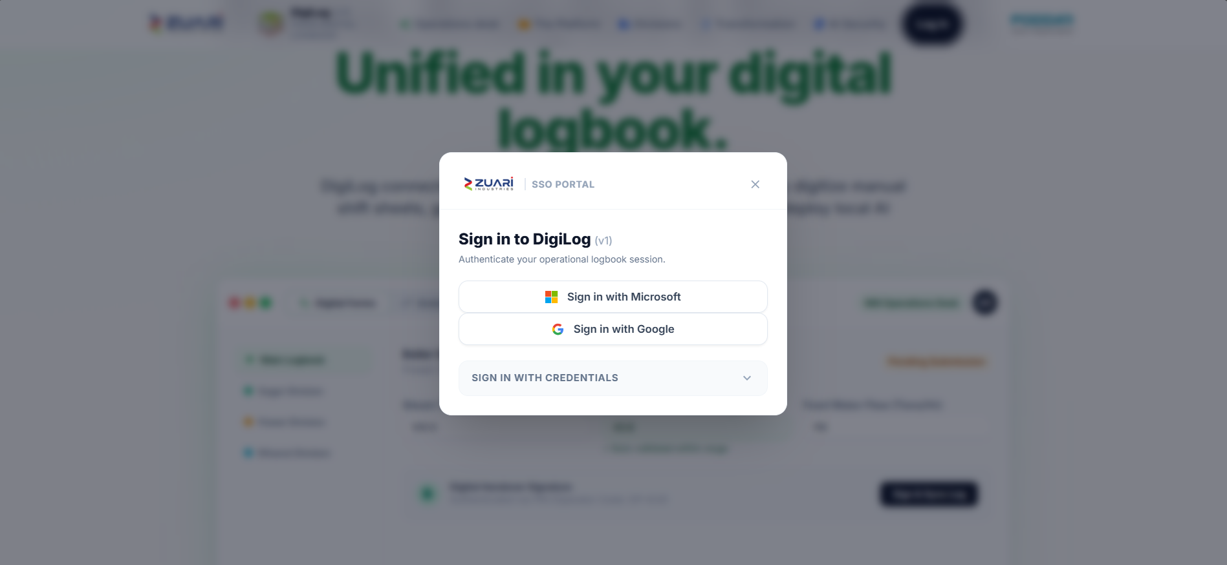

1.1.2 Sign-in methods
- Sign in with Microsoft (needs HTTPS).
- Sign in with Google.
- Sign in with credentials:
- Username or corporate email
- Security key phrase / password
- Sign In
- Forgot? shows: Contact your IT administrator for password reset. There is no self-reset screen.

1.1.3 After a good login
- Toast: Signed in successfully.
- You land on Home.

1.1.4 Messages that block login
- Admin account on this page: You do not have permission to sign in on this page. Use /admin/login.
- Inactive: Your account is deactivated. Contact your administrator.
- No app access: You do not have access to use this application. Please contact the administrator.

1.2 Sign in — administrator
- Open /admin/login.
- Enter Email address and Password.
- Click Sign In as Admin.
- You land on Config → Employees.
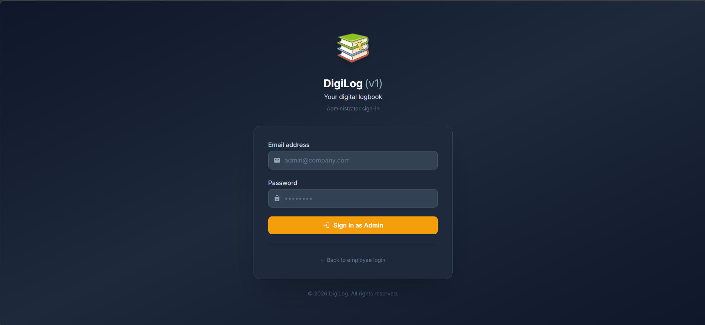
- Link ← Back to employee login returns to the public page.

1.3 Home
- Greeting: Hello, {first name}.
- Home is a picker, not a form.

1.3.1 Homepage cards
- Forms Hub → Open Forms Hub → operation forms and equipment.
- BI Control Tower → Open BI Control Tower → eight dashboards.
- Empty: No homepage destinations assigned.
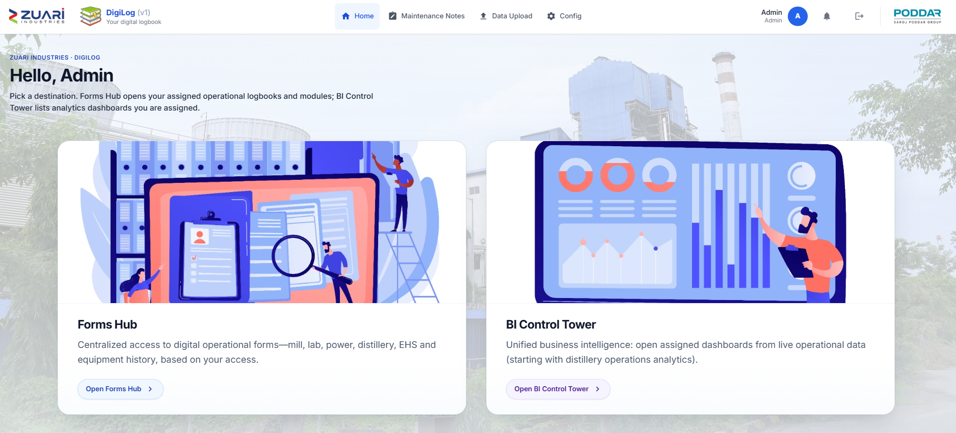

1.3.2 Who gets which card
- An administrator assigns Forms Hub and/or BI Control Tower.
- A card does not unlock every form. Forms and dashboards are mapped separately (see 8.1).

1.4 Navigation bar
Items appear only when you have access.
- Home — back to the two cards.
- Maintenance Notes — short notes (Sugar / Power / Production / Engineering). Distillery category does not see this.
- Approvals — HOD inbox.
- Data Upload — workbooks for dashboards.
- Config — administrators only.
- Bell — notifications.
- Avatar — profile photo.
- Logout — sign out.
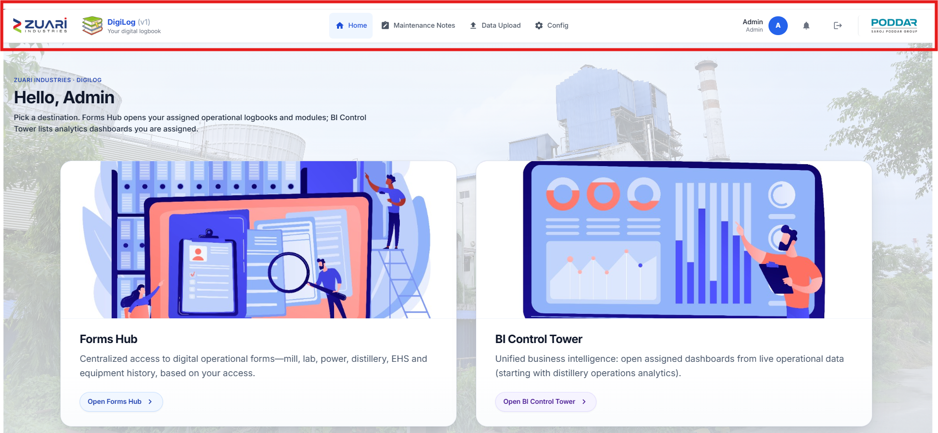

1.5 What you can see (access)
- Homepage cards: Forms Hub and/or BI Control Tower.
- App and form mapping: which Forms Hub cards and form rows you see.
- View only: View only — you can see this data but cannot submit or edit.
- Employee category: Notes plant lock (Sugar / Engineering → Sugar House; Power → Power Plant; Production → Production House).
- HOD assignment: Approvals in the navbar.
- Data Upload grant: which upload tabs you see.
- Locked-card manage: rename / move / delete imported equipment cards.

2. Operation Form
Every daily logbook and sampling sheet lives in Forms Hub → Operations forms. This chapter is the feature list for those cards.

2.1 Forms Hub

2.1.1 What it is
- Landing page for all operation apps and equipment apps.
- Title: Forms Hub.
- Two sections:
- Operations forms — Daily operational logbooks including mill, lab, power, distillery, and EHS forms.
- Equipment maintenance and history — covered in chapter 3.
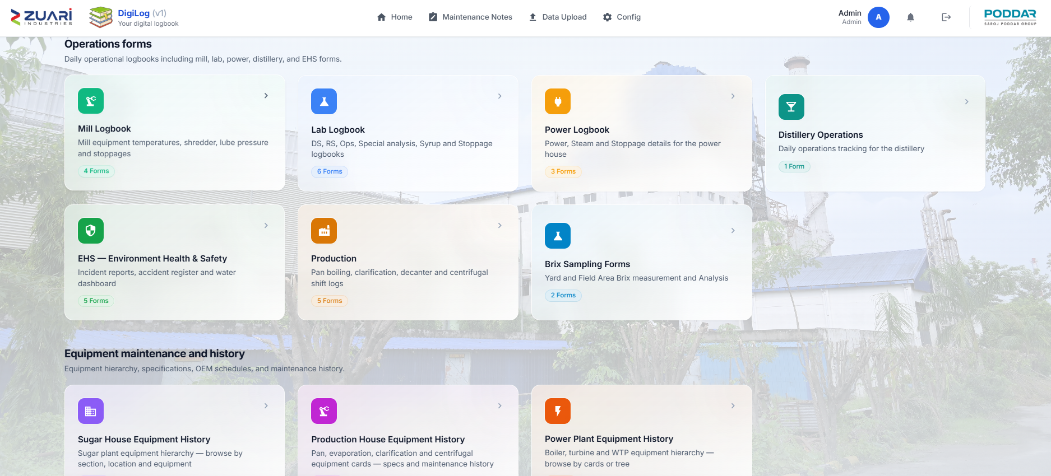

2.1.2 How to open
- Home → Open Forms Hub.
- Empty: No applications assigned — Contact your admin to get access.

2.1.3 App card
- Shows the app name and N Form(s).
- Click the card to open Available Forms.

2.1.4 Form row actions (desktop)
- Open Form — fill a new entry (equipment hub cards say Open).
- View Data — past rows.
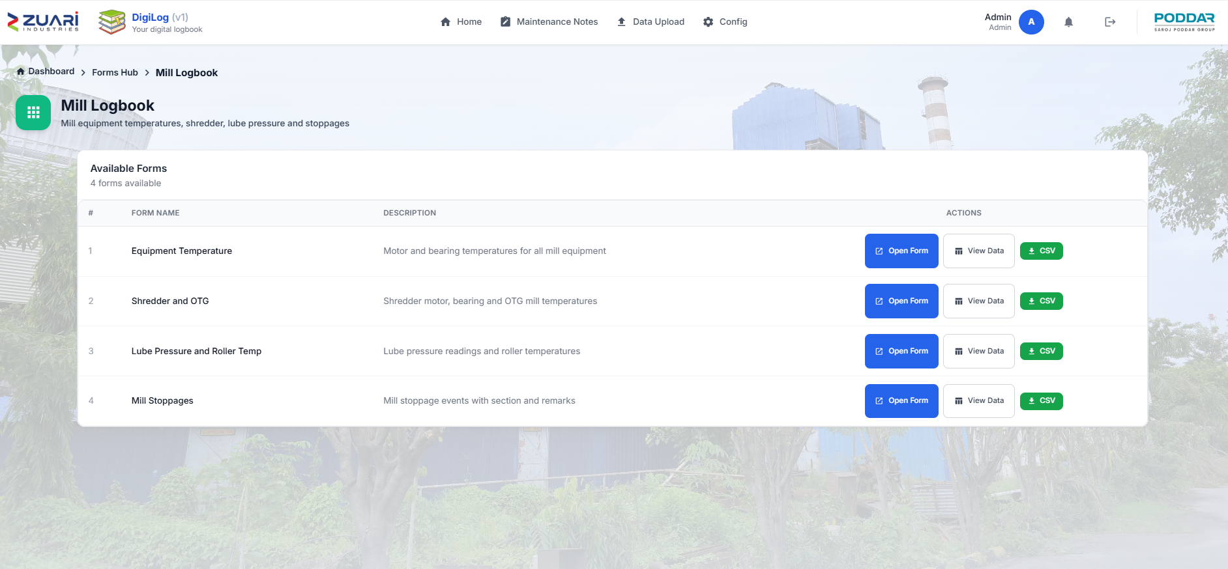
- CSV — download rows.

2.1.5 Form row actions (phone)
- Open Digital Form (or Open).
- View Logs.
- Excel Download.

2.1.6 View only
- Banner: View only — you can see this data but cannot submit or edit.

2.2 Shared submit steps (all data forms)
- Set Report Date / Sampling Date / Operation Date and Shift where asked.
- Fill the sections for this shift.
- Click Submit.
- Read Confirmation Policy Notice.
- Click Confirm & Commit.
- If Forms Approval is on, wait for the HOD (chapter 5). If sent back, correct and submit again.
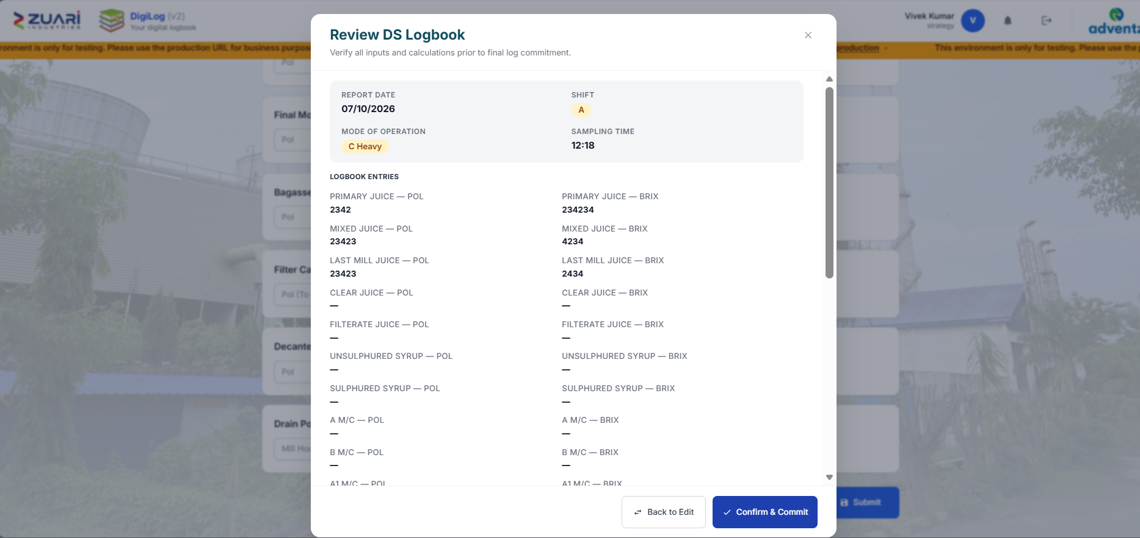

2.2.1 Common validation
- Mill / lab: Date and Shift are required.
- Distillery: Operation Date is required.
- Power Details: Date and General remarks are required.
- Field Brix: many boxes required (see 2.9.2).

2.2.2 Live operations apps (feature list)
- Mill Logbook — 4 forms (2.3).
- Lab Logbook — 6 forms (2.4).
- Power Logbook — 3 forms (2.5).
- Distillery Operations — 1 form (2.6).
- EHS — Environment Health & Safety — 5 forms (2.7).
- Production — 5 forms (2.8).
- Brix Sampling Forms — 2 forms (2.9).
Retired (not in the grid): Mill House Equipment History, Power Plant Equipment History (old).

2.3 Mill Logbook
- Who: mill operators / shift in-charge.
- When: each mill shift A / B / C.
- Dashboards: Milling Operations. Names on temperature tabs come from Data Upload → Milling Operations maps (chapter 6).

2.3.1 Equipment Temperature
- What: motor and bearing temperatures for mill-side machines.
- How to open: Forms Hub → Mill Logbook → Equipment Temperature → Open Form.
- Header fields: Report Date, Shift, Time.
- Equipment cards: Cane Kicker, Cardian Drum 1, Cardian Drum 2, Feeder Drum, Cane Carrier, Shred. Carrier, Belt Convy, IRC 1–4, Mill 0, Mill 4.
- Per equipment: Motor Temp (DE), Gear Box BRG Temp (DE), Gear Box BRG Temp (NDE), PB BRG Temp (DE), PB BRG Temp (NDE).
- Required: Date and Shift.
- Where it goes: Milling Operations → Equipment Temperature.

2.3.2 Shredder and OTG
- What: shredder motor / bearing / vibration and OTG bearing temperatures.
- How to open: Mill Logbook → Shredder and OTG → Open Form.
- Header: Report Date, Shift, Time.
- Shredder RHS / LHS: Motor BRG Temp, Bearing Temp (DCS), Bearing Temp (Site), Vibrations H / V / A.
- OTG Bearing Temperature: Mills 1–4; Input / Intermediate / Output; Mill side and Turbine side.
- Where it goes: Milling Operations → Shredder and OTG Temp.

2.3.3 Lube Pressure and Roller Temp
- What: lube pump line pressure and mill roller temperatures.
- How to open: Mill Logbook → Lube Pressure and Roller Temp → Open Form.
- Header: Date, Shift, Time.
- Lube Pump Pressure (Kg/Sq.Cm): ACC, MCC, Shredder, Mill 0.
- Mill roller temperatures: Mills 0–4, gear and pintal sides (as on the form).
- Where it goes: Milling Operations → Lube & Roller Temp.

2.3.4 Mill Stoppages
- What: mill stop events.
- How to open: Mill Logbook → Mill Stoppages → Open Form.
- Fields: Report Date, From, To, Section, Machinery, Remark.
- Required: Date, Start Time, End Time.
- Where it goes: Milling Operations → Mill Outage.

2.4 Lab Logbook
- Who: lab / process chemist.
- When: each lab shift A / B / C.
- Dashboards: Management Overview uses DS and Operations (and RS for gaps). Special Analysis, Syrup, and lab Stoppage are not on a BI dashboard.

2.4.1 DS Logbook
- What: direct sulphitation Pol / Brix log.
- How to open: Lab Logbook → DS Logbook → Open Form.
- Header: Date, Shift, Sampling Time, Mode of Operation (B Heavy / C Heavy).
- Pol and Brix pairs: Primary Juice, Mixed Juice, Last Mill Juice, Clear Juice, Filterate Juice, Unsulphured Syrup, Sulphured Syrup, A / B / A1 / C massecuite, A1 / A-Hy / A-Light / B-Hy / C-Light molasses, Final Molasses.
- Other: Bagasse Pol, Bagasse Moisture, Filter Cake Pol, Decanter Mud Pol, Mill Drain Pol, Boiling House Drain Pol.
- Required: Date and Shift.
- Where it goes: Management Overview — Pol in Cane % and mill/sugar gaps.

2.4.2 RS Logbook
- What: remelt sulphitation Pol / Brix log.
- How to open: Lab Logbook → RS Logbook → Open Form.
- Header: Date, Shift, Sampling Time.
- Groups: Juices, Massecuites, Molasses, Melt, IER, Filter Cake Pol (labels as on the form).
- Where it goes: Management Overview (fills a reading when DMR has no value).

2.4.3 Operations Logbook
- What: yard, crush, juice, sugar bagging, dryer readings.
- How to open: Lab Logbook → Operations Logbook → Open Form.
- Header: Report Date, Shift, Sampling Time.
- Input: Yard Balance (Qtls), Crushing (Qtls), Imbibition Water (Qtls), Imbibition Temperature (°C).
- Output: Mixed Juice DS/RS, Molasses DS/RS, Filter Cake DS/RS.
- Sugar: DS Large / Medium / Small, RS Large / Medium / Small — Qty, Mesh, Bag Temp.
- Pharma 20 / 30 / 40: Qty, Bag Temp.
- FBD DS / RS and RSD: inlet / outlet / hopper temp and moisture.
- Where it goes: Management Overview — Yard Bal. (8AM) if DMR has no 8 AM figure (7–8 or 8–9 AM sample); mill/sugar gaps.

2.4.4 Special Analysis Logbook
- What: retention, moisture, colour by product grade.
- How to open: Lab Logbook → Special Analysis Logbook → Open Form.
- Header: Date, Shift, Sampling Time.
- Products: DSL, DSM, DSS, RSL, RSM, RSS, Pharma20, Pharma30, Pharma40.
- Per product: Retention (%), Moisture (%), Colour (IU).
- Extra colour: Clr Juice DS, Raw Melt RS, Clear Melt RS, Fine Liquor RS.
- Dashboard: none.

2.4.5 Syrup Logbook
- What: syrup made and diverted.
- How to open: Lab Logbook → Syrup Logbook → Open Form.
- Header: Date, Shift.
- Syrup Production: Syrup Prod DS, Syrup Prod RS.
- Diversion: Diversion Mode, Syrup Diversion, Molasses to Dist DS, Molasses to Dist RS.
- TRS: Syrup TRS, Boil House TRS.
- Dashboard: none.

2.4.6 Stoppage Logbook
- What: lab / process stoppages.
- How to open: Lab Logbook → Stoppage Logbook → Open Form.
- Fields: Report Date, From, To, Reason, Remark.
- Dashboard: none.

2.5 Power Logbook
- Who: power house.
- Dashboards: Power Plant Operations; power/steam cells on Management Overview.

2.5.1 Power Details
- What: generation, import, export, sugar / cogen / distillery splits.
- How to open: Power Logbook → Power Details → Open Form.
- Header: Report Date, Time.
- Crushing: Cane Crushed (Qtls), Bagasse Produced (Qtls).
- Operating Hours: 30.85MW STG, 3MW STG (O), 3MW STG (N), 4MW STG.
- Power Generation: same four STGs.
- Power Gen by DG Set: 625KVA 1–3, 380KVA 4.
- Power Import: Grid, 3MW Old, 3MW New, 4MW.
- Power Export to Grid / Power to Sugar / Power to Cogen / Power to Distillery: as on the form.
- Power to Sugar (Breakup): Mill, DS, Raw & Ref., 70TPH, ETP, Colony, Sugar CPU, Others.
- Required: Date and General remarks.
- Where it goes: Power Plant Operations; Management Overview power ratios.

2.5.2 Steam Details
- What: steam raised and used on 150 / 70 / 35 TPH.
- How to open: Power Logbook → Steam Details → Open Form.
- Header: Report Date, Time.
- 150 TPH: generation, consumption, PRDS paths, extraction, fuel Firewood/Baggase (MT).
- 70 TPH: generation, TG and distillery steam, fuel.
- 35 TPH: generation, 4 MW, PRDS, distillery, ejector, deareator, slop (MT).
- Where it goes: Power Plant Operations steam tabs; Management Overview steam cells.

2.5.3 Stoppage Details
- What: power-house outages.
- How to open: Power Logbook → Stoppage Details → Open Form.
- Fields: Report Date, From, To, Section (+ specify), Sub-Section (+ specify), Machinery (+ specify), Category (+ specify), General remarks, Photo 1, Photo 2.
- Where it goes: Power Plant Operations → Outage.

2.6 Distillery Operations

2.6.1 Distillery Operations Form
- What: daily ethanol, feed, stock, and calculated efficiencies.
- Who: distillery.
- When: daily (operation date).
- How to open: Distillery Operations → Distillery Operations Form → Open Form.
- Header: Operation Date, Operation Mode.
- Throughput & quality: Syrup/Molasses Used (Qtls), Wash Distilled, TRS, UFS, Alcohol %.
- Production: Actual Ethanol Production (BL), AL/BL Ratio (%).
- Storage: Total BH Molasses, Total CH Molasses, Ethanol in Storage (BL).
- Calculated (auto): FS, FS%, FS Quantity, Theoretical yield, Alcohol prod in fermentation, FE, Actual prod. AL, DE, OE, REC BL, REC AL, TRS QTY, UFS QTY, Total mol in store (Qtls).
- Required: Operation Date.
- Where it goes: Distillery Operations dashboard; Management Overview Distillery row.

2.7 EHS — Environment Health & Safety
- Who: EHS / safety / water.
- Dashboard: none of these five feed BI Control Tower.

2.7.1 Accident Report / Near Miss Report
- What: workplace accident or near miss.
- When: when an event happens.
- How to open: EHS — Environment Health & Safety → Accident Report / Near Miss Report → Open Form.
- Header: Date, Time, Incident type.
- Person Involved: Name, Contact No., Dept / Section, Type, Other (specify).
- Incident Details: Location, Severity, Description / Cause.
- Treatment: Treatment Type, What was given, By Whom.
- Follow-up: Significant Hazard Identified.
- Incident Photos: Image 1–3.
- Document Upload: Document 1–3.

2.7.2 Water Dashboard — Ground Water Abstraction
- What: bore-well extraction and use.
- How to open: EHS → Water Dashboard — Ground Water Abstraction → Open Form.
- GW Pump 1 (Truck Yard) / 2 (36 Block) / 3 (Admin): Meter Reading, Extracted (KL).
- Total Bore Well: Total Ext. (KL).
- Domestic Uses: Colony (KL), Fire & Labour (KL).
- Industrial Uses: Distillery, Power Plant, Refinery, DS, Mill, Total Industrial (KL).
- Cane Crushing: On Date (TCD), To Date (TCD).
- Water per Tonne Cane: Sugar + Dist (L/T), Industrial (L/T), Total Sugar Ext (L/T).
- Remarks.

2.7.3 Water Dashboard — ETP Working
- What: effluent treatment quantity and quality.
- How to open: EHS → Water Dashboard — ETP Working → Open Form.
- Cane Crushing: On Date / To Date (TCD).
- ETP Inlet / Outlet: Meter Reading, KL.
- Quality: pH (G Shift), TSS <30 ppm, COD <250 ppm, BOD <30 ppm, TDS <2100 mg/L, Oil & Grease <10 mg/L.
- Effluent: 200 L/TCD On Date, On Date (KLD), Remarks.

2.7.4 Water Dashboard — CPU Water Recycle
- What: CPU inlet/outlet and outlet quality.
- How to open: EHS → Water Dashboard — CPU Water Recycle → Open Form.
- CPU Inlet / Outlet: On Date (KL), To Date (KL).
- Inlet pH: A / B / C Shift.
- Outlet Quality: pH (5.5–8.5), TSS <30 ppm, COD <250 ppm, BOD <30 ppm, TDS <2100 mg/L, Oil & Grease <10 mg/L, Transmittance >85.
- Remarks.

2.7.5 Daily Safety Toolbox Talk
- What: toolbox talk record.
- How to open: EHS → Daily Safety Toolbox Talk → Open Form.
- Fields: Date, Shift, Time From, Time To, Prepared By, Topic Discussed, No. of Attendees.
- Photos: Attendance Sheet, Session Photo 1, Session Photo 2.

2.8 Production
- Who: production / boiling house / chemist.
- Dashboard: none of these five feed BI Control Tower.
- Shifts on chemist sheet: 8–4, 4–12, 12–8 (not A/B/C).

2.8.1 Shift Chemist Job Log Book
- How to open: Production → Shift Chemist Job Log Book → Open Form.
- General: Date, Season, Instructions / Remarks.
- Each shift (8–4, 4–12, 12–8): Jobs Done, Jobs To Be Done, Chemist Sign.

2.8.2 A-Centrifugal Machine Stoppage Log Book
- How to open: Production → A-Centrifugal Machine Stoppage Log Book → Open Form.
- General: Date, Shift.
- Parameters: S.H.W. Temp (°C), S.H.W. Pressure (Kg/cm²), Air Pressure (Kg/cm²).
- Machines No.1, No.2, No.3 NHEC, No.4 WB: Basket Cleaning, Screen Condition, From, To, Duration, Reasons, Separator, Remarks.
- Sign-off: Operator / Chemist / Section Head [TO CONFIRM] exact labels on your build.

2.8.3 Pan Log Book
- How to open: Production → Pan Log Book → Open Form.
- Strike / lab groups: Massecuite Grade, Strike No., Pan No., times, Qty, lab purity / Brix (as on the form).

2.8.4 Decanter Log Book
- How to open: Production → Decanter Log Book → Open Form.
- Time slots: 8 AM–9 AM through 7 AM–8 AM (24 slots).
- 1st Stage / 2nd Stage: mud, centrate, floc, load, torque, vibration (as on the form).

2.8.5 Clarification Log Book
- How to open: Production → Clarification Log Book → Open Form.
- Instructions: HOD / Dy HOD / Sectional Head (as on the form).
- Hourly: Juice Flow (T/Hr), MOL dose, pH, temperatures.

2.9 Brix Sampling Forms
- Who: cane quality / field staff.
- Dashboard: Cane Quality (Field Sampling / Yard Sampling).
- Hub list may show GSMA in the title; the form heading may hide that prefix.

2.9.1 Yard Brix Sampling Form
- How to open: Brix Sampling Forms → Yard Brix Sampling Form → Open Form.
- Groups: Record Info, Origin, Transport, Cane Details, Quality.
- Key fields: Sampling Date, Delivery Point, Truck Number, Variety, Middle Brix %, crop condition flags.

2.9.2 Field Brix Sampling Form
- How to open: Brix Sampling Forms → Field Brix Sampling Form→ Open Form.
- Required: Sampling Date, Name, Test Type, Grower Name, Village Name, Variety of Cane, Land Type, Soil Type, Crop Type, Field Condition, Crop Condition, Sampling Point, Bottom Brix %, Middle Brix %, Top Brix %.
- Where it goes: Cane Quality → Field Sampling.

2.10 Editing, View Data, and form approvals
- There is no separate Save draft on these logbooks.
- View Data (phone View Logs) lists stored rows.
- Admins can edit/delete a row when it has no open approval and you are not view-only.
- Badges: pending / needs modification / resubmitted.
- If Forms Approval is on, the HOD uses Approvals → Forms (chapter 5).
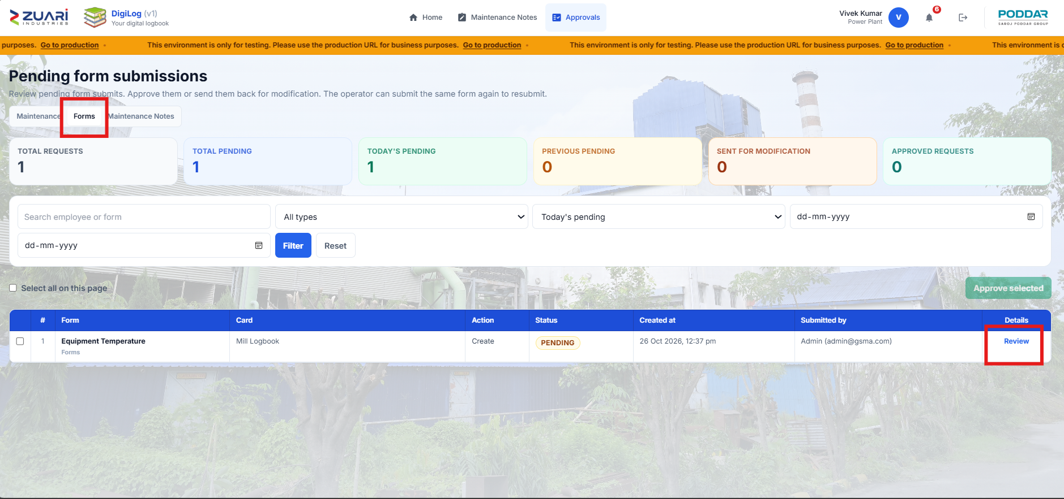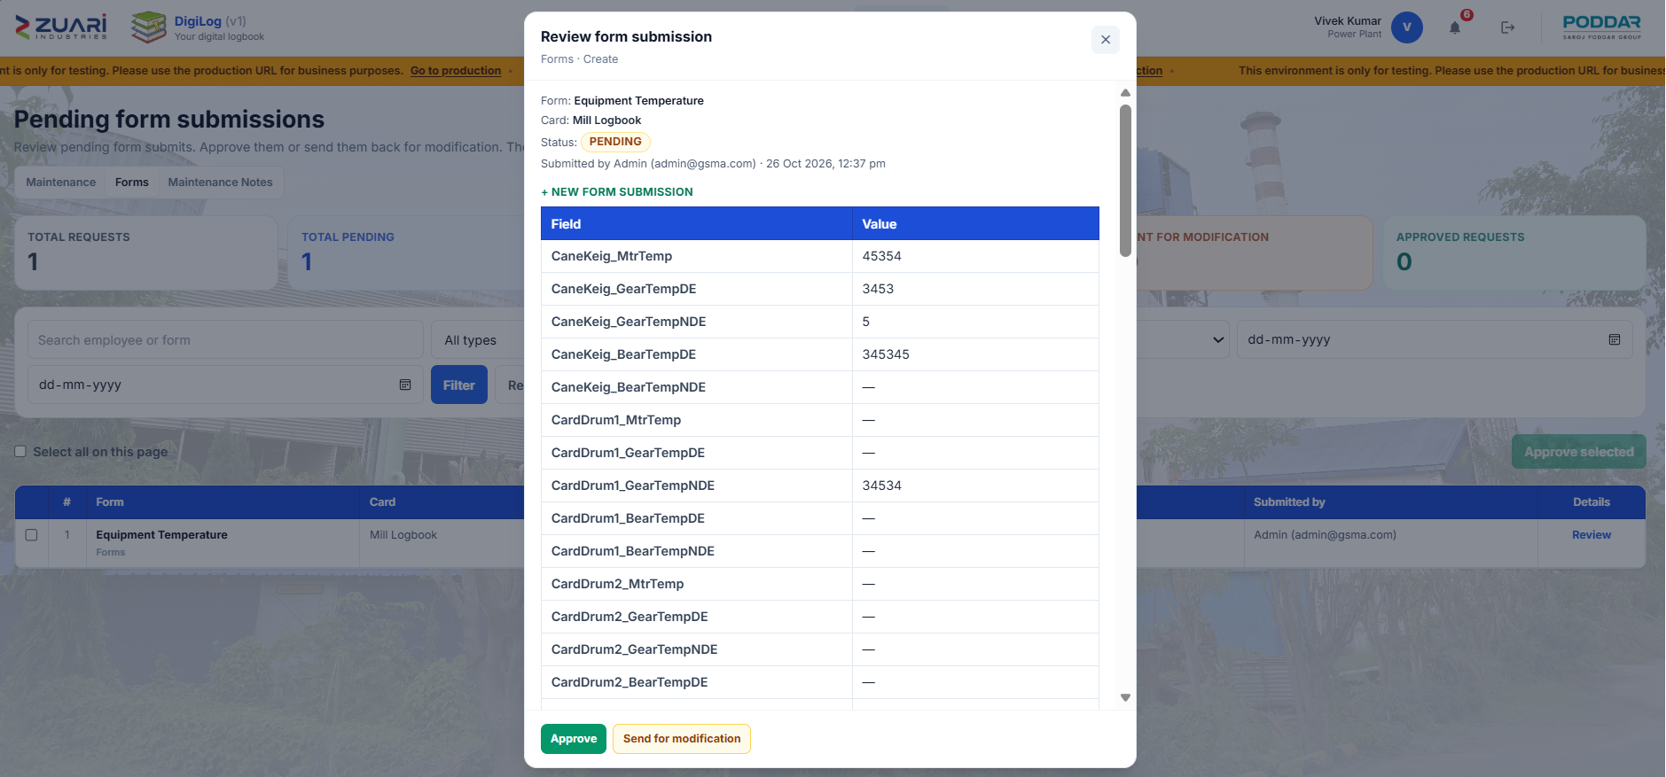

2.11 Common mistakes
- Wrong date or shift — row sits on another shift.
- Duplicate Submit — two rows; ask admin to remove extras if allowed.
- View-only login — cannot submit.
- Sent back by HOD — correct and submit again (resubmit).
- Wrong unit (Qtls vs T) — dashboard looks impossible.
- Mill names blank on dashboard — mapping file not uploaded (chapter 6).

3. Equipment Maintenance History
Three plant registers under Forms Hub → Equipment maintenance and history. They are parallel books, not one tree.

3.1 Feature list — the three cards
- Power Plant Equipment History — folders → equipment → four disciplines (3.2).
- Sugar House Equipment History — same pattern, with Location on the card (3.3).
- Production House Equipment History — flat list, no folder tree (3.4).
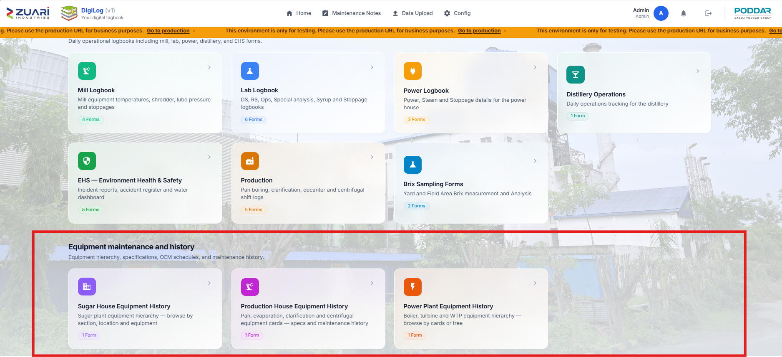

3.1.1 How they relate
- Power and Sugar: Equipment Specification, OEM Maintenance Schedule, Equipment Maintenance History, per Mechanical / Civil / Electrical / Instrument.
- Production: specification and history only (no OEM schedule, no disciplines).
- Each plant has its own history HOD (chapter 8.6).
- Maintenance Notes is a separate module (chapter 4), not a fourth equipment card.

3.1.2 How to open
- Home → Open Forms Hub.
- Section Equipment maintenance and history.
- Click one of the three app cards (Open).

3.2 Power Plant Equipment History

3.2.1 What you see
- Header: Power Plant Equipment History — Browse boiler, turbine and water treatment equipment by cards or tree.
- Views: Cards, Tree, Mind map, Starred, Move history.
- Folder card: title, item count.
- Equipment card: name, 4 disciplines · Choose section, Tag: when present.
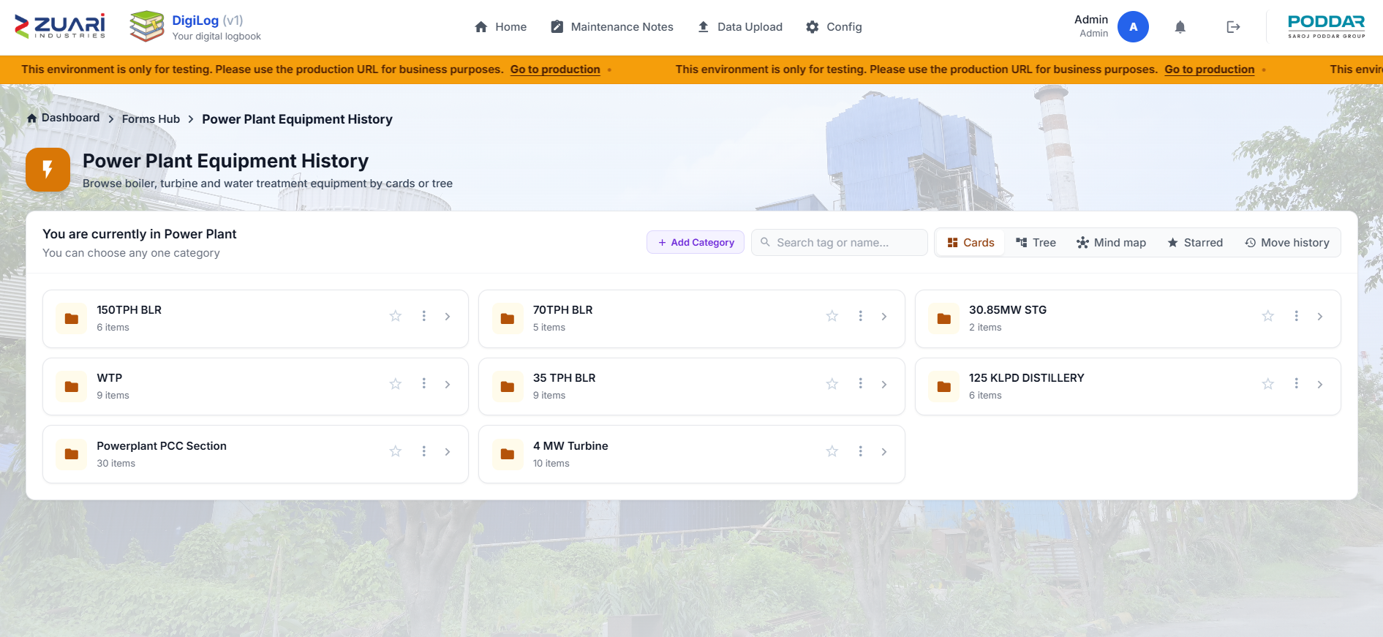

3.2.2 Search
- Placeholder: Search tag or name...
- Tree opens matching branches.
- Move history search: Search user or card...

3.2.3 Open a machine
- Open the folder path.
- Click the equipment.
- Click a discipline: Mechanical, Civil, Electrical, Instrument.
- Detail shows Specification, OEM schedule, Maintenance History.
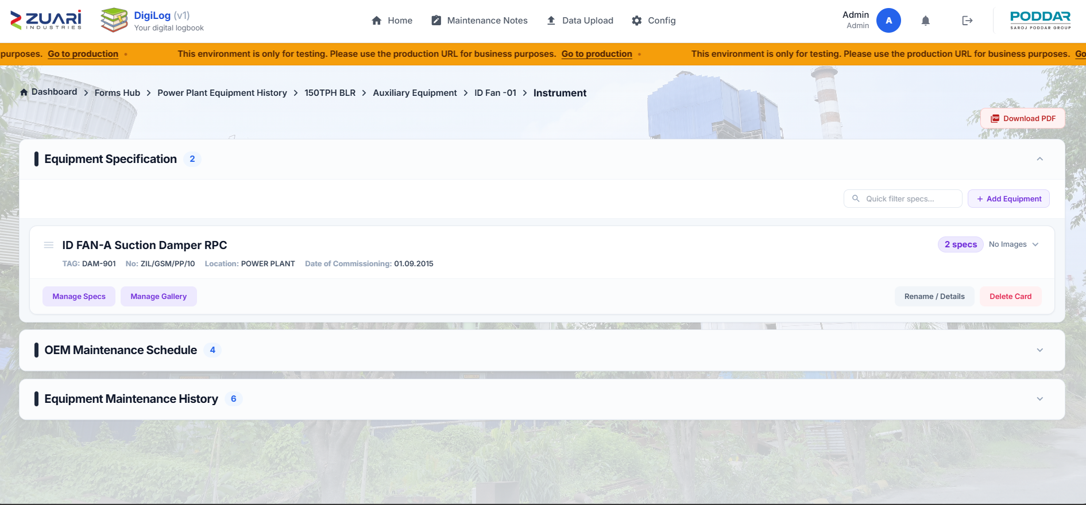

3.2.4 Add a history record
- Add Record on Equipment Maintenance History.
- Fields: Season (Off-Season / Season), Year, Date of Start, Date of Finish, Outage / Observation, Action Taken, Maintenance Type (RM, PM, PdM, CBM, CM, RCM), Repair Cost (Rs.), Service (Internal / External), Provider, Responsible, Remarks, Before / After photos.
- If approval is on: save as draft, then Submit all (N) (or submit that row for hod approval).
- Download Excel / Download PDF on the detail page.
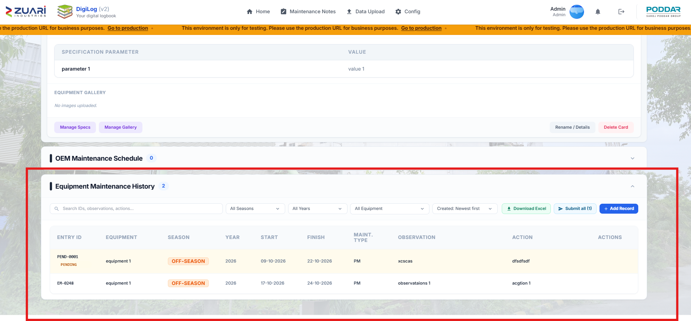

3.2.5 Read history
- Columns: Entry ID, Season, Year, Start, Finish, Maint. Type, Observation, Action.
- Filters: Search IDs, observations, actions..., All Seasons / Off-Season / Season, All Years, Created Newest / Oldest first.
- Badges: Pending, Needs modification, Approval pending, Delete pending.

3.2.6 Star, Move, locks
- Star this card / Remove from starred.
- Move is same level only → Move here.
- Move history columns: User, Card, From, To, Date.
- Seeded / locked Power cards need locked-card manage acess for Power (chapter 8.1).
- Star / Move / Edit / Delete only when the tree is the live database tree [TO CONFIRM].

3.2.7 Who can edit
- App assigned; not view-only.
- History delete: administrator only.
- Do not edit while Approval pending, except draft or Needs modification.

3.3 Sugar House Equipment History

3.3.1 What you see
- Header: Sugar House Equipment History — Browse sugar plant equipment by section, location, main and sub equipment.
- Same views as Power: Cards, Tree, Mind map, Starred, Move history.
- Equipment cards also show Location:.

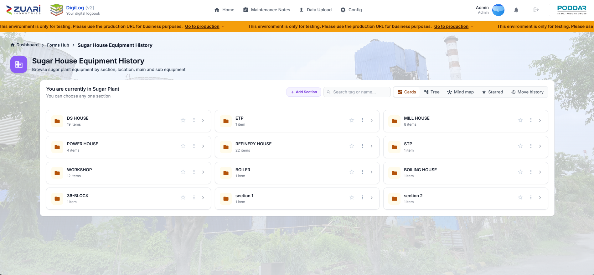

3.3.2 Search, add, read, move
- Same steps as 3.2.2–3.2.6.
- History HOD is the Sugar House HOD.
- Imported cards stay locked until locked-card manage for Sugar.

3.4 Production House Equipment History

3.4.1 What you see
- Header: Production House Equipment History — All production house equipment cards — specs and maintenance history.
- Flat grid. No Cards / Tree / Mind map / Starred / Move history.
- Card shows: name, house section, type, duty, capacity, spec count, history count.
- House sections: Pan & Crystallizer, Evaporation, Clarification, Centrifugal & Drier House.
- No OEM Maintenance Schedule.
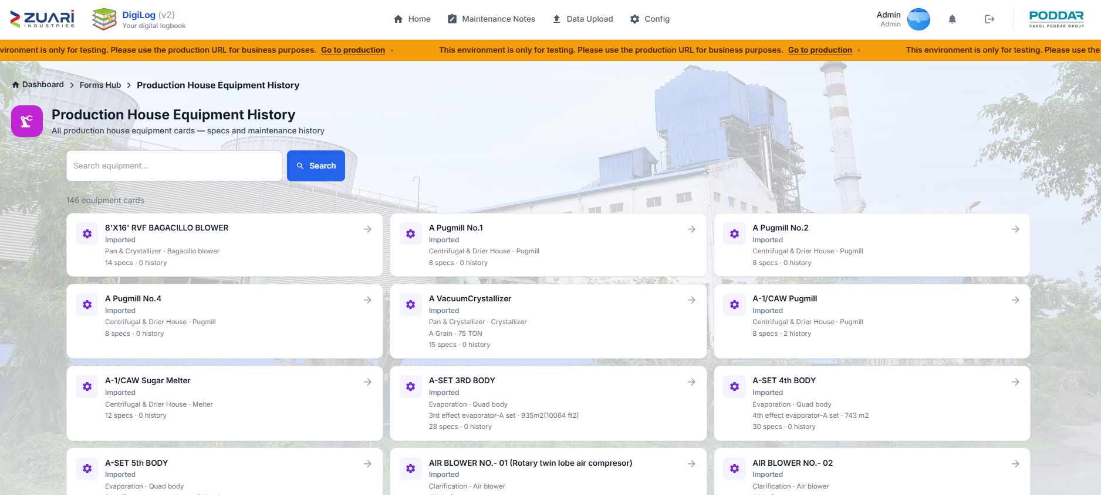

3.4.2 Search
- Search equipment… → Search.
- Clear removes the filter.

3.4.3 Add or update
- Open the card.
- Equipment details: Name, Type, Duty, Capacity → Save details.
- Imported: Identity locked — ask an admin for locked-card manage access.
- Add Record on history (same field set as Power/Sugar; observation is not forced).
- Submit for Production House HOD when approval is on.
- Download PDF (specification + history).
- Delete card removes the equipment — only if allowed.

3.5 Shared history field list
- Season — Off-Season / Season.
- Year.
- Date of Start / Date of Finish.
- Outage / Observation.
- Action Taken.
- Maintenance Type — RM, PM, PdM, CBM, CM, RCM.
- Repair Cost (Rs.).
- Service — Internal / External.
- Provider, Responsible, Remarks.
- Service Photos — Before / After.

4. Maintenance Notes
A short shared register of work the plant intends to do. It is not an equipment life-history row (chapter 3) and not a shift logbook (chapter 2).

4.1 Who can open it
- Navbar Maintenance Notes.
- Allowed: Sugar House, Power Plant, Production House staff.
- Engineering category uses Sugar House.
- Distillery category does not get this menu.
- Administrators see all plants.
- Unavailable copy: Maintenance Notes is not available — This register is only for Sugar House, Power Plant, and Production employees.

4.2 What you see
- Title: Maintenance Notes.
- Subtitle: Shared register of work the plant intends to carry out. Anyone can add a note. Completed is set only after the plant HOD approves.
- KPI tiles: Pending, Awaiting HOD, Rework, Completed.
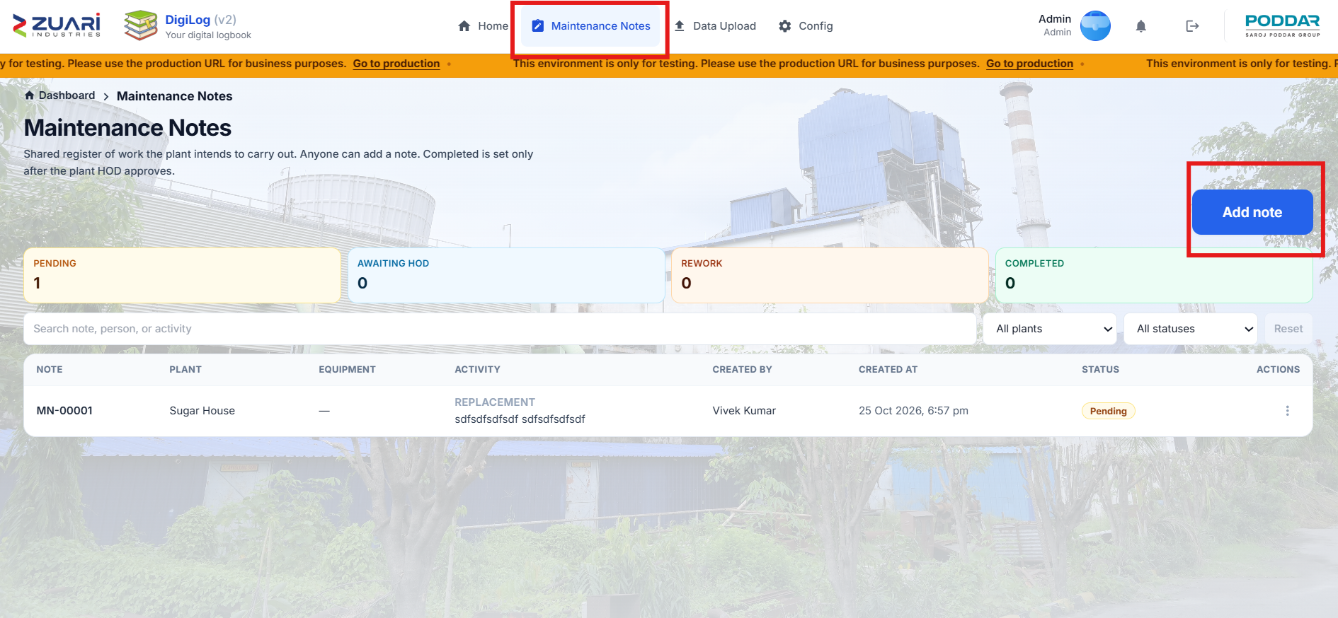

4.3 Filters
- Search: Search note, person, or activity.
- Plant: All plants, or locked to Sugar House / Power Plant / Production House.
- Status: All statuses, Pending, Approval Pending, Rework Required, Completed.
- Reset.
- Empty: No maintenance notes match these filters.

4.4 Add a note
- Click Add note / Add maintenance note.
- Plant* — locked from your employee category, or chosen by admin.
- Locked copy: Plant is set from your employee category. Equipment comes from that plant’s hierarchy.
- Unlocked copy: Plant decides which HOD can close the note. Equipment comes from that plant’s hierarchy.
- Tick Not related to a specific equipment, or pick Equipment*.
- Activity type*:
- Inspection
- Repair
- Replacement
- Lubrication
- Cleaning / Descaling
- Overhaul
- Calibration
- Painting / Civil
- Other
- Activity (short text) — max 80* characters.
- Details (optional).
- Photos (max as on form).
- Documents — PDF or Word, 10 MB each.
- Submit / Save changes / Cancel.
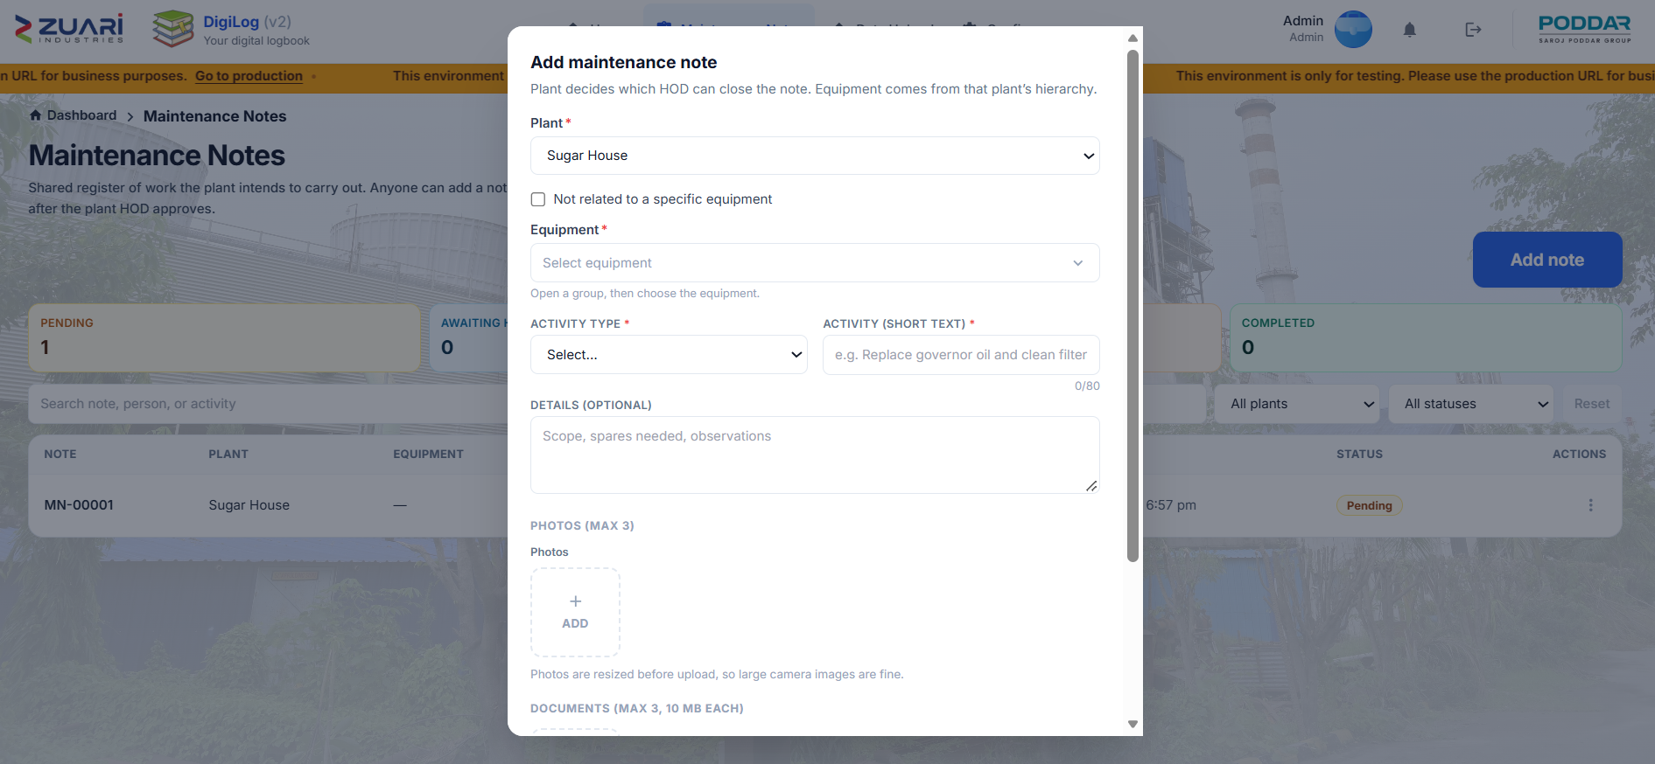

4.5 Submit for HOD
- Row actions: View, Edit, Submit (when allowed).
- Submit for completion modal: Completion remarks (optional) → Submit for approval.
- Status becomes Approval Pending.
- HOD works in Approvals → Maintenance Notes (chapter 5.3).

4.6 View only
- You have view-only access. You can read the register but cannot add or submit notes.

4.7 Statuses (feature list)
- Pending — written, not yet sent to HOD.
- Approval Pending — waiting for HOD.
- Rework Required — HOD sent it back.
- Completed — HOD approved.

5. Approvals
HOD inbox for three queues. Navbar Approvals shows only if you are HOD for history, forms, and/or notes.

5.1 Open and tabs
- Path: /maintenance/approvals.
- Denied: Approvals — You are not the assigned HOD for maintenance history, Forms Hub, or Maintenance Notes.
- Tabs (only those you are entitled to):
- Maintenance
- Forms
- Maintenance Notes
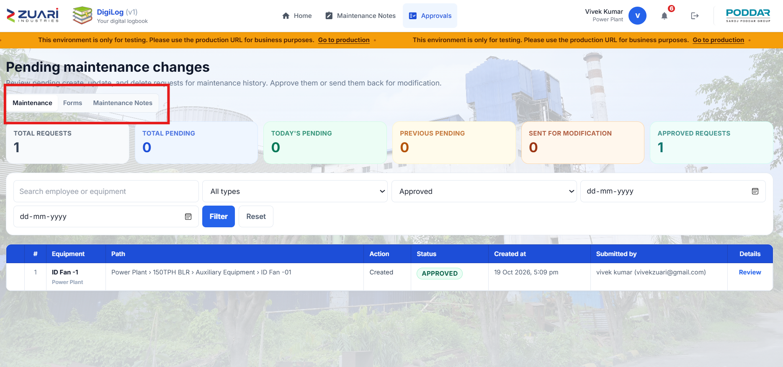
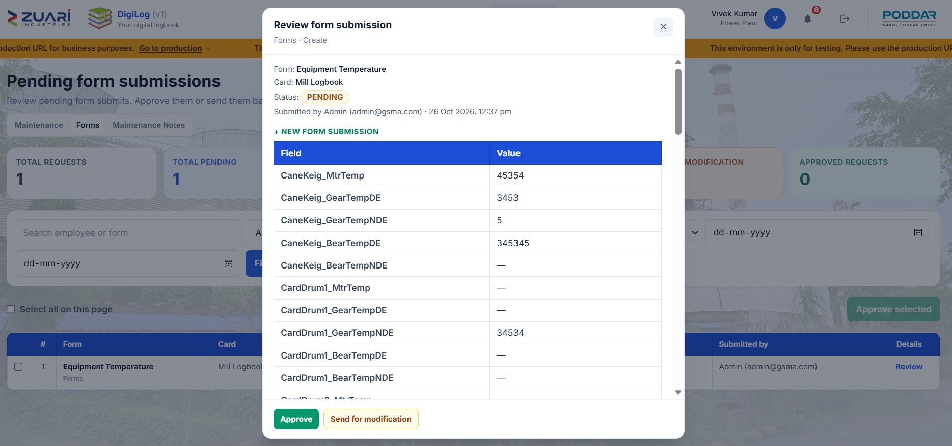

5.2 Maintenance and Forms (shared desk)

5.2.1 Titles
- Maintenance: Pending maintenance changes.
- Forms: Pending form submissions — Review pending form submits. Approve them or send them back for modification. The operator can submit the same form again to resubmit.

5.2.2 Summary cards
- Total Requests
- Total Pending
- Today's Pending
- Previous Pending
- Sent for modification
- Approved Requests

5.2.3 Filters
- Search: Search employee or equipment (forms: Search employee or form).
- Type: All types / Create / Update / Delete.
- Status: Today's pending, Previous pending, Total pending, Resubmitted, Sent for modification, Approved.
- Date from / to.
- Filter / Reset.

5.2.4 Actions
- Approve.
- Send for modification — comment required — Send back.
- Bulk: Select all on this page, Approve selected (n).
- Conflict: Apply requested values or Discard.
- Review titles: Review form submission / Review maintenance history change.
- Toasts: Approved., Sent for modification., Selected changes approved.

5.3 Maintenance Notes tab
- Title: Maintenance notes approval.
- KPIs: Awaiting you, Rework, Completed.
- Search: Search activity, person, or note.
- Plant: All your plants (or locked plant).
- Statuses: Approval Pending, Rework Required, Completed.
- Actions: Review, View, Approve, Reject.
- Reject modal: Send back for rework — Reason (required) — Reject.
- Success: note marked Completed, or sent back for rework.

5.4 Email (no login)
- Combined digest (IST) can cover Forms + Maintenance History + Maintenance Notes at Time 1 and optional Time 2 (set in Config, chapter 8).
- Forms mail includes OPEN APPROVALS INBOX (NO LOGIN).
- Links expire in 7 days.
- If the link is dead, sign in and use navbar Approvals.

5.5 What each tab approves (feature list)
- Forms — Operation Form submits (chapter 2) when Forms Approval is on.
- Maintenance — Equipment history create/update/delete (chapter 3) when History Approval is on.
- Maintenance Notes — completion of notes (chapter 4).

6. Data Upload
Workbooks that feed some dashboards. Navbar Data Upload. Page title: Data Ingestion Center.

6.1 Who can open it
- Administrators see all three sections.
- Employees see only sections granted in Data upload mapping (chapter 8.1).
- No grant: navbar hidden; URL sends you to Home.
- Intro: Use the sections below to upload specific reference files for dashboards.
- Back to Modules returns to Home.
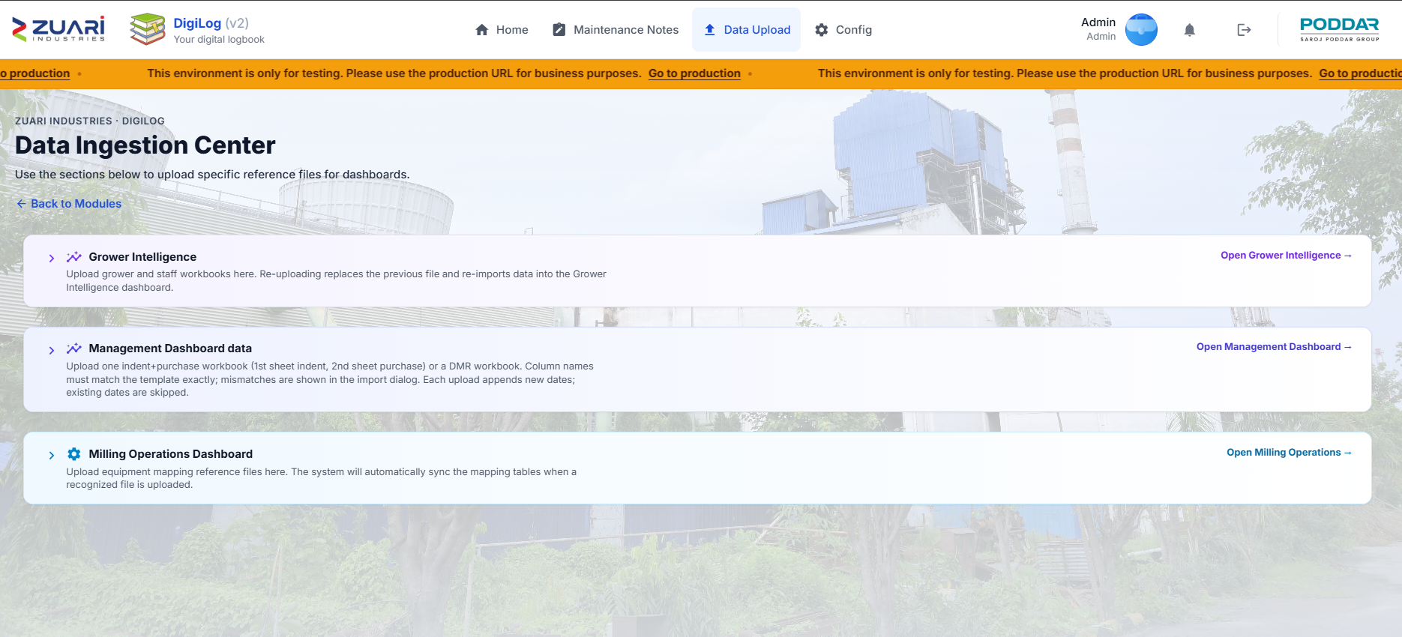

6.2 Feature list — sections and slots
- Grower Intelligence
- Grower Details Season
- Staff wise Bonding
- Management Dashboard
- Centre Indent & Purchase
- DMR workbook
- Milling Operations
- Mill Equipment Mapping
- Shredder Equipment Mapping
- Lube & Roller Mapping

6.3 Grower Intelligence
- Heading: Grower Intelligence.
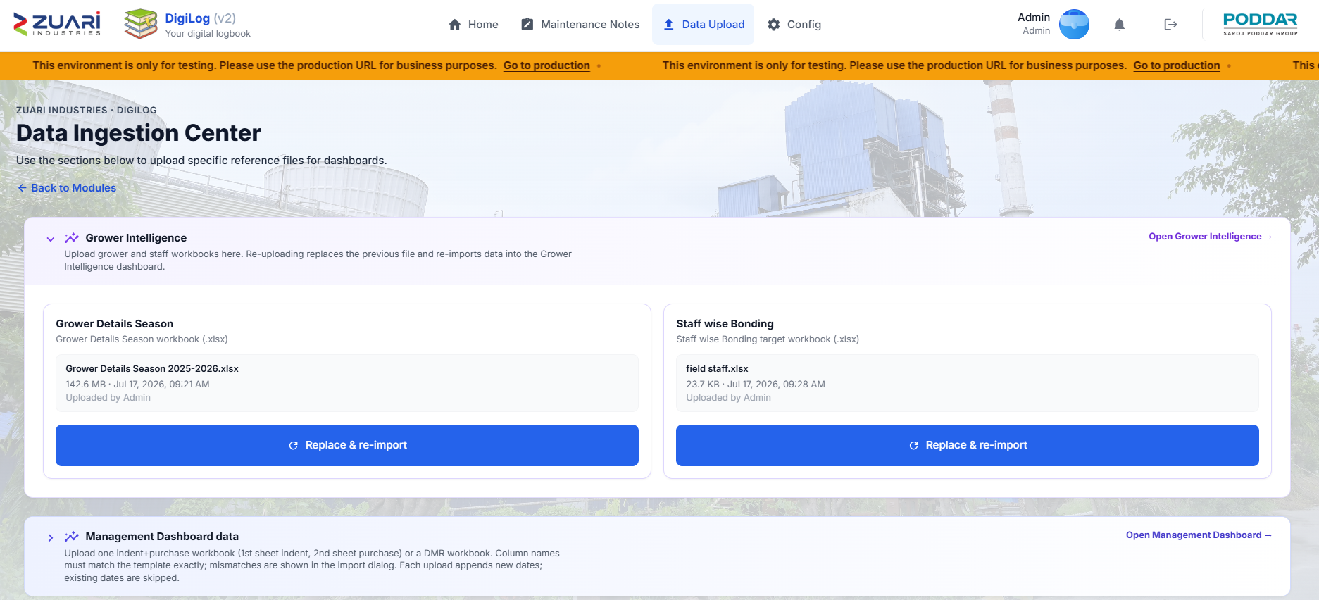
- Link: Open Grower Intelligence →.

6.3.1 Grower Details Season
- Hint: Grower Details Season workbook (.xlsx).
- Feeds: Grower Intelligence dashboard (grower / dishonour).
- Buttons: Upload & import / Replace & re-import / Uploading….
- Empty: No file uploaded yet.

6.3.2 Staff wise Bonding
- Hint: Staff wise Bonding target workbook (.xlsx).
- Feeds: Staff Drilldown.
- Same upload buttons as 6.3.1.

6.3.3 File rules and messages
- Accept: .xlsx,.xls.
- Toasts: Upload started., Purchy data imported. Open Grower Intelligence in Live mode., Purchy files must be Excel (.xlsx or .xls)., Upload failed.

6.4 Management Dashboard
- Heading: Management Dashboard data.
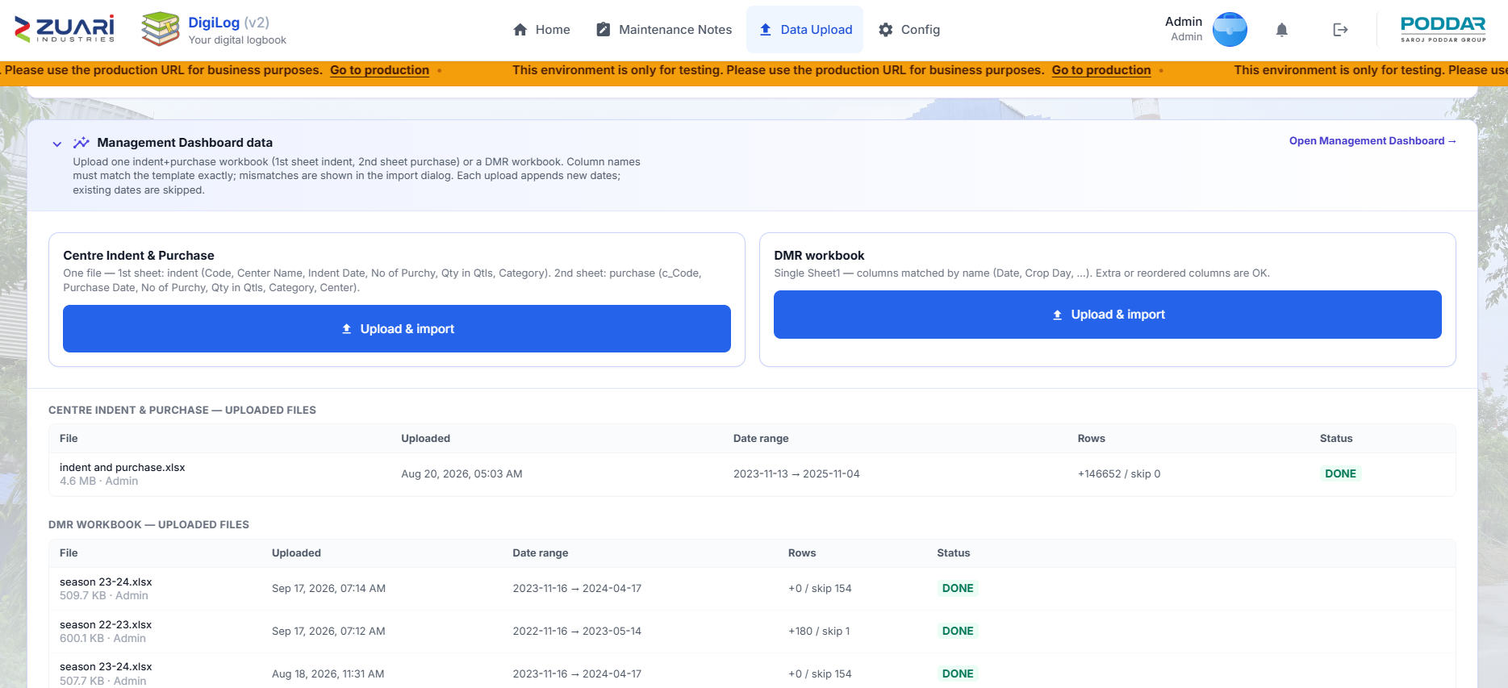
- Link: Open Management Dashboard →.

6.4.1 Centre Indent & Purchase
- One file — 1st sheet indent, 2nd sheet purchase (column names listed on the screen).
- Feeds: Management Overview indent/purchase/overrun; Centre Maturity.

6.4.2 DMR workbook
- Single Sheet1 — columns by name on the screen.
- Feeds: Management Overview mill and sugar spine, including Yard Bal. (8AM) when that column is filled.

6.4.3 History table
- Columns: File, Uploaded, Date range, Rows, Status (done / failed / pending).
- Toast: Management Dashboard data imported. (or the import error).

6.5 Milling Operations
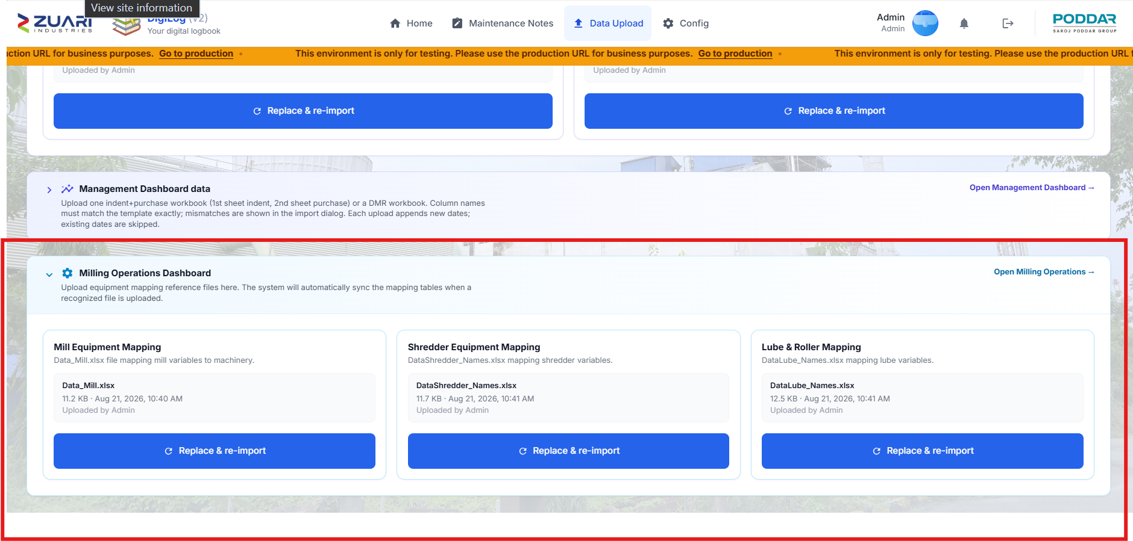
- Heading: Milling Operations Dashboard.

6.5.1 Mill Equipment Mapping
- Hint names the mill mapping workbook (e.g. Data_Mill.xlsx).
- Feeds: Equipment Temperature names on Milling Operations.

6.5.2 Shredder Equipment Mapping
- Feeds: Shredder and OTG Temp names.

6.5.3 Lube & Roller Mapping
- Feeds: Lube & Roller Temp names.

6.5.4 Messages
- Toast: File uploaded. Optional: Mapping auto-synced successfully.

6.6 Cautions
- Caution. Upload to the correct slot. A Grower file in DMR will not fix the scorecard.
- Caution. Mill temperature charts show codes until the three mapping files are uploaded.

7. Dashboards
Eight dashboards in BI Control Tower. They are not forms.

7.1 BI Control Tower
- Open: Home → Open BI Control Tower.
- Empty: No BI dashboards assigned.
- Views: Card view / List view.
- Shared dates on most cockpits: WTD · MTD · STD · Custom, From / To, Compare.
- Green % = better; rose = worse. Some loss metrics treat a drop as good.
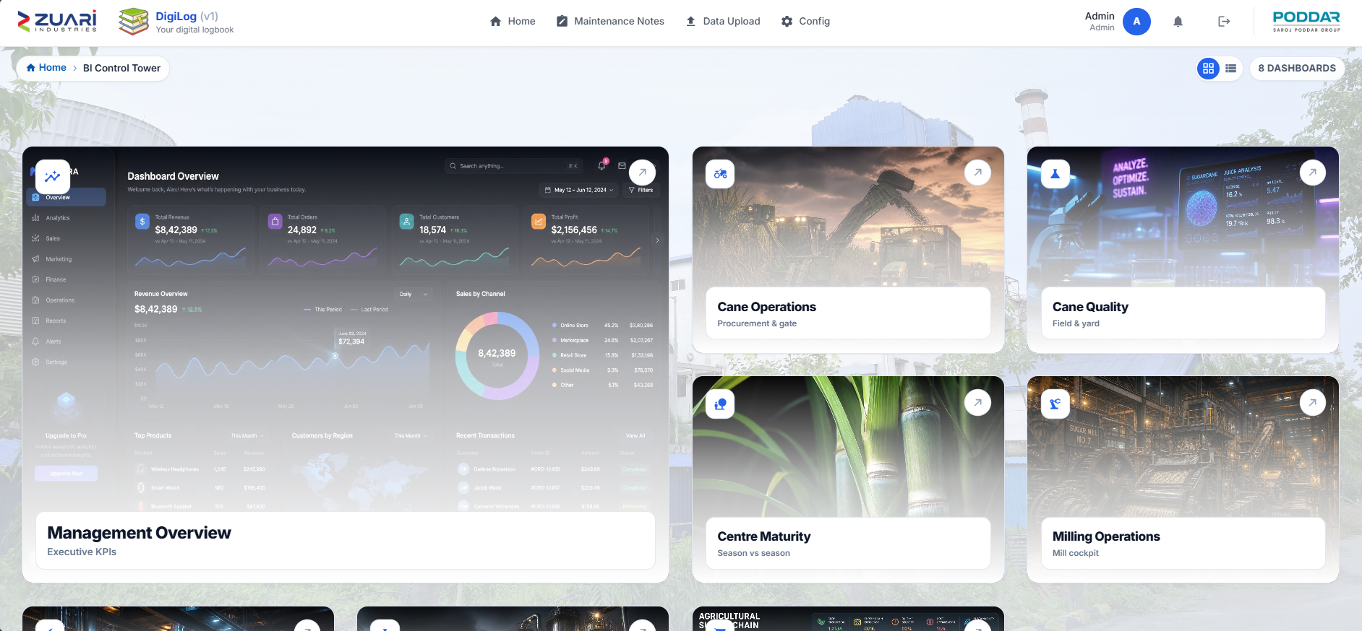

7.1.1 Feature list — hub cards (order)
- Management Overview — Executive KPIs
- Cane Operations — Procurement & gate
- Cane Quality — Field & yard
- Centre Maturity — Season vs season
- Milling Operations — Mill cockpit
- Power Plant Operations — Generation & steam
- Distillery Operations — Production analytics
- Grower Intelligence — Grower & dishonour

7.1.2 Dashboard map
- Management Overview — whole plant vs compare window — leadership — DMR + indent/purchase + lab/power/distillery forms.
- Cane Operations — purchase, gate, holding, transit — cane office — MSSQL (AIRACANE).
- Cane Quality — field/yard Brix — cane quality — Brix forms.
- Centre Maturity — centre vs indent — cane planning — Indent & Purchase upload.
- Milling Operations — stops and temperatures — mill — Mill Logbook + mapping files.
- Power Plant Operations — generation, steam, outages — power house — Power Logbook.
- Distillery Operations — ethanol and efficiency — distillery — Distillery Operations Form.
- Grower Intelligence — bonding and dishonour — cane/commercial — Grower Intelligence upload.

7.2 Management Overview
- Page header: Management Dashboard.
- Who: leadership / HODs, daily in season.
- Rows: Cane, Milling, Sugar, Power, Distillery.
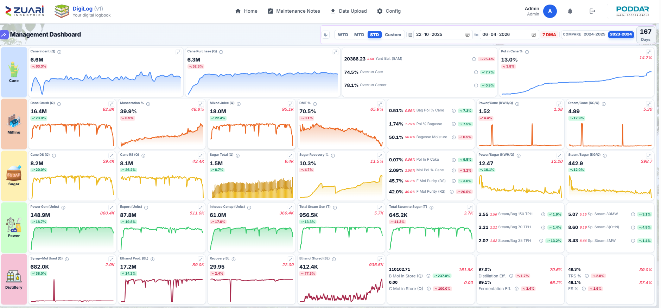
- Click a cell for the trend. Compare % is on the cell and the expand window.

7.2.1 Cane row
- Cane Indent (Q) / Cane Purchase (Q) — Qtls.
- Yard Bal. (8AM) — Qtls. Cane in the yard at 8 AM. Mainly DMR workbook. If DMR is empty: Operations Logbook yard balance at 7–8 or 8–9 AM.
- Overrun Gate / Overrun Center — %.
- Pol in Cane % — DS Logbook or DMR.

7.2.2 Milling and Sugar rows
- Crush, Mixed Juice, Masceration %, DMF %, Bag Pol % Cane (lower better), Sugar Total, Recovery %, Power/Cane, Steam/Cane, Power/Sugar, Steam/Sugar, DS/RS cane, Pol In F Cake.

7.2.3 Power and Distillery rows
- Power Gen, Export, Inhouse, steam raised, steam to sugar, Steam/Bag, Sp. Steam.
- Syrup+Mol Used, Ethanol Prod. (BL), Recovery BL, stocks, Distillation / Fermentation Eff., TRS & FS %.

7.2.4 Sources and reading
- Sources: Data Upload → Centre Indent & Purchase and DMR; Operations Logbook and DS Logbook → Lab Logbook; Power Details and Steam Details → Power Logbook; Distillery Operations Form.
- Blank mill/sugar cells usually mean the DMR file is missing those dates.
SCREENSHOT PLACEHOLDER
04.png
management — Management scorecard. Highlight: Cane row with Yard Bal. (8AM)

7.3 Cane Operations
- Header: Cane Operations — Cut to crush · Gate · Transit · Holding.
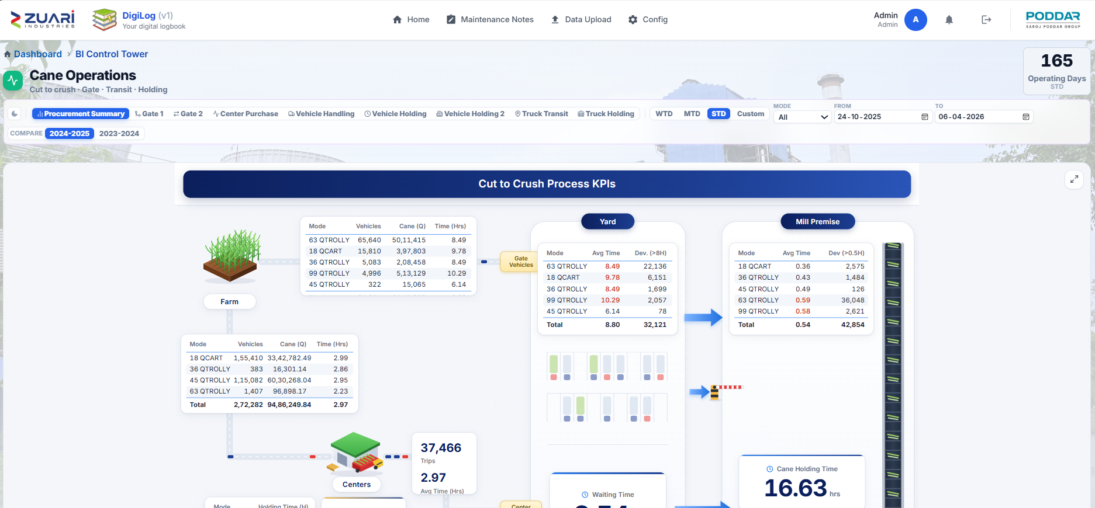
- Tabs: Procurement Summary, Gate 1, Gate 2, Center Purchase, Vehicle Handling, Vehicle Holding, Vehicle Holding 2, Truck Transit, Truck Holding.

7.3.1 Tabs (feature list)
- Procurement Summary — cut-to-crush map (no KPI chips).
- Gate 1 — Total Cane Purchased (Qtls), No. of Parchy, Avg Parchy Size, Avg Parchy Overrun (lower better).
- Gate 2 — vehicles, Avg/Max Yard Holding (Hrs), Vehicles Exceeding (>8 Hrs).
- Center Purchase — purchase, parchie, trips, top/bottom 10 centres.
- Vehicle Handling / Holding / Holding 2 / Truck Transit / Truck Holding — SLA slider, 🟢 Target / 🟠 Breach.

7.3.2 Source
- MSSQL database (AIRACANE).

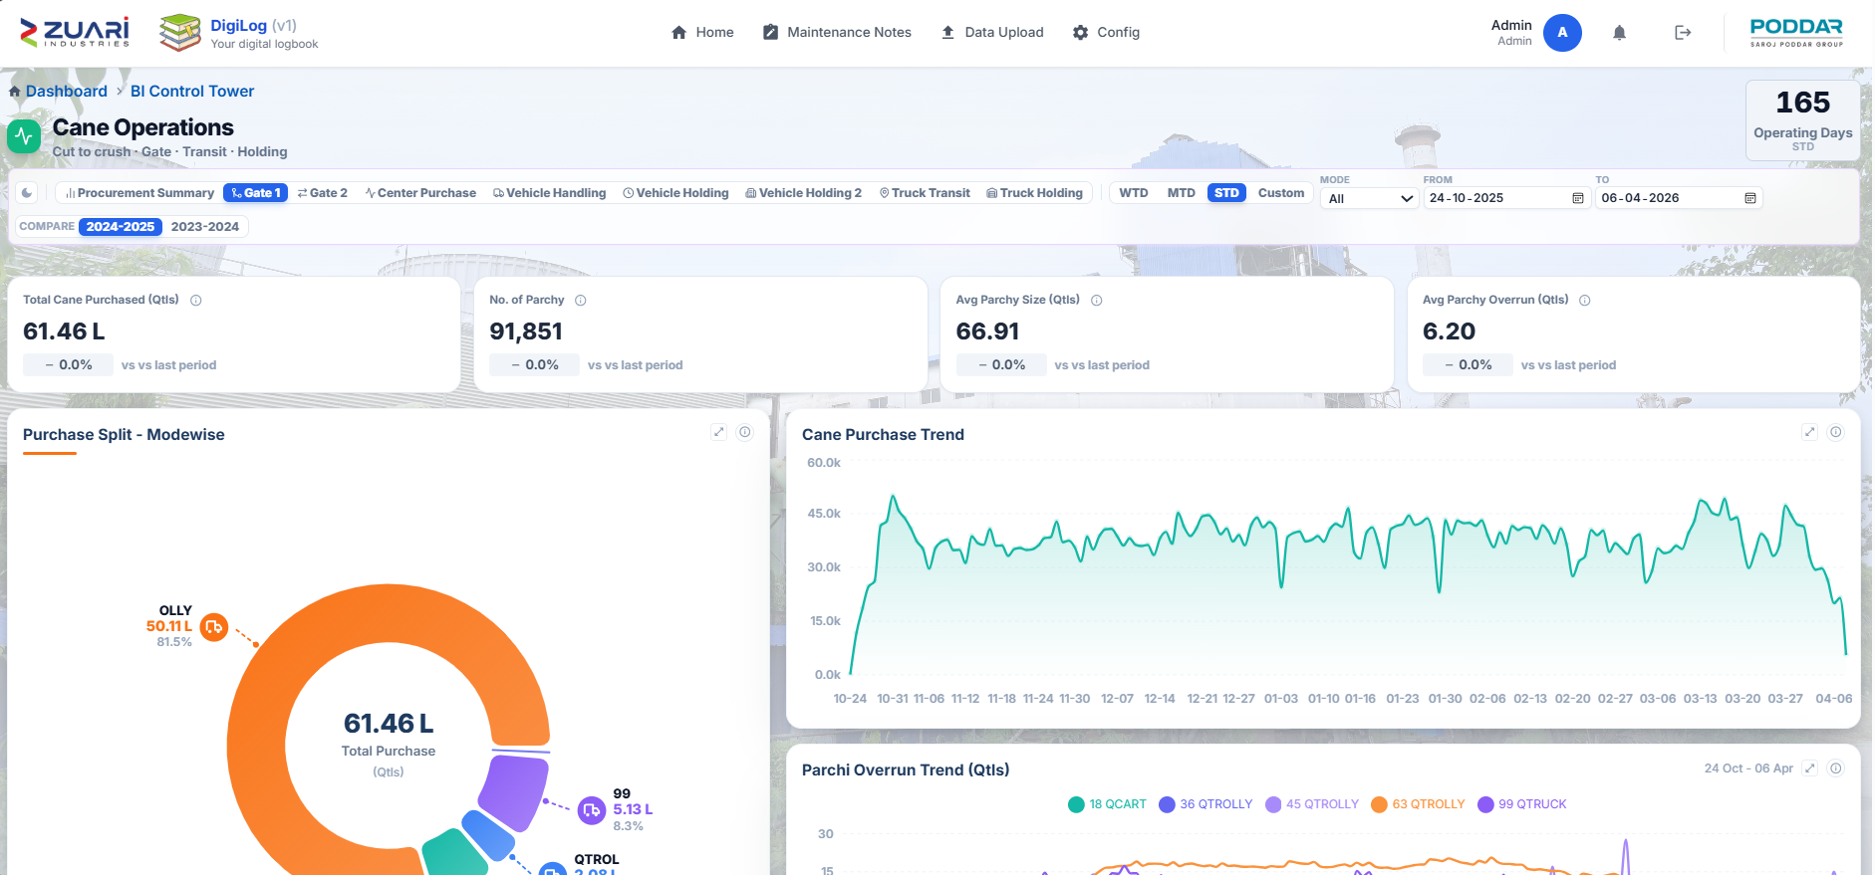

7.4 Cane Quality
- Page header: Brix Sampling Analytics.
- Tabs: Field Sampling, Yard Sampling.

7.4.1 Field
- AVG MID BRIX %, AVERAGE MATURITY, TOTAL SAMPLES, BOTTOM BRIX < {threshold}% (default 18 ).
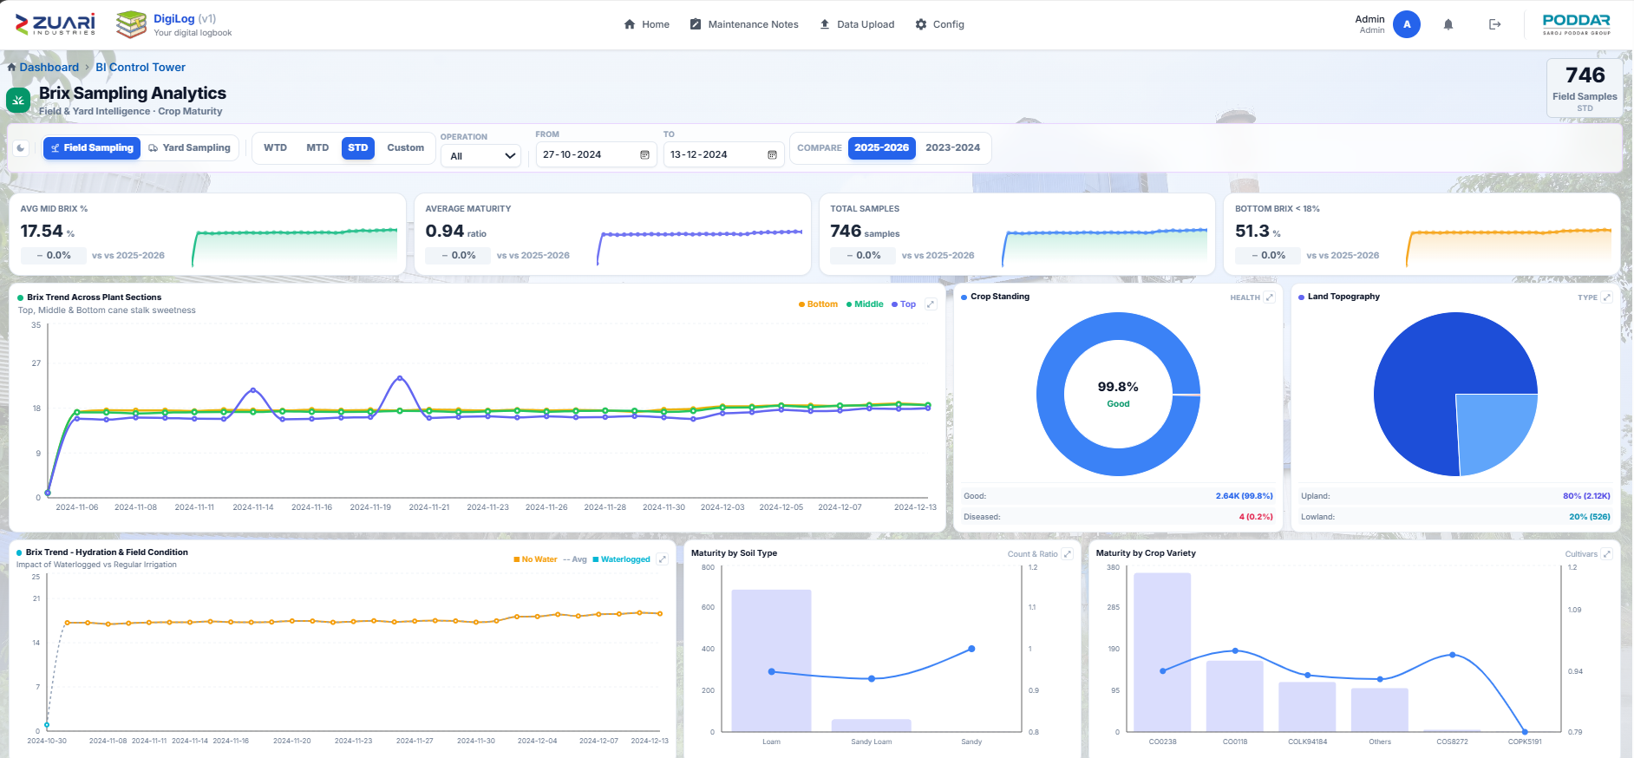
- Filter: Operation.

7.4.2 Yard
- AVG MIDDLE BRIX %, diseased / stale counts.
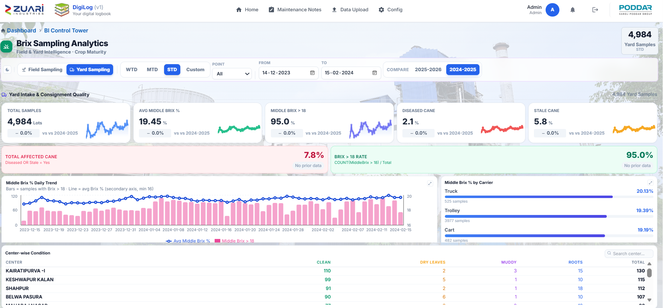
- Filter: Point.

7.4.3 Source
- Field Brix Sampling and Yard Brix Sampling → Brix Sampling Forms.

7.5 Centre Maturity
- KPIs: Indent Qty (Qtl), Purchase Qty (Qtl), Maturity %.
- Four section tables: Center Name, Indent, Maturity badge (red → green).
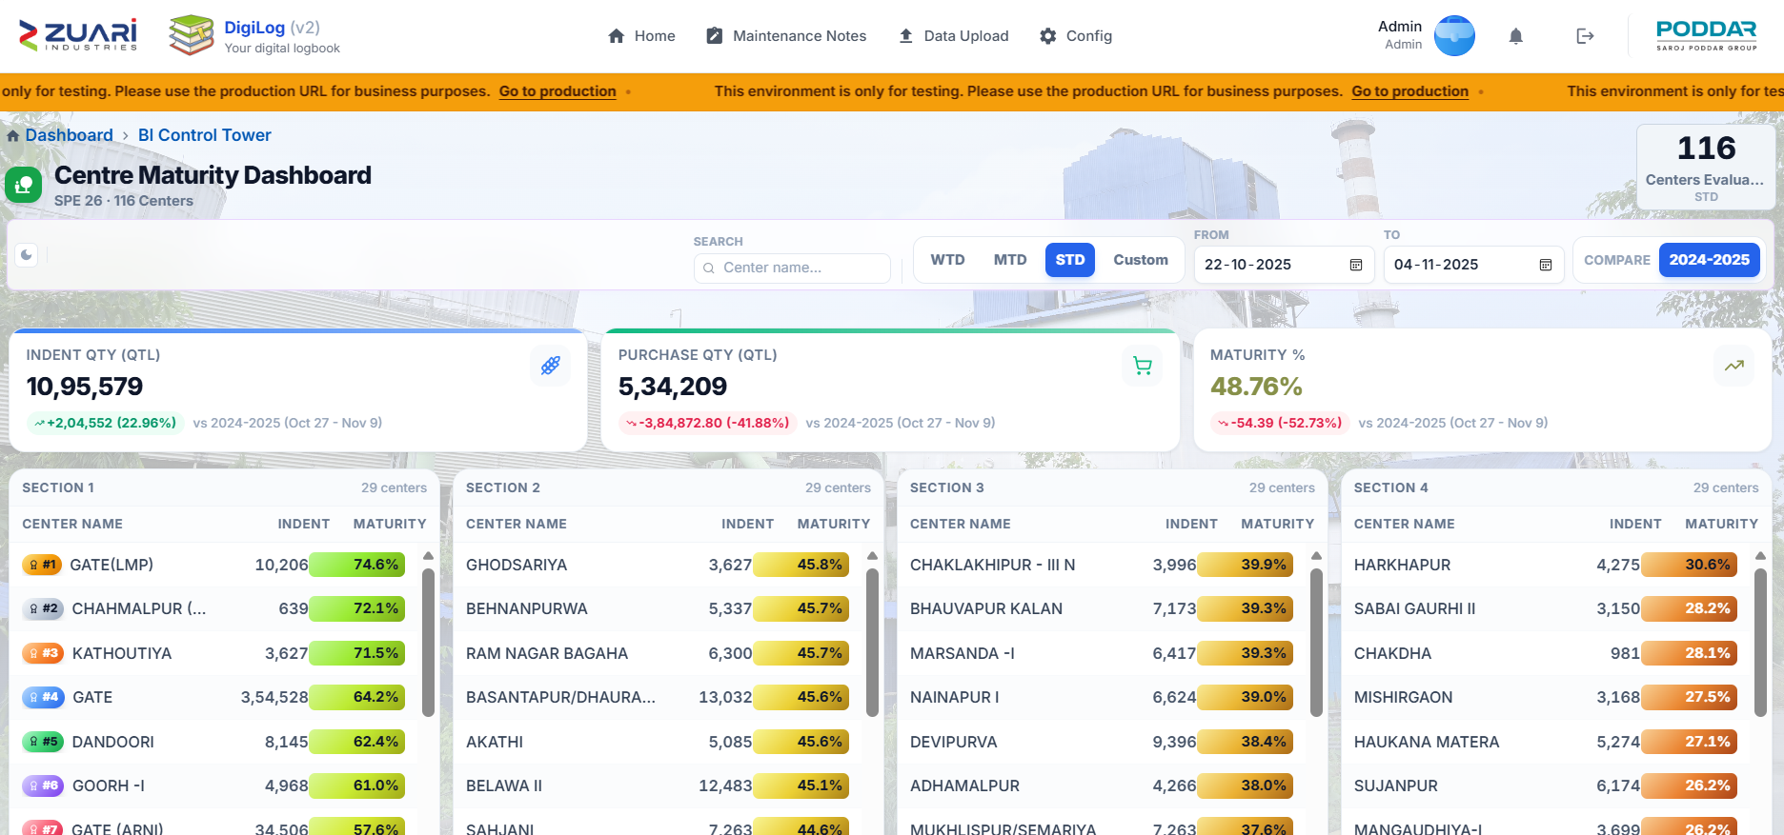
- Search: Center name...
- Source: Data Upload → Centre Indent & Purchase.

7.6 Milling Operations
- Page header: Milling Division Cockpit.
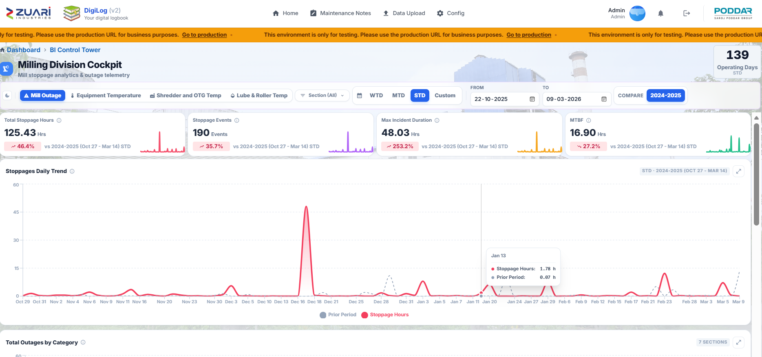
- Tabs: Mill Outage, Equipment Temperature, Shredder and OTG Temp, Lube & Roller Temp.

7.6.1 Mill Outage
- Total Stoppage Hours, Stoppage Events, Max Incident Duration, MTBF.
- Lower stoppage hours is better.

7.6.2 Temperature tabs
- Names from Data Upload mapping files (chapter 6.5).
- Blank names mean the mapping file is missing.

7.7 Power Plant Operations
- Page header: Power House.
- Tabs: Power Summary, Generation, Consumption, Steam Summary, Steam Consumption, Outage, Process.
- Look at Total Power Generation, PLF, export vs in-house, steam, Outage Duration (Hrs).
- Source: Power Details, Steam Details, Stoppage Details → Power Logbook.
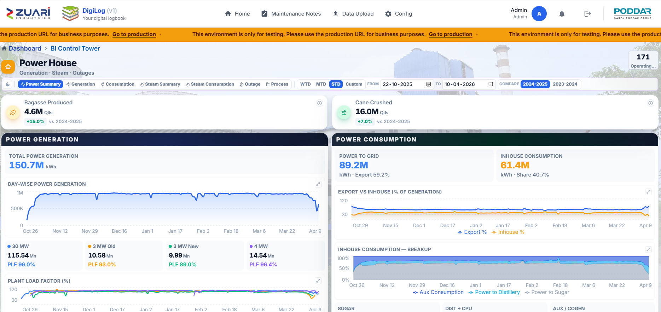

7.8 Distillery Operations
- KPI strip: Operating Days, Total Ethanol Produced (BL), Syrup/Molasses Consumed (Q), Fermentation Efficiency (%), Distillation Efficiency (%).
- Charts: Ethanol Vol, Ferm. Sugar, Overall Efficiency, Wash Distilled, Molasses Stock, Ethanol Stock.
- Year types: SS (Sugar Season), ESY (Ethanol Supplier Year), FY (Financial Year).
- Source: Distillery Operations Form. Operating days = days with ethanol production.
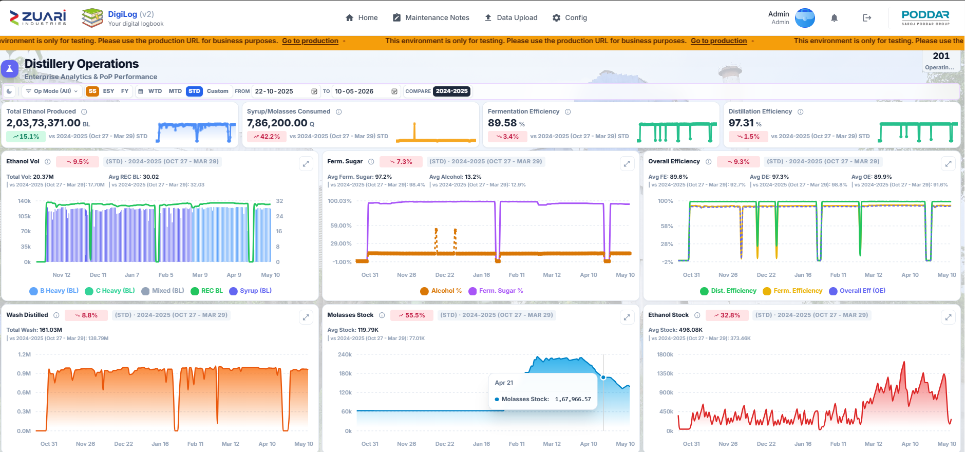

7.9 Grower Intelligence
- Tabs: Grower Performance, Purchy Dishonour, Dishonour Drilldown, Staff Drilldown, Failure by Date.
- Dishonour KPIs: Bonded Growers, 2025 Indent / Supply / Dishonour count, qty, % [TO CONFIRM] year label.
- These KPIs do not show compare %.
- Filters: Society, Loyalty, Zone Head … Village Staff, Dishonour Bucket.
- Source: Grower Details Season; Staff wise Bonding for Staff Drilldown.
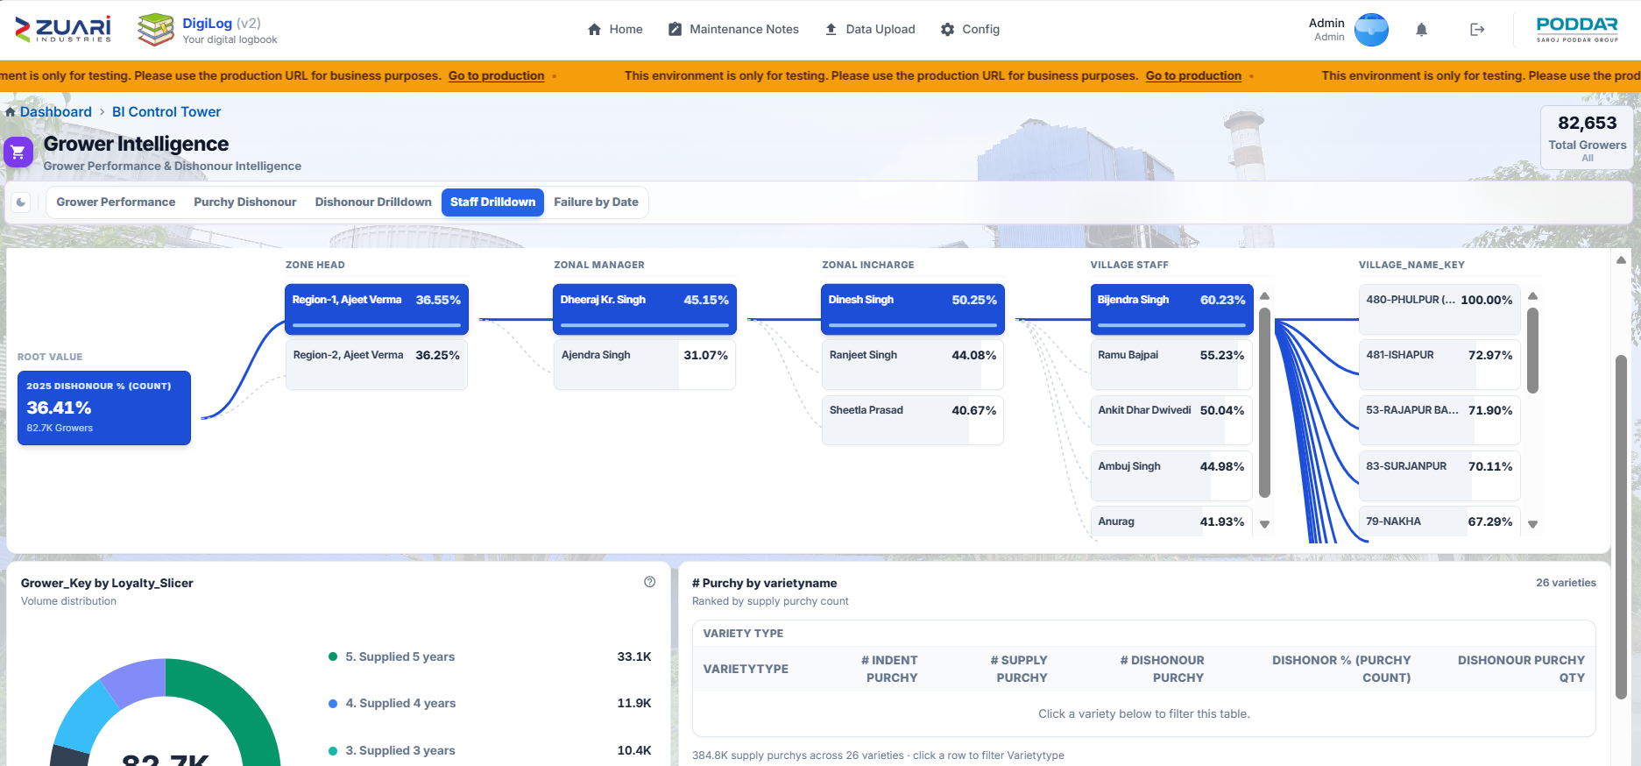

8. Config
Administrators only. Navbar Config. Subtitle: Employees, categories, BI settings, and other portal configuration. Sidebar group: Settings. Default: Employees.
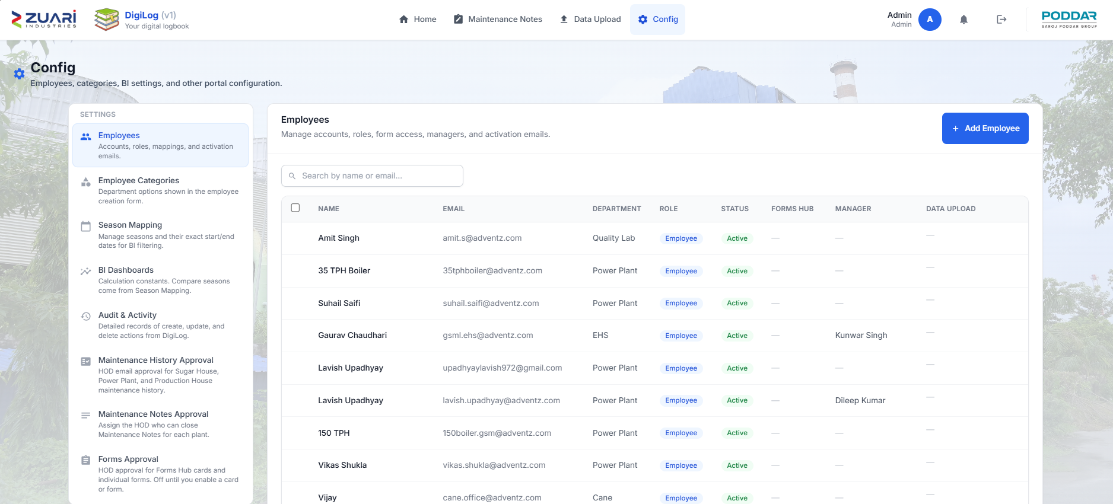

8.1 Employees
- Table: Name, Email, Department, Role, Status (Active / Inactive), Forms Hub (badge View only when set), Manager, Data upload, Locked cards, Actions.
- Header: Send Mail (n), Add Employee.

8.1.1 Add / Edit employee
- Fields: Full Name, Email, Department, Role (employee / admin), Account Active (edit).
- Buttons: Cancel, Save.
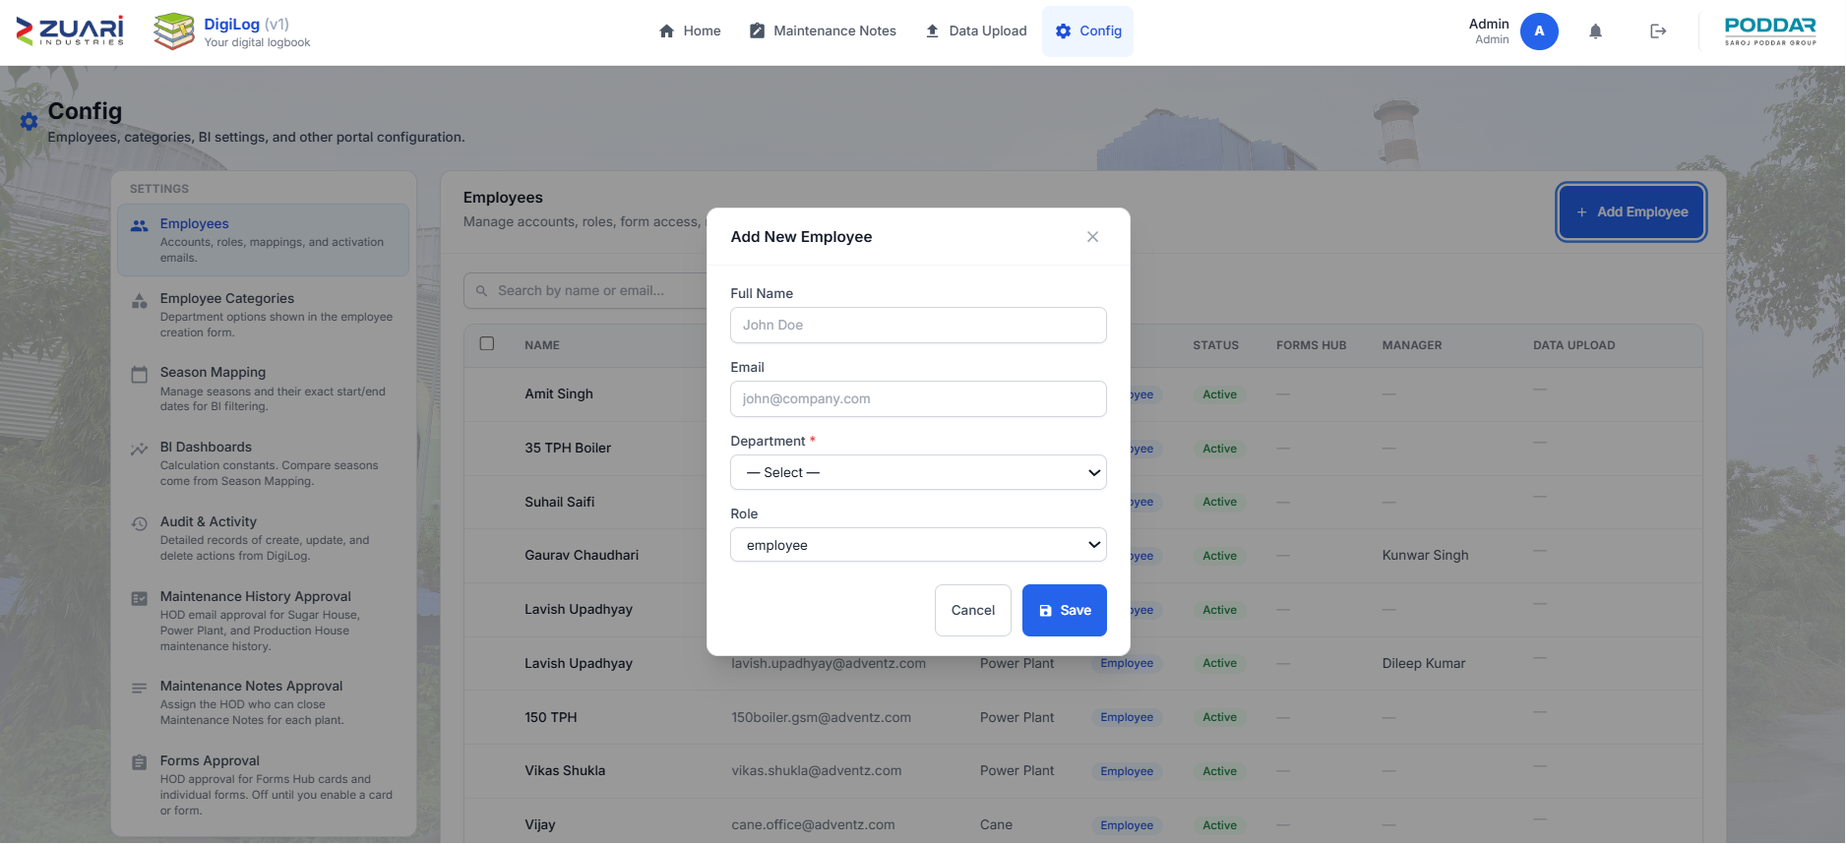

8.1.2 Row menu (feature list)
- Send activation email
- Form mapping — which Forms Hub apps and forms. Toast: Form mapping saved. Forms Hub homepage card updated automatically.
- Forms Hub access — Full access vs View only
- Dashboard mapping — which BI dashboards. Toast: Dashboard mapping saved. BI Control Tower homepage card updated automatically.
- Data upload mapping — Grower Intelligence, Management Dashboard, Milling Operations
- Locked card manage access — Sugar House, Power Plant, Production House
- Assign manager
- Edit employee
- Delete employee
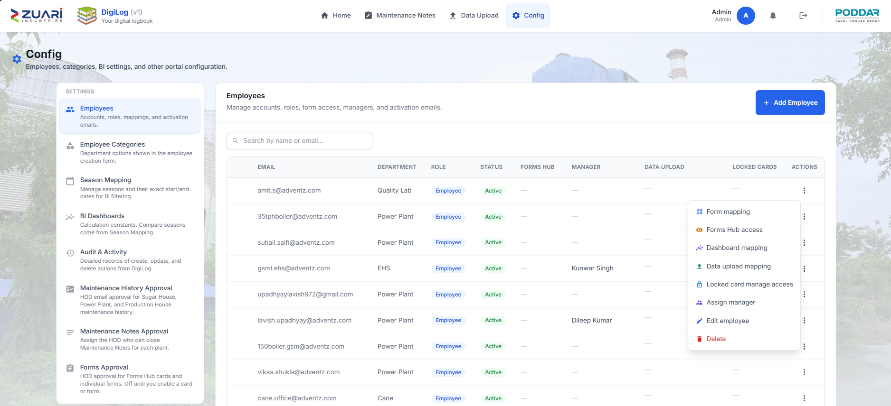

8.2 Employee Categories
- Department options on the employee form.
- Add / edit / delete categories.
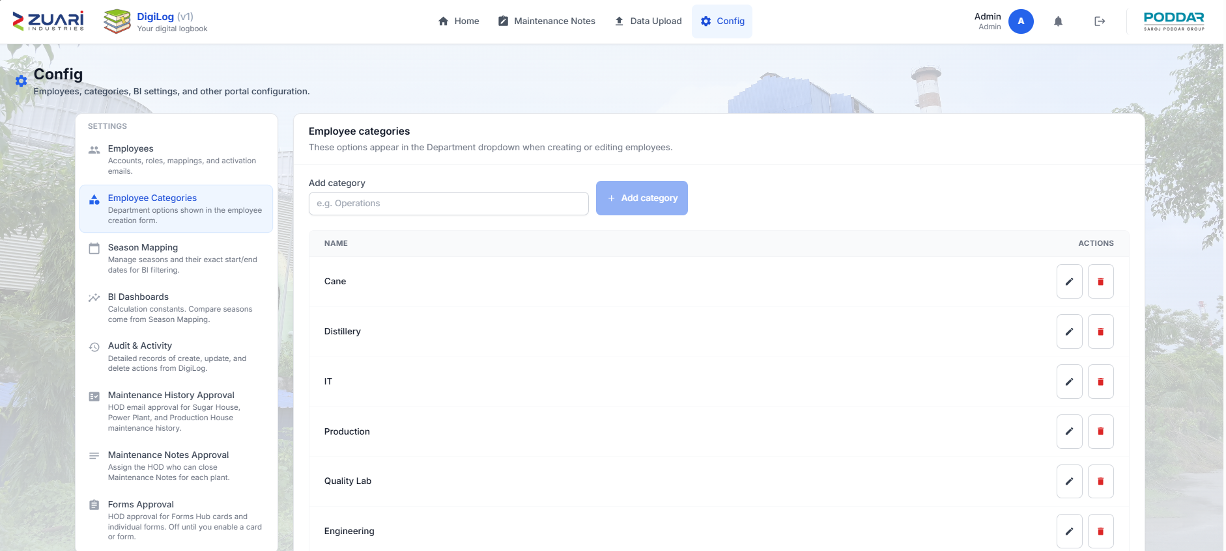
- Toast: Category added.

8.3 Season Mapping
- Sugar Season (SS): Season Label (e.g. 2025-2026), From, To, Add Season.
- ESY / FY date rules are shown on the same page exact card titles.
- These windows drive STD on dashboards.
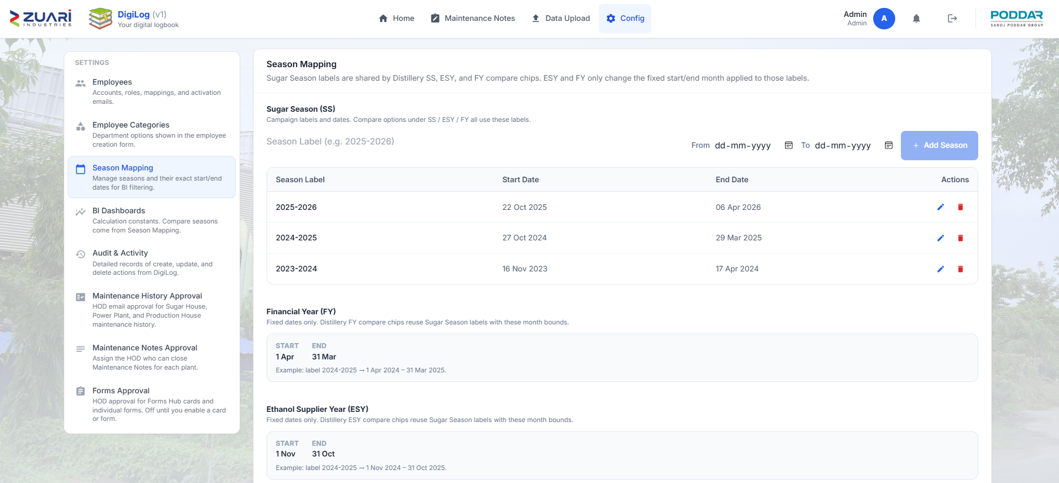

8.4 BI Dashboards
- Calculation Constants per Sugar Season (dropdown, (Current) on the active season).
- Theoretical Yield Factor (default 64.4).
- Power Export Tariff (₹ / kWh) (default ₹4.85).
- Brix Ripeness Threshold (default 18).
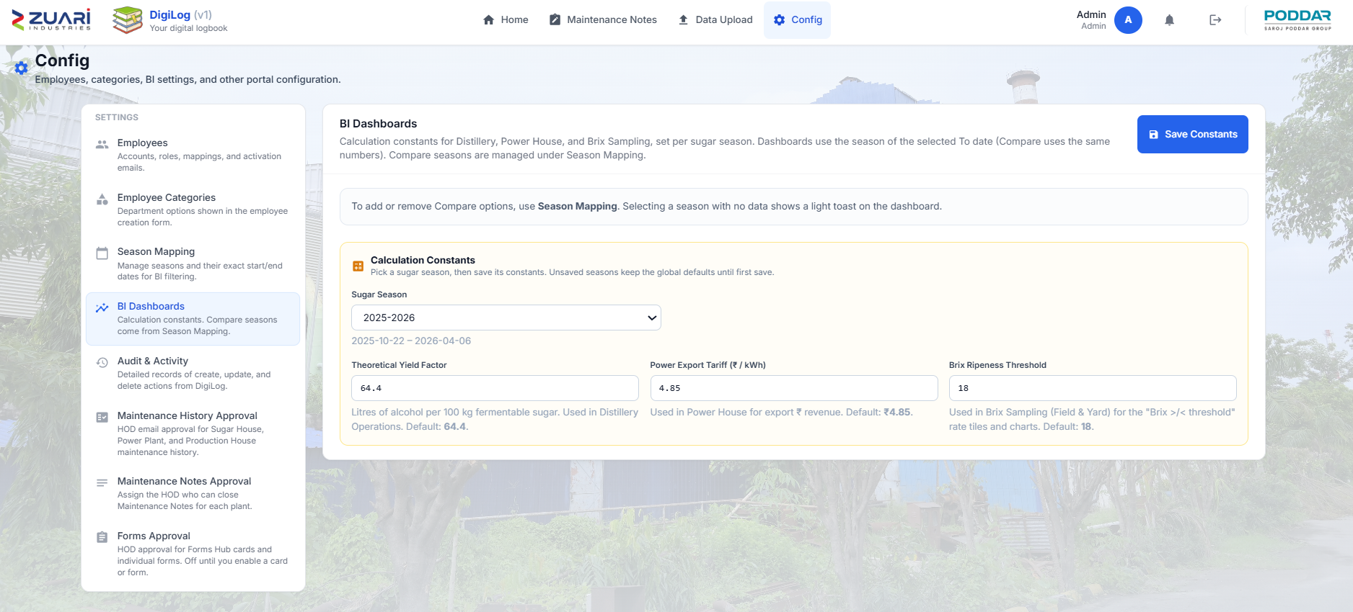
- Save Constants.

8.5 Audit & Activity
- Tabs: Change Log, Activity Log, Session Log.
- Change Log filters: Create / Update / Delete / Login; All results / Success / Failed.
- Session Log: All sessions / Online now / Ended.
- Location cascade (Home → Forms Hub → …).
- Refresh.
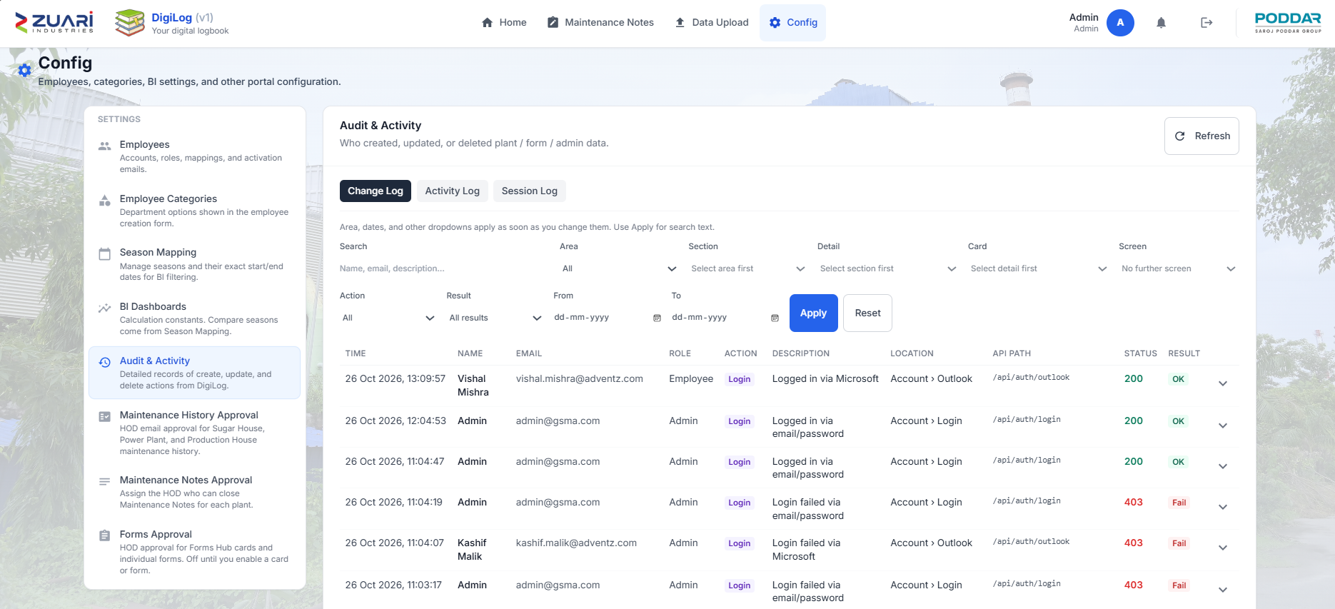

8.6 Maintenance History Approval
- Three cards: Sugar House, Power Plant, Production House.
- Per card:
- Enable HOD approval
- HOD employee
- Combined digest times (IST): Time 1, Time 2 (optional)
- Copy: The HOD receives one email covering Forms, Maintenance History, and Maintenance Notes at each time (IST). Leave Time 2 blank to send only once per day.
- When on: Resend full digest, Email new pending only
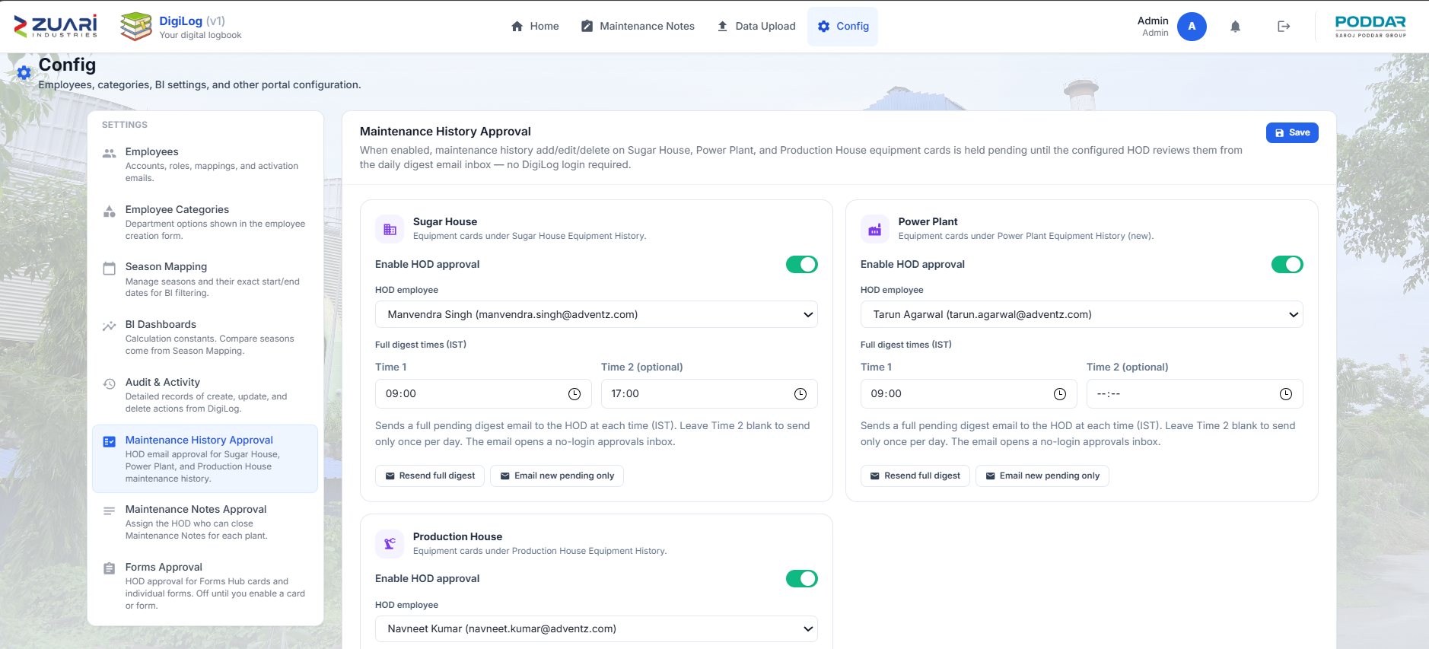
- Save.

8.7 Maintenance Notes Approval
- Same three plant cards.
- HOD who can close notes for this plant.
- Same digest times and resend buttons as 8.6.
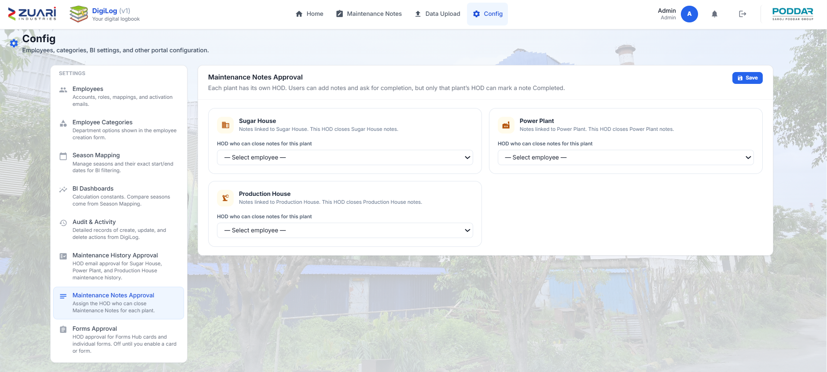
- Save.

8.8 Forms Approval
- Per Forms Hub app card:
- Enable HOD approval for this card
- Card HOD
- Digest times and resend buttons (same combined-email copy)
- Expand Forms per form:
- Inherit card / On / Off
- Form HOD (optional — leave blank to use card HOD)
- Empty: No data forms found to configure.
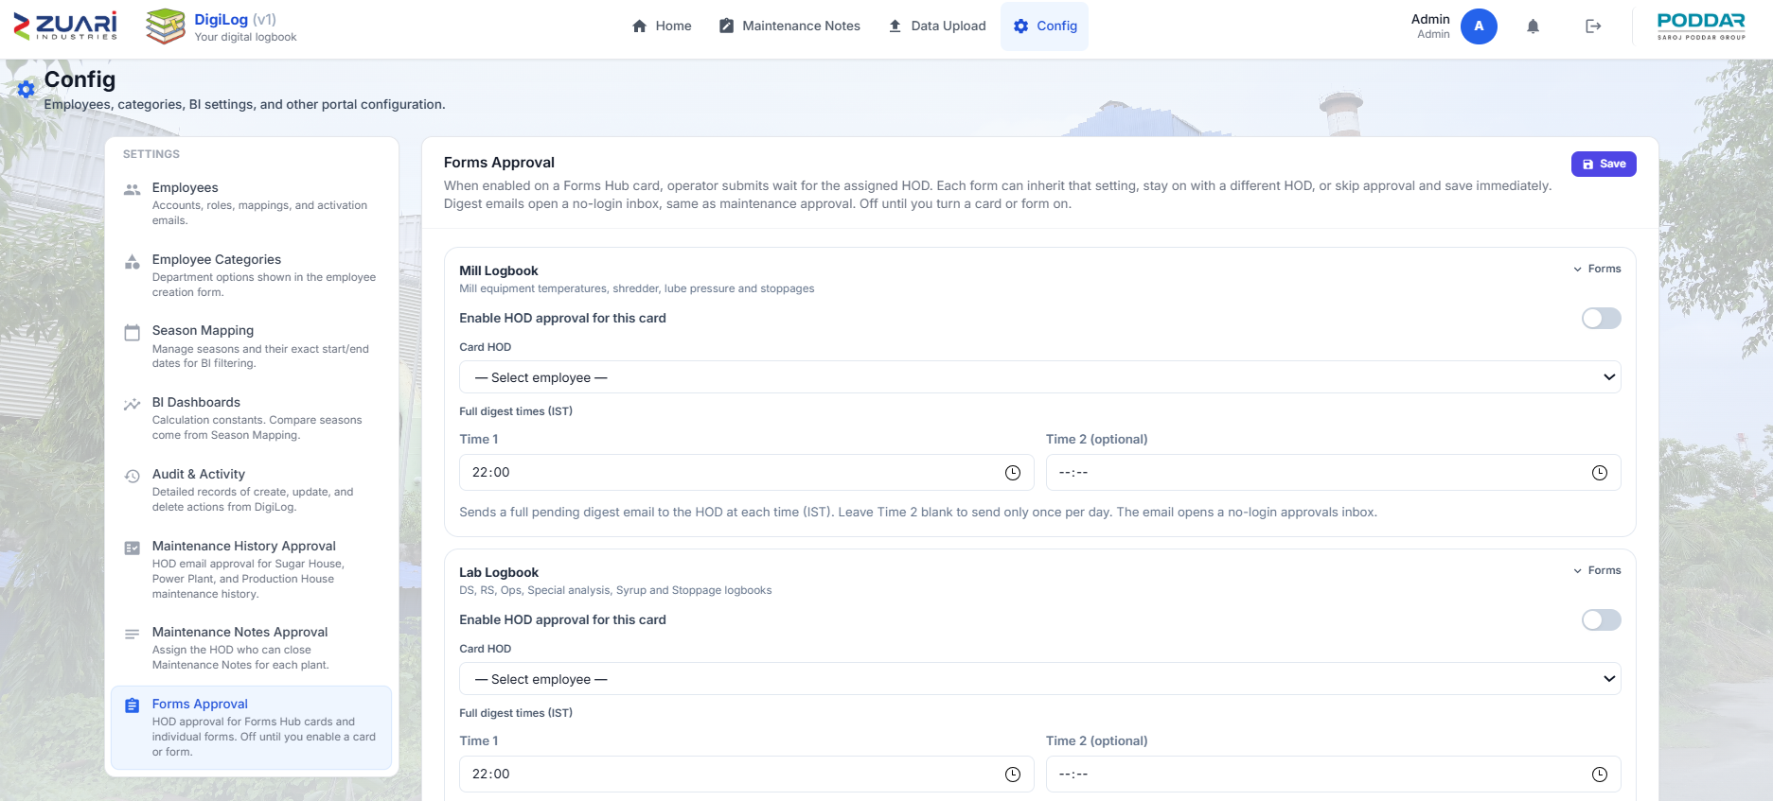
- Save.

9. Profile and notifications

9.1 Profile (avatar)
- Click your avatar on the navbar.
- Shows name, email, Department (or No department on file).
- Upload photo (PNG / JPEG).
- Crop: Drag to center your face… → Save photo.
- Remove photo.
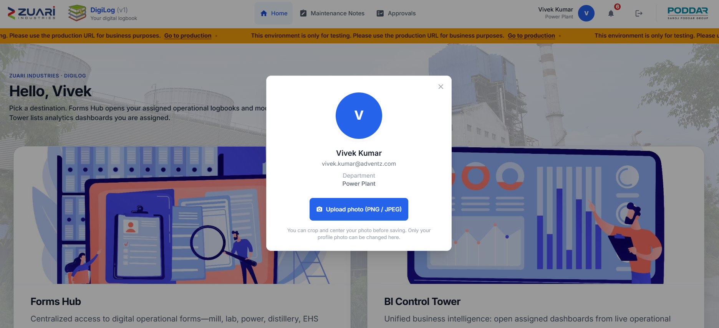
- Other fields are read-only.

9.2 Notifications (bell)
- Panel title: Notifications.
- Mark all read.
- Empty: No notifications.
- Loading: Loading….
- Per item: Remove notification.
- Times: Just now, Nm ago, and similar.
- Updates live, and every 60 seconds.
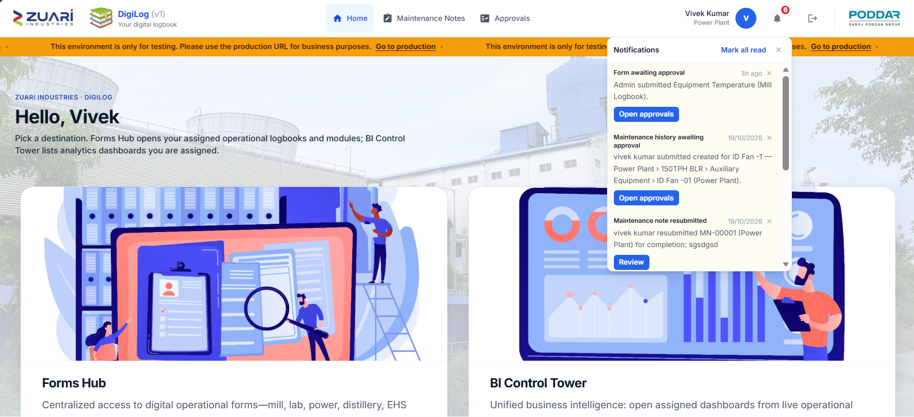

10. Daily and shift workflows

10.1 Start of shift (operator / chemist)
- Sign in on the employee page. Confirm there is no amber staging bar.
- Home → Open Forms Hub → your app → today’s sheet (chapter 2).
- Set Report Date = today and Shift = this shift.
- Fill readings in the units on the form.
- Submit → Confirm & Commit.
- If Forms Approval is on, tell the HOD (chapter 5). Do not submit a second copy.

10.1.1 Extra sheets by area
- Mill: also Mill Stoppages if the mill stopped.
- Lab: Operations Logbook and DS Logbook in the same shift.
- Power: Power Details needs Date and General remarks. Add Stoppage Details if a machine was down.
- Distillery: one Distillery Operations Form for the operation date.

10.2 Handover
- Open View Data for the same form.
- Confirm this shift’s row is there (or Pending).
- Tell the incoming shift: date, shift, stoppage, any send-back.
- Logout.

10.3 Maintenance job
- Forms Hub → Power / Sugar / Production register (chapter 3).
- Find the equipment.
- Open the discipline (Power and Sugar only).
- Add Record → photos → submit for HOD if approval is on.
- Short running note: navbar Maintenance Notes (chapter 4).

10.4 HOD — close the inbox
- Approvals (chapter 5).
- Forms — approve or Send for modification.
- Maintenance — history drafts for your plant.
- Maintenance Notes — complete or return.
- Email digest may group all three. Forms link expires in 7 days.

10.5 Morning management look
- BI Control Tower → Management Overview. Set STD or yesterday.
- Read Cane (indent, purchase, Yard Bal. (8AM), Pol in Cane).
- Read Milling / Sugar. If blank, ask whether DMR workbook was uploaded (chapter 6).
- Crush down → Milling Operations → Mill Outage.
- Generation down → Power Plant Operations → Outage.
- Ethanol off → Distillery Operations.

10.6 Data owner after a workbook arrives
- Data Upload → correct tab → correct slot (chapter 6).
- Open the dashboard that should change and check yesterday’s date.

11. Troubleshooting and FAQs

11.1 Sign-in and Home
- Cannot sign in on the marketing page. Admin accounts use /admin/login. Employees use Log in. Message: You do not have permission to sign in on this page.
- Forgot password. Forgot? → Contact your IT administrator for password reset.
- Home is empty. No homepage destinations assigned. Ask admin for Forms Hub and/or BI Control Tower (8.1).
- A form disappeared. Access is by mapping, not last season’s memory. Ask admin.

11.2 Forms
- Submit blocked. Fill Date and Shift. Distillery needs Operation Date. Power Details needs General remarks. Field Brix has many required boxes (2.9.2).
- View only. Banner: View only — you can see this data but cannot submit or edit.
- Submitted twice. Stop. Ask admin to remove the extra View Data row if policy allows.
- HOD sent it back. Correct and submit again (resubmit).
- CSV vs Excel Download. Same action. Desktop CSV. Phone Excel Download. Desktop open button is Open Form; phone is Open Digital Form.

11.3 Equipment and Notes
- Cannot rename or move. Imported/seeded cards need locked-card manage. Move is same-level only.
- Production has no tree / OEM schedule. Normal (3.4).
- Maintenance Notes is not available. Category is not Sugar, Engineering, Power, or Production.

11.4 Approvals and Config
- No Approvals menu. You are not set as HOD (8.6–8.8).
- Email link dead. Forms inbox links expire after 7 days. Use navbar Approvals.
- Wrong plant on Maintenance Notes. Administrator must fix employee category.

12. Glossary
- A / B / C — shift codes on mill, lab, and many sheets.
- AIRACANE — mill cane database for Cane Operations.
- Approvals — HOD inbox for Forms, Maintenance, Notes.
- Bagasse pol — sugar left in bagasse; lower is better.
- BI Control Tower — home of the eight dashboards.
- BL — bulk litres (ethanol).
- Brix — dissolved solids; cane quality.
- CBM / CM / PdM / PM / RM / RCM — maintenance types on history.
- Compare — prior date window for dashboard %.
- Config — administrator settings (chapter 8).
- CSV — download of form rows (phone: Excel Download).
- DE / NDE — driving end / non-driving end.
- Discipline — Mechanical, Civil, Electrical, Instrument.
- DMR workbook — daily manufacturing report upload.
- DMA — day moving average (Management 7 DMA).
- DS / RS — double sulphitation / refined sugar.
- ESY / FY / SS — Ethanol Supplier Year / Financial Year / Sugar Season.
- Forms Hub — operation forms and equipment registers.
- HOD — head of department who approves.
- Indent — planned cane from a centre.
- Kg/Sq.Cm — pressure unit.
- Locked card — equipment node that needs extra grant to rename/move/delete.
- Maturity % — purchase ÷ indent.
- MTBF — mean time between mill stoppages.
- MTD / WTD / STD — month / week / season to date.
- OEM schedule — maker’s maintenance plan on Power/Sugar cards.
- Overrun — purchase above indent.
- Parchy / Purchy — cane purchase slip.
- PLF — plant load factor.
- Pol — sucrose measure.
- Q / Qtls — quintals.
- SLA — holding or transit time target.
- Starred — personal shortlist of equipment cards.
- TCD — tonnes cane per day.
- TRS / FS — total reducing sugar / fermentable sugar.
- View only — read forms; cannot submit or edit.
- Yard Bal. (8AM) — cane in the factory yard at 8 AM on Management.

13. Support and escalation

13.1 Who to call
- Password / Microsoft / Google — IT administrator. No self-service reset.
- Missing card, form, dashboard, upload tab — DigiLog administrator (chapter 8.1).
- View-only banner — DigiLog administrator, Forms Hub access.
- Waiting too long for approval — your HOD (chapter 5).
- Wrong plant on Notes — DigiLog administrator, employee category.
- Locked equipment card — DigiLog administrator with locked-card grant.
- Staging vs production — DigiLog administrator. Staging is testing only.
- Dashboard number looks wrong — data owner or the person who fills the source form. Do not edit the dashboard.

