
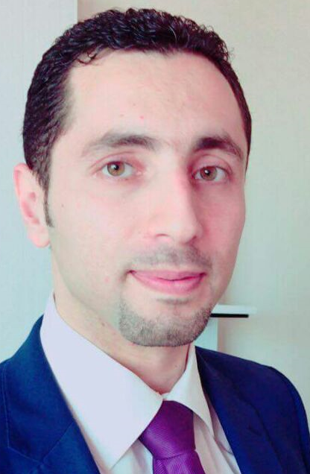

Ibrahim Ali Ibrahim
Dubai | +971 554955848 | ibrahim.ali84@hotmail.com | Blog: ibrahimaliblog.wordpress.com

EDUCATION
2007
Al-Quds University- Jerusalem, Palestine BS Computer Science, June 2007

Profile Summary
Experienced as Senior SharePoint Developer having more than 8 years in Information Technology in Application Development & support. Strong experience in all facets of developing, deploying, troubleshooting, installations and maintenance for various SharePoint sites. Having good experience in providing application support during testing, training and implementation.

Highly skilled in designing and developing user-friendly database-driven websites, e-commerce websites, ECM – Enterprise Content Management systems. Application support and implementation by using Microsoft technologies – ASP.Net, C#, VB.Net, SharePoint 2013/2010/2007, SharePoint & Nintex workflows, SQL server & Windows Operating systems.

Experience with Nintex workflow, Silverlight from Microsoft. Fusion charts, Telerik & component art that helps the end user to puts visual analytics to intuitive report authoring. Drag-and-drop to place content exactly where you want it on the flexible and fluid canvas. Quickly discover patterns as you explore a single unified view of linked, interactive visualizations.

Familiar with highly complex technical information into terms and concepts that end users can easily understand. Furthermore, Passionate Software Programmer, multi-task oriented enjoy a challenge, problem solver, and continually stay abreast of the latest advancements in the IT field.

Designing of As-Is Process Capturing, To-Be Process Design, Process Maps and Flows, Business Analysis, Process Analysis, Data Analysis SOW using MS Visio.
Executed process analysis, process Gap analysis and created process flows in MS Visio
Highly proficient in preparing Business Requirement documents (BRD), Functional Requirement Documents (FRD), User Requirement Document (URD) after process mapping.

Technical EXPERIENCE
MEGA Enterprise Architecture tool.
Process Maker, Open source web based workflow engine.
Apigee API management platform.
OutSystems Development platform.
SharePoint 2010, 2013 and o365.
SharePoint Designer.
NINTEX Workflow 2010, 2013, o365 & Forms.
ASP.NET Web Forms Frameworks.
C#/VB.NET/AJAX/ADO.NET.
Silver light +WCF.
Windows Forms Programming(C#, VB.Net).
Microsoft Visual Studio.NET 2012, 2010, 2008, 2005.
TFS (Team Foundation Server) and Visual Source Safe.
Microsoft SQL Server 2012, 2008, 2005, Microsoft Access, MySQL, Oracle 9i/10g.
Working with CodeSmith code generator.
Experience working with 3rd party control libraries, Microsoft Ajax Toolkit, Telerik 2008-2011, Infrajestics 2008/2010, Spire. Office, component Art and Fusion Charts.
Dot Net Nuke CMS.
CSS & xHTML.

Related EXPERIENCE
Shift Technologies (AW Rostamani Group), Dubai, UAE, Feb 2016 - Current.
Working as a Senior Technical Consultant - Mega Enterprise Architecture.
Infotouch, Dubai Internet City, UAE, June 2011 – Jan 2016.
Worked for Infotouch in Software Development Department as a:
• SharePoint - Lead Developer.
• System Analyst

WAFA (Wafa Palestinian News & Info Agency), Ramallah, Palestine, Feb 2011–May 2011.
Working in WAFA in Software Department as a Software Developer and Database developer, and working on wafa websites (wafa.ps/wafainfo.ps/wafaimages.ps).

ITLAQ Technologies, Ramallah, Palestine, Dec 2010–Jan2011.
Working in ITLAQ in Software Development Department as a SharePoint 2010 & Nintex Developer.

NTS (Next Level Technology Systems), Ramallah, Palestine, May 2009 – Dec 2010.
Working in NTS in Software Development Department as an Asp.Net Developer, and I used smart components, some applications such as CodeSmith, CMS Applications (Dot Net Nuke).

ITASSCO (International Technical Advisory Services Solutions), Ramallah, Palestine, Aug 2008 –May 2009.
Worked in ITASSCO in Software Department as an Asp.Net Developer and Database Designer and developer, and I used smart components such as component Art, cute soft, Infrajestics, Telerik

Major Projects executed
SharePoint Client: Abu Dhabi Farmers Services Center, Abu Dhabi
www.adfsc.ae
• Leading the Project.
• Building the Project architecture
• Design the Development Methodology
• Build Web Parts to Administer and view the Correspondences.
• Build Master Pages and Page Layouts.
• Build high fixable List creation by using saved template.
• Configure SharePoint Search Managed Properties and Scopes and customize Search Results page.

Client: Sheikh Zayed Mosque (SZM), Abu Dhabi Intranet Portal for (SZM) to manage their internal Procedures
• Leading the Project.
• Build Web Interact with the Portal.
• Build Master Pages and Page Layouts.
Client: Borouge (ADNOC), Abu Dhabi,
www.borouge.com
• Design the Development Methodology
• Build Web Parts to Administer and view the Correspondences.
• Build Master Pages and Page Layouts.

SharePoint & Nintex workflows & Forms
Client: OSHAD, Abu Dhabi Enterprise Application which is partly Intranet Portal & website that helps OSHAD to manage entities in Abu Dhabi for safety and incidents. Leading the Project.
www.oshad.ae
• Building the Project architecture
• Design the Development Methodology
• Build Web Parts to Administer and Interact with the Portal.
• Build Master Pages and Page Layouts.
• Build high fixable List creation by using saved template.
• Configure SharePoint Search Managed Properties and Scopes and customize Search Results page.

Client: Youth and Sport Authority, Dubai Intranet Portal that helps the Company department to manage their Correspondences, Business & Financial Operations, HR Processes, Archive the New and old Documents.

LANGUAGES
Arabic – Native Language
English – Good.

Certifications
MCTS: Microsoft SharePoint 2010 Application Development.
MCP: Developing Microsoft SharePoint Server 2013 Core Solutions.
ISTQB, Software Testing Foundation.

Trainings
ISTQB, Agile Tester Foundation, Dubai, UAE.
Clarity Consultants Institute, Dubai, UAE
PMP Exam preparation course 36 hours.

pERSONAL
Date of Birth: April 3rd, 1984 Place of Birth: AL-Kuwait
Nationality: Jordanian.
Address: Dubai – UAE.

