Amir Shaikh 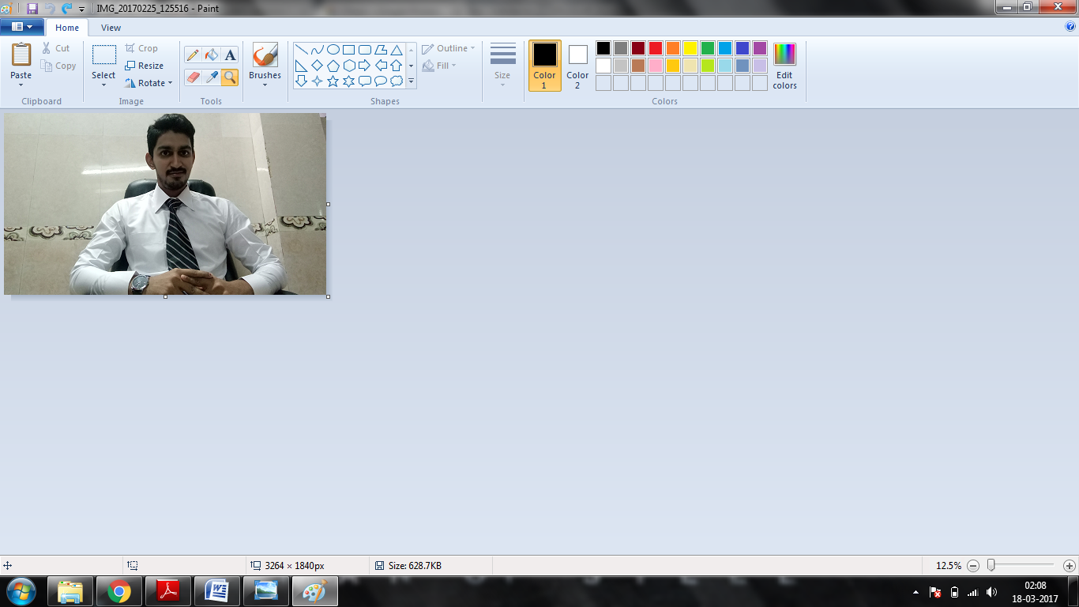

MSc. Computer Science(Big Data)

# Contact Information

Room no.1/2,

Near Kajupada Line .

Kurla west Mumbai 400 072

Aamirsk1995@gmail.com

+91-8286190685

# Objectives

To be associated with an organization that provides career development opportunities as a Software Tester or Developer and an environment to enable me to contribute in its growth.

# Education

**SSC**

Amrit Education Society High School

March 2011| Marks Obtained: 387/550 Percentage: 70.36%

**HSC**

VKK Krishna Menon College

February 2013| Marks Obtained: 313/600 Percentage:52.16%

**FYBSC (Computer Science) (Sem I)**

K J Somaiya College of Science and Commerce, Mumbai

October 2013| Marks Obtained: 477/800 Percentage: 59.00%

**FYBSC (Computer Science) (Sem II)**

K J Somaiya College of Science and Commerce, Mumbai

March 2014| Marks Obtained: 494 /800 Percentage: 61.8%

**SYBSC (Computer Science) (Sem III)**

K J Somaiya College of Science and Commerce, Mumbai

October 2014| Marks Obtained: 500/800 Percentage: 62.5%

**SYBSC (Computer Science) (Sem IV)**

K J Somaiya College of Science and Commerce, Mumbai

March 2015| Marks Obtained: 442/800 Percentage: 55.2 %

**TYBSC (Computer Science) (Sem V)**

K J Somaiya College of Science and Commerce, Mumbai

March 2015| Marks Obtained: 476/800 Percentage: 59.5%

**TYBSC (Computer Science) (Sem VI)**

K J Somaiya College of Science and Commerce, Mumbai

March 2015| Marks Obtained: 496/800 Percentage: 62.0%

**PROJECT**: PETROL PUMP MANAGEMENT SYSTEM.

# Strengths

* + - Good Oral, Written & presentation skills
    - Easily get along with anyone
    - Quick learner with good grasping ability
    - Teaching Ability

# Technical Skills

**Languages:**

Programming Languages: SQL, PL/SQL, Java.

Operating System: Linux (Basics)

Web Designing: HTML, CSS.

Testing: Manual Testing.

Database: Oracle

**Tools:**

Apache Jmeter, Mantis, Trantula, Sellenium with Java.

**Others:**

Cloud computing, Big Data Analysis, Data Warehousing, Data Mining, Web Security.

# Personal Details

* + - Date of Birth: 17/09/1995
    - Gender: Male
    - Status: Single
    - Languages Known: English, Hindi, Marathi, Urdu

# Declaration

I hereby declare that the information furnished above is true to the best of my Knowledge.

**Place: Mumbai Amir**

**Copyright information**