Feedback Form
from flask import *

app=Flask(__name__)

@app.route("/")
def Form():
return render_template("customer.html")

@app.route("/process3",methods=['GET','POST'])
def display():
if request.method=="POST":
alldata=request.form
return render_template("result.html",result=alldata)

if __name__=='__main__':
app.run(debug=True)

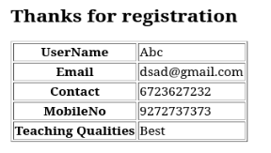
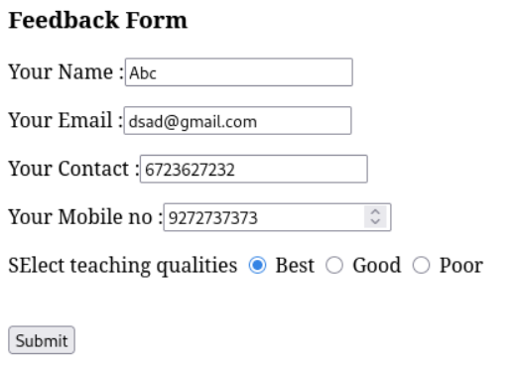
Quiz.py
from flask import Flask,render_template,request,json,jsonify
import os,requests

app = Flask(__name__)

@app.route('/', methods =['GET'])
def home():

return render_template('home.html')

@app.route('/getData', methods =['POST'])
def getCity():
stname = request.form.get('sname')
url = f"http://172.16.5.154:4000/api/getAll/{stname}"
responsess = requests.get(url)
data = responsess.json()

return render_template('home1.html',data=data)

if __name__ == "__main__":
app.run(port = 5000,debug=False)

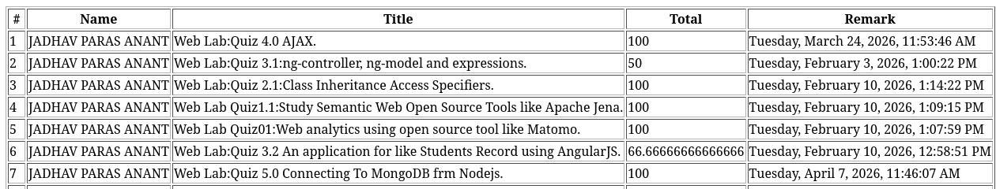

Weather.py

from flask import Flask,render_template,request,json
import os,requests
app = Flask(__name__)
@app.route('/', methods =['GET'])
def home():
#url = "https://samples.openweathermap.org/data/2.5/forecast?id=52494&appid=b1b15e88fa797225412429c1c50c122a1"
#response = requests.get(url)

#list_of_data = response.json()
#print(list_of_data['cnt'])
#return list_of_data
#return render_template('home.html',weather=list_of_data)
return render_template('home.html')

@app.route('/getCity', methods =['POST'])
def getCity():
#city=request.args.get('city')
city=request.form['city']
api_key = "17b7453a8a96660330b788299e4dfcf3"

base_url = "http://api.openweathermap.org/data/2.5/weather?"
city_name=city
complete_url = base_url + "appid=" + api_key + "&q=" + city_name
response = requests.get(complete_url)
x = response.json()

if x["cod"] != "404":
y = x["main"]
sysk=x["sys"]
CountryN=sysk["country"]
Sunrise=sysk["sunrise"]
current_temperature = y["temp"]
current_pressure = y["pressure"]
current_humidity = y["humidity"]
dataL=[current_temperature,current_pressure,current_humidity,CountryN]
z = x["weather"]
return render_template('home1.html',city=city,dataL=dataL,x=x)

else:
return render_template('home2.html',city=city,x=x)

if __name__ == "__main__":
app.run(port = 5000,debug=False)

