Problem Statement – Practical 1
Student Profile Viewer App – A Basic Android Application Using Activities, Services, and User Interface Components
You are required to design and develop an Android application named Student Profile Viewer. The objective of this practical is to help students understand the basic components of Android such as Activities, Services, Content Providers, basic User Interface elements, and working with an Android Virtual Device (AVD) and USB Debugging.
Procedure:
Open Android Studio.
Click File → New → New Project.
Select Empty Views Activity.
Name: StudentProfileViewer
Package Name: package com.example.studentprofileviewer
Language: Java
Minimum SDK: API 21 (Android 5.0)
Click Finish.
Source Code
Design the Main Layout (activity_main.xml)
Procedure
- In Project Explorer, go to:
app → res → layout → activity_main.xml.
- Click Code tab (bottom of editor).
- Replace content with:
<?xml version="1.0" encoding="utf-8"?>
<ScrollView xmlns:android="http://schemas.android.com/apk/res/android" android:layout_width="match_parent" android:layout_height="match_parent"
android:fillViewport="true">
<LinearLayout
android:layout_width="match_parent" android:layout_height="wrap_content" android:orientation="vertical" android:padding="16dp">
<!-- Student Name -->
<TextView
android:layout_width="wrap_content" android:layout_height="wrap_content" android:text="Student Name" android:textStyle="bold"
android:paddingTop="8dp"/>

<EditText android:id="@+id/etName" android:layout_width="match_parent" android:layout_height="wrap_content" android:hint="Enter Name" android:inputType="textPersonName"/>
<!-- Roll Number --> <TextView
android:layout_width="wrap_content" android:layout_height="wrap_content" android:text="Roll Number" android:textStyle="bold" android:paddingTop="8dp"/>
<EditText android:id="@+id/etRoll" android:layout_width="match_parent" android:layout_height="wrap_content" android:hint="Enter Roll Number" android:inputType="number"/>
<!-- Course --> <TextView
android:layout_width="wrap_content" android:layout_height="wrap_content" android:text="Course" android:textStyle="bold" android:paddingTop="8dp"/>
<EditText android:id="@+id/etCourse" android:layout_width="match_parent" android:layout_height="wrap_content" android:hint="Enter Course" android:inputType="text"/>
<!-- Email --> <TextView
android:layout_width="wrap_content" android:layout_height="wrap_content"
android:text="Email" android:textStyle="bold" android:paddingTop="8dp"/>
<EditText android:id="@+id/etEmail" android:layout_width="match_parent" android:layout_height="wrap_content" android:hint="Enter Email" android:inputType="textEmailAddress"/> <!-- Button --> <Button
android:id="@+id/btnViewProfile" android:layout_width="match_parent" android:layout_height="wrap_content"
android:text="View Profile" android:paddingTop="12dp" android:layout_marginTop="16dp"/>
</LinearLayout> </ScrollView>

Create Profile Activity
Procedure
- Right-click app → java → com.example.studentprofileviewer.
- Select New → Activity → Empty Activity.
- Name: ProfileActivity.
- Click Finish.
Android Studio generates ProfileActivity.java and activity_profile.xml
Layout (activity_profile.xml)
<?xml version="1.0" encoding="utf-8"?>
<LinearLayout xmlns:android="http://schemas.android.com/apk/res/android" android:layout_width="match_parent" android:layout_height="match_parent" android:orientation="vertical" android:padding="16dp">
<TextView
android:id="@+id/tvName" android:layout_width="match_parent" android:layout_height="wrap_content"
android:textSize="18sp" android:textStyle="bold" android:padding="8dp"/>
<TextView
android:id="@+id/tvRoll" android:layout_width="match_parent" android:layout_height="wrap_content"
android:textSize="18sp" android:padding="8dp"/>
<TextView
android:id="@+id/tvCourse" android:layout_width="match_parent" android:layout_height="wrap_content" android:textSize="18sp" android:padding="8dp"/>
<TextView android:id="@+id/tvEmail" android:layout_width="match_parent" android:layout_height="wrap_content"
android:textSize="18sp" android:padding="8dp"/> </LinearLayout>
Code (ProfileActivity.java)
package com.example.studentprofileviewer; import android.content.Intent; import android.os.Bundle; import android.widget.TextView;
import androidx.appcompat.app.AppCompatActivity;

public class ProfileActivity extends AppCompatActivity {
TextView tvName, tvRoll, tvCourse, tvEmail;
@Override
protected void onCreate(Bundle savedInstanceState) { super.onCreate(savedInstanceState); setContentView(R.layout.activity_profile);
// Initialize TextViews tvName = findViewById(R.id.tvName); tvRoll = findViewById(R.id.tvRoll); tvCourse = findViewById(R.id.tvCourse); tvEmail = findViewById(R.id.tvEmail); // Get data from Intent (sent from MainActivity)
String name = getIntent().getStringExtra("NAME");
String roll = getIntent().getStringExtra("ROLL");
String course = getIntent().getStringExtra("COURSE");
String email = getIntent().getStringExtra("EMAIL");
// Set data to TextViews tvName.setText("Name: " + name); tvRoll.setText("Roll Number: " + roll); tvCourse.setText("Course: " + course); tvEmail.setText("Email: " + email);
// Start LoggingService in background
Intent serviceIntent = new Intent(this, LoggingService.class); serviceIntent.putExtra("NAME", name); serviceIntent.putExtra("ROLL", roll);
startService(serviceIntent);
} }
Add Logging Service
Procedure
- Right-click app → java → com.example.studentprofileviewer.
- Select New → Java Class
- Name: LoggingService.
- Click Finish.
package com.example.studentprofileviewer;

import android.app.Service; import android.content.Intent; import android.os.IBinder;
import android.util.Log;

public class LoggingService extends Service {

private static final String TAG = "LoggingService";

@Override public void onCreate() { super.onCreate();
Log.d(TAG, "Service Created");
}

@Override
public int onStartCommand(Intent intent, int flags, int startId) {
// Get data passed from ProfileActivity
String name = intent.getStringExtra("NAME");
String roll = intent.getStringExtra("ROLL");

Log.d(TAG, "Profile Viewed: " + name + " (Roll: " + roll + ")");

// Service runs once and stops (not sticky)
return START_NOT_STICKY;
}

@Override public void onDestroy() { super.onDestroy();
Log.d(TAG, "Service Destroyed");
}

@Override
public IBinder onBind(Intent intent) { // Not using bound service here
return null;
}
}
MainActivity.java
package com.example.studentprofileviewer;

import android.content.Intent; import android.os.Bundle; import android.widget.Button; import android.widget.EditText;
import androidx.appcompat.app.AppCompatActivity;

public class MainActivity extends AppCompatActivity {

EditText etName, etRoll, etCourse, etEmail;
Button btnViewProfile;

@Override
protected void onCreate(Bundle savedInstanceState) { super.onCreate(savedInstanceState);
setContentView(R.layout.activity_main);

etName = findViewById(R.id.etName); etRoll = findViewById(R.id.etRoll); etCourse = findViewById(R.id.etCourse); etEmail = findViewById(R.id.etEmail);
btnViewProfile = findViewById(R.id.btnViewProfile);

btnViewProfile.setOnClickListener(v -> {
Intent intent = new Intent(MainActivity.this, ProfileActivity.class); intent.putExtra("NAME", etName.getText().toString()); intent.putExtra("ROLL", etRoll.getText().toString()); intent.putExtra("COURSE", etCourse.getText().toString()); intent.putExtra("EMAIL", etEmail.getText().toString()); startActivity(intent);
});
} }
Register Service in Manifest
Open AndroidManifest.xml → inside <application> add:
<service android:name=".LoggingService" />
Run and Test
Procedure
- Connect your phone via USB (enable Developer Options → USB Debugging).
- In Android Studio, click Run .
- Select your device.
- Enter student details → click View Profile.
- ProfileActivity opens and shows details.
- Open Logcat (bottom panel in Android Studio).
Filter by LoggingService.
You’ll see:
D/LoggingService: Service Created
D/LoggingService: Profile Viewed: Ramesh (Roll: 101)
D/LoggingService: Service Destroyed

Practical:02
2.1: Create an Android app that defines custom colors in colors.xml and applies them to the background of a TextView
STEP 1 — Create New Project
- Open Android Studio
- Click New Project
- Select Empty Views Activity
- Click Next
- Fill details:
Project Name: Practical2_1_CustomColors
Package Name: (auto)
Language: Java
Minimum SDK: API 21
- Click Finish
Android separates reusable items into folders under res/ Examples:
- colors.xml → stores color definitions
- strings.xml → stores text
- styles.xml → themes
- layout.xml → UI structure
This practical focuses on colors.xml
STEP 3 — Define Custom Colors in colors.xml
Go to:
app → res → values → colors.xml
Replace everything inside with:
<?xml version="1.0" encoding="utf-8"?>
<resources>
<color name="myBackground">#FF9800</color> <!-- Orange -->
<color name="myTextColor">#FFFFFF</color> <!-- White -->
</resources>
STEP 4 — Design the UI in activity_main.xml
Go to
app → res → layout → activity_main.xml Replace with:
<?xml version="1.0" encoding="utf-8"?>
<LinearLayout xmlns:android="http://schemas.android.com/apk/res/android" android:orientation="vertical" android:layout_width="match_parent" android:layout_height="match_parent" android:gravity="center">
<TextView android:id="@+id/txtSample" android:layout_width="wrap_content" android:layout_height="wrap_content" android:text="Hello Custom Colors!" android:textSize="24sp" android:padding="20dp" />
</LinearLayout>
Why not set colors here?
Because practical requires setting color using Java code.
STEP 5 — Write Java code in MainActivity.java
Go to: app → java → yourpackagename → MainActivity.java
Replace code with:
package com.example.practical2_1_customcolors; import android.os.Bundle; import android.widget.TextView; import androidx.appcompat.app.AppCompatActivity; public class MainActivity extends AppCompatActivity {
@Override protected void onCreate(Bundle savedInstanceState) { super.onCreate(savedInstanceState); setContentView(R.layout.activity_main);
// Step 1: Find TextView by ID
TextView txt = findViewById(R.id.txtSample); // Step 2: Apply custom colors from colors.xml txt.setBackgroundColor(getResources().getColor(R.color.myBackground)); txt.setTextColor(getResources().getColor(R.color.myTextColor));
}
}
STEP 6 — Run the App
- Choose Emulator or Physical Device
- Press Run ▶
- Output Expected:
A screen displaying:
Orange background TextView
White text inside
Text: Hello Custom Colors!

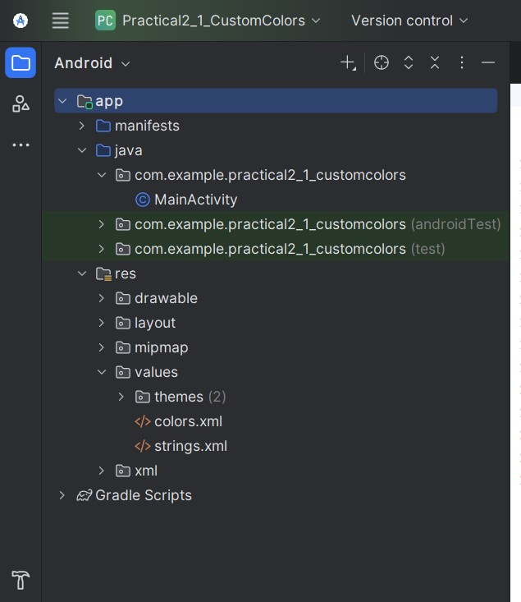

Problem Statement:02
To implement an Android application using resource files to dynamically modify displayed text and background color through user interaction.
STEP 1: Create the Android Project
Open Android Studio
Click → New Project
Choose Template
Select:
- Empty Views Activity Click Next
Project Configuration (IMPORTANT)
Fill exactly like this (you may change app name slightly):
- Name: ResourceDemoApp
- Package name: auto-generated (leave it)
- Save location: default
- Language: Java
- Minimum SDK: API 21 or above
Click Finish
Wait till Gradle build completes.
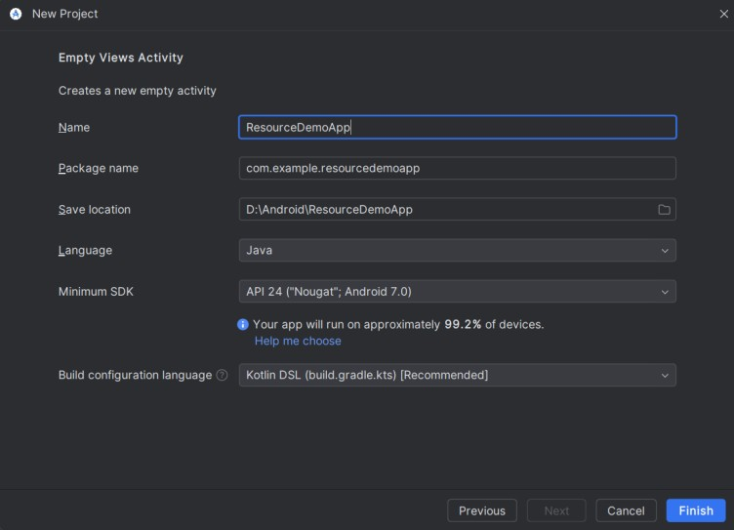
Step3: Open:
res → values → strings.xml
(SETUP STRING RESOURCES)
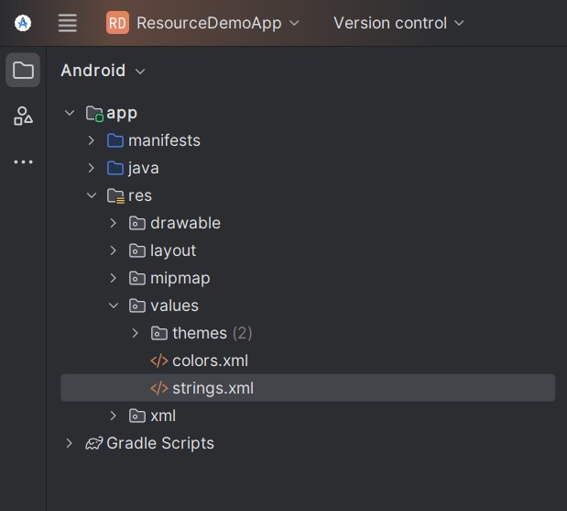
Code:
<resources>
<string name="app_name">ResourceDemoApp</string>
<!-- Text shown on screen -->
<string name="light_mode_text">Welcome to Resource Demo</string>
<string name="dark_mode_text">Dark Mode Activated</string>
<!-- Button labels -->
<string name="btn_dark">Switch to Dark Mode</string>
<string name="btn_light">Switch to Light Mode</string>
</resources> Step:04 res → values → colors.xml
Code:
<resources>
<color name="light_background">#FFFFFF</color>
<color name="dark_background">#222222</color>
<color name="light_text">#000000</color>
<color name="dark_text">#FFFFFF</color>
</resources> Step:05 res → layout → activity_main.xml
Replace everything with this:
<?xml version="1.0" encoding="utf-8"?>
<RelativeLayout xmlns:android="http://schemas.android.com/apk/res/android" android:id="@+id/main_layout" android:layout_width="match_parent" android:layout_height="match_parent" android:background="@color/light_background">
<TextView android:id="@+id/tvMessage" android:layout_width="wrap_content" android:layout_height="wrap_content" android:text="@string/light_mode_text" android:textSize="22sp" android:textColor="@color/light_text" android:layout_centerInParent="true"/>
<Button android:id="@+id/btnToggle" android:layout_width="wrap_content" android:layout_height="wrap_content" android:text="@string/btn_dark" android:layout_centerHorizontal="true" android:layout_alignParentBottom="true" android:layout_marginBottom="50dp"/>
</RelativeLayout>
Step6:Locate: java → your.package.name → MainActivity.java
Code:
package com.example.resourcedemoapp; import androidx.appcompat.app.AppCompatActivity; import android.os.Bundle; import android.widget.Button; import android.widget.RelativeLayout; import android.widget.TextView;
public class MainActivity extends AppCompatActivity { boolean isLightMode = true;
@Override
protected void onCreate(Bundle savedInstanceState) { super.onCreate(savedInstanceState); setContentView(R.layout.activity_main);
RelativeLayout mainLayout = findViewById(R.id.main_layout);
TextView tvMessage = findViewById(R.id.tvMessage); Button btnToggle = findViewById(R.id.btnToggle); btnToggle.setOnClickListener(v -> {
if (isLightMode) { // Switch to Dark Mode
mainLayout.setBackgroundColor(getResources().getColor(R.color.dark_background)); tvMessage.setText(getString(R.string.dark_mode_text)); tvMessage.setTextColor(getResources().getColor(R.color.dark_text));
btnToggle.setText(getString(R.string.btn_light)); isLightMode = false;
} else {
// Switch to Light Mode
mainLayout.setBackgroundColor(getResources().getColor(R.color.light_background));
tvMessage.setText(getString(R.string.light_mode_text)); tvMessage.setTextColor(getResources().getColor(R.color.light_text)); btnToggle.setText(getString(R.string.btn_dark)); isLightMode = true;
}

});
} }
Now Run the App
Practical:2.3
Practical Title
Exploration of Drawable and Dimension Resources in Android
Aim
To study and implement Drawable and Dimension resources in an Android application for designing a visually consistent and well-spaced user interface.
Scenario
Consider a scenario where a college is developing a simple “College Notice Board App” for laboratory demonstration.
The application displays important notices with icons and proper spacing so that the information looks clear, readable, and visually organized on different screen sizes.
To achieve this, the developer uses drawable resources for icons and backgrounds, and dimension resources to control padding, margins, and text sizes instead of hard-coding values.
Problem Statement
To design and develop a simple Android application named “College Notice Board App” that demonstrates the use of drawable and dimension resources.
The application should:
- Use drawable resources for notice icons and background design
- Apply dimension resources for margins, padding, and text sizes
- Maintain uniform spacing and layout alignment across the screen • Avoid hard-coded size values in layout files

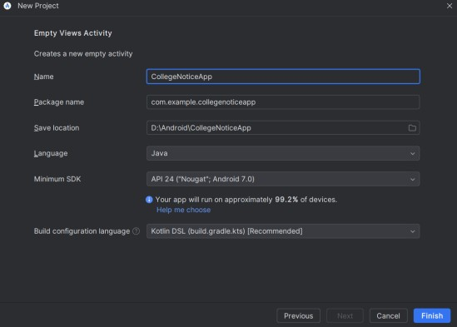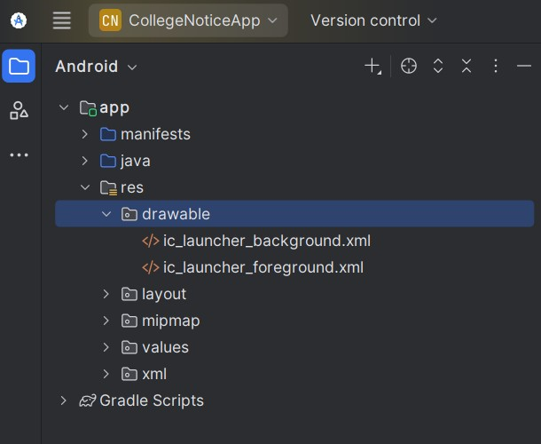

PRACTICAL: Drawable & Dimension Resources (TCSC)
STEP 1: Open Android Studio
- Click New Project
STEP 2: Select Project Template
- Choose Empty Views Activity
- Click Next
STEP 3: Configure Your Project Fill exactly like this:
Field | Value
Name | CollegeNoticeApp
Package name | com.example.collegenoticeapp
Save location | Default
Language | Java
Minimum SDK | API 21 (Android 5.0)
Build configuration language Default
Click Finish
Wait until Gradle build completes.
STEP 4: Add Image (Drawable Resource)
- Copy your image logo.jpg
- Go to:
app → src → main → res → drawable
- Paste logo.jpg inside drawable No renaming required STEP 5: Create Dimension Resources
Open:
res → values → dimens.xml If not present:
- Right-click values
- New → Values Resource File
- Name: dimens
<?xml version="1.0" encoding="utf-8"?>
<resources>
<dimen name="logo_size">120dp</dimen>
<dimen name="padding_large">16dp</dimen>
<dimen name="padding_medium">12dp</dimen>
<dimen name="text_large">20sp</dimen>
<dimen name="text_medium">16sp</dimen>

</resources> STEP 6: Edit Layout File
Open:
res → layout → activity_main.xml
Replace entire code with this:
<?xml version="1.0" encoding="utf-8"?>
<LinearLayout xmlns:android="http://schemas.android.com/apk/res/android" android:layout_width="match_parent" android:layout_height="match_parent" android:orientation="vertical" android:gravity="center" android:padding="@dimen/padding_large">

<ImageView android:layout_width="@dimen/logo_size" android:layout_height="@dimen/logo_size" android:src="@drawable/logo" android:contentDescription="College Logo" android:layout_marginBottom="@dimen/padding_medium" />

<TextView android:layout_width="wrap_content" android:layout_height="wrap_content" android:text="TCSC" android:textSize="@dimen/text_large" android:layout_marginBottom="@dimen/padding_medium" />

<TextView android:layout_width="wrap_content" android:layout_height="wrap_content" android:text="College Notice Board" android:textSize="@dimen/text_medium" />
</LinearLayout> STEP 7: Java File
Open:
java → com.example.collegenoticeapp → MainActivity.java
Default code is sufficient:
package com.example.collegenoticeapp; import android.os.Bundle; import androidx.appcompat.app.AppCompatActivity; public class MainActivity extends AppCompatActivity {
@Override protected void onCreate(Bundle savedInstanceState) { super.onCreate(savedInstanceState); setContentView(R.layout.activity_main);
}
}
STEP 8: Run the Application
1. Click Run

Practical No:4.1
Aim: To design a simple Android application using Linear Layout to display student information and understand vertical and horizontal orientation.
Problem Statement:
Design an Android application that displays student details such as Name, Roll Number, Course, and College Name using Linear Layout. Arrange the views vertically and horizontally to understand orientation.
Step 1: Create New Project
Open Android Studio
Click New Project
Select Empty Views Activity
Click Next
Fill details:
Name: StudentProfileLinearLayout
Package: com.example.studentprofile
Language: Java
Click Finish
Step 2: Open Layout File app > res > layout > activity_main.xml Switch to Code view (XML only)
Source Code:
<?xml version="1.0" encoding="utf-8"?>
<LinearLayout xmlns:android="http://schemas.android.com/apk/res/android" android:id="@+id/main" android:layout_width="match_parent" android:layout_height="match_parent" android:orientation="vertical"
android:padding="16dp">
<!-- Title --> <TextView
android:layout_width="wrap_content" android:layout_height="wrap_content" android:text="Student Profile" android:textSize="22sp" android:textStyle="bold" android:layout_gravity="center" android:paddingBottom="20dp" />
<!-- Name Row --> <LinearLayout
android:layout_width="match_parent" android:layout_height="wrap_content" android:orientation="horizontal">
<TextView
android:layout_width="wrap_content" android:layout_height="wrap_content"
android:text="Name: " android:textStyle="bold" />
<TextView
android:layout_width="wrap_content" android:layout_height="wrap_content"
android:text="Nikhil" /> </LinearLayout>
<!-- Roll Number Row --> <LinearLayout
android:layout_width="match_parent" android:layout_height="wrap_content" android:orientation="horizontal" android:paddingTop="10dp">
<TextView
android:layout_width="wrap_content" android:layout_height="wrap_content"
android:text="Roll No: " android:textStyle="bold" />
<TextView
android:layout_width="wrap_content" android:layout_height="wrap_content" android:text="21MCA001" />
</LinearLayout>
<!-- Course Row --> <LinearLayout
android:layout_width="match_parent" android:layout_height="wrap_content" android:orientation="horizontal" android:paddingTop="10dp">
<TextView
android:layout_width="wrap_content" android:layout_height="wrap_content" android:text="Course: " android:textStyle="bold" />
<TextView
android:layout_width="wrap_content" android:layout_height="wrap_content" android:text="BSc IT" />
</LinearLayout>
<!-- College Row --> <LinearLayout
android:layout_width="match_parent" android:layout_height="wrap_content" android:orientation="horizontal" android:paddingTop="10dp">
<TextView
android:layout_width="wrap_content" android:layout_height="wrap_content" android:text="College: " android:textStyle="bold" />
<TextView
android:layout_width="wrap_content" android:layout_height="wrap_content" android:text="ABC Institute of Technology" />
</LinearLayout>
</LinearLayout>
Step 4: Java File (No Code Needed)
Open:
MainActivity.java
No changes required because:
This is static UI only, no button or logic.
Step 5: Run the App

Practical 4.2
Aim: To design a simple login screen using Relative Layout and understand positioning of views relative to parent and other views.
Problem Statement
Create an Android application to design a Login Screen using Relative Layout with Username, Password, and Login Button positioned relative to each other. Project Name: LoginRelativeLayout activity_main.xml: Source Code
<?xml version="1.0" encoding="utf-8"?>
<RelativeLayout xmlns:android="http://schemas.android.com/apk/res/android" android:id="@+id/main" android:layout_width="match_parent" android:layout_height="match_parent" android:padding="20dp">
<!-- Title --> <TextView
android:id="@+id/txtTitle" android:layout_width="wrap_content" android:layout_height="wrap_content"
android:text="Login" android:textSize="24sp" android:textStyle="bold"
android:layout_centerHorizontal="true" />
<!-- Username -->
<EditText
android:id="@+id/edtUsername" android:layout_width="match_parent" android:layout_height="wrap_content" android:hint="Username" android:layout_below="@id/txtTitle" android:layout_marginTop="20dp" />
<!-- Password --> <EditText
android:id="@+id/edtPassword" android:layout_width="match_parent" android:layout_height="wrap_content" android:hint="Password" android:inputType="textPassword" android:layout_below="@id/edtUsername" android:layout_marginTop="10dp" />
<!-- Login Button --> <Button android:id="@+id/btnLogin" android:layout_width="wrap_content" android:layout_height="wrap_content"
android:text="Login" android:layout_below="@id/edtPassword" android:layout_centerHorizontal="true" android:layout_marginTop="20dp" /> </RelativeLayout> MainActivity.java
package com.example.loginrelativelayout;

import android.os.Bundle;
import androidx.appcompat.app.AppCompatActivity;

public class MainActivity extends AppCompatActivity {

@Override
protected void onCreate(Bundle savedInstanceState) { super.onCreate(savedInstanceState);
setContentView(R.layout.activity_main);
} }
Run

Practical 4.3
Problem Statement
Develop an Android application that displays a student mark sheet using Table Layout, showing subject names and corresponding marks in rows and columns.
Project Name: MarkSheetTableLayout
Source Code: activity_main.xml
<?xml version="1.0" encoding="utf-8"?>
<TableLayout xmlns:android="http://schemas.android.com/apk/res/android" android:id="@+id/main" android:layout_width="match_parent" android:layout_height="match_parent" android:padding="16dp"
android:stretchColumns="1">
<!-- Title -->
<TableRow> <TextView
android:layout_span="2" android:layout_width="wrap_content" android:layout_height="wrap_content" android:text="Student Mark Sheet"
android:textSize="22sp" android:textStyle="bold" android:gravity="center" />
</TableRow>
<!-- Header Row -->
<TableRow> <TextView
android:text="Subject" android:textStyle="bold" />
<TextView
android:text="Marks" android:textStyle="bold" />
</TableRow>
<!-- Row 1 -->
<TableRow>
<TextView android:text="Mathematics" />
<TextView android:text="85" />
</TableRow>
<!-- Row 2 -->
<TableRow>
<TextView android:text="Computer Science" />
<TextView android:text="90" />
</TableRow>
<!-- Row 3 -->
<TableRow>
<TextView android:text="Physics" />
<TextView android:text="78" />
</TableRow>
<!-- Row 4 -->
<TableRow>
<TextView android:text="English" />
<TextView android:text="88" />
</TableRow>
</TableLayout>
Run
Prac-4.4
Problem Statement
Develop an Android application that displays a list of contact names entered by the user using ListView.
Project Name: ContactListViewApp activity_main.xml
SourceCode:
<?xml version="1.0" encoding="utf-8"?>
<LinearLayout xmlns:android="http://schemas.android.com/apk/res/android" android:id="@+id/main" android:layout_width="match_parent" android:layout_height="match_parent" android:orientation="vertical"
android:padding="16dp"> <TextView
android:layout_width="wrap_content" android:layout_height="wrap_content" android:text="Contact List" android:textSize="22sp" android:textStyle="bold" android:layout_gravity="center" android:paddingBottom="10dp"/>
<EditText android:id="@+id/edtName" android:layout_width="match_parent" android:layout_height="wrap_content" android:hint="Enter contact name"/>
<Button android:id="@+id/btnAdd" android:layout_width="wrap_content" android:layout_height="wrap_content" android:text="Add" android:layout_gravity="center" android:paddingTop="10dp"/>
<ListView android:id="@+id/listView" android:layout_width="match_parent" android:layout_height="wrap_content" android:paddingTop="10dp"/> </LinearLayout> MainActivity.java
SourceCode:
package com.example.contactlistviewapp; import android.os.Bundle; import android.view.View; import android.widget.ArrayAdapter; import android.widget.Button; import android.widget.EditText; import android.widget.ListView; import androidx.appcompat.app.AppCompatActivity;
import java.util.ArrayList;
public class MainActivity extends AppCompatActivity {
EditText edtName;
Button btnAdd;
ListView listView;
ArrayList<String> contactList;
ArrayAdapter<String> adapter; @Override
protected void onCreate(Bundle savedInstanceState) { super.onCreate(savedInstanceState); setContentView(R.layout.activity_main); edtName = findViewById(R.id.edtName); btnAdd = findViewById(R.id.btnAdd); listView = findViewById(R.id.listView); contactList = new ArrayList<>();
adapter = new ArrayAdapter<>( this,
android.R.layout.simple_list_item_1, contactList
);
listView.setAdapter(adapter);
btnAdd.setOnClickListener(new View.OnClickListener() {
@Override
public void onClick(View view) {
String name = edtName.getText().toString();
if (!name.isEmpty()) { contactList.add(name); adapter.notifyDataSetChanged();
edtName.setText("");
}
}
});
} }
Click Run
Prac-4.5
Problem Statement
Design an Android application using GridView that allows the user to enter items dynamically and display them in a grid format on the screen.
Aim
To create an Android application that uses GridView with Adapter to display user-entered items dynamically in a grid arrangement. Project Name: DynamicGridViewApp activity_main.xml source Code:
<?xml version="1.0" encoding="utf-8"?>
<LinearLayout xmlns:android="http://schemas.android.com/apk/res/android" android:layout_width="match_parent" android:layout_height="match_parent" android:orientation="vertical" android:padding="16dp">
<EditText android:id="@+id/etItem" android:layout_width="match_parent" android:layout_height="wrap_content" android:hint="Enter item" />
<Button android:id="@+id/btnAdd" android:layout_width="match_parent" android:layout_height="wrap_content" android:text="Add to Grid" />
<GridView android:id="@+id/gridView" android:layout_width="match_parent" android:layout_height="match_parent" android:numColumns="2" android:horizontalSpacing="10dp" android:verticalSpacing="10dp" /> </LinearLayout>

MainActivity.java
SourceCode:
package com.example.dynamicgridviewapp; import android.os.Bundle; import android.view.View; import android.widget.ArrayAdapter; import android.widget.Button; import android.widget.EditText; import android.widget.GridView;
import androidx.appcompat.app.AppCompatActivity;

import java.util.ArrayList;
public class MainActivity extends AppCompatActivity {
EditText etItem;
Button btnAdd;
GridView gridView;
ArrayList<String> itemList;
ArrayAdapter<String> adapter;
@Override
protected void onCreate(Bundle savedInstanceState) { super.onCreate(savedInstanceState); setContentView(R.layout.activity_main); etItem = findViewById(R.id.etItem); btnAdd = findViewById(R.id.btnAdd); gridView = findViewById(R.id.gridView); itemList = new ArrayList<>(); adapter = new ArrayAdapter<>(
this,
android.R.layout.simple_list_item_1, itemList
);
gridView.setAdapter(adapter);
btnAdd.setOnClickListener(new View.OnClickListener() {
@Override
public void onClick(View v) {
String item = etItem.getText().toString();
if (!item.isEmpty()) { itemList.add(item);
adapter.notifyDataSetChanged();
etItem.setText("");
}
}
});
} }
Run

Practical:8.1: Services
Aim-To study and implement an Android Service that performs a background task (such as a counter or timer) without direct user interaction.
Problem Statement – Develop an Android application that implements a Started Service which runs a background counter (or timer) and logs the count every second using Logcat.
The service should: Start when a button is clicked.
Continue running even when the activity is minimized.
Stop when a stop button is pressed.
Display output in Logcat or Toast messages for verification.
STEP 1: Create Project-Open Android Studio
Click New Project
Select: Empty Views Activity
Click Next
Configure Project
Field | Value
Name | StartedServiceCounter
Package Name | com.example.startedservicecounter
Language | Java
Minimum SDK | API 21 (or default)
Click Finish
Wait for Gradle sync. STEP 2: Create Service Class
Right Click on: app > java > com.example.startedservicecounter
New → Java Class
Name it: CounterService STEP 3: Write CounterService.java
Replace everything with this: package com.example.startedservicecounter; import android.app.Service; import android.content.Intent; import android.os.Handler; import android.os.IBinder; import android.util.Log; import android.widget.Toast; public class CounterService extends Service { private Handler handler; private Runnable runnable; private int counter = 0; private boolean isRunning = false;
@Override public int onStartCommand(Intent intent, int flags, int startId) {
if (isRunning) {
Log.d("CounterService", "Service already running"); return START_STICKY;
}
isRunning = true; handler = new Handler(); runnable = new Runnable() {
@Override public void run() { counter++;
Log.d("CounterService", "Counter: " + counter); handler.postDelayed(this, 1000);
}
};
handler.post(runnable);
Toast.makeText(this, "Service Started", Toast.LENGTH_SHORT).show(); return START_STICKY;
}
@Override public void onDestroy() { super.onDestroy();

if (handler != null && runnable != null) { handler.removeCallbacks(runnable);
}
isRunning = false; counter = 0;
Toast.makeText(this, "Service Stopped", Toast.LENGTH_SHORT).show();
Log.d("CounterService", "Service Destroyed");
}
@Override public IBinder onBind(Intent intent) {
return null;
}
}
STEP 4: Register Service in AndroidManifest.xml
Open:
app > manifests > AndroidManifest.xml
Inside <application> tag add this:
<service android:name=".CounterService" android:enabled="true" android:exported="false"/>
Very important step Without this → app crashes.
STEP 5: Design Layout
Open:res > layout > activity_main.xml Replace everything with:
<?xml version="1.0" encoding="utf-8"?>
<LinearLayout xmlns:android="http://schemas.android.com/apk/res/android" android:layout_width="match_parent" android:layout_height="match_parent" android:orientation="vertical" android:gravity="center" android:padding="20dp">
<Button android:id="@+id/btnStart" android:layout_width="wrap_content" android:layout_height="wrap_content" android:text="Start Service"/>
<Button android:id="@+id/btnStop" android:layout_width="wrap_content" android:layout_height="wrap_content" android:text="Stop Service" android:layout_marginTop="20dp"/>
</LinearLayout>
STEP 6: Write MainActivity.java
Open:MainActivity.java Replace everything with: package com.example.startedservicecounter; import android.content.Intent; import android.os.Bundle; import android.view.View; import android.widget.Button; import androidx.appcompat.app.AppCompatActivity; public class MainActivity extends AppCompatActivity {
Button btnStart, btnStop;
@Override protected void onCreate(Bundle savedInstanceState) { super.onCreate(savedInstanceState); setContentView(R.layout.activity_main);

btnStart = findViewById(R.id.btnStart); btnStop = findViewById(R.id.btnStop); btnStart.setOnClickListener(new View.OnClickListener() {
@Override public void onClick(View view) {
Intent intent = new Intent(MainActivity.this, CounterService.class);
startService(intent);
}
});
btnStop.setOnClickListener(new View.OnClickListener() {
@Override public void onClick(View view) {
Intent intent = new Intent(MainActivity.this, CounterService.class);
stopService(intent);
}
});
}y
}
STEP 7: Run the App
What Should Happen?
Click Start Service
Counter starts in Logcat Toast appears
Minimize app
Service keeps running (check Logcat)
Click Stop Service
Counter stops
“Service Stopped” Toast
How to See Logcat
Bottom → Logcat
Filter by:CounterService
You’ll see: Counter: 1,Counter: 2,Counter: 3
Practical:8.2
Aim :To study and implement Android Notification to alert users about application events.
Problem Statement :Develop an Android application that generates a Notification when a button is clicked.
The notification should: Display a title and message.
Appear in the notification panel.
Open the application when clicked. Project Name: Notification activity_main.xml
<?xml version="1.0" encoding="utf-8"?>
<LinearLayout xmlns:android="http://schemas.android.com/apk/res/android" android:layout_width="match_parent" android:layout_height="match_parent" android:gravity="center" android:orientation="vertical">
<Button android:id="@+id/btnNotify" android:layout_width="wrap_content" android:layout_height="wrap_content" android:text="Generate Notification" />
</LinearLayout> MainActivity.java
package com.example.notification; import android.app.NotificationChannel; import android.app.NotificationManager; import android.app.PendingIntent; import android.content.Intent; import android.os.Build; import android.os.Bundle; import android.widget.Button;
import androidx.appcompat.app.AppCompatActivity; import androidx.core.app.NotificationCompat; public class MainActivity extends AppCompatActivity {
private static final String CHANNEL_ID = "notification_channel";

@Override
protected void onCreate(Bundle savedInstanceState) { super.onCreate(savedInstanceState); setContentView(R.layout.activity_main);
Button btnNotify = findViewById(R.id.btnNotify); // Create Notification Channel (Required for Android 8+) createNotificationChannel(); btnNotify.setOnClickListener(view -> {
// Intent to open app when notification clicked
Intent intent = new Intent(MainActivity.this, MainActivity.class); intent.setFlags(Intent.FLAG_ACTIVITY_CLEAR_TOP);
PendingIntent pendingIntent = PendingIntent.getActivity(
MainActivity.this,
0,
intent,
PendingIntent.FLAG_IMMUTABLE
);
// Build Notification
NotificationCompat.Builder builder =
new NotificationCompat.Builder(MainActivity.this, CHANNEL_ID)
.setSmallIcon(android.R.drawable.ic_dialog_info)
.setContentTitle("Notification Alert")
.setContentText("Button Clicked! This is your notification.")
.setPriority(NotificationCompat.PRIORITY_DEFAULT) .setContentIntent(pendingIntent)
.setAutoCancel(true);
// Show Notification
NotificationManager notificationManager =
(NotificationManager) getSystemService(NOTIFICATION_SERVICE); notificationManager.notify(1, builder.build());
});
}
// Method to create Notification Channel private void createNotificationChannel() {
if (Build.VERSION.SDK_INT >= Build.VERSION_CODES.O) { CharSequence name = "Notification Channel";
String description = "Channel for app notifications"; int importance = NotificationManager.IMPORTANCE_DEFAULT; NotificationChannel channel =
new NotificationChannel(CHANNEL_ID, name, importance);
channel.setDescription(description); NotificationManager manager =
getSystemService(NotificationManager.class);
if (manager != null) {
manager.createNotificationChannel(channel);
}
}
} }
AndroidManifest.xml
Make sure this line exists:
<?xml version="1.0" encoding="utf-8"?>
<manifest xmlns:android="http://schemas.android.com/apk/res/android" xmlns:tools="http://schemas.android.com/tools">
<uses-permission android:name="android.permission.POST_NOTIFICATIONS" />
<application
android:allowBackup="true"
android:dataExtractionRules="@xml/data_extraction_rules" android:fullBackupContent="@xml/backup_rules" android:icon="@mipmap/ic_launcher" android:label="@string/app_name" android:roundIcon="@mipmap/ic_launcher_round" android:supportsRtl="true"
android:theme="@style/Theme.Notification">
<activity
android:name=".MainActivity" android:exported="true">
<intent-filter>
<action android:name="android.intent.action.MAIN" />
<category android:name="android.intent.category.LAUNCHER" /> </intent-filter>
</activity>
</application> </manifest>
Final Output When you:
Run app
Click Generate Notification
Pull notification panel
You will see: Notification Alert
Button Clicked! This is your notification.
Click it App opens
Notification disappears automatically
Practical Completion Statement (For Record)
The Android application was successfully developed to generate a notification on button click. The notification displays title and message in the notification panel and opens the application when clicked.

Practical:09
Aim: To study database programming using SQLite in Android.
Problem Statement:Develop an Android application using SQLite database to create a table and perform insert, update, delete and display operations on the stored records.
What is SQLite?
SQLite is a lightweight database built inside Android.
No installation needed
No internet required
Works offline
Data stored inside app
What We Will Build
A simple Student Record App
Table: student
Columns: id (Primary Key), name, marks
Operations: Insert student Update student Delete student Display all students
STEP 1 — Create Project
- Open Android Studio
- Click New Project
- Select Empty Views Activity
- Click Next
Project Details
Field | Value
Name | SQLiteDemo
Language | Java
Min SDK | 21
Click Finish
Wait for Gradle to build. STEP 2 — How SQLite Works in Android
Android gives a helper class called:
SQLiteOpenHelper
We must create our own class extending this.
This class:Creates database
Creates table
Handles version changes STEP 3 — Create DatabaseHelper Class
Right click:
app > java > yourpackage
New → Java Class
Name it: DatabaseHelper DatabaseHelper.java package com.example.sqlitedemo; import android.content.ContentValues; import android.content.Context; import android.database.Cursor; import android.database.sqlite.SQLiteDatabase; import android.database.sqlite.SQLiteOpenHelper; public class DatabaseHelper extends SQLiteOpenHelper { public static final String DATABASE_NAME = "Student.db"; public static final String TABLE_NAME = "student"; public static final String COL_1 = "ID"; public static final String COL_2 = "NAME"; public static final String COL_3 = "MARKS"; public DatabaseHelper(Context context) { super(context, DATABASE_NAME, null, 1);
}
@Override public void onCreate(SQLiteDatabase db) { db.execSQL("CREATE TABLE " + TABLE_NAME +
" (ID INTEGER PRIMARY KEY AUTOINCREMENT, NAME TEXT, MARKS INTEGER)");
}
@Override public void onUpgrade(SQLiteDatabase db, int oldVersion, int newVersion) { db.execSQL("DROP TABLE IF EXISTS " + TABLE_NAME);
onCreate(db);
}
public boolean insertData(String name, String marks) { SQLiteDatabase db = this.getWritableDatabase(); ContentValues contentValues = new ContentValues(); contentValues.put(COL_2, name); contentValues.put(COL_3, marks); long result = db.insert(TABLE_NAME, null, contentValues); return result != -1;
}
public Cursor getAllData() {
SQLiteDatabase db = this.getWritableDatabase(); return db.rawQuery("SELECT * FROM " + TABLE_NAME, null);
}
public boolean updateData(String id, String name, String marks) {
SQLiteDatabase db = this.getWritableDatabase();
ContentValues contentValues = new ContentValues(); contentValues.put(COL_1, id); contentValues.put(COL_2, name); contentValues.put(COL_3, marks); db.update(TABLE_NAME, contentValues, "ID = ?", new String[]{id});
return true;
}
public Integer deleteData(String id) {
SQLiteDatabase db = this.getWritableDatabase(); return db.delete(TABLE_NAME, "ID = ?", new String[]{id});
}
}

STEP 4 — Design Layout (activity_main.xml) Replace with:
<?xml version="1.0" encoding="utf-8"?>
<ScrollView xmlns:android="http://schemas.android.com/apk/res/android" android:layout_width="match_parent" android:layout_height="match_parent">
<LinearLayout android:layout_width="match_parent" android:layout_height="wrap_content" android:orientation="vertical" android:padding="20dp">
<EditText android:id="@+id/editId" android:layout_width="match_parent" android:layout_height="wrap_content" android:hint="Enter ID" />
<EditText
android:id="@+id/editName" android:layout_width="match_parent" android:layout_height="wrap_content" android:hint="Enter Name" />
<EditText android:id="@+id/editMarks" android:layout_width="match_parent" android:layout_height="wrap_content" android:hint="Enter Marks" />
<Button android:id="@+id/btnAdd" android:layout_width="match_parent" android:layout_height="wrap_content" android:text="Insert" />

<Button
android:id="@+id/btnView" android:layout_width="match_parent" android:layout_height="wrap_content" android:text="View All" />
<Button
android:id="@+id/btnUpdate" android:layout_width="match_parent" android:layout_height="wrap_content" android:text="Update" />
<Button android:id="@+id/btnDelete" android:layout_width="match_parent" android:layout_height="wrap_content" android:text="Delete" /> </LinearLayout>
</ScrollView> STEP 5 — MainActivity.java
Replace code with:
package com.example.sqlitedemo; import androidx.appcompat.app.AppCompatActivity; import android.database.Cursor; import android.os.Bundle; import android.view.View; import android.widget.Button; import android.widget.EditText; import android.widget.Toast; public class MainActivity extends AppCompatActivity {
DatabaseHelper myDb;
EditText editName, editMarks, editId;
Button btnAddData, btnViewAll, btnUpdate, btnDelete;
@Override protected void onCreate(Bundle savedInstanceState) { super.onCreate(savedInstanceState); setContentView(R.layout.activity_main); myDb = new DatabaseHelper(this); editId = findViewById(R.id.editId); editName = findViewById(R.id.editName); editMarks = findViewById(R.id.editMarks); btnAddData = findViewById(R.id.btnAdd); btnViewAll = findViewById(R.id.btnView); btnUpdate = findViewById(R.id.btnUpdate); btnDelete = findViewById(R.id.btnDelete); AddData(); viewAll();
UpdateData();
DeleteData();
}
public void AddData() { btnAddData.setOnClickListener(v -> { boolean isInserted = myDb.insertData(
editName.getText().toString(), editMarks.getText().toString()
);
if (isInserted)
Toast.makeText(MainActivity.this, "Data Inserted", Toast.LENGTH_LONG).show();
else
Toast.makeText(MainActivity.this, "Data Not Inserted", Toast.LENGTH_LONG).show();
});
}

public void viewAll() { btnViewAll.setOnClickListener(v -> { Cursor res = myDb.getAllData(); if (res.getCount() == 0) {
Toast.makeText(MainActivity.this, "No Data Found", Toast.LENGTH_LONG).show();
return;
}
StringBuffer buffer = new StringBuffer(); while (res.moveToNext()) { buffer.append("ID :" + res.getString(0) + "\n"); buffer.append("Name :" + res.getString(1) + "\n"); buffer.append("Marks :" + res.getString(2) + "\n\n");
}
Toast.makeText(MainActivity.this, buffer.toString(), Toast.LENGTH_LONG).show();
});
}
public void UpdateData() { btnUpdate.setOnClickListener(v -> { boolean isUpdate = myDb.updateData(
editId.getText().toString(), editName.getText().toString(), editMarks.getText().toString()
);
if (isUpdate)
Toast.makeText(MainActivity.this, "Data Updated", Toast.LENGTH_LONG).show();
else
Toast.makeText(MainActivity.this, "Data Not Updated", Toast.LENGTH_LONG).show();
});
}
public void DeleteData() { btnDelete.setOnClickListener(v -> {
Integer deletedRows = myDb.deleteData(editId.getText().toString()); if (deletedRows > 0)
Toast.makeText(MainActivity.this, "Data Deleted", Toast.LENGTH_LONG).show();
else
Toast.makeText(MainActivity.this, "Data Not Deleted", Toast.LENGTH_LONG).show();
});
}
}
Run The App
Test:
Insert → Enter name & marks
View → Shows all records
Update → Enter ID + new values
Delete → Enter ID
Concept | Meaning
SQLiteOpenHelper | Manages database
onCreate() | Creates table
insert() | Adds data
rawQuery() | Reads data
update() | Modifies data
delete() | Removes data

Practical10
Runtime Camera Permission in Android (Java)
Aim: To study and implement security features and runtime permission handling in Android applications.
Problem Statement: Develop an Android application that requests Camera permission at runtime. When the user clicks a button, the application should: Check whether the Camera permission is granted. If not granted, request the permission from the user. Display a message indicating whether the permission is granted or denied. The application should handle permission approval and denial properly.
From Android 6.0 (Marshmallow) onwards, permissions like Camera, Location, etc. must be requested at runtime, not only in the Manifest.
There are 3 main steps in runtime permission handling:
Declare permission in AndroidManifest.xml
Check permission using ContextCompat.checkSelfPermission()
Request permission using ActivityCompat.requestPermissions()
Handle result inside onRequestPermissionsResult()
We will implement exactly this.
Project Setup
Project Name: CameraPermissionApp
Language: Java
Template: Empty Views Activity Minimum SDK: API 23 or above
- AndroidManifest.xml
Add Camera permission inside <manifest> but outside <application>.
<uses-permission android:name="android.permission.CAMERA"/>
- activity_main.xml
<?xml version="1.0" encoding="utf-8"?>
<LinearLayout xmlns:android="http://schemas.android.com/apk/res/android" android:layout_width="match_parent" android:layout_height="match_parent" android:gravity="center" android:orientation="vertical">

<Button android:id="@+id/btnCamera" android:layout_width="wrap_content" android:layout_height="wrap_content" android:text="Request Camera Permission"/>
</LinearLayout> 3. MainActivity.java package com.example.camerapermissionapp; import android.Manifest; import android.content.pm.PackageManager; import android.os.Bundle; import android.widget.Button; import android.widget.Toast; import androidx.annotation.NonNull; import androidx.appcompat.app.AppCompatActivity; import androidx.core.app.ActivityCompat; import androidx.core.content.ContextCompat; public class MainActivity extends AppCompatActivity { private static final int CAMERA_REQUEST_CODE = 100;
Button btnCamera; @Override protected void onCreate(Bundle savedInstanceState) { super.onCreate(savedInstanceState); setContentView(R.layout.activity_main); btnCamera = findViewById(R.id.btnCamera); btnCamera.setOnClickListener(v -> checkCameraPermission());
}
private void checkCameraPermission() { // Step 1: Check if permission already granted if (ContextCompat.checkSelfPermission(this,
Manifest.permission.CAMERA) == PackageManager.PERMISSION_GRANTED) {

Toast.makeText(this,
"Camera Permission Already Granted",
Toast.LENGTH_SHORT).show();
} else {
// Step 2: Request permission
ActivityCompat.requestPermissions(this, new String[]{Manifest.permission.CAMERA},
CAMERA_REQUEST_CODE);
}
}
// Step 3: Handle user response
@Override public void onRequestPermissionsResult(int requestCode,
@NonNull String[] permissions,
@NonNull int[] grantResults) {
super.onRequestPermissionsResult(requestCode, permissions, grantResults); if (requestCode == CAMERA_REQUEST_CODE) {
if (grantResults.length > 0
&& grantResults[0] == PackageManager.PERMISSION_GRANTED) {
Toast.makeText(this,
"Camera Permission Granted",
Toast.LENGTH_SHORT).show();
} else {
Toast.makeText(this,
"Camera Permission Denied",
Toast.LENGTH_SHORT).show();
}
}
}
}
What happens when button is clicked? checkCameraPermission() is called.
App checks:
If permission already granted → show message.
If not granted → ask user for permission.
- System shows permission dialog.
- User selects Allow or Deny.
- onRequestPermissionsResult() receives result.
- Based on result → show proper message. How This Implements Security
Runtime permission:
- Prevents apps from accessing camera without user knowledge.
- Gives user full control.
- Improves privacy.
- Prevents misuse of sensitive features.

