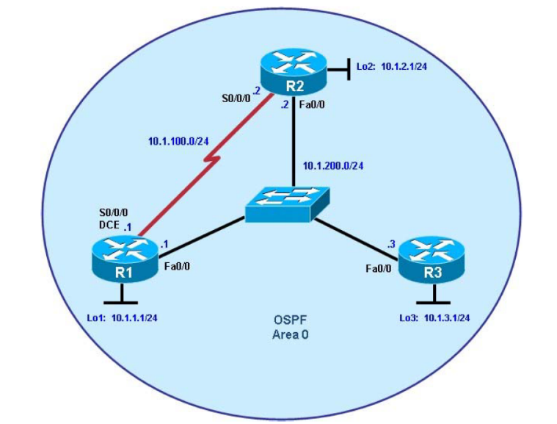
P 1 Single-Area OSPF Link Costs and Interface Priorities.
Objectives
• Configure single-area OSPF on a router.
• Advertise loopback interfaces into OSPF.
• Verify OSPF adjacencies.
• Verify OSPF routing information exchange.
• Modify OSPF link costs.
• Change interface priorities.

Step 1: Configure addressing and loopbacks.
R1
R1# configure terminal
R1(config)# interface Loopback1
R1(config-if)# description Engineering Department
R1(config-if)# ip address 10.1.1.1 255.255.255.0
R1(config-if)# exit

R1(config)# interface FastEthernet0/0
R1(config-if)# ip address 10.1.200.1 255.255.255.0
R1(config-if)# no shutdown
R1(config-if)# exit
R1(config)# interface Serial 0/0/0
R1(config-if)# ip address 10.1.100.1 255.255.255.0
R1(config-if)# clock rate 64000
R1(configif)# bandwidth 64
R1(config-if)# no shutdown
R2
R2# configure terminal
R2(config)# interface Loopback2
R2(config-if)# description Marketing Department
R2(config-if)# ip address 10.1.2.1 255.255.255.0
R2(config-if)# exit

R2(config)# interface FastEthernet0/0
R2(config-if)# ip address 10.1.200.2 255.255.255.0
R2(config-if)# no shutdown
R2(config-if)# exit

R2(config)# interface Serial 0/0/0
R2(config-if)# ip address 10.1.100.2 255.255.255.0
R2(config-if)# bandwidth 64
R2(config-if)# no shutdown

R3
R3# configure terminal
R3(config)# interface Loopback3
R3(config-if)# description Accounting Department
R3(config-if)# ip address 10.1.3.1 255.255.255.0
R3(config-if)# exit

R3(config)# interface FastEthernet0/0
R3(config-if)# ip address 10.1.200.3 255.255.255.0
R3(config-if)# no shutdown
R3(config-if)# exit

Step 2: Add physical interfaces to OSPF.
R1
R1(config)# router ospf 1
R1(config-router)# network 10.1.100.0 0.0.0.255 area 0
R1(config-router)# network 10.1.200.0 0.0.0.255 area 0
R1(config-router)# end

R2
R2(config)# router ospf 1
R2(config-router)# network 10.1.100.0 0.0.0.255 area 0
R2(config-router)# network 10.1.200.0 0.0.0.255 area 0

R3
R3(config)# router ospf 1
R3(config-router)# network 10.1.200.0 0.0.0.255 area 0

Step 3: Use OSPF show commands.
R1
R1# show ip protocols
R1# show ip ospf
R1# show ip ospf neighbor
R1# show ip ospf interface FastEthernet 0/0
R1# show ip ospf interface brief
R1# show ip ospf database

Step 4: Add loopback interfaces to OSPF.
R1# show ip route
R2# show ip route
R3# show ip route

R1
R1(config)# router ospf 1
R1(config-router)# network 10.1.1.0 0.0.0.255 area 0

R2
R2(config)# router ospf 1
R2(config-router)# network 10.1.2.0 0.0.0.255 area 0

R3
R3(config)# router ospf 1
R3(config-router)# network 10.1.3.0 0.0.0.255 area 0

R1# show ip route
R2# show ip route
R3# show ip route

R1
R1(config)# interface loopback1
R1(config-if)# ip ospf network point-to-point

R2
R2(config)# interface loopback2
R2(config-if)# ip ospf network point-to-point

R3
R3(config)# interface loopback3
R3(config-if)# ip ospf network point-to-point

Step 5: Modify OSPF link costs.
R1
R1(config)# interface FastEthernet 0/0
R1(config-if)# ip ospf cost 50

R2
R2(config)# interface FastEthernet 0/0
R2(config-if)# ip ospf cost 50

R3
R3(config)# interface FastEthernet 0/0
R3(config-if)# ip ospf cost 50

R1# show ip route

Step 6: Modify interface priorities to control the DR and BDR election.
R1
R1(config)# interface FastEthernet 0/0
R1(config-if)# ip ospf priority 10

R2
R2(config)# interface FastEthernet 0/0
R2(config-if)# ip ospf priority 5

R1
R1# show ip ospf neighbor detail
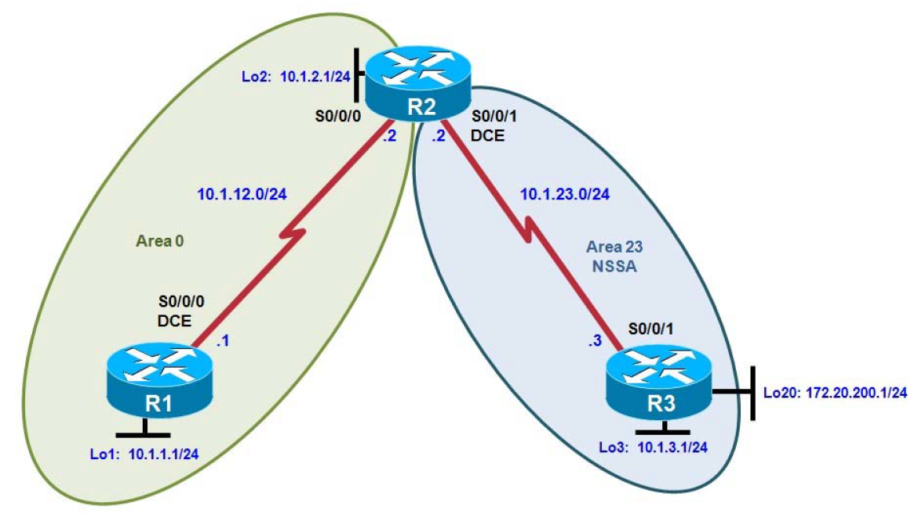
P 2 Multi-Area OSPF with Stub Areas and Authentication
Step 1: Configure addressing and loopbacks.

R1# configure terminal
Enter configuration commands, one per line. End with CNTL/Z.
R1(config)# interface loopback 1
R1(config-if)# description Engineering Department
R1(config-if)# ip address 10.1.1.1 255.255.255.0
R1(config-if)# interface serial 0/0/0
R1(config-if)# ip address 10.1.12.1 255.255.255.0
R1(config-if)# clockrate 64000
R1(config-if)# no shutdown

R2# configure terminal
Enter configuration commands, one per line. End with CNTL/Z.
R2(config)# interface loopback 2
R2(config-if)# description Marketing Department
R2(config-if)# ip address 10.1.2.1 255.255.255.0
R2(config-if)# interface serial 0/0/0
R2(config-if)# ip address 10.1.12.2 255.255.255.0
R2(config-if)# no shutdown
R2(config-if)# interface serial 0/0/1
R2(config-if)# ip address 10.1.23.2 255.255.255.0
R2(config-if)# clockrate 64000
R2(config-if)# no shutdown

R3# configure terminal
Enter configuration commands, one per line. End with CNTL/Z.
R3(config)# interface loopback 3
R3(config-if)# description Accounting Department
R3(config-if)# ip address 10.1.3.1 255.255.255.0
R3(config-if)# interface loopback 20
R3(config-if)# description Connection to another AS
R3(config-if)# ip address 172.20.200.1 255.255.255.0
R3(config-if)# interface serial 0/0/1
R3(config-if)# ip address 10.1.23.3 255.255.255.0
R3(config-if)# no shutdown

Step 2: Add interfaces into OSPF.

R1(config)# router ospf 1
R1(config-router)# network 10.1.12.0 0.0.0.255 area 0
R1(config-router)# network 10.1.1.0 0.0.0.255 area 0
R1(config-router)# exit
R1(config)# interface loopback 1
R1(config-if)# ip ospf network point-to-point

R2(config)# router ospf 1
R2(config-router)# network 10.1.12.0 0.0.0.255 area 0
R2(config-router)# network 10.1.2.0 0.0.0.255 area 0
R2(config-router)# exit
R2(config)# interface loopback 2
R2(config-if)# ip ospf network point-to-point

Add the subnet between R2 and R3 into OSPF area 23 using the network command. Add loopback 3 on
R3 into area 23.

R2(config)# router ospf 1
R2(config-router)# network 10.1.23.0 0.0.0.255 area 23

R3(config)# router ospf 1
R3(config-router)# network 10.1.23.0 0.0.0.255 area 23
R3(config-router)# network 10.1.3.0 0.0.0.255 area 23
R3(config-router)# exit
R3(config)# interface loopback 3
R3(config-if)# ip ospf network point-to-point

Step 3: Configure a stub area.

R2(config)# router ospf 1
R2(config-router)# area 23 stub

R3(config)# router ospf 1
R3(config-router)# area 23 stub

Step 4: Configure a totally stubby area.

R2(config)# router ospf 1
R2(config-router)# area 23 stub no-summary

Step 5: Configure OSPF interface authentication.

R2(config)# interface serial 0/0/1
R2(config-if)# ip ospf authentication
R2(config-if)# ip ospf authentication-key cisco

R3(config)# interface serial 0/0/1
R3(config-if)# ip ospf authentication
R3(config-if)# ip ospf authentication-key cisco

R1(config)# interface serial 0/0/0
R1(config-if)# ip ospf authentication message-digest
R1(config-if)# ip ospf message-digest-key 1 md5 cisco

R2(config)# interface serial 0/0/0
R2(config-if)# ip ospf authentication message-digest
R2(config-if)# ip ospf message-digest-key 1 md5 cisco
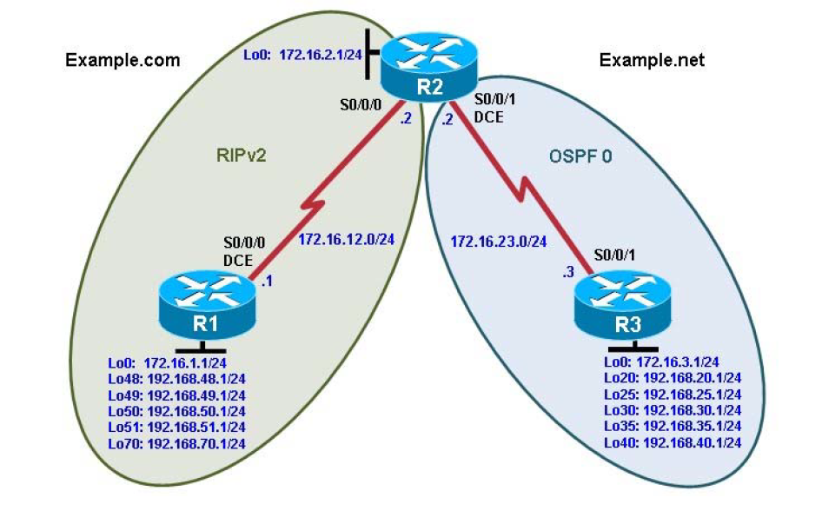
P 3 Redistribution Between RIP and OSPF
Step 1: Configure loopbacks and assign addresses.

R1(config)# interface Loopback0
R1(config-if)# ip address 172.16.1.1 255.255.255.0
R1(config-if)# interface Loopback48
R1(config-if)# ip address 192.168.48.1 255.255.255.0
R1(config-if)# interface Loopback49
R1(config-if)# ip address 192.168.49.1 255.255.255.0
R1(config-if)# interface Loopback50
R1(config-if)# ip address 192.168.50.1 255.255.255.0
R1(config-if)# interface Loopback51
R1(config-if)# ip address 192.168.51.1 255.255.255.0
R1(config-if)# interface Loopback70
R1(config-if)# ip address 192.168.70.1 255.255.255.0
R1(config-if)# interface Serial0/0/0
R1(config-if)# ip address 172.16.12.1 255.255.255.0
R1(config-if)# clock rate 64000
R1(config-if)# bandwidth 64
R1(config-if)# no shutdown

R2(config)# interface Loopback0
R2(config-if)# ip address 172.16.2.1 255.255.255.0
R2(config-if)# interface Serial0/0/0
R2(config-if)# ip address 172.16.12.2 255.255.255.0
R2(config-if)# bandwidth 64
R2(config-if)# no shutdown
R2(config-if)# interface Serial0/0/1
R2(config-if)# ip address 172.16.23.2 255.255.255.0
R2(config-if)# clock rate 64000
R2(config-if)# bandwidth 64
R2(config-if)# no shutdown

R3(config)# interface Loopback0
R3(config-if)# ip address 172.16.3.1 255.255.255.0
R3(config-if)# interface Loopback20
R3(config-if)# ip address 192.168.20.1 255.255.255.0
R3(config-if)# interface Loopback25
R3(config-if)# ip address 192.168.25.1 255.255.255.0
R3(config-if)# interface Loopback30
R3(config-if)# ip address 192.168.30.1 255.255.255.0
R3(config-if)# interface Loopback35
R3(config-if)# ip address 192.168.35.1 255.255.255.0
R3(config-if)# interface Loopback40
R3(config-if)# ip address 192.168.40.1 255.255.255.0
R3(config-if)# interface Serial0/0/1
R3(config-if)# ip address 172.16.23.3 255.255.255.0
R3(config-if)# bandwidth 64
R3(config-if)# no shutdown

Step 2: Configure RIPv2.

R1(config)# router rip
R1(config-router)# version 2
R1(config-router)# no auto-summary
R1(config-router)# network 172.16.0.0
R1(config-router)# network 192.168.48.0
R1(config-router)# network 192.168.49.0
R1(config-router)# network 192.168.50.0
R1(config-router)# network 192.168.51.0
R1(config-router)# network 192.168.70.0

R2(config)# router rip
R2(config-router)# version 2
R2(config-router)# no auto-summary
R2(config-router)# network 172.16.0.0

R1# show ip route rip
R2# show ip route rip

Step 3: Configure passive interfaces in RIP.

R1# show ip route rip
R2(config)# router rip
R2(config-router)# passive-interface serial 0/0/1
R2# show ip protocols

R1(config)# router rip
R1(config-router)# passive-interface loopback 0
R1(config-router)# passive-interface loopback 48
R1(config-router)# passive-interface loopback 49
R1(config-router)# passive-interface loopback 50
R1(config-router)# passive-interface loopback 51
R1(config-router)# passive-interface loopback 70
R2(config)# router rip
R2(config-router)# passive-interface loopback 0

Step 4: Summarize a supernet with RIP.

R2# show ip route rip
R1(config)# ip route 192.168.48.0 255.255.252.0 null0
R1(config)# router rip
R1(config-router)# redistribute static
R1# show ip route
R2# show ip route

Step 5: Suppress routes using prefix lists.

R1(config)# ip prefix-list RIP-OUT permit 192.168.48.0/22
R1(config)# ip prefix-list RIP-OUT deny 192.168.48.0/22 le 24
R1(config)# ip prefix-list RIP-OUT permit 0.0.0.0/0 le 32

R1(config)# router rip
R1(config-router)# distribute-list prefix RIP-OUT out serial0/0/0

R2# show ip route rip
R2# show ip rip database

Step 6: Configure OSPF.

R2(config)# router ospf 1
R2(config-router)# network 172.16.23.0 0.0.0.255 area 0
R3(config)# router ospf 1
R3(config-router)# network 172.16.0.0 0.0.255.255 area 0
R3(config-router)# network 192.168.0.0 0.0.255.255 area 0

R3(config)# interface Loopback0
R3(config-if)# ip ospf network point-to-point
R3(config-if)# interface Loopback20
R3(config-if)# ip ospf network point-to-point
R3(config-if)# nterface Loopback25
R3(config-if)# ip ospf network point-to-point
R3(config-if)# interface Loopback30
R3(config-if)# ip ospf network point-to-point
R3(config-if)# interface Loopback35
R3(config-if)# ip ospf network point-to-point
R3(config-if)# interface Loopback40
R3(config-if)# ip ospf network point-to-point

R3# show ip ospf neighbor
R2# show ip route ospf
R3# show ip route ospf

Step 7: Configure passive interfaces in OSPF.

R3(config)# router ospf 1
R3(config-router)# passive-interface default
R3(config-router)# no passive-interface serial 0/0/1
R3# how ip protocols

Step 8: Allow one-way redistribution.

R2(config)# router rip
R2(config-router)# redistribute ospf 1 metric 4
R2# show ip protocols
R1# show ip route rip
R1# ping 192.168.30.1
R1# traceroute 192.168.30.1
R2(config)# router ospf 1
R2(config-router)# default-information originate always

Step 9: Redistribute between two routing protocols.

R2(config)# router ospf 1
R2(config-router)# no default-information originate always
R2(config-router)# redistribute rip
R3# show ip route ospf
R2(config)# router ospf 1
R2(config-router)# redistribute rip subnets
R3# show ip route ospf
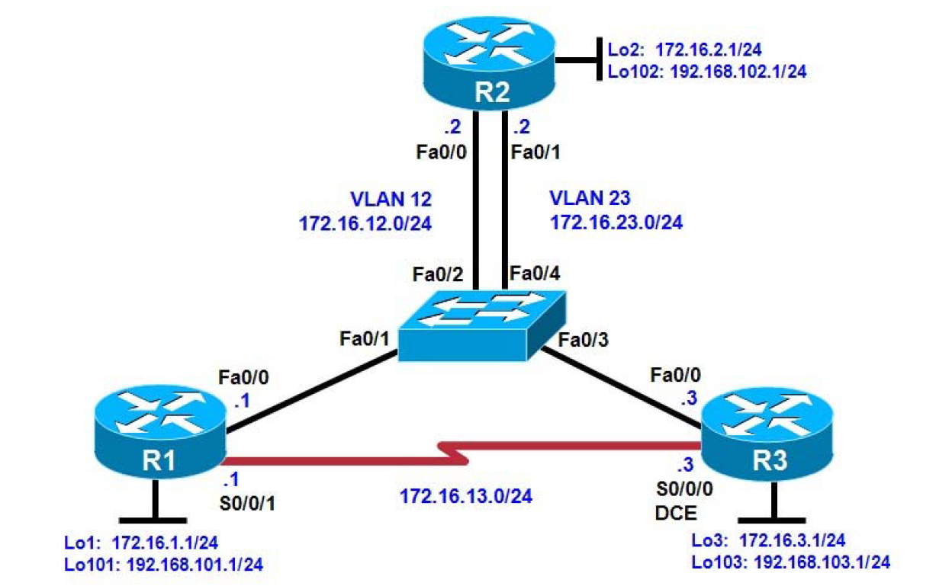
P 4 Manipulating Administrative Distances
Step 1: Configure router loopbacks and addressing.

R1# conf t
R1(config)# interface loopback 1
R1(config-if)# ip address 172.16.1.1 255.255.255.0
R1(config-if)# interface loopback 101
R1(config-if)# ip address 192.168.101.1 255.255.255.0
R1(config-if)# interface fastethernet 0/0
R1(config-if)# ip address 172.16.12.1 255.255.255.0
R1(config-if)# no shutdown
R1(config-if)# interface serial 0/0/1
R1(config-if)# bandwidth 64
R1(config-if)# ip address 172.16.13.1 255.255.255.0
R1(config-if)# no shutdown

R2# conf t
R2(config)# interface loopback 2
R2(config-if)# ip address 172.16.2.1 255.255.255.0 R2(configif)#
interface loopback 102
R2(config-if)# ip address 192.168.102.1 255.255.255.0
R2(config-if)# interface fastethernet 0/0
R2(config-if)# ip address 172.16.12.2 255.255.255.0
R2(config-if)# no shutdown
R2(config-if)# interface fastethernet 0/1
R2(config-if)# ip address 172.16.23.2 255.255.255.0
R2(config-if)# no shutdown

R3# conf t
R3(config)# interface loopback 3
R3(config-if)# ip address 172.16.3.1 255.255.255.0
R3(config-if)# interface loopback 103
R3(config-if)# ip address 192.168.103.1 255.255.255.0
R3(config-if)# interface fastethernet 0/0
R3(config-if)# ip address 172.16.23.3 255.255.255.0
R3(config-if)# no shutdown
R3(config-if)# interface serial 0/0/0
R3(config-if)# bandwidth 64
R3(config-if)# ip address 172.16.13.3 255.255.255.0
R3(config-if)# clock rate 64000
R3(config-if)# no shutdown

Step 2: Configure switch VLANs.

Switch(config)# vlan 12
Switch(config-vlan)# name R1-R2
Switch(config-vlan)# vlan 23
Switch(config-vlan)# name R2-R3
Switch(config-vlan)# exit

Switch(config)# interface fastEthernet 0/1
Switch(config-if)# description To R1 Fa0/0
Switch(config-if)# switchport mode access
Switch(config-if)# switchport access vlan 12
Switch(config-if)# interface fastEthernet 0/2
Switch(configif)# description To R2 Fa0/0
Switch(config-if)# switchport mode access
Switch(config-if)# switchport access vlan 12

Switch(config-if)# interface fastEthernet 0/3
Switch(configif)# description To R3 Fa0/0
Switch(config-if)# switchport mode access
Switch(config-if)# switchport access vlan 23
Switch(config-if)# interface fastEthernet 0/4
Switch(configif)# description To R2 Fa0/1
Switch(config-if)# switchport mode access
Switch(config-if)# switchport access vlan 23

Step 3: Configure RIP.

R1(config)# router rip
R1(config-router)# version 2
R1(config-router)# no auto-summary
R1(config-router)# network 172.16.0.0
R1(config-router)# network 192.168.101.0

R2(config)# router rip
R2(config-router)# version 2
R2(config-router)# no auto-summary
R2(config-router)# network 172.16.0.0
R2(config-router)# network 192.168.102.0

R3(config)# router rip
R3(config-router)# version 2
R3(config-router)# no auto-summary
R3(config-router)# network 172.16.0.0
R3(config-router)# network 192.168.103.0

R1# show ip route rip
R2# show ip route rip
R3# show ip route rip

Step 4: Configure OSPF.

R1(config)# interface loopback 1
R1(config-if)# ip ospf network point-to-point
R1(config-if)# interface loopback 101
R1(config-if)# ip ospf network point-to-point
R1(config-if)# router ospf 1
R1(config-router)# network 172.16.0.0 0.0.255.255 area 0
R1(config-router)# network 192.168.101.0 0.0.0.255 area 0

R2(config)# interface loopback 2
R2(config-if)# ip ospf network point-to-point
R2(config-if)# interface loopback 102
R2(config-if)# ip ospf network point-to-point
R2(config-if)# router ospf 1
R2(config-router)# network 172.16.0.0 0.0.255.255 area 0
R2(config-router)# network 192.168.102.0 0.0.0.255 area 0

R3(config)# interface loopback 3
R3(config-if)# ip ospf network point-to-point
R3(config-if)# interface loopback 103
R3(config-if)# ip ospf network point-to-point
R3(config-if)# router ospf 1
R3(config-router)# network 172.16.0.0 0.0.255.255 area 0
R3(config-router)# network 192.168.103.0 0.0.0.255 area 0

R1# show ip ospf neighbor
R1# show ip route

R2# show ip ospf neighbor
R2# show ip route

R3# show ip ospf neighbor
R3# show ip route

Step 5: Modify the routing protocol distance.

R1(config)# router rip
R1(config-router)# distance 100

R2(config)# router rip
R2(config-router)# distance 100

R3(config)# router rip
R3(config-router)# distance 100

R1# show ip route
R2# show ip route
R3# show ip route

R1# show ip protocols

Step 6: Modify distance based on route source.

R1(config)# router ospf 1
R1(config-router)# distance 85 192.168.100.0 0.0.3.255

R2(config)# router ospf 1
R2(config-router)# distance 85 192.168.100.0 0.0.3.255

R3(config)# router ospf 1
R3(config-router)# distance 85 192.168.100.0 0.0.3.255

R1# show ip route
R2# show ip route
R3# show ip route

R1# show ip protocols

Step 7: Modify distance based on an access list.

R1(config)# access-list 1 permit 172.16.0.0 0.0.255.255
R1(config)# router rip
R1(config-router)# distance 65 0.0.0.0 255.255.255.255 1

R2(config)# access-list 1 permit 172.16.0.0 0.0.255.255
R2(config)# router rip
R2(config-router)# distance 65 0.0.0.0 255.255.255.255 1

R3(config)# access-list 1 permit 172.16.0.0 0.0.255.255
R3(config)# router rip
R3(config-router)# distance 65 0.0.0.0 255.255.255.255 1

R1# show ip protocols
R1# show ip route

R2# show ip protocols
R2# show ip route

R3# show ip protocols
R3# show ip route
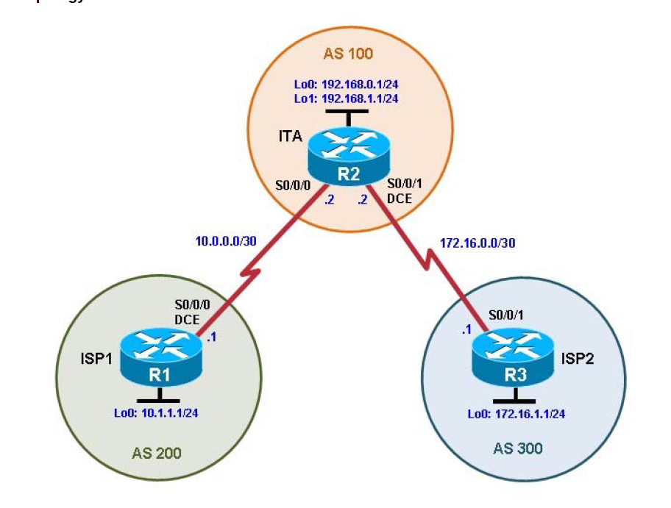
P 5 Configuring BGP with Default Routing

Step 1: Configure the hostname and interface addresses.

Router R1 (hostname ISP1) hostname ISP1
interface Lo0
description ISP1 Internet Network
ip address 10.1.1.1 255.255.255.0
interface Serial0/0/0
description ISP1 -> ITA
ip address 10.0.0.1 255.255.255.252
clock rate 128000
no shutdown
end

Router R2 (hostname ITA)
hostname ITA
interface Lo0
description Core router network link 1
ip address 192.168.0.1 255.255.255.0 !

interface Lo1
description Core router network link 2
ip address 192.168.1.1 255.255.255.0
interface Serial0/0/0
description ITA -> ISP1
ip address 10.0.0.2 255.255.255.252
no shutdown

interface Serial0/0/1
description ITA -> ISP2
ip address 172.16.0.2 255.255.255.252
clock rate 128000
no shutdown
end

Router R3 (hostname ISP2)
hostname ISP2
interface Lo0
description ISP2 Internet Network
ip address 172.16.1.1 255.255.255.0

interface Serial0/0/1
description ISP2 -> ITA
ip address 172.16.0.1 255.255.255.252
no shutdown
end

Step 2: Configure BGP on the ISP routers.

ISP1(config)# router bgp 200
ISP1(config-router)# neighbor 10.0.0.2 remote-as 100
ISP1(config-router)# network 10.1.1.0 mask 255.255.255.0

ISP2(config)# router bgp 300
ISP2(config-router)# neighbor 172.16.0.2 remote-as 100
ISP2(config-router)# network 172.16.1.0 mask 255.255.255.0

Step 3: Configure BGP on the ITA boundary router.

ITA(config)# router bgp 100
ITA(config-router)# neighbor 10.0.0.1 remote-as 200
ITA(config-router)# neighbor 172.16.0.1 remote-as 300
ITA(config-router)# network 192.168.0.0
ITA(config-router)# network 192.168.1.0

ITA# show ip route

Step 4: Verify BGP on the routers.

ITA# show ip bgp
ISP1# show ip bgp
ITA# show ip bgp neighbors

Step 5: Configure route filters.

ISP2# show ip rout

ITA(config)# access-list 1 permit 192.168.0.0 0.0.1.255
ITA# clear ip bgp *

ISP2# show ip route

ISP1# show ip route

Step 6: Configure primary and backup routes using floating static routes.

ITA# show ip route
ITA(config)# ip route 0.0.0.0 0.0.0.0 10.0.0.1 210
ITA(config)# ip route 0.0.0.0 0.0.0.0 172.16.0.1 220
ITA# show ip route

ISP1# config t
ISP1(config)# interface loopback 100
ISP1(config-if)# ip address 192.168.100.1 255.255.255.0

ITA# show ip route
ITA# ping
ITA# ping 192.168.100.1 source 192.168.1.1

Step 7: Configure primary and backup routes using a default network and a static route.

ITA(config)# no ip route 0.0.0.0 0.0.0.0 10.0.0.1 210
ITA(config)# no ip route 0.0.0.0 0.0.0.0 172.16.0.1 220

ISP1(config)# router bgp 200
ISP1(config-router)# network 192.168.100.0
ISP1(config-router)# end

ITA# show ip route
ITA(config)# ip default-network 192.168.100.0
ITA# show ip route
ITA(config)# ip route 0.0.0.0 0.0.0.0 172.16.0.1 220
ITA# show ip route
ITA# clear ip bgp 10.0.0.1
ITA# show ip route

P6 - Configuring OSPF for IPv6
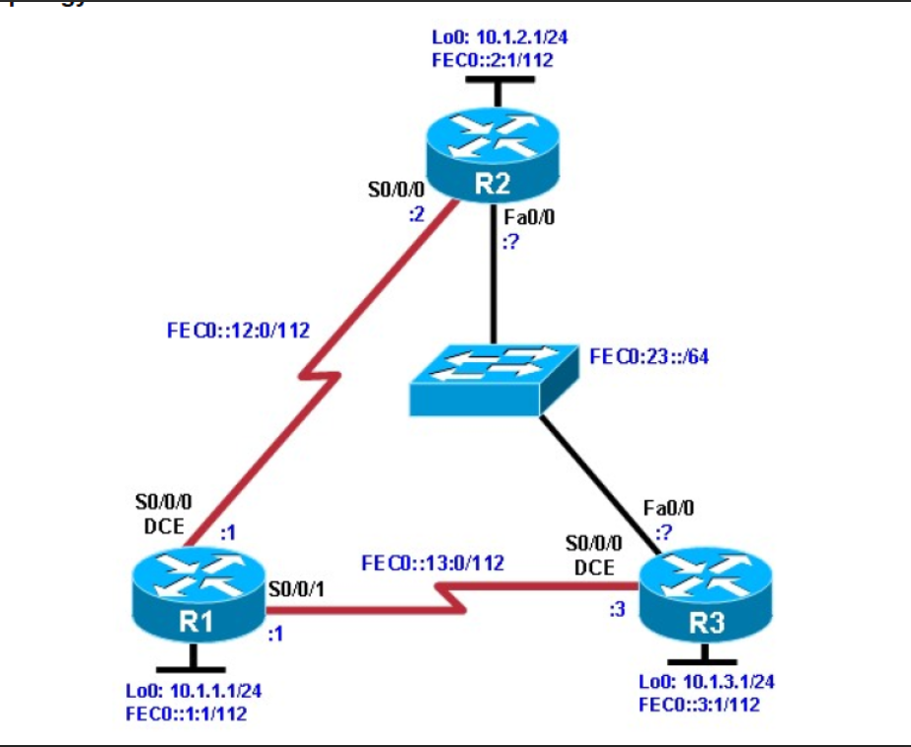
P6 - Configuring OSPF for IPv6
Step 2: Configuring the hostname and loopback interfaces.

Router(config)# hostname R1
R1(config)# interface loopback0
R1(config-if)# ip address 10.1.1.1 255.255.255.0 \
R1(config-if)# ipv6 address FEC0::1:1/112

Router(config)# hostname R2
R2(config)# interface loopback0
R2(config-if)# ip address 10.1.2.1 255.255.255.0
R2(config-if)# ipv6 address FEC0::2:1/112

Router(config)# hostname R3
R3(config)# interface loopback0
R3(config-if)# ip address 10.1.3.1 255.255.255.0
R3(config-if)# ipv6 address FEC0::3:1/112

Step 3: Configure static IPv6 addresses.

R1(config)# interface serial0/0/0
R1(config-if)# ipv6 address FEC0::12:1/112
R1(config-if)# clockrate 64000
R1(config-if)# bandwidth 64
R1(config-if)# no shutdown
R1(config-if)# interface serial0/0/1
R1(config-if)# ipv6 address FEC0::13:1/112
R1(config-if)# bandwidth 64
R1(config-if)# no shutdown

R2(config)# interface serial0/0/0
R2(config-if)# ipv6 address FEC0::12:2/112
R2(config-if)# bandwidth 64
R2(config-if)# no shutdown

R3(config)# interface serial0/0/0
R3(config-if)# ipv6 address FEC0::13:3/112
R3(config-if)# clockrate 64000
R3(config-if)# bandwidth 64
R3(config-if)# no shutdown

R1# ping FEC0::12:2
R1# ping FEC0::13:3

R2# ping FEC0::12:1

R3# ping FEC0::13:1

Step 4: Change the link-local address on an interface.

R1# show ipv6 interface serial 0/0/0

R2# show ipv6 interface serial 0/0/0

R1(config)# interface serial0/0/0
R1(config-if)# ipv6 address FE80::1 link-local

R2(config)# interface serial0/0/0
R2(config-if)# ipv6 address FE80::2 link-local

R1# ping FE80::2
R2# ping FE80::1

R1# show ipv6 interface serial 0/0/0

R2# show ipv6 interface serial 0/0/0

Step 5: Configure EUI-64 addresses.

R2(config)# interface fastEthernet 0/0
R2(config-if)# ipv6 address FEC0:23::/64 eui-64
R2(config-if)# no shutdown

R3(config)# interface fastEthernet 0/0
R3(config-if)# ipv6 address FEC0:23::/64 eui-64
R3(config-if)# no shutdown

R2# show ipv6 interface fastEthernet 0/0
R2# show ipv6 interface brief
R2# ping FEC0:23::218:B9FF:FECD:BEF0

R3# ping FEC0:23::218:B9FF:FE92:28D8

Step 6: Enable IPv6 routing and CEF.

R1(config)# ipv6 unicast-routing
R1(config)# ipv6 cef

R2(config)# ipv6 unicast-routing
R2(config)# ipv6 cef

R3(config)# ipv6 unicast-routing
R3(config)# ipv6 cef

7: Configure OSPFv3.

R1(config)# interface loopback0
R1(config-if)# ipv6 ospf 1 area 0
R1(config-if)# interface serial0/0/0
R1(config-if)# ipv6 ospf 1 area 0
R1(config-if)# interface serial0/0/1
R1(config-if)# ipv6 ospf 1 area 0

R2(config)# interface loopback0
R2(config-if)# ipv6 ospf 1 area 0
R2(config-if)# interface serial0/0/0
R2(config-if)# ipv6 ospf 1 area 0
R2(config-if)# interface fastEthernet 0/0
R2(config-if)# ipv6 ospf 1 area 0

R3(config)# interface loopback0
R3(config-if)# ipv6 ospf 1 area 0
R3(config-if)# interface serial0/0/0
R3(config-if)# ipv6 ospf 1 area 0
R3(config-if)# interface fastEthernet 0/0
R3(config-if)# ipv6 ospf 1 area 0

R1# show ipv6 ospf neighbor
R2# show ipv6 ospf neighbor
R3# show ipv6 ospf neighbor

R1# show ipv6 route
R2# show ipv6 route
R3# show ipv6 route

P7 – Configuring Ether Channel
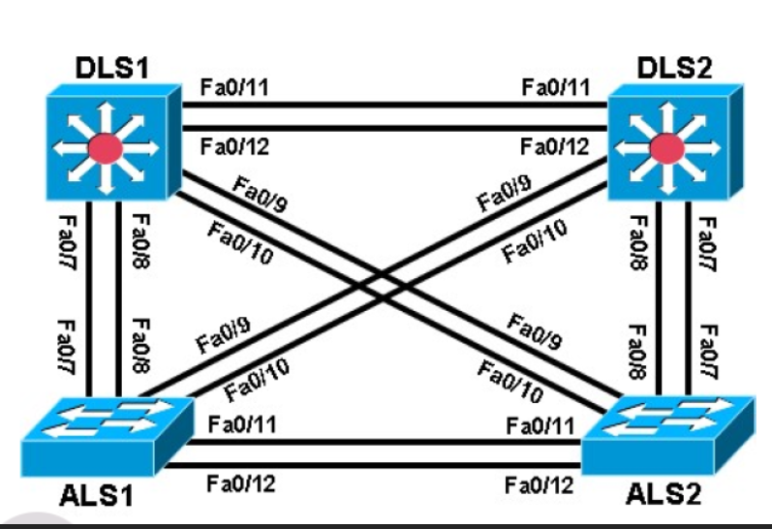

Step 1: Prepare the switches for the lab and Configure basic switch parameters.

DLS1# configure terminal
Enter configuration commands, one per line. End with CNTL/Z.
DLS1(config)# interface range fastEthernet 0/7 - 12
DLS1(config-if-range)# switchport trunk encapsulation dot1q
DLS1(config-if-range)# switchport mode trunk

Step 3: Configure an EtherChannel with Cisco PAgP.

ALS1# show interfaces trunk
ALS1(config)# interface range fastEthernet 0/11 - 12
ALS1(config-if-range)# channel-group 1 mode desirable
Creating a port-channel interface Port-channel 1
ALS1(config)# interface port-channel 1
ALS1(config-if)# switchport mode trunk
ALS1# show etherchannel summary

ALS2(config)# interface range fastEthernet 0/11 - 12
ALS2(config-if-range)# channel-group 1 mode desirable
Creating a port-channel interface Port-channel 1
ALS2(config)# interface port-channel 1
ALS2(config-if)# switchport mode trunk
ALS2# show etherchannel summary

ALS1# show interfaces trunk
ALS1# show spanning-tree

Step 4: Configure an 802.3ad LACP EtherChannel.

ALS1(config)# interface range fastEthernet 0/7 - 8
ALS1(config-if-range)# channel-group 2 mode active
Creating a port-channel interface Port-channel 2
ALS1(config-if-range)# interface port-channel 2
ALS1(config-if)# switchport mode trunk
ALS1# show etherchannel summary

Step 5: Configure a Layer 3 EtherChannel.

DLS1(config)# interface range fastEthernet 0/11 - 12
DLS1(config-if-range)# no switchport
DLS1(config-if-range)# channel-group 3 mode desirable
Creating a port-channel interface Port-channel 3
DLS1(config-if-range)# interface port-channel 3
DLS1(config-if)# no switchport
DLS1(config-if)# ip address 10.0.0.1 255.255.255.0

DLS2(config)# interface range fastEthernet 0/11 - 12
DLS2(config-if-range)# no switchport
DLS2(config-if-range)# channel-group 3 mode desirable
Creating a port-channel interface Port-channel 3
DLS2(config-if-range)# interface port-channel 3
DLS2(config-if)# no switchport
DLS2(config-if)# ip address 10.0.0.2 255.255.255.0

DLS1# ping 10.0.0.2
DLS1# show etherchannel summary

Step 6: Configure load balancing.

DLS1# show etherchannel load-balance
EtherChannel Load-Balancing Operational State (src-mac):
Non-IP: Source MAC address
IPv4: Source MAC address
IPv6: Source IP address

ALS1(config)# port-channel load-balance src-dst-mac
ALS1# show etherchannel load-balance
EtherChannel Load-Balancing Operational State (src-dst-mac):
Non-IP: Source XOR Destination MAC address
IPv4: Source XOR Destination MAC address
IPv6: Source XOR Destination IP address

P8 - Inter-VLAN Routing with an External Router
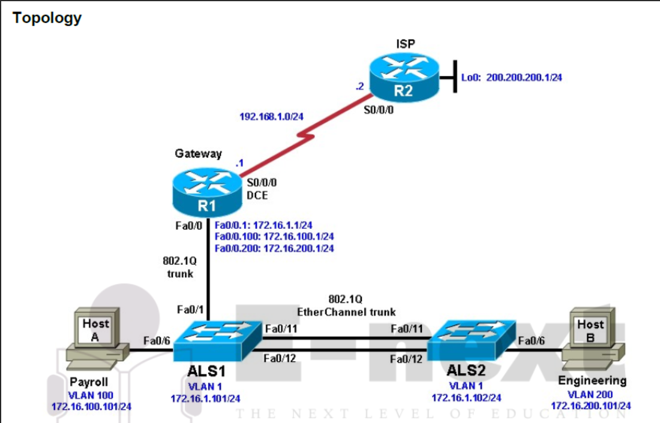
Required Resources
• 2 routers (Cisco 1841 with Cisco IOS Release 12.4(24)T1 Advanced IP Services or comparable)
• 2 switches (Cisco 2960 with the Cisco IOS Release 12.2(46)SE C2960-LANBASEK9-M image or comparable)

Step 3: Configure the routers.

Router(config)# hostname ISP
ISP(config)# interface Loopback0
ISP(config-if)# ip address 200.200.200.1 255.255.255.0
ISP(config-if)# interface Serial0/0/0
ISP(config-if)# ip address 192.168.1.2 255.255.255.0
ISP(configif)# no shutdown
ISP(config-if)# exit
ISP(config)# ip route 172.16.0.0 255.255.0.0 192.168.1.1

Router(config)# hostname Gateway
Gateway(config)# interface Serial0/0/0
Gateway(config-if)# ip address 192.168.1.1 255.255.255.0
Gateway(config-if)# clockrate 64000
Gateway(config-if)# no shutdown
Gateway(config-if)# exit
Gateway(config)# ip route 0.0.0.0 0.0.0.0 192.168.1.2

Step 4: Configure the switches.

Switch(config)# hostname ALS1
ALS1(config)# interface vlan 1
ALS1(config-if)# ip address 172.16.1.101 255.255.255.0
ALS1(config-if)# no shutdown
ALS1(config-if)# exit
ALS1(config)# ip default-gateway 172.16.1.1

Switch(config)# hostname ALS2
ALS2(config)# interface vlan 1
ALS2(config-if)# ip address 172.16.1.102 255.255.255.0
ALS2(config-if)# no shutdown
ALS2(config-if)# exit
ALS2(config)# ip default-gateway 172.16.1.1

ALS1(config)# enable secret cisco
ALS1(config)# line vty 0 15
ALS1(config-line)# password cisco
ALS1(config-line)# login
ALS1(config-line)# end
ALS2(config)# enable secret cisco
ALS2(config)# line vty 0 15
ALS2(config-line)# password cisco
ALS2(config-line)# login
ALS2(config-line)# end

Step 5: Confirm the VLANs.

ALS1# show vlan

Step 6: Configure trunk links and EtherChannel on switches.

ALS1# configure terminal
Enter configuration commands, one per line. End with CNTL/Z.
ALS1(config)# interface range fastEthernet 0/11 - 12
ALS1(config-if-range)# switchport mode trunk
ALS1(config-if-range)# channel-group 1 mode desirable
ALS1(config-if-range)# end

ALS2# configure terminal
Enter configuration commands, one per line. End with CNTL/Z.
ALS2(config)# interface range fastEthernet 0/11 - 12
ALS2(config-if-range)# switchport mode trunk
ALS2(config-if-range)# channel-group 1 mode desirable
ALS2(config-if-range)# end

ALS1# show etherchannel 1 summary

Step 7: Configure VTP.

ALS2(config)# vtp mode client
Setting device to VTP CLIENT mode.

ALS1(config)# vtp domain SWLAB
Changing VTP domain name from NULL to SWLAB
%SW_VLAN-6-VTP_DOMAIN_NAME_CHG: VTP domain name changed to SWLAB.

ALS1(config)# vtp version 2
ALS1# show vtp status

ALS2# show vtp status

ALS1(config)# vlan 100
ALS1(config-vlan)# name Payroll
ALS1(config-vlan)# vlan 200
ALS1(config-vlan)# name Engineering

ALS2# show vlan brief

ALS1(config)# interface fastEthernet 0/6
ALS1(config-if)# switchport mode access
ALS1(config-if)# switchport access vlan 100
ALS1(config-if)# spanning-tree portfast

ALS2(config)# interface fastEthernet 0/6
ALS2(config-if)# switchport mode access
ALS2(config-if)# switchport access vlan 200
ALS2(config-if)# spanning-tree portfast

ALS1# show vlan brief

ALS2# show vlan brief

ALS1(config)# interface fastEthernet 0/1
ALS1(config-if)# switchport mode trunk
ALS1(config-if)# end

Step 10: Configure the Gateway router Fast Ethernet interface for VLAN trunking.

Gateway(config)# interface fastEthernet 0/0
Gateway(config-if)# no shut
The following is a sample configuration for the VLAN 1 subinterface.
Gateway(config)# interface fastEthernet 0/0.1
Gateway(config-subif)# description Management VLAN 1
Gateway(config-subif)# encapsulation dot1q 1 native
Gateway(config-subif)# ip address 172.16.1.1 255.255.255.0

Gateway(config-subif)# interface fastEthernet 0/0.100
Gateway(config-subif)# description Payroll VLAN 100
Gateway(config-subif)# encapsulation dot1q 100
Gateway(config-subif)# ip address 172.16.100.1 255.255.255.0

Gateway(config-subif)# interface fastEthernet 0/0.200
Gateway(config-subif)# description Engineering VLAN 200
Gateway(config-subif)# encapsulation dot1q 200
Gateway(config-subif)# ip address 172.16.200.1 255.255.255.0
Gateway(configsubif)# end
Gateway# show ip interface brief
Gateway# show interfaces description
Gateway# show vlans

P9 – Modifying Default Spanning Tree
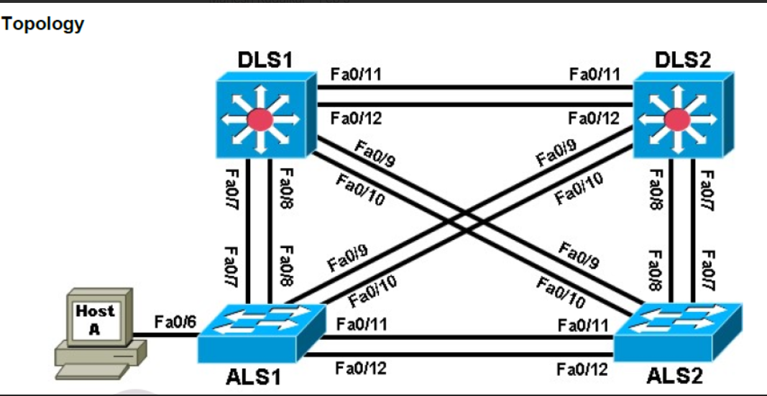
Required Resources
• 2 switches (Cisco 2960 with the Cisco IOS Release 12.2(46)SE C2960-LANBASEK9-M image or
comparable)
• 2 switches (Cisco 3560 with the Cisco IOS Release 12.2(46)SE C3560-ADVIPSERVICESK9-M
image or comparable)
• 1 PC (optional) attached to switch ALS1.

Step 1: Prepare the switches for the lab.

DLS1(config)# interface range fastEthernet 0/7 - 12
DLS1(config-if-range)# switchport trunk encapsulation dot1q
DLS1(config-if-range)# switchport mode trunk

Step 2: Display default spanning tree information for all switches.

DLS1# show spanning-tree
DLS2# show spanning-tree
ALS1# show spanning-tree
ALS2# show spanning-tree

Switch# show spanning-tree
Switch# conf t
Switch(config)# interface range fastEthernet 0/1-24
Switch(config-if-range)# no shutdown
Switch(config-if-range)# end
Switch# show spanning-tree
DSL1# show interfaces trunk

Step 3: Configure specific switches to be primary and secondary root.

DLS2# debug spanning-tree events
Spanning Tree event debugging is on

DLS1(config)# spanning-tree vlan 1 root primary
ALS1(config)# spanning-tree vlan 1 root secondary
DLS1# show run | include span spanning-tree mode pvst
ALS1# show run | include span
DLS1# show spanning-tree

Step 4: Change the root port using the spanning-tree port-priority command.

DLS2# show spanning-tree
DLS1# show spanning-tree
DLS1(config)# int fastEthernet 0/12
DLS1(config-if)# spanning-tree port-priority 112
DLS2# show spanning-tree
DLS1# show spanning-tree

Step 5: Configure PortFast on an access port.
ALS1(config)# interface fastEthernet 0/6
ALS1(config-if)# shutdown
ALS1# debug spanning-tree events

ALS1(config)# interface fastEthernet 0/6
ALS1(config-if)# switchport mode access
ALS1(config-if)# no shut
ALS1(config-if)# end

ALS1(config)# interface fastEthernet 0/6
ALS1(config-if)# shutdown
ALS1(config)# interface fastEthernet 0/6
ALS1(config-if)# spanning-tree portfast
ALS1(config-if)# no shutdown
ALS1(config-if)# end
ALS1# undebug all

Step 6: Change root port using the spanning-tree cost command.

ALS2# show spanning-tree
ALS2(config)# interface fastEthernet 0/10
ALS2(config-if-range)# spanning-tree cost 10
ALS2# show spanning-tree
P 9 Modifying Default Spanning Tree.txt
Displaying P 9 Modifying Default Spanning Tree.txt.

