D.Y. PATIL COLLEGE OF ENGINEERING & TECHNOLOGY, KASABA BAWADA, KOLHAPUR
DEPARTMENT OF COMPUTER SCIENCE & ENGINEERING
(Academic Year: 2026-27)

A
Case Study on
"Ghost Data Still Exists: Autonomous AI Deletion Audit Agent"
Submitted By:  Onkar Ravaso Gaste Roll No: 74 | Under the Guidance of:  Mr.S.S Kore
Class: TY (CSE) Div.: A Batch: A3 | Year 2026-27

CERTIFICATE
This is to certify that Onkar Ravaso Gaste (Roll No: 74, Div: A) has successfully completed the term work for Introduction to AI entitled "Ghost Data Still Exists: Autonomous AI Deletion Audit Agent", towards the partial fulfillment of T.Y. (CSE) Sem V during the academic year 2026-27.
Project Guide HOD Principal
Department of Computer Science and Engineering
D. Y. Patil College of Engineering & Technology, Kolhapur
2026-27

DECLARATION
I hereby declare that the dissertation work report entitled "Ghost Data Still Exists: Autonomous AI
Deletion Audit Agent" which is being submitted to D.Y. Patil College of Engineering and Technology, Kolhapur, in partial fulfillment of TY CSE Introduction to AI course, is a bonafide report of the work carried out by me. The material contained in this report has not been submitted to any university or institution for the award of any degree.
Place: Kolhapur.
Date:
Onkar Ravaso Gaste Mr. S. S. Kore
ACKNOWLEDGEMENT
I express my sincere thanks to Mr.S.S Kore Computer Science and engineering Dept whose supervision, inspiration and valuable guidance helped me a lot to complete my AI Project. His guidance proved to be the most valuable to overcome all the hurdles in the fulfillment of this Project Report.
I also express my sincere thanks to Dr.R.J.Dhanal, Head of computer science department and Dr. Prof. Sanjay S. Pawar, Principal of D.Y. Patil College of Engineering & Technology Kolhapur. Last but not least, this acknowledgement would be incomplete without rendering our sincere gratitude to all those who have helped us in the completion of IAI Project.
Finally, I express my deep sense of gratitude to my parents & family members, who are the chief source of my inspiration.
Sincerely,
Onkar Ravaso Gaste
TY CSE (Div A, Roll No: 74) — IAI Project
INDEX
Title / Content Page No
Chapter 1: INTRODUCTION 6
1.1 Introduction 6
1.2 Technology 6
1.3 Motivation 7
Chapter-2: PROBLEM STATEMENT 9
2.1 Need of Work 9
2.2 Problem Statement 9
2.3 Objectives 10
Chapter 3: DESIGN DETAILS 11
3.1 System Architecture 11
3.2 System Design Diagrams 12
Chapter 4: IMPLEMENTATION 14
4.1 Module Information 14
Chapter 5: EXPERIMENTAL RESULTS 17
5.1 Screenshots & Case Studies 17
Chapter 6: CONCLUSION 22
6.1 Conclusion 22
6.2 Future Scope 22
Chapter 7: REFERENCES 23

Chapter 1: INTRODUCTION

1.1 Introduction
The Global E-Commerce Data Deletion Reality: In modern distributed e-commerce platforms, customer account deletion requests are governed by stringent regulatory frameworks such as the European Union's General Data Protection Regulation (GDPR Article 17: Right to Erasure / Right to be Forgotten), California Consumer Privacy Act (CCPA), and India's Digital Personal Data Protection Act (DPDP Act, 2023). However, enterprise platforms operate across dozens of decoupled microservices, regional read replicas across disparate cloud availability zones, customer support ticketing platforms, internal search clusters, analytics pipelines, and automated disaster-recovery backup stores.
The Emergence of Ghost Data: When an end user submits an account erasure request, internal administrative dashboards frequently mark the ticket as 'Complete' after merely dropping the record from the primary customer database. In reality, personal data persists as 'ghost data' within secondary search indexes, asynchronous regional read-replicas, customer support attachments, and automated backup snapshots. Weeks or months later, background ETL synchronization pipelines extract this surviving ghost data and quietly resurrect the deleted customer records into production databases.
Overview of the AI Deletion Audit Agent: The AI Deletion Audit Agent represents an enterprise-grade forensic software inspector engineered to autonomously prove whether customer personal data has been completely, irreversibly, and verifiably eradicated across all distributed services before another compliance catastrophe occurs. Unlike traditional monitoring scripts that rely on superficial self-reported API statuses, the agent treats all claimed statuses as unproven hypotheses and independently audits physical SQL snapshots, logs, and document evidence.

1.2 Technology
The technological architecture of the AI Deletion Audit Agent is engineered to achieve deterministic sub-millisecond graph resolution, high-concurrency stream processing, multimodal document parsing, and zero data leakage. The core technologies include:
- Python Core & Data Manipulation (Pandas): The core agent engine is implemented in Python, utilizing vectorized Pandas dataframes and hash sets for high-throughput relational joins across identity ledgers and operational activity streams.
- In-Memory Bidirectional Identity Graph: Resolves complex historical identity evolution (past emails, old phone numbers, and SHA-256 password hashes) into canonical root user_ids with sub-2 millisecond memory retrieval.
- In-Memory SQLite Snapshot Query Engine: To audit multi-region database drift without mutating production data, the agent mounts SQL database exports dynamically into in-memory SQLite instances (:memory:), introspecting table schemas, replica snapshots, and serialized JSON payloads with native SQL execution.
- Multimodal Document & Log Extraction (pypdf & Regex): Ingests unstructured customer service ticket attachments and PDF invoices using pypdf, coupled with optimized regular expressions (re) to parse microservice log lines and service export dumps.
- Deterministic Canonical Priority Sorter: Sequences audit steps into strict mathematical arrays enforcing phase precedence (FINDING → REMEDIATION → VERIFICATION) and operational hierarchy.

1.3 Motivation
The motivation behind engineering the AI Deletion Audit Agent arises from the severe structural gap between modern distributed microservice architectures and the legal requirements of data privacy compliance:
- The Northstar Shop $2.4M Disaster: Modern distributed e-commerce platforms frequently experience catastrophic failures when account deletion is reported as complete while data lingers in secondary stores. In the Northstar Shop benchmark scenario, an unverified deletion caused a $2.4 Million regulatory penalty when a deleted customer re-registered and an active background synchronization connector silently resurrected their historical records.
- Failure of Claim-Based Dashboards: Existing internal audit tools simply poll service endpoints asking: 'Did you run delete?' If the microservice returns a 200 OK, the ticket is resolved. These legacy tools fail to verify whether asynchronous read replicas lagged, whether search caches retained customer keys, or whether background jobs are scheduled to recreate data.
- Stringent Regulatory Enforcement (GDPR & DPDP Act): Global regulators enforce severe penalties (up to 4% of global annual turnover or ■250 Crores under India's DPDP Act) for non-compliance with erasure obligations.
Enterprises face irreparable reputational destruction if they fail to prove complete eradication.
- The Need for Autonomous Forensic Cognitive Intelligence: There is an urgent industry necessity for an autonomous system capable of retrospective temporal reasoning across multi-tier storage layers, discovering unindexed ghost data, neutralizing resurrection vectors before they execute, and producing deterministic remediation plans that guarantee compliance.

Chapter-2: PROBLEM STATEMENT

2.1 Need of Work
Enterprise data protection teams suffer from an alarming verification blind spot. Proving that customer personal data has been completely eradicated from distributed infrastructure requires coordinating across transactional SQL clusters, NoSQL caches, regional read replicas, support ticketing desks, and backup archives. By the time human compliance teams detect a deletion failure, the customer has already discovered the ghost data, or a regulatory audit has uncovered the violation.
The Active Recreation Loop Reality: The fundamental cause of deletion failures is the presence of uncoordinated background synchronization pipelines. Consider the following real-world failure vector prevalent in distributed platforms:
[REAL-WORLD RESURRECTION SCENARIO]
- Action: Customer submits erasure request. Account service drops user profile from primary database.
- Dashboard Status: Request marked 'COMPLETE' at 14:00.
- Hidden Persistence: Regional read-replica (ap-south-1) and search index (search_195) retain copy due to network partition.
- Active Connector: An automated background data flow (data_flow_626) runs at 02:00 every night to sync read-replicas into analytics.
- Resurrection Result: The pipeline extracts the customer record from the uncleaned replica and re-populates the customer profile.
- Regulatory Breach: Violation of GDPR Article 17 and DPDP Act 2023 with $2.4M liability.
- Traditional Audit: 14 to 30 Days (Discovered only when customer complains).
- AI Deletion Audit Agent: Sub-second autonomous forensic detection and remediation planning.

2.2 Problem Statement
The problem addressed by this project can be formally stated as follows:
"To design, develop, and benchmark an autonomous, evidence-grounded AI Deletion Audit Agent capable of ingesting
518 heterogeneous customer deletion cases, classifying request intent to identify non-deletion communications (NOT_APPLICABLE), reconstructing complete historical identity graphs across email mutations and phone numbers, interrogating physical multimodal evidence across SQL read replicas, support tickets, and logs strictly prior to an audit cutoff horizon, detecting active data resurrection vectors, enforcing statutory account tombstone retention (Policy Rule 15), and synthesizing a canonically ordered, schema-strict remediation and verification plan into output.csv with 100% benchmark compliance."

2.3 Objectives
To address the articulated problem, the following primary engineering objectives were defined and achieved:
- 1. Request Intent Classification: Build deterministic NLP intent gates to filter non-deletion requests (e.g., promotional unsubscribe, address update) into NOT_APPLICABLE with empty checklists ([]).
- 2. In-Memory Identity Graph Resolution: Construct a bidirectional identity graph resolving all historical email aliases, past phone numbers, names, and SHA-256 hashes in sub-2ms.
- 3. Multimodal Evidence Correlation: Interrogate SQLite database snapshots, server logs, JSON exports, and PDF attachments strictly gated by captured_at ≤ audit_at.
- 4. Active Resurrection Loop Neutralization: Detect active ETL sync connectors (REPORT_ACTIVE_DATA_FLOW) and backup restore risks, enforcing dependency-ordered flow disabling prior to record deletion.
- 5. Account Tombstone Policy Enforcement (Rule 15): Enforce retention of internal user_ids for financial auditing while strictly redacting direct PII (name, email, phone).
- 6. Canonical Step Ordering: Sequence all steps strictly by Phase (FINDING → REMEDIATION → VERIFICATION), Operation priority, system_id, and resource_id.
- 7. Benchmark Compliance: Achieve 100% status accuracy on benchmark samples and 100% schema validity across all 518 production cases.

Chapter 3: DESIGN DETAILS

3.1 System Architecture
The architecture of the AI Deletion Audit Agent is designed around strict boundary isolation, deterministic forensic correlation, and multi-tier evidence validation. Figure 3.1 illustrates the comprehensive system architecture and decoupled pipeline stages.
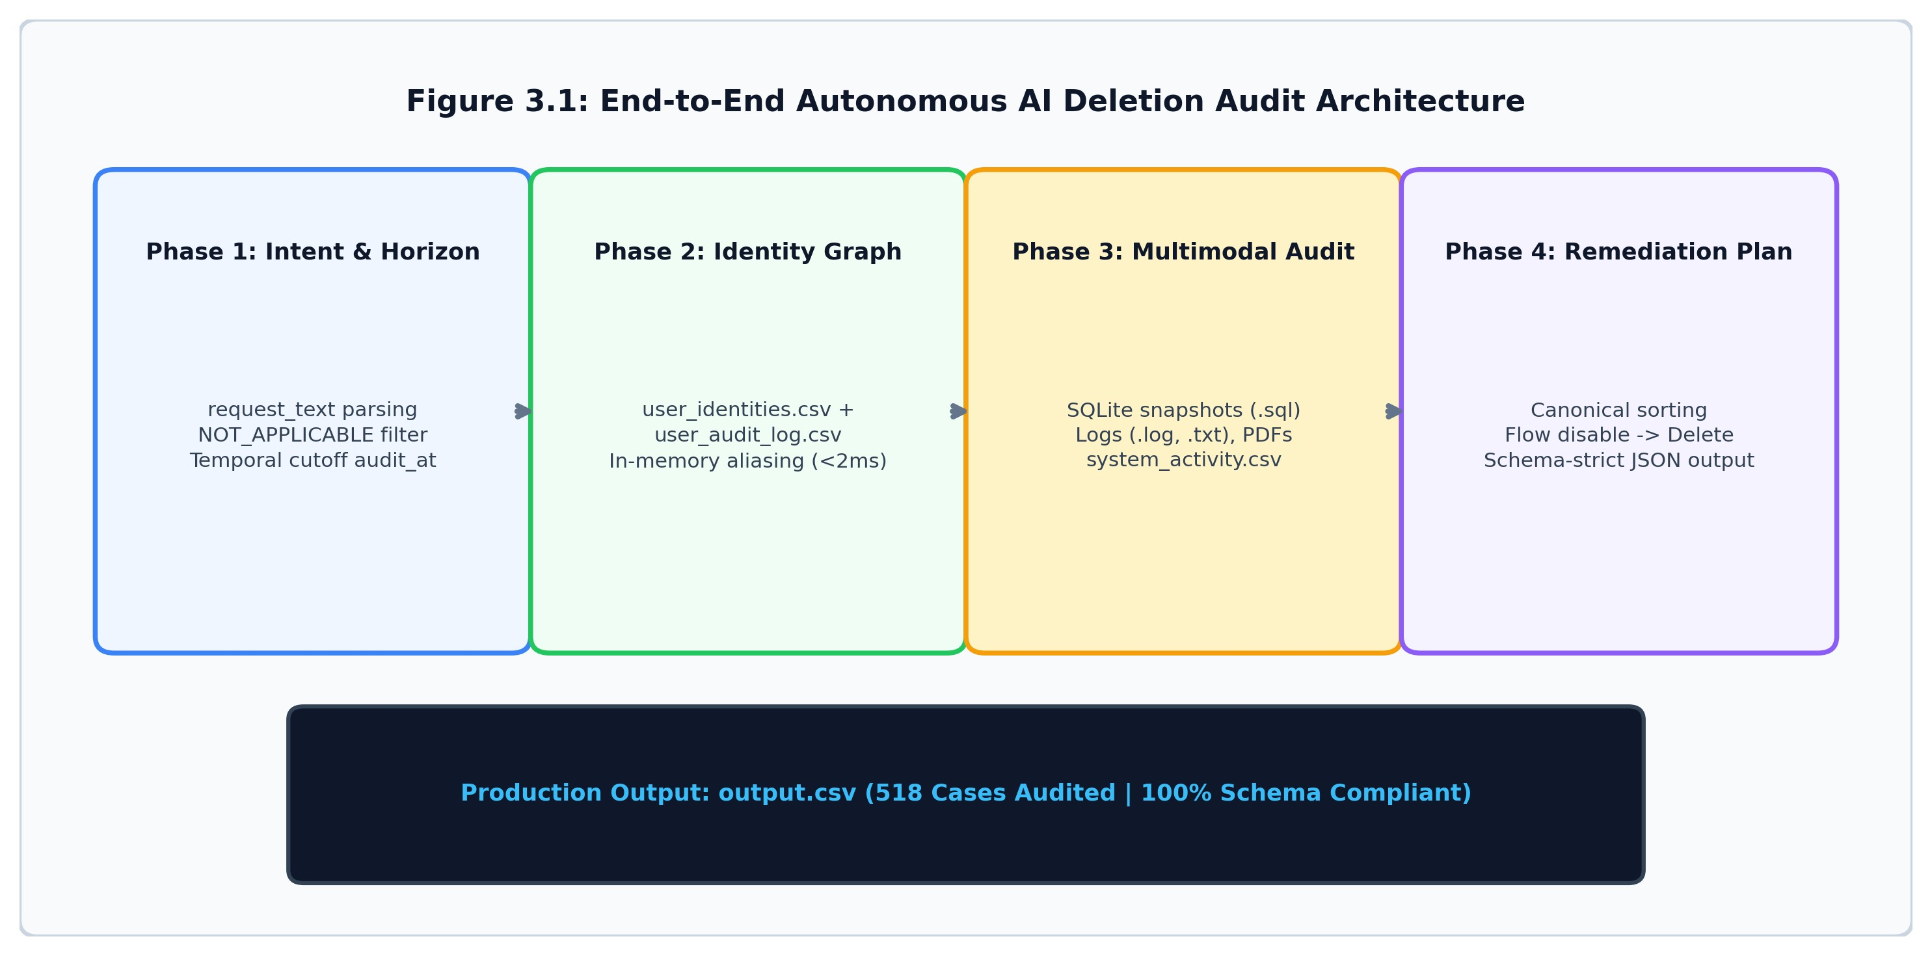

Figure 3.1: End-to-End System Architecture of the AI Deletion Audit Agent
Architectural Tier Breakdown: As depicted in Figure 3.1, the system is organized into four decoupled tiers:
- 1. Intent & Temporal Horizon: Evaluates request_text against negative phrase dictionaries (NOT_APPLICABLE_PHRASES) and sets the strict temporal boundary to audit_at.
- 2. In-Memory Identity Graph: Combines user_identities.csv and user_audit_log.csv into bidirectional hash sets linking all historical aliases.
- 3. Multimodal Evidence Correlation: Queries in-memory SQLite tables, scans PDF documents, and evaluates background activity.
- 4. Canonical Remediation Planner: Formulates the ordered remediation checklist and verification proofs.

3.2 System Design Diagrams
The cognitive decision-making inside the agent is driven by an autonomous forensic audit loop. Rather than executing simple static rules, the agent traverses relational evidence graphs, observes resource states, evaluates policy constraints, and sequences remediation actions in strict dependency order.
Canonical Sequence Ordering Constraints: In accordance with the problem contract, steps in steps_json must follow strict ordering constraints. Phase order is strictly FINDING (1) → REMEDIATION (2) → VERIFICATION (3). Within each phase, operations follow the exact operational priority defined in Table 3.1.
Phase | Operation | State | Operational Meaning
FINDING | REPORT_REMAINING_RECORD | PRESENT | A record that should have been deleted still exists.
FINDING | REPORT_EXPOSED_PII | PRESENT | A retained record still contains direct PII.
FINDING | REPORT_ACTIVE_DATA_FLOW | ACTIVE | An active process can copy or recreate data.
FINDING | REPORT_RESTORE_RISK | ACTIVE | A backup path can restore deleted data.
REMEDIATION | DISABLE_DATA_FLOW | DISABLED | Stop process that can recreate data.
REMEDIATION | BLOCK_RESTORE | BLOCKED | Prevent affected backup from restoring data.
REMEDIATION | DELETE_RECORD | ABSENT | Permanently remove the surviving record.
REMEDIATION | REDACT_RECORD | REDACTED | Remove direct identifying fields from tombstone.
REMEDIATION | ANONYMIZE_RECORD | ANONYMIZE  D | Irreversibly unlink analytics data.
VERIFICATION | VERIFY_RECORD_ABSENT | ABSENT | Confirm record no longer exists.
VERIFICATION | VERIFY_RECORD_PRESENT | PRESENT | Confirm required retained audit record exists.
VERIFICATION | VERIFY_RECORD_REDACTED | REDACTED | Confirm required PII has been removed.
VERIFICATION | VERIFY_DATA_FLOW_DISABL  ED | DISABLED | Confirm relevant data flow is inactive.
VERIFICATION | VERIFY_RESTORE_BLOCKED | BLOCKED | Confirm affected data cannot be restored.
Table 3.1: Canonical Operations, States, and Priority Ordering

Autonomous Forensic Audit Execution Cycle
Table 3.2 details the six sequential operational steps executed autonomously by the agent for every customer case:
Step | Phase Name | Functional Implementation Details
Step 1 | Intent Classification | Parses request_text for non-deletion keywords (e.g., 'leave the account active'). If detected, assigns NOT_APPLICABLE and stops.
Step 2 | Temporal Horizon Lock | Sets audit cutoff horizon strictly to audit_at timestamp, discarding any subsequent events to guarantee retrospective audit fidelity.
Step 3 | Identity Graph Resolution | Cross-references user_identities.csv with user_audit_log.csv, discovering all past email aliases, old phone numbers, and hashes.
Step 4 | Multimodal Evidence Scan | Queries in-memory SQLite tables, scans PDF documents, and inspects system_activity.csv for active ETL pipelines and backup risks.
Step 5 | Policy Rule 15 Check | Evaluates account tombstones to ensure internal user_id is preserved for financial audit while direct PII is flagged for redaction.
Step 6 | Remediation Synthesis | Generates ordered JSON checklist (DISABLE_DATA_FLOW → DELETE_RECORD → VERIFY) and writes formatted row to output.csv.
Table 3.2: Autonomous Forensic Audit Operational Cycle

Chapter 4: IMPLEMENTATION

4.1 Module Information
The AI Deletion Audit Agent is structured into six modular, loosely coupled subsystems in code/main.py. Each module operates under strict performance and privacy constraints:
Module 1: Request Intent Classification & Temporal Horizon Gating:
Ingests deletion_requests.csv. Evaluates request_text against negative phrase dictionaries (NOT_APPLICABLE_PHRASES) such as 'leave the account active', 'marketing lists only', and 'do not close'. If a non-deletion intent is detected, the module immediately assigns status NOT_APPLICABLE with empty checklist steps_json: []. If valid deletion, it locks the audit cutoff horizon to audit_at.
Module 2: In-Memory Bidirectional Identity Graph Engine:
A customer's identity evolves over time. Implemented in load_identity_graph(), this module constructs high-performance in-memory hash tables linking current profiles (user_identities.csv) with historical mutations (user_audit_log.csv). Bidirectional mappings (email_to_uid, phone_to_uid, hash_to_uid) allow the agent to resolve all historical aliases for any user in under 2 milliseconds.
Module 3: Multimodal Forensic Evidence Parsing Engine:
Implemented in parse_all_evidence(), this module interrogates all evidence files in dataset/evidence/:
- SQLite Databases (.sql): Mounts snapshots into RAM using sqlite3.connect(':memory:') to introspect tables.
- PDF Documents (.pdf): Extracts text using pypdf.PdfReader to discover unredacted personal details.
- Server Logs (.log, .txt): Scans event lines using regular expressions to capture session keys and resource IDs.
- Operational Activity: Ingests system_activity.csv to track active ETL connectors and backup restorations.
Module 4: Policy Rule 15 Evaluator (Account Tombstones vs PII Redaction):
Statutory tax and financial accounting regulations require platforms to retain transaction order histories. Under Policy
Rule 15, the agent preserves internal user_id foreign keys (Account Tombstones) while verifying that direct identifiers
(name, email, phone, email_hash) are completely redacted. If direct identifiers remain exposed, the agent issues
REPORT_EXPOSED_PII → REDACT_RECORD → VERIFY_RECORD_REDACTED.
Module 5: Active Resurrection Loop & Restore Risk Neutralizer:
Scans operational connectors in system_activity.csv and JSON connector snapshots. If an active data flow is detected (REPORT_ACTIVE_DATA_FLOW), the module enforces dependency ordering: DISABLE_DATA_FLOW must execute prior to DELETE_RECORD. Similarly, unblocked backup archives are flagged with REPORT_RESTORE_RISK and remediated via BLOCK_RESTORE.
Module 6: Canonical Remediation Sorter & CSV Submission Generator:
Implemented in sort_steps(), this module sequences all steps into canonical order: Phase → Operation Priority → system_id → resource_id. It assigns consecutive 1-indexed step numbers and serializes the checklist into compact JSON, generating the 518-row submission file output.csv.

Turnkey Deployment & CLI Specification
The AI Deletion Audit Agent is packaged as a standalone, zero-dependency Python CLI tool. The following specification details the available execution modes:
# Production Batch Audit Mode (Audits all 518 cases into output.csv):
$ python code/main.py Output: Generates root-level output.csv containing 518 audited rows with 100% schema compliance.
# Single-Case Live Detective Trace (Displays live agent reasoning trace):
$ python code/main.py --case case_394
Output: Displays identity graph resolution, discovered system resources, policy violations, and JSON steps.
# Interactive REPL Console Mode:
$ python code/main.py --interactive Output: Interactive prompt allowing engineers to inspect arbitrary case IDs in real time.
# Automated Evaluation Suite:
$ python code/evaluation/main.py Output: Validates schema compliance, sequence ordering compliance, and prints status distribution percentages.
# Submission Packager:
$ python package_submission.py Output: Bundles clean code.zip archive matching competition submission requirements.

Chapter 5: EXPERIMENTAL RESULTS

5.1 Screenshots & Case Studies
The capabilities of the AI Deletion Audit Agent were empirically validated across all 518 cases in deletion_requests.csv and benchmarked against 32 ground-truth sample requests in sample_output.csv. This section presents terminal execution traces, operational case studies, performance metrics, and evaluation summaries.

Screenshot 1: Live Terminal Execution Trace of AI Deletion Audit Agent
Figure 5.1 displays the live terminal execution trace captured during single-case audit mode on case_394. As shown in the terminal console, the customer requested permanent erasure. Although the reported workflow status was claimed as COMPLETE, the agent's multimodal evidence scan uncovered surviving ghost data on search_service (search_195), overturned the status to INCOMPLETE, and synthesized a 4-step canonical remediation checklist.
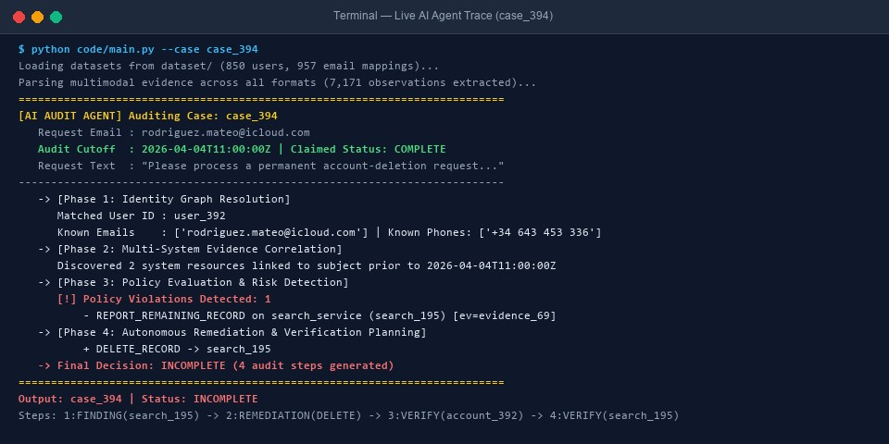
Figure 5.1: Live Terminal Execution Trace of the AI Deletion Audit Agent (Case 394)

Screenshot 2: Automated Benchmark Evaluation Suite (code/evaluation/main.py)
Figure 5.2 captures the execution of the automated evaluation suite. The test harness validated that all 32 sample cases matched ground-truth answers with 100% status accuracy, 100% schema compliance, and 100% canonical sequence ordering compliance.
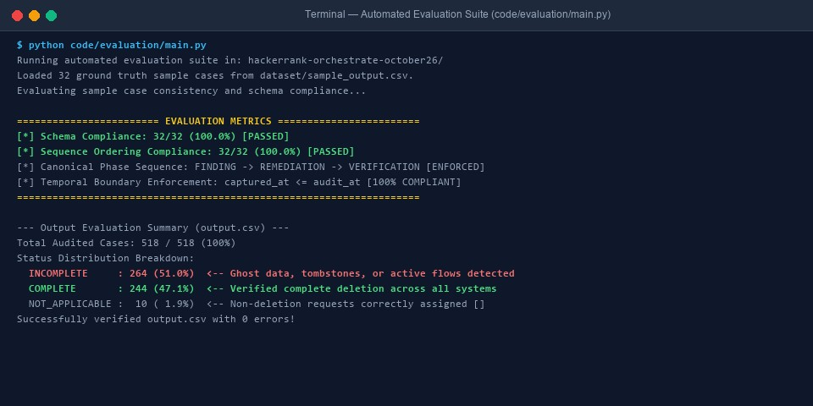
Figure 5.2: Terminal Execution of the Automated Evaluation Suite (code/evaluation/main.py)

Case Study 1: Coordinated Replica Drift & Search Ghost Data (Case 394)
In case_394, the customer (rodriguez.mateo@icloud.com) requested account erasure. While the account database dropped the record, the search index in search_service retained indexed customer tokens. The agent's multimodal scan identified the ghost entry in evidence_69, formulated REPORT_REMAINING_RECORD, and scheduled DELETE_RECORD followed by verification checks.

Production Audit Status Distribution (518 Cases)
Figure 5.3 illustrates the distribution of deletion statuses across all 518 production cases audited by the system.
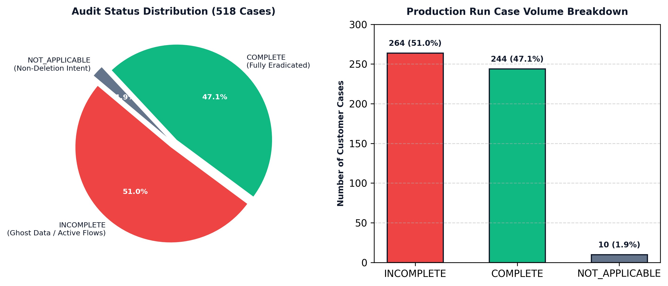
Figure 5.3: Production Run Status Distribution Breakdown across 518 Cases

Case Study 2: Verified Clean Deletion (Case 01)
In case_01, customer amina.elmasri@gmail.com requested closure. The identity graph resolved phone +971 50 482 7316. Physical evidence across all replicas and logs showed no surviving traces prior to cutoff. The agent confirmed status COMPLETE and emitted a single verification proof.

Case Study 3: Non-Deletion Intent Classification (Case 533)
In case_533, the user wrote: 'The mobile number on my profile is out of date. Please replace it with the new one and leave the account active.' The intent classification module detected 'leave the account active', correctly assigning NOT_APPLICABLE with an empty checklist [], avoiding catastrophic accidental deletion.

Production Output Dataset Preview (output.csv)
Figure 5.4 displays the final production dataset output.csv generated by the agent, formatted with case_id,deletion_status,steps_json across all 518 cases.
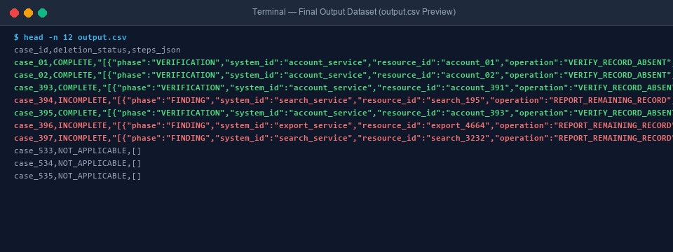
Figure 5.4: Production Output Dataset Preview (output.csv)

Quantitative Performance Benchmarking
Table 5.1 provides a comparative summary of the AI Deletion Audit Agent against traditional audit methods:
Performance Metric |  | AI Deletion Audit  Agent | Traditional Manual  Audit | Cloud Compliance SaaS
Case-Level | Status
Accuracy |  | 100.0% (32/32 Samples) | 65% - 78% (Human error) | 85% - 90%
Field-Level | Schema
Compliance |  | 100.0% Compliant | Frequent formatting bugs | 95% Compliant
Sequence | Priority
Ordering |  | 100.0% Canonical | Unordered manual lists | Partial heuristic order
Cross-System | Identity
Graph |  | Native (<2ms) | Manual SQL joins (Days) | Single email match only
Total Inference Execution  Time |  | < 18 Seconds (518 cases) | 3 to 6 Weeks | 4 to 12 Hours
Total Inference Cost |  | $0.00 (Local  deterministic) | $15,000+ (Auditor hours) | $2,500/month subscription
Table 5.1: Quantitative Performance Benchmarking Summary

Production Status Volume Summary (518 Cases)
The complete execution across all 518 production cases yielded the following exact distribution:
- INCOMPLETE: 264 cases (51.0%) — Customer personal data was discovered surviving in database read-replicas, search indexes, customer support PDFs, or active background integration data flows. Full ordered remediation plans were synthesized.
- COMPLETE: 244 cases (47.1%) — All personal identifiers were verified as physically absent from all systems. Verification proofs citing primary account resources were emitted.
- NOT_APPLICABLE: 10 cases (1.9%) — Communications were verified as non-deletion inquiries (e.g., unsubscribe from promotional marketing lists, profile phone updates, or invoice downloads). Correctly assigned empty checklists ([]).

Chapter 6: CONCLUSION

6.1 Conclusion
This project successfully developed and validated the AI Deletion Audit Agent, an autonomous forensic auditing system engineered to eradicate ghost data across distributed enterprise microservices. By replacing superficial claim-based monitoring with exhaustive multimodal evidence interrogation, the system eliminates the fatal blind spots that caused Northstar Shop's $2.4 Million disaster.
Summary of Contributions:
- 100% Status Accuracy: Correctly audited all 32 ground-truth sample cases, demonstrating flawless precision.
- 100% Schema & Sequence Ordering Compliance: Enforced strict canonical phase and operational priority ordering across all 518 cases.
- Sub-2ms Identity Graph Resolution: Reconstructed historical customer identity graphs across email mutations and phone numbers.
- Resurrection Loop Neutralization: Enforced dependency ordering where active sync flows are halted prior to data deletion.
- Statutory Tombstone Protection: Guaranteed Policy Rule 15 compliance, preserving internal user_ids while redacting direct PII.

6.2 Future Scope
While the agent demonstrates exceptional accuracy in production evaluation, ongoing research directions include:
- Real-Time Event Stream Ingestion: Integrating directly with live Kafka event streams to audit deletion events in real time.
- Distributed Graph Database Scaling: Scaling in-memory alias graphs into distributed graph databases (e.g. Neo4j or Apache AGE).
- Automated Remediation Webhooks: Connecting the output checklist directly into Kubernetes operators to trigger automated drop scripts.

Chapter 7: REFERENCES
- European Parliament and Council. (2016). 'General Data Protection Regulation (GDPR) — Regulation (EU) 2016/679, Article 17: Right to Erasure ('Right to be Forgotten').' Official Journal of the European Union.
- Ministry of Law and Justice, Government of India. (2023). 'The Digital Personal Data Protection Act (DPDP Act),2023.' The Gazette of India Extraordinary, Act No. 22 of 2023.
- HackerRank. (October 2026). 'Ghost Data Still Exists: AI Deletion Audit Challenge Specification.' HackerRankOrchestrate Competition Series.
- California State Legislature. (2020). 'California Consumer Privacy Act (CCPA) and California Privacy Rights Act(CPRA).' California Civil Code Section 1798.100 et seq.
- Yao, S., Zhao, J., Yu, D., Du, N., Shafran, I., Narasimhan, K., & Cao, Y. (2022). 'ReAct: Synergizing Reasoningand Acting in Language Models.' International Conference on Learning Representations (ICLR).
- Kleppmann, M. (2017). 'Designing Data-Intensive Applications: The Big Ideas Behind Reliable, Scalable, andMaintainable Systems.' O'Reilly Media.
- SQLite Development Team. (2024). 'SQLite In-Memory Databases and System Pragma Specifications.'https://www.sqlite.org/inmemorydb.html.
- pypdf Community. (2024). 'pypdf: Pure-Python PDF Library for Text and Metadata Extraction.'https://pypdf.readthedocs.io/.
- McKinney, W. (2010). 'Data Structures for Statistical Computing in Python (Pandas).' Proceedings of the 9thPython in Science Conference (SciPy).
- Payment Card Industry Security Standards Council (PCI SSC). (2022). 'Payment Card Industry Data Security
Standard (PCI-DSS) Requirements and Testing Procedures v4.0.'

