D. Y. Patil College of Engineering and Technology, Kolhapur
Computer Science & Engg.
Subject – Advanced Programming Concepts
Assignment No. 13
Title of Mini-Project – StudySphere: AI Multi-Format Document Learning & Study Studio
Description –
1. Project Overview
StudySphere is a comprehensive, full-stack Python and Django-based academic study platform designed to transform how students interact with course documents. When a user uploads study material in any universal format (PDF, DOCX, TXT, CSV, Excel spreadsheets, or scanned image notes), the system automatically ingests, normalizes, and extracts the core knowledge base. It then synthesizes the material into 9 synchronized learning modalities accessible via a modern studio interface: Executive Study Breakdown, Matplotlib Visual Charts, Categorized Notes, 3D Active Recall Flashcards, Interactive HTML5 Canvas Concept Map, Offline Podcast Audio Briefings, Instant Practice Quizzes, Timed Mock Examinations, and Raw Source Document Inspection. The primary goal is to eliminate manual rote compilation, provide multi-sensory revision, and significantly boost cognitive retention across technical curricula.
2. Technologies and Libraries Used
• Python – Core high-level programming language executing the entire processing, linguistics, and server pipeline.
• Django – Industry-standard web framework providing MVC/MVT architecture, URL routing, ORM database modeling, session tracking, and secure HTTP endpoints.
• pypdf – Reads and extracts digital text streams from multi-page PDF documents and extracts embedded page images.
• python-docx – Parses Microsoft Word (.docx) files, traversing paragraph objects and tabular data cells.
• pandas – Performs tabular data analysis and statistical summaries (describe()) on uploaded CSV and Excel spreadsheets.
• NLTK (Natural Language Toolkit) – Used for sentence boundary disambiguation (sent_tokenize) and stopword removal to calculate extractive sentence salience scores.
• matplotlib – Generates publication-quality horizontal bar charts visualizing keyword and topic weighting distributions in light-mode aesthetics.
• winocr & Pillow (PIL) – Native Windows Media Optical Character Recognition engine parsing scanned PDF pages, diagrams, and image lecture notes.
• pyttsx3 – Offline, cross-platform Text-to-Speech (TTS) speech synthesis engine producing audio podcast study briefings (.wav) without requiring internet or paid API keys.
• HTML5, CSS3, & Canvas API – Interactive frontend interface featuring 3D flip card animations, force-directed canvas physics simulation, and amber theme toggle.
• SQLite – Relational database persisting uploaded document models, extracted concept nodes, and student quiz submissions.
• GitHub – Cloud repository hosting, tracking commits, and facilitating collaborative code version control.
3. Working of the Project
Step 1: Document Upload – The user drags and drops any study file (.pdf, .docx, .txt, .csv, .xlsx, .png, .jpg) via the unified upload modal.
Step 2: Multi-Layer Text Extraction – pypdf extracts digital PDF text; if the PDF is scanned or image-based, winocr OCR automatically extracts text from embedded images.
Step 3: Text Normalization & Cleaning – Regular expressions reconnect words split across line breaks (e.g. exami-\nnations -> examinations) and normalize encoding artifacts.
Step 4: Salience Scoring & Summarization – Words are scored after removing stopwords. Sentences are ranked by term frequency density to compile executive summary paragraphs.
Step 5: Concept Map & Network Extraction – Multi-word compound concepts are detected, singular/plural terms are consolidated, and authentic definitional sentences are extracted.
Step 6: Media Synthesis – Matplotlib renders the keyword distribution chart to disk, while pyttsx3 synthesizes a conversational podcast audio briefing (.wav).
Step 7: Studio Delivery – The user navigates seamlessly across all 9 synchronized learning views in the web browser with live entity inspection.
4. Techniques and Algorithms
Extractive Sentence Salience Algorithm: Sentences are scored based on the normalized frequency of informative content words. The highest-density sentences are assembled chronologically to preserve original context without hallucination.
Morphological Lemmatization & Plural Consolidation: Custom rule-based linguistic normalization merges plural and singular variants (e.g. results and result -> Results (58x)), ensuring concept network nodes never duplicate.
Definitional Pattern Matching: Scans document sentences for definitional markers (is a, refers to, defined as, provides, enables, stores) to attach verbatim definitions and exact source citations to each node.
Force-Directed Canvas Physics Simulation: Nodes in the concept map calculate repulsive Coulomb forces and spring-like edge tensions in real-time, allowing users to drag, zoom, and explore connections interactively.
Dual Audio Playback Architecture: Uses HTML5 audio for local .wav streaming with automatic fallback to browser Web Speech API (window.speechSynthesis) for universal device compatibility.
5. Main Features
• Universal Ingestion: Supports PDF, DOCX, TXT, CSV, Excel, and image formats with strict empty-file validation.
• 9 Synchronized Learning Modes: Complete study suite from executive summary to timed 10-minute mock exams.
• Interactive Canvas Mind-Map: Dynamic visual knowledge graph with clickable node inspector showing definitions and source excerpts.
• Audio Walkthrough Briefing: Podcast player with speed controls (1x, 1.25x, 1.5x) and full synchronized transcript.
• Active Recall 3D Flashcards: Interactive flip cards dynamically compiled from document key terms.
• Instant Quiz & Timed Mock Exam: Multiple choice questions with genuine distractors, instant grading, and downloadable exam certificates.
• Dual Visual Themes: Clean light-mode default with a persistent Warm Amber / Golden Yellow theme.
6. Applications
The project is engineered for engineering and university coursework revision, competitive examination preparation (GATE, GRE), technical research paper digestion, lecture notes structuring, and auditory study on mobile devices during commutes.
7. Limitations
• Very large PDF documents (>150 pages) require additional processing time for OCR and audio synthesis.
• OCR accuracy depends on image clarity, lighting contrast, and handwriting legibility on uploaded photos.
• Extractive summarization preserves original phrasing and relies on well-structured source text.
• Local TTS voice tone depends on installed operating system speech synthesis voices.
8. Role of Python
Python serves as the backbone of the entire application. It handles binary file ingestion, OCR parsing, natural language processing, data analysis with pandas, chart rendering with matplotlib, local speech synthesis with pyttsx3, and web server delivery via Django's MVT framework and SQLite ORM. HTML5, CSS3, and JavaScript are used strictly for UI presentation and client-side canvas physics.
9. Conclusion
StudySphere demonstrates the practical application of Python's scientific, NLP, and web frameworks in solving real-world educational challenges. By converting static documents into multi-sensory interactive learning environments, the project significantly reduces study preparation overhead, enhances recall, and satisfies university curriculum specifications.
Snapshots –
Snapshot 1: Matplotlib Keyword Weighting & Topic Distribution Chart
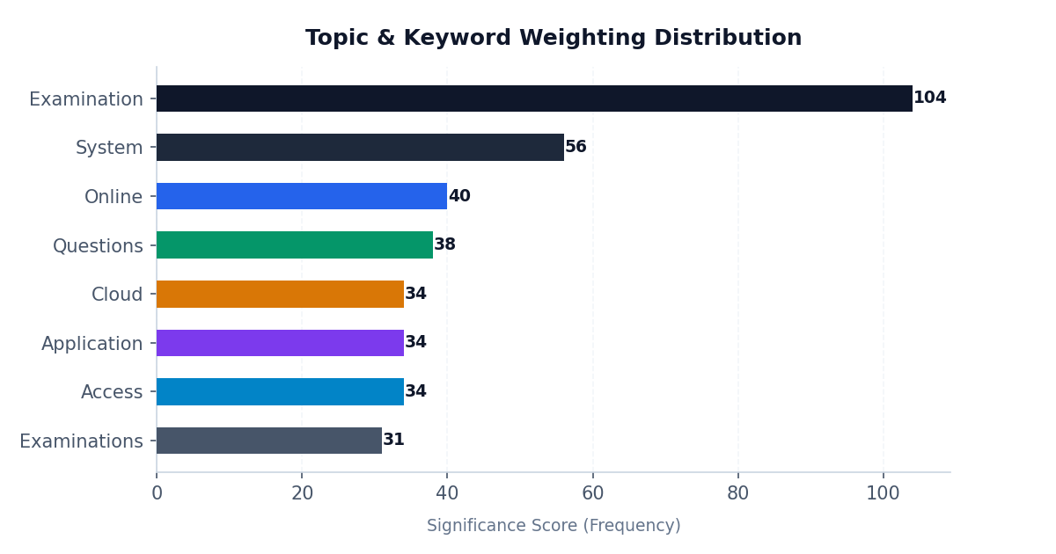
Snapshot 2: Interactive Concept Mind-Map & Semantic Knowledge Network
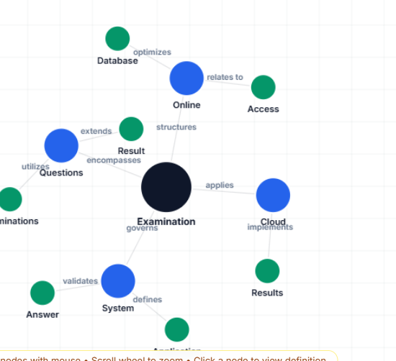
Snapshot 3: Ingestion Studio Analysis & Document Flow Architecture
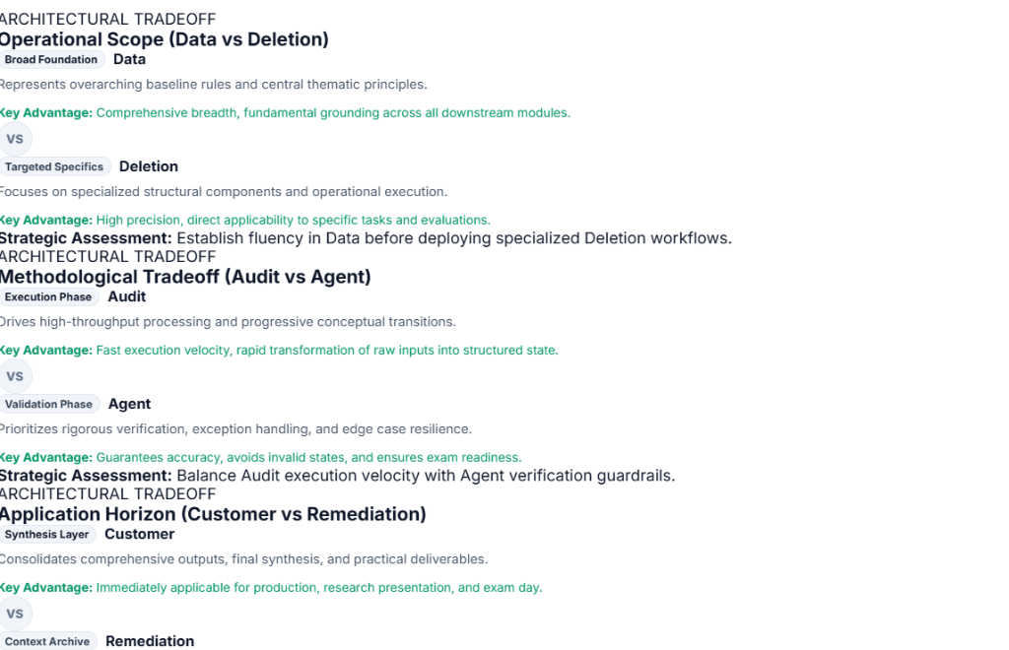
Date of Submission –
Juno Roll No | Name of Student | Sign
27 | Tejas Ankush Shelake
28 | Jija Shashin Kumbhojakar

