Command Line working application (Jar file provided by sir on github)

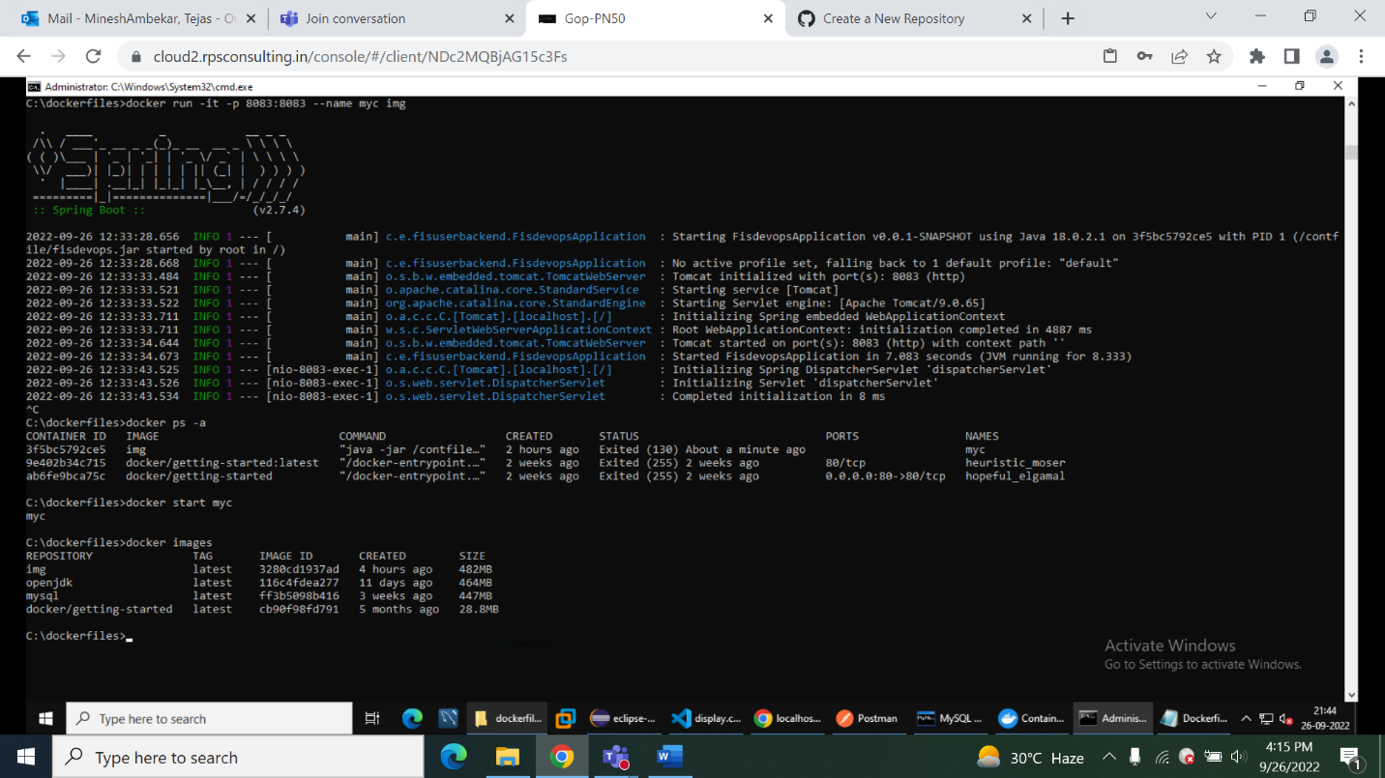

Test1 is working:

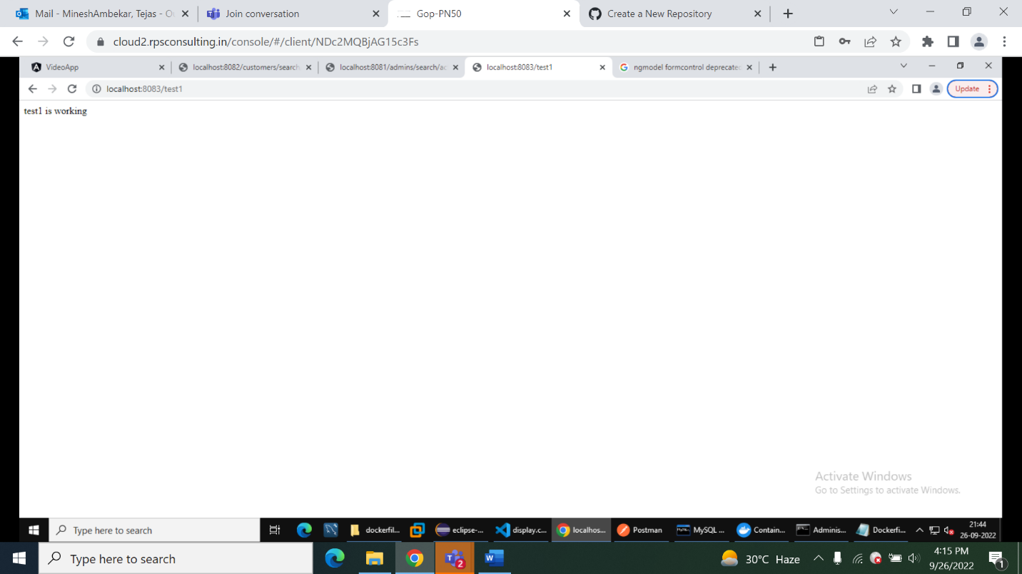

Test2 is working:

Dockerfile Contents:

