Admin Functions:

Customer Functions:

Added 1007 Entry: (using Admin functions)

Display movie details: (Admin Function)

Searching by Lead Actor name: (Admin Function)

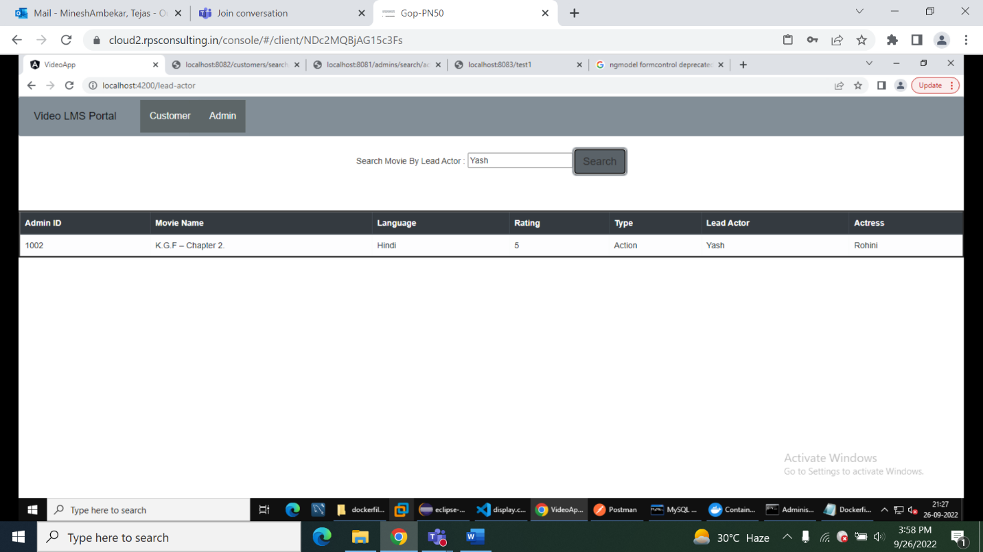

Deleted 1007 record using Admin ID: (Admin Function)

Displayed all records 1007 is deleted:

Search by movie Ratings: (Customer Function connected via feign client to Admin)

