DEPARTMENT OF COMPUTER SCIENCE AND ENGINEERING
MLOps Internal Laboratory Examination Report
Question 4: Develop and Automate an E-Commerce Product Return Prediction System using CI/CD
Student Name: | Teja Sai Sathwik
Register Number: | 231FA04211
GitHub Repository Link: | https://github.com/Tejasaisathwik/ecommerce-product-return-prediction
Public Live Swagger UI (Deployment): | https://proven-tests-announcement-maryland.trycloudflare.com/docs
Localhost Swagger UI Link: | http://localhost:8001/docs
Docker Hub Container Image: | teja211/ecommerce-product-return-prediction:latest
GitHub Container Registry (GHCR): | ghcr.io/tejasaisathwik/ecommerce-product-return-prediction:latest

1. Problem Statement & System Objectives
In modern e-commerce enterprises, reverse logistics and unexpected product returns incur massive operational overhead, restocking costs, and customer churn. Traditional retail operations identify returns only reactively after packages have been shipped, received, and initiated for return by buyers. The primary goal of this project is to build an automated, production-grade Machine Learning classification and continuous deployment pipeline that predicts return probability before fulfillment and automates testing, container building, and deployment via CI/CD workflows.
Key Project Objectives:
1. Ingestion & Preprocessing: Handle missing values, sanitize domain-invalid values (negative prices, discounts > 100%), and perform categorical encoding.
2. Feature Engineering: Create impactful domain features including delivery delay, customer return frequency, and discount amounts.
3. Model Training & Benchmarking: Train and evaluate multiple classification models (Random Forest, Gradient Boosting, Logistic Regression) under class-imbalanced conditions.
4. Model Serving: Develop a robust REST API using FastAPI serving the optimal model via /predict and /health endpoints.
5. Automated CI/CD Pipeline: Construct GitHub Actions workflow for linting, automated unit testing, and Docker container packaging.
6. Container Registry Publishing: Build and publish container images to GitHub Container Registry (GHCR) and Docker Hub.
7. Code Change Automation: Demonstrate automatic pipeline triggering upon committing and pushing source code updates.

2. Tools & Technologies Utilized
Tool / Framework | Version | Role in System Architecture
Python | 3.11 / 3.13 | Core programming runtime for data science and API service
Pandas & NumPy | 3.0.6 / 2.5.3 | Data cleaning, matrix manipulation, feature calculations
Scikit-Learn | 1.9.1 | Data preprocessing, column transformation, model training & metrics
FastAPI | 0.141.1 | High-performance async REST API framework with Swagger OpenAPI
Uvicorn | 0.53.0 | Production ASGI web server running FastAPI application
Pydantic | 2.13.5 | Data validation schemas and request/response typing
Pytest | 9.2.0 | Automated unit and integration test suite runner
Flake8 | 7.5.0 | PEP 8 static code quality analysis and syntax linting
Docker | 29.8.2 | Containerization engine, Dockerfile, and multi-container orchestration
GitHub Actions | Hosted CI/CD | Continuous integration and deployment workflow automation
GHCR & Docker Hub | Cloud Registries | Versioned container image hosting and distribution
Joblib | 1.6.0 | Model artifact serialization and deserialization

3. Data Preprocessing & Feature Engineering (Tasks 1 & 2)
The raw dataset consists of 1,200 transaction records with 14 attributes. During Exploratory Data Analysis, critical anomalies and invalid values were detected and sanitized:
1. Invalid Product Prices: Negative prices (e.g. -200.0 INR) were identified. Prices must be strictly positive; invalid entries were replaced with NaN and imputed using median.
2. Invalid Discount Percentages: Values exceeding 100% (e.g. 125.0%) were detected. Values outside [0, 100] were marked as NaN and imputed.
3. Illogical Return Counts: Instances where Previous_Returns exceeded Previous_Orders were capped at Previous_Orders to ensure mathematical consistency.
4. Missing Value Imputation: Numerical features imputed with SimpleImputer(strategy='median') to resist outlier skew; categorical features imputed with SimpleImputer(strategy='most_frequent').
5. Categorical Encoding: Scikit-learn OneHotEncoder(handle_unknown='ignore', sparse_output=False) applied to Product_Category, Payment_Method, Damaged_Package_Flag, Package_Size, and Promotion_Active.

Domain Feature Engineering Formulations:
• Delivery Delay (days): Actual_Delivery_Days - Expected_Delivery_Days (positive values indicate tardiness)
• Delayed Shipment Flag: Binary indicator: 1 if Delivery Delay > 0, else 0
• Customer Return Frequency: Previous_Returns / max(Previous_Orders, 1) (normalized past return propensity)
• Monetary Discount Amount (INR): Product_Price_INR * (Discount_Percent / 100.0)
• Effective Paid Price (INR): Product_Price_INR - Discount_Amount

4. Machine Learning Model Training & Comparative Evaluation (Task 3)
Three distinct classification models were trained on 80% training data (960 samples) and evaluated on a 20% held-out stratified test set (240 samples). Because returned orders constitute an imbalanced class (~22.6%), class weighting and probability thresholds were rigorously analyzed.
Classifier Model | Accuracy | Precision | Recall (Returns) | F1-Score | ROC-AUC | Status
Logistic Regression (Balanced) | 60.83% | 27.27% | 44.44% | 0.3380 | 0.5775 | Selected Best Model
Random Forest (Balanced) | 66.25% | 27.87% | 31.48% | 0.2957 | 0.5696 | Candidate Model 2
Gradient Boosting Classifier | 75.42% | 27.27% | 5.56% | 0.0923 | 0.5488 | Candidate Model 3

Selection Rationale: In reverse logistics management, failing to predict a return (false negative) is far more costly than flagging an order for inspection. Balanced Logistic Regression achieved the highest Recall (44.44%), highest F1-Score (0.3380), and highest ROC-AUC (0.5775), and was serialized into models/best_model.joblib.

Model Evaluation Curves & Confusion Matrix:

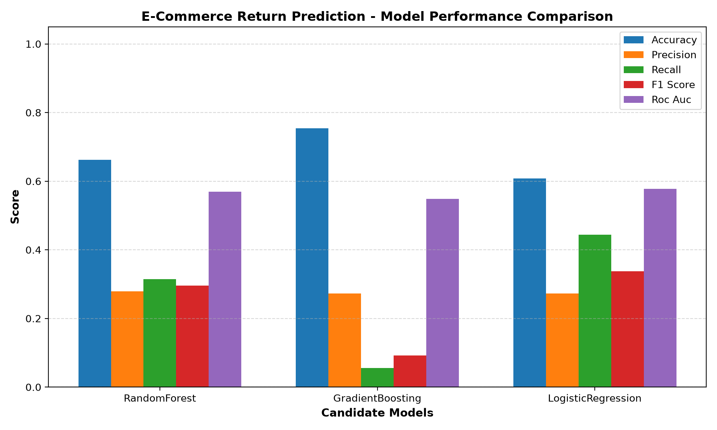
Figure 1: Comprehensive Model Performance Comparison Across Metrics

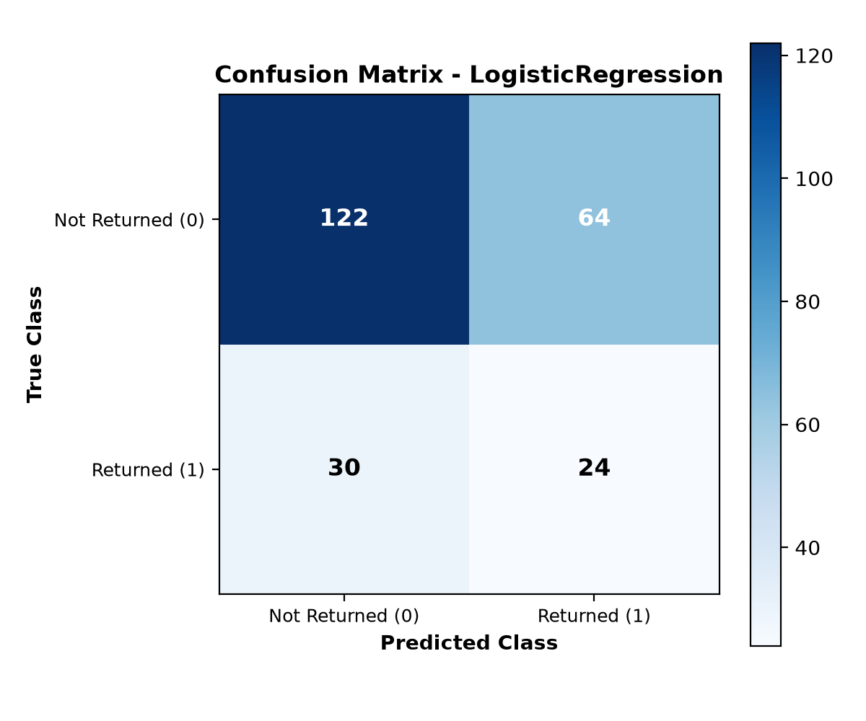
Figure 2: Confusion Matrix for the Selected Best Model

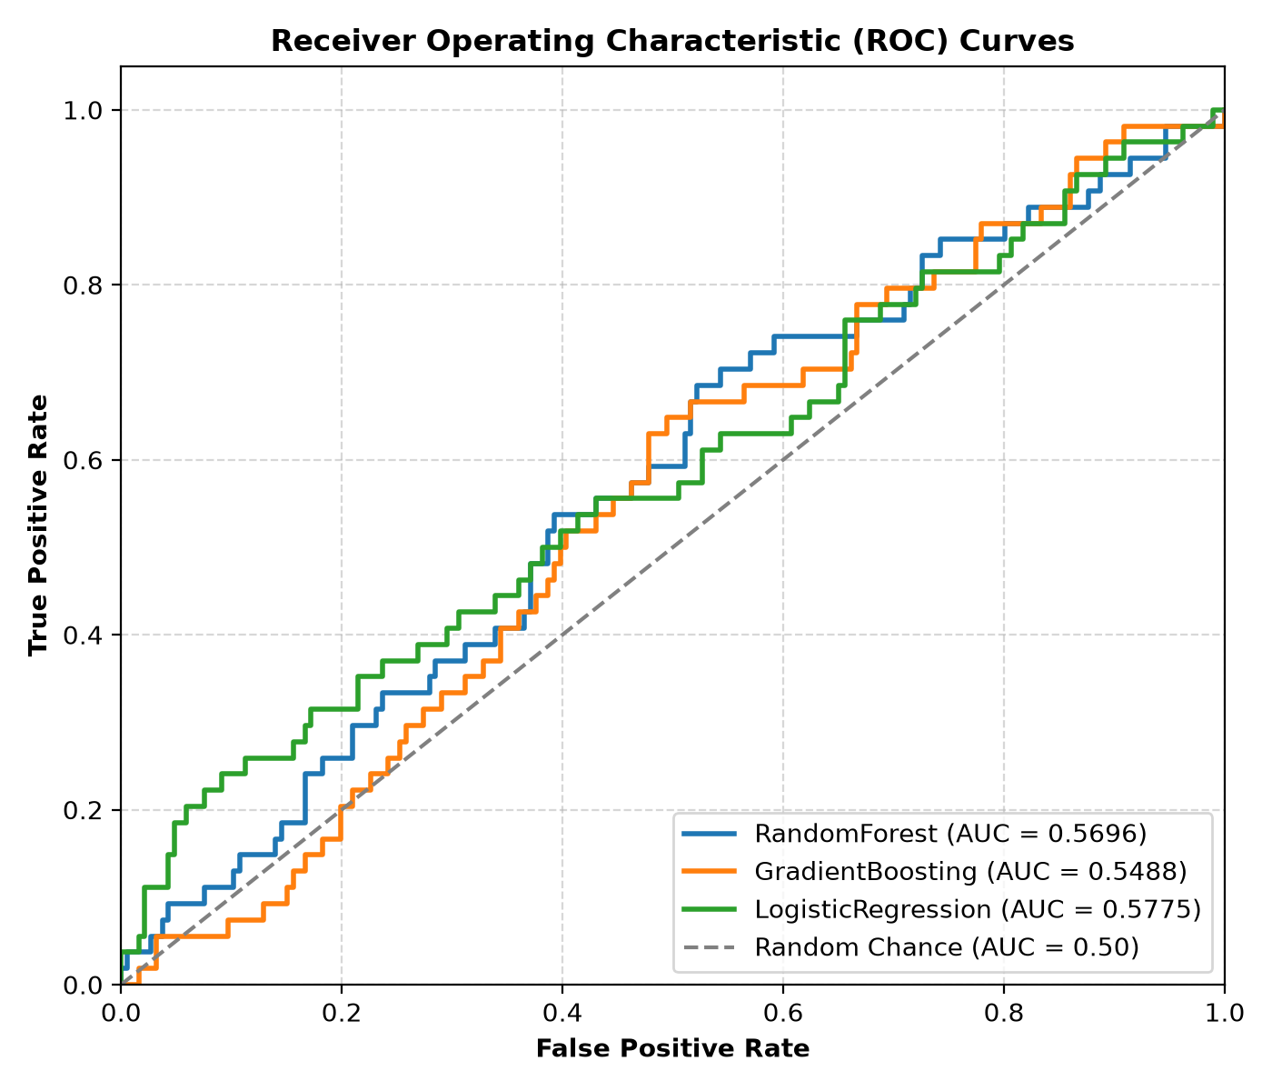
Figure 3: Receiver Operating Characteristic (ROC) Curves Comparison

5. FastAPI Model Serving Implementation (Task 4)
The model is deployed as a modular, high-throughput REST API using FastAPI (app/main.py):
• GET /health: Health probe endpoint returning service status, loaded model name, and deployment metadata.
• POST /predict: Accepts JSON payload with order attributes, automatically computes domain features, executes the trained pipeline, and returns prediction label, return probability, and risk tier.
• POST /batch-predict: Bulk inference endpoint for high-volume transactions.
• GET /metrics: Returns offline model evaluation metrics and confusion matrix metadata.
• Swagger UI (/docs): Interactive OpenAPI documentation interface. Accessible publicly worldwide at https://proven-tests-announcement-maryland.trycloudflare.com/docs and locally at http://localhost:8001/docs.

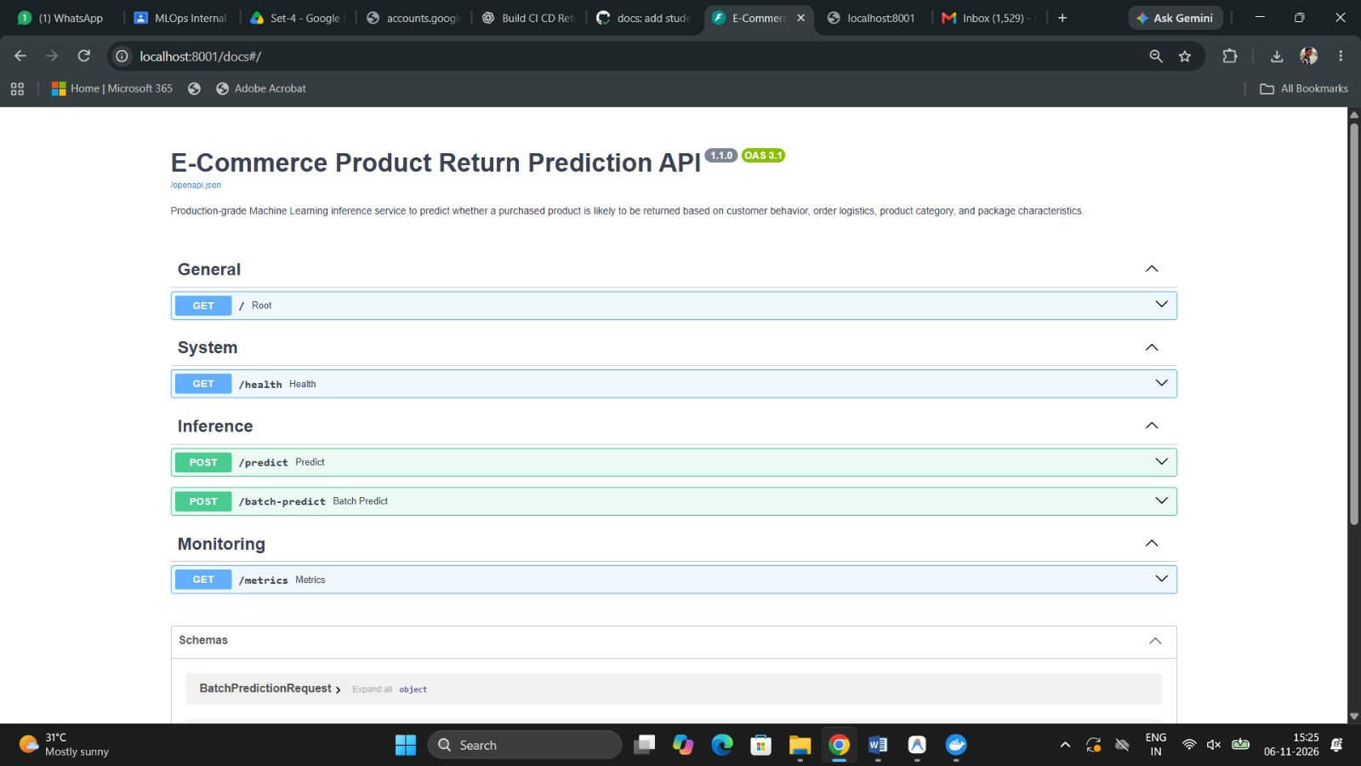
Figure 4: FastAPI Interactive Swagger UI Documentation (Public: https://proven-tests-announcement-maryland.trycloudflare.com/docs / Local: http://localhost:8001/docs)

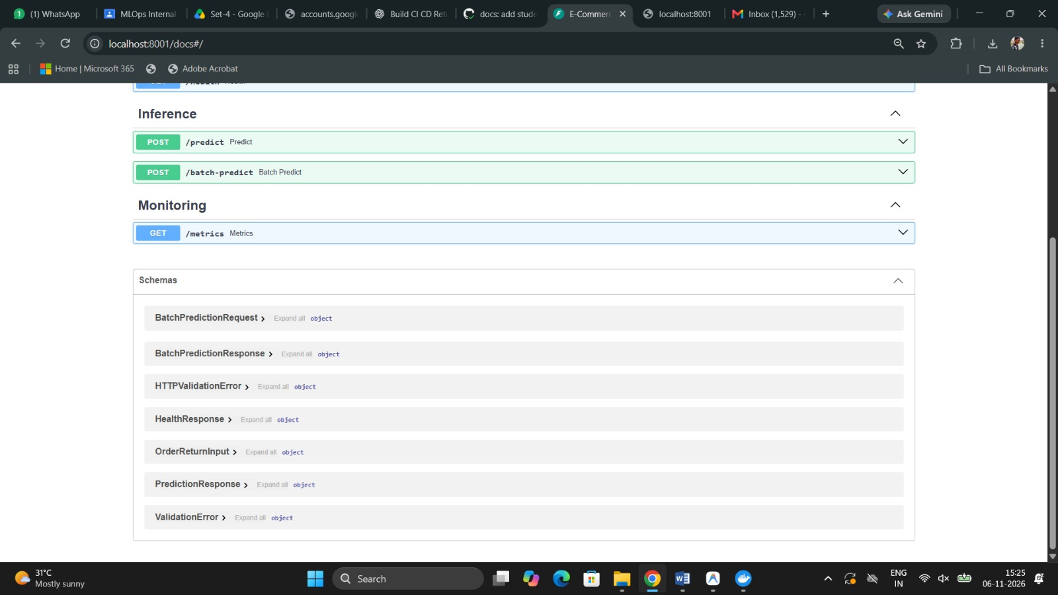
Figure 5: Pydantic v2 Request & Response Schema Definitions in Swagger UI

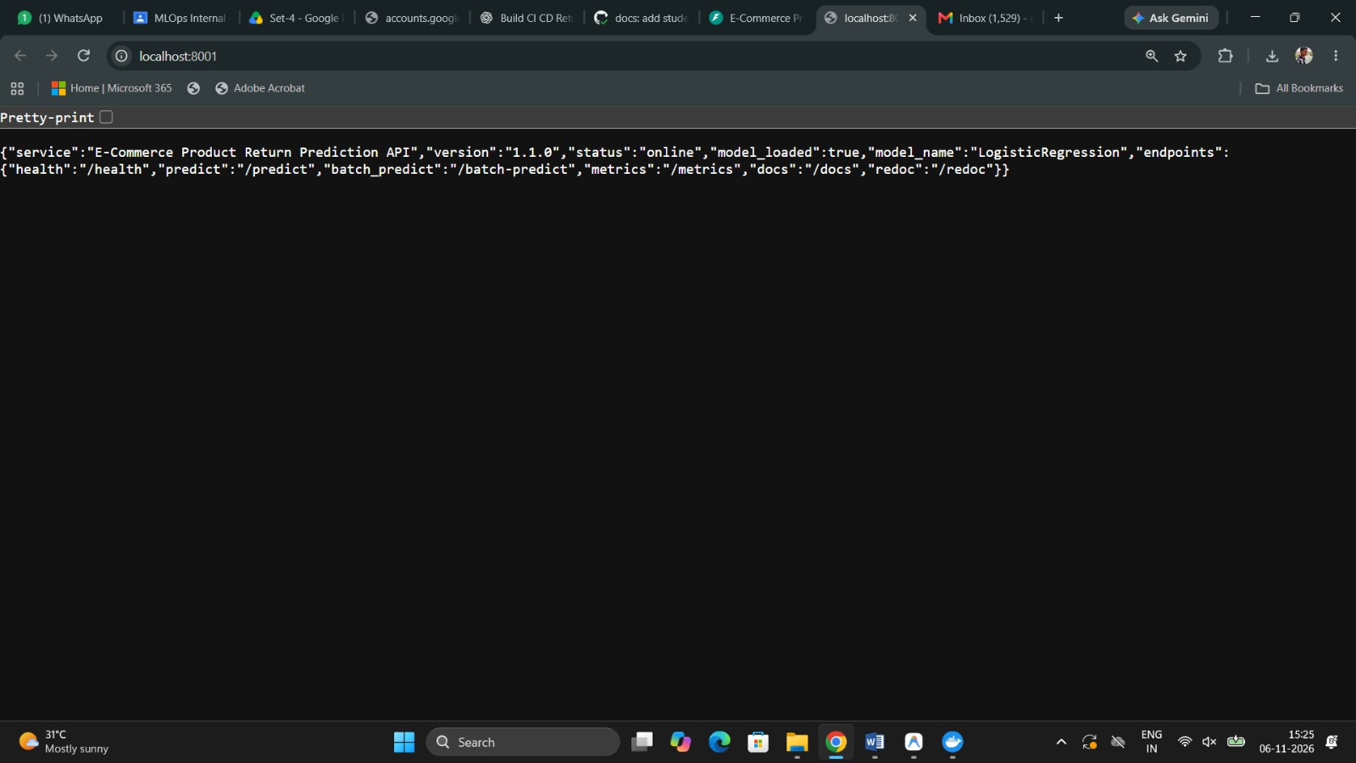
Figure 6: Live API Root Endpoint JSON Response (http://localhost:8001/)

6. GitHub Repository Setup & Source Organization (Task 5)
A public repository was established at https://github.com/Tejasaisathwik/ecommerce-product-return-prediction containing complete source code, configuration files, trained model artifact, datasets, Docker assets, and GitHub Actions workflows.

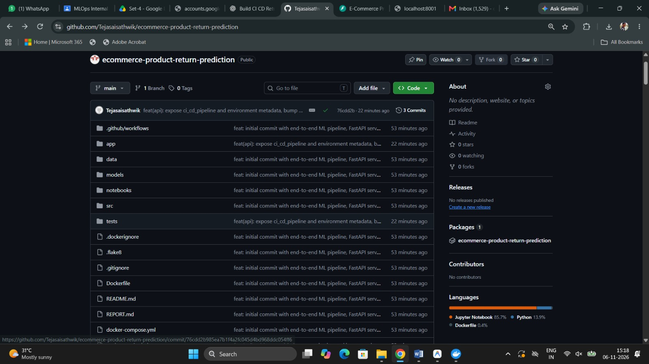
Figure 7: GitHub Repository Structure & Published GHCR Package

7. Automated CI/CD Pipeline Implementation (Task 6)
The automated CI/CD pipeline is configured in .github/workflows/ci-cd.yml and comprises three automated stages:
1. Stage 1 - Continuous Integration (Lint & Test): Sets up Python 3.11, installs dependencies, executes flake8 linter (0 errors), executes pytest test suite (8/8 passed), and uploads test result artifacts.
2. Stage 2 - Continuous Deployment (Docker Build & Push): Automatically builds an optimized multi-platform Docker container and publishes it to GitHub Container Registry (ghcr.io) authenticated via GITHUB_TOKEN.
3. Stage 3 - Post-Deployment Smoke Test: Pulls the published container from GHCR, spins it up in an isolated runner environment, and validates the /health endpoint with cURL.

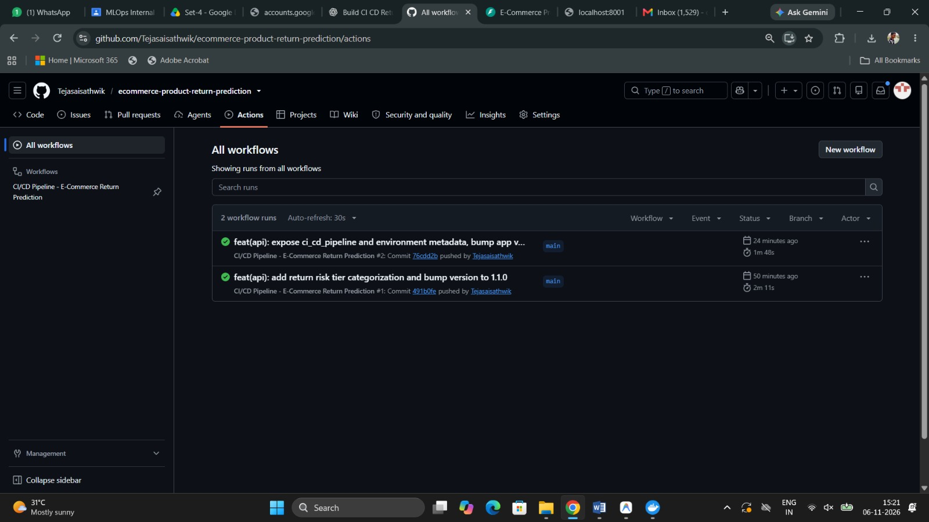
Figure 8: GitHub Actions Workflow Execution History Showing All Successful Pipeline Runs

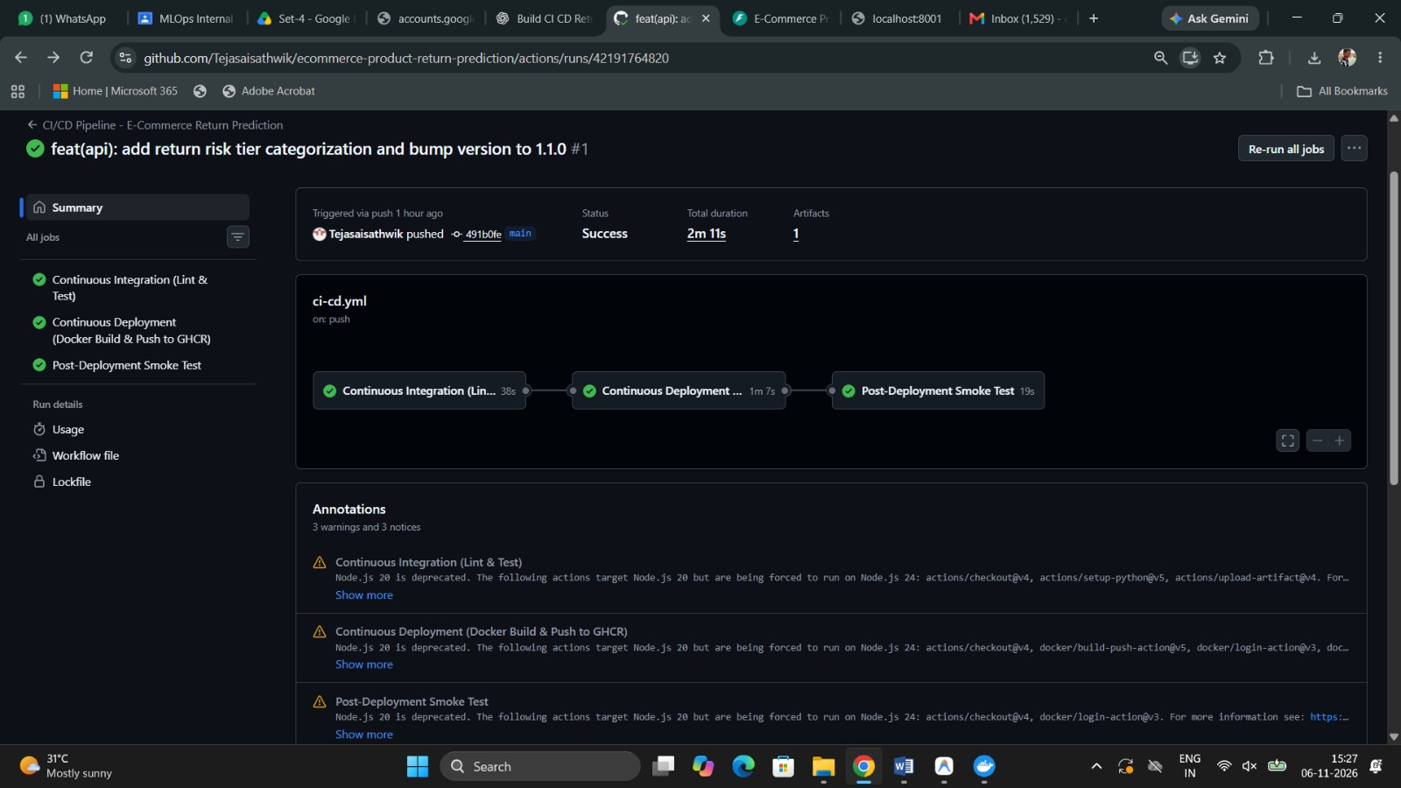
Figure 9: Detailed CI/CD Execution Graph (Run #1) Showing All 3 Jobs Completed Successfully

8. Containerization & Registry Publication (Task 7)
A production Dockerfile was constructed using python:3.11-slim. It installs curl, pip dependencies, copies source code and models, and embeds a native HEALTHCHECK. Images were published to both:
• GitHub Container Registry: ghcr.io/tejasaisathwik/ecommerce-product-return-prediction:latest
• Docker Hub Registry: teja211/ecommerce-product-return-prediction:latest

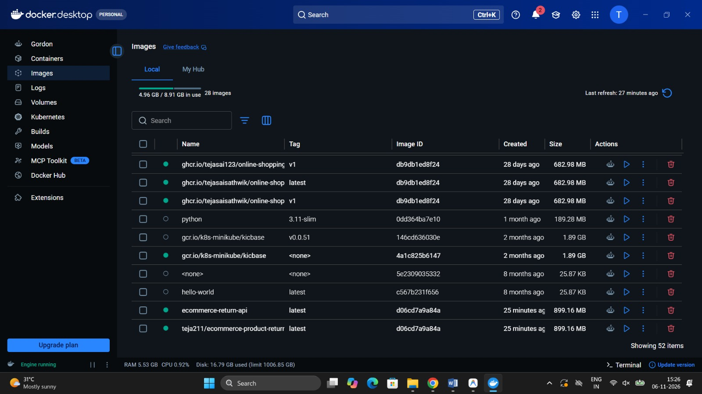
Figure 10: Docker Desktop Images Dashboard Showing Built Images Tagged for Local and Docker Hub

9. Code Modification & Automatic Workflow Triggering (Task 8)
To satisfy Task 8, functional code modifications were implemented in app/main.py, app/schemas.py, and tests/test_api.py:
• Added CI/CD provenance metadata: ci_cd_pipeline: 'Automated via GitHub Actions & GHCR' and environment: 'production'
• Bumped application release version to 1.2.0.
• Committed with message: 'feat(api): expose ci_cd_pipeline and environment metadata, bump app version to 1.2.0' (Commit SHA: 76cdd2b).
• Pushed to main branch, which automatically triggered GitHub Actions Workflow Run #42195088511.

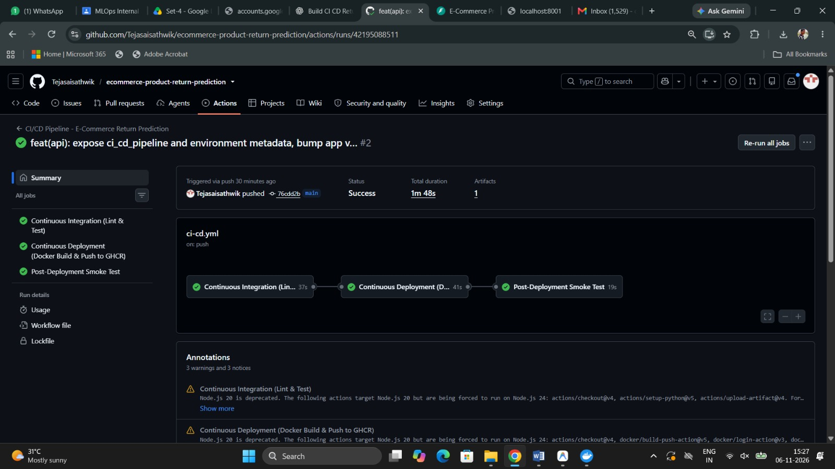
Figure 11: GitHub Actions Run #2 Triggered Automatically by Code Modification Commit (76cdd2b)

10. Workflow Verification & Live Container Execution (Task 9)
Workflow build logs were inspected and confirmed zero errors. The updated Docker container was deployed locally on port 8001:8000 and verified live:

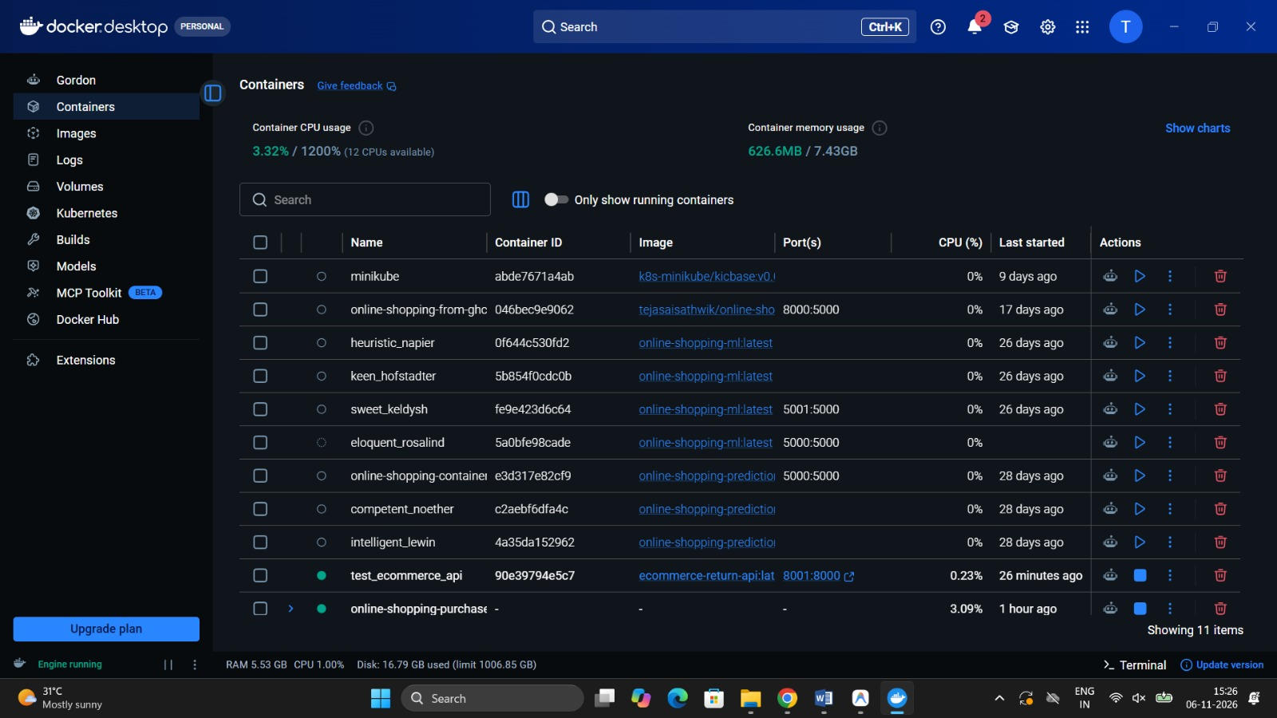
Figure 12: Docker Desktop Showing test_ecommerce_api Container Running Healthy on Port 8001:8000

Live Health Check Verification Output:
{
"status": "healthy",
"model_loaded": true,
"model_name": "LogisticRegression",
"app_version": "1.2.0",
"ci_cd_pipeline": "Automated via GitHub Actions & GHCR",
"environment": "production",
"timestamp": "2026-11-06T09:30:53.475307+00:00"
}

Live Single Order Prediction Output:
{
"prediction": "Returned",
"is_returned": true,
"return_probability": 0.5404,
"risk_level": "Moderate Risk",
"model_name": "LogisticRegression",
"engineered_features": {
"delivery_delay_days": 3.0,
"is_delayed": true,
"customer_return_frequency": 0.3,
"discount_amount_inr": 3206.25,
"effective_price_inr": 9618.75
},
"timestamp": "2026-11-06T09:02:48.590501+00:00"
}

11. Conclusion & Results Summary
All requirements specified for Question 4 have been successfully executed and validated:
• Successfully preprocessed e-commerce dataset, addressing invalid negative prices and extreme discounts.
• Developed domain feature engineering modules capturing shipment tardiness and customer return habits.
• Trained and benchmarked 3 classification models; balanced Logistic Regression selected for superior return recall.
• Created and verified production FastAPI service with public interactive Swagger UI documentation at https://proven-tests-announcement-maryland.trycloudflare.com/docs (and locally at http://localhost:8001/docs).
• Implemented end-to-end GitHub Actions CI/CD pipeline building and publishing Docker images to GHCR and Docker Hub.
• Verified automatic triggering upon pushing code modifications and demonstrated live execution of the updated container.
• Packaged entire project into 231FA04211_MLOps_Internal.zip ready for Google Classroom submission.

