A Git cheat sheet provides a concise reference for commonly used Git commands, categorized for quick access. It typically includes:
1. Setup & Configuration:
- git config --global user.name "Your Name": Sets the global username for commits.
- git config --global user.email "your_email@example.com": Sets the global email for commits.
2. Starting a Project:
- git init: Initializes a new Git repository in the current directory.
- git clone <repository_url>: Clones a remote repository to your local machine.
3. Making Changes:
- git status: Shows the status of your working directory and staging area.
- git add <file>: Adds a specific file to the staging area.
- git add . : Adds all changes in the current directory to the staging area.
- git commit -m "Commit message": Commits staged changes with a descriptive message.
4. Branching & Merging:
- git branch: Lists local branches.
- git branch <branch_name>: Creates a new branch.
- git checkout <branch_name>: Switches to a different branch.
- git merge <branch_name>: Merges changes from a specified branch into the current branch.
5. Remote Operations:
- git remote add origin <repository_url>: Adds a remote repository.
- git push origin <branch_name>: Pushes local commits to a remote branch.
- git pull origin <branch_name>: Fetches and merges changes from a remote branch.
6. Undoing Changes:
- git reset HEAD <file>: Unstages a file.
- git checkout -- <file>: Discards unstaged changes in a file.
- git revert <commit_id>: Creates a new commit that undoes the changes of a previous commit.
7. Viewing History:
- git log: Displays the commit history.
- git log --oneline: Displays a concise commit history
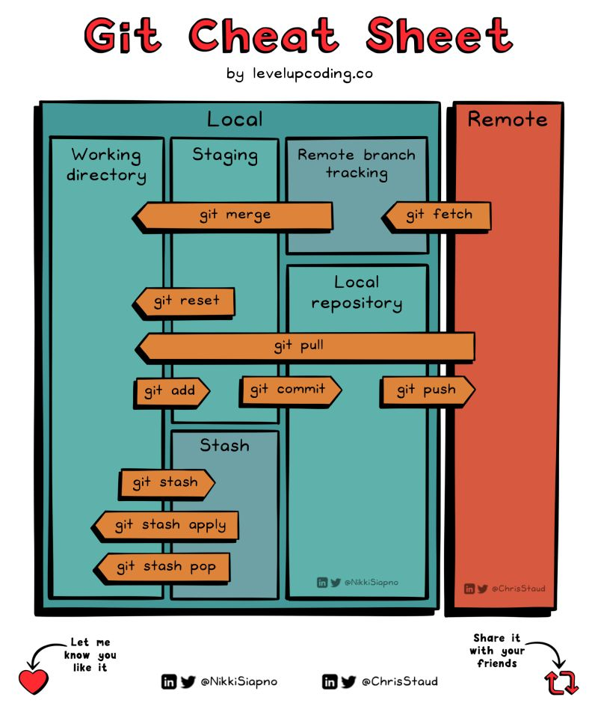

SWITCH BRANCH
To switch branches in Git, the primary commands used are git checkout and, in newer Git versions, git switch.
1. Using git checkout:
Switching to an existing local branch.
Code
git checkout <branch-name>
Replace <branch-name> with the name of the branch you want to switch to.
- Creating and switching to a new local branch:
Code
git checkout -b <new-branch-name>
This command creates a new branch named <new-branch-name> and immediately switches your working directory to it.
- Switching back to the previously active branch:
Code
git checkout -
This command acts as a toggle, switching between your current branch and the branch you were on before the most recent switch.
2. Using git switch (for newer Git versions):
Switching to an existing local branch.
Code
git switch <branch-name>
- Creating and switching to a new local branch:
Code
git switch -c <new-branch-name>
Important considerations before switching branches:
- Uncommitted changes:
If you have uncommitted changes in your current branch, Git will prevent you from switching to another branch to avoid data loss. You must either commit these changes or stash them using git stash before switching.
- Remote branches:
To switch to a remote branch, you may first need to fetch its contents using git fetch origin (or git fetch --all), and then you can switch to it. If you want to create a local tracking branch from a remote one, you can use git checkout -b <local_branch_name> origin/<remote_branch_name> or git switch -c <local_branch_name> origin/<remote_branch_name>.
MERGE
To merge a Git branch into main, switch to the main branch (git checkout main), pull the latest changes from the remote repository (git pull origin main), then merge your feature branch into main using git merge <your-feature-branch-name>. If conflicts arise, resolve them manually, add the resolved files, and then commit and push the changes to update the main branch on the remote repository.
Here's a step-by-step process:
- Switch to the main branch
This ensures you are on the branch you want to merge into.
Code- git checkout main
- Fetch and pull the latest changes
Update your local main branch with the latest changes from the remote repository.
Code- git pull origin main
- Merge your feature branch
Execute the merge command, replacing <your-feature-branch-name> with the name of your feature branch.
Code- git merge <your-feature-branch-name>
- Resolve merge conflicts (if any)
If Git indicates conflicts, open the affected files, manually resolve the conflicting changes, and then stage the resolved files.
Code- git add resolved-file.txt
After resolving all conflicts, complete the merge commit:
Code- git commit
- Push the merged changes
Finally, push the updated main branch to the remote repository.
Code- git push origin main

