**Bus Reservation System Project In C Language**

The C programming language was used to create the Bus Reservation System Project with Source Code. This C-based bus reservation system aids the user in reserving bus tickets.

A bus reservation system source code in C language that allows users to view the bus schedule, book tickets, cancel bookings, and check the bus status board.

**What is Bus Reservation System?**

The Bus Reservation System is a user-friendly online bus booking system that automates online ticket purchases. Integrate our online bus ticketing system into your website to give your client allow your clients to purchase tickets for various nations. You can handle reservations, client data, and passenger lists with the bus ticket reservation system. You can also plan routes, set seat availability, upload an interactive seat map, and allow customers to choose seats.

**Project Details and Technology**

The project’s name is Bus Reservation System, and the project’s specifications and technologies are as follows: The project was developed in C/C++. The programming language used is C. Sourcecodehero.com is the project’s developer, and Dev-C++ or Code Blocks are the recommended IDEs, with a desktop application as the project type. The database of this system only saves data in.DAT files.

| **ABOUT PROJECT** | **PROJECT DETAILS** |
| --- | --- |
| **Project Name :** | Bus Reservation System |
| **Project Platform :** | C |
| **Programming Language Used:** | C Programming Language |
| **Developer Name :** | sourcecodehero.com |
| **IDE Tool (Recommended):** | VS Code |
| **Project Type :** | Desktop Application |
| **Database:** | Stores data in . DAT file |
|  |  |

**What is the importance of the Bus reservation system Project?**

A bus reservation system is an online or mobile software solution that automates the ticket booking and purchasing process for clients while providing a personalized user experience.

**Why do we need a bus reservation system?**

Use a bus ticket reservation system to allow your consumers to order tickets online. The Bus Reservation System is a user-friendly online bus booking system that automates online ticket purchases. … You can handle reservations, client data, and passenger lists with the bus ticket reservation system.

**Who are the beneficiaries of this system?**  The beneficiaries of this system are the bus company and people

The user must first enter the bus number, after which the system will display the entire number of bus seats along with the passengers’ names, and the user must then enter the number of tickets, seat number, and person’s name.

This C software for bus reservations also has a login system, which makes it more stable. There is no risk of data loss or abuse; it only t; item minutes. This bus reservation system mini project in C design is simple and uncomplicated, making it simple to learn, utilize, and navigate for users.

**SOURCE CODE:**

**#include <stdio.h>**

**#include <stdlib.h>**

**#include <string.h>**

**char ch[10][130]={"Cardiff Express","Belfast Express","Derby Express","Chester Express","Newport Express","Truro Express"};**

**char name[32][100]={'\0'};**

**char number[32][2]={'\0'};**

**int num1[32]={0};**

**int trno;**

**void bus();//for list of bus**

**void name_number(int booking,char numstr[100]);**

**void booking();//for booking the tickets**

**int read_number(int trno);//for reading the number from the file**

**void read_name(int trno);//for reading the name from the file**

**void status();//for printing the status by user input**

**void status_1(int trno);//for printing the status while booking ticket**

**void cancle();**

**int main()**

**{**

**login();**

**int num,i;**

**do{**

**system("cls");**

**printf("\n\n\n");**

**printf("====================================== WELCOME TO BUS RESERVATION SYSTEM ======================================\n\n\n");**

**printf("\t\t\t\t\t[1]=> View Bus List\n");**

**printf("\n");**

**printf("\t\t\t\t\t[2]=> Book Tickets\n");**

**printf("\n");**

**printf("\t\t\t\t\t[3]=> Cancle Booking\n");**

**printf("\n");**

**printf("\t\t\t\t\t[4]=> Bus Status Board\n");**

**printf("\n");**

**printf("\t\t\t\t\t[5]=> Exit\n\n");**

**printf("===============================================================================================================\n\n");**

**printf("\t\t\tEnter Your Choice:: ");**

**scanf("%d",&num);**

**switch(num)**

**{**

**case 1:**

**bus();//for list of bus**

**break;**

**case 2:**

**booking();//for booking the tickets**

**break;**

**case 3:**

**cancle();**

**break;**

**case 4:**

**status();**

**break;**

**}**

**getch();**

**}while(num != 5);**

**system("CLS");**

**printf("\t----------------------------------------------------------------------------------------------------------\n");**

**printf("\t\t\t\t\tThank You For Using This System\t\t\t\t\t\t\n");**

**printf("\t----------------------------------------------------------------------------------------------------------\n");**

**printf("\t\t\t Brought To You By code-projects.org");**

**getch();**

**return 0;**

**}**

**void bus()**

**{**

**system("cls");**

**printf("\n\n\n");**

**printf("=========================================== BUS RESERVATION SYSTEM ============================================\n\n\n");**

**printf("\t\t\t\t\t[1] => %s\n",ch[0]);**

**printf("\n");**

**printf("\t\t\t\t\t[2] => %s\n",ch[1]);**

**printf("\n");**

**printf("\t\t\t\t\t[3] => %s\n",ch[2]);**

**printf("\n");**

**printf("\t\t\t\t\t[4] => %s\n",ch[3]);**

**printf("\n");**

**printf("\t\t\t\t\t[5] => %s\n",ch[4]);**

**}**

**void booking()**

**{**

**int i=0;**

**char numstr[100];**

**system("cls");**

**printf("=========================================== BUS RESERVATION SYSTEM ============================================\n\n\n");//for entering train number**

**bus();//for seeing train least**

**printf("Enter the Bus number:--->");**

**scanf("%d",&trno);**

**system("cls");**

**printf("=========================================== BUS RESERVATION SYSTEM ============================================\n\n\n");//for selecting coach**

**printf("Your Bus Number is %d ********** %s",trno,ch[trno-1]);**

**status_1(trno);**

**FILE *f1, *fopen();//for reading the seats from the user.**

**char str1[80]="32",str2[4],str3[4];**

**int seat1,seat2,booking=0;**

**if(trno == 1)**

**{**

**f1 = fopen("tr1.txt","r+");**

**fgets(str1,80,f1);**

**fclose(f1);**

**}else if(trno == 2)**

**{**

**f1 = fopen("tr2.txt","r+");**

**fgets(str1,80,f1);**

**fclose(f1);**

**}else if(trno == 3)**

**{**

**f1 = fopen("tr3.txt","r+");**

**fgets(str1,80,f1);**

**fclose(f1);**

**}**

**else if(trno == 4)**

**{**

**f1 = fopen("tr4.txt","r+");**

**fgets(str1,80,f1);**

**fclose(f1);**

**}**

**else if(trno == 5)**

**{**

**f1 = fopen("tr5.txt","r+");**

**fgets(str1,80,f1);**

**fclose(f1);**

**}**

**seat1=atoi(str1);//covert the string into number**

**if(seat1 <= 0)**

**{**

**printf("There is no blank seat in this bus ");**

**}else**

**{**

**printf("\n\n\n\t\t\t\tAvailable Seats:------>%d\n",seat1);**

**printf("\n\t\t\t\tNumber of Tickets:----->");**

**scanf("%d",&booking);**

**printf("\n");**

**seat1=seat1-booking;**

**itoa(trno,numstr,10);**

**name_number(booking,numstr);**

**printf("\n\t\t\t\tThe Total booking amount is %d",200*booking);**

**itoa(seat1, str1, 10);**

**//for reading the seats from the user.**

**if(trno == 1)**

**{**

**f1 = fopen("tr1.txt","w");**

**fputs(str1,f1);**

**fclose(f1);**

**}**

**else if(trno == 2)**

**{**

**f1 = fopen("tr2.txt","w");**

**fputs(str1,f1);**

**fclose(f1);**

**}**

**else if(trno == 3)**

**{**

**f1 = fopen("tr3.txt","w");**

**fputs(str1,f1);**

**fclose(f1);**

**}**

**else if(trno == 4)**

**{**

**f1 = fopen("tr4.txt","w");**

**fputs(str1,f1);**

**fclose(f1);**

**}**

**else if(trno == 5)**

**{**

**f1 = fopen("tr5.txt","w");**

**fputs(str1,f1);**

**fclose(f1);**

**}**

**}**

**}**

**void name_number(int booking,char numstr[100])**

**{**

**char tempstr[100],tempstr1[12]="status",tempstr2[12]="number";**

**int number;**

**FILE *a,*b;**

**int i=0;**

**strcat(numstr,".txt");**

**strcat(tempstr1,numstr);**

**strcat(tempstr2,numstr);**

**a = fopen(tempstr1,"a");//for open the file to write the name in the file**

**b = fopen(tempstr2,"a");//for open the file for writing the number in the file**

**for(i=0; i<booking; i++)//for entering the person name and seat number in the file**

**{**

**printf("============================Enter the details for ticket no %d============================\n\n\n",i+1);**

**printf("\t\t\t\tEnter the seat number:--->");**

**scanf("%d",&number);**

**printf("\t\t\t\tEnter the name of person:--->");**

**scanf("%s",name[number-1]);**

**printf("\n======================================================================================================\n\n");**

**printf("\n");**

**itoa(number, tempstr, 10);**

**fprintf(a,"%s ",name[number-1]);**

**fprintf(b,"%s ",tempstr);**

**}**

**fclose(a);**

**fclose(b);**

**}**

**int read_number(int trno)//for putting the numeric value in the array**

**{**

**char tempstr[100],tempstr2[12]="number";**

**FILE *a,*b;**

**char numstr[100];**

**int i=0,j=0,k;**

**itoa(trno,numstr,10);**

**strcat(numstr,".txt");**

**strcat(tempstr2,numstr);**

**a = fopen(tempstr2,"a+");//for open the file to write the name in the file**

**while(!feof(a))**

**{**

**number[i][j] = fgetc(a);**

**if(number[i][j] == ' ')**

**{**

**j=0;**

**i++;**

**}**

**else**

**{**

**j++;**

**}**

**}**

**k=i;**

**for(i=0; i<k; i++)**

**{**

**num1[i] = atoi(number[i]);**

**}**

**fclose(a);**

**return k;**

**}**

**void read_name(int trno)//for putting the numeric value in the array**

**{**

**char tempstr1[12]="status";**

**FILE *b;**

**char numstr[100];**

**int i=0,j=0,k=0;**

**itoa(trno,numstr,10);**

**strcat(numstr,".txt");**

**strcat(tempstr1,numstr);**

**b = fopen(tempstr1,"a+");//for open the file to write the name in the file**

**while(!feof(b))**

**{**

**name[i][j] = fgetc(b);**

**if(name[i][j] == ' ')**

**{**

**j=0;**

**i++;**

**}**

**else**

**{**

**j++;**

**}**

**}**

**name[i][j]='\0';**

**k=i;**

**fclose(b);**

**}**

**void status()**

**{**

**system("cls");**

**printf("=========================================== BUS RESERVATION SYSTEM ============================================\n\n\n");**

**int i,trno,index=0,j;**

**printf("Enter the number of bus:---->");**

**scanf("%d",&trno);**

**j=read_number(trno);**

**read_name(trno);**

**printf("____________________________________________________________________________________________________________________\n");**

**printf(" Bus.no-->%d---->%s \n",trno,ch[trno-1]);**

**printf("____________________________________________________________________________________________________________________\n");**

**char tempname[33][10]={"Empty ","Empty ","Empty ","Empty ","Empty ","Empty ","Empty ","Empty ","Empty ","Empty ","Empty ","Empty ","Empty ","Empty ","Empty ","Empty ","Empty ","Empty ","Empty ","Empty ","Empty ","Empty ","Empty ","Empty ","Empty ","Empty ","Empty ","Empty ","Empty ","Empty ","Empty ","Empty ","Empty "};**

**for(i=0; i<j; i++)**

**{**

**strcpy(tempname[num1[i]],name[i]);**

**}**

**for(i=0; i<8; i++)**

**{**

**printf("\t\t\t\t");**

**for(j=0; j<4; j++)**

**{**

**printf("%d.%s\t",index+1,tempname[index+1]);**

**index++;**

**}**

**printf("\n");**

**}**

**}**

**void status_1(int trno)**

**{**

**printf("Your Bus Number is %d ********** %s",trno,ch[trno-1]);**

**system("cls");**

**printf("=========================================== BUS RESERVATION SYSTEM ============================================\n\n\n");**

**int i,index=0,j;**

**j=read_number(trno);**

**read_name(trno);**

**char tempname[33][10]={"Empty ","Empty ","Empty ","Empty ","Empty ","Empty ","Empty ","Empty ","Empty ","Empty ","Empty ","Empty ","Empty ","Empty ","Empty ","Empty ","Empty ","Empty ","Empty ","Empty ","Empty ","Empty ","Empty ","Empty ","Empty ","Empty ","Empty ","Empty ","Empty ","Empty ","Empty ","Empty ","Empty "};**

**for(i=0; i<j; i++)**

**{**

**strcpy(tempname[num1[i]],name[i]);**

**}**

**for(i=0; i<8; i++)**

**{**

**printf("\t\t\t\t");**

**for(j=0; j<4; j++)**

**{**

**printf("%d.%s\t",index+1,tempname[index+1]);**

**index++;**

**}**

**printf("\n");**

**}**

**}**

**void cancle()**

**{**

**int seat_no,i,j;**

**char numstr[100],tempstr2[15]="number",tempstr1[15]="status";**

**printf("Enter the bus number:---->");**

**scanf("%d",&trno);**

**itoa(trno,numstr,10);**

**strcat(numstr,".txt");**

**strcat(tempstr1,numstr);**

**strcat(tempstr2,numstr);**

**read_number(trno);**

**read_name(trno);**

**status_1(trno);**

**printf("Enter the seat number:--->");**

**scanf("%d",&seat_no);**

**FILE *a,*b;**

**a = fopen(tempstr1,"w+");**

**b = fopen(tempstr2,"w+");**

**for(i=0; i<32; i++)**

**{**

**if(num1[i] == seat_no)**

**{**

**for(j=0; j<32; j++)**

**{**

**if(num1[j] != seat_no && num1[j] != 0)**

**{**

**fprintf(b,"%d ",num1[j]);**

**fprintf(a,"%s",name[j]);**

**}**

**else if(num1[j] == seat_no && num1[j] != 0)**

**{**

**strcpy(name[j],"Empty ");**

**}**

**}**

**}**

**}**

**fclose(a);**

**fclose(b);**

**printf("\n\n");**

**printf("======================================================================================================\n");**

**printf("\t\t\t\tYour 200 rupees has been Returned\t\t\t\n");**

**printf("======================================================================================================\n");**

**}**

**void login()**

**{**

**int a=0,i=0;**

**char uname[10],c=' ';**

**char pword[10],code[10];**

**char user[10]="user";**

**char pass[10]="pass";**

**do**

**{**

**system("cls");**

**printf("\n ========================= LOGIN FORM ========================= ");**

**printf(" \n ENTER USERNAME:-");**

**scanf("%s", &uname);**

**printf(" \n ENTER PASSWORD:-");**

**while(i<10)**

**{**

**pword[i]=getch();**

**c=pword[i];**

**if(c==13) break;**

**else printf("*");**

**i++;**

**}**

**pword[i]='\0';**

**//char code=pword;**

**i=0;**

**//scanf("%s",&pword);**

**if(strcmp(uname,"user")==0 && strcmp(pword,"pass")==0)**

**{**

**printf(" \n\n\n WELCOME TO OUR SYSTEM !!!! LOGIN IS SUCCESSFUL");**

**printf("\n\n\n\t\t\t\tPress any key to continue...");**

**getch();//holds the screen**

**break;**

**}**

**else**

**{**

**printf("\n SORRY !!!! LOGIN IS UNSUCCESSFUL");**

**a++;**

**getch();//holds the screen**

**}**

**}**

**while(a<=2);**

**if (a>2)**

**{**

**printf("\nSorry you have entered the wrong username and password four times!!!");**

**getch()**

**}**

**system("cls");**

**}**

**Major Functionalities Used in Bus Reservation System using C**

The time needed: 5 minutes.

The following are the basic functionalities of the Bus Reservation System Project in C with Source

* **LOGIN FORM**

When you start the project from any compiler or by double-clicking the executable.exe file, you’ll see the screen shown in low is Login scdirectdow.   
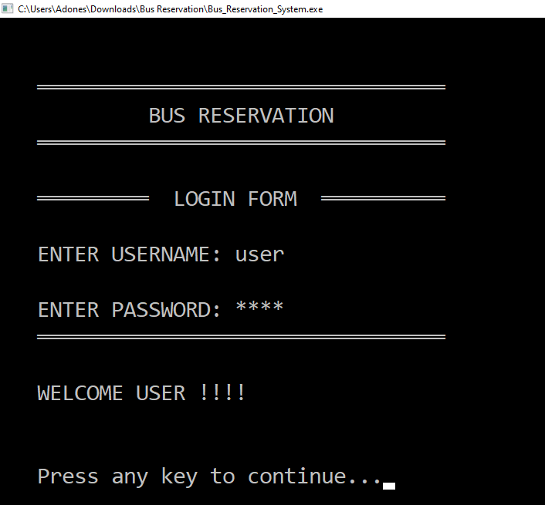

* **MAIN MENU**

After you log in it will direct you to the main menu of bus reservations it’s composed of viewing bus the list, bookbookingkets, can canceling booking, bus status board, and exitexiting**IEW BUS LIST**

If you press number 1 it means you will VA new bus list. The image below is theanample of a view bus list.  
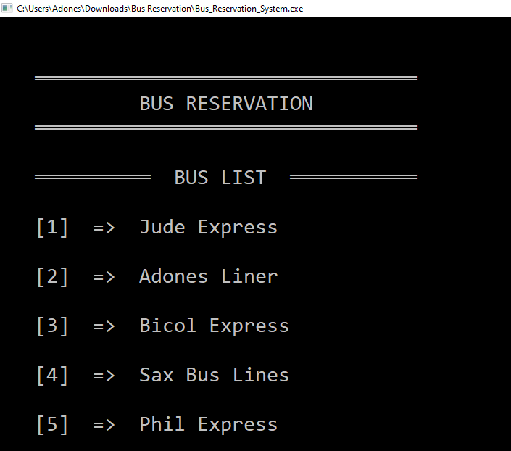

* **BOOK TICKETS**

In thfor e image below, which is for the booking tickets for the bus.  
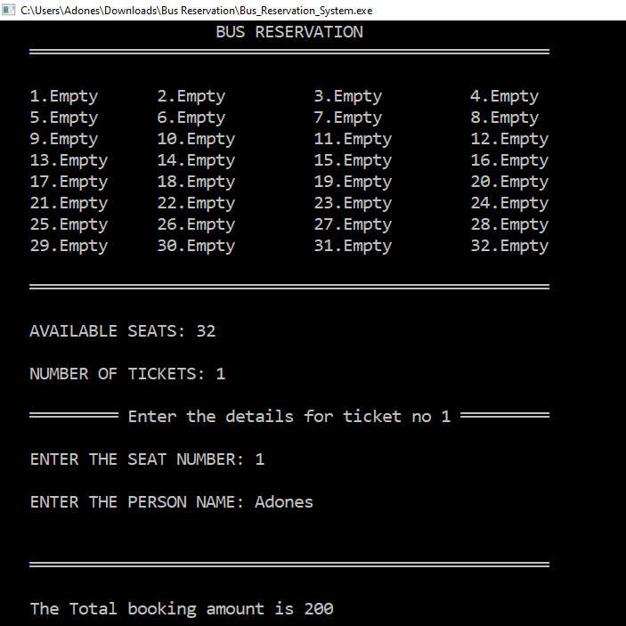

* **CANCEL BOOKING**

The image below is for the canceled booking of the bus.  
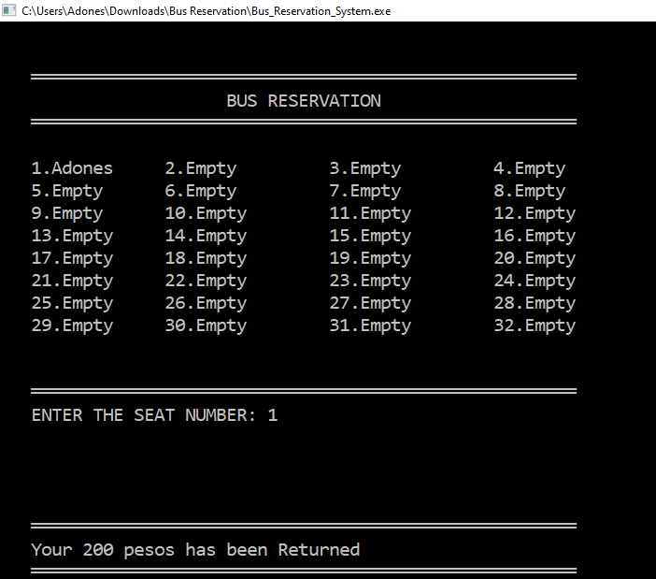

[Download Now](https://sourcecodehero.com/wp-content/uploads/2021/11/Bus-Reservation-System-Project-In-C.zip)

**Conclusion:**

**This system is based on the concept to reserve bus tickets. From this system, the user can view the bus list, book tickets, cancel bookings and check the bus status board. While booking tickets, the user has to enter the bus number then the system displays total bus seat numbers with the passenger’s name and the user has to enter the number of tickets, seat number, and name of the person. Here, cancel booking also features refunding. A login system is also available in this system to make it more secure. There’s no chance of data misuse or loss & it’s not time-consuming. The whole project is developed in ‘C’ Programming language, and different variables and strings have been used for the development of this project. It’s easy to operate and understand by users.**