Week one: Design Patterns and Principles

Exercise 1: Implementing the Singleton Pattern Scenario:

You need to ensure that a logging utility class in your application has only one instance throughout the application lifecycle to ensure consistent logging.

CODE:

File: Logger.java

public class Logger {

private static Logger instance;

private Logger() {

System.out.println("Instance is created");

}

public static Logger getInstance() {

if (instance == null) {

instance = new Logger();

}

return instance;

}

}

File: LoggerSafe.java

public class LoggerSafe {

private LoggerSafe() {

System.out.println("Instance Created");

}

private static class SafeInstanceCreator {

private static final LoggerSafe INSTANCE = new LoggerSafe();

}

public static LoggerSafe getInstance() {

return SafeInstanceCreator.INSTANCE;

}

}

File: Test.java

public class Test {

public static void main(String[] args) {

System.out.println("Hello World");

// Unsafe version

Logger obj1 = Logger.getInstance();

Logger obj2 = Logger.getInstance();

if (obj2 == obj1) {

System.out.println("Same instance");

} else {

System.out.println("Different instances");

}

// Safer version

LoggerSafe obj3 = LoggerSafe.getInstance();

LoggerSafe obj4 = LoggerSafe.getInstance();

if (obj4 == obj3) {

System.out.println("Same safe instance");

} else {

System.out.println("Different safe instances");

}

}

}

OUTPUT:

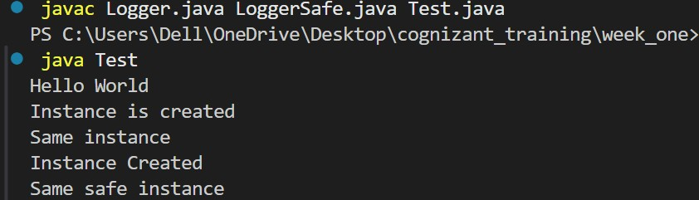

Exercise 2: Implementing the Factory Method Pattern Scenario:

You are developing a document management system that needs to create different types of documents (e.g., Word, PDF, Excel). Use the Factory Method Pattern to achieve this.

CODE:

File: main.java

public class Main {

public static void main(String[] args) {

System.out.println("Hello world");

WordDocumentFactory wdf = new WordDocumentFactory();

Document wordDoc = wdf.createDocument();

wordDoc.open();

PDFDocumentFactory pdfFactory = new PDFDocumentFactory();

Document pdfDoc = pdfFactory.createDocument();

pdfDoc.open();

ExcelDocumentFactory excelFactory = new ExcelDocumentFactory();

Document excelDoc = excelFactory.createDocument();

excelDoc.open();

}

}

File: Document.java

public interface Document {

void open();

}

File: DocumentFactory.java

public abstract class DocumentFactory {

public abstract Document createDocument();

}

File: PDFDocument.java

public class PDFDocument implements Document {

public void open() {

System.out.println("Opening PDF document...");

}

}

File: ExcelDocument.java

public class ExcelDocument implements Document {

public void open() {

System.out.println("Opening Excel document...");

}

}

File: WordDocument.java

public class WordDocument implements Document {

public void open() {

System.out.println("Opening word document...");

}

}

File: PDFDocumentFactory.java

public class PDFDocumentFactory extends DocumentFactory {

public Document createDocument() {

return new PDFDocument();

}

}

File: ExcelDocumentFactory.java

public class ExcelDocumentFactory extends DocumentFactory {

public Document createDocument() {

return new ExcelDocument();

}

}

File: WordDocumentFactory.java

public class WordDocumentFactory extends DocumentFactory {

public Document createDocument() {

return new WordDocument();

}

}

OUTPUT:

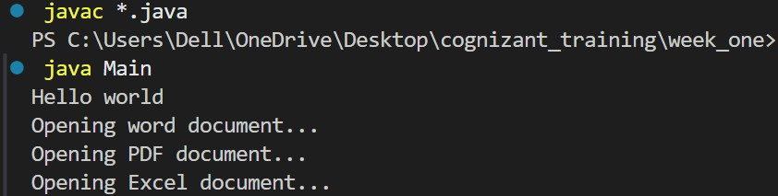

Week one: Algorithms Data Structures

Exercise 2: E-commerce Platform Search Function Scenario:

You are working on the search functionality of an e-commerce platform. The search needs to be optimized for fast performance.

CODE:

File: Product.java

public class Product {

int productID;

String productName;

String category;

public Product(int productID, String productName, String category) {

this.productID = productID;

this.productName = productName;

this.category = category;

}

@Override

public String toString() {

return "Product{" +

"ID=" + productID +

", Name='" + productName + '\'' +

", Category='" + category + '\'' +

'}';

}

}

File: Products.java

import java.util.Comparator;

import java.util.List;

public class Products {

public Product findNameLs(List<Product> products, String pName) {

for (Product x : products) {

if (x.productName.equalsIgnoreCase(pName)) {

return x;

}

}

return null;

}

public Product findNameBs(List<Product> products, String pName) {

products.sort(Comparator.comparing(x -> x.productName.toLowerCase()));

int s = 0;

int e = products.size() - 1;

while (s <= e) {

int mid = (s + e) / 2;

Product miProduct = products.get(mid);

int comp = pName.compareToIgnoreCase(miProduct.productName);

if (comp == 0)

return miProduct;

else if (comp > 0)

s = mid + 1;

else

e = mid - 1;

}

return null;

}

public Product findIDLs(List<Product> products, int pID) {

for (Product x : products) {

if (x.productID == pID) {

return x;

}

}

return null;

}

public Product findIDBs(List<Product> products, int pID) {

products.sort(Comparator.comparingInt(x -> x.productID));

int s = 0;

int e = products.size() - 1;

while (s <= e) {

int mid = (s + e) / 2;

Product miProduct = products.get(mid);

if (miProduct.productID == pID)

return miProduct;

else if (miProduct.productID < pID)

s = mid + 1;

else

e = mid - 1;

}

return null;

}

public Product findCategoryLs(List<Product> products, String pCategory) {

for (Product x : products) {

if (x.category.equalsIgnoreCase(pCategory)) {

return x;

}

}

return null;

}

public Product findCategoryBs(List<Product> products, String pCategory) {

products.sort(Comparator.comparing(x -> x.category.toLowerCase()));

int s = 0;

int e = products.size() - 1;

while (s <= e) {

int mid = (s + e) / 2;

Product miProduct = products.get(mid);

int comp = pCategory.compareToIgnoreCase(miProduct.category);

if (comp == 0)

return miProduct;

else if (comp > 0)

s = mid + 1;

else

e = mid - 1;

}

return null;

}

}

File: TestSearch.java

import java.util.ArrayList;

import java.util.List;

public class TestSearch {

static List<Product> products = new ArrayList<>();

public static void main(String[] args) {

products.add(new Product(101, "Laptop", "Electronics"));

products.add(new Product(102, "Shoes", "Fashion"));

products.add(new Product(103, "Notebook", "Educational"));

products.add(new Product(104, "Table", "Furniture"));

products.add(new Product(105, "Fan", "Electornics")); // Note: typo in category

Products pro = new Products();

Product prName = pro.findNameBs(products, "laptop");

Product prID = pro.findIDBs(products, 103);

Product prCategory = pro.findCategoryLs(products, "Furniture");

System.out.println(prName);

System.out.println(prID);

System.out.println(prCategory);

}

}

OUTPUT:

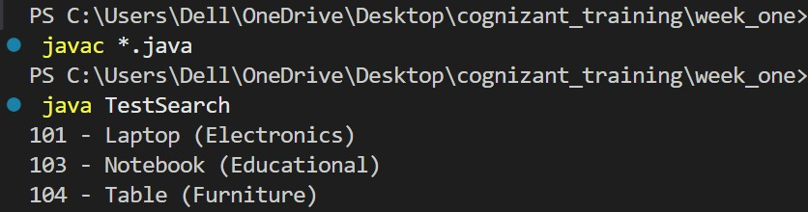

Time Complexity Analysis:

Linear Search –

Best case: O(1)

Average case: O(n)

Worst case: O(n)

Binary Search –

Best case: O(1)

Average case: O(log n)

Worst case: O(log n)

From comparing the Best case, Average case, Worst case of the linear and binary search we conclude that the most efficient algorithm is Binary Search.

Therefor we should use Binary Search as its more efficient and consumes less time in running the program.

Exercise 7: Financial Forecasting Scenario:

You are developing a financial forecasting tool that predicts future values based on past data

CODE:

File: Forecast.java

public class Forecast {

public static void main(String[] args) {

FinancialForecast ffc = new FinancialForecast();

double initialInvestment = 1000.0;

double growthRate = 0.05;

int forecastYears = 5;

double ans = ffc.iterativeFF(initialInvestment, growthRate, forecastYears);

System.out.printf("The predicted value of the investment is: %.2f", ans);

}

}

File: FinancialForecast.java

public class FinancialForecast {

public double forecast(double presentValue, double rate, int years) {

if (years == 0) return presentValue;

double pV = presentValue \* (rate + 1);

return forecast(pV, rate, years - 1);

}

public double iterativeFF(double presentValue, double rate, int years) {

return presentValue \* Math.pow(1 + rate, years);

}

}

OUTPUT:

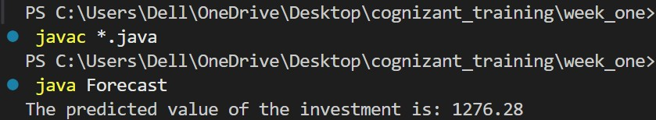

Concept:

Recurssion is a algorithm which helps in exploring all the possible answer the recursion consist of two part: base case part – to stop the recursion

recursive part – to recursively explore all the possibilities

for calculating the future value of the initial investment, we are using the formula future value = initial investment \* (1 + rate%) ^ years

Pros:

Recurssion explore all the possible outcomes this helps in finding the most global solution.

Cons:

The time complexity of the recursion Is usually too much compared to other solution, also it uses extra stack space for finding the answer.

We can optimize the recursive solution by iterative operation using the pow function of Math class.

Time complexity:

Recurssion: Worst case TC – O(n) n: no. of years Iteration:

Worst case TC – O(n)

(Due to the use of the pow function)

Space complexity:

Recurssion: Worst case SC – O(n) Iteration:

Worst case SC – O(1)