Blockcahin

Question 1:-

Experiment with Anders Blockchain.

1)to single window

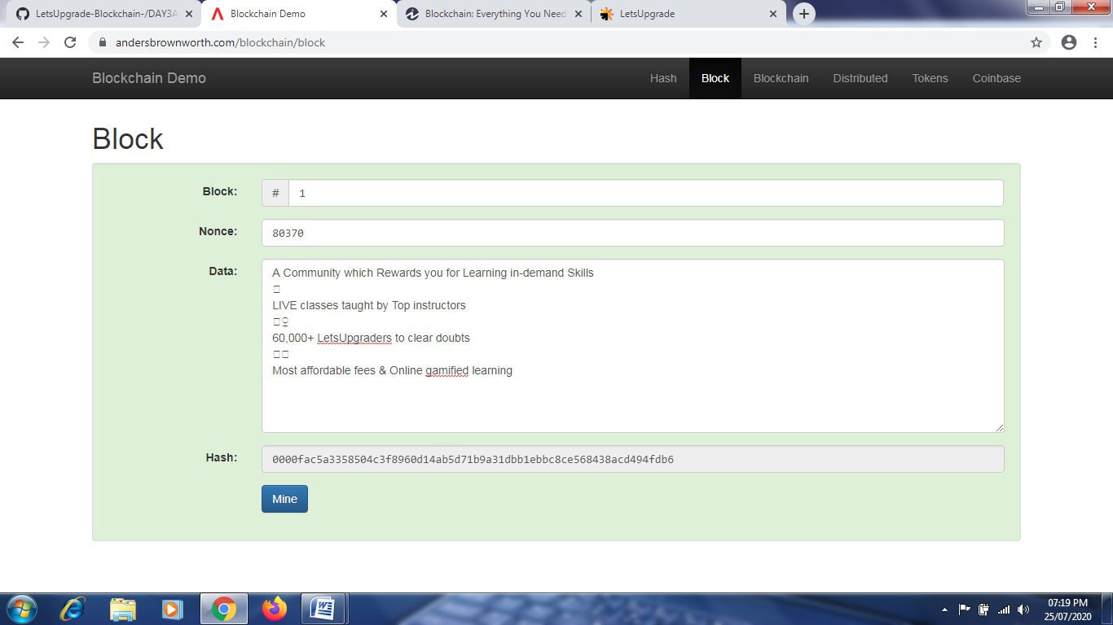

2)to multiple

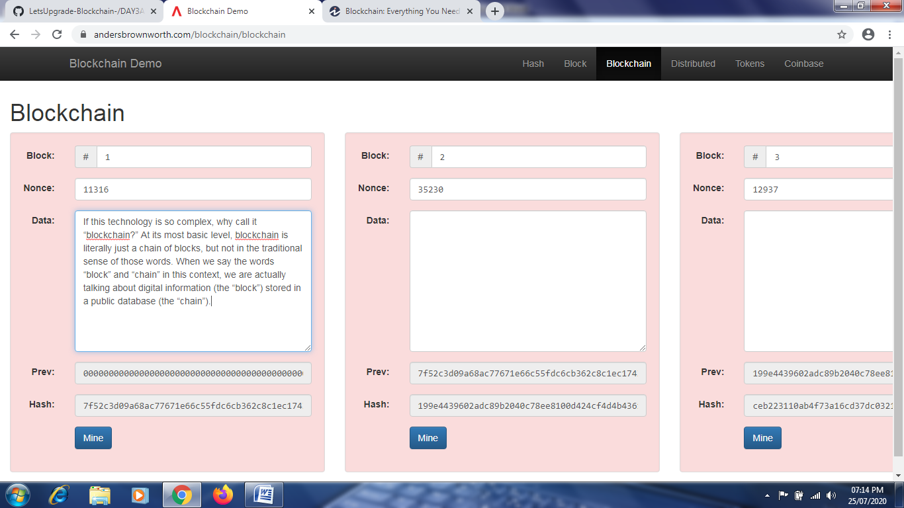

Question 2:-

Make a Sample contract on Remix.Ethereum.org and publish it in your Github

