**Future Interns _CS_02**

**Gophish**

**Step 1:**

Please create a new Gmail account for the implementation of the phishing attack, and then we need to get the App passwords by clicking Gmail settings, then enable two-factor authentication. After enabling two-factor authentication, we can get the app passwords options. Then type gophish, we get the app password for that, then log in to gophish.

**Step 2:**

Next, create sending profiles in Gophish. Enter the Name and set the Interface type to SMTP since we will be using Gmail. In the host field, be sure to enter smtp.gmail.com:587. Then, click on Send Test Email to verify if it is functioning correctly. If it is working properly, we will receive a notification stating, "Email sent."

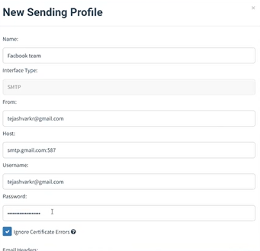

Step 3:

Create a Landing page and give a name for the landing Page, then click on import site and copy the URL of your landing page and paste it there.

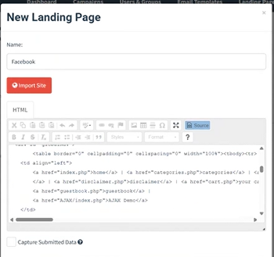

Step 4:

Now we have to create an email template, this is how mail will be sent to the user, after creating email templates then click on users and groups, then select add user, where you add the mail id to whom you want to send, if you want to send the mail to multiple users click on import bulk users

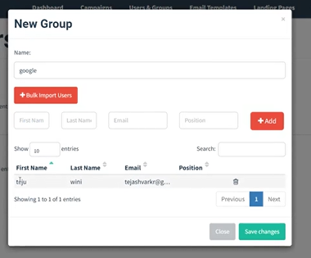

Step 5:

If all the steps are done correctly. We will get, message notifying us that the campaign has launched successfully, then we can view the details in the dashboard

