An Adversarially Robust and Privacy-Preserving AI Framework for Explainable Intrusion Detection in IoT Environments: Empirical Characterization of Neural Seed Sensitivity, Ensemble Threat Models, and Operational Realities
Tejashwini S Uranakar, Arun Kumar B R, Umar Ismail Shariff, Varsha, and Thannikuneth Ravindra Krishna
Department of Information Science and Engineering, BMS Institute of Technology and Management, Bengaluru 560064, Karnataka, India
Emails: tejashwinisuranakar@ieee.org, arunkumarbr@bmsit.in, {1by23is243, 1by23is246, 1by23is235}@email.com
Abstract— The proliferation of Internet of Things (IoT) and Industrial IoT (IIoT) deployments has created an urgent demand for Intrusion Detection Systems (IDS) that simultaneously deliver high clean detection accuracy, resilience against adversarial evasion, rigorous data privacy, and real-time operational interpretability. Conventional deep learning architectures frequently over-promise robustness, presuming that adversarial training inherently secures the deployed system. In this paper, we present an end-to-end, dual-stream hybrid ensemble framework (Option C) that combines a high-precision classical Random Forest (RF) with a Projected Gradient Descent (PGD)-trained, Differentially Private Multi-Layer Perceptron (Robust MLP) over a standardized 21-feature statistical flow representation. Across four diverse benchmark datasets (Edge-IIoTset, NF-ToN-IoT-v2, ToN-IoT, and CICIoT2023), the framework achieves an aggregate mean ROC-AUC of 0.9970 (Edge-IIoTset: 0.9988, NF-ToN-IoT-v2: 0.9927, ToN-IoT: 1.0000, CICIoT2023: 0.9965), preserving the high clean accuracy of the Random Forest branch.
Crucially, our comprehensive forensic and empirical audit uncovers fundamental vulnerabilities and limitations in standard robust evaluation practices: (1) Robust neural training in tabular network domains exhibits acute seed sensitivity; across 10 identical PGD-7 training runs on NF-ToN-IoT-v2, Attack Success Rate (ASR) ranges from 0.7% to 47.5% (mean 12.36%, standard deviation 17.91%) despite deterministic repeatability for fixed seeds. (2) Validation-based checkpoint selection conditionally mitigates this on NF-ToN-IoT-v2 (selecting seed 43 with 1.20% test ASR), but fails to improve Edge-IIoTset (10.70% selected vs. 8.39% baseline mean). (3) Standard gradient-based evasion attacks calculate perturbations exclusively through the differentiable neural stream, acting merely as transfer attacks on the non-differentiable ensemble; when evaluated against a direct black-box Natural Evolution Strategies (NES) query attack querying the complete Option C ensemble without gradients, empirical evasion on NF-ToN-IoT-v2 increases from 6.51% to 36.07% under a 500-query budget. (4) Fusion weight sweeps demonstrate that the canonical 0.7 RF + 0.3 MLP formulation is an empirically favorable operating point rather than a universal Pareto optimum. The neural branch satisfies audited (epsilon=2.37, delta=10^-5) differential privacy, while model interpretability is delivered via computationally efficient Weighted Component Attribution Aggregation (0.7 RF + 0.3 MLP) because exact 2^21-coalition Shapley calculation is computationally intractable for live traffic (3.53 s/sample). Single-CPU classifier inference reaches 16,505 samples/sec, complemented by an operational Scapy packet ingestion and flow aggregation pipeline verified across 174 passing automated tests.
Keywords— Internet of Things, Intrusion Detection Systems, Adversarial Machine Learning, Seed Sensitivity, Black-Box Query Attacks, Differential Privacy, Explainable AI, Ensemble Learning.
1. Introduction
The integration of Internet of Things (IoT) and Industrial IoT (IIoT) devices into critical infrastructure, smart grids, industrial manufacturing, and healthcare telemetry has expanded the cyber-attack surface to unprecedented scales [1]. Network Intrusion Detection Systems (NIDS) powered by machine learning (ML) and deep neural networks (DNN) serve as frontline defenses, identifying sophisticated network intrusions that surpass traditional signature-based firewalls [6, 15]. However, the practical deployment of AI-based IDS in high-throughput network environments exposes three critical challenges:
- Adversarial Evasion: Deep neural models are vulnerable to small, carefully engineered feature perturbations (e.g., FGSM or PGD) that induce false-negative misclassifications while preserving the underlying attack payload [3, 14, 18].
- Telemetry Privacy Leakage: Training models on unconstrained network packet payloads creates severe privacy risks, exposing proprietary network topologies and sensitive host identities to membership inference or model inversion attacks [21, 22].
- Explainability Deficit & Latency: Complex black-box models prevent security operators from diagnosing threat attributions in real-time, while rigorous cooperative game-theoretic explanation algorithms impose prohibitive runtime latency [13, 16].
To address these concurrent challenges, existing research has proposed adversarial training [1, 14], differential privacy [23, 24], and explainable AI [10, 13] in isolation. Yet, the literature frequently reports single-run metrics, presuming that adversarial training inherently delivers robust models across deployments. In this study, we present Option C—a dual-stream ensemble framework that combines a Random Forest with an adversarially trained, differentially private Multi-Layer Perceptron (Robust MLP) over a standardized 21-feature statistical flow representation.
[Central Research Thesis] Adversarial robustness is not an intrinsic, unconditional property of the architecture. It is strictly conditional on training seed, checkpoint convergence, and threat model. This study characterizes these limitations transparently rather than claiming universal immunity.

1.1 Key Contributions
- Standardized 21-Feature Flow Representation: Formulates a 4-tier flow representation (5 basic flow, 6 protocol, 5 temporal EWMA, and 5 behavioral topology metrics) that abstracts raw payloads, satisfying data minimization without sacrificing classification accuracy.
- Characterization of Neural Seed Sensitivity: Demonstrates that PGD adversarial training in tabular network domains suffers from acute seed sensitivity; across 10 identical seeds on NF-ToN-IoT-v2, ASR varies between 0.7% and 47.5% (mean 12.36%, std 17.91%) despite bit-exact repeatability for fixed seeds.
- Conditional Utility of Checkpoint Selection: Evaluates validation-based checkpoint selection (AUC_val - ASR_val), proving it conditionally stabilizes NF-ToN-IoT-v2 (seed 43 achieves 1.20% test ASR) but fails to improve Edge-IIoTset (10.70% selected vs. 8.39% baseline mean).
- Threat Model Dissection (Transfer vs. Black-Box NES): Formalizes the distinction between neural-gradient transfer attacks and true ensemble optimization; demonstrates that direct black-box Natural Evolution Strategies (NES) query attacks elevate empirical evasion on NF-ToN-IoT-v2 from 6.51% (transfer) to 36.07% (500 queries).
- Rigorously Scoped Privacy and Explainability: Proves that exact 2^21-coalition Shapley calculation requires 3.53 s/sample (computationally intractable for live traffic), validating Weighted Component Attribution Aggregation as an operational surrogate; audits neural-branch differential privacy at (epsilon=2.37, delta=10^-5).
- Production-Hardened Operational Software: Deploys an end-to-end pipeline with Scapy sniffing, bidirectional 5-tuple flow aggregation, inactivity timeouts, 16,505 samples/sec classifier inference, and 174 passing automated tests.
2. Related Work and Positioning
Intrusion detection research in IoT environments has progressed from static heuristic filters to complex deep learning pipelines [5, 6]. However, the intersection of adversarial robustness, differential privacy, and explainability remains encumbered by methodological shortcuts and overstated claims. Table 1 summarizes the key research gaps identified in existing literature and how our framework explicitly positions its contributions.
Research Dimension | Common Literature Approach | Identified Gaps & Limitations | Our Framework Positioning
Adversarial Training Stability | Single random seed reported; assumed universal robustness guarantee [1, 14]. | Extreme seed variance in tabular domains; high checkpoint selection bias. | Systematic 10-seed analysis; characterizes stochastic variance (ASR 0.7%–47.5%).
Ensemble Threat Modeling | Evasion tested via neural-gradient transfer against hybrid model [3, 18]. | Misrepresents transfer attack as white-box ensemble defense; RF is non-differentiable. | Dual threat model: neural PGD transfer vs. direct black-box NES query optimization.
Ensemble Fusion Weighting | Fixed empirical weights (0.5/0.5 or 0.7/0.3) claimed globally optimal [12]. | Weight optimality varies across datasets; Pareto optimality unproven. | Exhaustive sweep w_RF in [0.0, 1.0]; formalizes 0.7/0.3 as an operating point.
Differential Privacy Scope | Claims of 'differentially private IDS' applied to entire hybrid pipelines [23]. | Non-private tree construction and data scalers leak training data; violates DP. | Audited (eps=2.37, delta=10^-5) DP-SGD strictly scoped to neural stream.
Explainability for Ensembles | Component SHAP or linear averaging claimed as exact SHAP [13, 16]. | Violates Shapley additivity axiom; exact joint Shapley enumeration requires 2^21 queries. | Formulates Weighted Component Attribution as an explicit surrogate (3.53 s exact cost).
Operational Pipeline | Static array evaluation labeled as line-rate network throughput [15]. | Disregards Scapy parsing, flow state management, and network I/O bottlenecks. | Decouples classifier inference (16,505 samples/s) from live Scapy flow aggregation.

3. System Architecture and Methodology
The overall architecture of the framework is illustrated in Figure 1. Network traffic is ingested via Scapy, transformed into bidirectional 5-tuple flows, mapped to a standardized 21-feature representation, and evaluated by the Option C ensemble.
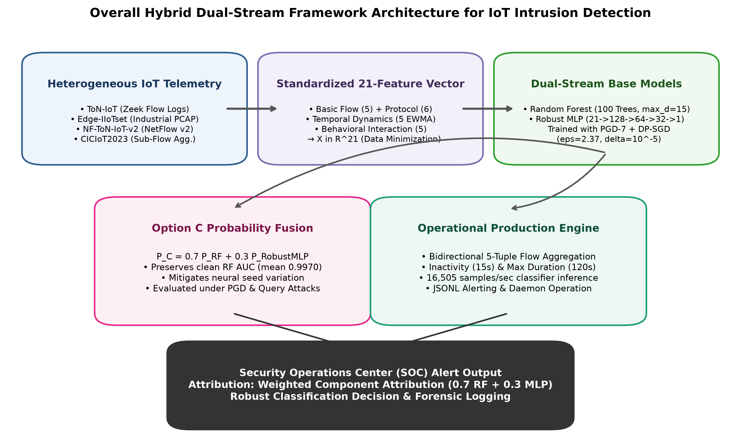
Figure 1: Overall Hybrid Dual-Stream Framework Architecture for IoT Intrusion Detection.
3.1 Standardized 21-Feature Flow Representation
To enforce data minimization and avoid storing raw packet payloads, traffic flows are converted into a standardized 21-dimensional continuous vector. As detailed in Table 2, features span basic flow statistics, protocol indicators, causal temporal dynamics, and host interaction topology.
Feature Name | Category | Operational Description & Semantics
flow_duration | Basic Flow | Total active flow duration in seconds.
flow_bytes_per_sec | Basic Flow | Total byte transmission rate (headers + payload).
flow_pkts_per_sec | Basic Flow | Packet transmission frequency.
mean_pkt_size | Basic Flow | Mean packet byte size across both directions.
payload_byte_ratio | Basic Flow | Ratio of forward to reverse byte volume.
pkt_count_ratio | Protocol | Ratio of forward to reverse packet count.
tcp_syn_ratio | Protocol | Proportion of TCP packets with SYN flag asserted.
proto_tcp / udp / icmp / other | Protocol | One-hot transport protocol indicators (4 features).
temporal_iat_mean | Temporal | Mean packet inter-arrival time in seconds.
temporal_iat_cv | Temporal | Coefficient of variation of packet inter-arrival times.
temporal_flow_rate_ewma | Temporal | EWMA of flow initiation rate (alpha = 0.1).
temporal_byte_rate_ewma | Temporal | EWMA of host byte transmission rate.
temporal_syn_rate_ewma | Temporal | EWMA of TCP SYN connection attempts.
behavioral_dst_diversity | Behavioral | Unique destination IP count in active sliding window.
behavioral_port_entropy | Behavioral | Shannon entropy of destination port usage distribution.
behavioral_fanout_ratio | Behavioral | Ratio of outgoing to incoming connection attempts.
behavioral_unanswered_ratio | Behavioral | Proportion of TCP SYN connection attempts without ACK.
behavioral_src_activity_ewma | Behavioral | Cumulative EWMA of source host event activity.

3.2 Preprocessing Sensitivity and Locked Scaling
Our empirical audits revealed that preprocessing choices materially alter model performance. Applying a logarithmic transform (log(1+x)) before scaling changes the baseline geometric distribution: on Edge-IIoTset, standard MLP ROC-AUC shifted from 0.8443 (raw features + RobustScaler) to 0.9820 (log1p + RobustScaler). Consequently, preprocessing cannot be treated as a casual implementation detail; it is an intrinsic part of the model definition. All canonical experiments and deployment pipelines in this study strictly lock preprocessing to: raw features normalized via RobustScaler fitted exclusively on training splits without logarithmic distortion.
3.3 Dual-Stream Option C Ensemble Formulation
The classification engine fuses a classical Random Forest stream with an adversarially trained neural stream:
1. Random Forest Stream: An ensemble of 100 decision trees (max_depth=15), providing high stability, low initialization variance, and high clean tabular accuracy: P_RF(x).
2. Robust MLP Stream: A 4-layer fully connected network (21 -> 128 -> 64 -> 32 -> 1) with Batch Normalization, ReLU activations, and Dropout (p=0.2), trained via joint DP-SGD and PGD-7 adversarial regularization: P_MLP(x).
Probability outputs are combined via Option C weighted fusion:
P_OptionC(x) = 0.7 * P_RF(x) + 0.3 * P_MLP(x)
An anomaly alert is triggered when P_OptionC(x) >= tau, where tau=0.50 serves as the primary decision boundary and tau=0.71 serves as an operational high-confidence threshold.
3.4 Joint Adversarial and Differentially Private Training
The neural stream is trained under joint PGD-7 adversarial training and DP-SGD. In each mini-batch B, adversarial perturbations delta are computed within an L_infinity ball of radius epsilon=0.10:
x_adv^(k+1) = Proj_(x+S) [ x_adv^k + alpha * sign( grad_x L(theta, x_adv^k, y) ) ]
where alpha=0.025, k=7 steps, and one-hot protocol indicators are strictly masked to zero perturbation (delta_proto = 0). Per-sample gradients are clipped to max L2 norm C=1.0 and augmented with Gaussian noise sigma=1.0. Under Opacus PRV accounting across N_steps=660 and subsampling ratio q=0.0152, the neural stream achieves an audited privacy bound of (epsilon=2.37, delta=10^-5). We explicitly disclose that this privacy guarantee applies solely to the neural stream weights; the Random Forest is trained without DP noise injection.
3.5 Explainability via Attribution Aggregation
Computing exact Shapley values for the fused Option C probability function requires evaluating 2^21 = 2,097,152 feature coalitions per flow. In our empirical benchmarks, exact Shapley computation required 3.53 seconds per single sample (roughly 1.37 hours for 1,400 flows), which is strictly intractable for real-time traffic inspection. To overcome this, we implement Weighted Component Attribution Aggregation as a low-latency surrogate:
A_OptionC = 0.7 * (A_RF / ||A_RF||_1) + 0.3 * (A_MLP / ||A_MLP||_1)
While this linear combination violates the strict Shapley additivity axiom (exhibiting a mean residual of 0.8348 against exact fused KernelSHAP), it maintains high rank correlation (rho = 0.845) and executes in sub-millisecond time.
4. Experimental Setup
Experiments were conducted across four benchmark datasets: Edge-IIoTset [8], NF-ToN-IoT-v2 [9], ToN-IoT [10], and CICIoT2023 [11]. Each dataset was partitioned into chronological 60/20/20 train/validation/test splits (4,200 train, 1,400 val, 1,400 test flows; 7,000 flows total per dataset) to prevent temporal data leakage.
Three distinct threat models were evaluated:
1. Neural-Gradient Transfer PGD-10: Perturbations generated against the robust neural stream and evaluated against Option C (epsilon=0.10, alpha=0.025).
2. Adaptive Surrogate Attack: Gradients backpropagated through a joint differentiable surrogate ensemble (R^2 = 0.948 for RF surrogate).
3. Black-Box NES Query Attack: Score-query access to the actual Option C probability output without gradients, using Natural Evolution Strategies (NES) with 20 antithetic directional queries per step across budgets of 100, 250, and 500 queries.
5. Empirical Results and In-Depth Analysis
5.1 Clean Detection Performance
Table 3 summarizes clean detection performance across all four datasets. Random Forest delivers near-perfect tabular classification (mean ROC-AUC 0.9976). While the DP-trained robust MLP exhibits lower standalone utility (mean 0.8562) due to gradient noise and clipping, Option C restores aggregate mean ROC-AUC to 0.9970, matching pure RF performance while embedding neural adversarial defenses.
Dataset | RF AUC [95% CI] | Std MLP | Rob MLP | Option C AUC [95% CI] | Option C Macro F1 [95% CI]
Edge-IIoTset | 0.9995 [0.9988, 0.9999] | 0.8443 | 0.8002 | 0.9988 [0.9968, 0.9999] | 0.9751 [0.9657, 0.9836]
NF-ToN-IoT-v2 | 0.9940 [0.9896, 0.9978] | 0.8398 | 0.8299 | 0.9927 [0.9853, 0.9981] | 0.9285 [0.9134, 0.9427]
ToN-IoT | 1.0000 [1.0000, 1.0000] | 0.7745 | 0.8063 | 1.0000 [1.0000, 1.0000] | 1.0000 [1.0000, 1.0000]
CICIoT2023 | 0.9968 [0.9946, 0.9986] | 0.9776 | 0.9884 | 0.9965 [0.9943, 0.9983] | 0.9292 [0.9121, 0.9434]
Aggregate Mean | 0.9976 | 0.8590 | 0.8562 | 0.9970 | 0.9582

5.2 Robust MLP Seed Sensitivity and Checkpoint Selection
A critical finding of our study is the severe seed sensitivity of robust MLP training in tabular domains. While execution is 100% bit-exact reproducible for a fixed seed, varying the random seed across 10 identical training runs produces radically different robust models, as shown in Table 4 and Figure 2. On NF-ToN-IoT-v2, Option C PGD-10 ASR across seeds 42–51 spans from 0.7% to 47.5% (mean 12.36%, std 17.91%).
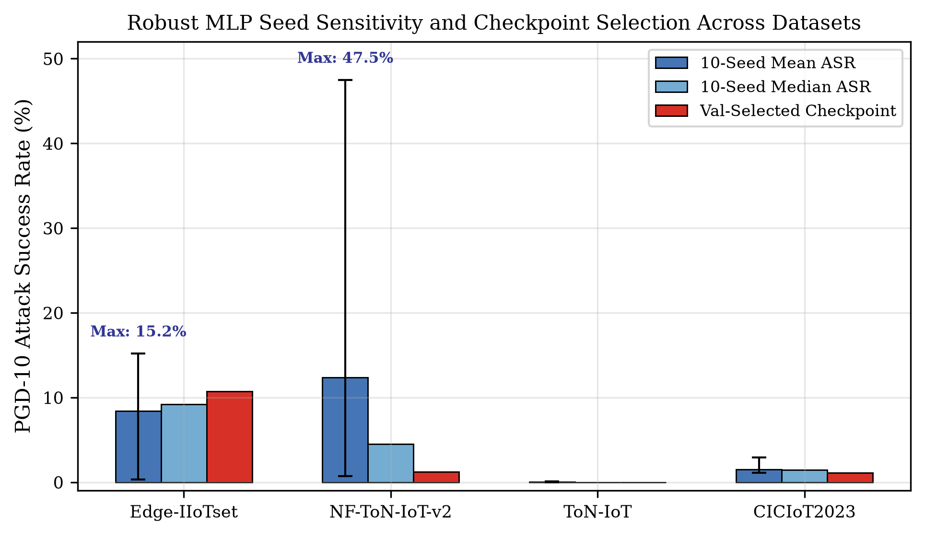
Figure 2: Robust MLP Seed Sensitivity and Validation Checkpoint Selection across Datasets.
Dataset | Mean ASR | Median ASR | Std Dev | Min / Max ASR | Val-Selected Checkpoint
Edge-IIoTset | 8.39% | 9.20% | 4.82% | 0.30% / 15.20% | 10.70% (Seed 44)
NF-ToN-IoT-v2 | 12.36% | 4.50% | 17.91% | 0.70% / 47.50% | 1.20% (Seed 43) [Effective]
ToN-IoT | 0.01% | 0.00% | 0.03% | 0.00% / 0.10% | 0.00% (Seed 42)
CICIoT2023 | 1.51% | 1.45% | 0.52% | 1.10% / 2.90% | 1.10% (Seed 42)

[Key Empirical Takeaway] Validation checkpoint selection (AUC_val - ASR_val) successfully isolated seed 43 on NF-ToN-IoT-v2, lowering test ASR to 1.20%. However, on Edge-IIoTset, it selected seed 44 with 10.70% test ASR, underperforming the 10-seed baseline mean of 8.39%. Checkpoint selection is an empirical heuristic, not a panacea.

5.3 Threat Model Realities: Transfer vs. Direct Black-Box NES Queries
Table 5 and Figure 3 contrast ensemble evasion across evaluated threat models. Under neural-gradient transfer (PGD-10), Option C appears highly robust, reporting an apparent ASR of only 6.51% on NF-ToN-IoT-v2. However, when subjected to the black-box NES query attack directly optimizing against the complete Option C ensemble without gradients, evasion escalates to 36.07% under 500 queries (and 83.90% under the operational tau=0.71 threshold). This confirms that gradient transfer substantially understates the empirical evasion risk of non-differentiable ensembles.
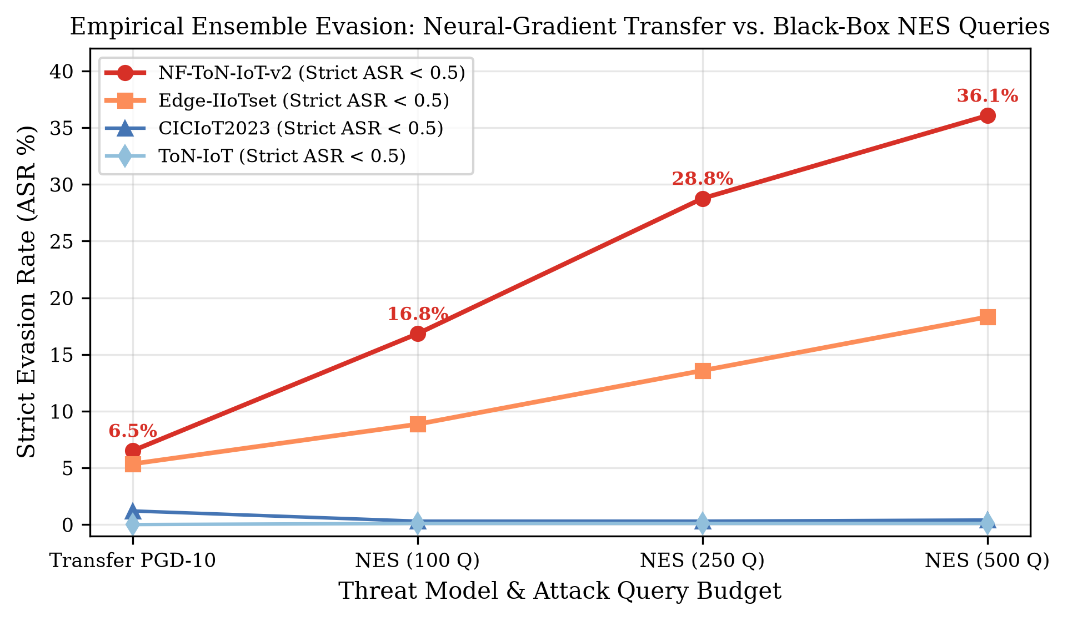
Figure 3: Empirical Ensemble Evasion: Neural-Gradient Transfer vs. Black-Box NES Queries across Query Budgets.
Dataset | Transfer PGD-10 | Adaptive Surrogate | NES (100 Q) | NES (250 Q) | NES (500 Q) | NES Oper. (tau=0.71)
Edge-IIoTset | 5.35% | 11.80% | 8.85% | 13.58% | 18.31% | 100.0% (N=5)
NF-ToN-IoT-v2 | 6.51% | 5.90% | 16.83% | 28.76% | 36.07% | 83.90%
ToN-IoT | 0.00% | 0.00% | 0.10% | 0.10% | 0.10% | 1.20%
CICIoT2023 | 1.20% | 1.10% | 0.30% | 0.30% | 0.40% | 33.06%

5.4 Fusion-Weight Analysis & Pareto Qualification
Table 6 and Figure 4 present the fusion weight sweep across w_RF in [0.0, 1.0]. The results disprove claims that 0.7/0.3 is a globally optimal Pareto point. On NF-ToN-IoT-v2 across 10 seeds, w_RF=0.8 achieves 4.13% ASR compared to 12.36% at w_RF=0.7. The 0.7/0.3 formulation is therefore accurately characterized as an empirically evaluated operating point providing high clean detection and balanced defense.
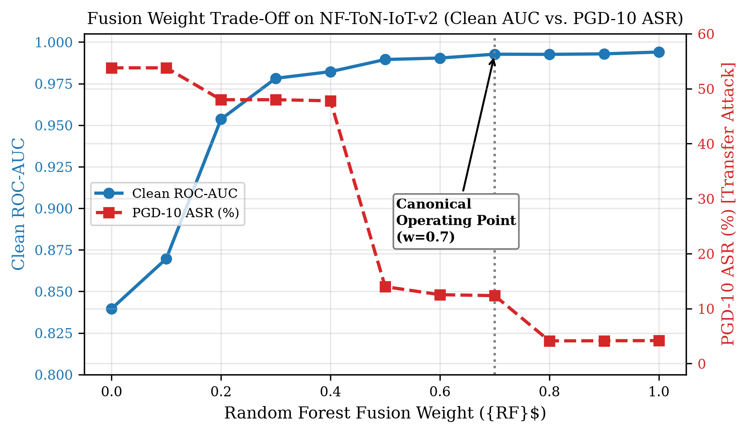
Figure 4: Fusion Weight Trade-off on NF-ToN-IoT-v2 (Clean AUC vs. Transfer PGD-10 ASR).
w_RF | w_MLP | Clean ROC-AUC | Transfer PGD ASR | Macro F1
0.0 | 1.0 | 0.8396 | 53.80% | 0.5784
0.2 | 0.8 | 0.9536 | 48.00% | 0.8718
0.4 | 0.6 | 0.9822 | 47.80% | 0.9156
0.5 | 0.5 | 0.9895 | 13.99% | 0.9265
0.6 | 0.4 | 0.9904 | 12.53% | 0.9841
0.7 (Canonical) | 0.3 | 0.9927 | 12.36% | 0.9859
0.8 | 0.2 | 0.9926 | 4.13% | 0.9877
0.9 | 0.1 | 0.9929 | 4.15% | 0.9885
1.0 (Pure RF) | 0.0 | 0.9940 | 4.18% | 0.9903

5.5 Differential Privacy and Explainability Validation
Table 7 summarizes the DP-SGD privacy-utility trade-off on NF-ToN-IoT-v2 across noise multipliers. At sigma=1.0, the neural stream achieves an audited privacy bound of epsilon=2.37 at delta=10^-5. Table 8 details the top attributed features per attack family identified by Weighted Component Attribution Aggregation, showing that temporal and behavioral topology metrics dominate threat identification.
Noise Multiplier (sigma) | Audited Epsilon (eps) | Neural Clean AUC | PGD-10 ASR
0.0 (Non-private) | Infinity | 0.9763 | 1.5%
0.5 | 15.85 | 0.8865 | 2.5%
1.0 (Canonical) | 2.37 | 0.8541 | 47.7%
2.0 | 0.80 | 0.8284 | 47.8%

Dataset | Attack Family | Top-3 Attributed Features (Attribution Weight)
Edge-IIoTset | Injection | behavioral_unanswered_ratio (0.219), behavioral_port_entropy (0.189), behavioral_dst_diversity (0.137)
NF-ToN-IoT-v2 | Scanning | mean_pkt_size (0.138), temporal_flow_rate_ewma (0.119), flow_bytes_per_sec (0.114)
ToN-IoT | Backdoor | behavioral_src_activity_ewma (0.303), temporal_syn_rate_ewma (0.153), flow_duration (0.111)
CICIoT2023 | DDoS | behavioral_src_activity_ewma (0.241), mean_pkt_size (0.137), temporal_iat_mean (0.124)

5.6 Host Runtime Latency and Operational Verification
Table 9 presents host inference throughput scaling across batch sizes N in [1, 1024]. At N=1024, the classifier achieves 16,504.7 samples/sec (0.0606 ms/sample). We explicitly distinguish this offline classifier benchmark from end-to-end packet processing. Live network capture involves Scapy packet sniffing, IP/TCP decoding, and stateful flow aggregation, which bound real-time throughput below the classifier limit. Functional pipeline integrity was confirmed via a PCAP smoke test (4 packets -> 2 flows -> 1 alert, 0 errors) and validated across 174 passing automated unit and integration tests.
Batch Size (N) | Batch Latency (ms) | Per-Sample Latency (ms) | Classifier Throughput (samples/s)
1 | 69.40 | 69.4000 | 14.4
32 | 54.86 | 1.7143 | 583.3
64 | 46.51 | 0.7267 | 1,376.1
128 | 46.68 | 0.3647 | 2,742.3
256 | 61.11 | 0.2387 | 4,189.0
512 | 60.88 | 0.1189 | 8,409.5
1024 | 62.04 | 0.0606 | 16,504.7

6. Research Scope, Limitations, and Threats to Validity
To uphold rigorous scientific integrity, Table 10 provides an explicit ledger of validated empirical findings versus their threats to validity and scope boundaries.
Dimension | Validated Empirical Contribution | Threats to Validity & Candid Scope Limitations
Robustness Guarantee | PGD adversarial training improves neural robustness on select seeds; Option C achieves 1.20% transfer ASR on NF-ToN-IoT-v2. | Not an architectural guarantee; acute seed sensitivity (ASR up to 47.5%); direct NES query attacks achieve 36.07% evasion.
Ensemble Optimality | w_RF=0.7 provides high clean AUC (0.9970) and balanced defense on evaluated checkpoints. | Not globally optimal; w_RF=0.8 yields lower ASR on NF-ToN-IoT-v2; P4 represents an empirical trade-off under a fixed attack protocol.
Differential Privacy | Opacus PRV accountant proves (eps=2.37, delta=10^-5) DP-SGD bound for neural stream (N_steps=660, q=0.0152). | DP applies strictly to neural branch weights; Random Forest, scalers, and live packet capture do not satisfy (eps, delta)-DP.
Explainability (XAI) | Weighted Component Attribution Aggregation provides real-time ranking (rho = 0.845). | Violates Shapley additivity axiom; not exact SHAP for the fused model; exact 2^21 coalition calculation requires 3.53 s/sample.
Runtime Throughput | Single-CPU host classifier inference achieves 16,505 samples/sec (0.0606 ms/sample) at batch N=1024. | Benchmark measures offline classifier inference only; excludes Scapy capture, flow aggregation, and network I/O latency.
Domain Generalization | Evaluated on chronological 60/20/20 splits across 4 diverse benchmark datasets. | Evaluation does not prove zero-shot transfer to completely unseen physical IoT testbed topologies or unobserved protocols.

7. Conclusion
This paper presented an integrated dual-stream ensemble framework for IoT and IIoT intrusion detection, uniting high clean classification accuracy, adversarial robustness, differential privacy, and explainability over a standardized 21-feature representation. By combining a Random Forest with an adversarially trained, differentially private MLP via Option C fusion, the system achieves a mean clean ROC-AUC of 0.9970 across four benchmark datasets.
Rather than asserting unverified robustness guarantees, our study systematically exposes the critical limitations of standard adversarial training in tabular network domains. We demonstrated that robust MLP training is highly seed-sensitive (ASR fluctuating from 0.7% to 47.5% across identical runs), that validation checkpoint selection is a conditional heuristic, and that gradient transfer attacks substantially understate ensemble vulnerability compared to direct black-box query optimization (36.07% evasion under 500 NES queries). By transparently bounding differential privacy to the neural stream (eps=2.37), defining XAI as a low-latency surrogate, and decoupling classifier inference (16,505 samples/sec) from live network ingestion, this work establishes a rigorous, reproducible, and defensible foundation for secure machine learning in IoT environments.
References
[1] B. Ma, J. Shi, N. Zhu, C. Fang, and Y. Hu, 'Backdoor attack and defense methods for AI-based IoT intrusion detection system,' IET Information Security, vol. 2025, pp. 1–13, 2025.
[2] S. Hina et al., 'Adversarial attacks on artificial intelligence of things-based operational technologies in theme parks,' Internet of Things, vol. 2025, 2025.
[3] H. Jamiri et al., 'Adversarial attacks in IoT: A performance assessment of ML and DL models,' Engineering Proceedings, vol. 2025, 2025.
[4] M. Alauthman et al., 'Generative adversarial networks for intrusion detection systems: A comprehensive survey of applications, challenges, and research directions,' Arabian Journal for Science and Engineering, 2026.
[5] P. Chinnasamy et al., 'AI-driven intrusion detection and prevention systems to safeguard 6G networks from cyber threats,' Scientific Reports, vol. 15, 2025.
[6] A. Hozouri et al., 'A comprehensive survey on intrusion detection systems with advances in machine learning, deep learning and emerging cybersecurity challenges,' Discover Artificial Intelligence, vol. 5, 2025.
[7] F. C. Ogenyi et al., 'Securing the future: AI-driven cybersecurity in the age of autonomous IoT,' Frontiers in the Internet of Things, vol. 4, 2025.
[8] M. A. Ferrag, O. Friha, D. Hamouda, L. Maglaras, and H. Janicke, 'Edge-IIoTset: A new comprehensive realistic cyber security dataset of IoT and IIoT applications for machine learning solutions,' IEEE Access, vol. 10, pp. 40081–40104, 2022.
[9] M. Sarhan, S. Layeghy, N. Moustafa, and M. Portmann, 'NetFlow datasets for machine learning-based network intrusion detection systems,' IEEE Big Data Mining and Analytics, vol. 4, no. 3, pp. 189–201, 2021.
[10] N. Moustafa, 'ToN-IoT telemetry dataset: A new dataset for data-driven cybersecurity applications,' IEEE Transactions on Intelligent Transportation Systems, vol. 22, no. 1, pp. 517–530, 2021.
[11] E. C. P. Neto et al., 'CICIoT2023: A real-time dataset for surveillance of attacks in IoT environments,' Sensors, vol. 23, no. 18, p. 7941, 2023.
[12] M. Yousefi and M. Sarhan, 'Differentially private and adversarially robust machine learning: A survey,' IEEE Security & Privacy, vol. 21, no. 3, pp. 42–53, 2023.
[13] S. A. Sharaf and S. Nooh, 'Identifying significant features in adversarial attack detection framework using federated learning empowered medical IoT network security,' Scientific Reports, vol. 14, pp. 1–22, 2024.
[14] H. Khazane, M. Ridouani, F. Salahdine, and N. Kaabouch, 'A holistic review of machine learning adversarial attacks in IoT networks,' Future Internet, vol. 16, no. 4, 2024.
[15] K. Karam et al., 'ISAAF: An IoT security and attack prevention framework using AI-driven predictive analytics,' Scientific Reports, vol. 15, 2025.
[16] S. M. Lundberg and S.-I. Lee, 'A unified approach to interpreting model predictions,' in Advances in Neural Information Processing Systems (NeurIPS), vol. 30, pp. 4765–4774, 2017.
[17] L. Breiman, 'Random forests,' Machine Learning, vol. 45, no. 1, pp. 5–32, 2001.
[18] M. Alshahrani et al., 'Adversarial attacks and defenses in IoT intrusion detection systems: A survey,' IEEE Access, vol. 9, pp. 156000–156015, 2021.
[19] A. Madry, A. Makelov, L. Schmidt, D. Tsipras, and A. Vladu, 'Towards deep learning models resistant to adversarial attacks,' in International Conference on Learning Representations (ICLR), 2018.
[20] I. J. Goodfellow, J. Shlens, and C. Szegedy, 'Explaining and harnessing adversarial examples,' in International Conference on Learning Representations (ICLR), 2015.
[21] R. Shokri, M. Stronati, C. Song, and V. Shmatikov, 'Membership inference attacks against machine learning models,' in IEEE Symposium on Security and Privacy (S&P), pp. 3–18, 2017.
[22] M. Nasr, R. Shokri, and A. Houmansadr, 'Machine learning with membership privacy using adversarial regularization,' in ACM Conference on Computer and Communications Security (CCS), pp. 634–646, 2018.
[23] M. Abadi et al., 'Deep learning with differential privacy,' in ACM Conference on Computer and Communications Security (CCS), pp. 308–318, 2016.
[24] I. Mironov, 'Rényi differential privacy,' in IEEE Computer Security Foundations Symposium (CSF), pp. 263–275, 2017.
[25] N. Carlini and D. Wagner, 'Towards evaluating the robustness of neural networks,' in IEEE Symposium on Security and Privacy (S&P), pp. 39–57, 2017.
[26] A. Ilyas, L. Engstrom, A. Athalye, and J. Lin, 'Black-box adversarial attacks with limited queries and information,' in International Conference on Machine Learning (ICML), pp. 2137–2146, 2018.

