1528. Shuffle String
You are given a string s and an integer array indices of the same length. The string s will be shuffled such that the character at the i^{th} position moves to indices[i] in the shuffled string.
Return the shuffled string.
Example 1:
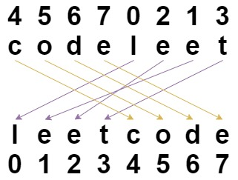
Input: s = "codeleet", indices = [4,5,6,7,0,2,1,3]
Output: "leetcode"
Explanation: As shown, "codeleet" becomes "leetcode" after shuffling.
Example 2:
Input: s = "abc", indices = [0,1,2]
Output: "abc"
Explanation: After shuffling, each character remains in its position.
Constraints:
- s.length == indices.length == n
- 1 <= n <= 100
- s consists of only lowercase English letters.
- 0 <= indices[i] < n
- All values of indices are unique.

Solution
var restoreString = function(s, indices) {
let result=new Array(s.length);
for(let i=0;i<s.length;i++){
result[indices[i]]=s.char[i];

}
return result.join("");
};

1st saw this problem I understood the problem but I don’t know how to write the code for this problem then I took help from the chatgpt to get solution literally I did not understood then ,I searched in google I get one video in youtube explantion about this problem, I did not understood then I went to the another video he was explaining well then I understood the problem ,I came to know how to write the code
Even some time I got confused , so I take example and I traced it then I understood the problem ,
Now I will explain how to write the code
1st take one variable and initialize it with empty given array length
Then use for loop to arrange in a right format initialize i=o;i<s.length;i++;
Then what ever value in s it will show the charcter of that index value then consider the value of indices that is indices of i=0
Then result[indices[i]]=s.char[i]
Result[4]=c;
Then store the value of c in index c
For example result=[ , , , , , c , , , ,]
[0 , 1,2,3,4,5,6,7]
Like this do for all the letters the u will get the right output

