Advanced Data Visualization with Motion

using Flourish Tool:

“Analyzing Depression in Students”
https://public.flourish.studio/story/2792289/

Tejashwini Saravanan
School of Business, Government, and Economics
Seattle Pacific University
Independent Study (ISM6900 - 911)
Ryan C. LaBrie, Ph.D.
December 23, 2024- Monday
Fall 2024

Abstraction
The goal of this project is to use Flourish Studio to explore and illustrate the potential of motion characteristics in data visualisation. The study of a student depression dataset that was obtained from Kaggle is the main objective of this research. Extracting valuable insights from the information, successfully communicating discoveries through dynamic and interactive visualisations, and demonstrating how motion-based data visualisations may improve data interpretation and storytelling are the main objectives.

Overview
Mental health issues, especially depression, are becoming a major problem for students across the world. To find patterns and trends in the data pertaining to depression, this study makes use of data visualisation methods. Innovative methods of data presentation will be investigated using Flourish Studio, a platform renowned for its interactive and motion-enabled visualisations. A compelling and simple method of interpreting complicated datasets will be made possible using motion characteristics.

Objectives
to use the dataset to examine the frequency and trends of depression among students.
to use the motion elements of Flourish Studio to produce dynamic and engaging visualisations.
to assess the usefulness of motion-enhanced visualisations for communicating and interpreting data.

Dataset Description
Source: Kaggle https://www.kaggle.com/datasets/ikynahidwin/depression-student-dataset
Dataset Title: Depression Among Students
Attributes: The dataset includes variables such as age, gender, academic performance, sleep patterns, physical activity, social support, and depression severity levels.
The dataset will undergo preprocessing steps such as handling missing values, normalization, and encoding categorical variables to prepare it for visualization.

methodologies
1. Data Preparation and Cleaning:
- Look for incorrect or missing values in the dataset.
- To guarantee compatibility with Flourish Studio, do data modifications.
2. EDA, or exploratory data analysis:
- To comprehend data distributions and linkages, make use of statistical tools and static visualisations.
3. Designing Visualisations with Flourish Studio:
- Make several visualisations using motion, such as:
- Scatter plots with animation to display patterns over time.
- Bar charts are used for dynamic category comparisons.
- animations of line charts to show changes in data over time.
4. Perspectives and Analysis:
- Examine the visualisations to derive important information about the variables affecting student depression.
Assessment:
- Get user opinions on the motion features' effect and ease of usage.
- To evaluate additional value, contrast static and motion-enhanced visualisations.

Findings
Important Results:
found patterns and associations between the degree of depression and academic pressures.
highlighted high-risk demographic groupings.
Resulting Visualisation:
A group of dashboards displaying motion-enabled information, such as progression analyses, timelines, and category comparisons

Talk details of
Effective communication of patterns and trends is greatly improved by Flourish Studio's usage of motion elements. Motion visualisations provide a natural method to see how things change over time and comprehend how the data relate to one another. This method works especially well in mental health and education settings where it's important to communicate ideas to non-technical audiences.
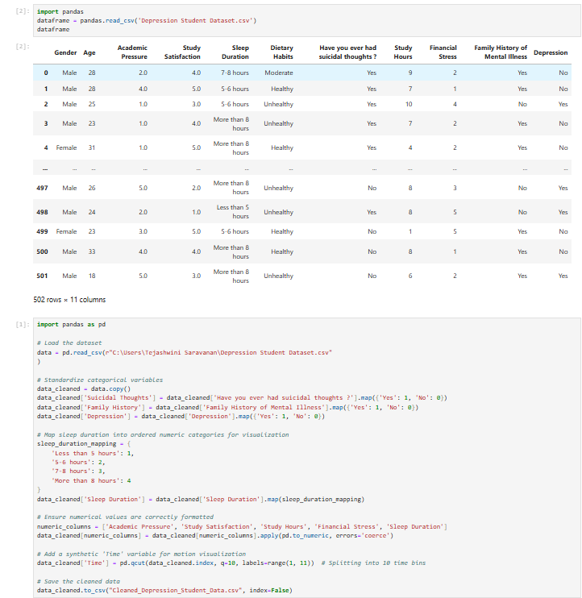
Below is the Python code used for data cleaning and preparation:

Dashboards description:
- "Impact of Academic Pressure on Suicidal Thoughts: A Motion Scatter Plot" is the title of the visualisation.
Caption: This dynamic scatter plot examines, by gender, the connection between study satisfaction, suicidal ideation, and academic pressure. The motion element provides insights into how academic pressure might affect students' mental health and well-being by reflecting how these characteristics vary over time as study hours do.
Brief Analysis: Colour-coded points indicate gender variations in the plot, which shows how different degrees of academic pressure link with the frequency of suicide ideation. Higher study satisfaction is represented by larger points, and the time axis (study hours) enables an investigation of how these variables change as study hours rise. These graphic sheds light on the intricate relationships that exist between study habits, academic stress, and mental health, offering important insights into the difficulties that students encounter.

- Academic Pressure vs. Study Satisfaction: A Motion Bubble Chart" is the name of the visualisation.
Caption: Using age-group-specific bubble colours, this motion bubble chart illustrates the connection between study enjoyment and academic pressure. Students' depression state is revealed by the popup information, which furthers the investigation of their well-being. The size of each bubble is based on their degree of study satisfaction.

Brief Analysis: The graph illustrates the relationship between study satisfaction and academic pressure, highlighting differences between age groups. It provides information about students' mental health by displaying their depression status in the popup for every data point. This makes it easier to comprehend how age and academic pressure affect students' general well-being. A dynamic element is added by the motion feature, which displays how these relationships evolve over time.
- The visualization's name is "Lifestyle Factors Impacting Academic and Personal Well-Being: A Motion Tree Map"
Caption: This motion tree map visualises the effects of variables including age, academic pressure, study satisfaction, study hours, and financial stress while classifying and nesting data according to sleep length and eating habits. The dynamic age filter offers individualised information on students' lifestyles and general wellbeing.
In summary, the graph illustrates the relationship between sleep length fluctuations and study hours as well as financial stress. While the motion feature shows changes over time, the layered design enables a cumulative perspective of these aspects. Age-specific insights are provided by the visualisation by filtering the data by age, which aids in understanding how these dynamics impact student well-being across various demographic groups.
- The visualization's name is "Family History of Mental Illness: Trends in Academic and Personal Well-Being"
The impact of a family history of mental illness on age, academic pressure, study satisfaction, study hours, and financial stress across time is examined in this motion line graphic.
Brief Analysis: The graph shows patterns in the academic and psychological difficulties faced by students with different family histories of mental illness. The lines provide a thorough understanding of the interrelated elements that influence mental health outcomes by tracking changes in age, academic pressure, study satisfaction, study hours, and financial stress. Over time, the motion component improves our comprehension of these dynamics.
- The visualization's name is "Sleep Duration vs Study Hours and Financial Stress: A Stacked Motion Chart"
The association between sleep length, study hours, and financial stress over time is depicted in this stacked area chart. Age-based data filtering allows for a targeted examination of these variables for various age groups.
Brief Analysis: The graph illustrates the relationship between study hours, financial stress, and differences in sleep length. A cumulative perspective of these aspects is made possible by the layered design, and changes over time are revealed by the motion feature. The visualisation provides age-specific insights by filtering the data by age, which aids in understanding how these dynamics impact the well-being of students across various demographic groups.

In conclusion
The potential of motion-based visualisations to improve data storytelling is demonstrated by this study. This research highlights the value of creative visualisation approaches in tackling complicated social challenges while offering practical insights into student depression as examined by Flourish Studio.

Tools and Technologies
- Flourish Studio: For creating motion-based visualizations.
- Python: For data preprocessing and EDA.
- Kaggle: Data sourcing platform.
- Excel/CSV: For data cleaning and formatting.

--------------------------------------------------------------------------------------------------------------------------------

