**Exercise 1: Control Structures**

**Scenario 1:** The bank wants to apply a discount to loan interest rates for customers above 60 years old.

* + **Question:** Write a PL/SQL block that loops through all customers, checks their age, and if they are above 60, apply a 1% discount to their current loan interest rates.

**Scenario 2:** A customer can be promoted to VIP status based on their balance.

* + **Question:** Write a PL/SQL block that iterates through all customers and sets a flag IsVIP to TRUE for those with a balance over $10,000.

**Scenario 3:** The bank wants to send reminders to customers whose loans are due within the next 30 days.

* + **Question:** Write a PL/SQL block that fetches all loans due in the next 30 days and prints a reminder message for each customer.

Code:

DECLARE

CURSOR cur_customers IS

SELECT c.CustomerID, FLOOR(MONTHS_BETWEEN(SYSDATE, c.DOB) / 12) AS age

FROM Customers c;

BEGIN

FOR rec IN cur_customers LOOP

IF rec.age > 60 THEN

-- Apply 1% discount to loans of this customer

UPDATE Loans

SET InterestRate = InterestRate - 1

WHERE CustomerID = rec.CustomerID;

END IF;

END LOOP;

COMMIT;

END;

/

**Output:  
Before Update:**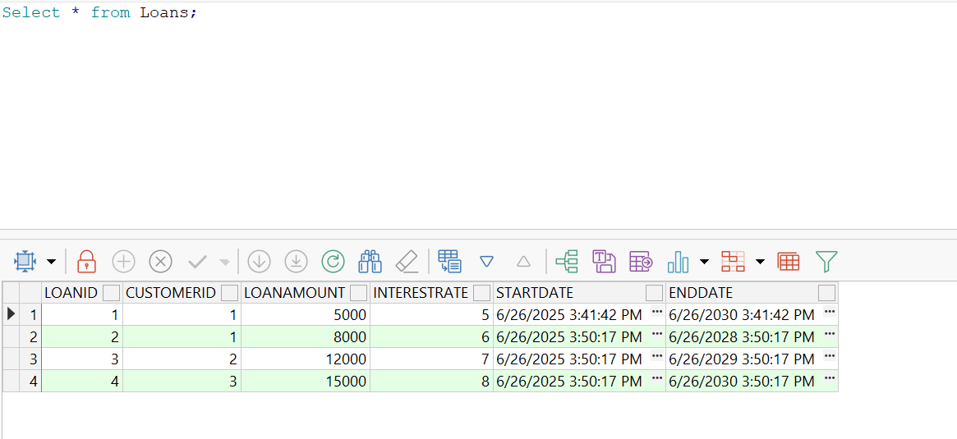

**After:**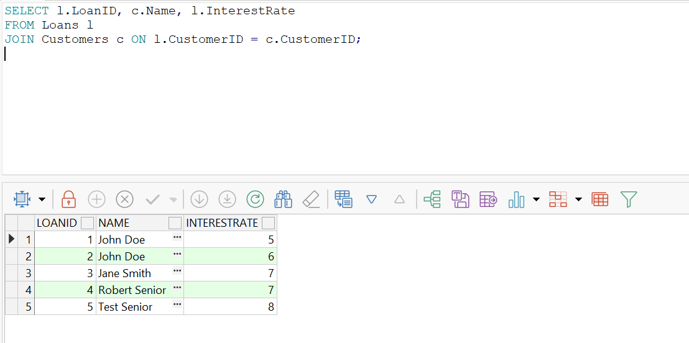

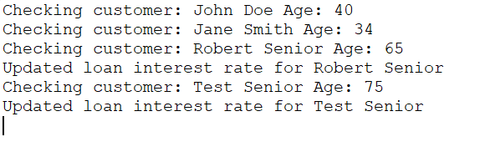

**Scenario 2:  
Code:**

BEGIN

FOR rec IN (SELECT CustomerID, Balance FROM Customers) LOOP

IF rec.Balance > 10000 THEN

UPDATE Customers

SET IsVIP = 'TRUE'

WHERE CustomerID = rec.CustomerID;

ELSE

UPDATE Customers

SET IsVIP = 'FALSE'

WHERE CustomerID = rec.CustomerID;

END IF;

END LOOP;

COMMIT;

END;

/

**Output:**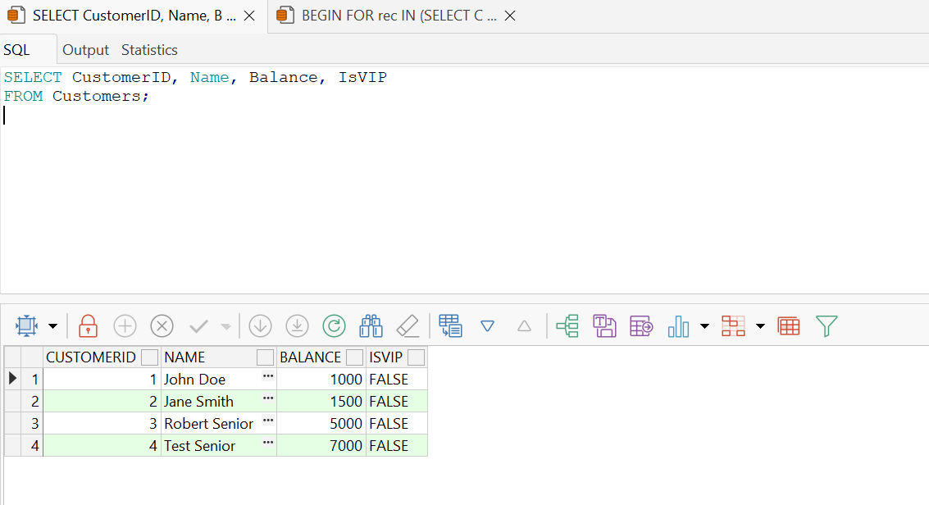

**Scenario 3:  
Code:**

DECLARE

CURSOR cur_due_loans IS

SELECT l.LoanID, l.CustomerID, l.EndDate, c.Name

FROM Loans l

JOIN Customers c ON l.CustomerID = c.CustomerID

WHERE l.EndDate BETWEEN SYSDATE AND SYSDATE + 30;

BEGIN

FOR rec IN cur_due_loans LOOP

DBMS_OUTPUT.PUT_LINE('Reminder: Loan ID ' || rec.LoanID || ' for customer ' || rec.Name || ' is due on ' || TO_CHAR(rec.EndDate, 'YYYY-MM-DD'));

END LOOP;

END;

/

**Output:**

**Exercise 3: Stored Procedures**

**Scenario 1:** The bank needs to process monthly interest for all savings accounts.

* + **Question:** Write a stored procedure **ProcessMonthlyInterest** that calculates and updates the balance of all savings accounts by applying an interest rate of 1% to the current balance.

**Scenario 2:** The bank wants to implement a bonus scheme for employees based on their performance.

* + **Question:** Write a stored procedure **UpdateEmployeeBonus** that updates the salary of employees in a given department by adding a bonus percentage passed as a parameter.

**Scenario 3:** Customers should be able to transfer funds between their accounts.

* + **Question:** Write a stored procedure **TransferFunds** that transfers a specified amount from one account to another, checking that the source account has sufficient balance before making the transfer.

**Scenario 1:  
Code:**

CREATE OR REPLACE PROCEDURE ProcessMonthlyInterest AS

BEGIN

UPDATE Accounts

SET Balance = Balance * 1.01,

LastModified = SYSDATE

WHERE AccountType = 'Savings';

COMMIT;

END;

/

**Output:**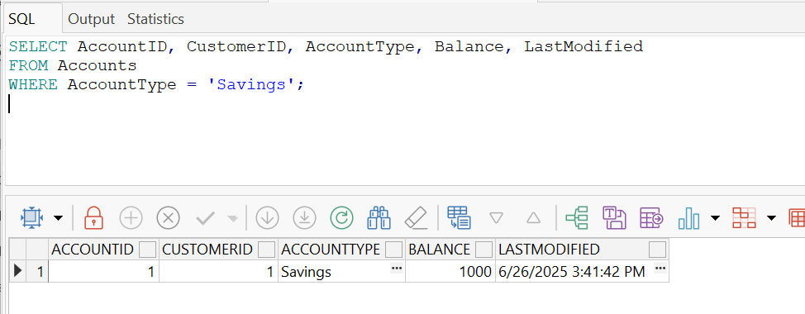

**Scenario 2:  
Code:**CREATE OR REPLACE PROCEDURE UpdateEmployeeBonus (

p_department IN VARCHAR2,

p_bonus_percent IN NUMBER

) AS

BEGIN

UPDATE Employees

SET Salary = Salary + (Salary * p_bonus_percent / 100)

WHERE Department = p_department;

COMMIT;

END;

/

**Output:**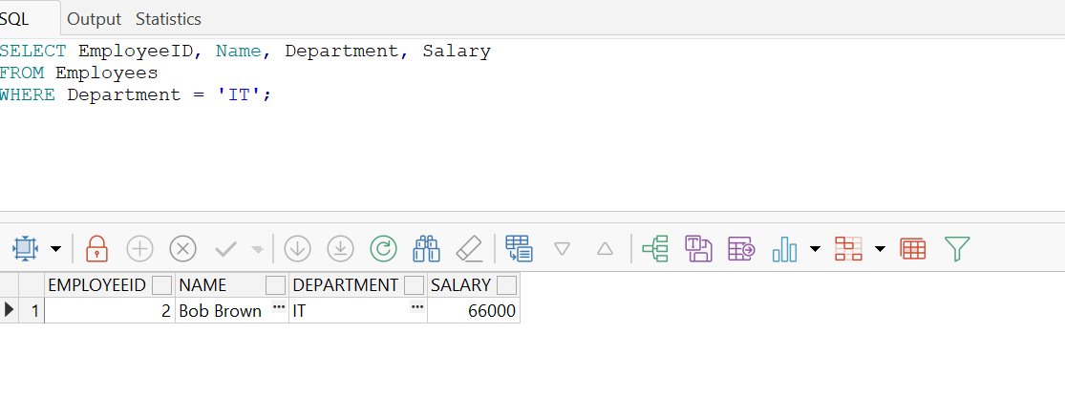

**Scenario 3:  
Code:**

CREATE OR REPLACE PROCEDURE TransferFunds (

p_from_account IN NUMBER,

p_to_account IN NUMBER,

p_amount IN NUMBER

) AS

v_balance NUMBER;

BEGIN

*-- Get current balance of source account*

SELECT Balance INTO v_balance

FROM Accounts

WHERE AccountID = p_from_account

FOR UPDATE;

*-- Check for sufficient funds*

IF v_balance < p_amount THEN

RAISE_APPLICATION_ERROR(-20001, 'Insufficient balance in source account.');

END IF;

*-- Deduct from source*

UPDATE Accounts

SET Balance = Balance - p_amount,

LastModified = SYSDATE

WHERE AccountID = p_from_account;

*-- Add to target*

UPDATE Accounts

SET Balance = Balance + p_amount,

LastModified = SYSDATE

WHERE AccountID = p_to_account;

COMMIT;

END;

/

**Output:**