**Create a new React Application with the name “myfirstreact”  
  
Code:**

function App(){

  return(

    <h1> welcome to the first session of React</h1>

  );

}

export default App;

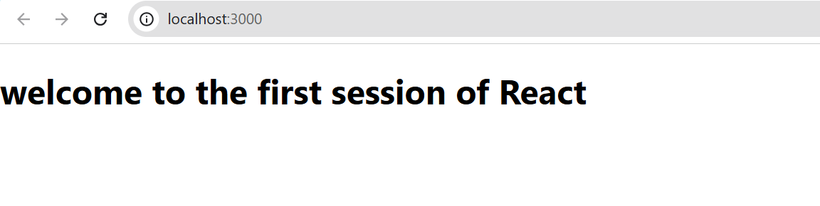

**Create a react app for Student Management Portal named StudentApp:  
  
Code:**

import Home from './components/Home';

import About from './components/About';

import Contact from './components/Contact';

function App() {

  return (

    <div className='container'>

      <Home/>

      <About/>

      <Contact/>

    </div>

  );

}

export default App;

import React, {Component} from 'react';

class Home extends Component{

    render(){

         return (

            <div>

                <h3>Welcome to Home page of Student Management Portal</h3>

            </div>

        );

    }

}

export default Home;

import React, { Component } from 'react';

class About extends Component {

    render() {

        return (

            <div>

                <h3>Welcome to About page of Student Management Portal</h3>

            </div>

        );

    }

}

export default About;

import React, {Component} from 'react';

 class Contact extends Component{

    render(){

         return (

            <div>

                <h3>Welcome to Contact page of Student Management Portal</h3>

            </div>

        );

    }

}

export default Contact;

**Output:**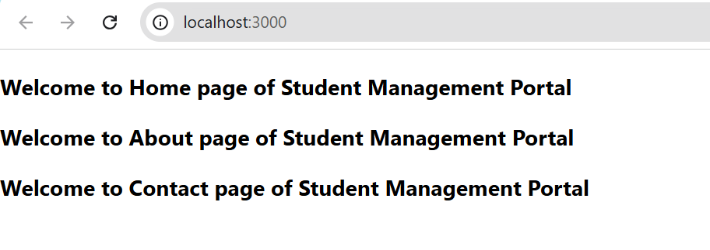

**Create a react app for Student Management Portal named scorecalculatorapp:  
  
Code:**import '../Stylesheets/mystyle.css'

const percentToDecimal= (decimal) => {

return (decimal.toFixed(2) + '%')

}

const calcScore = (total, goal) => {

return percentToDecimal(total/goal)

}

export const CalculateScore = ({Name, School, total, goal}) => (

<div className="formatstyle">

<h1><font color="Brown">Student Details:</font></h1>

<div className="Name">

<b> <span> Name: </span> </b>

<span>{Name}</span>

</div>

<div className="School">

<b> <span> School: </span> </b>

<span>{School}</span>

</div>

<div className="Total">

<b><span>Total:</span> </b>

<span>{total}</span>

<span>Marks</span>

</div>

<div className="Score">

<b>Score:</b>

<span>

{calcScore( total, goal )}

</span>

</div>

</div>

)

import { CalculateScore } from '../src/Components/CalculateScore.js';

function App()

{

return(

<div>

<CalculateScore Name={"Steeve"}

School={"DNV Public School"}

total={284}

goal={3}

/>

</div>

)

}

export default App;

.Name{

    font-weight : 300;

    color: blue;

}

.School{

    color:crimson;

}

.Total{

    color: darkmagenta;

}

.formatstyle{

    text-align:center;

    font-size: large;

}

.Score{

    color: forestgreen;

}

1. Output:  
   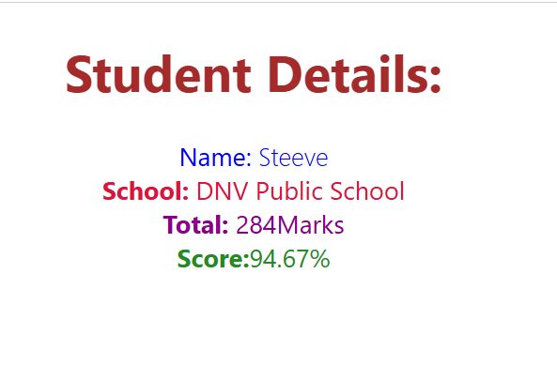  
     
   **Create a new react application using *create-react-app* tool with the name as “blogapp”**

**Code:**

import React from 'react';

const Post = ({ title, body }) => (

  <div style={{ margin: '20px', padding: '10px', border: '1px solid #ccc' }}>

    <h3>{title}</h3>

    <p>{body}</p>

  </div>

);

export default Post;

import React from 'react';

import Posts from './Posts';

function App() {

  return (

    <div className="App">

      <h1>Welcome to BlogApp</h1>

      <Posts />

    </div>

  );

}

export default App;

import React, { Component } from 'react';

import Post from './Post';

class Posts extends Component {

  constructor(props) {

    super(props);

    this.state = {

      posts: [],

      hasError: false,

    };

  }

  // Load posts using fetch API

  loadPosts = () => {

    fetch('https://jsonplaceholder.typicode.com/posts')

      .then(res => res.json())

      .then(data => {

        this.setState({ posts: data });

      })

      .catch(error => {

        throw error; // so it can be caught by componentDidCatch

      });

  };

  // Lifecycle method to fetch posts on mount

  componentDidMount() {

    this.loadPosts();

  }

  // Lifecycle method to catch errors

  componentDidCatch(error, info) {

    console.error("Error caught in componentDidCatch:", error);

    alert("An error occurred while loading posts.");

    this.setState({ hasError: true });

  }

  render() {

    if (this.state.hasError) {

      return <h2>Something went wrong. Please try again later.</h2>;

    }

    return (

      <div>

        <h2>All Posts</h2>

        {this.state.posts.map(post => (

          <Post key={post.id} title={post.title} body={post.body} />

        ))}

      </div>

    );

  }

}

export default Posts;

Output:  
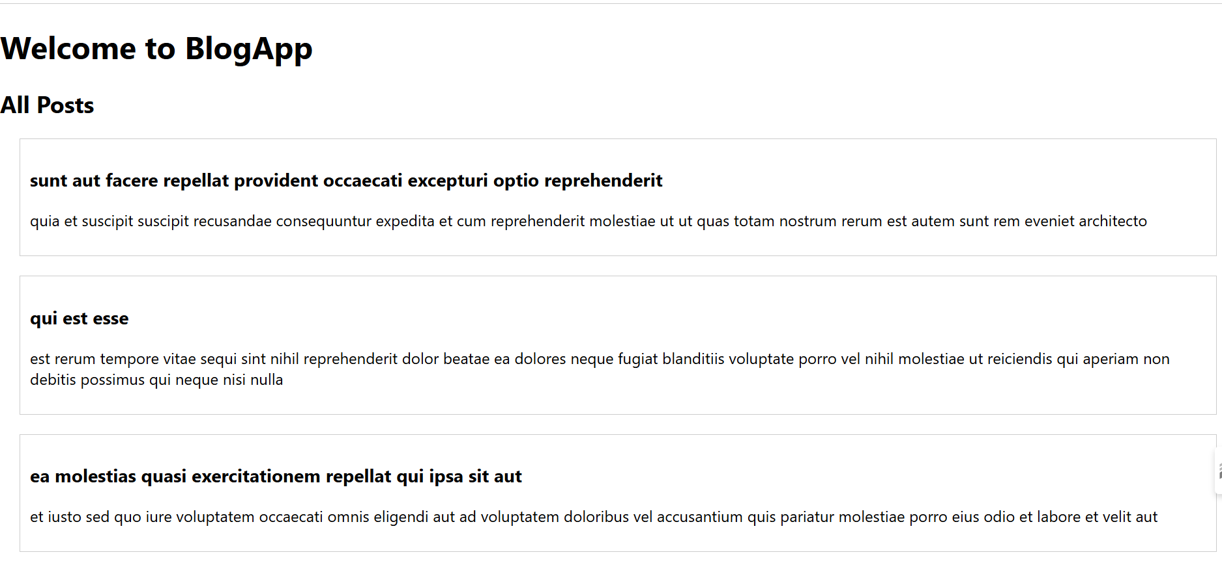  
 **My Academy team at Cognizant want to create a dashboard:  
  
Code:**

import styles from './Components/CohortDetails.module.css';

function CohortDetails(props) {

    return (

        <div className={styles.box}>

            <h3 style={{ color: props.status === 'ongoing' ? 'green' : 'blue' }}>

                {props.cohort.cohortCode} -

                <span>{props.cohort.technology}</span>

            </h3>

            <dl>

                <dt>Started On</dt>

                <dd>{props.cohort.startDate}</dd>

                <dt>Current Status</dt>

                <dd>{props.cohort.currentStatus}</dd>

                <dt>Coach</dt>

                <dd>{props.cohort.coachName}</dd>

                <dt>Trainer</dt>

                <dd>{props.cohort.trainerName}</dd>

            </dl>

        </div>

    );

}

export default CohortDetails;

.box {

  width: 300px;

  display: inline-block;

  margin: 10px;

  padding: 10px 20px;

  border: 1px solid black;

  border-radius: 10px;

}

dt {

  font-weight: 500;

}

import logo from './logo.svg';

import './App.css';

import { CohortsData} from './Cohort'

import CohortDetails from './CohortDetails';

import React from 'react';

import styles from './module.css';

function App() {

  return (

  <div>

    <h1>Cohorts Details</h1>

    {CohortsData.map(cohort => <CohortDetails cohort={cohort}/>)}

  </div>

  );

}

export default App;

**Output:**

