**NEW HORIZON PUBLIC SCHOOL & Penguin kids**

COMPUTER SCIENCE

INVESTIGATORY PROJECT

**ABC MALL – BILLING SYSTEM**By-

**NAME: TEJAS KOLATHAPULLY**

**STD: XII – A**

**ROLL NO: 24**

2020-2021

**INDEX**

|  |  |  |
| --- | --- | --- |
| S.No | Content | Page.No |
| 1 | Acknowledgement | 3 |
| 2 | Certificate | 4 |
| 3 | Introduction | 5 |
| 4 | Program | 7 |
| 5 | Output | 24 |
| 6 | Software | 27 |
| 7 | Bibliography | 28 |

**Acknowledgement**

**I wish to express my deep gratitude and sincere thanks to my Respected Principal Dr.Prashant Bukkawar of New Horizon Public School, New Panvel for his encouragement and for all the facilities that he provided for this project work on “Billing system” which also encouraged me to do a lot of research work and learn about new things.**

**I extend my hearty thanks to my subject teacher Mrs.Rohini. I take this opportunity to express my deep sense of gratitude for her invaluable guidance, useful suggestions and constant encouragement, which has sustained my efforts at all stages of this project work.**

**I can’t forget to offer my sincere thanks to my parents and friends who helped me to carry out this project work and thank them for their valuable advice and support, which I received from time to time.**

**Certificate**

**This is to certify that Mst.Shivraj Madane, a student of class XII has successfully completed the Computer Science investigatory project as prescribed by the CBSE for academic session 2020-2021.**

**Signature of Signature of Signature of Subject Teacher Principal External Examiner**

**SCHOOL STAMP**

**Introduction**

**This software project is a traditional supermarket billing system with some added functionality. This system is built for fast data processing and bill generation for supermarket customers. The billing system consists of an sql database and effective front end designed in Python. The billing database is a collection of product name, price and other product categories. A product when billed is searched from the database and its price is added to the bill based upon the product quantity. The supermarket billing system is built to help supermarkets calculate and display bills and serve the customer in a faster and efficient manner. This software project consists of an effective and easy GUI to help the employee in easy bill calculation and providing an efficient customer service.One can add more number of products in the SQL database as per the requirement.**

**It is very useful and effective software as it does take only a small amount of memory to work and gives the user a smooth and lag free experience for heavyworks also.**

**PROGRAM**

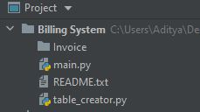

**1.Readme.txt**

## Steps to start the app ##  
  
1.Create a empty folder with name "Invoice" in the same directory.  
  
2.Start Xampp and create a database and name it "shop".  
  
3.Run table_creator.py only once.  
  
4.Run main.py

**2.table_creator.py**

*import* mysql.connector *as* sql  
conn=sql.connect(host='localhost',user='root',passwd='manager',database='shop')  
*if* conn.is_connected():  
 print('successfully connected')  
  
c=conn.cursor()  
  
c.execute('create table tax(category varchar(50),tax_percent int)')  
  
c.execute('create table products(product_name varchar(50),product_cost int,category varchar(50))')  
  
l1 = [["cosmetics",5],["grocery",10],["colddrink",5]]  
l2 = [["soap",40,"cosmetics"],["face_cream",120,"cosmetics"],["face_wash",80,"cosmetics"],["spray",180,"cosmetics"],  
 ["gel",90,"cosmetics"],["lotion",120,"cosmetics"],["rice",30,"grocery"],["food_oil",130,"grocery"],["wheat",40,"grocery"],  
 ["daal",80,"grocery"],["sugar",40,"grocery"],["tea",60,"grocery"],["maza",40,"colddrink"],["coke",50,"colddrink"],  
 ["frooti",40,"colddrink"],["thumbsup",50,"colddrink"],["limca",35,"colddrink"],["sprite",35,"colddrink"]]  
  
  
*for* i *in* l1 :  
 c.execute('insert into tax values("{}","{}")'.format(i[0],i[1]))  
 conn.commit()  
  
  
  
*for* i *in* l2 :  
 c.execute('insert into products values("{}","{}","{}")'.format(i[0],i[1],i[2]))  
 conn.commit()  
  
  
  
  
  
  
# =============Category and Tax======================#  
 #1 name = cosmetics tax_percent = 5  
 #2 name = grocery tax_percent = 10  
 #3 name = colddrink tax_percent = 5  
  
# =============Product and cost======================#  
  
 #category name = cosmetics  
 #1 name = soap cost = 40  
 #2 name = face_cream cost = 120  
 #3 name = face_wash cost = 80  
 #4 name = spray cost = 180  
 #5 name = gel cost = 90  
 #6 name = lotion cost = 120  
  
 #category name = grocery  
 #1 name = rice cost = 30  
 #2 name = food_oil cost = 130  
 #3 name = wheat cost = 40  
 #4 name = daal cost = 80  
 #5 name = sugar cost = 40  
 #6 name = tea cost = 60  
  
 #category name = colddrink  
 #1 name = maza cost = 40  
 #2 name = coke cost = 50  
 #3 name = frooti cost = 40  
 #4 name = thumbsup cost = 50  
 #5 name = limca cost = 35  
 #6 name = sprite cost = 35

**3.main.py**

*from* tkinter *import* *  
*from* tkinter *import* messagebox  
*import* math, random, os  
  
*import* mysql.connector *as* sql  
conn=sql.connect(host='localhost',user='root',passwd='manager',database='shop')  
*if* conn.is_connected():  
 print('successfully connected')  
c=conn.cursor()  
  
  
*def* price(*prodname*,*t*):  
 *t*.execute('select product_cost from products where product_name=("{}")'.format(*prodname*))  
 record = *t*.fetchall()[0][0]  
 *return* int(record)  
  
  
*def* tax(*category*,*t*):  
 *t*.execute('select tax_percent from tax where category=("{}")'.format(*category*))  
 record = *t*.fetchall()[0][0]  
 *return* (int(record)/100)  
  
  
*class* Bill_App:  
 *def __init__*(self, *root*):  
 self.root = *root* self.root.geometry("1350x700+0+0")  
 self.root.title("Billing Software")  
 bg_color = "YELLOW"  
 title = Label(self.root, text="ABC MALL ", bd=12, relief=GROOVE, bg=bg_color, fg="black",  
 font=("times new roman", 30, "bold"), pady=2).pack(fill=X)  
 # =============Variables======================  
 # =============Cosmatics======================  
 a = b = c = d = e = f = g = h = i = j = k = l = m = n = o = p = q = r = s = 0  
  
 self.soap = IntVar()  
 self.face_cream = IntVar()  
 self.face_wash = IntVar()  
 self.spray = IntVar()  
 self.gel = IntVar()  
 self.lotion = IntVar()  
 # =============Grocery========================  
 self.rice = IntVar()  
 self.food_oil = IntVar()  
 self.daal = IntVar()  
 self.wheat = IntVar()  
 self.sugar = IntVar()  
 self.tea = IntVar()  
 # =============Cold Drinka====================  
 self.maza = IntVar()  
 self.coke = IntVar()  
 self.frooti = IntVar()  
 self.thumbsup = IntVar()  
 self.limca = IntVar()  
 self.sprite = IntVar()  
 # =============Barcode====================  
 # self.limca = 10  
 # =============Total Product Price and Tax variables====================  
 self.cosmetic_price = StringVar()  
 self.grocery_price = StringVar()  
 self.cold_drink_price = StringVar()  
  
 self.cosmetic_tax = StringVar()  
 self.grocery_tax = StringVar()  
 self.cold_drink_tax = StringVar()  
 # =============Customer Detail================  
 self.c_name = StringVar()  
 self.c_phon = StringVar()  
 self.bill_no = StringVar()  
 x = random.randint(1000, 9999)  
 self.bill_no.set(str(x))  
 self.search_bill = StringVar()  
 # =============Customer Detail================  
 F1 = LabelFrame(self.root, bd=10, relief=GROOVE, text="Customer Details", font=("times new roman", 15, "bold"),  
 fg="black", bg=bg_color)  
 F1.place(x=0, y=90, relwidth=1)  
  
 cname_lbl = Label(F1, text="Customer Name", fg="black", bg=bg_color, font=("times new roman", 14, "bold")).grid(  
 row=0, column=0, padx=20, pady=5)  
 cname_txt = Entry(F1, width=11, textvariable=self.c_name, font="arial 15", bd=7, relief=SUNKEN).grid(row=0,  
 column=1,  
 pady=5,  
 padx=10)  
  
 cphn_lbl = Label(F1, text="Phone No.", fg="black", bg=bg_color, font=("times new roman", 14, "bold")).grid(  
 row=0, column=2, padx=20, pady=5)  
 cphn_txt = Entry(F1, width=11, textvariable=self.c_phon, font="arial 15", bd=7, relief=SUNKEN).grid(row=0,  
 column=3,  
 pady=5,  
 padx=10)  
  
 cbill_lbl = Label(F1, text="Bill Number", fg="black", bg=bg_color, font=("times new roman", 14, "bold")).grid(  
 row=0, column=4, padx=20, pady=5)  
 cbill_txt = Entry(F1, width=11, textvariable=self.search_bill, font="arial 15", bd=7, relief=SUNKEN).grid(row=0,  
 column=5,  
 pady=5,  
 padx=10)  
  
 bill_btn = Button(F1, text="Search", command=self.find_bill, width=10, bd=7, font="arial 12 bold").grid(row=0,  
 column=6,  
 padx=50,  
 pady=10)  
  
 # =============Cosmetics Frame================  
 F2 = LabelFrame(self.root, bd=10, relief=GROOVE, text="Cosmetics", font=("times new roman", 15, "bold"),  
 fg="black", bg=bg_color)  
 F2.place(x=3, y=205, width=325, height=380)  
 bath_lbl = Label(F2, text="Bath Soap", font=("times new roman", 15, "bold"), bg=bg_color, fg="black").grid(  
 row=0, column=0, padx=10, pady=10, sticky="w")  
 bath_txt = Entry(F2, width=10, textvariable=self.soap, font=("times new roman", 12, "bold"), bd=5,  
 relief=SUNKEN).grid(row=0, column=1, padx=8, pady=10)  
  
 face_crm_lbl = Label(F2, text="Face Cream", font=("times new roman", 15, "bold"), bg=bg_color, fg="black").grid(  
 row=1, column=0, padx=10, pady=10, sticky="w")  
 face_crm_txt = Entry(F2, width=10, textvariable=self.face_cream, font=("times new roman", 12, "bold"), bd=5,  
 relief=SUNKEN).grid(row=1, column=1, padx=8, pady=10)  
  
 face_w_lbl = Label(F2, text="Face Wash", font=("times new roman", 15, "bold"), bg=bg_color, fg="black").grid(  
 row=2, column=0, padx=10, pady=10, sticky="w")  
 face_w_txt = Entry(F2, width=10, textvariable=self.face_wash, font=("times new roman", 12, "bold"), bd=5,  
 relief=SUNKEN).grid(row=2, column=1, padx=8, pady=10)  
 # face_w_txt.insert(0,'username')  
 # face_w_txt.pack()  
  
  
  
 hair_s_lbl = Label(F2, text="Hair Spray", font=("times new roman", 15, "bold"), bg=bg_color, fg="black").grid(  
 row=3, column=0, padx=10, pady=10, sticky="w")  
 hair_s_txt = Entry(F2, width=10, textvariable=self.spray, font=("times new roman", 12, "bold"), bd=5,  
 relief=SUNKEN).grid(row=3, column=1, padx=8, pady=10)  
  
  
 hair_gel_lbl = Label(F2, text="Hair Gel", font=("times new roman", 15, "bold"), bg=bg_color, fg="black").grid(  
 row=4, column=0, padx=10, pady=10, sticky="w")  
 hair_gel_txt = Entry(F2, width=10, textvariable=self.gel, font=("times new roman", 12, "bold"), bd=5,  
 relief=SUNKEN).grid(row=4, column=1, padx=8, pady=10)  
  
 body_lbl = Label(F2, text="Body Lotion", font=("times new roman", 15, "bold"), bg=bg_color, fg="black").grid(  
 row=5, column=0, padx=10, pady=10, sticky="w")  
 body_txt = Entry(F2, width=10, textvariable=self.lotion, font=("times new roman", 12, "bold"), bd=5,  
 relief=SUNKEN).grid(row=5, column=1, padx=10, pady=10)  
  
 # =============Grocery Frame================  
 F3 = LabelFrame(self.root, bd=10, relief=GROOVE, text="Grocery", font=("times new roman", 15, "bold"),  
 fg="black", bg=bg_color)  
 F3.place(x=320, y=205, width=285, height=380)  
 g1_lbl = Label(F3, text="Rice", font=("times new roman", 15, "bold"), bg=bg_color, fg="black").grid(row=0,  
 column=0,  
 padx=10,  
 pady=10,  
 sticky="w")  
 g1_txt = Entry(F3, width=10, textvariable=self.rice, font=("times new roman", 12, "bold"), bd=5,  
 relief=SUNKEN).grid(row=0, column=1, padx=8, pady=10)  
  
 g2_lbl = Label(F3, text="Food Oil", font=("times new roman", 15, "bold"), bg=bg_color, fg="black").grid(row=1,  
 column=0,  
 padx=10,  
 pady=10,  
 sticky="w")  
 g2_txt = Entry(F3, width=10, textvariable=self.food_oil, font=("times new roman", 12, "bold"), bd=5,  
 relief=SUNKEN).grid(row=1, column=1, padx=8, pady=10)  
  
 g3_lbl = Label(F3, text="Daal", font=("times new roman", 15, "bold"), bg=bg_color, fg="black").grid(row=2,  
 column=0,  
 padx=10,  
 pady=10,  
 sticky="w")  
 g3_txt = Entry(F3, width=10, textvariable=self.daal, font=("times new roman", 12, "bold"), bd=5,  
 relief=SUNKEN).grid(row=2, column=1, padx=8, pady=10)  
  
 g4_lbl = Label(F3, text="Wheat", font=("times new roman", 15, "bold"), bg=bg_color, fg="black").grid(row=3,  
 column=0,  
 padx=10,  
 pady=10,  
 sticky="w")  
 g4_txt = Entry(F3, width=10, textvariable=self.wheat, font=("times new roman", 12, "bold"), bd=5,  
 relief=SUNKEN).grid(row=3, column=1, padx=8, pady=10)  
  
 g5_lbl = Label(F3, text="Suger", font=("times new roman", 15, "bold"), bg=bg_color, fg="black").grid(row=4,  
 column=0,  
 padx=10,  
 pady=10,  
 sticky="w")  
 g5_txt = Entry(F3, width=10, textvariable=self.sugar, font=("times new roman", 12, "bold"), bd=5,  
 relief=SUNKEN).grid(row=4, column=1, padx=8, pady=10)  
  
 g6_lbl = Label(F3, text="Tea", font=("times new roman", 15, "bold"), bg=bg_color, fg="black").grid(row=5,  
 column=0,  
 padx=10,  
 pady=10,  
 sticky="w")  
 g6_txt = Entry(F3, width=10, textvariable=self.tea, font=("times new roman", 12, "bold"), bd=5,  
 relief=SUNKEN).grid(row=5, column=1, padx=10, pady=10)  
  
 # =============Cold Drink Frame================  
 F4 = LabelFrame(self.root, bd=10, relief=GROOVE, text="Cold Drink", font=("times new roman", 15, "bold"),  
 fg="black", bg=bg_color)  
 F4.place(x=600, y=205, width=300, height=380)  
 c1_lbl = Label(F4, text="Maza", font=("times new roman", 15, "bold"), bg=bg_color, fg="black").grid(row=0,  
 column=0,  
 padx=10,  
 pady=10,  
 sticky="w")  
 c1_txt = Entry(F4, width=10, textvariable=self.maza, font=("times new roman", 12, "bold"), bd=5,  
 relief=SUNKEN).grid(row=0, column=1, padx=8, pady=10)  
  
 c2_lbl = Label(F4, text="Coke", font=("times new roman", 15, "bold"), bg=bg_color, fg="black").grid(row=1,  
 column=0,  
 padx=10,  
 pady=10,  
 sticky="w")  
 c2_txt = Entry(F4, width=10, textvariable=self.coke, font=("times new roman", 12, "bold"), bd=5,  
 relief=SUNKEN).grid(row=1, column=1, padx=8, pady=10)  
  
 c3_lbl = Label(F4, text="Frooti", font=("times new roman", 15, "bold"), bg=bg_color, fg="black").grid(row=2,  
 column=0,  
 padx=10,  
 pady=10,  
 sticky="w")  
 c3_txt = Entry(F4, width=10, textvariable=self.frooti, font=("times new roman", 12, "bold"), bd=5,  
 relief=SUNKEN).grid(row=2, column=1, padx=8, pady=10)  
  
 c4_lbl = Label(F4, text="ThumbsUp", font=("times new roman", 15, "bold"), bg=bg_color, fg="black").grid(row=3,  
 column=0,  
 padx=10,  
 pady=10,  
 sticky="w")  
 c4_txt = Entry(F4, width=10, textvariable=self.thumbsup, font=("times new roman", 12, "bold"), bd=5,  
 relief=SUNKEN).grid(row=3, column=1, padx=8, pady=10)  
  
 c5_lbl = Label(F4, text="Limca", font=("times new roman", 15, "bold"), bg=bg_color, fg="black").grid(row=4,  
 column=0,  
 padx=10,  
 pady=10,  
 sticky="w")  
 c5_txt = Entry(F4, width=10, textvariable=self.limca, font=("times new roman", 12, "bold"), bd=5,  
 relief=SUNKEN).grid(row=4, column=1, padx=8, pady=10)  
  
 c6_lbl = Label(F4, text="Sprite", font=("times new roman", 15, "bold"), bg=bg_color, fg="black").grid(row=5,  
 column=0,  
 padx=10,  
 pady=10,  
 sticky="w")  
 c6_txt = Entry(F4, width=10, textvariable=self.sprite, font=("times new roman", 12, "bold"), bd=5,  
 relief=SUNKEN).grid(row=5, column=1, padx=10, pady=10)  
  
 # =============Bill Area Frame================  
 F5 = Frame(self.root, bd=10, relief=GROOVE)  
 F5.place(x=905, y=205, width=440, height=350)  
 bill_title = Label(F5, text="Bill Area", font="arial 15 bold", bd=7, relief=GROOVE).pack(fill=X)  
 scrol_y = Scrollbar(F5, orient=VERTICAL)  
 self.textarea = Text(F5, yscrollcommand=scrol_y.set)  
 scrol_y.pack(side=RIGHT, fill=Y)  
 scrol_y.config(command=self.textarea.yview)  
 self.textarea.pack(fill=BOTH, expand=1)  
  
 # =============Button Frame================  
 F6 = LabelFrame(self.root, bd=10, relief=GROOVE, text="Bill Menu", font=("times new roman", 15, "bold"),  
 fg="black", bg=bg_color)  
 F6.place(x=3, y=560, relwidth=1, height=140)  
 m1_lbl = Label(F6, text="Total Cosmetic Price", bg=bg_color, fg="black",  
 font=("times new roman", 14, "bold")).grid(row=0, column=0, padx=20, pady=1, sticky="w")  
 m1_txt = Entry(F6, width=15, textvariable=self.cosmetic_price, font="arial 10 bold", bd=7, relief=SUNKEN).grid(  
 row=0, column=1, padx=10, pady=1)  
  
 m2_lbl = Label(F6, text="Total Grocery Price", bg=bg_color, fg="black",  
 font=("times new roman", 14, "bold")).grid(row=1, column=0, padx=20, pady=1, sticky="w")  
 m2_txt = Entry(F6, width=15, textvariable=self.grocery_price, font="arial 10 bold", bd=7, relief=SUNKEN).grid(  
 row=1, column=1, padx=10, pady=1)  
  
 m3_lbl = Label(F6, text="Total Cold Drink Price", bg=bg_color, fg="black",  
 font=("times new roman", 14, "bold")).grid(row=2, column=0, padx=20, pady=1, sticky="w")  
 m3_txt = Entry(F6, width=15, textvariable=self.cold_drink_price, font="arial 10 bold", bd=7,  
 relief=SUNKEN).grid(row=2, column=1, padx=10, pady=1)  
  
 c1_lbl = Label(F6, text="Cosmetic Tax", bg=bg_color, fg="black", font=("times new roman", 14, "bold")).grid(  
 row=0, column=3, padx=20, pady=1, sticky="w")  
 c1_txt = Entry(F6, width=15, textvariable=self.cosmetic_tax, font="arial 10 bold", bd=7, relief=SUNKEN).grid(  
 row=0, column=4, padx=10, pady=1)  
  
 c2_lbl = Label(F6, text="Grocery Tax", bg=bg_color, fg="black", font=("times new roman", 14, "bold")).grid(  
 row=1, column=3, padx=20, pady=1, sticky="w")  
 c2_txt = Entry(F6, width=15, textvariable=self.grocery_tax, font="arial 10 bold", bd=7, relief=SUNKEN).grid(  
 row=1, column=4, padx=10, pady=1)  
  
 c3_lbl = Label(F6, text="Cold Drink Tax", bg=bg_color, fg="black", font=("times new roman", 14, "bold")).grid(  
 row=2, column=3, padx=20, pady=1, sticky="w")  
 c3_txt = Entry(F6, width=15, textvariable=self.cold_drink_tax, font="arial 10 bold", bd=7, relief=SUNKEN).grid(  
 row=2, column=4, padx=10, pady=1)  
 btn_f = Frame(F6, bd=7, relief=GROOVE)  
 btn_f.place(x=820, width=510, height=180)  
 total_btn = Button(btn_f, text="Total", command=self.total, bg="YELLOW", fg="black", pady=10, width=10, bd=4,  
 font="arial 10 bold").grid(row=0, column=0, padx=5, pady=5)  
 gbill_btn = Button(btn_f, command=self.bill_area, text="Generate Bill", bg="YELLOW", fg="black", pady=10,  
 width=10, bd=4, font="arial 10 bold").grid(row=0, column=1, padx=5, pady=5)  
 clear_btn = Button(btn_f, text="Clear", command=self.clear_data, bg="YELLOW", fg="black", pady=10, width=10,  
 bd=4, font="arial 10 bold").grid(row=0, column=2, padx=5, pady=5)  
 exit_btn = Button(btn_f, text="Exit", command=self.Exit_app, bg="YELLOW", fg="black", pady=10, width=10, bd=4,  
 font="arial 10 bold").grid(row=0, column=3, padx=5, pady=5)  
 # scan_btn = Button(btn_f, text="SCAN", command=self.Scan_app, bg="YELLOW", fg="black", pady=10, width=10, bd=4,  
 # font="arial 10 bold").grid(row=0, column=4, padx=5, pady=5)  
 self.welcome_bill()  
  
 *def* total(self):  
 self.c_s_p = self.soap.get() * price("soap",c)  
 self.c_fc_p = self.face_cream.get() * price("face_cream",c)  
 self.c_fw_p = self.face_wash.get() * price("face_wash",c)  
 self.c_spr_p = self.spray.get() * price("spray",c)  
 self.c_g_p = self.gel.get() * price("gel",c)  
 self.c_l_p = self.lotion.get() * price("lotion",c)  
 self.total_cosmatic_price = float(  
 self.c_s_p +  
 self.c_fc_p +  
 self.c_fw_p +  
 self.c_spr_p +  
 self.c_g_p +  
 self.c_l_p  
 )  
 self.cosmetic_price.set("Rs. " + str(self.total_cosmatic_price))  
 self.c_tax = round(self.total_cosmatic_price * tax("cosmetics",c), 2)  
 self.cosmetic_tax.set("Rs. " + str(self.c_tax))  
 self.g_r_p = self.rice.get() * price("rice",c)  
 self.g_fo_p = self.food_oil.get() * price("food_oil",c)  
 self.g_w_p = self.wheat.get() * price("wheat",c)  
 self.g_d_p = self.daal.get() * price("daal",c)  
 self.g_s_p = self.sugar.get() * price("sugar",c)  
 self.g_t_p = self.tea.get() * price("tea",c)  
 self.total_grocery_price = float(  
 self.g_r_p +  
 self.g_fo_p +  
 self.g_w_p +  
 self.g_d_p +  
 self.g_s_p +  
 self.g_t_p  
 )  
 self.grocery_price.set("Rs. " + str(self.total_grocery_price))  
 self.g_tax = round(self.total_grocery_price * tax("grocery",c), 2)  
 self.grocery_tax.set("Rs. " + str(self.g_tax))  
 self.cd_m_p = self.maza.get() * price("maza",c)  
 self.cd_c_p = self.coke.get() * price("coke",c)  
 self.cd_f_p = self.frooti.get() * price("frooti",c)  
 self.cd_th_p = self.thumbsup.get() * price("thumbsup",c)  
 self.cd_l_p = self.limca.get() * price("limca",c)  
 self.cd_s_p = self.sprite.get() * price("sprite",c)  
 self.total_cold_drink_price = float(  
 self.cd_m_p +  
 self.cd_c_p +  
 self.cd_f_p +  
 self.cd_th_p +  
 self.cd_l_p +  
 self.cd_s_p  
 )  
 self.cold_drink_price.set("Rs. " + str(self.total_cold_drink_price))  
 self.cd_tax = round(self.total_cold_drink_price * tax("colddrink",c), 2)  
 self.cold_drink_tax.set("Rs. " + str(self.cd_tax))  
 self.total_bill = float(  
 self.total_cosmatic_price +  
 self.total_grocery_price +  
 self.total_cold_drink_price +  
 self.c_tax +  
 self.g_tax +  
 self.cd_tax  
 )  
  
 *def* welcome_bill(self):  
 self.textarea.delete('1.0', END)  
 self.textarea.insert(END, "\t Welcome ABC MALL")  
 self.textarea.insert(END, f"\n Bill Number :{self.bill_no.get()}")  
 self.textarea.insert(END, f"\n Customer Name :{self.c_name.get()}")  
 self.textarea.insert(END, f"\n Phone Number :{self.c_phon.get()}")  
  
 self.textarea.insert(END, f"\n======================================")  
 self.textarea.insert(END, f"\n Product\t\tQTY\t\tPrice")  
 self.textarea.insert(END, f"\n======================================")  
  
 *def* bill_area(self):  
 *if* self.c_name.get() == "" *or* self.c_phon.get() == "":  
 messagebox.showerror("Error", "Customer Details are Required")  
 *elif* self.cosmetic_price.get() == "Rs. 0.0" *and* self.grocery_price.get() == "Rs. 0.0" *and* self.cold_drink_price.get() == "Rs. 0.0":  
 messagebox.showerror("Error", "No Product Selected")  
 *else*:  
 self.welcome_bill()  
 # ===cosmatics=====  
 *if* self.soap.get() != 0:  
 self.textarea.insert(END, f"\n Bath Soap\t\t{self.soap.get()}\t\t{self.c_s_p}")  
 *if* self.face_cream.get() != 0:  
 self.textarea.insert(END, f"\n Face Cream\t\t{self.face_cream.get()}\t\t{self.c_fc_p}")  
 *if* self.face_wash.get() != 0:  
 self.textarea.insert(END, f"\n Face Wash \t\t{self.face_wash.get()}\t\t{self.c_fw_p}")  
 *if* self.spray.get() != 0:  
 self.textarea.insert(END, f"\n Hair Spray\t\t{self.spray.get()}\t\t{self.c_s_p}")  
 *if* self.gel.get() != 0:  
 self.textarea.insert(END, f"\n Hair Gell \t\t{self.gel.get()}\t\t{self.c_g_p}")  
 *if* self.lotion.get() != 0:  
 self.textarea.insert(END, f"\n Body Loshan\t\t{self.lotion.get()}\t\t{self.c_l_p}")  
 # ===Grocery=====  
 *if* self.rice.get() != 0:  
 self.textarea.insert(END, f"\n Rice \t\t{self.rice.get()}\t\t{self.g_r_p}")  
 *if* self.food_oil.get() != 0:  
 self.textarea.insert(END, f"\n Food Oil\t\t{self.food_oil.get()}\t\t{self.g_fo_p}")  
 *if* self.daal.get() != 0:  
 self.textarea.insert(END, f"\n Daal \t\t{self.daal.get()}\t\t{self.g_d_p}")  
 *if* self.wheat.get() != 0:  
 self.textarea.insert(END, f"\n Wheat \t\t{self.wheat.get()}\t\t{self.g_w_p}")  
 *if* self.sugar.get() != 0:  
 self.textarea.insert(END, f"\n Suger \t\t{self.sugar.get()}\t\t{self.g_s_p}")  
 *if* self.tea.get() != 0:  
 self.textarea.insert(END, f"\n Tea \t\t{self.tea.get()}\t\t{self.g_t_p}")  
  
 # ===Cold Drink=====  
 *if* self.maza.get() != 0:  
 self.textarea.insert(END, f"\n Maza \t\t{self.maza.get()}\t\t{self.cd_m_p}")  
 *if* self.coke.get() != 0:  
 self.textarea.insert(END, f"\n Cock \t\t{self.coke.get()}\t\t{self.cd_c_p}")  
 *if* self.frooti.get() != 0:  
 self.textarea.insert(END, f"\n Frooti \t\t{self.frooti.get()}\t\t{self.cd_f_p}")  
 *if* self.thumbsup.get() != 0:  
 self.textarea.insert(END, f"\n Thumbs Up\t\t{self.thumbsup.get()}\t\t{self.cd_th_p}")  
 *if* self.limca.get() != 0:  
 self.textarea.insert(END, f"\n Limca\t\t{self.limca.get()}\t\t{self.cd_l_p}")  
 *if* self.sprite.get() != 0:  
 self.textarea.insert(END, f"\n Sprite \t\t{self.sprite.get()}\t\t{self.cd_s_p}")  
 self.textarea.insert(END, f"\n--------------------------------------")  
 *if* self.cosmetic_tax.get() != "Rs. 0.0":  
 self.textarea.insert(END, f"\n Cosmatic Tax \t\t\t{self.cosmetic_tax.get()}")  
  
 *if* self.grocery_tax.get() != "Rs. 0.0":  
 self.textarea.insert(END, f"\n Grocery Tax \t\t\t{self.grocery_tax.get()}")  
  
 *if* self.cold_drink_tax.get() != "Rs. 0.0":  
 self.textarea.insert(END, f"\n ColdDrink Tax\t\t\t{self.cold_drink_tax.get()}")  
 self.textarea.insert(END, f"\n Total Bill \t\t\t Rs. {self.total_bill}")  
 self.textarea.insert(END, f"\n---------------------------------------")  
 self.save_bill()  
  
 *def* save_bill(self):  
 op = messagebox.askyesno("Save Bill", "Do you want to save the bill?")  
 *if* op > 0:  
 self.bill_data = self.textarea.get('1.0', END)  
 f1 = open("Invoice\\" + str(self.bill_no.get()) + ".txt", "w")  
 f1.write(self.bill_data)  
 f1.close()  
 messagebox.showinfo("Saved", f"Bill no. :{self.bill_no.get()} saved successfullt")  
 *else*:  
 *return  
  
 def* find_bill(self):  
 present = "no"  
 *for* i *in* os.listdir("Invoice\\"):  
 *if* i.split(".")[0] == self.search_bill.get():  
 f1 = open(f"Invoice\\{i}", "r")  
 self.textarea.delete('1.0', END)  
 *for* d *in* f1:  
 self.textarea.insert(END, d)  
 f1.close()  
 present = "yes"  
 *if* present == "no":  
 messagebox.showerror("Error", "Invalid Bill No")  
  
 *def* clear_data(self):  
 op = messagebox.askyesno("clear", "Do you want to Reset Entries?")  
 *if* op > 0:  
 # =============Cosmatics======================  
 self.soap.set(0)  
 self.face_cream.set(0)  
 self.face_wash.set(0)  
 self.spray.set(0)  
 self.gel.set(0)  
 self.lotion.set(0)  
 # =============Grocery========================  
 self.rice.set(0)  
 self.food_oil.set(0)  
 self.daal.set(0)  
 self.wheat.set(0)  
 self.sugar.set(0)  
 self.tea.set(0)  
 # =============Cold Drinka====================  
 self.maza.set(0)  
 self.coke.set(0)  
 self.frooti.set(0)  
 self.thumbsup.set(0)  
 self.limca.set(0)  
 self.sprite.set(0)  
 # =============Total Product Price and Tax variables====================  
 self.cosmetic_price.set("")  
 self.grocery_price.set("")  
 self.cold_drink_price.set("")  
  
 self.cosmetic_tax.set("")  
 self.grocery_tax.set("")  
 self.cold_drink_tax.set("")  
 # =============Customer Detail================  
 self.c_name.set("")  
 self.c_phon.set("")  
 self.bill_no.set("")  
 x = random.randint(1000, 9999)  
 self.bill_no.set(str(x))  
 self.search_bill.set("")  
 self.welcome_bill()  
  
 *def* Exit_app(self):  
 op = messagebox.askyesno("Exit", "Do you want to exit?")  
 *if* op > 0:  
 self.root.destroy()  
  
 *def* Scan_app(self):  
 exec  
  
  
root = Tk()  
obj = Bill_App(root)  
  
root.mainloop()

**OUTPUT**

**MYSQL TABLES -**

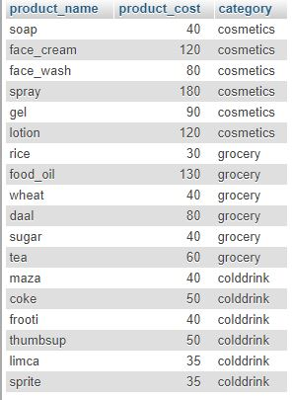

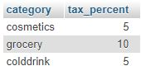

**INTERFACE –**

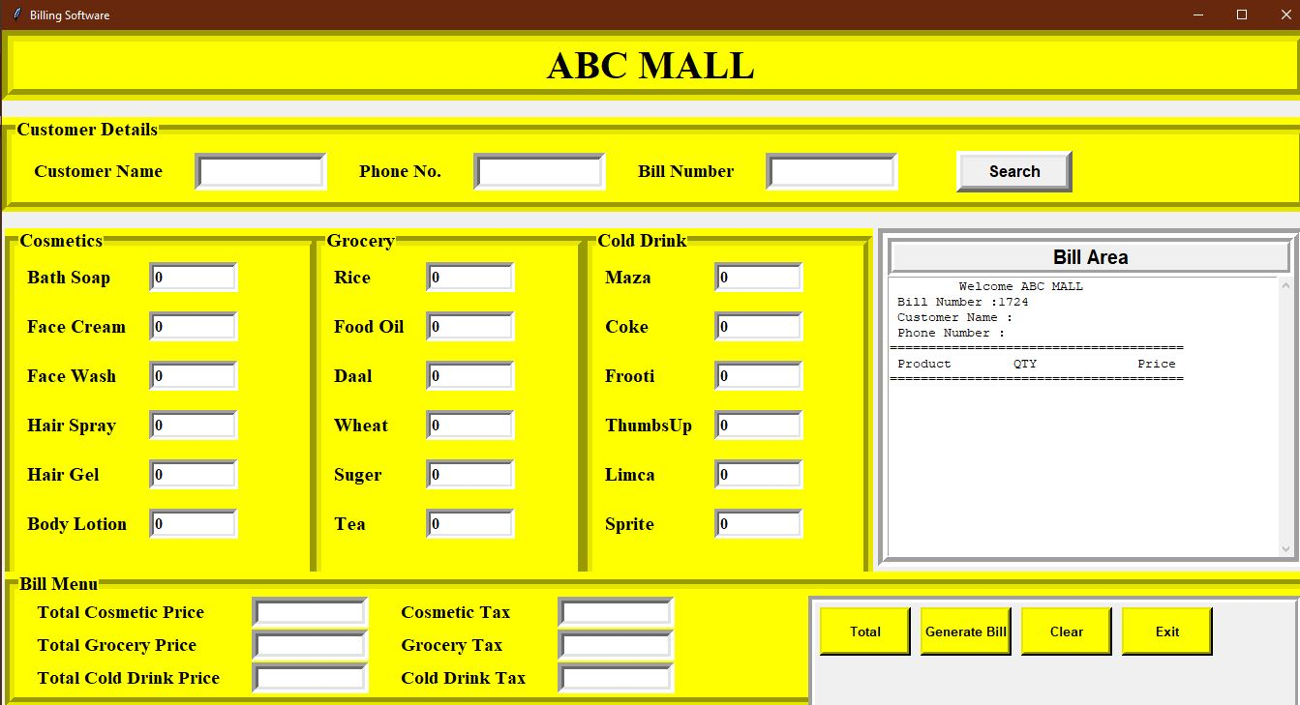

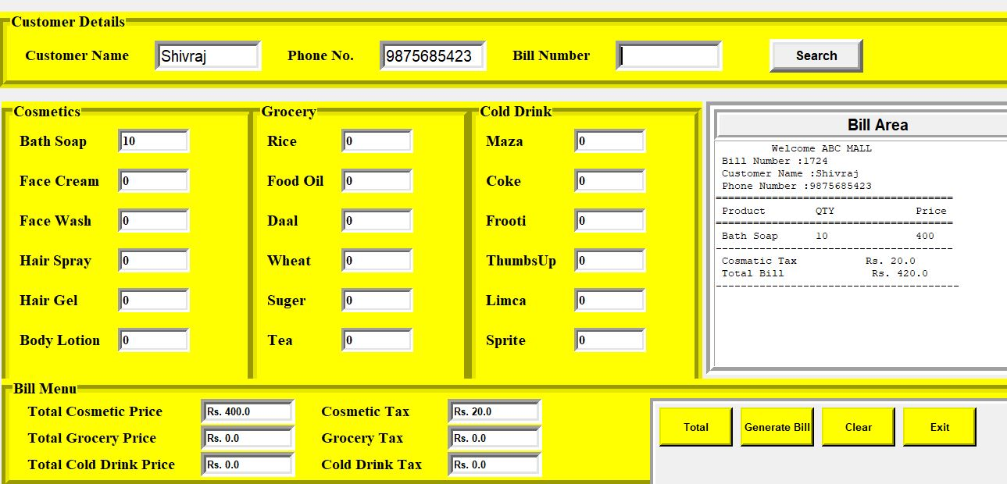

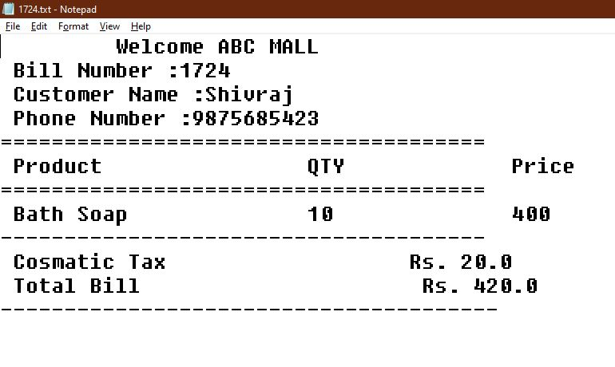

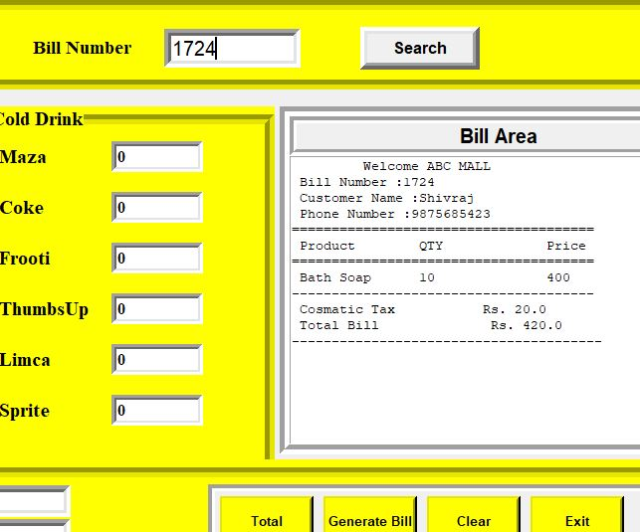

**SOftware**

**SOFTWARE -**

* Pycharm
* Visual Studio Code
* Xampp
* Google Chrome

**LANGUAGES -**

* Python(tkinter)
* MYSQL

**BIBLIOGRAPHY**

* [www.google.com](http://www.google.com)
* [www.youtube.com](http://www.youtube.com)
* [www.wikipedia.org](http://www.wikipedia.org)
* Computer Science with Python by Sumita Arora