**Experiment No. 5.2**

1. **To implement programs based on looping. (for loop)**

**Questions:**

1. Implement a python program to print all elements of a list. 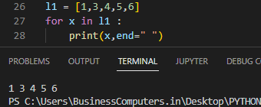
2. Create a list of integer elements. Implement a python program to make a new list which will store square of elements of previous list. 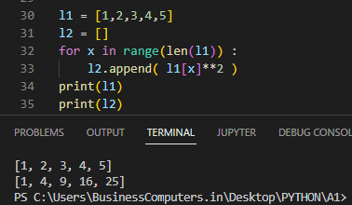
3. Using range (1,101), make two list, one containing all even numbers and other containing all odd numbers. 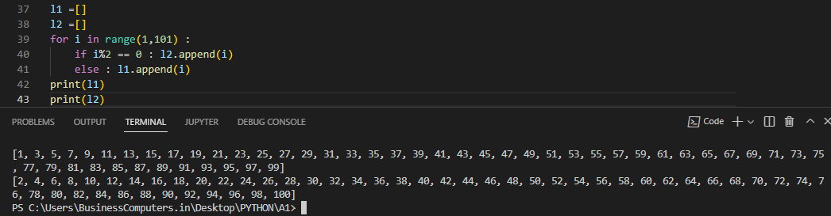
4. Implement a python program to print all natural numbers from 1 to n. 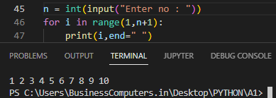
5. Implement a python program to print all natural numbers in reverse from n to 1. 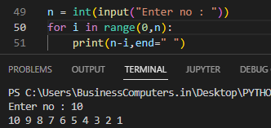
6. Implement a python program to print multiplication table of user entered number. 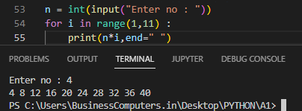
7. Implement a python program to generate a Fibonacci series. (e.g. 1 1 2 3 5 8----)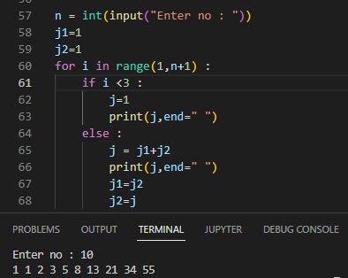
8. Implement a python program to find factorial of a user entered number. 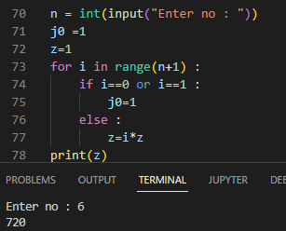
9. Generate following pattern.(by accepting no. of iterations from user)

1

1 2

1 2 3

1 2 3 4…..

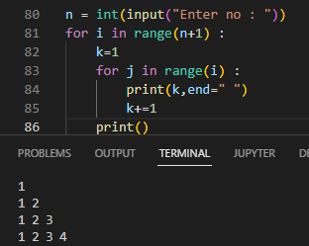

1. Generate following pattern. (by accepting no. of iterations from user)

*

* *

* * *

* * * *……

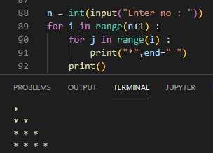

1. **To implement Iterator and loop control statements (break, continue, pass).**
2. Implement a Python program to demonstrate the default iterator used. 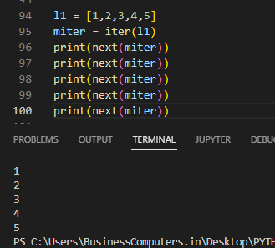
3. Implement a Python program that prints all the numbers from 0 to 6 except 3 and 6.  
   (Note : Use 'continue' statement) 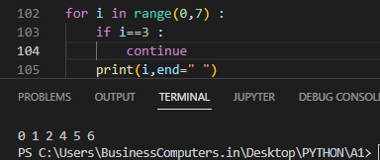
4. Implement a Python program to find HCF of two user entered numbers. 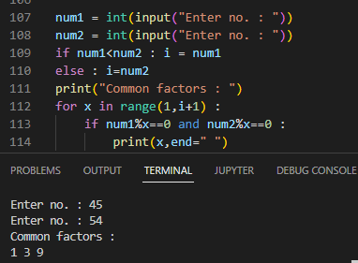
5. Implement a Python program to find LCM of two user entered numbers. (Note: use ‘break’ statement)

