**Experiment No. 2.1**

**Aim:** Implement List and Tuple in Python.

**Problem Statements:**

1. Implement List in Python.
2. Implement Tuple in Python.

**Questions:**

**A.Implement List in Python.**

1. Create following lists and print them at once.
   1. List1= 20,30,10, 40,50,50
   2. List2= Apple, banana, orange, mango, apple
   3. List3= 10.5, 20, cherry, papaya, 30,30.3
2. Print first two elements of list3.
3. Print list1 two times.
4. Find and print whether element 60 is present in list2 or not.
5. Find the length of list2.
6. Sort the elements of list1.
7. Write a Python program to sum all the items in a list.
8. Delete the last element of list2.
9. Print list3 in reverse order.
10. Find how many times element 50 is present in list1.
11. Find the sum of the elements of list1.
12. Create a copy of list3.
13. Modify second and third element of list1 to 70 and 80 respectively.
14. Find whether element 20 is present in the list, and if it is present, replace it with 90.
15. Combine list1 and list2.
16. Remove all elements from list2.
17. Delete list3.
18. Create following lists:
    1. Data1=34,45,67,23,65
    2. Data2=’abc’, ‘xyz’, ‘pqr’, ‘def’
    3. Create a list by combining data1 and data2.
    4. Find first element of a nested list.
    5. Find the element present at second index in first element of a nested list.

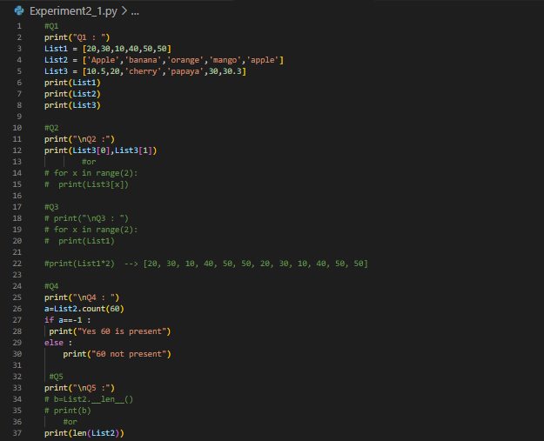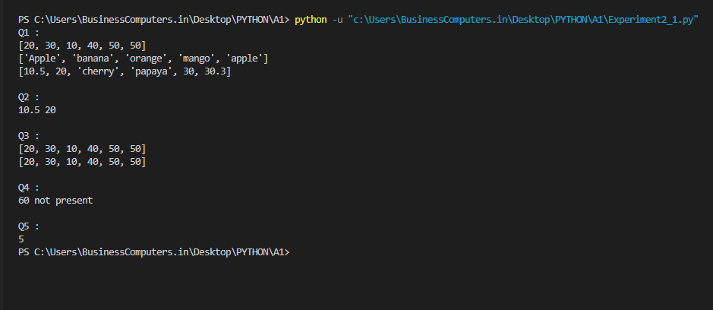

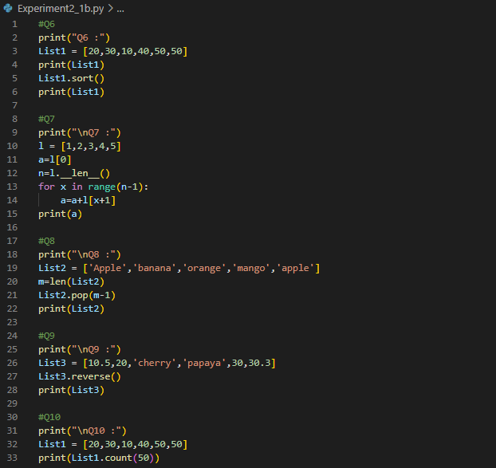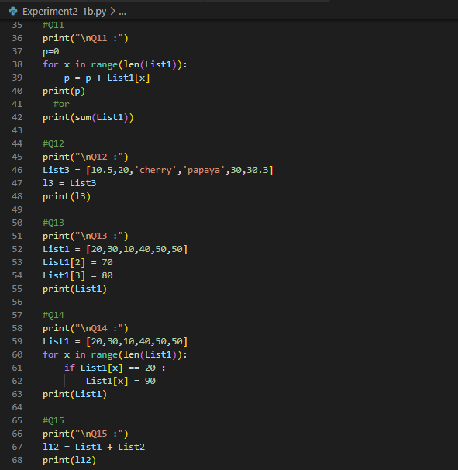

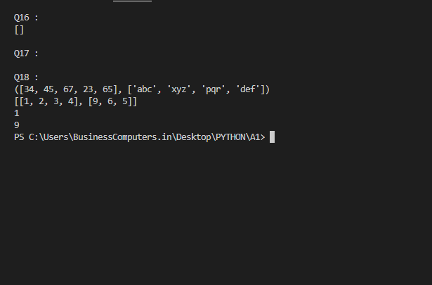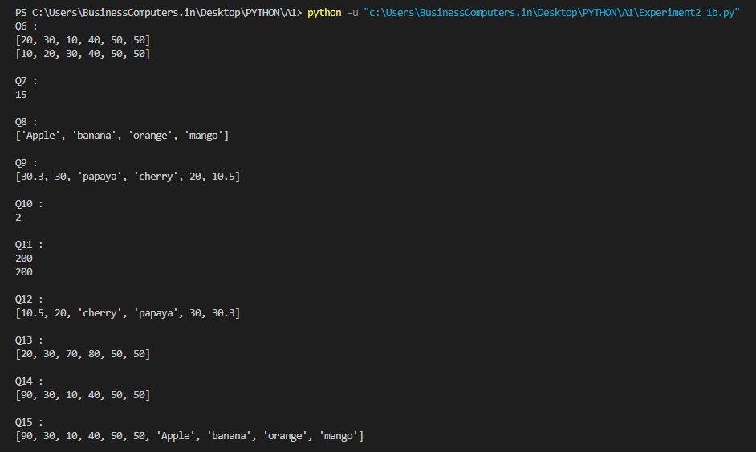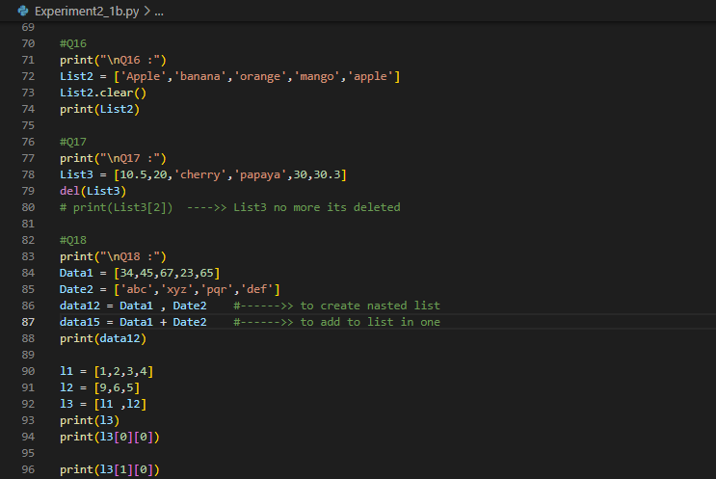

**B.Implement Tuple in Python.**

1. Write a Python program to create a tuple.
2. Write a Python program to create a tuple with different data types.
3. Write a Python program to create a tuple with numbers and print one item.
4. Write a Python program to get the 4th element and 4th element from last of a tuple.
5. Write a Python program to check whether an element exists within a tuple.
6. Write a python program to create a tuple containing one integer element and print it.
7. Write a Python program to convert a list to a tuple.
8. Write a Python program to slice a tuple.
9. Write a Python program to find the index of an item of a tuple.
10. Write a Python program to find the length of a tuple.

