**Experiment No. 2.2**

**Aim:** To implement Dictionary and Set in Python.

**Problem Statements:**

1. To implement dictionary in Python.
2. To implement set in Python.
3. **To implement dictionary in Python.**

**Questions:**

1. Create dictionary ‘Student’ with keys roll_no, name, age, contact. Assign values of your choice.
2. Create dictionary ‘Stud’ with keys roll_no and name. Assign values of your choice.
3. Create an empty dictionary by the name ‘Sample’.
4. Create a tuple and add it as a key to dictionary ‘Sample’. Assign values of your choice.
5. Retrieve the value of name from ‘Student’.
6. Update the value of age to 30 in ‘Student’.
7. Find how many elements are present in dictionary ‘Stud’.
8. Produce a printable string representation of dictionary ‘Stud’.
9. Retrieve all the keys from ‘Student’.
10. Retrieve all the values from ‘Stud’.
11. Add all elements of dictionary Stud to Sample.
12. Find the value of name from ‘Stud’.
13. Update contact=1234567890 in ‘Stud’.
14. Create a tuple. Add all the tuple items to a dictionary as keys and set the default value of all the keys to 10.
15. Implement a python program to prove that mutable data types cannot be assigned as a key to dictionary.
16. Implement a python program to create a dictionary containing list and tuple values. Also access elements from list and tuple in dictionary.

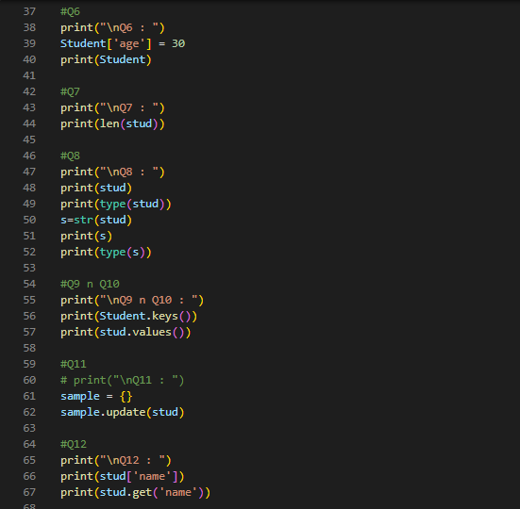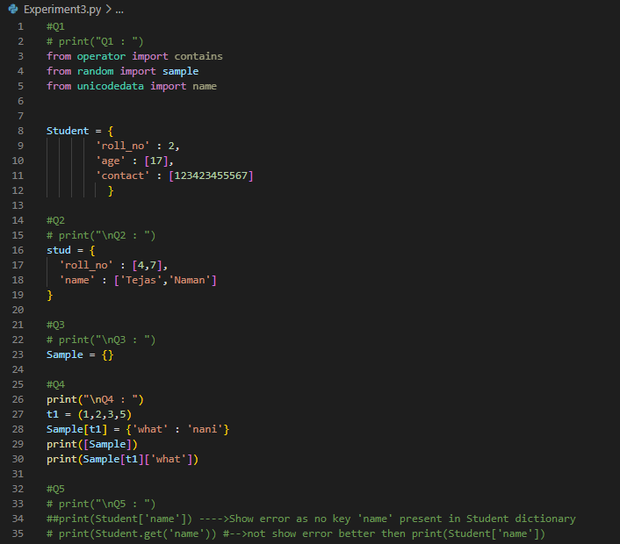

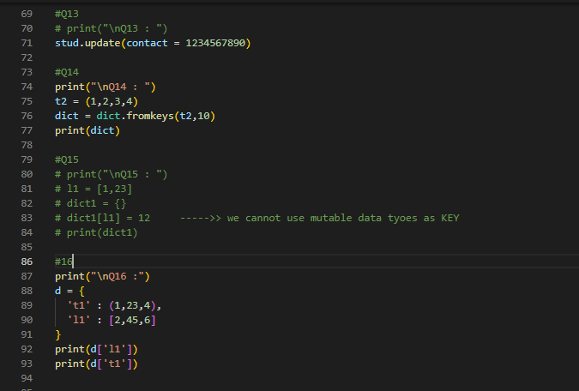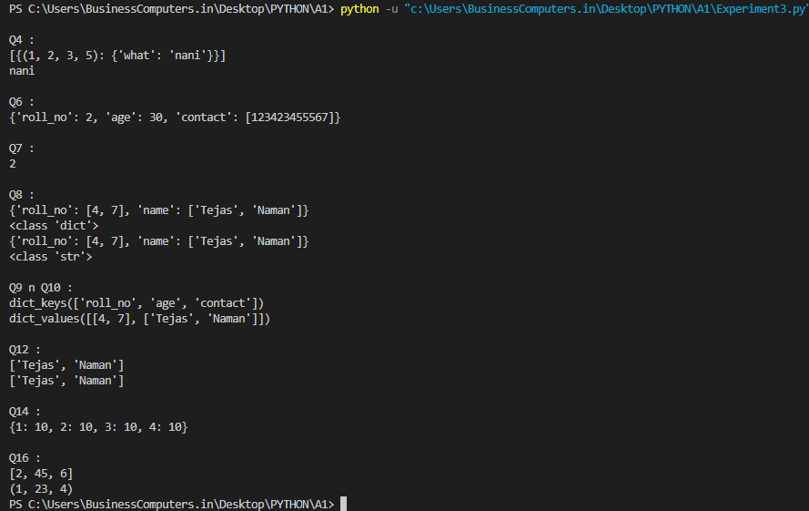

1. **To implement set in Python.**
2. Create and print following sets:
   1. Set1 containing values physics, chemistry, maths.
   2. Set2 containing values physics, chemistry, computer_science, electronics
3. Add element ‘biology’ to Set1.
4. Add elements ‘IT’, ’Aero’ to Set2.
5. Perform union, intersection and difference of Set1 and Set2.
6. Apply all the comparison operators and comparison methods on Set1 and Set2.
7. Delete element ‘maths’ from Set1.
8. Delete a random element from Set2.
9. Delete all the elements fromSet1.
10. Delete Set2.
11. Implement a python program to prove that mutable elements cannot be added inside a set.
12. Implement a python program to create an empty set.
13. 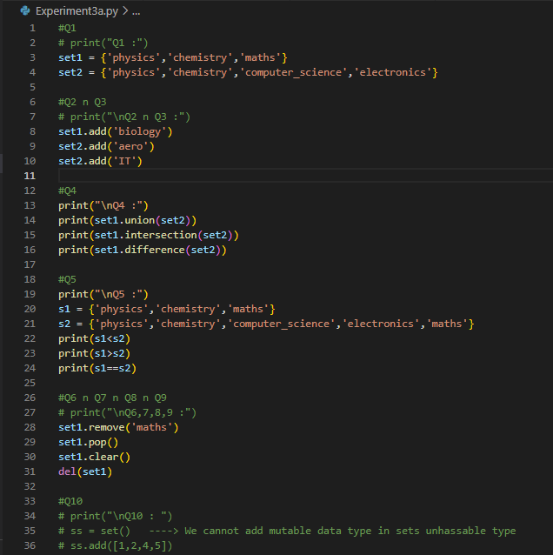Implement a python program to create a dictionary and add it to the frozenset. Also, print the frozenset.

