**Experiment No. 5**

**Aim:** To implement programs based on decision making statements and looping in Python.

**Problem statement:**

1. To implement programs based on decision making.(if-else statements)
2. To implement programs based on looping.( while loop)
3. To implement programs based on looping.( for loop)
4. To implement Iterator and loop control statements (break, continue, pass).
5. Pattern generation using nested ‘for’ loop.
6. **To implement programs based on decision making. (if-else statements)**

**Questions:**

1. Implement a python program to find maximum of two values entered by a user. 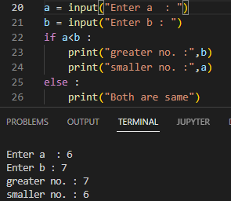
2. Implement a python program to take values of length and breadth of a rectangle from user and check if it is square or not. If it is a square, find the area of the square. 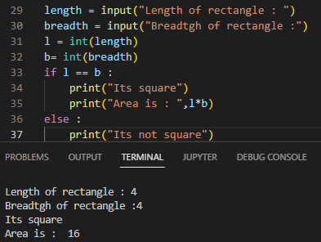
3. Implement a Python program to take input of age of 3 people by user and determine oldest and youngest among them. 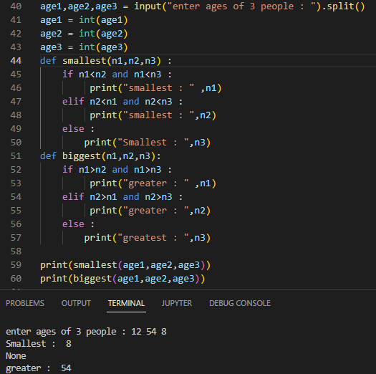
4. Implement a Python program to create a list containing elements- 10, 20, 30, 40, 50. Find whether element 20 is present in the list or not and if present, replace it with 60. 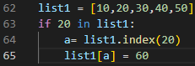
5. Implement a python program to create a tuple ‘stud’ with values name, age, address. Create a dictionary ‘student’ with keys accepted from tuple. Take value of name, age and address from user and add it inside the dictionary. Display ‘welcome’ message if the age is greater than or equal to 18 otherwise display ‘invalid’ message. 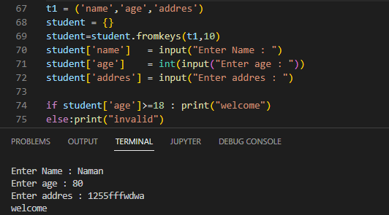
6. A company decided to give bonus of 10% (of salary) to employee if his/her year of service is more than 5 years. Implement a Python program to ask user for their salary and year of service and print the net bonus amount and the total salary adding bonus. 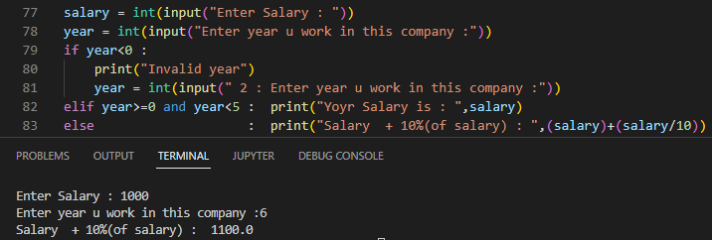
7. Aschool has following rules for grading system:  
   Below 25 – F, 25 to 45 – E, 45 to 50 – D, 50 to 60 – C, 60 to 80 – B, Above 80 - A  
   Implement a Python program to ask user to enter marks and print the corresponding grade. 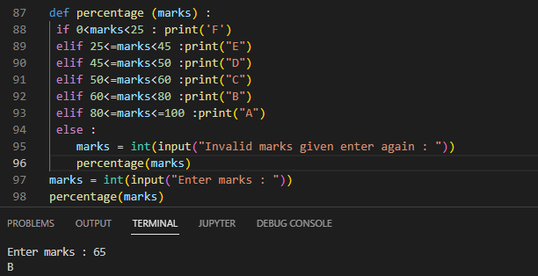
8. A student will not be allowed to sit in exam if his/her attendance is less than 75%. Implement a Python program to take following input from user: Number of classes held, Number of classes attended and print percentage of class attended and whether student is allowed to sit in exam or not. 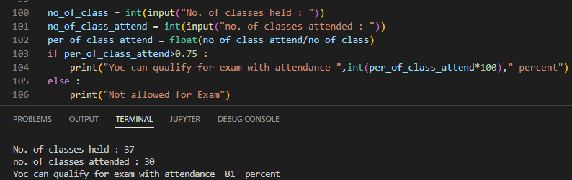
9. Write a Python program to check if a year is leap year or not. (Tip: Use % operator) 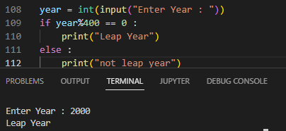
10. Implement a python program to demonstrate the use of shorthand if and if-else statements. 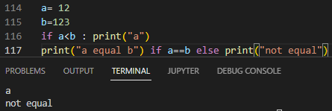
11. **To implement programs based on looping.(while loop)**

**Questions:**

1. Implement a python program to write an infinite while loop. 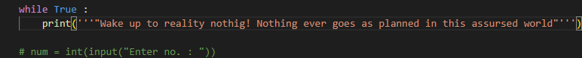
2. Implement a python program to print multiplication table of user entered number. 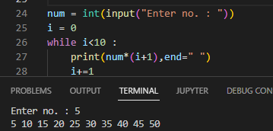
3. Implement a python program to take 10 integers from keyboard using loop and print their average value on the screen. 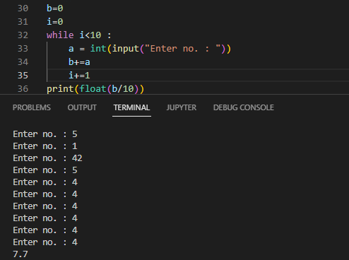
4. Implement a python program to accept an integer number from user and check whether it is an Armstrong number or not. (Armstrong number: e. g. 153= 13+53+33 ) 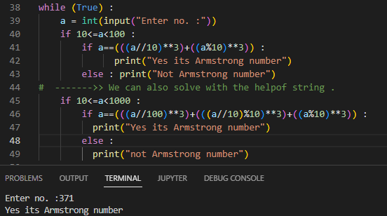
5. Implement a python program to count the number of digits in a user entered number. 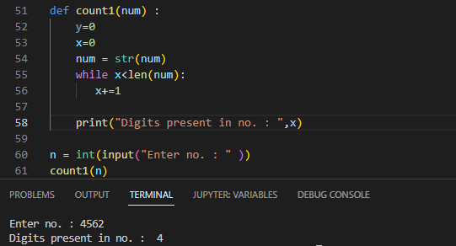
6. Implement a python program to calculate the sum of digits of a number given by user. 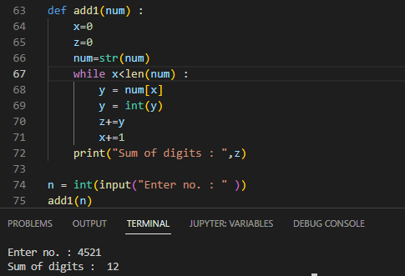
7. Implement a python program to print all natural numbers from 1 to n.
8. Implement a python program to print all natural numbers in reverse from n to 1. 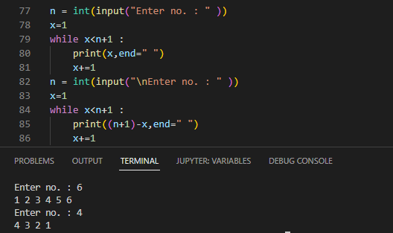
9. Implement a python program to print all even numbers between 1 to 10.
10. Implement a python program to print all odd numbers between 1 to 10. 