**Experiment No. 6**

**Aim:** To implement programs based on object oriented concepts in Python.

**Problem statement:** To implement programs based on classes, objects, methods and destructor.

**Questions:**

1. Implement a basic python program to demonstrate class, object and method.

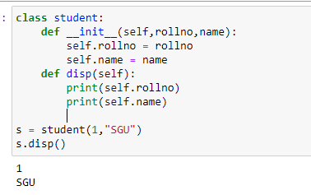

1. Implement a python program to use built in attributes.

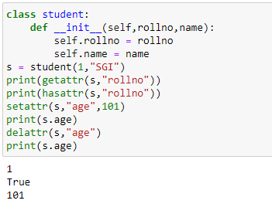

1. Implement a python program to use built in class attributes.

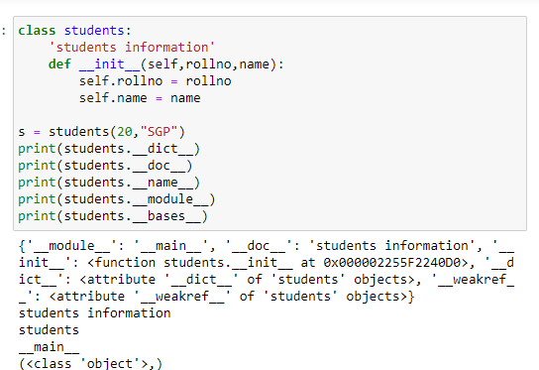

1. Implement a python program to demonstrate destructor in python. 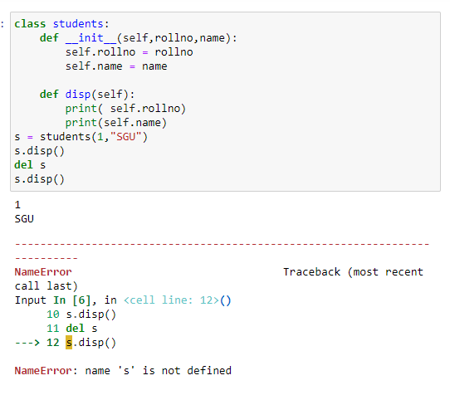
2. Implement a python program to find area of a rectangle using classes and objects

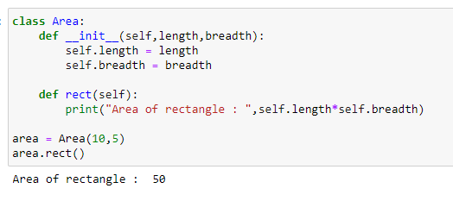

1. Define a class to represent a bank account. Include the following details like name of the depositor, account number, type of account, balance amount in the account. Write methods to assign initial values, to deposit an amount, withdraw an amount after checking the balance, to display name, account number, account type and balance. (Give multiple options to user and run the appropriate case depending on the option selected. Options: New Customer, Deposit, Withdrawal, Display, Exit