EXECUTIVE SUMMARY
SDRF Helping Hands is a disaster-response coordination platform being developed under the guidance of Prof. Varun Dutt at Indian Institute of Technology (IIT) Mandi, with mentorship support from Mr. Anshul Sharma.
The project is designed to improve coordination between the State Disaster Response Force (SDRF) and associated emergency departments by providing a centralized digital platform for emergency management.
The system aims to address common challenges faced during disasters, including delayed communication, lack of centralized monitoring, poor volunteer coordination, equipment tracking difficulties, and connectivity issues in remote regions.
To improve disaster-response efficiency, the platform integrates multiple features into a single system, including:
- Real-time incident monitoring
- Emergency reporting system
- Volunteer coordination
- Equipment tracking
- Official updates and communication
- Weather intelligence integration
- Offline operational support
The project is being developed using modern technologies such as React.js, Node.js, Express.js, SQLite, Material UI, and React Leaflet, along with secure authentication mechanisms including JWT and bcrypt encryption.
Several major modules have already been implemented, and the project is currently progressing toward feature refinement, testing, and production readiness.
The long-term vision of SDRF Helping Hands is to establish a reliable, scalable, and technology-enabled disaster-response ecosystem capable of improving emergency preparedness and reducing response time during disasters.

- PROJECT INTRODUCTION
SDRF Helping Hands is a disaster-response coordination platform being developed to improve emergency management and communication among the State Disaster Response Force (SDRF) and associated departments.
The project aims to create a centralized system for managing emergency incidents, volunteers, rescue equipment, and official updates during disaster situations.
In disaster-prone regions such as Himachal Pradesh, emergencies including landslides, flash floods, road accidents, cloudbursts, and heavy snowfall often require quick coordination between multiple agencies such as SDRF, Police, Medical Services, Fire Department, and District Administration.
Currently, emergency coordination often depends on phone calls, manual reporting, and separate communication systems, which may cause delays and reduce response efficiency.
To address these challenges, SDRF Helping Hands is being developed as a technology-enabled platform that supports:
- Real-time incident monitoring
- Emergency reporting
- Volunteer coordination
- Equipment tracking
- Official updates and communication
- Weather intelligence integration
- Offline operational support
The primary goal of the project is to improve disaster preparedness, strengthen coordination, and reduce emergency response time through a centralized digital system.

2. PROBLEM STATEMENT & NEED OF THE PROJECT
Disaster-response operations often face several challenges that affect the speed and effectiveness of emergency management.
In states like Himachal Pradesh, disasters such as landslides, flash floods, road accidents, cloudbursts, and heavy snowfall require rapid coordination between multiple departments including SDRF, Police, Medical Services, Fire Department, and District Administration.
However, current emergency-response systems commonly face the following issues:
- Delayed communication between departments
- Lack of a centralized monitoring system
- Manual incident reporting processes
- Difficulty in managing volunteers during emergencies
- Limited tracking of rescue equipment
- Internet connectivity issues in remote areas
Due to these challenges, response time may increase and operational coordination can become difficult during critical situations.
To address these problems, SDRF Helping Hands is being developed as a centralized disaster-response coordination platform that enables:
- Faster emergency reporting
- Real-time incident monitoring
- Better volunteer coordination
- Rescue equipment tracking
- Department communication through a common platform
- Offline support during network disruptions
The project aims to improve disaster preparedness and strengthen emergency response through a reliable and technology-enabled system.

3. OBJECTIVES OF THE PROJECT
The primary objective of SDRF Helping Hands is to develop a centralized disaster-response coordination platform that improves emergency management and communication among disaster-response agencies.
The project is designed to support the State Disaster Response Force (SDRF) and associated departments in managing emergency situations more efficiently.
The major objectives of the project are:
1. Centralized Coordination: To provide a single platform for SDRF personnel, nodal officers, volunteers, and emergency departments to coordinate disaster-response activities.
2. Real-Time Incident Monitoring: To enable live tracking of emergency incidents using map-based geolocation systems.
3. Emergency Reporting: To allow fast and structured reporting of emergencies with location and severity details.
4. Volunteer Management: To improve volunteer coordination through skill-based registration and location-based emergency dispatch.
5. Equipment Tracking: To monitor rescue equipment availability and operational status through a digital tracking system.
6. Better Communication: To improve information sharing among SDRF, Police, Medical Services, Fire Department, and other agencies.
7. Offline Operational Support: To maintain essential system functionality during internet connectivity issues in remote disaster-prone areas.
The overall objective of the project is to improve disaster preparedness, reduce response time, and strengthen emergency coordination through technology-enabled solutions.

4. TEAM STRUCTURE, ROLES & RESPONSIBILITIES
The SDRF Helping Hands project is being developed at Indian Institute of Technology (IIT) Mandi under academic guidance and mentorship support.
The project follows a collaborative development approach where responsibilities have been divided among team members according to their specialization areas including database development, backend systems, frontend development, Android application support, Artificial Intelligence integration, and documentation.
Project Guidance
Project Guide
Prof. Varun Dutt
Professor, Indian Institute of Technology (IIT) Mandi
Provided academic guidance, technical direction, project planning support, and feedback throughout the development process.
Project Mentor
Mr. Anshul Sharma
Provided mentorship support in project execution, technical guidance, feature planning, and implementation strategies.

Student Team & Roles
S. No. | Team Member | Role & Responsibility
1 | Ashwani | Backend Development, AI Features & Project Documentation
2 | Tejas | Backend Development & AI Module Support
3 | Ritika | Frontend Development, UI/UX Design & Android Application
4 | Tavish | Frontend Development, Design & Android Application
5 | Yuvraj | Database Design & Database Documentation

Team Contributions
The development work completed till date includes collaborative contributions across multiple areas of the system.
Backend & AI Development
- API development
- Authentication system
- Incident management logic
- Volunteer coordination workflows
- Equipment tracking backend
- AI-based future planning features
Frontend & Application Development
- Dashboard interface design
- Emergency reporting UI
- Incident map interface
- Volunteer module interface
- Android application support
- Responsive system design
Database Development
- Database structuring
- Incident data management
- Volunteer database design
- Equipment inventory records
- Authentication-related database implementation
Documentation & Planning
- Project documentation
- Technical planning
- Feature documentation
- System workflow preparation
The collaborative team structure helped ensure smooth development, efficient feature implementation, and better coordination throughout the project lifecycle.

5. TECHNOLOGY STACK USED
The SDRF Helping Hands platform is being developed using a modern full-stack architecture to ensure scalability, security, performance, and maintainability.
The project includes technologies across frontend development, backend systems, database management, security, APIs, and mapping services.
Technology Area | Technology Used | Purpose
Frontend Framework | React 18 + Vite | User Interface Development
UI Design Library | Material UI (MUI) + Emotion | Responsive and Professional UI Design
Routing System | React Router | Navigation Between Pages
Mapping Service | React Leaflet | Real-Time Incident Mapping
Backend Runtime | Node.js | Server-Side Execution
Backend Framework | Express.js | API and Business Logic Development
Database | SQLite (better-sqlite3) | Data Storage and Management
Future Database | PostgreSQL | Production-Level Scalability
Authentication | JWT (JSON Web Token) | Secure User Login & Route Protection
Password Security | bcryptjs | Password Hashing & Encryption
File Upload Handling | Multer | Secure Media Upload Management
Weather Intelligence API | Open-Meteo API | Weather Forecast and Climate Information
QR Code Tracking | QR-based Scanning | Equipment Tracking
Version Control | Git | Code Management & Collaboration

6. SYSTEM ARCHITECTURE & WORKFLOW
The architecture of SDRF Helping Hands follows a modern full-stack modular design, ensuring efficient communication between the frontend, backend, database, and external services.
The system has been designed to support real-time disaster management operations, secure communication, and future scalability.
The platform follows a Frontend → Backend → Database → External Services architecture.
System Components
1. Frontend Layer
The frontend acts as the user interaction layer and provides access to different modules of the platform.
This layer is responsible for:
- Incident monitoring dashboard
- Emergency reporting forms
- Volunteer management interface
- Equipment tracking system
- Official updates and alerts
- Interactive map visualization
Technologies Used:
React.js, Vite, Material UI, React Leaflet

2. Backend Layer
The backend handles system logic, authentication, request processing, and communication between modules.
This layer manages:
- Incident management APIs
- Volunteer coordination logic
- Equipment tracking workflows
- Authentication and authorization
- Weather data integration
- Offline synchronization support
Technologies Used:
Node.js, Express.js

3. Database Layer
The database stores and manages all system-related information.
This includes:
- User records
- Emergency incidents
- Volunteer information
- Equipment inventory
- Updates and notifications
- Authentication data
Technologies Used:
SQLite (Current)
PostgreSQL (Planned for future deployment)
4. External Services
The platform integrates external systems for operational support.
These include:
- Open-Meteo API for weather forecasting
- SMS Notification Services for emergency communication
- GPS Services for location tracking
- QR Code System for equipment monitoring

System Workflow
The operational workflow of the platform is as follows:
User Input → Frontend Interface → Backend APIs → Database/External Services → Response Displayed to User
This workflow enables fast communication, secure data handling, and real-time operational coordination during emergency situations.
Figure 6.1: High-Level System Architecture
(Insert Architecture Diagram Here)
Suggested Diagram Structure:
Users / SDRF Personnel
↓
Frontend (React + Vite)
↓
Backend (Node.js + Express)
↓
Database (SQLite/PostgreSQL)
↓
External APIs (Weather, SMS, GPS)

8. IMPLEMENTED WEBSITE MODULES
The SDRF Helping Hands platform has been developed as a modular web-based disaster-response coordination system. Multiple operational pages have been implemented to support different aspects of emergency management.
The following website modules have been successfully developed and integrated into the platform.
1. Home Page
The Home Page acts as the primary entry point of the platform and provides quick access to major system functionalities.
Features Implemented
- System overview section
- Navigation to operational modules
- Emergency access shortcuts
- Quick information display
- Home Page
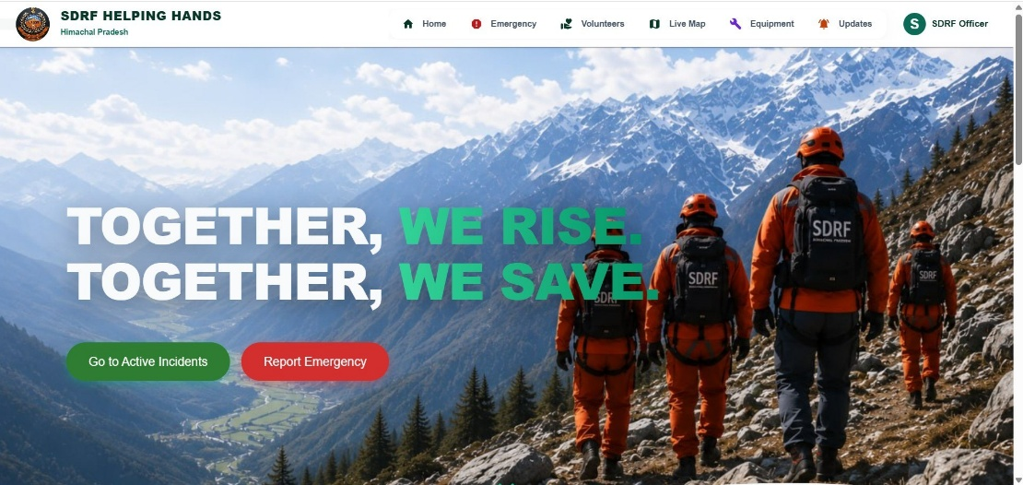

2. Live Operational Dashboard
The Live Dashboard has been developed to support real-time disaster monitoring and operational awareness.
Features Implemented
- Real-time incident visualization
- Geospatial map integration
- Disaster category filtering:
  - Landslides
  - Floods
  - Fires
  - Medical Emergencies
  - Road Accidents
- Weather information support
- SDRF operational visibility

- Live Dashboard
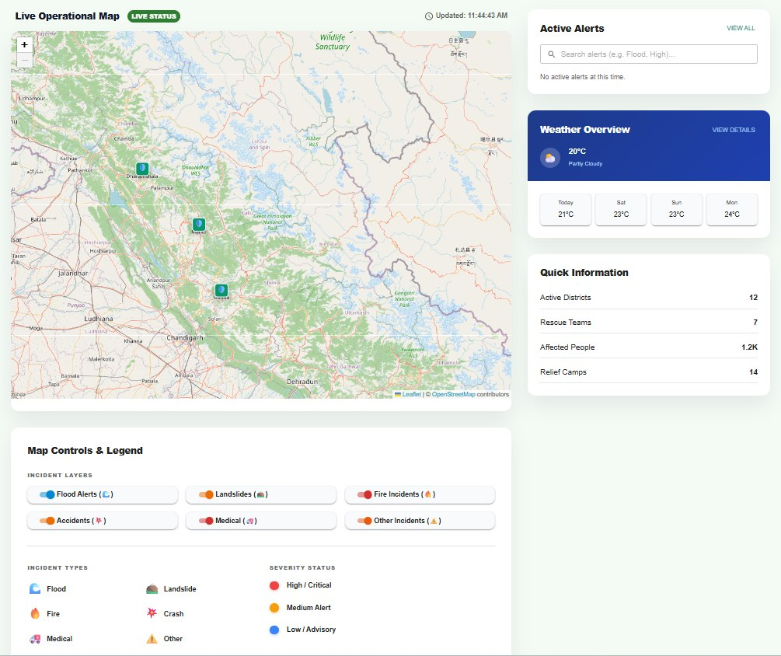

3. Emergency Reporting Page
The Emergency Page enables rapid reporting of emergency situations.
Features Implemented
- Emergency type selection
- Severity-level classification
- Department dispatch option
- GPS/manual location support
- Media upload functionality
- SOP and emergency contact support

- Emergency Page
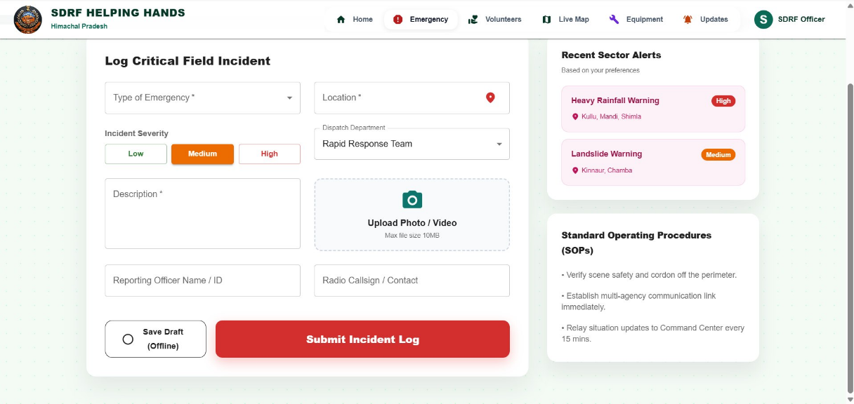

4. Equipment Management Page
The Equipment module has been developed for rescue equipment management.
Features Implemented
- Equipment inventory dashboard
- QR-code scanning support
- Equipment status tracking
- Equipment categorization
- Stock monitoring

- Equipment Page
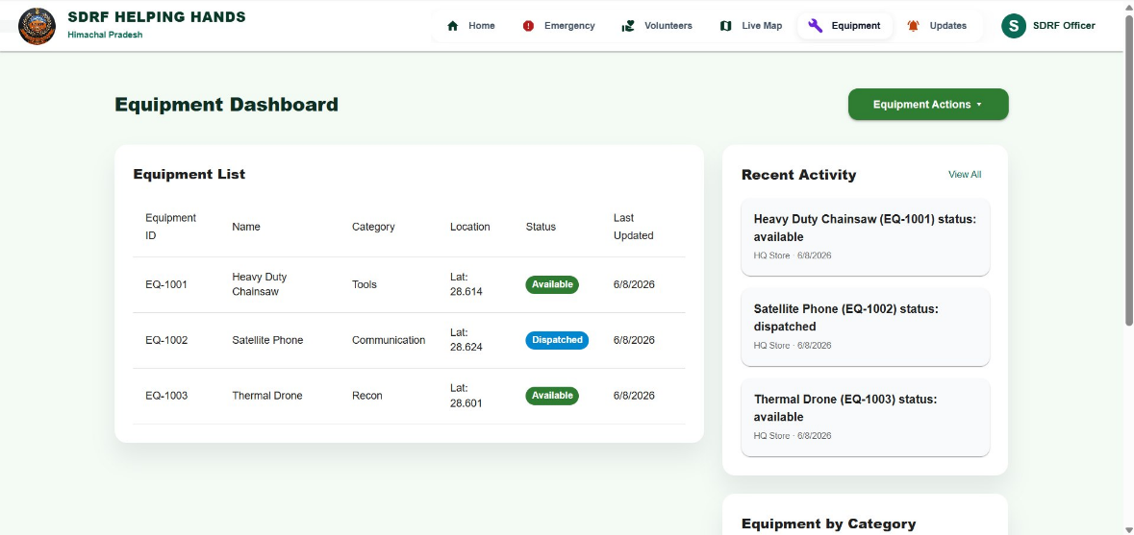

5. Volunteer Command Center
The Volunteer Page supports manpower coordination during emergencies.
Features Implemented
- Volunteer registration
- Skill-based categorization
- GPS-based volunteer tracking
- Radius-based emergency broadcasting
- Volunteer availability management
- Volunteer Page
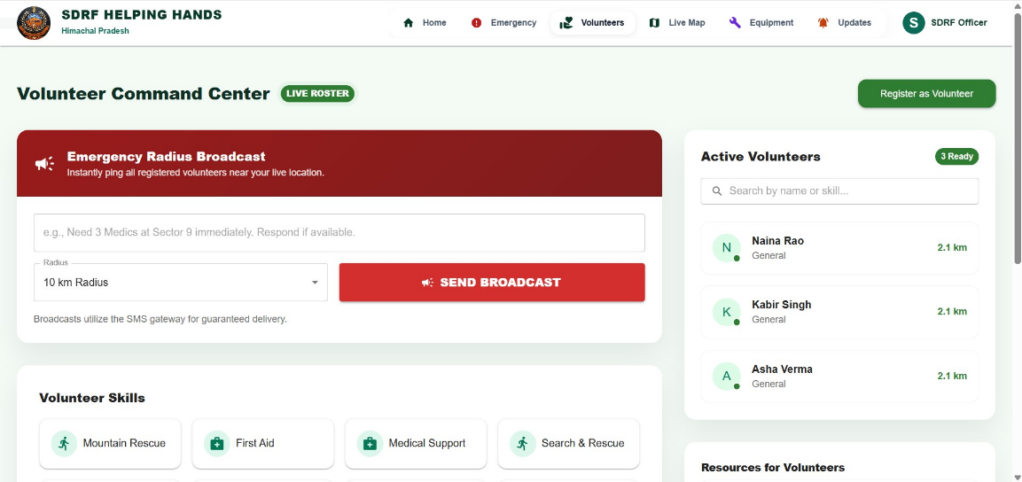

6. Updates & Intelligence Feed
The Updates module improves operational communication among agencies.
Features Implemented
- Department-wise updates
- Official bulletins
- Weather alerts
- Health and transport advisories
- Intel pin support

- Updates Page
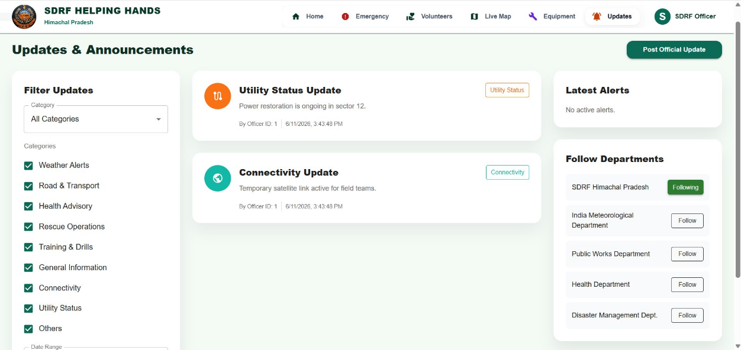

9. REMAINING WORK & FUTURE DEVELOPMENT
Although major core functionalities of SDRF Helping Hands have been successfully implemented, several advanced features and optimizations are planned to further improve system efficiency, scalability, and production readiness.
The following development work is planned for future implementation:

1. Advanced Media Verification System
To improve the reliability and authenticity of field reports, the platform will be enhanced with stronger media verification mechanisms.

Planned Work
- Full implementation of SHA-256 media integrity verification
- Tamper-proof photo and video validation
- Metadata verification for uploaded incident evidence
This feature will help reduce false reporting and improve trust in field-generated emergency data.

2. Enhanced Notification & Communication System
The current communication workflow will be further strengthened to support emergency coordination.
Planned Work
- Complete SMS fallback communication system
- Push notification optimization
- Emergency escalation workflow for delayed responses
This enhancement will improve communication reliability during disaster situations.

3. Advanced Offline Resilience
Although basic offline functionality has been implemented, additional offline capabilities are planned for remote operational areas.
Planned Work
- Enhanced offline synchronization
- Intelligent local caching system
- Better recovery after network restoration
This feature is especially important for remote and disaster-prone regions where internet connectivity may be unstable.

4. Smart Volunteer Coordination
The volunteer coordination system will be expanded to support better responder management.
Planned Work
- Advanced skill tagging system
- Specialized responder classification:
  - Mountain Rescue
  - First Aid
  - Rope Rescue
  - Drone Operations
- Improved volunteer matching during emergencies
This enhancement will support faster and more effective manpower deployment.

5. Advanced Intelligence & Incident Analysis
Future development will focus on improving operational decision-making.
Planned Work
- Better disaster-risk visualization
- Improved incident analytics dashboard
- Enhanced operational intelligence support
This will help authorities improve emergency planning and disaster preparedness.

6. Inter-Agency Coordination Improvements
The communication framework among departments will be further strengthened.
Planned Work
- Better coordination between SDRF, Police, Medical Services, and Fire Department
- Improved task communication system
- Enhanced operational update sharing
This enhancement aims to improve unified response during emergency situations.

7. Production-Level Testing & Deployment
Before large-scale deployment, the platform will undergo additional optimization and testing.
Planned Work
- Large-scale testing
- Security improvements
- Performance optimization
- UI refinement
- Production deployment preparation
The future development of SDRF Helping Hands aims to make the platform more intelligent, reliable, scalable, and suitable for real-world disaster-response operations at the state level.

10. CHALLENGES FACED DURING DEVELOPMENT
During the development of SDRF Helping Hands, several technical and operational challenges were encountered. Since the platform is designed for disaster-response coordination, maintaining reliability, usability, security, and real-time communication required careful planning and implementation.
The major challenges faced during development are discussed below.

1. Real-Time Incident Monitoring
Developing a live incident monitoring system using maps posed technical challenges.
Challenges Faced
- Real-time plotting of incidents on maps
- Managing multiple incident categories simultaneously
- Maintaining smooth performance during updates
Solution Approach
The issue was addressed using React Leaflet with categorized incident filtering for better visualization and performance.

2. GPS & Location Accuracy
Location accuracy is critical for emergency-response operations.
Challenges Faced
- GPS permission handling
- Location inconsistencies in remote areas
- Providing backup location methods
Solution Approach
The system supports both GPS-based location capture and manual location entry for better reliability.

3. Volunteer Coordination
Managing volunteers efficiently during emergencies required structured coordination mechanisms.
Challenges Faced
- Skill-based responder categorization
- Radius-based responder identification
- Volunteer availability management
Solution Approach
A Volunteer Command Center was developed with skill-based registration and location-aware filtering.

4. Equipment Tracking & Management
Digitally managing rescue equipment was another major challenge.
Challenges Faced
- Equipment categorization
- QR-code integration
- Equipment status synchronization
Solution Approach
A dedicated equipment management system was implemented with QR-based tracking and status monitoring.

5. Offline Support in Remote Regions
Many disaster-prone regions experience poor network connectivity.
Challenges Faced
- Maintaining functionality without internet
- Preventing data loss during disruptions
Solution Approach
An offline action queue mechanism was implemented to temporarily store actions and synchronize data after network restoration.

6. Security & Authentication
Since the platform handles emergency-response information, security was a major priority.
Challenges Faced
- Preventing unauthorized access
- Secure password management
- Route protection
Solution Approach
The platform uses JWT authentication and bcrypt-based password encryption to improve security.

7. Team Coordination & Module Integration
As the project involved frontend, backend, database, and system integration work, team coordination was also important.
Challenges Faced
- Module integration
- Frontend-backend synchronization
- Database connectivity management
Solution Approach
Regular testing, collaborative development, and structured workflows helped ensure smooth integration among modules.
Despite these challenges, the team successfully implemented the major core functionalities of the platform and continues working toward system optimization and production readiness.
11. CONCLUSION
The SDRF Helping Hands project has been developed as a comprehensive disaster-response coordination platform aimed at improving emergency management, communication, and operational efficiency among the State Disaster Response Force (SDRF) and associated agencies.
The platform addresses major disaster-management challenges by providing a centralized system for real-time incident monitoring, emergency reporting, volunteer coordination, rescue equipment management, official updates, and offline operational support.
The project successfully integrates modern technologies to support emergency-response operations through:
- Real-time disaster monitoring through geospatial mapping
- Structured emergency incident reporting
- Volunteer registration and coordination mechanisms
- Equipment and rescue asset tracking
- Official updates and intelligence sharing
- Weather information integration
- Offline operational support for remote areas
- Secure authentication and database management
The platform has been developed using a modern technology stack including React.js, Node.js, Express.js, SQLite, Material UI, React Leaflet, JWT authentication, and secure backend services, ensuring scalability, maintainability, and system reliability.
Major core functionalities have already been implemented, while future development efforts are planned to further improve communication systems, offline resilience, volunteer coordination, operational intelligence, and production-level readiness.
The long-term vision of SDRF Helping Hands is to establish a reliable, scalable, and technology-enabled disaster-management ecosystem capable of improving preparedness, strengthening coordination, and reducing emergency response time, especially in disaster-prone regions such as Himachal Pradesh.
This project demonstrates how technology-driven solutions can significantly contribute to strengthening disaster-response operations and supporting better coordination between emergency agencies at the state level.

