FSDA1

**Tejas Naik**

[tejasnaik0007.tn@gmail.com](mailto:tejasnaik0007.tn@gmail.com)

**Excel Assignment6**

1. What are the various elements of the Excel interface? Describe how they're used.

A. **Quick Access Toolbar**: This toolbar can be customized and lets you choose which commands you want to access easily. By default, this contains the save, undo, and redo commands.

**Ribbon:** The Ribbon interface contains the commands that are available for use in Excel. This has multiple tabs including the File, Home, Insert, Page Layout, Formulas, Data, Review, View, Add-ins, and Help tabs.

**Name Box:** The Name Box is an input box which normally displays the name or location of the active cell on the worksheet. This is also used to directly create a named range. When you open a blank workbook, the selected cell is A1, by default.

**Formula Bar:** This allows you to enter or edit data, formula or a function that will appear in the selected cell whose name or location appears in the Name Box.

**Status Bar:** The Status Bar in the bottom-left corner of the Excel window displays various information about the current mode of the workbook.

2. Write down the various applications of Excel in the industry.

A. Data entry, Data management, Accounting, Financial analysis, Charting and graphing, Programming.

3. On the ribbon, make a new tab. Add some different groups, insert commands in the groups and name them according to their commands added. Copy and paste the screenshot of the steps you followed.

A. 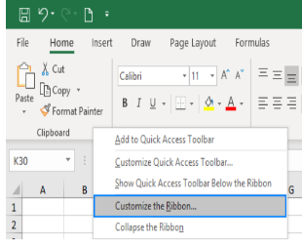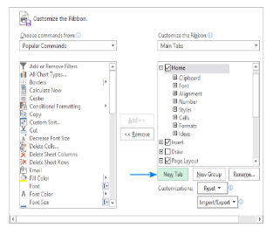

4. Make a list of different shortcut keys that are only connected to

formatting with their functions.

A. control + b: applies bold font formatting to headers

alt + h + b + a: applies borders to the cells

alt + h + b + t: gives an outline border to the dataset

alt + h + o + w: autofits column widths

control + 1: opens format cells dialog box

5. What distinguishes Excel from other analytical tools?

A. We can do a lot of things with Excel: modelling, visualization, reports, dynamic charts, etc. It can help you understand the meaning of many operations before further learning other tools (such as Python and R).

6. Create a table and add a custom header and footer to your table.

A.