COURSE : DATA STRUCTURE
CODE : CSA0313
DATE : 17/08/2026
NAME : TEJASRI M
REG NO : 192511047

ACTIVITY
SORTING ALGORITHMS

1. Insertion Sort

Idea: Builds the sorted array one element at a time by inserting each element into its correct position.

Algorithm:
Start from the second element.
Store it as key.
Compare key with elements before it.
Shift larger elements one position to the right.
Insert key in its correct position.
Repeat until all elements are sorted.

Example:
5, 3, 4, 1 → 3, 5, 4, 1 → 3, 4, 5, 1 → 1, 3, 4, 5

2. Selection Sort

Idea: Finds the smallest element and places it at the beginning of the unsorted portion.

Algorithm:
Find the minimum element in the array.
Swap it with the first unsorted element.
Move the boundary of the sorted portion forward.
Repeat until the array is sorted.

Example:
5, 3, 4, 1 → 1, 3, 4, 5

3. Merge Sort

Idea: Uses the divide-and-conquer technique.

Algorithm:
Divide the array into two halves.
Recursively divide each half until single elements remain.
Compare elements of the divided arrays.
Merge them in sorted order.
Continue merging until one sorted array is obtained.

Example:
8, 4, 2, 6
→ [8,4] [2,6]
→ [4,8] [2,6]
→ [2,4,6,8]

4. Bubble Sort

Idea: Repeatedly compares adjacent elements and swaps them if they are in the wrong order.

Algorithm:
Compare adjacent elements.
Swap them if the first is greater than the second.
Continue through the array.
After each pass, the largest unsorted element moves to the end.
Repeat until no swaps are needed.

Example:
5, 3, 4, 1
→ 3, 4, 1, 5
→ 3, 1, 4, 5
→ 1, 3, 4, 5

5. Radix Sort

Idea: Sorts numbers digit by digit, starting from the least significant digit.

Algorithm:
Find the largest number.
Start with the units digit.
Group numbers according to the current digit.
Collect the numbers in order.
Move to the next digit.
Repeat until all digits have been processed.

Example:
170, 45, 75, 90, 802, 24, 2, 66
→ Sort by units
→ Sort by tens
→ Sort by hundreds
→ 2, 24, 45, 66, 75, 90, 170, 802

6. Quick Sort

Idea: Uses divide-and-conquer by selecting a pivot and partitioning the array.

Algorithm:
Select an element as the pivot.
Place smaller elements before the pivot.
Place larger elements after the pivot.
Recursively apply the same process to the left and right portions.
Combine the results.

Example:
5, 3, 8, 4, 2
Pivot = 5
→ [3,4,2] 5 [8]
→ [2,3,4] 5 [8]

7. Heap Sort

Idea: Uses a binary heap data structure to sort elements.

Algorithm:
Build a max heap from the array.
Swap the root (largest element) with the last element.
Reduce the heap size.
Heapify the remaining elements.
Repeat until all elements are sorted.

Example:
4, 10, 3, 5, 1
→ Build Max Heap
→ Move largest element to the end
→ Heapify
→ Repeat
→ 1, 3, 4, 5, 10

COMPARATIVE TABLE OF SORTING ALGORITHMS
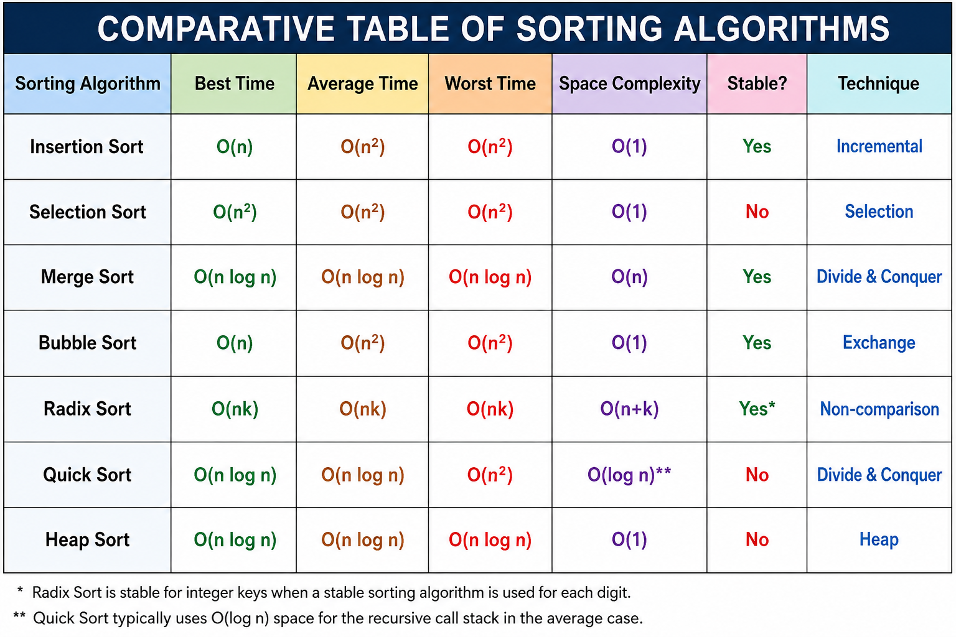
n = number of elements
k = number of digits/maximum key length
Radix sort is stable when its underlying digit-sorting method is stable.
Quicksort's auxiliary space depends on implementation; recursion can reach O(n) in the worst case.

INTERVENTION / KEY DIFFERENCES
Insertion Sort: Best for small or nearly sorted data.
Selection Sort: Simple, but generally slow for large data.
Merge Sort: Guaranteed O(n log n) and stable, but needs extra memory.
Bubble Sort: Very simple but inefficient for large datasets.
Radix Sort: Efficient for integers/strings with suitable fixed-length keys; does not use comparisons.
Quick Sort: Usually very fast in practice and widely used; worst case can be O(n²).
Heap Sort: Guaranteed O(n log n) with O(1) extra space, but usually less cache-friendly than quicksort.

