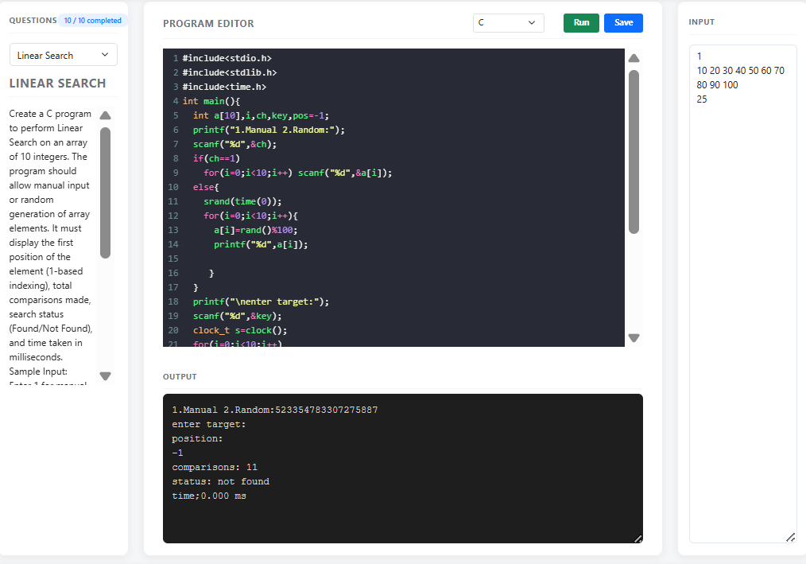
BINARY SEARCH

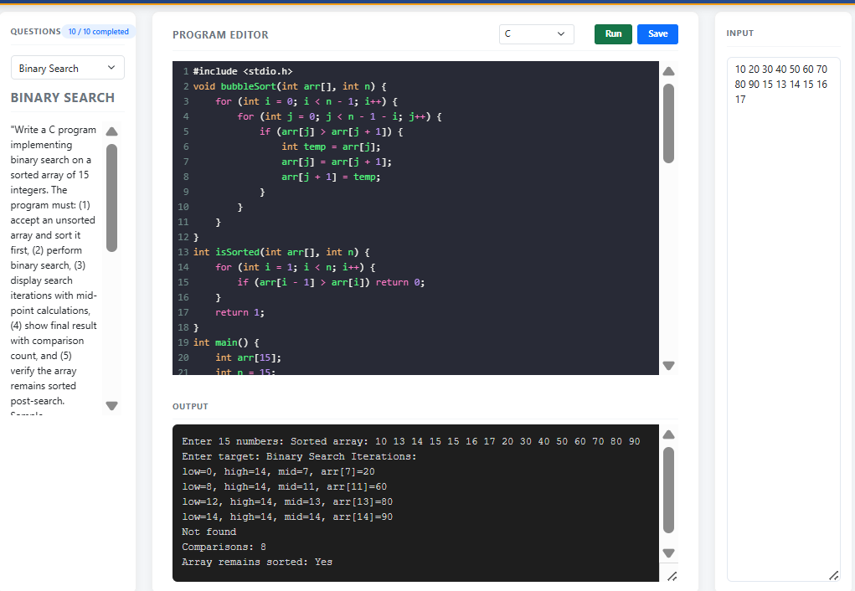
BINARY SEARCH-ITERATIVE
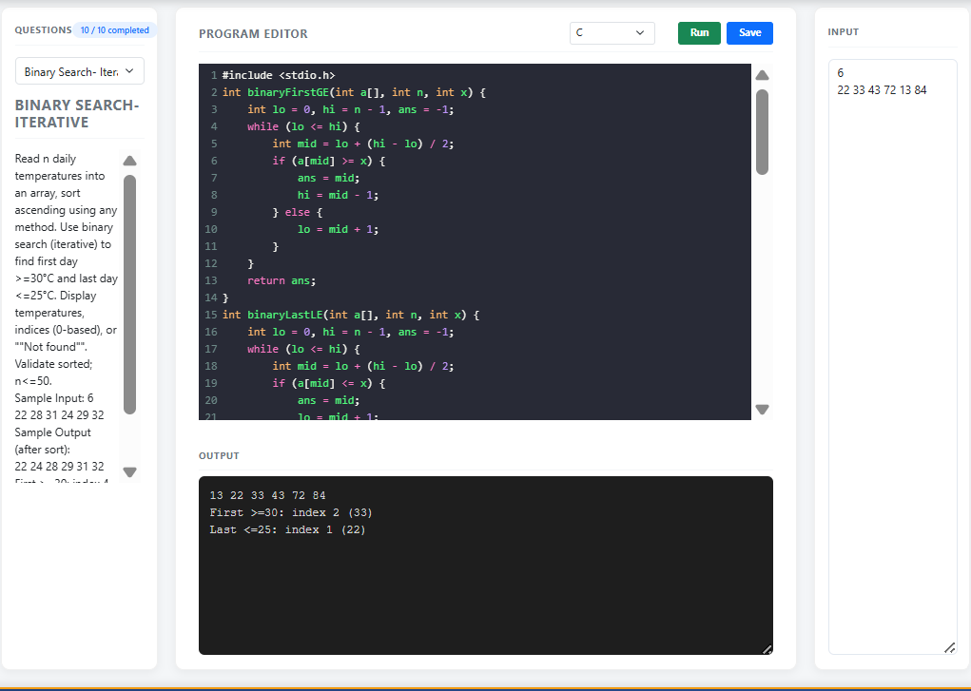

LINEAR SEARCH-SORT
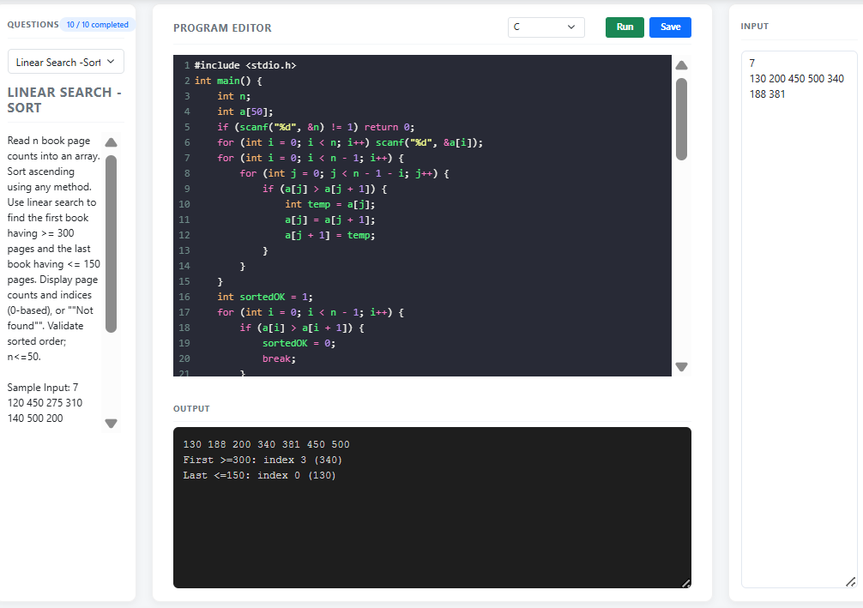

LINEAR SEARCH ON ARRAY
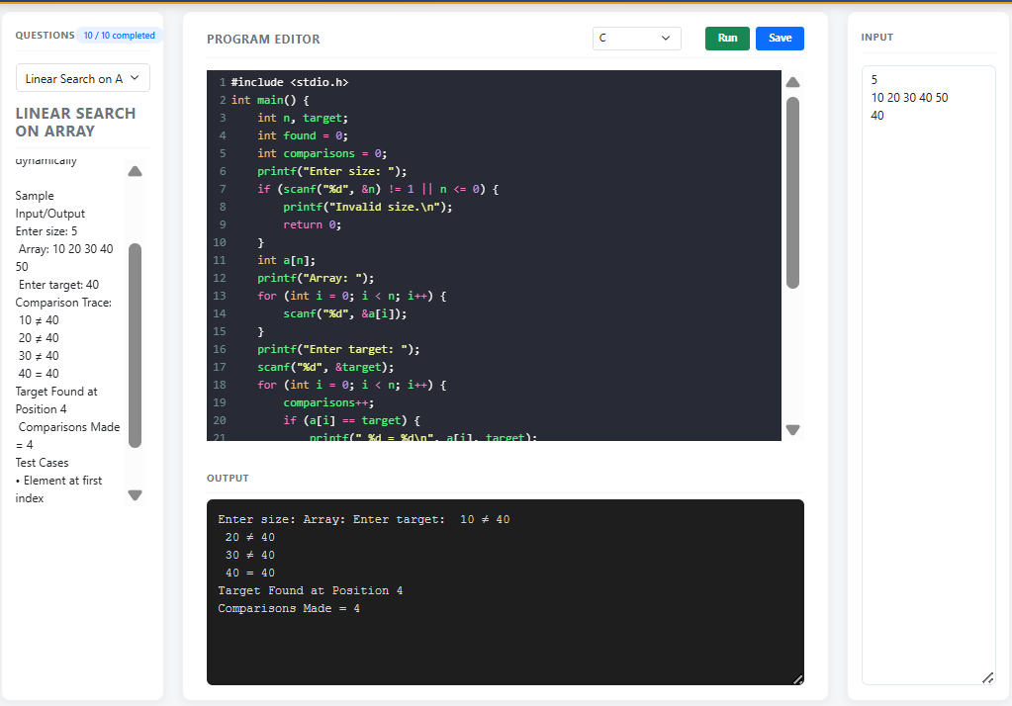
BINARY SEARCH-ARRAY
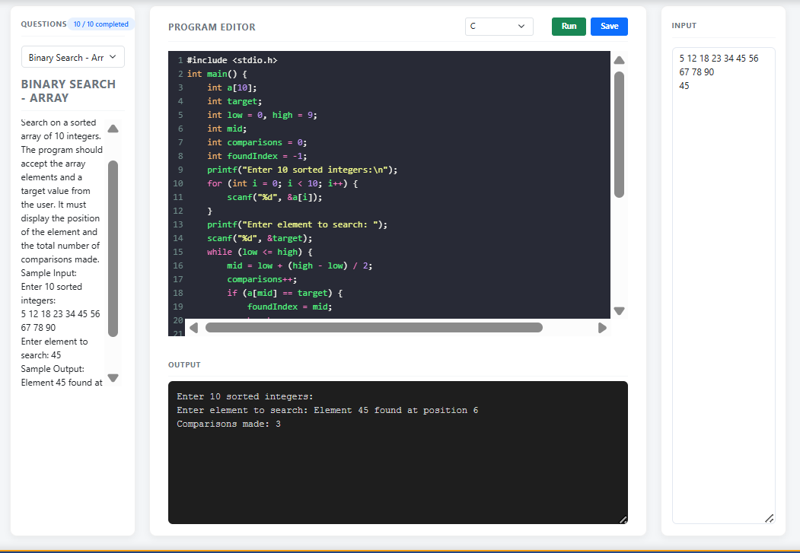

LINEAR SEARCH-TEMPERATURE
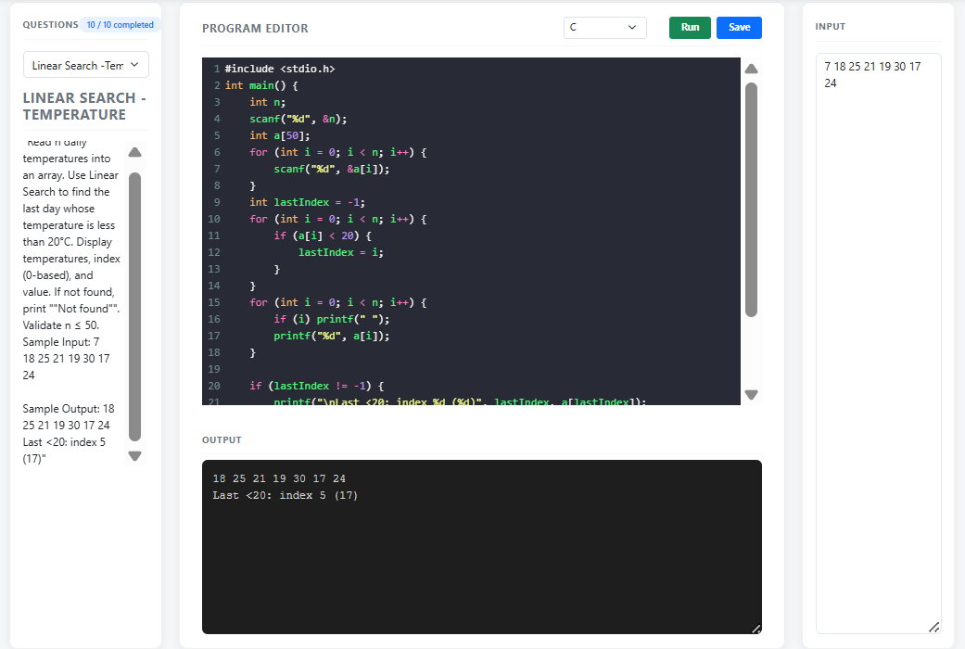
LINEAR SEARCH-PRICES
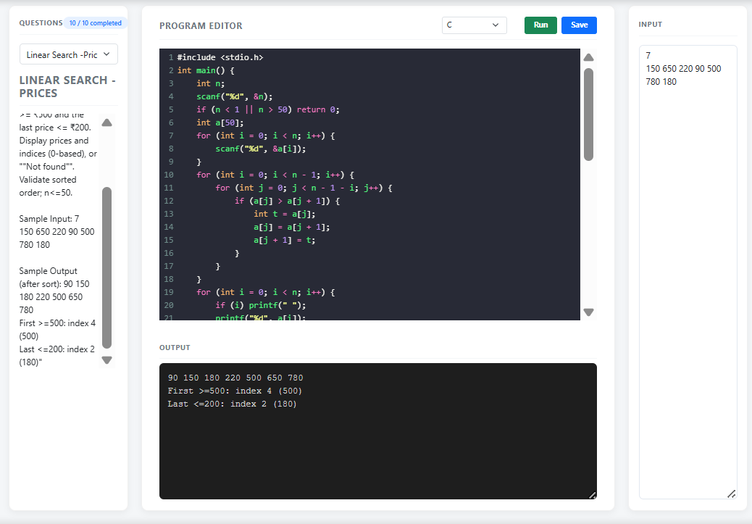

BIN.SEARCH-ITERATIVE-TEMP
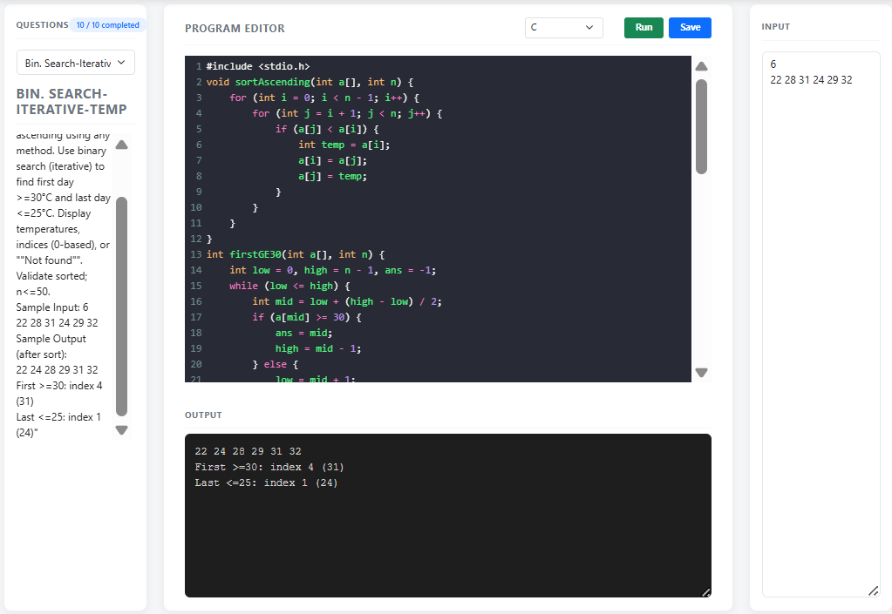
Linear search-anagrams

